Information for participants

Thank you for participating in our study at the CCNB of the Freie Universität Berlin.

1. General Information

The goal of this study is to investigate brain activation during the sensation and imagery of acupuncture. Acupuncture is the method of inserting needles and stimulating them by touch which causes nonpainful sensations in the body.
Your total participation is estimated to be a maximum of two hours.

This experiment will be structured as follows:
- Explanations and questionnaires outside of the MRI
- Going into the MRI
- Setting the acupuncture needles
- Time to get used to the sensation
- Start of MRI scanning
- One practice block
- Seven experimental blocks, each will last about 8 minutes
- End of MRI scanning
- Going out of the MRI and some last questionnaires

2. Acupuncture and Imagery

The stimulation will be given at three points, which the acupuncturist will mark onto your leg. To make it easier for you to tell the points apart, the experimenter will assign numbers of 1 to 3 to the points. Therefore, you will see these points again on a picture before going into the MRI machine as well as on the screen in the MRI.
Once you are in the MRI, the acupuncturist will put needles in these three locations and stimulate them one at a time in the experiment. In some trials, however, you will be asked to imagine the sensation of being stimulated that you previously experienced at the indicated point on your leg. Please try to replicate the feeling as accurately as you can using your imagination!

3. Information about the cues

Before each block, you will be shown a picture of a leg with numbers marking the three spots on your leg, and each of the spots will have one of three colours: green, blue or yellow. While the numbers of the points will always stay the same for every block, the colours of the three points will change. This will be demonstrated with a picture.

Therefore, it is crucial you take some time at the beginning of each block to memorize which colour corresponds to which point.

For example, if the upper point is green for you, the lower yellow and the right point is blue you will see a picture like this at the beginning of the first block:

As an example, this could be the next distribution of colours you see at the beginning of the second block:

4. Information about the structure of the blocks

Whithin each of the blocks there will be several so-called trials.
So, one trial goes as follows:

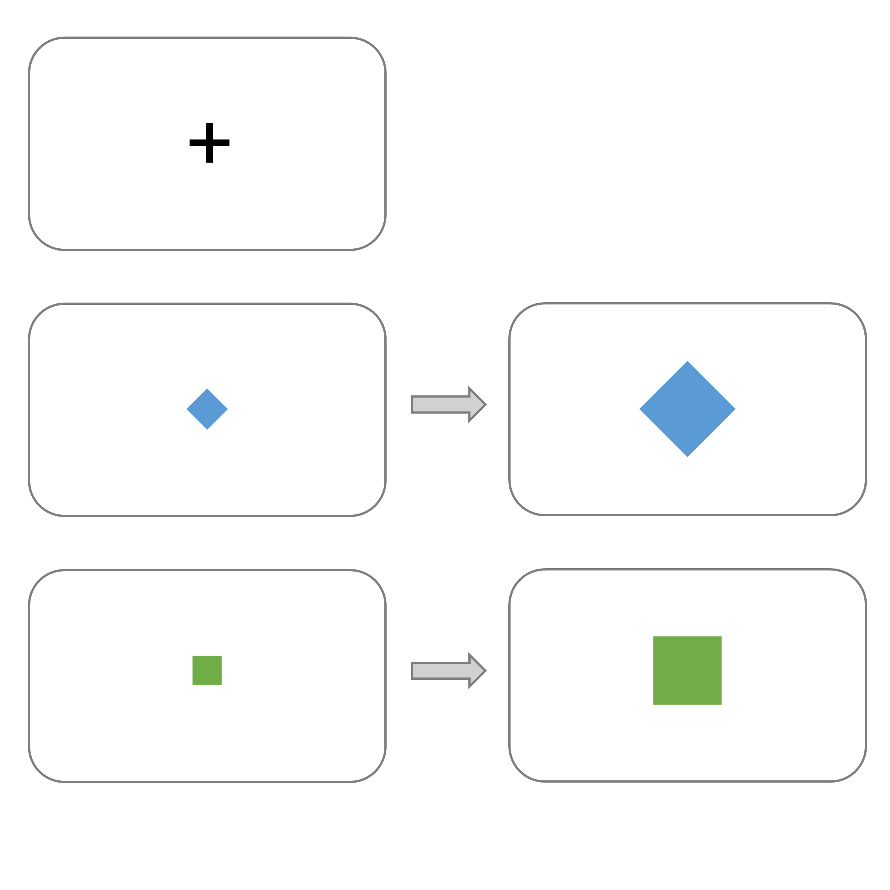

Each trial starts with a fixation cross and is followed by a cue that tells you the type of trial – a small square or a diamond on the screen. The shape will indicate to you whether the acupuncturist will stimulate you or you have to imagine the stimulation:
If you see a square cue, this indicates you will receive stimulation (acupuncture) at the location indicated by the colour of the square.
If you see a diamond cue, this indicates you need to imagine you are being stimulated at the location indicated by the colour of the diamond.

The colour will indicate the exact point location where you receive stimulation, or imagine it during the following block.

The cue will change size after one second. Once this happens, you will either receive the stimulation or imagine it at the point indicated by the colour as long as the cue is visible (five seconds).

For example, a trial in which you will receive stimulation on the green point will look like this:

A trial in which you will be asked to imagine the acupuncture-sensation on the blue point would look like this:

Next, you will see the fixation cross again before a spiral appears on the screen.
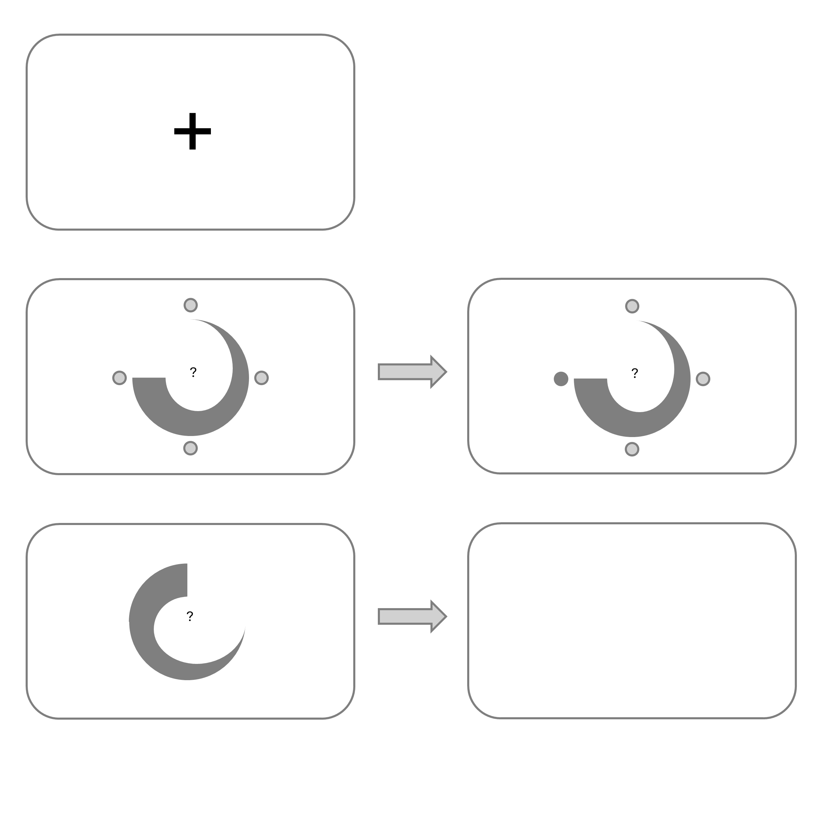

This is your prompt to answer the following question via a button press:
If it was a stimulation trial (square cue), please rate, how intense the stimulation felt.
If it was an imagery trial (diamond cue), please rate, how vivid your imagery of the sensation was.
To do this, you will use a button box, that looks like this:
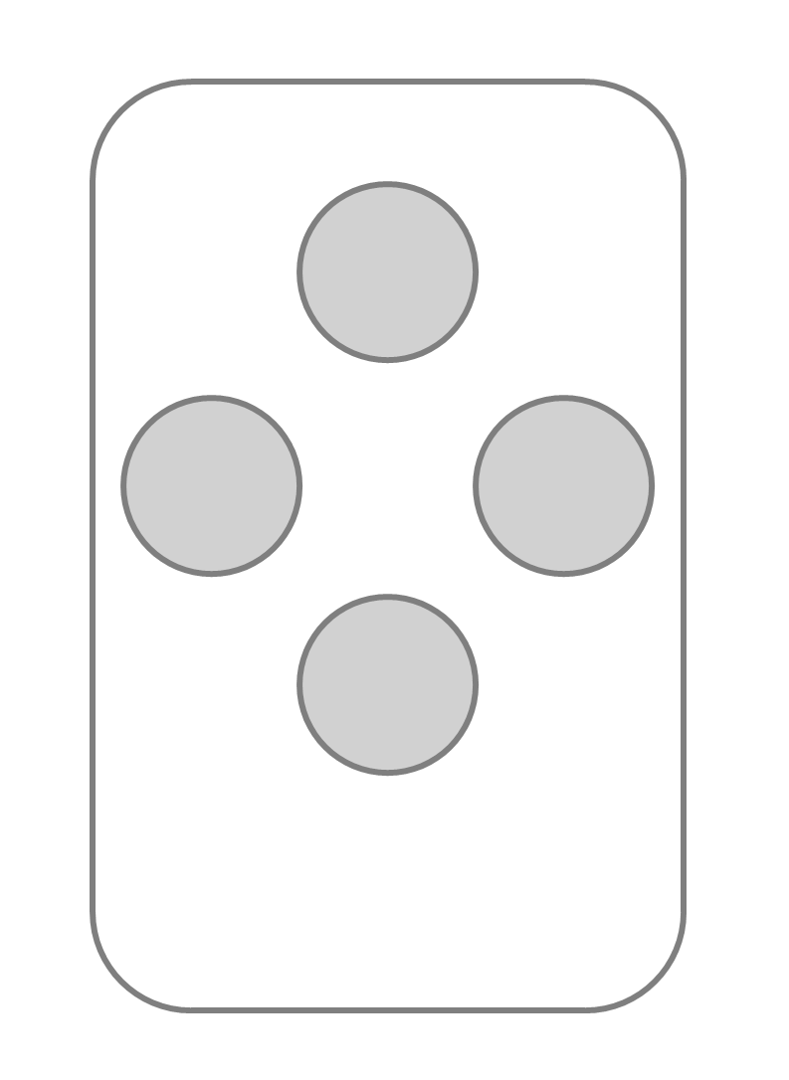
The buttons of the button box correspond to the circles around the spiral. The thickness of the spiral represents your answer options.

For stimulation, this is what lower and higher intensity would mean:

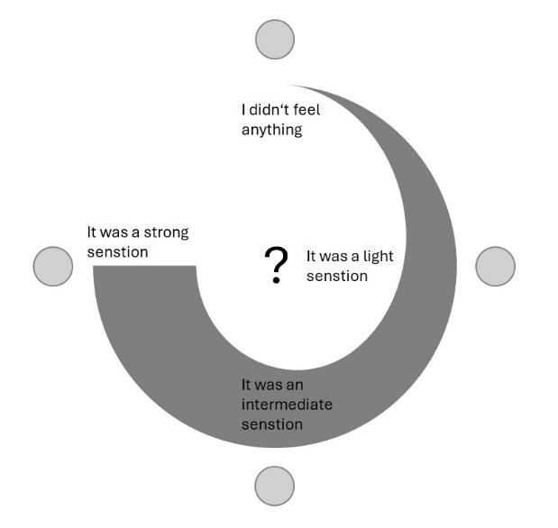

Analogue to this, for imagination trials the meaning would be as is in this picture:
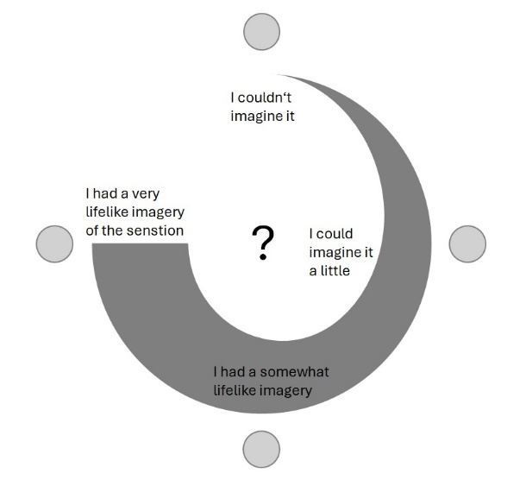
The button will turn gray when you press the answer.
In the practice block, the buttons will still be visible around the spiral to help you get used to answering:

Later in the experiment only the spiral will be shown, without buttons. You will always answer how intense the stimulation or imagination was. The spiral can be rotated in different directions, but the thinner part of the spiral always means no sensation felt/imagined, while the thicker end means high intensity of stimulation felt/imagined.

After you answer, the fixation cross will be shown again. After a short pause, the next trial will begin.

If you have any questions about the experiment, don't hesitate to ask!

