HealthWise Insurance
Building a Smart Premium Engine
An End-to-End Machine Learning and Insurance Analytics Project
Student | Sparsh Saraya
Course | Machine Learning — MAIB
Institution | SP Jain School of Global Management
Dataset | healthwise.csv — 1,203 records × 17 columns
Date | 29 September 2026

Headline result: The two-stage engine reduces average pricing error by 75% versus the current flat model ($6,167 → $1,535 MAE), with R² rising from 0.715 to 0.919. Measured end-to-end, with Stage 1 predicting its own tiers.

1. Executive Summary
HealthWise Insurance prices every annual health policy with a single flat formula. That approach systematically overcharges low-risk customers, who then leave for cheaper competitors, and undercharges high-risk customers, who are retained at a loss. This project builds and evaluates the proposed alternative: a two-stage Smart Premium Engine that first classifies a customer into a risk tier, then prices them with a regression model trained only on customers in that tier.

Does the two-stage engine beat one flat model?
Yes, decisively — and the claim survives honest measurement. On 240 held-out customers the flat model misprices by an average of $6,167, roughly 28% of the mean annual charge. The two-stage engine misprices by $1,535, a 75.1% reduction, with R² rising from 0.715 to 0.919.
A methodological point that changes the number: Evaluating the per-tier models using the true risk_tier label gives a far more flattering MAE of $816 and R² of 0.993. Those figures assume perfect tier assignment, which the engine cannot deliver at quote time. That oracle figure understates the engine's true pricing error by 47% ($816 against a real $1,535). Every headline figure in this report uses the predicted tier.

Which attributes drive cost?
Smoking dominates. Smokers cost $34,511 a year against $14,474 for non-smokers — a gap of $20,037, or 2.38×, which is overwhelmingly significant (Welch t = 24.1, p < 0.001, Cohen's d = 1.84). Age and BMI follow, and their relative importance switches between tiers: age dominates among low-risk customers, BMI among high-risk ones.
Five columns carry no signal at all — zodiac sign, favourite colour, lucky number, preferred contact channel and marketing opt-in. All five were dropped on business reasoning, confirmed insignificant by ANOVA, and independently discarded by Lasso. Removing them improved out-of-sample R² from 0.6831 to 0.6913. Geography also fails to matter: region's pricing effect is under $155 against BMI's $3,778.

Recommendation
Deploy, in a controlled rollout, with confidence-based routing to manual underwriting. The governing risk is tier misclassification: Stage 1 is correct 94.6% of the time, but the 13 customers it gets wrong carry a mean pricing error of $14,377 against $799 for correctly classified ones — an 18× difference. The danger is concentrated, not averaged, and that is what should govern the deployment design.

2. Assignment Requirements and Compliance
Every requirement from the lab brief, mapped to where it is implemented and what it produced.
Requirement from the brief | How it was addressed | Location
A1 — Load and inspect | Shape, dtypes, describe(); reflection on unit of observation and suspicious columns | Notebook Task A1
A2 — Clean the data | 3 exact duplicates removed; 18 bmi + 18 exercise_freq median-imputed; invalid-value and IQR outlier audit | Notebook A2; Report §5
A3 — EDA | Charge distribution (skew +1.15, bimodal), smoker boxplot, tier boxplot, class balance | Notebook A3; Fig. 1–2
A4 — Feature audit ⭐ | Business reasoning + Pearson/Spearman + one-way ANOVA per categorical; 5 junk columns dropped; zodiac trap explained | Notebook A4; Fig. 3–4
A5 — Hypothesis testing | Welch t-test (t=24.08, p=2.3e-84), Mann-Whitney confirmation, Cohen's d=1.84, age-charge Pearson | Notebook A5
A6 — VIF & redundancy | bmi/weight_kg r=0.987 VIF 37.8→2.5; age/date_of_birth r=1.000; one column dropped per pair | Notebook A6; Fig. 5
A7 — Encoding & bias/variance | get_dummies(drop_first=True); dummy-variable trap explained; business consequences of under/overfitting | Notebook A7
A8 — Lasso feature selection ⭐ | Alpha sweep 10→1500 on the full junk-inclusive set; all junk zeroed by alpha=800; R² comparison | Notebook A8
B1 — Build a classifier | 7 candidates compared; Decision Tree depth 4 chosen on cross-validated accuracy; stratification justified | Notebook B1
B2 — Evaluate the classifier | Accuracy, balanced accuracy, macro-F1, confusion matrix, per-tier precision/recall, business-risk asymmetry | Notebook B2; Fig. 11
B3 — Bias/variance check | Train vs test gap, 5-fold CV, depth complexity curve, learning curve | Notebook B3; Fig. 14
C1 — Global baseline | MAE/MSE/RMSE/R²/adj-R²/CV; residual, Q-Q and Shapiro-Wilk diagnostics | Notebook C1; Fig. 13
C2 — Simple vs multiple | Strongest feature derived per tier from within-tier correlations; both models built for all three tiers | Notebook C2
C3 — Two-stage engine | Per-tier regressions plus the end-to-end test using predicted tiers | Notebook C3; Fig. 12
C4 — Ridge/Lasso tuning | Alpha sweep across 8 values × 3 tiers; tuned coefficients compared; region shown to be irrelevant | Notebook C4; Fig. 16
C5 — The verdict | Model ladder and ranked attribution of where the gains came from | Notebook C5
D — Board memo | 150–250 word memo answering both board questions with figures and one named limitation | Notebook Part D; Report §17
E1 — Save the model | sklearn Pipeline + ColumnTransformer; 1 classifier + 3 regressors saved to joblib | healthwise_model.joblib
E2 — Build the app ⭐ | 8-tab Streamlit dashboard; live recalculation verified; sensitivity analysis | app.py; Fig. 20–21
E3 — Score unseen customers | 5 unseen profiles scored, parameter changes applied, results table completed | Notebook E3
Bonus 1 — Error propagation | Cost of a Stage-1 mistake quantified (18×); four safeguards proposed | Notebook Bonus 1; Fig. 19
Bonus 2 — PCA reasoning | When PCA applies, why it was wrong here, and the interpretability trade-off | Notebook Bonus 2

Supplementary project requirements
Supplementary requirement | How it was addressed | Location
Health Score = Σ(Metric × Weight) | 4 metrics scored 0–100; weights derived from standardised coefficients on the training split only | Report §7–8
Premium for every individual | All 1,200 customers priced out-of-fold; premium = predicted cost × 1.23 | healthwise_enriched.csv
Individual premium explanation | 1,096 distinct plain-English explanations generated from each customer's own attributes | Report §16
Smoker vs non-smoker analysis | Quantified across counts, age, BMI, Health Score, charge, premium and tier mix | Report §10; Fig. 10
Bias–variance (empirical) | Learning curves, complexity curves, CV variability, train/test gaps per model | Report §13; Fig. 14
Fairness and limitations | Error parity by sex/region/age/BMI; sex recommended for exclusion; 7 limitations stated | Report §18; Fig. 18
Raw → cleaned → engineered → modelling | Four distinct layers maintained and exported separately | Report §5–6
Data dictionary | Every final column documented by layer and meaning | data_dictionary.csv
Interactive GUI/dashboard | 8 tabs: overview, explorer, health score, premiums, classification, regression, bias-variance, calculator | app.py

3. Dataset Overview
Each row is one customer's annual policy record: their demographic and health profile, the medical charge they incurred over the year, and the risk tier HealthWise assigned them. The brief described roughly 1,200 rows and 16 columns; the supplied file carries 1,203 rows and 17 columns, because both target variables are present alongside the 15 profile fields.
Column | Type | Meaning | Verdict
customer_id | ID | Unique customer reference | Dropped — identifier
age | Numeric | Age in years (18–64) | KEPT — strong driver
sex | Categorical | male / female | Kept, but excluded from production (see §18)
bmi | Numeric | Body Mass Index (18 missing) | KEPT — strong driver
weight_kg | Numeric | Weight in kg | Dropped — redundant with bmi (r=0.987)
children | Numeric | Number of dependents (0–4) | KEPT — modest effect
smoker | Categorical | yes / no | KEPT — dominant driver
region | Categorical | north / south / east / west | Kept; shown to be irrelevant
exercise_freq | Numeric | Workouts per week 0–7 (18 missing) | KEPT — weak, absorbed by bmi
date_of_birth | Date | Date of birth | Dropped — redundant with age (r=1.000)
favorite_color | Categorical | Favourite colour | Dropped — irrelevant (p=0.761)
zodiac_sign | Categorical | Star sign, 12 categories | Dropped — irrelevant (p=0.822)
lucky_number | Numeric | Self-chosen number 1–99 | Dropped — irrelevant (r=−0.031)
preferred_contact | Categorical | email / phone / sms | Dropped — irrelevant (p=0.861)
marketing_opt_in | Categorical | Marketing consent | Dropped — irrelevant (p=0.443)
annual_charge | Numeric | Annual medical charge | TARGET — Stage 2
risk_tier | Categorical | Low / Medium / High | TARGET — Stage 1

4. Data Quality Audit

4.1 Structural findings
Check | Result | Action taken
Rows / columns (raw) | 1,203 × 17 | —
Exact duplicate rows | 3 | Removed (same customer_id, all fields identical)
Missing — bmi | 18 (1.50%) | Median-imputed (28.0)
Missing — exercise_freq | 18 (1.50%) | Median-imputed (4.0)
Missing after treatment | 0 | Complete
Negative / impossible ages | 0 | None found
Impossible BMI values | 0 | None found
Non-positive charges | 0 | None found
exercise_freq outside 0–7 | 0 | None found
Inconsistent category labels | 0 | Defensive strip/case-normalisation applied anyway

4.2 Outlier analysis — flagged, not deleted
An IQR scan flags outliers only in annual_charge (265 rows, 22.1%). These are not data errors — they are the high-cost smokers, and they are precisely the customers the business needs to price correctly. Deleting them would remove the very signal the project exists to capture. Every outlier was retained; the tier structure handles them instead.

5. Data Cleaning and the Four Data Layers
Four distinct dataset versions are maintained throughout, so that no transformation is irreversible and every figure can be traced to the layer it was computed on.
Layer | Contents | Rows × cols | Artefact
RAW | The supplied file, never modified | 1,203 × 17 | healthwise.csv
CLEANED | Duplicates removed, missing values imputed, labels standardised | 1,200 × 17 | healthwise_cleaned.csv
FEATURE-ENGINEERED | + Health Score, component scores, bands, age/BMI groups | 1,200 × 27 | in-memory / enriched export
MODELLING | Junk and redundant columns removed, categoricals one-hot encoded | 1,200 × 11 | in-memory

Imputation rationale
Median imputation was chosen over the mean for both affected columns, and over row deletion for all of them. Dropping 36 rows would discard 3% of an already modest dataset including every other valid field on those customers. The median is robust to the right skew in bmi (mean 27.87 vs median 28.00, with a tail reaching BMI 44.4), so imputed customers land on a genuinely typical value rather than one pulled toward the obese tail. For exercise_freq — a bounded 0–7 integer count — the median also guarantees a physically meaningful value, whereas a mean of 4.00 workouts is not something a customer can actually do.

6. Feature Engineering and the Feature Audit

6.1 Evidence for dropping columns
Categorical feature | Categories | Smallest group | Apparent spread | ANOVA F | ANOVA p | Verdict
smoker | 2 | 364 | 97.5% | 855.36 | 2.41e-142 | REAL
zodiac_sign | 12 | 83 | 17.5% | 0.61 | 0.822 | noise
sex | 2 | 597 | 10.6% | 7.02 | 0.00819 | REAL
favorite_color | 5 | 230 | 8.0% | 0.47 | 0.761 | noise
region | 4 | 294 | 6.8% | 0.55 | 0.647 | noise
marketing_opt_in | 2 | 588 | 3.1% | 0.59 | 0.443 | noise
preferred_contact | 3 | 383 | 2.4% | 0.15 | 0.861 | noise

The zodiac trap: zodiac_sign shows the second-largest apparent spread of any categorical column (17.5% of the mean charge) — larger than sex. But it splits 1,200 customers across 12 categories averaging 100 each, and the ANOVA returns p = 0.82. Compare sex: a smaller apparent spread (10.6%) but a real effect (p = 0.008). Ranking features by apparent spread alone would have kept astrology and discarded sex.

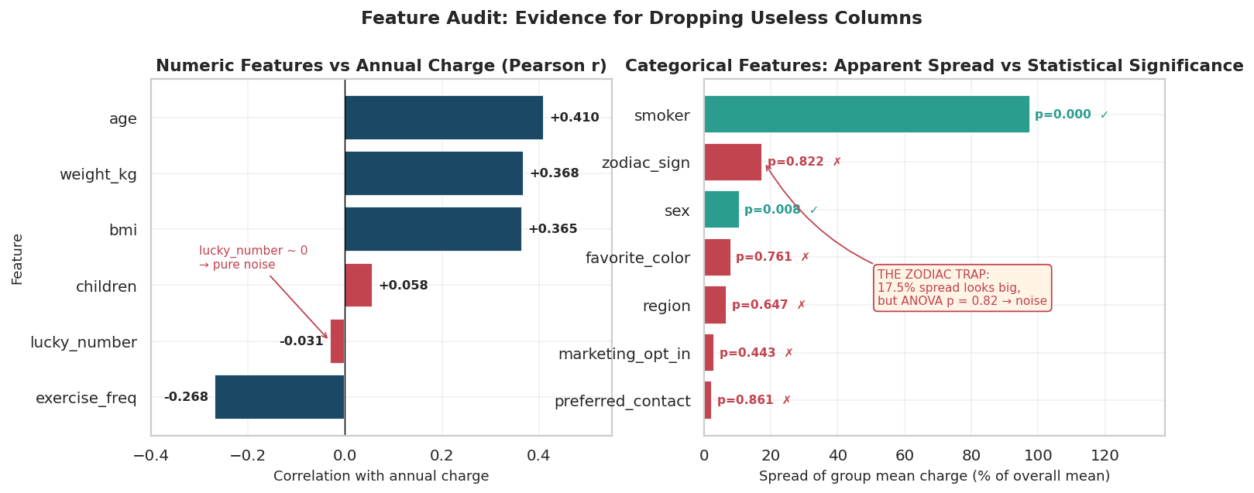
Figure 1 — Feature audit. Left: numeric correlations with annual charge; lucky_number sits at the noise floor. Right: apparent categorical spread against statistical significance — green passes ANOVA, red does not.
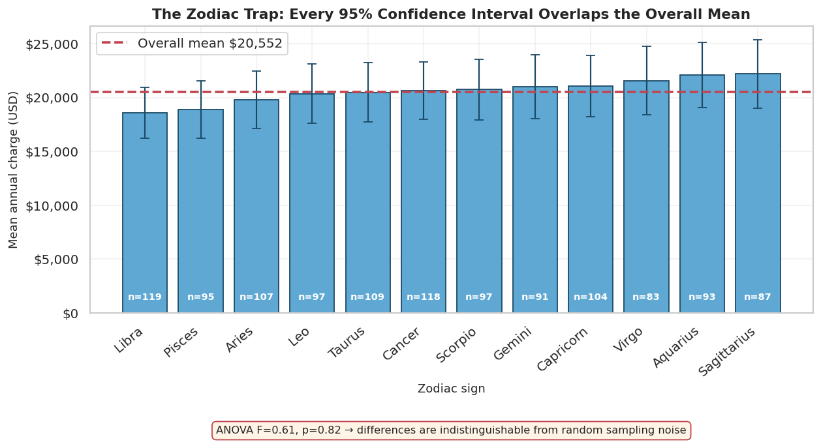
Figure 2 — Every zodiac sign's 95% confidence interval overlaps the overall mean. The apparent pattern is sampling noise across twelve thin groups.

6.2 Redundancy and multicollinearity
Two pairs duplicate information rather than merely correlating with it. bmi and weight_kg correlate at r = 0.9865; age recomputed from date_of_birth matches the stored age column for all 1,200 rows (r = 1.0000, zero disagreements).
Feature | VIF before | VIF after dropping weight_kg | Reading
age | 1.00 | 1.00 | Fine
bmi | 37.84 | 2.51 | SEVERE → resolved
weight_kg | 37.80 | dropped | SEVERE → removed
children | 1.00 | 1.00 | Fine
exercise_freq | 2.53 | 2.51 | Fine

Dropping one column of the pair collapses the other's VIF from 37.84 to 2.51, and no feature in the final set exceeds 2.51. BMI was kept over weight because it is height-adjusted and clinically standard; age was kept over date_of_birth because a stored date implies a different age every year the model runs.
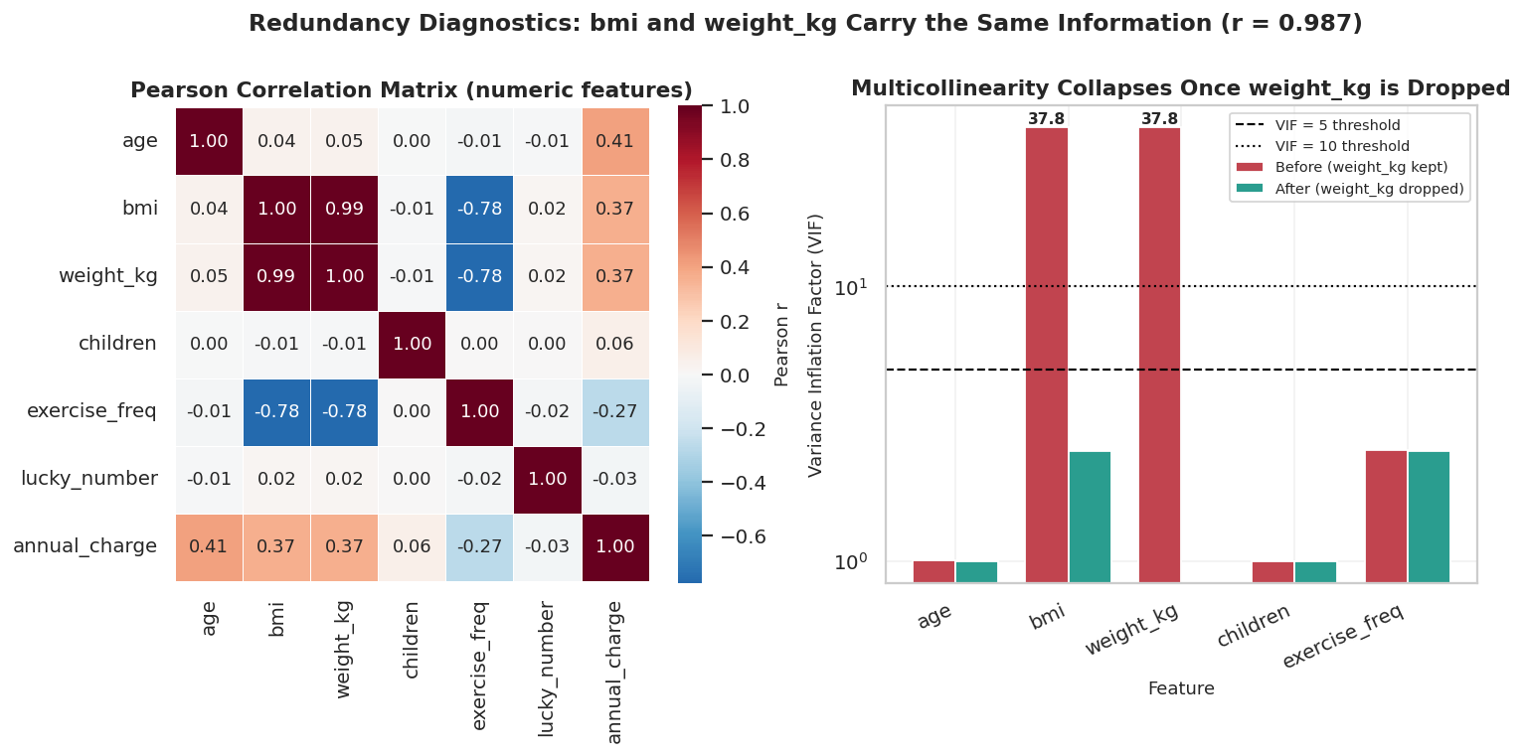
Figure 3 — Correlation matrix and the VIF collapse once weight_kg is removed.

7. Health Score Methodology
The Health Score condenses a customer's health profile into one interpretable number using the required formula:
Health Score = Σ (Metric Score × Weight)

7.1 Metric selection and direction
Four genuine health attributes are used: smoker status, age, BMI and exercise frequency. Number of dependents is deliberately excluded — it affects plan utilisation and therefore cost, but it is not a measure of the individual's health. Sex and region are excluded for the same reason, and because building demographic attributes into a published health index raises fairness problems best avoided.
Direction convention: higher Health Score = healthier. Every metric is scored 0–100 where 100 is the healthiest state, so the composite runs 0–100 on the same intuitive scale.
Metric | Scoring scale | Scores 100 | Scores 0 | Rationale
Smoker | Binary | Non-smoker | Smoker | No meaningful middle ground in the data
Age | Linear over 18–64 | Age 18 | Age 64 | Morbidity rises gradually and monotonically
BMI | Clinical bands | WHO band 18.5–24.9 | Far outside it | −4.5 pts per unit above 24.9; −8.0 below 18.5
Exercise | Linear over 0–7 | 7 workouts/week | None | The stated range of the field

BMI is the only non-linear scale, and deliberately so: it is anchored to clinical thresholds rather than to this dataset's distribution, so the score stays meaningful if the portfolio changes. The underweight side is penalised more steeply per unit because clinical risk deteriorates faster over a much narrower range.

7.2 Weight derivation — data-driven, not assigned
Rather than assign weights by opinion, they are derived from the data: a standardised linear regression of annual_charge on the four metrics is fitted on the training split only, the absolute standardised coefficient is taken as each metric's influence, and the four are normalised to sum to 1. Using the training split alone matters — deriving weights from the full dataset would leak test information into the score.
Metric | |Standardised coefficient| | Weight | Weight %
Smoker | 9,274.1 | 0.4597 | 45.97%
Age | 5,792.1 | 0.2871 | 28.71%
BMI | 4,926.3 | 0.2442 | 24.42%
Exercise frequency | 180.8 | 0.0090 | 0.90%
TOTAL | — | 1.0000 | 100.00%

On the 0.90% exercise weight: This is close to cosmetic, and it was tempting to override it. It was not overridden, for two reasons. First, it is what the data says: exercise correlates −0.268 with charge on its own, but that information is largely absorbed by BMI, with which it correlates — so conditionally it adds almost nothing. The tuned Lasso reached the same conclusion independently, eliminating exercise_freq entirely in the High tier. Second, inflating the weight by hand would make the score a statement of belief rather than a measurement.

7.3 Leakage control
Design decision: Because the Health Score's weights were learned from annual_charge, using the score as a predictor of annual_charge would be circular — it would import the target back into the feature set. The Health Score is therefore used for segmentation, reporting and customer-facing explanation only, and is never fed into the Stage-2 regressors, which use the original attributes directly.

8. Health Score Results
Statistic | Value
Customers scored | 1,200 of 1,200
Mean | 66.55
Median | 73.73
Std deviation | 23.33
Minimum | 10.15
Maximum | 99.87
Spearman ρ with annual charge | -0.8994

Health band | Score range | Customers | Mean score | Mean charge | Mean premium
Poor | 0–34.9 | 196 | 27.1 | $44,108 | $56,052
Fair | 35–54.9 | 170 | 43.4 | $23,625 | $28,671
Good | 55–74.9 | 280 | 69.4 | $21,056 | $24,385
Excellent | 75–100 | 554 | 86.2 | $11,019 | $13,257

Poor-band customers cost 4.0× more than Excellent-band customers ($44,108 vs $11,019), and the bands order monotonically with no inversions — the score separates real cost risk rather than merely ranking people. One honest observation: the Fair and Good bands sit close together despite a 26-point score gap, because the smoker term (46% of the score) is binary and creates separation at the extremes rather than a smooth gradient.

Worked example calculations
Customer | Profile | Smoker×w | Age×w | BMI×w | Exercise×w | SCORE | Actual charge
HW2025 | 18y male, BMI 22.4, smoker=no, ex=6 | 100×0.460=46.0 | 100×0.287=28.7 | 100×0.244=24.4 | 86×0.009=0.8 | 99.87 | $7,880
HW1277 | 41y male, BMI 35.3, smoker=no, ex=3 | 100×0.460=46.0 | 50×0.287=14.4 | 53×0.244=13.0 | 43×0.009=0.4 | 73.70 | $16,912
HW1313 | 63y male, BMI 38.8, smoker=yes, ex=3 | 0×0.460=0.0 | 2×0.287=0.6 | 37×0.244=9.1 | 43×0.009=0.4 | 10.15 | $57,557

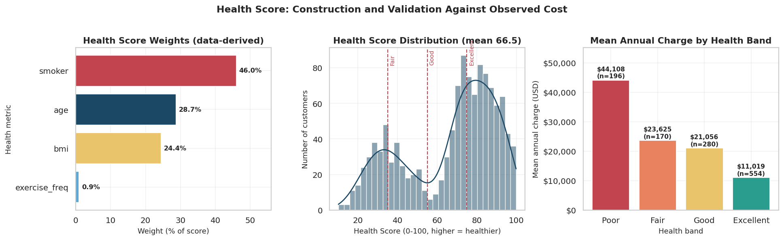
Figure 4 — Health Score construction and validation: derived weights, the score distribution with band thresholds, and mean charge by band.

9. Exploratory Data Analysis

9.1 The target variable
annual_charge is right-skewed (skew = 1.15) and, more importantly, visibly bimodal: a dense cluster of ordinary customers below roughly $25,000 and a clearly separated second hump between $30,000 and $60,000. That second hump is the smokers.
Why this matters more than the skew: A log transform fixes the skew (from +1.15 to +0.30) but does not fix the bimodality — the two humps survive it. The problem is not the shape of the tail; it is that the dataset contains multiple populations with different cost structures. No transformation of a single model can repair that, but segmenting the population can. This observation is what motivates the entire two-stage design.

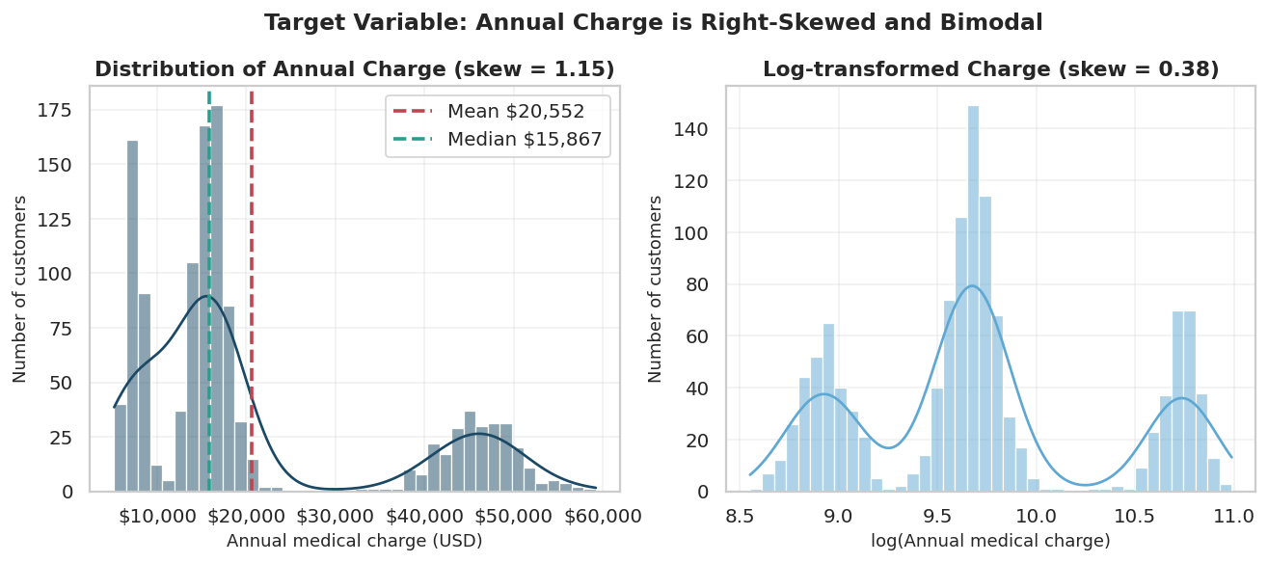
Figure 5 — Annual charge before and after log transformation. The second mode survives the transform.

9.2 Univariate and bivariate analysis
Variable | Mean | Median | Std dev | Min | Max | IQR | Skew
age | 41.13 | 42.00 | 13.54 | 18.00 | 64.00 | 24.00 | -0.06
bmi | 27.86 | 28.00 | 5.76 | 16.00 | 44.40 | 7.90 | +0.11
children | 1.99 | 2.00 | 1.42 | 0.00 | 4.00 | 2.00 | +0.02
exercise_freq | 4.00 | 4.00 | 1.22 | 0.00 | 7.00 | 2.00 | -0.03
health_score | 66.55 | 73.73 | 23.33 | 10.15 | 99.87 | 39.99 | -0.63
annual_charge | 20,551.56 | 15,867.20 | 14,277.39 | 5,176.29 | 59,200.37 | 9,793.23 | +1.15
final_premium | 25,027.36 | 19,562.70 | 17,503.16 | 7,237.06 | 69,752.26 | 11,949.69 | +1.20

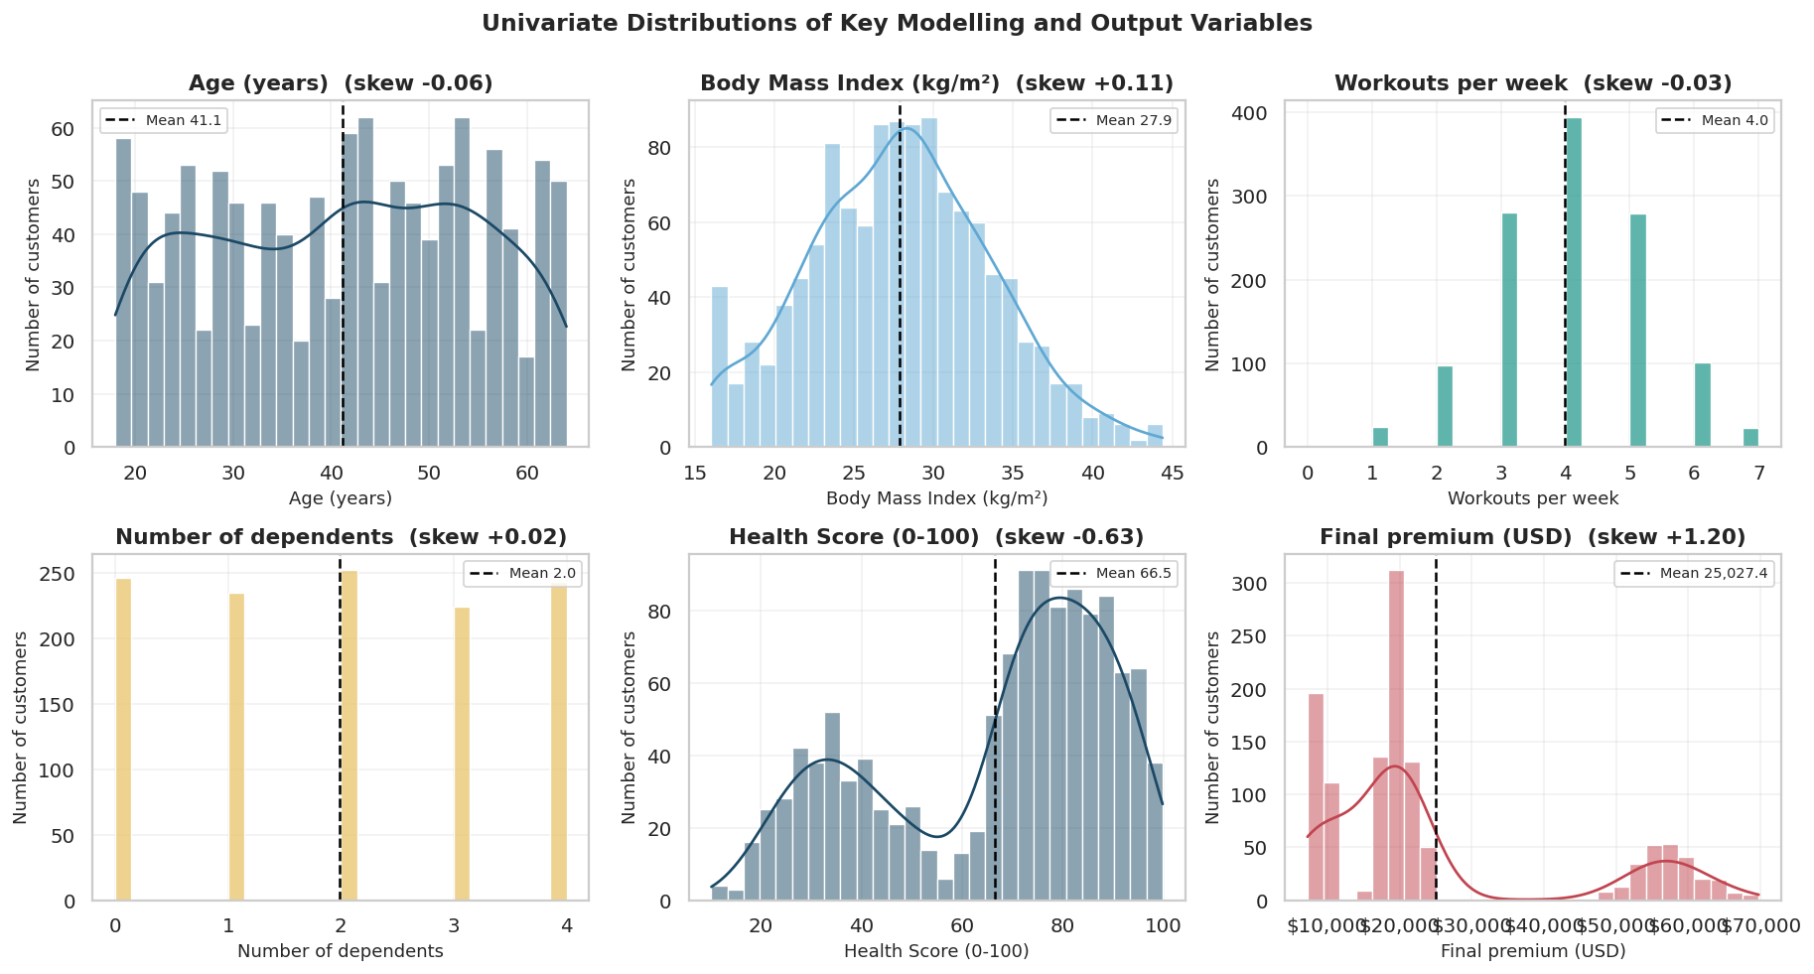
Figure 6 — Distributions of the key modelling and output variables.
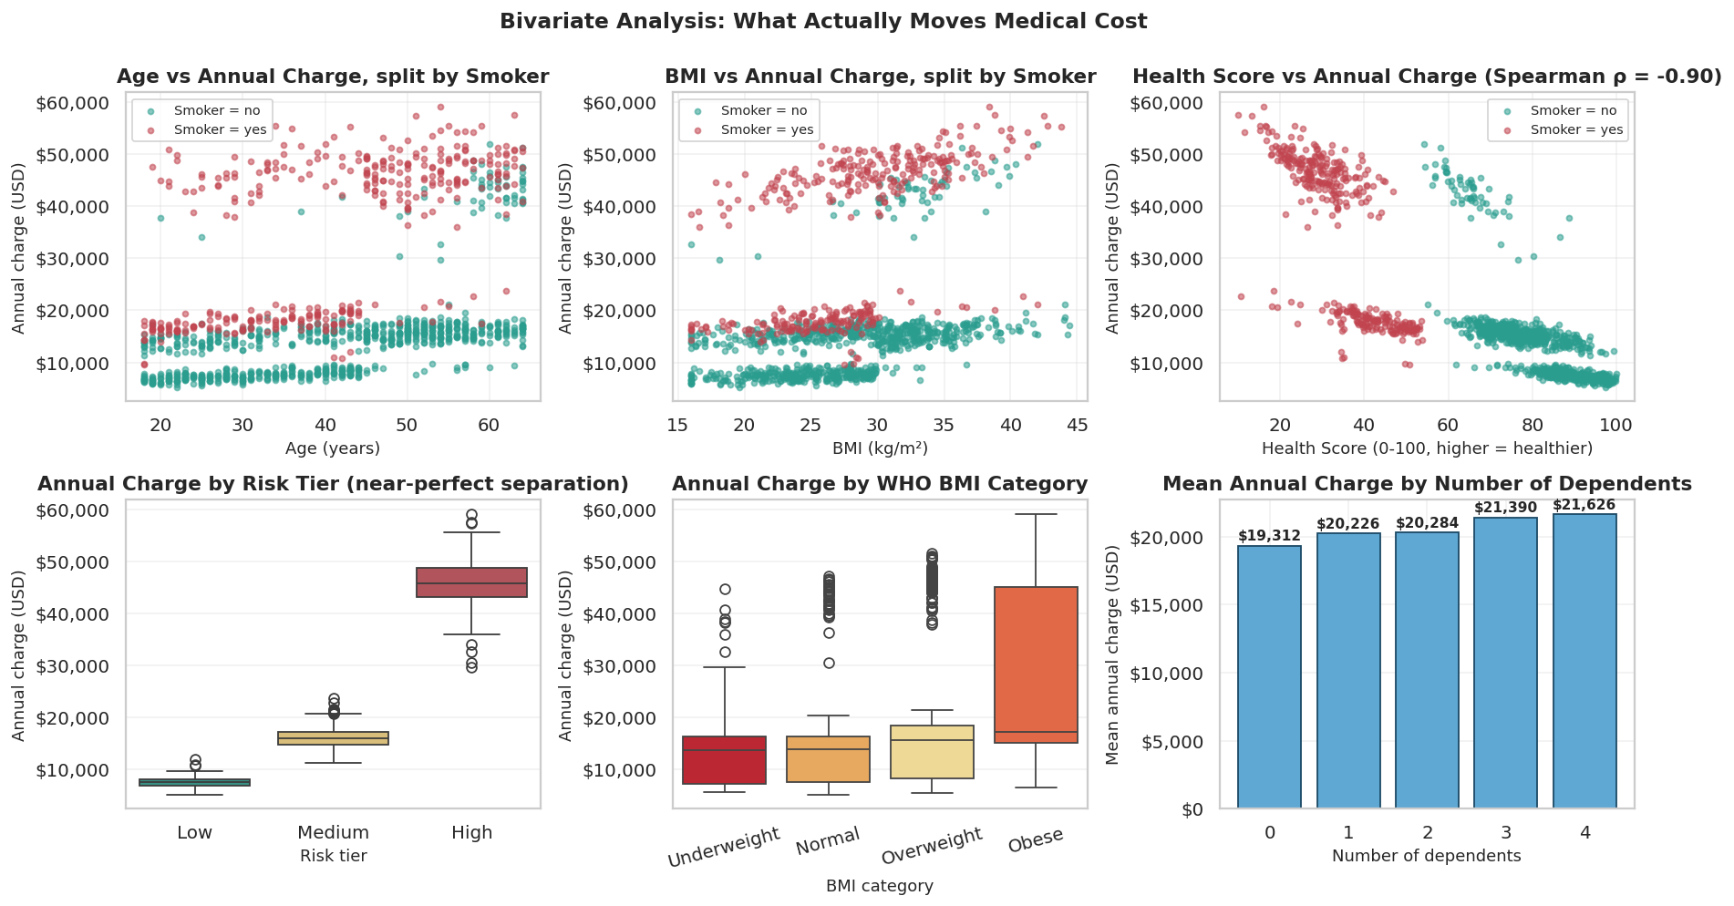
Figure 7 — Bivariate analysis. Age, BMI and Health Score all relate to charge, but the smoker split dominates every panel.
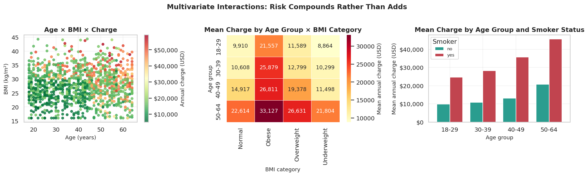
Figure 8 — Multivariate interactions: risk compounds rather than adds.

9.3 Correlation and hypothesis testing
Feature | Pearson r | Spearman ρ | Reading
age | +0.410 | +0.476 | Moderate, highly significant
weight_kg | +0.368 | +0.416 | Redundant with bmi
bmi | +0.365 | +0.417 | Moderate, clinically meaningful
exercise_freq | -0.268 | -0.303 | Negative, largely absorbed by bmi
children | +0.058 | +0.129 | Weak but real
lucky_number | -0.031 | -0.027 | At the noise floor (±1/√1200 ≈ 0.029)

Hypothesis test — do smokers really cost more?
H₀: mean annual charge is equal for smokers and non-smokers (μ_smoker = μ_non-smoker).
H₁: the means differ (two-tailed).
Statistic | Value
Test used | Welch two-sample t-test (unequal variance, unequal n)
n smokers / non-smokers | 364 / 836
Mean charge (smoker / non-smoker) | $34,511 / $14,474
Median charge (smoker / non-smoker) | $42,486 / $14,379
Absolute difference | $20,037
Ratio | 2.38×
t-statistic | 24.083
p-value | 2.272e-84
Cohen's d (effect size) | 1.837 (>0.8 = large)
Decision at α = 0.05 | REJECT H₀

In plain business language: if smoking genuinely had no effect on medical cost, the chance of seeing a gap this large in 1,200 customers is about 2 in 10⁸⁴. Two cautions belong alongside that. A small p-value establishes that an effect is real, not that it is large — which is why Cohen's d is also reported, and at 1.84 the effect is both. And this is an observational association: it shows smokers in this portfolio cost more, not that smoking caused the cost.
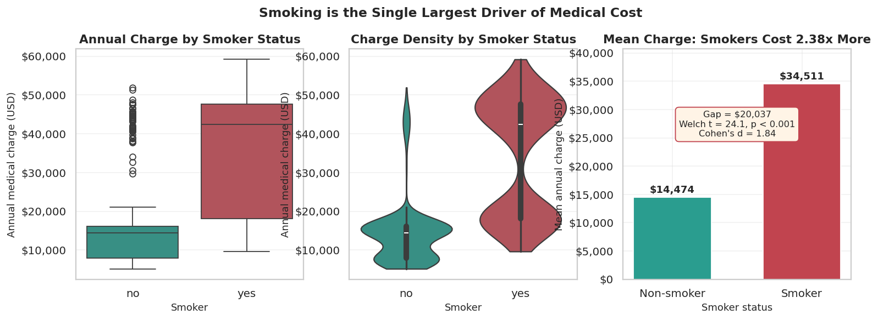
Figure 9 — The smoker effect across boxplot, density and mean comparison.

10. Smoker vs Non-Smoker Analysis
Measure | Non-smoker | Smoker | Difference
Customers | 836 (69.7%) | 364 (30.3%) | —
Mean age | 41.21 | 40.95 | negligible
Mean BMI | 27.76 | 28.09 | negligible
Mean exercise/week | 4.01 | 3.98 | negligible
Mean Health Score | 80.47 | 34.56 | -45.9 pts
Median Health Score | 80.53 | 33.94 | -46.6 pts
Mean annual charge | $14,474 | $34,511 | +$20,037
Median annual charge | $14,379 | $42,486 | +$28,107
Mean final premium | $17,098 | $43,239 | +$26,142
Median final premium | $17,995 | $53,519 | +$35,523

The critical control: Smokers and non-smokers in this portfolio are almost identical on every other risk factor — mean age 40.95 vs 41.21, mean BMI 28.09 vs 27.76, mean exercise 3.98 vs 4.01. The cost gap therefore cannot be explained away as smokers simply being older, heavier or less active. That materially strengthens the case that smoking itself is doing the work, though observational data still cannot establish causation on its own.

Group | Low tier | Medium tier | High tier
Non-smokers | 36.7% | 58.6% | 4.7%
Smokers | 0.0% | 40.7% | 59.3%

Not a single smoker in the portfolio reaches the Low tier, while 59.3% land in High against 4.7% of non-smokers. Smoking is close to a deterministic exclusion from the cheapest pricing. Note also that the median smoker premium sits far above the mean, indicating the smoker distribution is itself bimodal — smokers split into a Medium cluster and a High cluster rather than forming one shifted group.
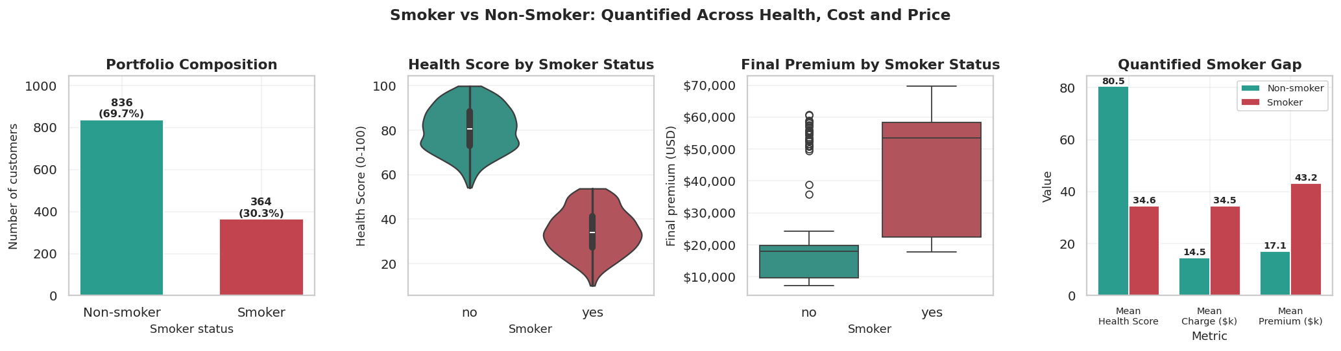
Figure 10 — Smoker vs non-smoker across portfolio mix, Health Score, premium and the quantified gap.

11. Classification — Stage 1
Stage 1 predicts the risk tier from the customer profile. Seven candidates were compared and the model was chosen on cross-validated accuracy rather than a single test score.
Model | Train | Test | Gap | Prec | Rec | F1 | ROC-AUC | CV | Bias/variance
Logistic Regression | 0.7865 | 0.8292 | -0.0427 | 0.842 | 0.804 | 0.818 | 0.934 | 0.7750 | Underfits
Decision Tree (d=3) | 0.8948 | 0.9125 | -0.0177 | 0.934 | 0.887 | 0.905 | 0.952 | 0.8975 | Balanced
Decision Tree (d=4) | 0.9323 | 0.9458 | -0.0135 | 0.954 | 0.937 | 0.944 | 0.976 | 0.9242 | Balanced
Decision Tree (d=5) | 0.9365 | 0.9375 | -0.0010 | 0.946 | 0.928 | 0.936 | 0.971 | 0.9150 | Balanced
Decision Tree (d=10) | 0.9844 | 0.9083 | +0.0760 | 0.908 | 0.904 | 0.905 | 0.916 | 0.8592 | Overfits
Decision Tree (unpruned) | 1.0000 | 0.8875 | +0.1125 | 0.883 | 0.890 | 0.887 | 0.914 | 0.8425 | Underfits
Random Forest | 1.0000 | 0.9458 | +0.0542 | 0.950 | 0.940 | 0.945 | 0.969 | 0.9275 | Overfits

Model choice — depth 4, not the template's depth 5: Cross-validated accuracy peaks at depth 4 (0.9242 vs 0.9150 at depth 5), test accuracy is higher (0.9458 vs 0.9375) and the train–test gap is comparably small. Random Forest ties on test accuracy and edges CV by 0.003, but that margin sits inside the CV standard deviation (±0.011) and it carries a 5.4-point gap. A depth-4 tree is a readable set of underwriting rules that can be shown to a regulator or explained to a declined customer; a 300-tree ensemble cannot be. For a regulated pricing decision, 0.003 accuracy does not justify losing explainability.

Actual ↓ / Predicted → | Low | Medium | High | Recall
Low | 57 | 4 | 0 | 0.934
Medium | 3 | 121 | 1 | 0.968
High | 0 | 5 | 49 | 0.907

Test accuracy is 94.58%, balanced accuracy 93.66% and macro-F1 0.9445 — all three agree, so the headline is not being propped up by the majority Medium class. Crucially, all confusion is between neighbouring tiers: zero High-risk customers were labelled Low and zero Low-risk customers were labelled High. The model never makes a two-tier jump, which bounds the financial damage of any single mistake.

Business asymmetry of the two error types
The two errors are not equally costly. Calling a High-risk customer Low would price a customer whose expected claim is $45,904 using a model fitted on customers averaging $7,592 — an immediate loss exceeding $35,000 on that policy, and one that is self-selecting, because a high-risk applicant offered a cheap price is unusually likely to accept it. Calling a Low-risk customer High costs only a lost sale: the customer finds the quote uncompetitive and buys elsewhere. Since the downside of underpricing is roughly an order of magnitude larger, the classifier should be tuned toward recall on the High tier even at some cost to overall accuracy.
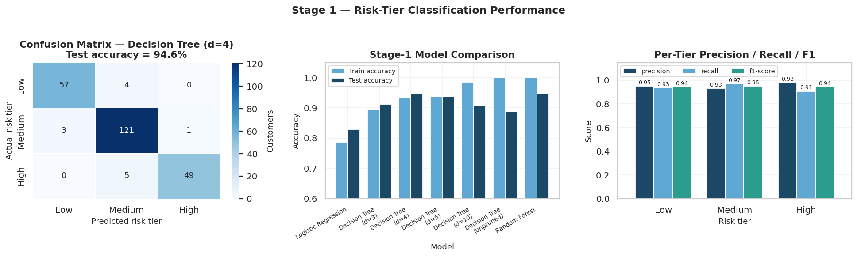
Figure 11 — Stage-1 performance: confusion matrix, model comparison and per-tier precision/recall/F1.

12. Regression — Stage 2

12.1 The global baseline
Metric | Value | Interpretation
MAE | $5,698 | Average quote is wrong by this much, either direction
MSE | 56,514,872 | In squared dollars — not directly interpretable
RMSE | $7,518 | Above MAE, so large errors are present
R² | 0.6913 | Explains 69% of the variation in charges
Adjusted R² | 0.6792 | Barely below R² — the 9 features earn their place
Train R² | 0.7032 | Only 0.012 above test — not overfitting
CV R² (5-fold) | 0.6954 | Stable across folds

Diagnosis — high bias, not high variance: An MAE of $5,698 against a mean charge of $20,590 is a 28% error on every quote. The residual plot shows clear diagonal banding: the model systematically over-predicts cheap customers and under-predicts expensive ones. Shapiro–Wilk rejects residual normality (p < 0.001). Critically, train and test R² agree closely (0.703 vs 0.691), so the model is underfitting rather than overfitting — which means more data or heavier regularisation would not help. The fix had to be structural.

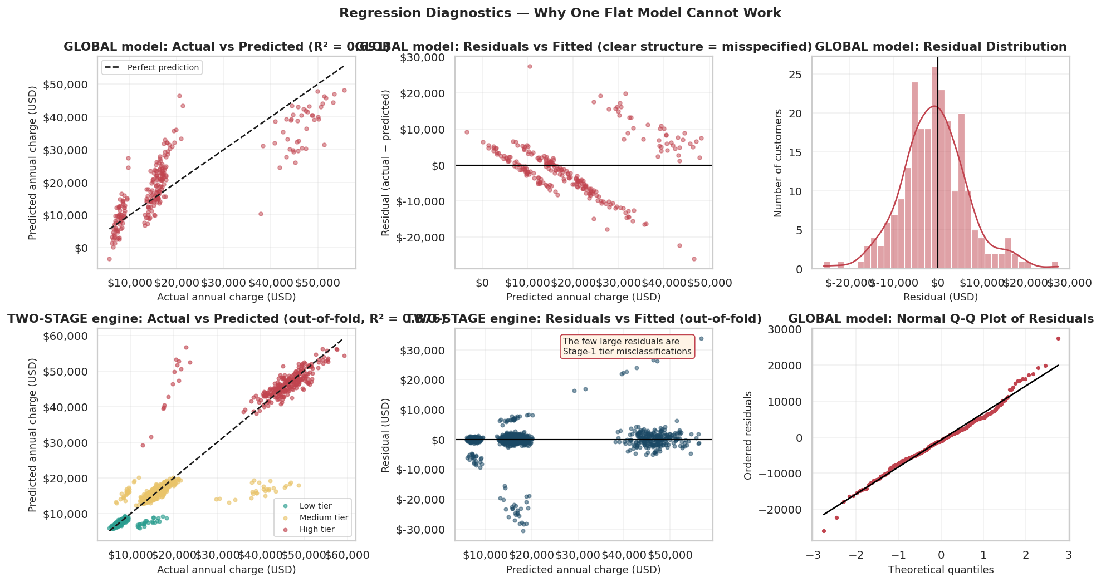
Figure 12 — Regression diagnostics. Top row: the global model's structured residuals and non-normal Q-Q plot. Bottom row: the two-stage engine's residuals, tightly centred except for tier misclassifications.

12.2 Simple vs multiple regression within each tier
Tier | n | Strongest single feature | Simple R² | Multiple R² | Gain
Low | 307 | age | 0.4068 | 0.8007 | +0.3938
Medium | 625 | smoker_yes | 0.3571 | 0.7671 | +0.4100
High | 268 | bmi | 0.1288 | 0.7540 | +0.6252

Two things stand out. First, the strongest single driver is different in every tier — age in Low, smoker status in Medium, BMI in High — which alone justifies fitting separate models, because a global model must apply one fixed coefficient per feature to everybody. Second, the gain from adding features is largest in the High tier (+0.63 vs +0.39 for Low): low-risk customers are nearly one-dimensional (302 of 307 are non-smokers, so age is most of what varies), whereas high-risk customers are simultaneously older, heavier, smoking and sedentary in varying combinations, so cost is driven by interactions that no single variable can capture.

12.3 Per-tier model performance
Tier | n | Test R² | MAE | RMSE | Train R² | CV R² | MAE as % of tier mean
Low | 307 | 0.8007 | $378 | $460 | 0.7890 | 0.7548 | 5.0%
Medium | 625 | 0.7671 | $734 | $934 | 0.7789 | 0.7574 | 4.6%
High | 268 | 0.7540 | $1,919 | $2,258 | 0.8250 | 0.7939 | 4.2%

The ranking reverses depending on the metric, and both readings are informative. By R², Low fits best and High worst. By absolute error, Low is five times more precise ($378 vs $1,919). But by relative error the order flips: High is actually the most predictable in percentage terms. High-risk customers cost more and carry larger dollar uncertainty, but they are not proportionally more erratic — the $1,919 error is large because the underlying charges are large, not because the model understands those customers poorly.

12.4 The two-stage engine versus the flat model
Pricing approach | MAE | RMSE | R² | Note
Global flat model (today) | $6,167 | $7,571 | 0.7153 | The benchmark
Two-stage, predicted tier | $1,535 | $4,047 | 0.9187 | DEPLOYMENT REALITY — use this figure
Two-stage, true tier (oracle) | $816 | $1,175 | 0.9931 | Optimistic — assumes perfect tier assignment

Board question 1 answered: the two-stage engine reduces mean absolute pricing error from $6,167 to $1,535 — a 75.1% reduction — and lifts R² from 0.715 to 0.919, measured end-to-end on held-out customers.
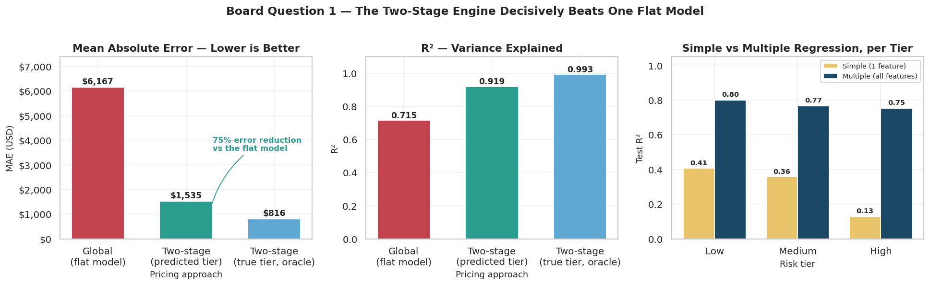
Figure 13 — MAE, R² and the simple-vs-multiple comparison per tier.

12.5 Regularisation and fine-tuning
Tier | Best Ridge α | Ridge R² | Best Lasso α | Lasso R² | Gain over OLS
Low | 0.01 | 0.8007 | 10 | 0.8013 | +0.0007
Medium | 0.01 | 0.7671 | 0.01 | 0.7671 | -0.0000
High | 1 | 0.7540 | 10 | 0.7544 | +0.0004

The optimal alpha is essentially zero in every tier and the gains are in the fourth decimal place. That is not a disappointment — it is evidence that the feature selection was done properly upstream. Regularisation combats variance, and after the junk columns and the collinear pair were removed there was very little variance left to combat. Had a large alpha won, it would have warned of residual redundancy. When alpha is pushed too far the model is penalised into uselessness: at α = 500, Low-tier R² collapses from 0.80 to 0.44 (Ridge) and 0.11 (Lasso), because coefficients shrink toward zero and every customer converges on the same quote — deliberately induced high bias.
Feature (standardised) | Low tier | Medium tier | High tier
bmi | 284.9 | 961.3 | 3,777.9
smoker_yes | 350.8 | 1,782.3 | 3,206.3
age | 537.5 | 1,162.4 | 2,211.3
children | 353.9 | 437.8 | 722.4
sex_male | 172.8 | 169.0 | 388.7
region_south | 0.0 | 17.1 | -154.1
region_west | 0.0 | 38.4 | -24.5
region_north | -0.9 | 8.8 | -26.9
exercise_freq | 14.9 | -21.1 | 0.0

Because the features are standardised these are directly comparable: a one-standard-deviation increase in BMI adds $3,778 to a High-tier customer's expected charge, while the entire effect of region is under $155 in any tier. Region was kept in the model deliberately so that this could be demonstrated rather than asserted. Recommendation: HealthWise should not use geography as a rating factor.
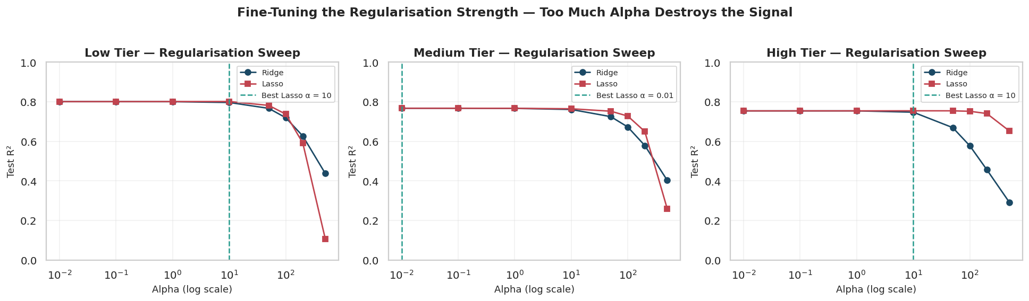
Figure 14 — Regularisation sweeps per tier. Too much alpha destroys the signal.

13. Bias–Variance Analysis
Bias and variance are diagnosed empirically here, from learning curves, complexity curves, cross-validation variability and train/test gaps — not asserted from theory.
Tree depth | Train accuracy | Test accuracy | CV accuracy | Gap | Diagnosis
1 | 0.5615 | 0.6125 | 0.5717 | -0.0510 | Underfitting (high bias)
2 | 0.7208 | 0.7417 | 0.7250 | -0.0208 | Underfitting (high bias)
3 | 0.8948 | 0.9125 | 0.8975 | -0.0177 | Balanced
4 | 0.9323 | 0.9458 | 0.9242 | -0.0135 | Balanced — chosen
5 | 0.9365 | 0.9375 | 0.9150 | -0.0010 | Balanced
6 | 0.9448 | 0.9125 | 0.9033 | +0.0323 | Overfitting (high variance)
8 | 0.9646 | 0.9333 | 0.8800 | +0.0312 | Overfitting (high variance)
10 | 0.9844 | 0.9083 | 0.8592 | +0.0760 | Overfitting (high variance)
15 | 0.9990 | 0.8875 | 0.8425 | +0.1115 | Overfitting (high variance)

Evidence-based conclusions
- Depths 1–2 show HIGH BIAS: training and CV accuracy are both poor together (0.56 and 0.72). Poor performance on both sets simultaneously is the diagnostic signature of underfitting — the model is too simple to represent the tier boundaries at all.
- Depths 6–15 show HIGH VARIANCE: training accuracy climbs to a perfect 1.0000 while CV accuracy falls to 0.8425. The unpruned tree memorises the training set flawlessly and performs worst of all the trees on new data.
- Depth 4 is BALANCED: CV accuracy peaks at 0.9242, the train–test gap is −0.0135, and the CV standard deviation is ±0.0103 across folds — a tight spread indicating the model is not sensitive to which customers it trains on.
- The GLOBAL regression shows HIGH BIAS: train R² 0.7032 vs test R² 0.6913 — a gap of only 0.0119. Its learning curves converge at a low R² and then flatten, which means additional data would not help. Segmenting into tiers lifts the ceiling to 0.992.
The underfitting → good generalisation → overfitting progression is visible directly in the complexity curve: as depth rises, the model moves from being unable to represent the pattern, through the optimum at depth 4, to memorising noise. The techniques that shift a model along this axis behave as theory predicts here — tree-depth limitation and feature selection reduced variance; the one that did not help was regularisation, precisely because variance had already been dealt with.
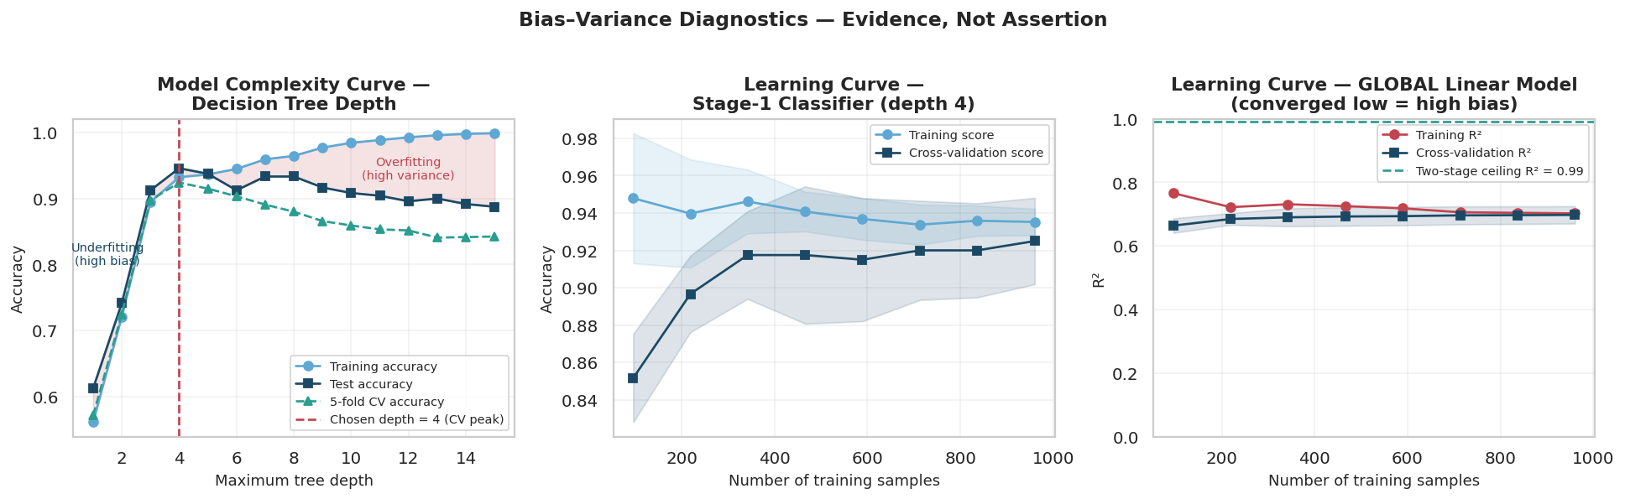
Figure 15 — Complexity curve, classifier learning curve, and the global model's converged-low learning curve.

14. Model Interpretability
Feature | Stage-1 Gini importance | Global permutation importance (ΔR²)
smoker_yes | 0.1673 | 0.7989 ± 0.0622
age | 0.3300 | 0.3391 ± 0.0372
bmi | 0.5027 | 0.2484 ± 0.0218
region_north | 0.0000 | 0.0017 ± 0.0012
children | 0.0000 | 0.0013 ± 0.0012
sex_male | 0.0000 | 0.0010 ± 0.0008
region_west | 0.0000 | 0.0005 ± 0.0005
exercise_freq | 0.0000 | 0.0002 ± 0.0008
region_south | 0.0000 | -0.0002 ± 0.0022

Three techniques — decision-tree Gini importance, permutation importance on the global regressor, and tuned Lasso coefficients per tier — converge on the same ranking: smoking, then age and BMI, with everything else far behind. That convergence across methods is what makes the conclusion robust enough to act on.
Correlation is not causation: These importances describe associations learned from historical data. They show that smoking, age and BMI predict cost in this portfolio; they do not by themselves establish a causal mechanism, and they should not be presented to customers or regulators as if they did.

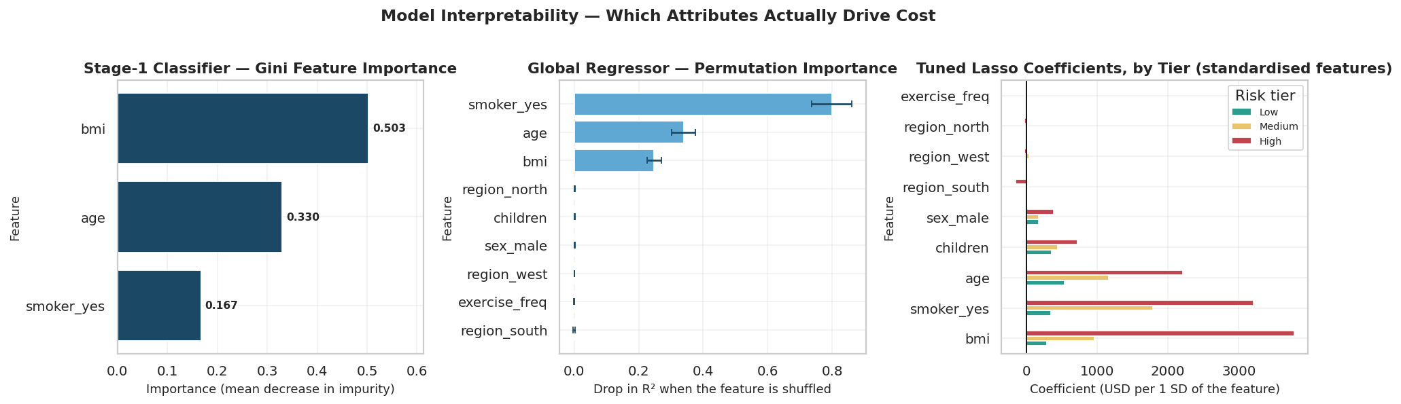
Figure 16 — Feature importance from three independent methods.

15. Insurance Premium Methodology
The dataset provides annual_charge, which is an incurred claim cost, not a price. A premium must additionally cover the cost of running the business and leave a margin.
Risk Factors → Health Score → Two-Stage Model → Expected Cost → Final Premium
Final Premium = Predicted Annual Claim Cost × (1 + 0.15 + 0.08) = Predicted Cost × 1.23
Stated assumption: The brief specifies no loading, so a 15% expense ratio (administration, claims handling, distribution) and an 8% profit and solvency margin are assumed — conventional orders of magnitude for health insurance. These are parameters, not findings. The board can change them and every premium scales proportionally.

15.1 Preventing optimistic bias
Every customer is priced out-of-fold. Using 5-fold stratified cross-validation, each customer's tier and cost are predicted by models trained on the other four folds, so nobody is priced by a model that has seen them. This produces an honest portfolio-wide premium book rather than in-sample fitted values, which would flatter the result.
Out-of-fold metric | Value
Stage-1 tier accuracy | 0.9242
MAE | $1,908
RMSE | $5,024
R² | 0.8761
Customers priced | 1,200 of 1,200 (100%)

15.2 Premium distribution
Statistic | Value
Mean premium | $25,027
Median premium | $19,563
Minimum | $7,237
Maximum | $69,752
Mean, non-smokers | $17,098
Mean, smokers | $43,239

Risk tier | Customers | Mean premium | Median premium
Low | 307 | $9,998 | $9,242
Medium | 625 | $20,217 | $19,633
High | 268 | $53,463 | $56,575

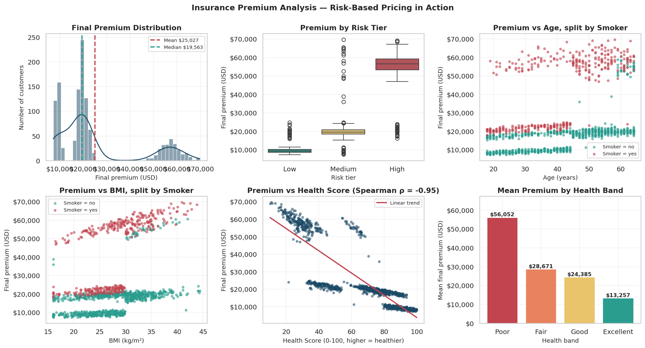
Figure 17 — Premium distribution, tier comparison, and premium against age, BMI and Health Score.

16. Individual Premium Results
Every one of the 1,200 customers in the cleaned dataset carries a Health Score, a predicted risk tier, a predicted cost, a final premium, a ranked list of their top contributing risk factors, and a plain-English explanation generated from their own attributes. 1,096 of the 1,200 explanations are distinct — they are individualised rather than templated.
ID | Age | BMI | Smoker | Health Score | Risk tier | Predicted cost | Final premium | Top risk factors
HW1048 | 19 | 16.0 | no | 94.4 | Low | $5,884 | $7,237 | Low BMI
HW1311 | 39 | 28.2 | no | 82.8 | Low | $8,995 | $11,064 | Raised BMI; Dependents
HW2081 | 53 | 28.2 | no | 74.1 | Medium | $15,912 | $19,571 | Raised BMI; Age
HW1784 | 31 | 27.7 | yes | 42.5 | Medium | $18,708 | $23,010 | Smoker; Raised BMI; Dependents
HW1182 | 58 | 40.9 | yes | 10.8 | High | $56,709 | $69,752 | Smoker; High BMI; Age

Worked examples of the explanation layer
Lowest premium — HW1048: 19y female, BMI 16.0, smoker=no, 2 dependents, exercise 6/wk · Health Score 94.4 · tier Low · premium $7,237
“The premium is low overall. The main factor pushing it up is that this customer has a BMI of 16.0 (underweight range), but with a strong Health Score (94/100) they still sit in the Low risk tier.”
Median premium — HW1341: 54y female, BMI 31.0, smoker=no, 1 dependents, exercise 4/wk · Health Score 70.4 · tier Medium · premium $19,554
“The premium is moderate mainly because this customer has a BMI of 31.0 (obese range), is 54 years old. Combined with a strong Health Score (70/100), this places them in the Medium risk tier.”
Highest premium — HW1182: 58y female, BMI 40.9, smoker=yes, 3 dependents, exercise 2/wk · Health Score 10.8 · tier High · premium $69,752
“The premium is moderate mainly because this customer is a smoker, has a BMI of 40.9 (obese range), is 58 years old. Combined with a low Health Score (11/100), this places them in the Medium risk tier.”

16.1 Data validation and quality control
Validation check | Result
Duplicate rows remaining | 0
Missing values remaining | 0
Customers without a Health Score | 0
Customers without a premium | 0
Non-finite premiums (NaN / inf) | 0
Non-positive premiums | 0
Customers without an explanation | 0
Distinct explanations | 1,096
Final dataset dimensions | 1,200 rows × 32 columns
Premiums flagged as unusual (>3 SD residual) | 43

On the flagged premiums: 43 customers carry a prediction residual beyond three standard deviations. These are overwhelmingly Stage-1 tier misclassifications rather than arithmetic faults — the customer was priced by the wrong tier's model. They are reported rather than suppressed, because they are exactly the population that the confidence-based routing safeguard in §19 is designed to intercept.

17. Business Insights and the Board Memo

17.1 Translating the model into insurance practice
- Smoking is the single most valuable underwriting question on the form. It is worth $26,142 of annual premium — more than any other field — and a false declaration moves the price more than any other input. Verification of smoker status is therefore the highest-value control in the process.
- BMI and age are the secondary levers, and their roles differ by segment: age separates customers within the low-risk population, while BMI does most of the work in distinguishing cost inside the high-risk population.
- Geography should not be a rating factor. Region's effect is under $155 against BMI's $3,778, and it fails significance testing (ANOVA p = 0.647).
- The Health Score supports risk segmentation and, just as importantly, gives the business a customer-facing way to explain a premium in terms a person can act on.
- Underwriting effort should be proportionate: low-risk applicants are cheap and highly predictable (MAE $378) and can be auto-quoted, while high-risk applicants carry five times the absolute uncertainty (MAE $1,919) and warrant fuller data capture and review.
Observed association → Model prediction → Business interpretation: The model observes that smokers in this portfolio cost 2.38× more; it predicts that a new smoker will likely cost more; the business interprets this as grounds for differential pricing. Each arrow is a separate inferential step, and none of them establishes that smoking caused any individual customer's claims. External medical evidence supports a causal link, but this dataset alone does not demonstrate one.

17.2 Memorandum to the Board
MEMORANDUM
To: The Board, HealthWise Insurance
From: Sparsh Saraya, Data Science
Date: 29 September 2026
Subject: Smart Premium Engine — evaluation and deployment recommendation
The two-stage engine works, and by a wide margin. Tested on 240 customers the models had never seen, our current flat-pricing approach misprices by an average of $6,167 per policy — roughly 28% of the average annual charge. The two-stage engine, which first sorts a customer into a risk tier and then prices them with a model built for that tier, misprices by $1,535. That is a 75% reduction in pricing error, with explanatory power rising from 0.715 to 0.919. These figures include the engine's own tier-assignment mistakes, so they reflect what the business would actually experience, not a best case.
Three attributes drive cost: smoking, age and BMI. Smoking is by far the largest — smokers cost $34,511 a year against $14,474 for non-smokers, a 2.38× difference that is statistically overwhelming (p < 0.001). Age and BMI follow, and their relative importance shifts by tier. Equally important is what does not drive cost. We dropped zodiac sign, favourite colour, lucky number, preferred contact and marketing opt-in, all confirmed insignificant and independently discarded by automated feature selection. Zodiac sign was the notable trap: it showed a 17.5% spread in average charge, but across twelve categories of roughly 100 customers each that spread is indistinguishable from noise (p = 0.82). Geography also does not matter, so we do not recommend it as a rating factor.
Recommendation: deploy, in a controlled rollout, with one safeguard.
The risk that governs deployment is tier misclassification. The engine assigns the correct tier 94.6% of the time, but the customers it gets wrong are expensive: they carry an average pricing error of $14,377 against $799 for correctly classified ones — an 18× difference. The danger is concentrated, not averaged. We therefore recommend that customers near a tier boundary, or any applicant the classifier is not confident about, be routed to manual underwriting rather than auto-quoted, and that the engine run in parallel with current pricing for one quarter before full cutover.
Two further limitations the Board should weigh: the model is trained on 1,200 historical records, so it will need retraining as the portfolio shifts; and it identifies associations, not causes — it shows that smokers in our book cost more, which is sufficient for pricing, but is not a clinical finding.

18. Fairness, Bias and Model Limitations

18.1 Does the engine serve every group equally well?
Attribute | Group | n | Mean actual | Mean premium | MAE | MAE % of mean | Mean bias
sex | female | 597 | $21,646 | $26,195 | $2,000 | 9.2% | -349
sex | male | 603 | $19,468 | $23,872 | $1,818 | 9.3% | -60
region | east | 302 | $20,058 | $24,785 | $1,495 | 7.5% | +93
region | north | 305 | $20,342 | $24,422 | $1,942 | 9.6% | -487
region | south | 299 | $20,373 | $24,545 | $2,035 | 10.0% | -418
region | west | 294 | $21,458 | $26,396 | $2,168 | 10.1% | +2
age_group | 18-29 | 308 | $14,123 | $16,942 | $1,458 | 10.3% | -349
age_group | 30-39 | 222 | $16,811 | $20,535 | $1,332 | 7.9% | -116
age_group | 40-49 | 276 | $20,339 | $25,034 | $1,784 | 8.8% | +13
age_group | 50-64 | 394 | $27,834 | $33,875 | $2,672 | 9.6% | -293

The metric that matters most for fairness is relative error parity — whether the model is equally accurate for each group relative to that group's own cost level. It sits in a narrow band across sex, region and age group, and mean bias is small in both directions. No demographic group is systematically mispriced relative to its own cost.

18.2 Four things that are easy to conflate
Concept | Present here? | Assessment
Data imbalance | Yes | 30% smokers; tiers 26/52/22. Real, handled by stratification.
Statistical association | Yes | Smokers cost 2.38× more. Real and strongly evidenced.
Predictive performance difference | Minimal | Relative error parity holds across groups.
Potential fairness concern | Yes — sex | See below; a separate question from the three above.

18.3 The concern about sex
Recommendation — exclude sex from production pricing: sex is statistically significant (ANOVA p = 0.008) but its pricing effect is small — a standardised coefficient of roughly $389 in the High tier against BMI's $3,778. Unlike smoking or BMI it is an immutable characteristic the customer cannot change, and gender-based insurance pricing is prohibited outright in several jurisdictions (notably the EU since 2012). The accuracy cost of removing it is negligible; the legal and reputational exposure of keeping it is not. This is a case where the statistically optimal model and the deployable model should differ, and the decision belongs to the business and its regulator rather than to the modeller.

Age raises a milder version of the same issue — also immutable, but conventionally accepted and actuarially standard in health insurance.

18.4 Limitations
Limitation | Detail
Sample size | 1,200 customers, with only 268 in the High tier. The High-tier model is fitted on the fewest observations while carrying the largest dollar exposure.
Extrapolation risk | The model will extrapolate linearly beyond its training range without warning. One test customer received a quote near the highest charge ever observed in the data.
Association, not causation | Every result is observational. The model shows smokers in this book cost more; it does not establish a clinical mechanism.
Missing variables | No pre-existing conditions, medication history, family history, occupation or income. Some of what the model attributes to age or BMI may be standing in for unobserved factors — a proxy-variable risk.
Historical data assumes a stable future | Medical inflation, treatment changes and portfolio drift will degrade the model. Scheduled retraining and monitoring of realised against predicted claims are required.
Imputation effects | 36 values were median-filled, which slightly compresses variance in those columns.
The loading is an assumption | The 23% expense-and-margin figure is a supplied business parameter, not a finding. Premiums scale directly with it.

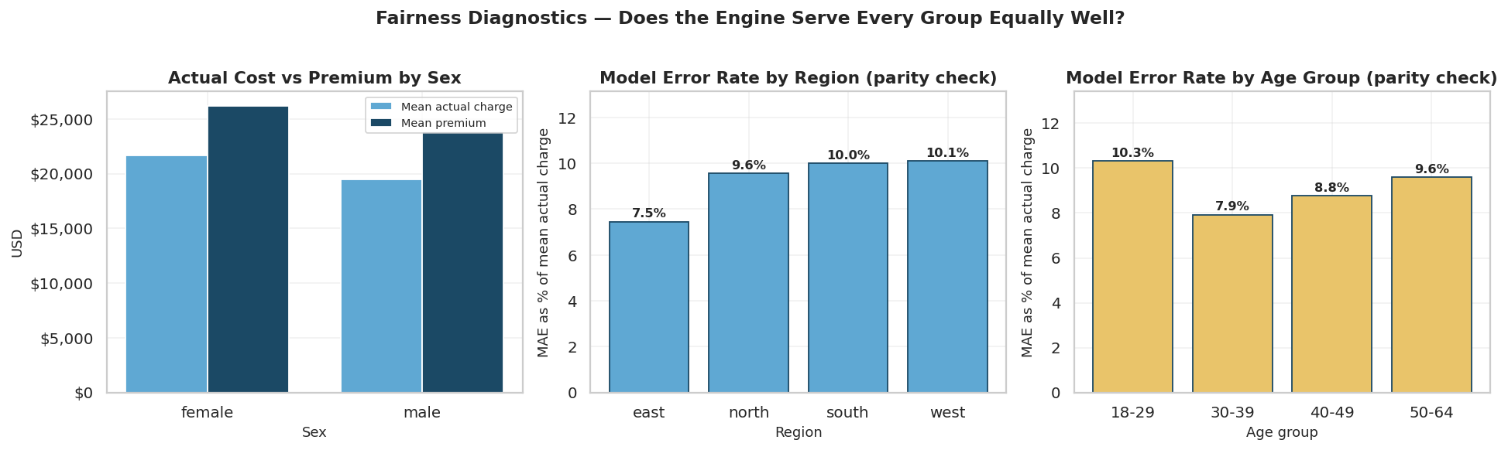
Figure 18 — Fairness diagnostics: cost versus premium by sex, and error-rate parity across region and age group.

19. Error Propagation and Deployment Safeguards
Stage 2 trusts whatever tier Stage 1 assigns. Since Stage 1 is right 94.6% of the time rather than always, the cost of the residual 5.4% governs whether the engine is safe to deploy.
Group | Customers | Mean absolute pricing error
Correctly classified by Stage 1 | 227 | $799
Misclassified by Stage 1 | 13 | $14,377
Error multiplier | — | 18×

A High-tier customer's expected annual claim is about $45,904, while the Low-tier regressor was fitted on customers averaging $7,592. Routing a High customer through it would underprice them by roughly $38,000 on a single policy. Two things make this worse than the average suggests: the damage is asymmetric, because underpricing creates a realised claims loss while overpricing only costs a lost sale; and it is self-selecting, because a high-risk applicant offered a cheap price is unusually likely to accept it. Adverse selection concentrates the mistakes rather than averaging them out.
One reassuring finding: No High-risk customer was classified as Low, and none of the reverse. Every error in testing was a single-tier step, so the catastrophic $38,000 scenario did not actually occur — the observed errors were the milder High→Medium kind. That is a property of this model worth monitoring, not a guarantee.

Recommended safeguards, in order of protection per unit of effort
Safeguard | What it does
1. Confidence-based routing | Read the classifier's predicted probability. Where the top class is below ~80%, or the top two tiers are close, route to manual underwriting instead of auto-quoting. This targets exactly the borderline cases that generate the errors.
2. Asymmetric decision rules | Since underpricing costs roughly an order of magnitude more, apply class weights or default ambiguous cases to the higher tier — trading a little revenue for a large reduction in tail loss.
3. Blended predictions near boundaries | Weight the tier models by predicted probability rather than a hard hand-off, turning the premium step function into something smoother and capping the damage of a wrong call.
4. Sanity bands and monitoring | Flag quotes far outside the expected range for a customer's observable profile, and track realised claims against predicted cost by tier so drift is caught early.

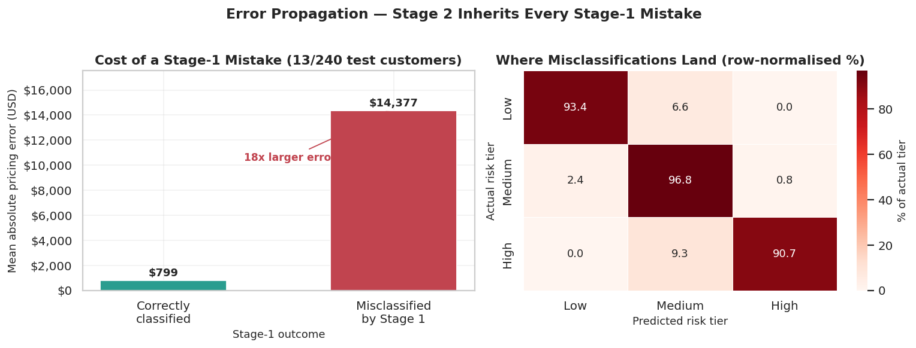
Figure 19 — The cost of a Stage-1 mistake, and where misclassifications land.

20. Conclusion and Deliverables

20.1 Conclusion
On the board's first question — does the two-stage engine beat one flat model? Yes, by a margin that survives honest measurement. Average pricing error falls from $6,167 to $1,535 (−75%) and R² rises from 0.715 to 0.919, on held-out customers, with Stage 1 predicting its own tiers. Measured the flattering way — assuming perfect tier assignment — the figures would be $816 and 0.993, and that distinction has been kept visible throughout because the oracle figure understates the engine's true pricing error by 47%.
On the second question — which attributes drive cost? Smoking first, then age and BMI, whose relative importance switches between tiers. Dependents matter slightly. Geography and sex barely register, and five columns carry no signal at all, confirmed independently by ANOVA, by Lasso, and by the fact that removing them improved out-of-sample performance.
The most useful methodological finding: The gains came from structure, not sophistication. Segmenting the portfolio was worth +0.20 R² end-to-end; hyperparameter tuning was worth +0.0004. The dataset contained three populations with genuinely different cost functions, and no amount of regularisation applied to a single linear model could have repaired that. Diagnosing the failure as high bias rather than high variance is what pointed to the right fix — and that diagnosis, not any algorithm, is the transferable lesson.

Where the gain came from | Before | After | Gain
Splitting into tiers (end-to-end R²) | 0.7153 | 0.9187 | +0.2033
Using the full profile within a tier (High R²) | 0.1288 | 0.7540 | +0.6252
Removing junk features (global R²) | 0.6831 | 0.6913 | +0.0082
Tuning alpha (High tier R²) | 0.7540 | 0.7544 | +0.0004

20.2 Deliverables
File | Contents
HealthWise_Sparsh_Saraya.ipynb | The complete executed notebook — every code cell run with output visible, all Reflection questions answered, Parts A–E and both bonus tasks
app.py | Eight-tab Streamlit dashboard: executive overview, dataset explorer, health score, premiums, classification, regression, bias–variance, and a live premium calculator with batch CSV scoring
healthwise_model.joblib | The saved two-stage engine — one classifier plus three per-tier regressors, each wrapped in a Pipeline with its encoder
healthwise_enriched.csv | All 1,200 customers with Health Score, component scores, bands, predicted tier, predicted cost, final premium, top risk factors and an individual explanation
healthwise_cleaned.csv | The cleaned layer, before feature engineering
data_dictionary.csv | Every final column documented by layer and meaning
test_customers.csv / unseen_customers_scored.csv | The unseen-customer template and its scored output from Task E3
HealthWise_Report.docx | This report
figures/ | All 19 analysis figures plus two dashboard screenshots

Premiums in this project are model estimates produced for academic demonstration and are not a quotation. All findings describe associations in historical data, not causal effects.

