Print your name:

Sara Liu

Today's date:

9/20/19

Class period:

7

-----------------------------------------------------

1. Plot the average step counts for inputs 0 < P < 100.

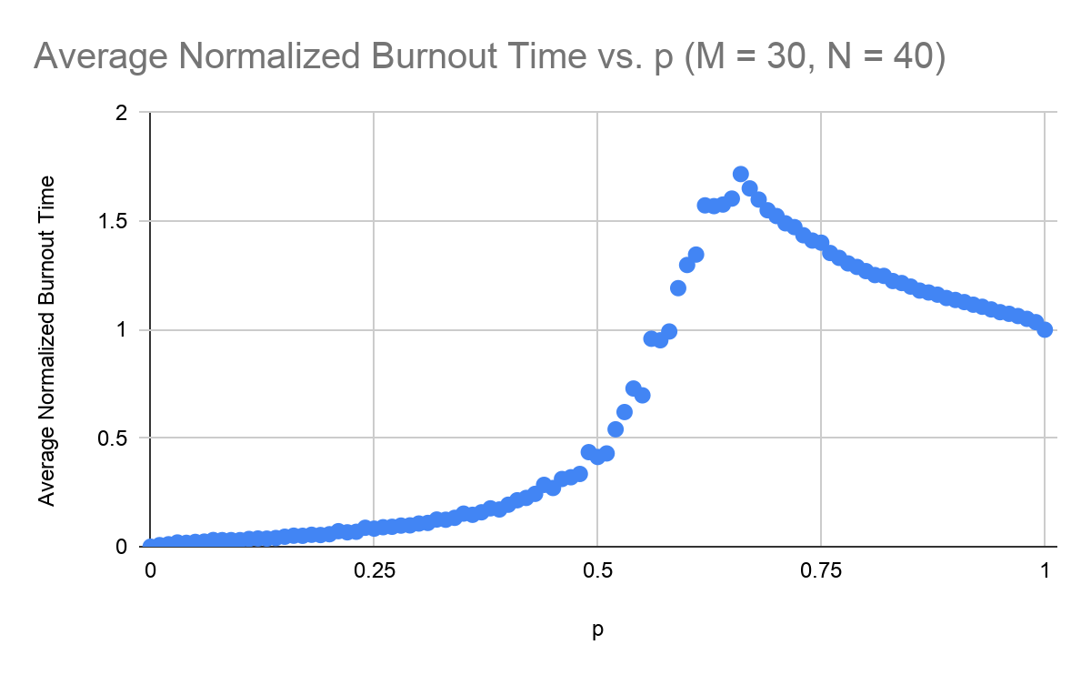

2. Report the random number seed, M, N, T, and delta P.

M = 30

N = 40

T = 100

Delta P = 0.01

3. Change M and N.

4. For example, scale each value up by a factor of two.

5. Plot the average step counts for inputs 0 < P < 100.

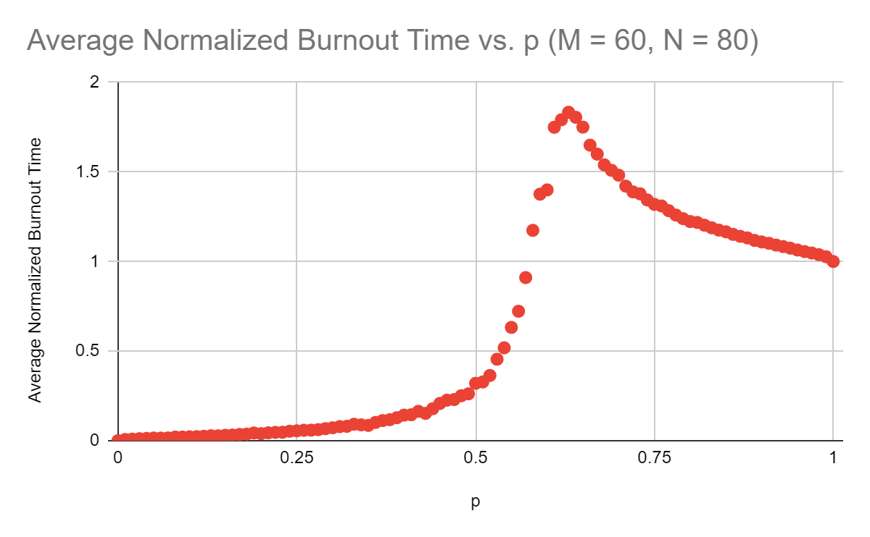

6. Report the change in M and N.

M = 60

N = 80

7. Show the two plots together, in an overlay.

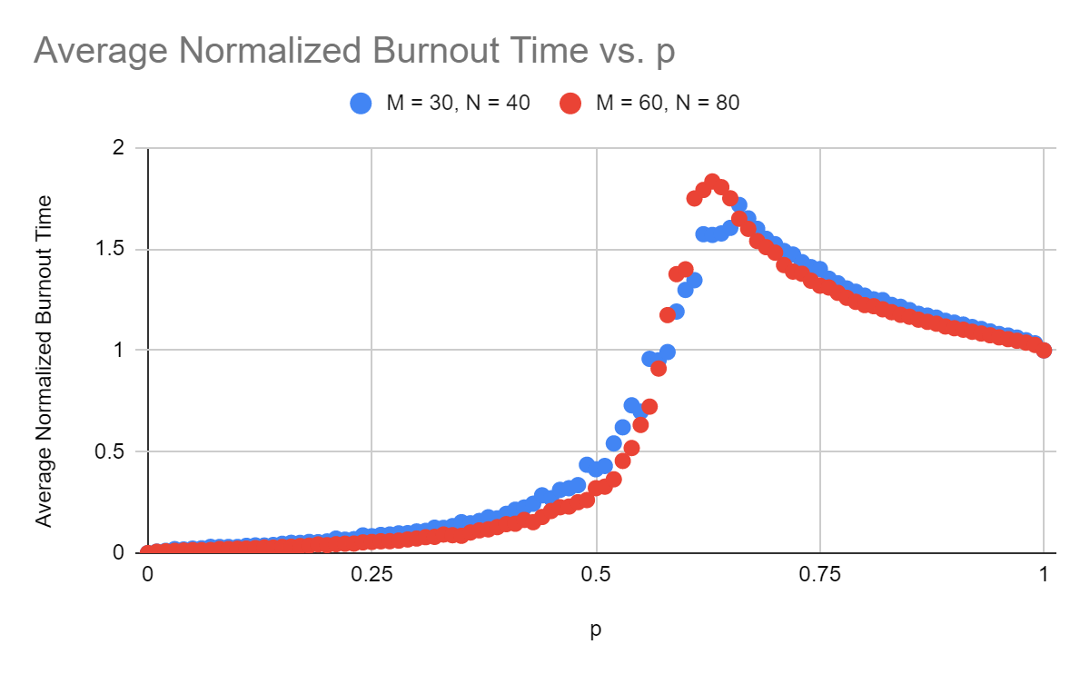

8. Scale up yet again.

M = 120

N = 160

9. Show all three plots together, in an overlay.

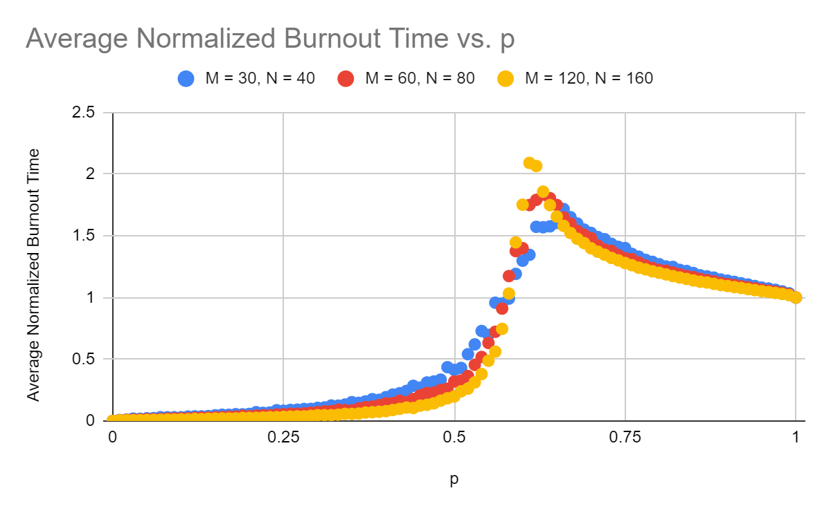

10. Report the three different values for M and N.

M = 30, N = 40

M = 60, N = 80

M = 120, N = 160

-----------------------------------------------------

END