Print your name:

Sara Liu

Today's date:

9/20/19

Class period:

7

-----------------------------------------------------

1. Initialize a grid M rows -by- N columns.

2. Each slot has a P% chance to be turned ON.

3. At time zero IGNITE the on-slots in the left column.

4. Then count the number of steps it takes to BURNOUT.

5. At each timestep spread to the four nearest neighbors.

6. Do not include diagonal neighbors.

7. Normalize the final count by dividing by the width.

8. Average the normalized burnout time over T trials.

9. Report M, N, T, and delta P that runs for 30+ seconds.

M = 180

N = 240

T = 256

Delta P = 0.01

10. Plot the runtime for np = 1 (serial), 2, 4, 8, 16, 32.

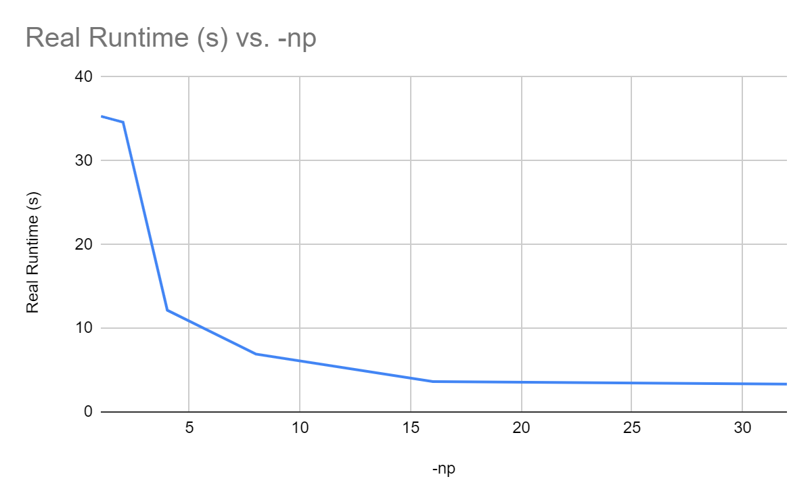

-----------------------------------------------------

END