Print your name:

Sara Liu

Today's date:

10/4/19

Class period:

7

-----------------------------------------------------

1. Initialize a grid M rows -by- N columns.

2. Each slot has a P% chance to be turned ON.

3. At time zero IGNITE the on-slots in the left column.

4. Then count the number of steps it takes to BURNOUT.

5. At each timestep spread to the four nearest neighbors.

6. Do not include diagonal neighbors.

7. Normalize the final count by dividing by the width.

8. Average the normalized burnout time over T trials.

9. Report M, N, T, delta P, np, and runtime.

M = 180

N = 240

T = 256

Delta P = 0.01

np = 32

Runtime = 3.374 s

10. What is the peak value?

p = 0.61

Average Normalized Burnout Time = 2.131653

11. Confirm AVG increases to peak then decreases.

Yes, the avg increases to peak and then decreases as shown by the graph below.

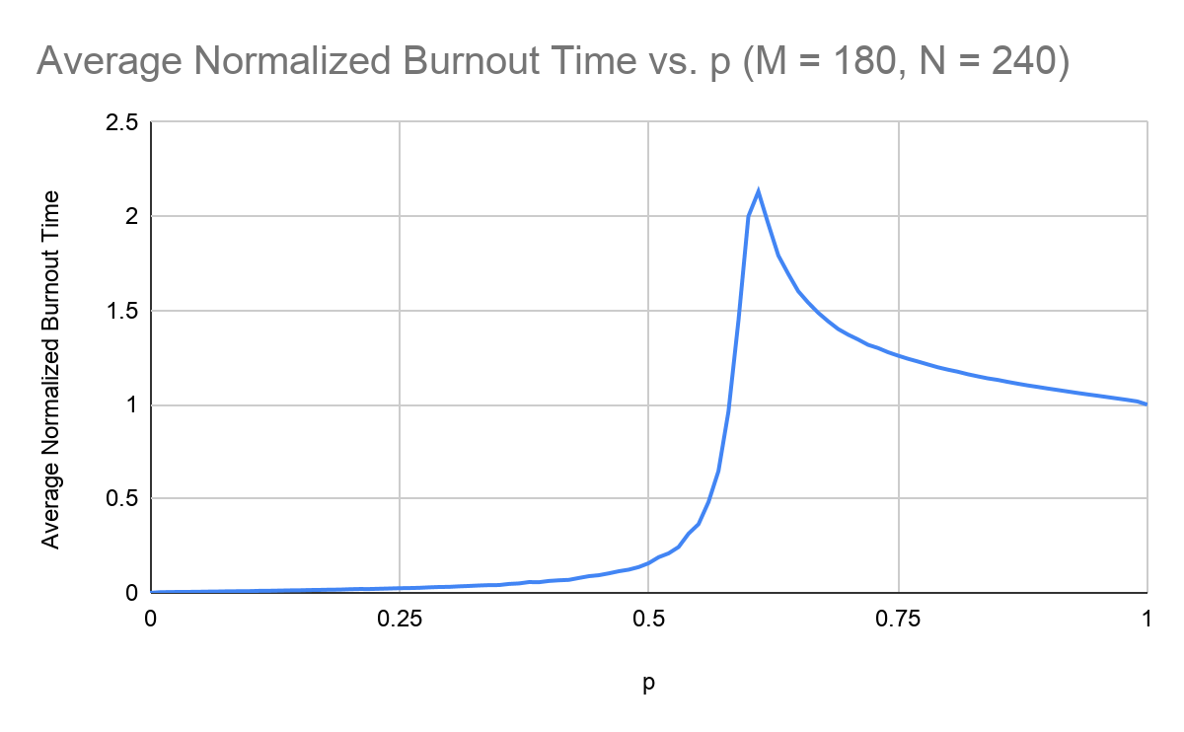

12. Confirmation can be done on output data only.

Yes, the output data shows increasing avg values from p = 0 to p = 0.61, and then decreases from p = 0.61 to p = 1.

13. Confirmation can be done with any language.

Yes, using a five-line Python program it can be seen that at p = 0.61 the avg value is highest.

14. Find the peak value for all your other plots.

Peak value for M = 360, N = 480:

p = 0.6

Average Normalized Burnout Time = 2.274513

Peak value for M = 720, N = 960:

p = 0.6

Average Normalized Burnout Time = 2.476802

Peak value for M = 1440, N = 1920:

P = 0.6

Average Normalized Burnout Time = 2.416104

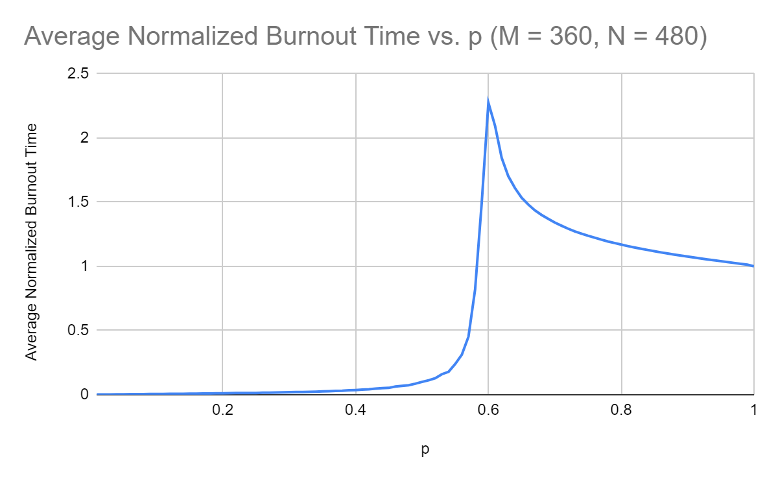

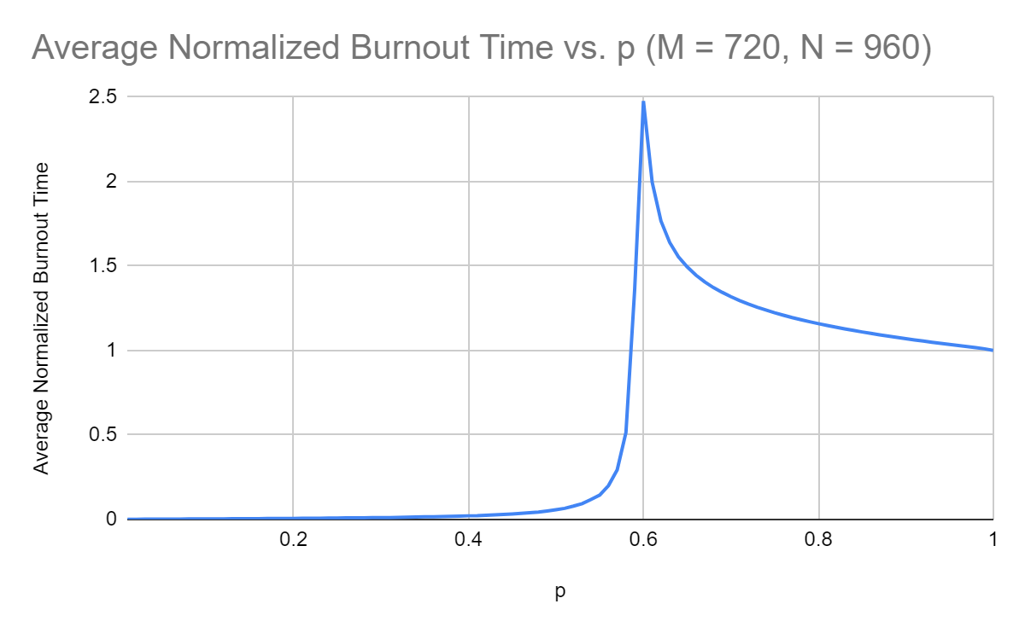

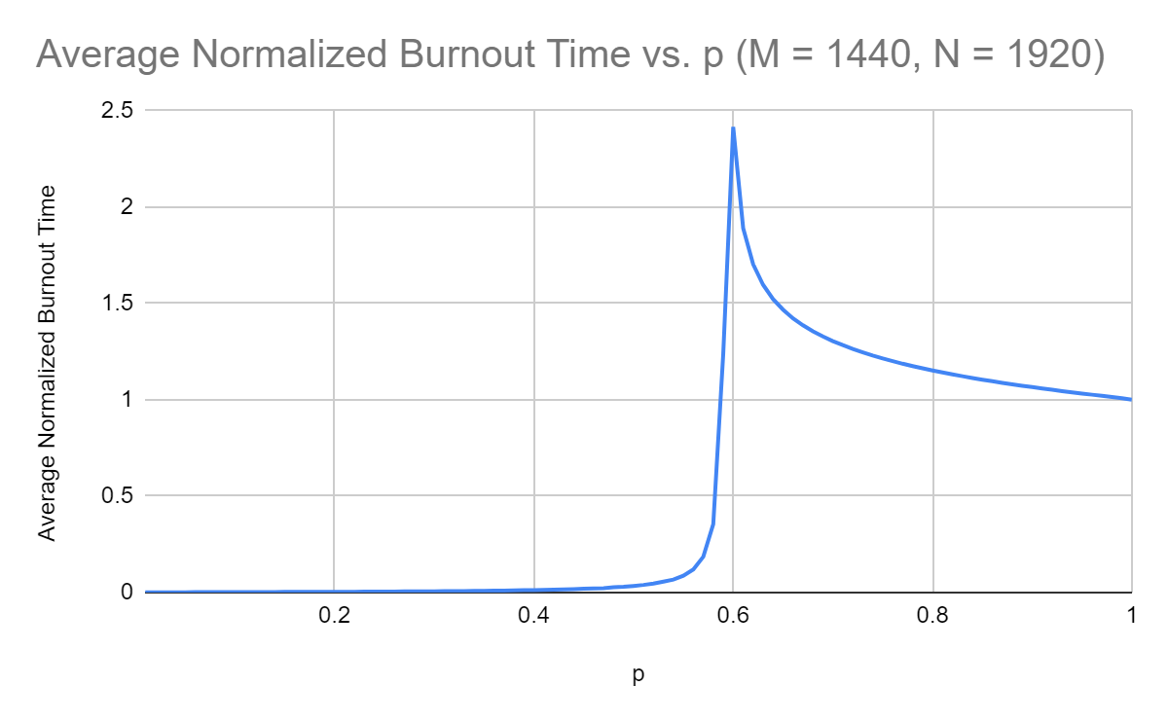

15. How does the peak change as resolution increases?

As resolution increases, the peak moves up and to the left, but it can only go so far left as to not pass below the critical probability.

-----------------------------------------------------

END