Print your name:

Sara Liu

Today's date:

11/22/19

Class period:

7

-----------------------------------------------------

1. Earth and Moon in orbit.

2. Launch a probe from the Moon toward Earth.

3. Need to pick two parameters, speed and angle.

4. Initialize probe:

x = xMoon + ( 2 \* Rm ) \* cos( angle ) ;

y = yMoon + ( 2 \* Rm ) \* sin( angle ) = ( 2 \* Rm ) \* sin( angle ) ;

vx = speed \* cos( angle ) ;

vy = speed \* sin( angle ) ;

5. Initial (x,y) not critical.

6. Gravity of Moon is small.

7. Okay to launch from surface.

8. Or start from "low Moon orbit."

9. Or ignore the Moon's gravity for the first day.

10. Find a pair (speed, angle) to maximize the exit

speed of the probe. Idea is to make one pass around

Earth first and then have a subsequent interaction

with the Moon, which in the meantime will have been

continuing on its own way around its regular orbit.

Find a very tight "fly by" behind the Moon so that

the probe exits in an extreme hyperbolic trajectory.

Don't worry about the exit angle because we could

have delayed launch by some amount of time in order

to "aim" at our deep space target (e.g., Jupiter).

Describe the solution pair found, and the outcome,

using whatever plots you deem appropriate.

Initial speed: 1700.0 m/s

Angle: 221 degrees

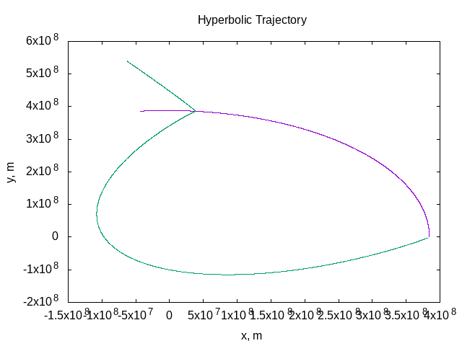

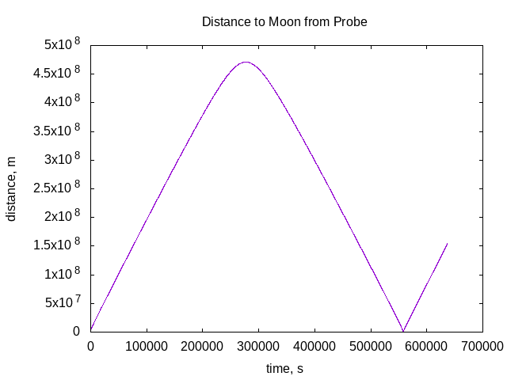

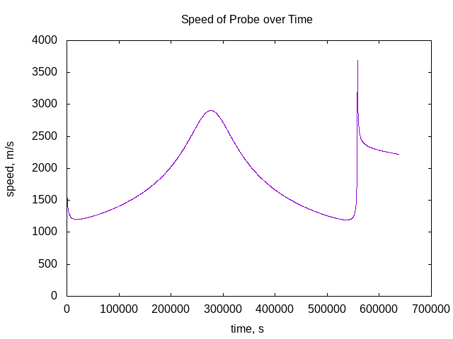

-----------------------------------------------------

END