Print your name:

Sara Liu

Today's date:

12/18/19

Class period:

7

-----------------------------------------------------

1. Launch a probe from the Moon toward Earth.

2. Initialize probe:

x = xMoon + ( 2 \* Rm ) \* cos( angle ) ;

y = ( 2 \* Rm ) \* sin( angle ) ;

vx = speed \* cos( angle ) ;

vy = speed \* sin( angle ) ;

3. Initial (x,y) not critical.

4. But this seems to work well:

x = xMoon + ( 2 \* Rm ) \* cos( angle ) ;

y = yMoon + ( 2 \* Rm ) \* sin( angle ) ;

5. Survey pairs of the two parameters (speed, angle).

For each pair you need to characterize the outcome of

the run. Does the probe crash into the Moon? Do we

even exit the Earth-Moon system? In cases that exit

the system:

speed > sqrt( 2 \* G \* mE / rE )

Idea is to make one pass around Earth first and then

have a subsequent interaction with the Moon, which in

the meantime will have been continuing on its own way

around its regular orbit.

6. Are there other possible outcomes?

The probe can also crash into the Earth.

7. Use angle = 181 , 182 , ... , 269 degrees

8. Use speeds that escape the Moon initially but are

not already escaping the Earth.

9. MPI, split the pairs across multiple workers.

7 workers, 13 degrees covered by each

10. Describe your runtime and what pair did you find

that maximizes the exit speed?

Runtime: 4 s

Initial Speed: 1860.000000 m/s

Initial Angle: 207.000000 degrees

Max exit speed: 2571.449627 m/s

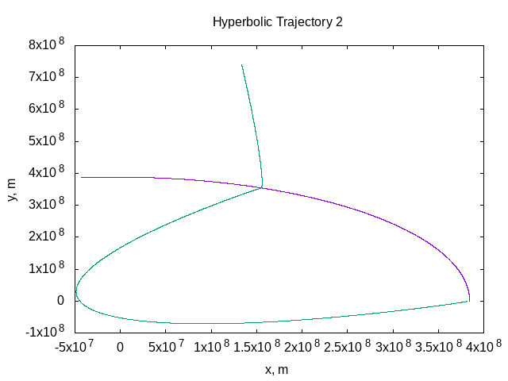

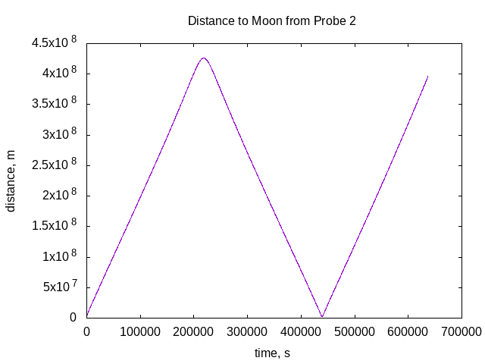

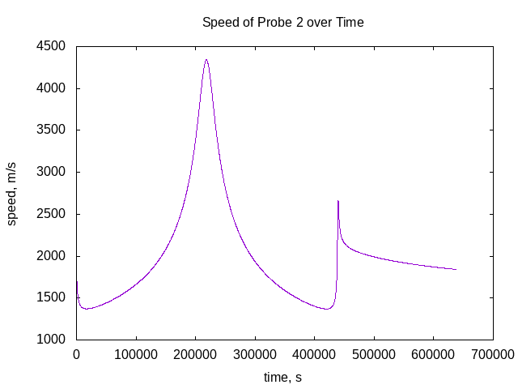

-----------------------------------------------------

END