**Lab #1: Measurements and Graphical Analysis**

**Materials**

* Balance
* Meter stick
* Aluminum discs of varying radii (constant thickness and density)

**Equations**

* Density (p) of each aluminum foil used was 2.70 g/cm3

1. **Write a brief outline of the procedure you will use to collect data. What data would you need to collect?**

We needed to collect data on the radius and mass of the disks.

**Procedure**

1. Measure the radius (cm) of each aluminum disc using the meter stick
2. Measure the mass(g) of each aluminum disc using the balance
3. Use the given equations above to create a new equation for the calculation of height:

and → or

1. The area (a) was calculated using the measured radii
2. Use the given height measurements to calculate the volume of the disks through the use of another formula:

**2. What is the precision of the meter stick used? Explain how you know this.**

Since our ruler was a meter stick with millimeter tick marks, we could accurately measure up to the tenth place of the centimeter (i.e, 4.1 cm). We added to the hundredth place which was one place after what was precisely determined through the meter stick. This seemed to be precise enough, but there might have also been some human error in handling the measurements and estimating the hundredths place.

**3. Create a data table. Make sure you give it a title and make sure you label each column. Include the units you will use. Include a column with calculated values that you will “linearize” your graph.**

Measurements and Calculations for Aluminum Disks

| Radius (cm) | Mass (g) | Linearization w/  radius2 (cm2) | Height (cm) | Volume (cm3) |
| --- | --- | --- | --- | --- |
| 6.70 cm | 0.69 grams | 44.89 cm2 | 0.001812 cm | 0.256 cm3 |
| 2.30 cm | 0.08 grams | 5.29 cm2 | 0.001783 cm | 0.03 cm3 |
| 3.10 cm | 0.09 grams | 9.61 cm2 | 0.001104 cm | 0.033 cm3 |
| 4.10 cm | 0.24 grams | 16.81 cm2 | 0.001683 cm | 0.089 cm3 |
| 4.60 cm | 0.39 grams | 21.16 cm2 | 0.002173 cm | 0.145 cm3 |

4. **Graph #1: Non-Linear graph showing the relationship between mass of disks (y-axis) and radius of disks (x-axis), assuming uniform thickness. Make this graph using your graphing calculator or online calculator and insert the picture of it in your document. Is this a LINEAR or NONLINEAR graph? You can provide a mathematical formula underneath your graph (just get it from the calculator).**

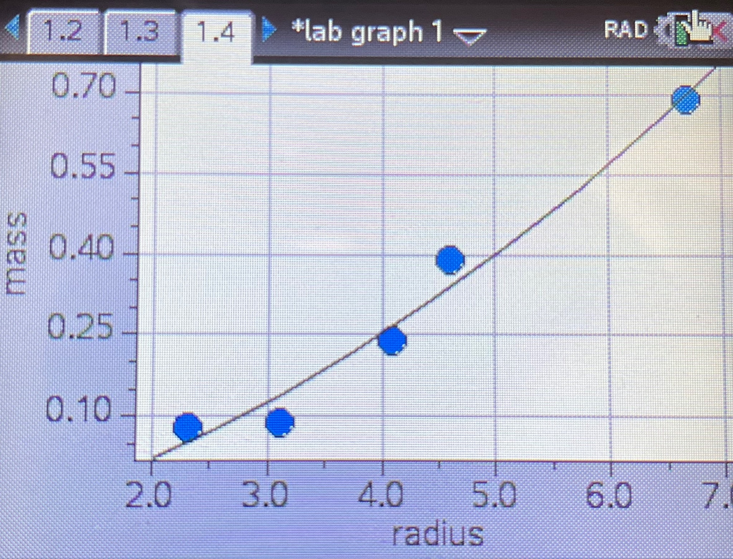

The graph is a nonlinear graph.

Graph 1 Linearized Equation (Quadratic):

5. **Graph #2: Linearized graph. Make this second graph using your calculator as well. How will you “linearize” a graph? Apply a line of best fit to your graph. Insert this graph. Again, using your calculator, get a mathematical formula…**

We were able to “linearize” the graph by changing r to r2 (radius to radius2).

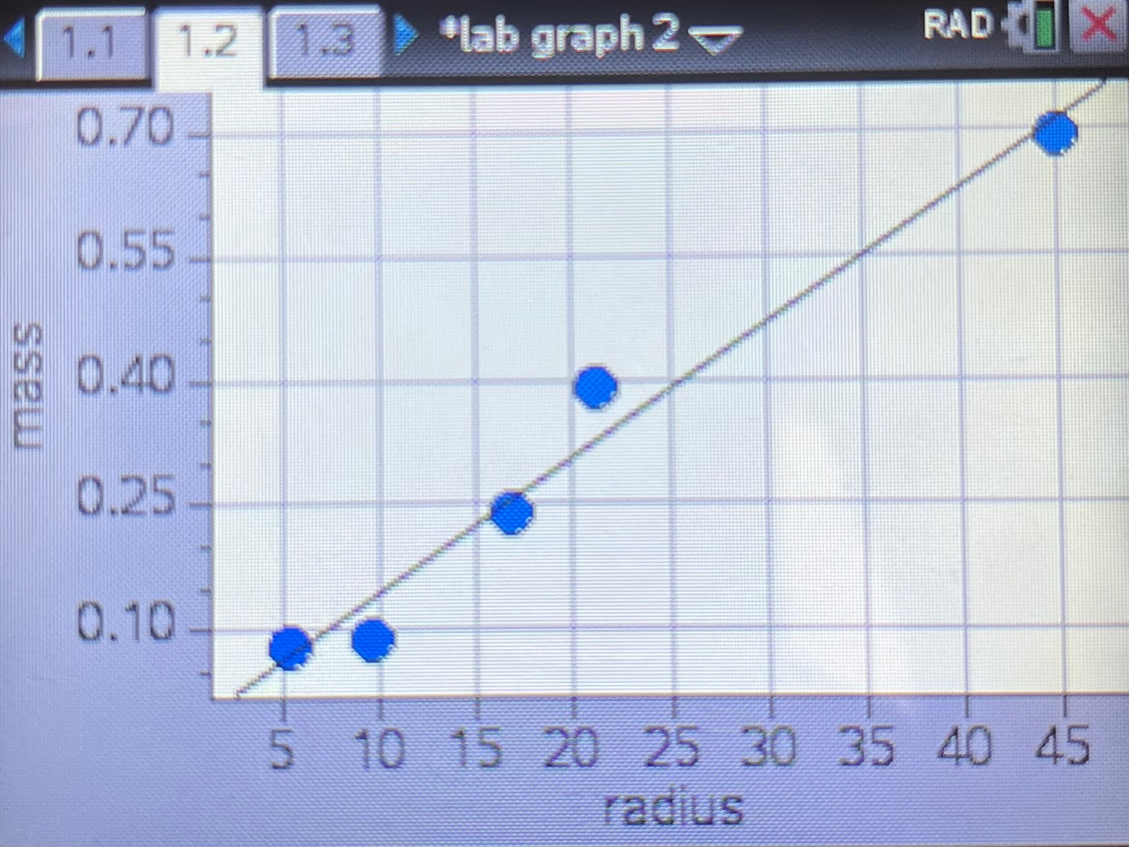

1. **Below your Graph #2. What is the equation for your line of best fit in the form**

**y = slope(x) + intercept**

Line of Best Fit Equation:

**Analysis Questions**

1. **Considering the mathematical relationship between disk radius r and disk mass m**

**(equation 4), what does the independent variable from your line of best fit represent?**

The independent variable of our line of best fit represents the radius (r) of the disks for Graph 1. Graph 2’s independent variable is r2. As radius2 or radius changes, mass changes.

1. **Use the mathematical relationship between mass of the disk m and the disk's radius r to equate the coefficient values from your line of best fit to physical quantities. What are the units for each?**

The slope represents mass over radius2. Using the equations below, mass over radius2 equals πph.

and

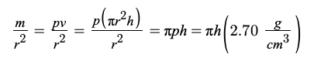

The units for mass are grams (g) and the units for radius2 are centimeters2 (cm2).

1. **Should you adjust the best-fit line to be sure it passes through the origin, (0,0)?**

**Justify your answer.**

The best-fit line should be adjusted so it passes through the origin (0,0) because if the radius of the disk is zero, the mass should be zero too. It’s not possible to have a mass of anything other than 0 g. when the radius is 0 cm., so the “b” (y-int) in the y = mx+b formula should be 0.

1. **~~Using the slope of your best fit line and your measured value for disk thickness, determine the experimental value for the disk material density. How does this value compare to the theoretical value provided by your teacher? What is your percent error?~~**

1. **What are some of the factors that may have caused error and how might these factors have been prevented?**

Some sources of error could be human error or not being precise enough in measuring the radius and mass of each aluminum disk. This would then cause the resulting measurements to be inaccurate, influencing later calculations as well and causing the numbers to be bigger or smaller than the known value. While this can’t be entirely solved, one way to prevent this from occurring would be to use a more precise measuring device, as a meter stick wouldn't be the most accurate when measuring something small. If we measured the radius to be smaller than it actually was and or measured the mass to be greater than it actually is, this would cause the experimental density of aluminum to be greater.

**Synthesis Questions**

1. **In this experiment, if we had used disks with a greater thickness, would the slope of your best fit line have been different? Would your experimental value for density be the same? Explain.**

The slope of the line of best fit would have increased if the disk thickness increased. Since the slope is m/r2, and mass is increasing but radius is not, the slope would also increase due to the greater value in the numerator of the slope equation. The experimental value for density would have been the same because even though the disks would have a greater thickness, there would still be a proportional increase in both mass and volume. The formula for density is mass divided by volume (), so if both mass and volume increased in the equation, the density would still remain the same.

1. **How would your graph of m versus r2 be different if you had used disks of the same thickness, but made out of steel? Draw a second line on your m versus r2 plot that represents disks made of steel.**

The graph would be different if the disks were made of steel because the mass of the disks would be greater. This would cause the slope of the line of best fit to increase, making the line steeper on the graph. An example of this is shown in the image below.



1. **Another group of students has acquired data for the exact same experiment; however, their disks are made of an unknown material that they are trying to determine. The group's m versus r2 data produced a line of best fit with slope equal to 122 kg/m2. Each disk they measured had the same 0.5 cm thickness. Calculate the density of the unknown material and use the table below to help determine what material their disks are made of.**

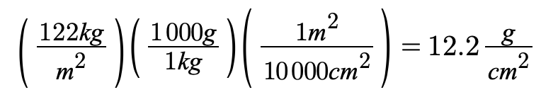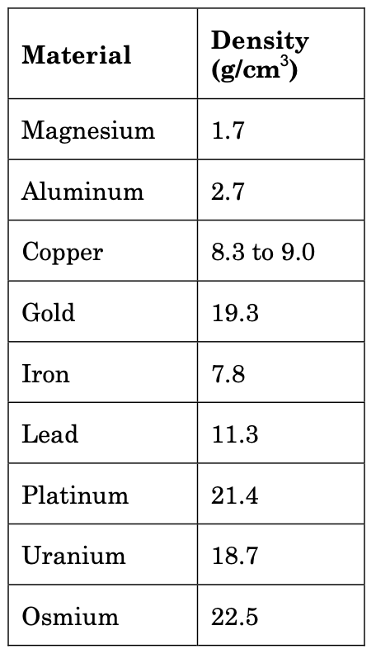

**Test** Equation :

Test Test Radius Value: 5 cm

The unknown material has a density of 7.76676 g/cm3 and that is similar to the density of iron.

**---------------------------------------------------------------------------------------------------------------------**

**Multiple Choice Questions**



1. E
2. A
3. C