Code.org Key Takeaways

Completion:

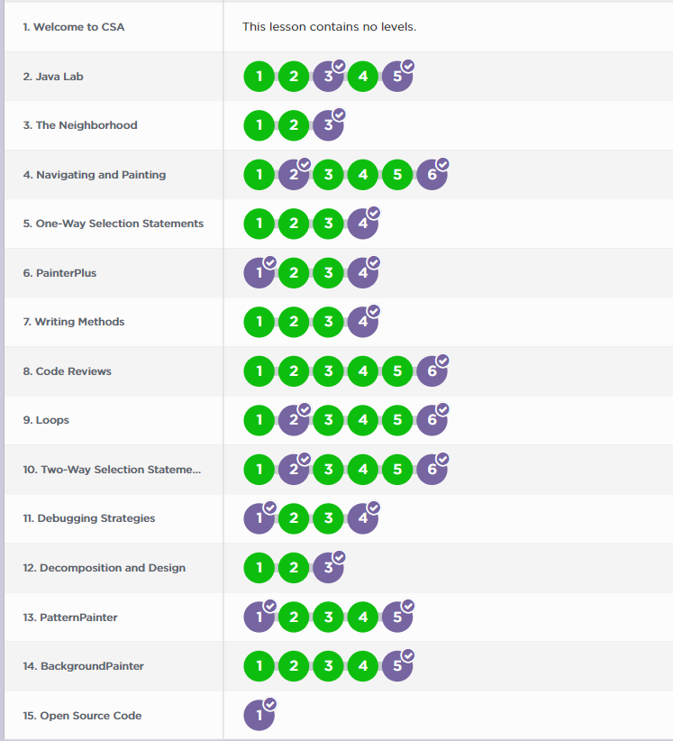

Creating and Using Objects:

* **Key Takeaways:**
* - writng headers
* public class Main() {}
* - creating sub classes
* Main main = new Main();
* - writing methods
* public void method() {}
* - extending methods
* method();
* - loops
* while(true)
* if(true)
* Creating Objects
* - in java we create objects in order to call non-static functions that are not inside the main method we're in
* - as long as it is inside the class we're in, we can provide the name and extend the object
* - instance of a class
* - types of food within a meal
* Extending Objects
* - public class Food extends vegetables {}
* **### Mainly from this unit in code.org, I learned the basics of java. I knew virtually nothing beforehand, so the simple tasks with the painter served as a great introductory for this programming language.**