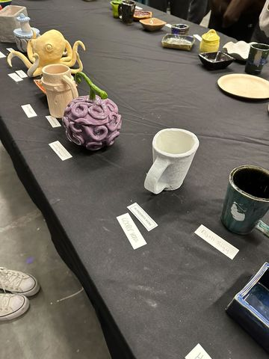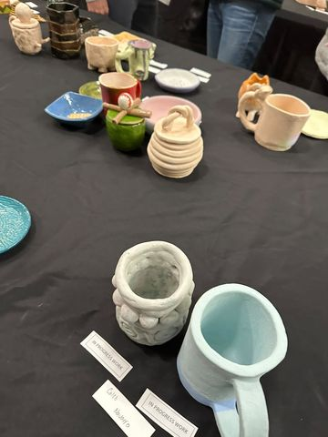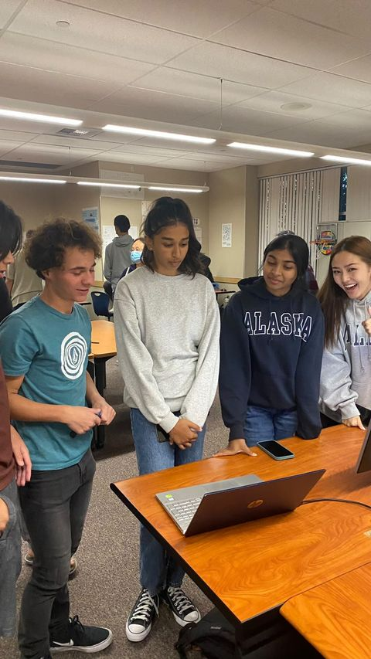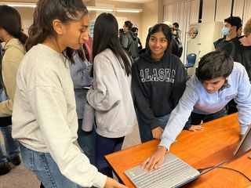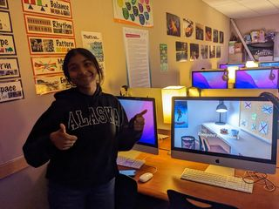

Night at the Museum was very interestin this trimester. Lots of people came to our website and they seemed to like our ideas. They liked our 2048 games as well as our Desmos API. I like the AP Studio Art displays since the art was beautiful like always. In the future, I would like to improve our website and have more features, but overall, it was a success!