

1. 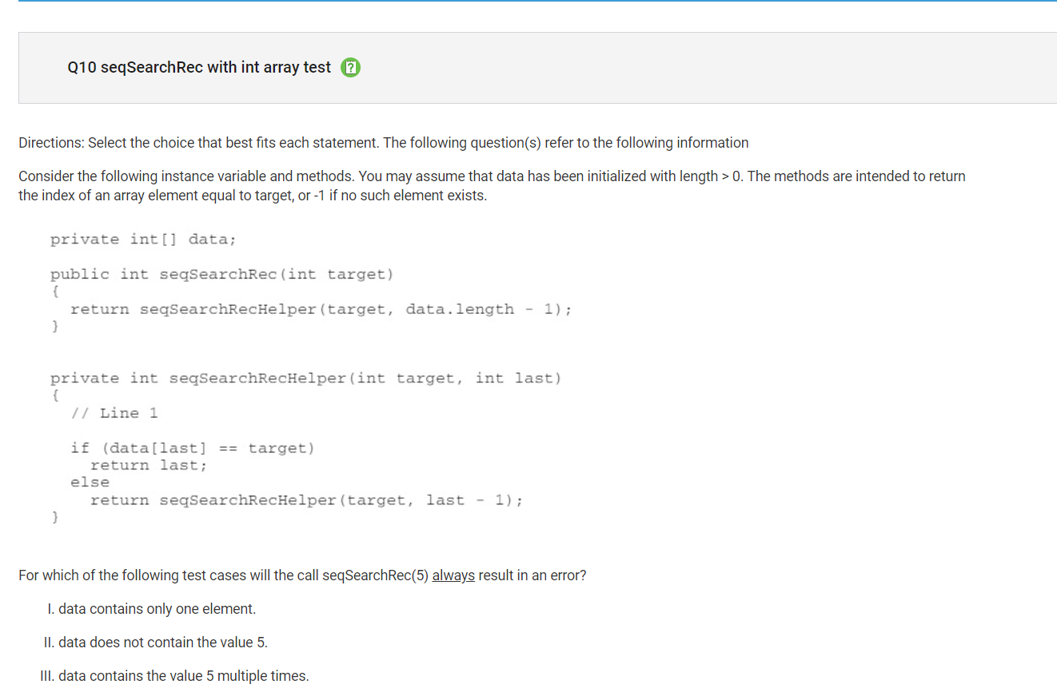
   1. I said the answer was I only, but it was II only. I was wrong because it would return the element if the element was was in bounds, but it’s not in thise case. So II would be the right answer.
2. 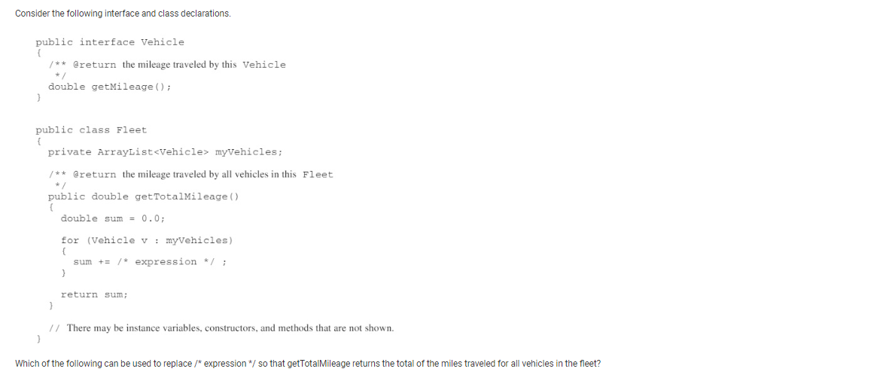
   1. I chose (myVehicles[v].getMilage()) when the correct answer was (v.getMileage()). This was wrong because v was the index of the myVehicles so I don’t need to reuse myVehicles in the answer.
3. 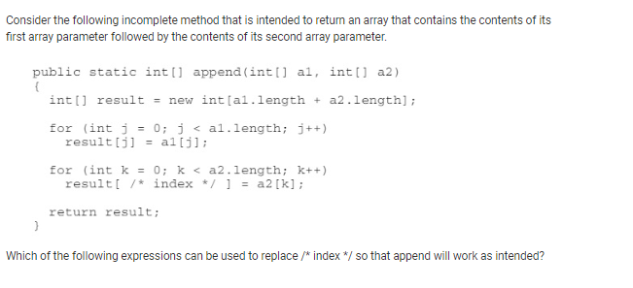
   1. I chose (k+a1.length -1) but the correct answer is (k+ a1.length). The value of the first was assigned with 1 so the answer I chose would give you the wrong index.
4. 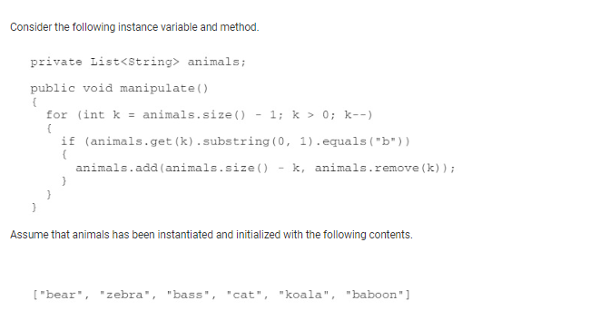
   1. I chose (bear, baboon, zebra, bass, cat, koala) but the right answer is (bear, zebra, bass, cat, koala, baboon). I just made an error with the k >1 when I thought it starts at 1.
5. 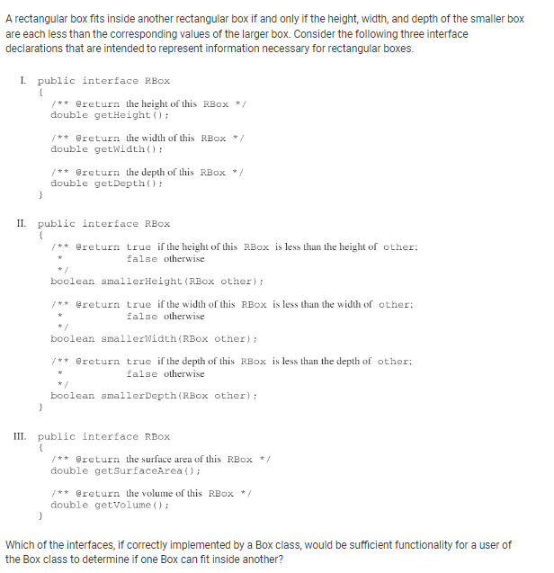
   1. I chose (I, II, and III). The correct answer is (I and II). III is wrong because it gives the user with area and volume methods but a box with a smaller surface area or volume can’t necessarily fit in a larger one.