# **Case Stydy – Pixogram**

# **Sarbajit Chhualsingh(sarbajit.c@in.ibm.com)**

Spring boot Microservices for Pixogram:

1. netflix-eureka-server
2. usernamanagement
3. mediaservice
4. followservice

Angular11 – Pixogram User Interface

1. PixogramUI

Database – MySql

# **Screens**

## Eureka Server

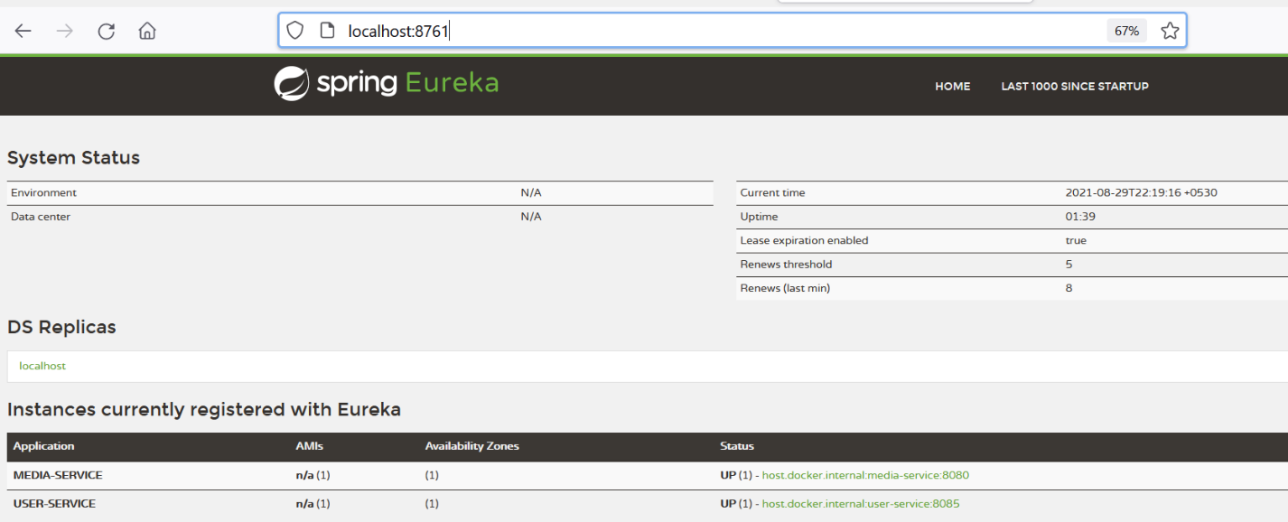

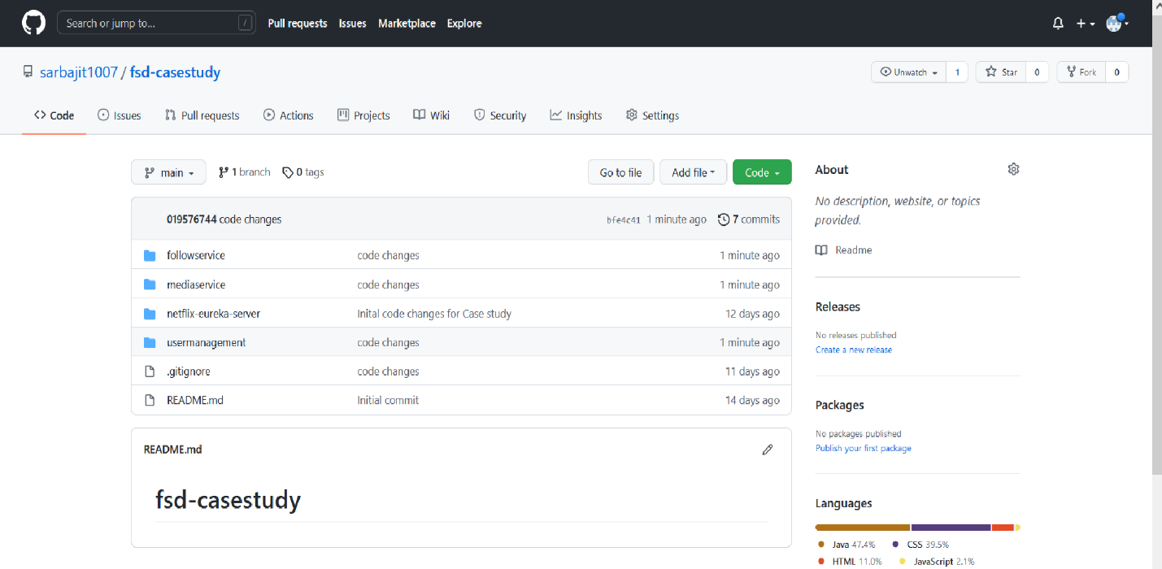

## **Database Details**

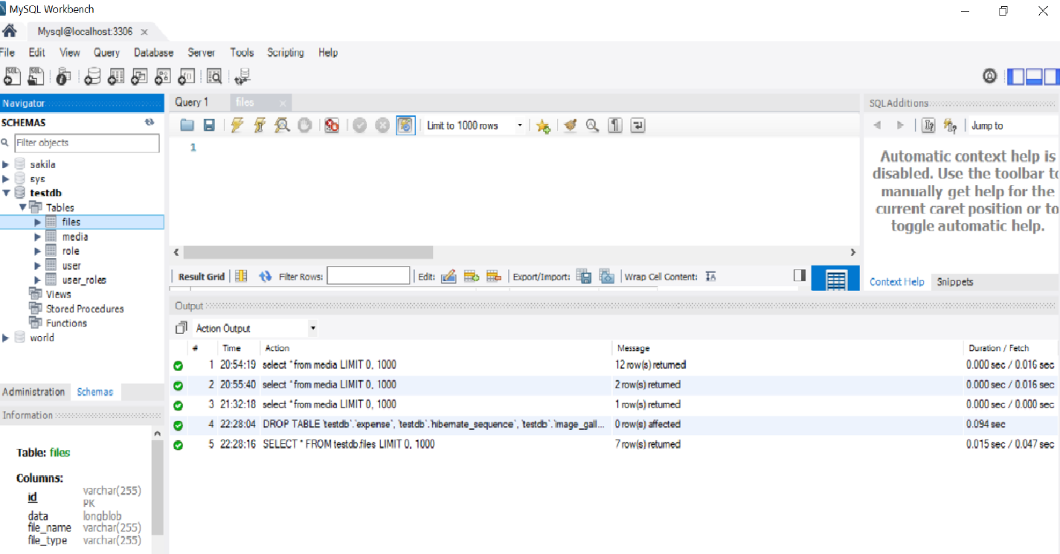

**describe user;**

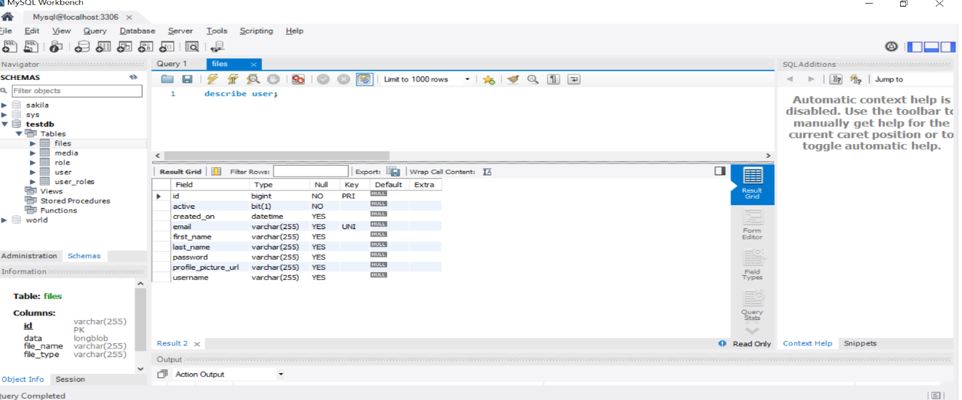

**describe role;**

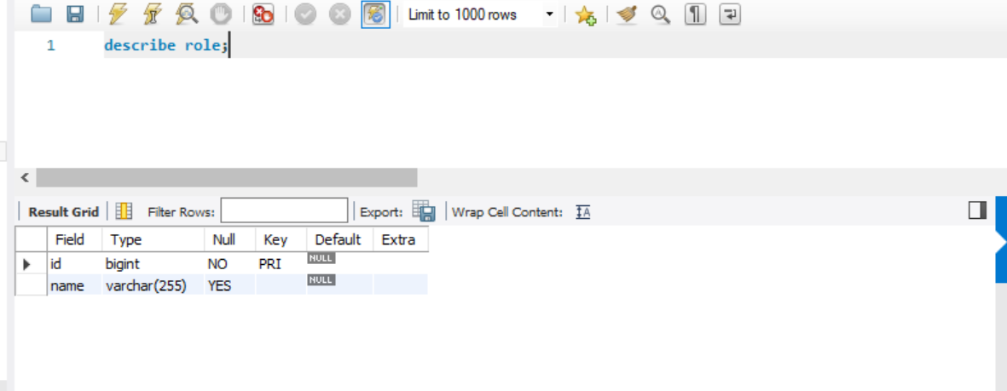

**describe user_roles;**

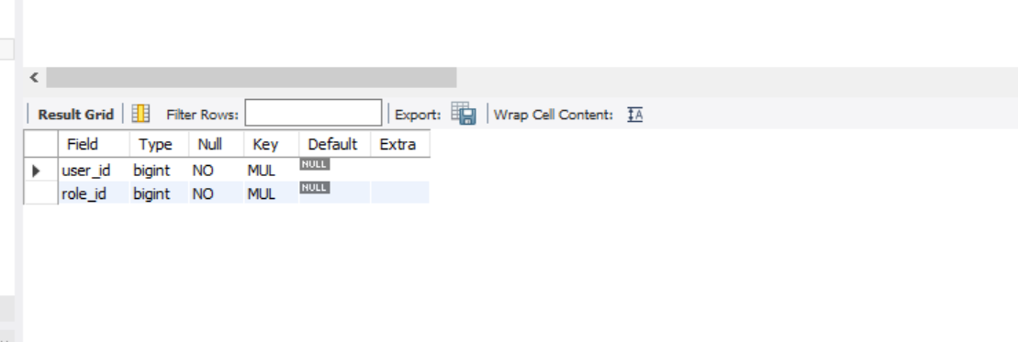

**describe media;**

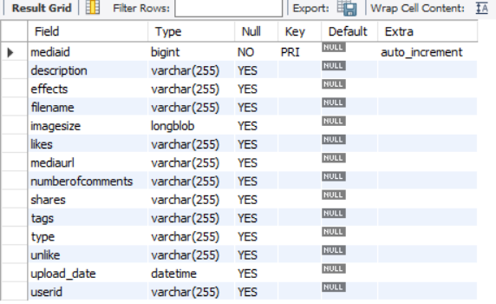

**select * from user;**

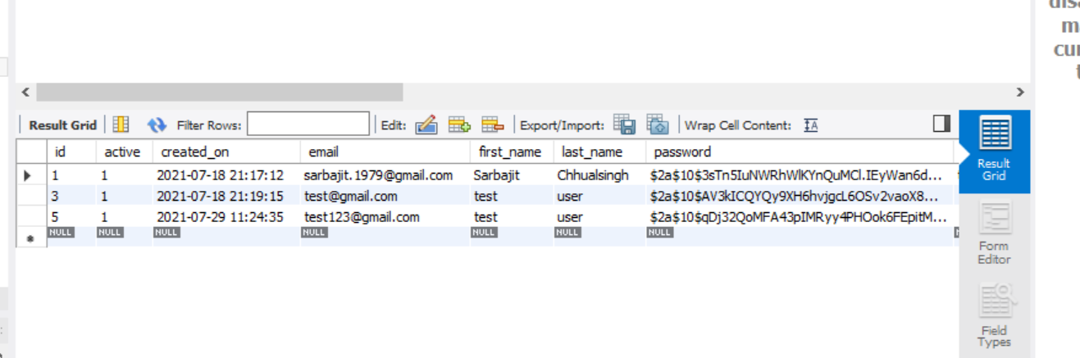

**select * from role;**

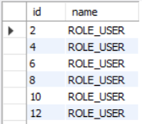

**select * from user_roles;**

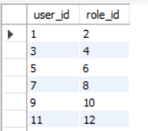

**select * from media;**

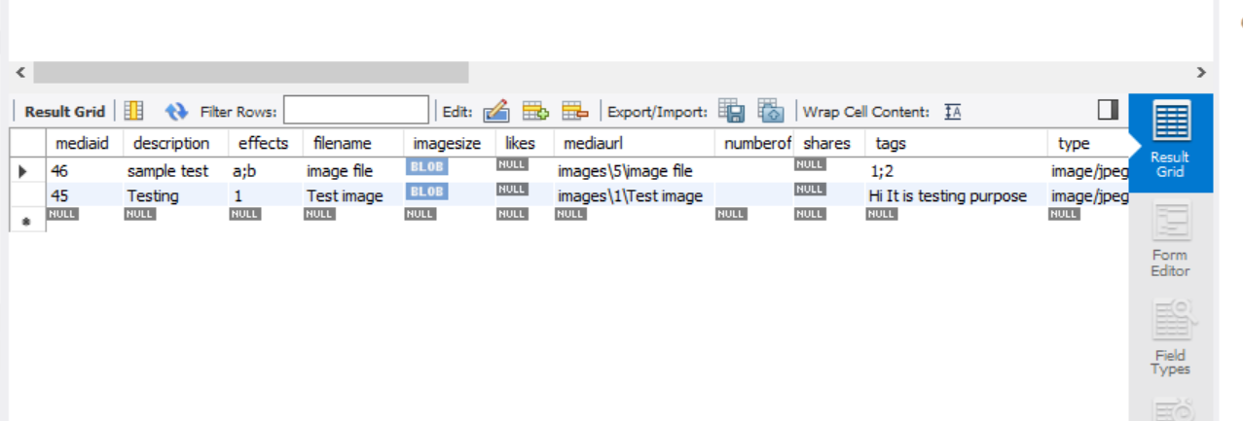

# **User management module screen shots**

Angular UI

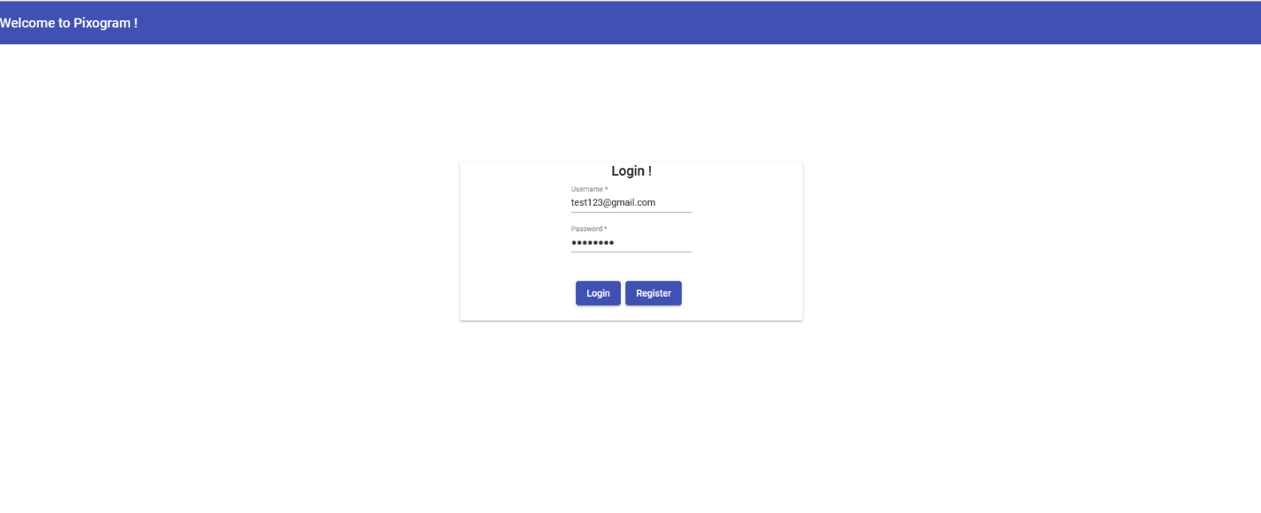

**My Media Page**

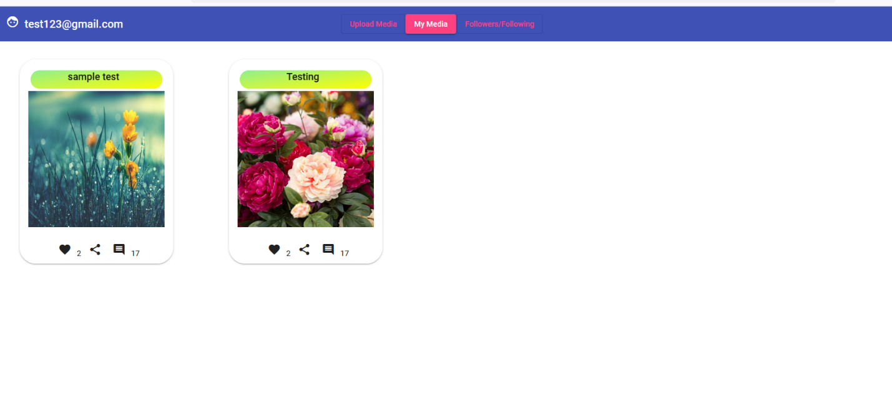**Upload Media Page**

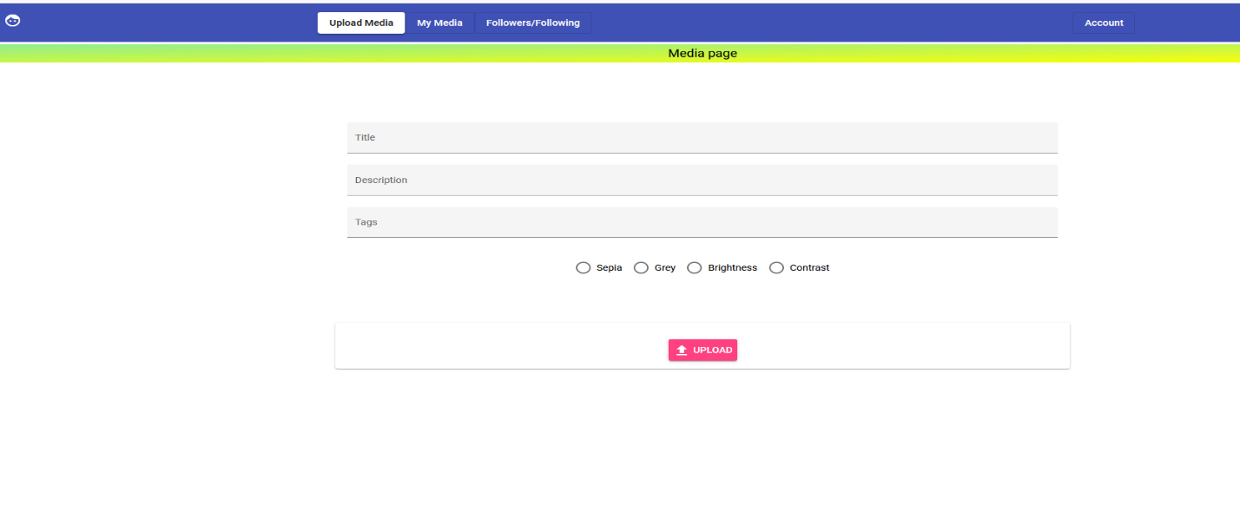

**Image Uploads**

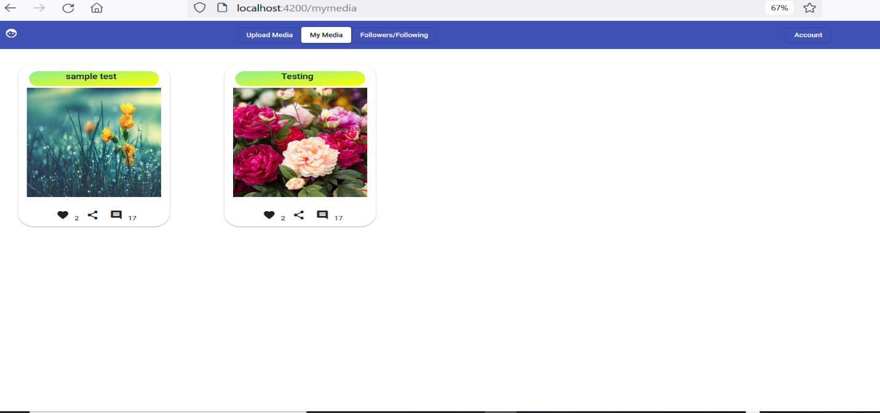

**My Media page**

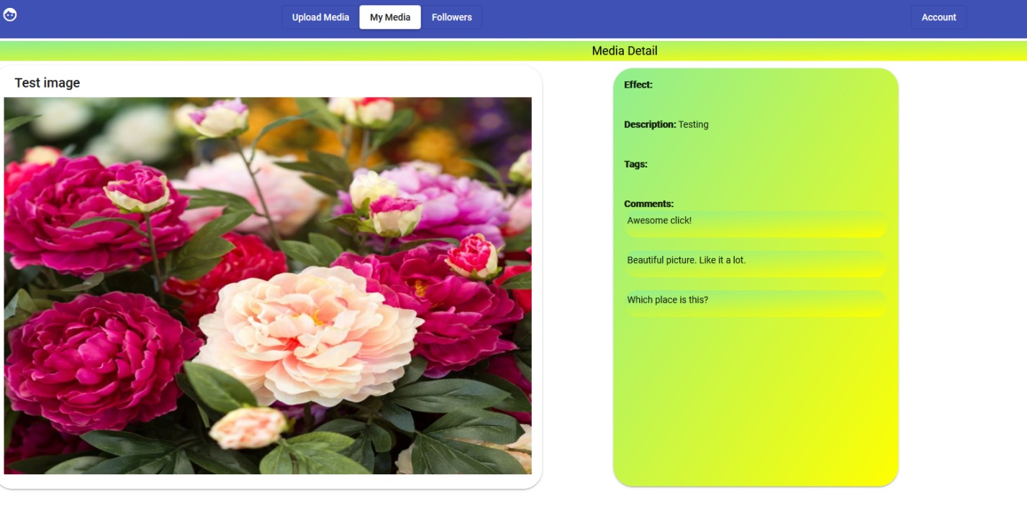

**User Registration Page**

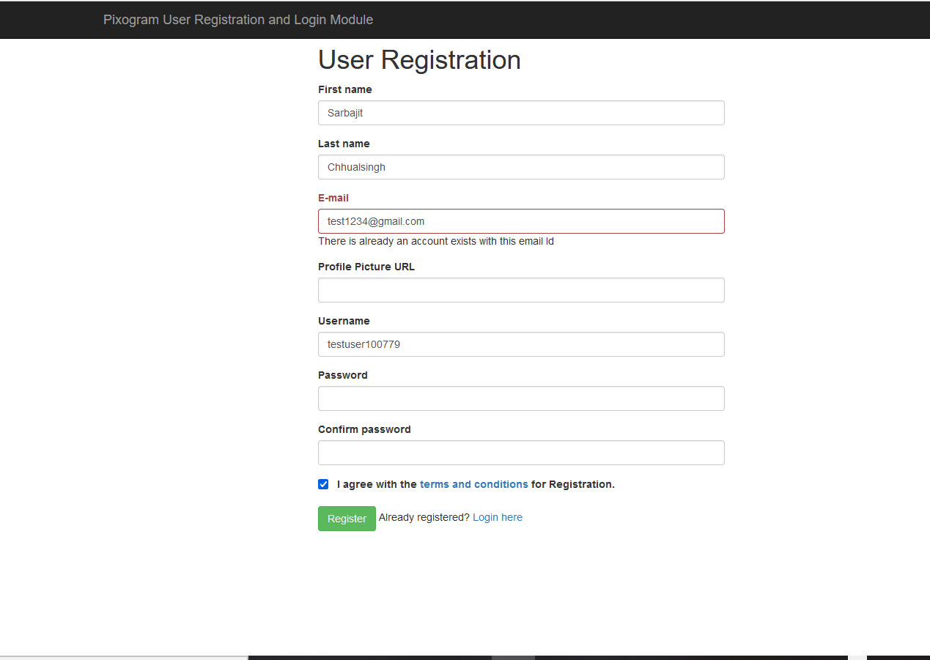

Successful registration

Postman detail : Single file Upload

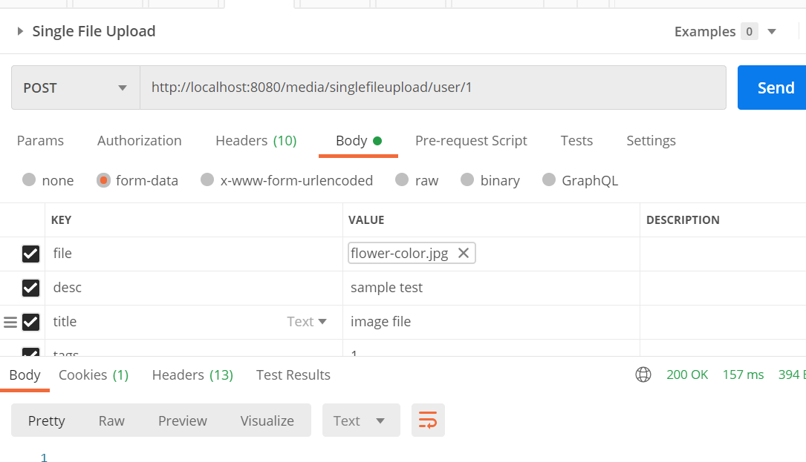

Multi file upload

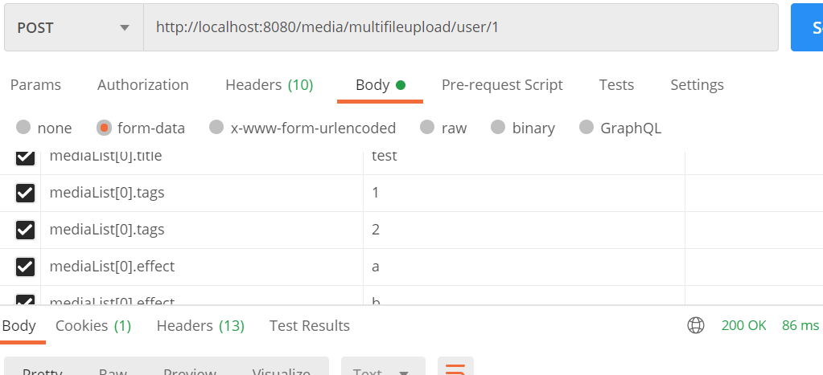

Get Medialist by user

