**WEB TECHNOLOGY LAB ASSIGNMENT-3**

**INDEX.HTML**

<!DOCTYPE html>

<html lang="end">

  <head>

    <meta charset="UTF-8">

    <meta http-equip="X-UA-Compatible" content="IE=edge">

    <meta name="viewport" content="width=device-width, initial-scale=1.0">

    <title>Admission form for VIT-Pune.</title>

    <link rel="stylesheet" href="style.css">

    <link rel="stylesheet" href="script.js">

  </head>

  <body>

    <hr>

    <form method="" action="" name="reg_form" onsubmit="return validate()">

      <h2>VIT-Pune Admission Form 2022-23</h2>

      <table>

        <tr>

          <td>

            <label>First Name: </label>

          </td>

          <td>

            <input type="text" name="name" placeholder="First Name">

          </td>

        </tr>

        <tr>

          <td>

            <label>Last Name: </label>

          </td>

          <td>

            <input type="text" name="lname" placeholder="Last Name">

          </td>

        </tr>

        <tr>

          <td>

            <label>Address: </label>

          </td>

          <td>

            <input type="textarea" size="50" name="address" placeholder="Address">

          </td>

        </tr>

        <tr>

          <td>

            <label>Gender: </label>

          </td>

          <td>

            <input type="radio" name="gender" value="male">Male <input type="radio" name="gender" value="femele">Female

          </td>

        </tr>

        <tr>

          <td>

            <label>Email Id: </label>

          </td>

          <td>

            <input type="text" name="email" placeholder="example@gmail.com">

          </td>

        </tr>

        <tr>

          <td>

            <label>Mobile: </label>

          </td>

          <td>

            <input type="number" name="mobile">

          </td>

        </tr>

        <tr>

          <td>

            <label>Date of Birth: </label>

          </td>

          <td>

            <input type="date" name="DOB">

          </td>

        </tr>

        <tr>

          <td>

            <label>Categary: </label>

          </td>

          <td>

            <select name="course">

              <option value="select course">select categary</option>

              <option value="Open">OPEN</option>

              <option value="Open">EWS</option>

              <option value="Obc">OBC</option>

              <option value="SC">SC</option>

              <option value="ST">ST</option>

            </select>

          </td>

        </tr>

        <tr>

          <td>

            <label>SSC Percentage: </label>

          </td>

          <td>

            <input type="number" name="Marks">

          </td>

        </tr>

        <tr>

          <td>

            <label>HSC Percentage: </label>

          </td>

          <td>

            <input type="number" name="Marks">

          </td>

        </tr>

        <tr>

          <td>

            <label>MHT-CET Percentile: </label>

          </td>

          <td>

            <input type="number" name="Marks">

          </td>

        </tr>

        <tr>

          <td>

            <label>JEE Percentile: </label>

          </td>

          <td>

            <input type="number" name="Marks">

          </td>

        </tr>

        <tr>

          <td>

            <label>Certficate submitted: </label>

          </td>

          <td>

            <input type="checkbox" name="certificate" value="Domicile">10th Marksheet <input type="checkbox" name="certificate" value="Nationality">12th Marksheet <input type="checkbox" name="certificate" value="">CET Marksheet

          </td>

        </tr>

        <tr>

          <td>

            <input type="submit" name="submit" value="Submit">

            <input type="reset" name="reset" value="Reset">

          </td>

        </tr>

      </table>

    </form>

  </body>

</html>

**---------------------------------------------------------------------------------------------------------**

**STYLE.CSS**

body{

    font-family: Calibri;

}

input[type="text"] {

    width: 250px;

}

input[type="submit"], input[type="reset"] {

    width: 77px;

    height: 27px;

    position: relative;left: 180px;

}

form{

    text-align: center;

    font-family: Calibri;

    font-size: 20px;

    border: 3px solid black;

    width: 600px;

    margin: 20px auto;

}

td {

    padding: 10px;

}

td:first-child {

    text-align: right;

    font-weight: bold;

}

td:last-child {

    text-align: left;

}

**---------------------------------------------------------------------------------------------------------**

**SCRIPT.JS**

function validate() {

    var fname = document.reg_form.fname;

    var lname = document.reg_form.lname;

    var address = document.reg_form.address;

    var gender = document.reg_form.gender;

    var email = document.reg_form.email;

    var mobile = document.reg_form.mobile;

    var categary = document.reg_form.course;

    var Marks = document.reg_form.Marks;

    if (fname.value.length <= 0) {

        alert("Name is required");

        fname.focus();

        return false;

    }

    if (lname.value.length <= 0) {

        alert("Last Name is required");

        lname.focus();

        return false;

    }

    if (address.value.length <= 0) {

        alert("Address is required");

        address.focus();

        return false;

    }

    if (gender.value.length <= 0) {

        alert("Gender is required");

        gender.focus();

        return false;

    }

    if (email.value.length <= 0) {

        alert("Email Id is required");

        email.focus();

        return false;

    }

    if (mobile.value.length <= 0) {

        alert("Mobile number is required");

        mobile.focus();

        return false;

    }

    if (categary.value == "select course") {

        alert("categary is required");

        categary.focus();

        return false;

    }

      if (Marks.value <= 0) {

        alert("Marks are manditory");

        Marks.focus();

        return false;

    }

    return false;

}

**OUTPUT :-**

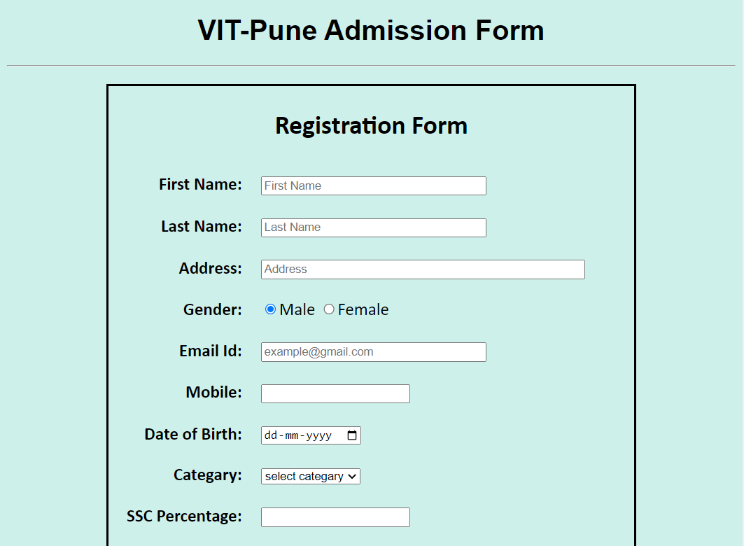****

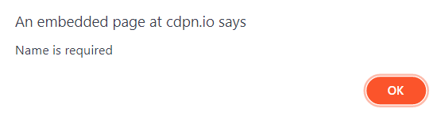

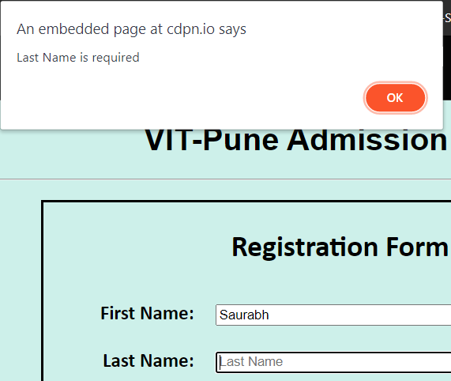

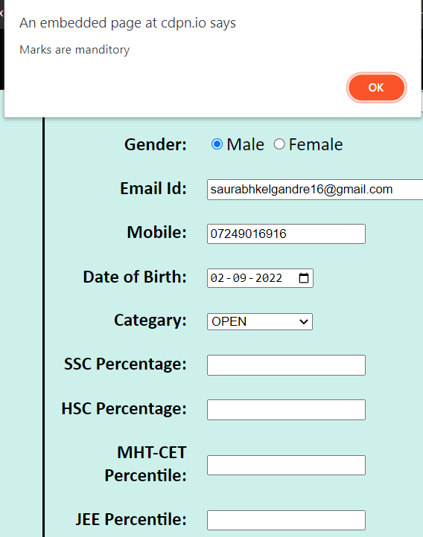

**The form is validated for parameters like Fname, Lname, Address, Email , mobile, category as well as SSC , HSC , CET and JEE Marks.**

**--------------------------------------------------------------------------------------------------------**