Walmart Sales Report

# 1. Executive Summary

This report provides a summary analysis of Walmart sales transactions, including sales performance by product category, customer ratings, payment methods, and profit margins. The data includes 10,051 transactions with details on locations, prices, and customer feedback.

# 2. Descriptive Statistics

unit_price quantity total_sales rating profit_margin  
count 10020.00 10020.00 10020.00 10020.00 10020.00  
mean 50.63 2.35 121.24 5.82 0.39  
std 21.20 1.60 112.47 1.76 0.09  
min 10.08 1.00 10.17 3.00 0.18  
25% 32.00 1.00 54.00 4.00 0.33  
50% 51.00 2.00 88.00 6.00 0.33  
75% 69.00 3.00 156.00 7.00 0.48  
max 99.96 10.00 993.00 10.00 0.57

# 3. Sales Analysis

The chart below shows the total sales by product category.

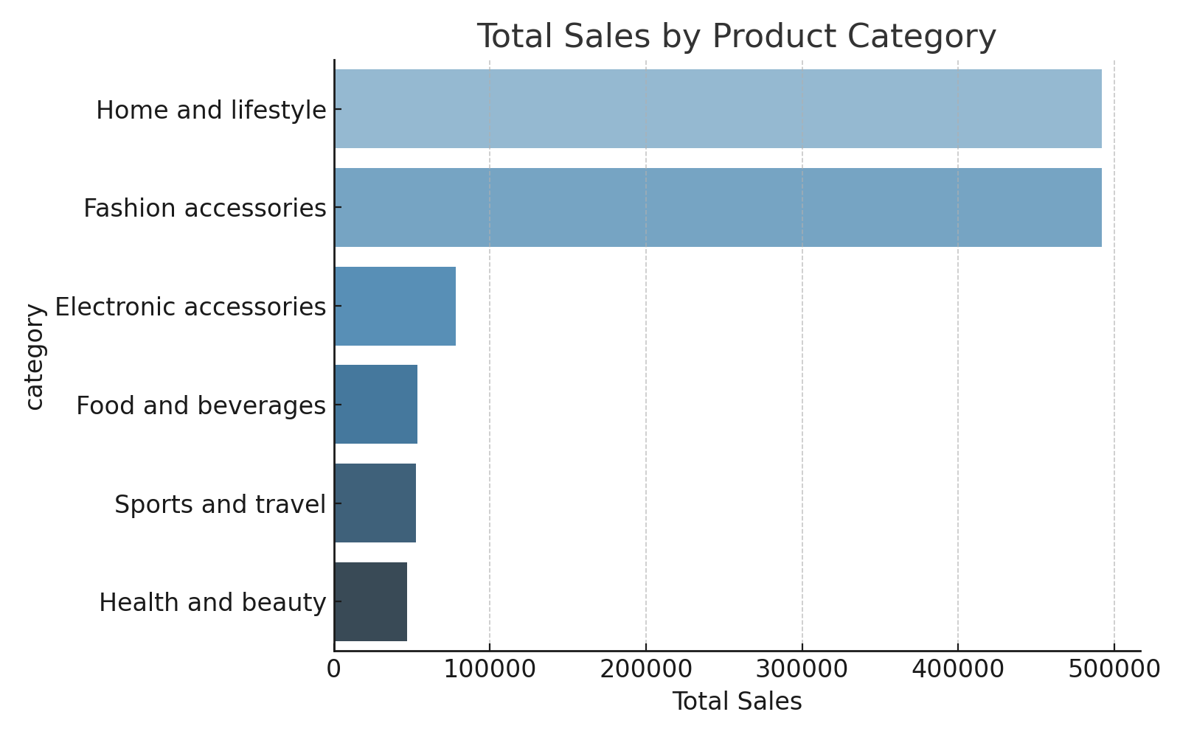

The chart below shows the average customer rating by payment method.

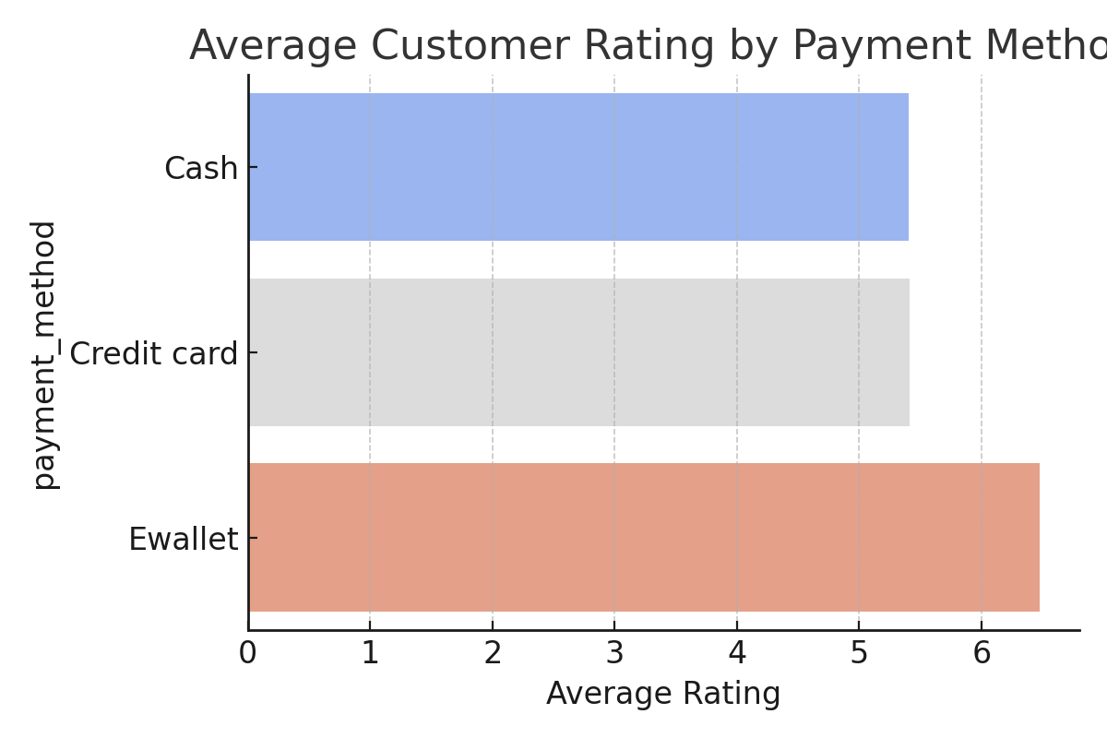

# 4. Key Insights

- The highest grossing product categories include fashion and health-related items.

- E-wallet and credit card users tend to give higher ratings.

- Most transactions include 1–3 units, with profit margins mostly around 33% or 48%.