* FFF

SATVIK JOSHI

STUDENT

H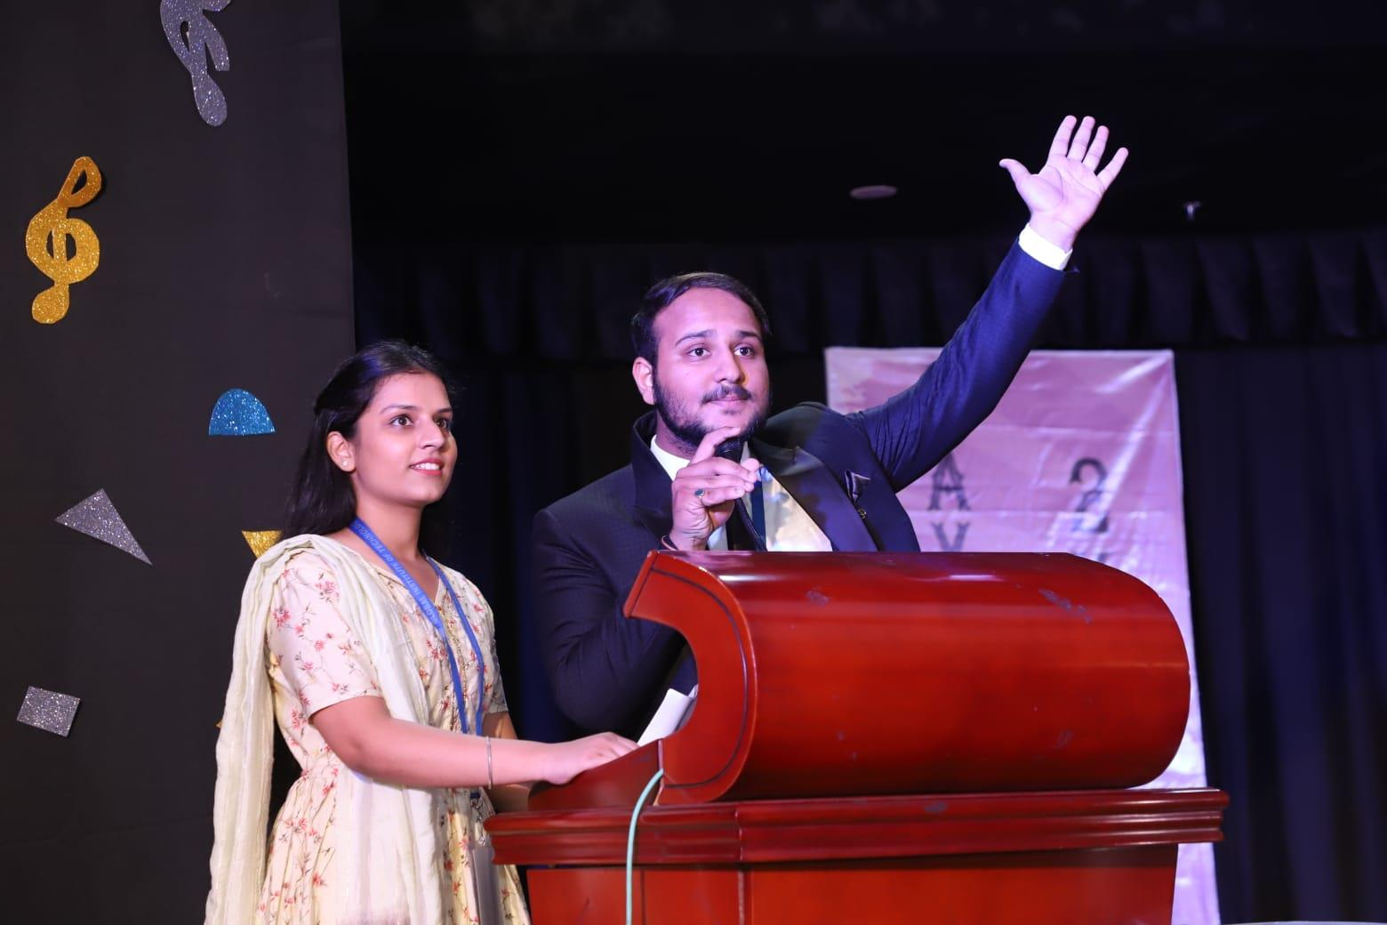

Contact Number : 8561052572

Email Id : [saatvik2710@gmail.com](mailto:saatvik2710@gmail.com)

Address : C-350,Kings Road, Nirman Nagar, Jaipur, Rajasthan

DOB : 27-10-2001

* C Language
* C++ Language
* Java
* Good knowledge of Social media
* LS
* Watching movies
* Drawing pichwai art
* Swimming
* Doing Stand-up Comedy

LS

LS

LS

LS

LS

LS

LS

LS

LS

LS

LS

LS

LS

LS

**PERSONAL DETAILS**

OBJECTIVE

To be a part of enthusiastic work environment wwwwhere where i can use my technical skills to accoma accomplish organizational goals.

QUALIFICATION

GLOBAL INSTITUTE OF TECHNOLOGY, JAIPUR

B.Tech( Computer Science)

8.21 cgpa

Saint Anselms Sr.Sec School, Jaipur

**SKILLS**

Class 12th Batch-2019

71.02 %

S Saint Anselms Sr.Sec School, Jaipur

Class 10th Batch-2017

08.80 cgpa

**INTEREST**