Final Project : Zomato Restaurants Data Visualization in PowerBI

Project Overview
This project aimed to create an interactive dashboard for analyzing data from a dataset containing information about Zomato. Zomato is a multinational restaurant aggregator and food delivery company. The dataset was sourced from TrippleTen and it included details about restaurants, menus, orders, users, and food items.

Data collection
Data set given by Trippleten contain the following data:

- Restaurants: Details about restaurants, including ratings and location.
- Orders: Data on orders, including sales amount, quantity, and date.

Data Preparation and Cleaning
In PowerBI, extensive data cleaning and validation were performed to ensure data accuracy and consistency:

- Restaurant Table:
  - Validated all columns and removed duplicates based on the restaurant ID.
  - Deleted the rows(86 rows) which have blank “Name” and “rating” columns.
  - Updated the “rating” column to replace the value from “--” to “0”.
  - Validated and deleted unwanted rows which do not have valid cuisine.
  - Split Cuisine column by “,” delimiter.
  - Split City column to keep only city name (removed area name)
- Order Table:
  - Validated to ensure all sales data were non-negative.
  - Deleted 2 rows which had the “currency” column value as “USD”.
  - Deleted 2 rows where sales_amount = -1

New Columns and Metrics
Several new columns and metrics were created to enhance the analysis:
- Conditional Columns 4.5+ Star Restaurant (Yes/No): Created from the ratings column in the restaurant table to identify high_rated restaurants.
- DAX Measures:
  - Revenue: Calculated using the formula SUMX(orders, orders[sales_amount] * orders[sales_qty]).

Data Visualization
All charts in this report and an interactive dashboard were designed and developed by me using Power BI, providing a dynamic and comprehensive visual representation of the data. I have used Donut-chart, Stacked Column charts, Line and stacked column charts, Clustered column charts and Key cards in the dashboard.

- Dashboard Design:
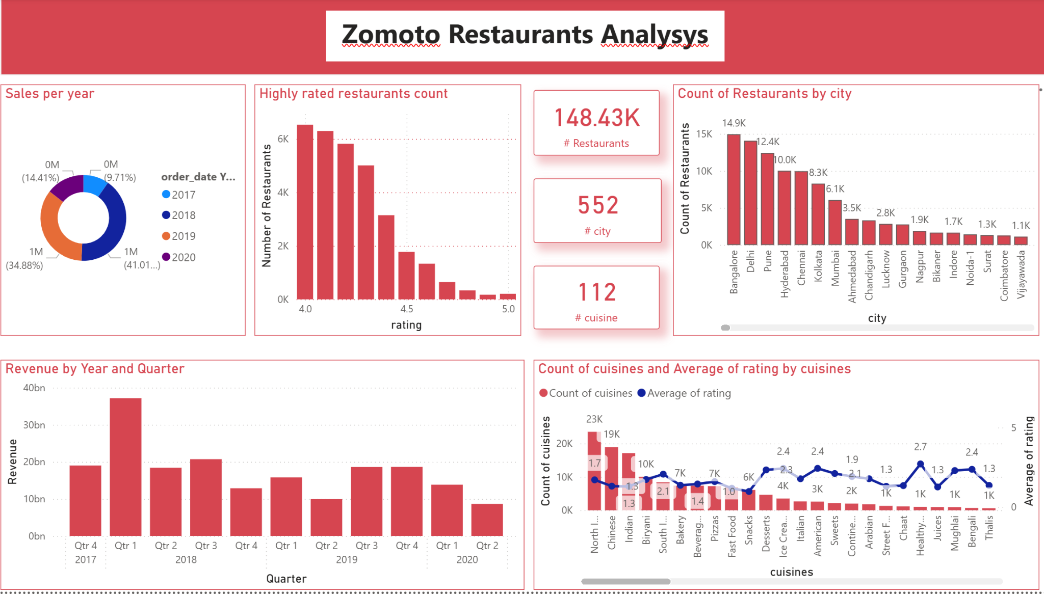

- Highly rated restaurants counts
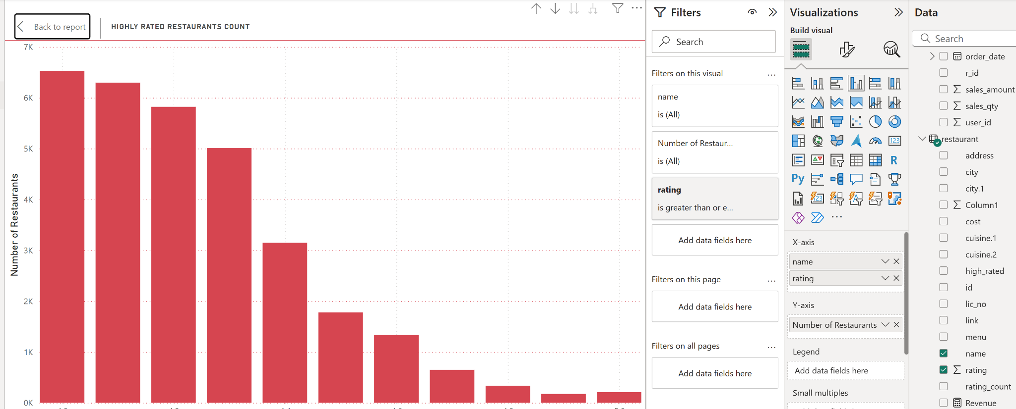

- Counts of restaurants by city
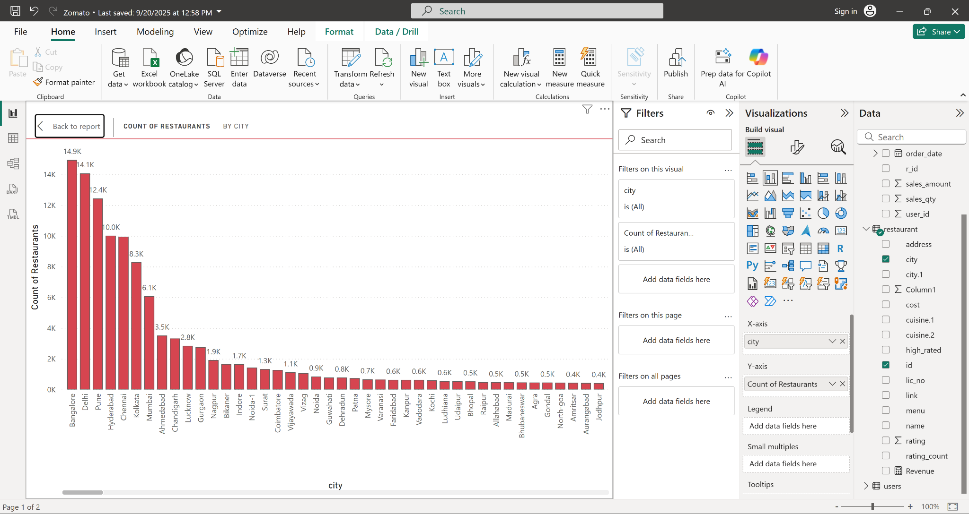

- Count of cuisines and average rating:
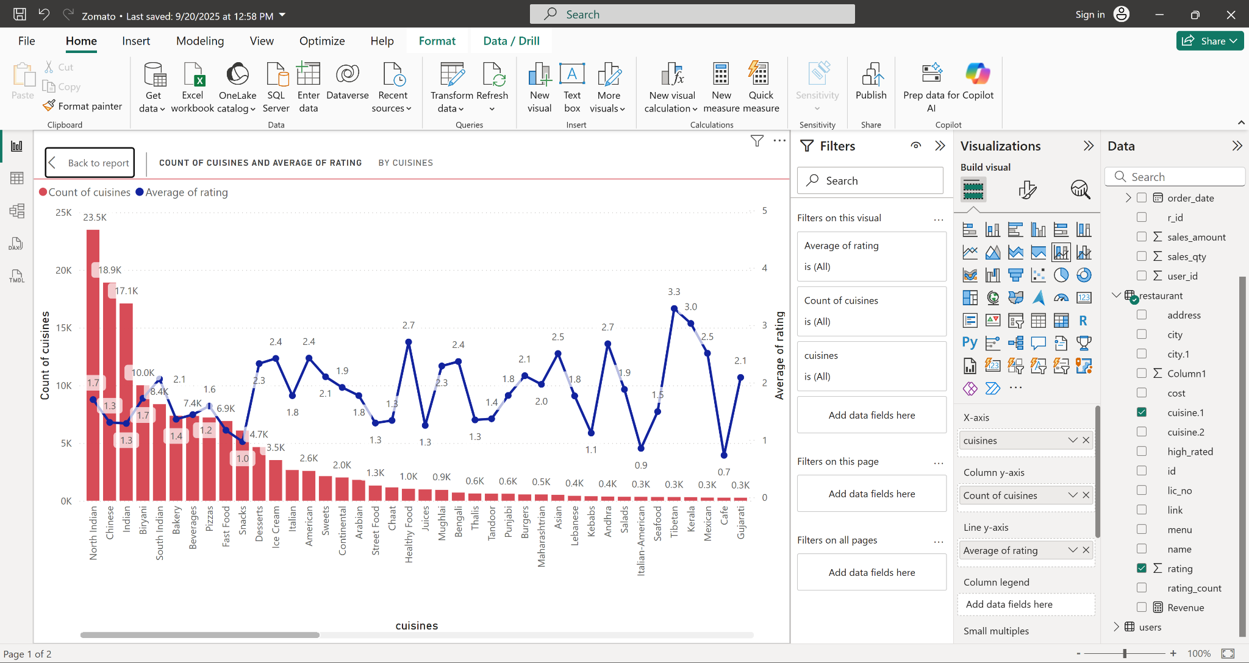

- Revenue by year and quarter:
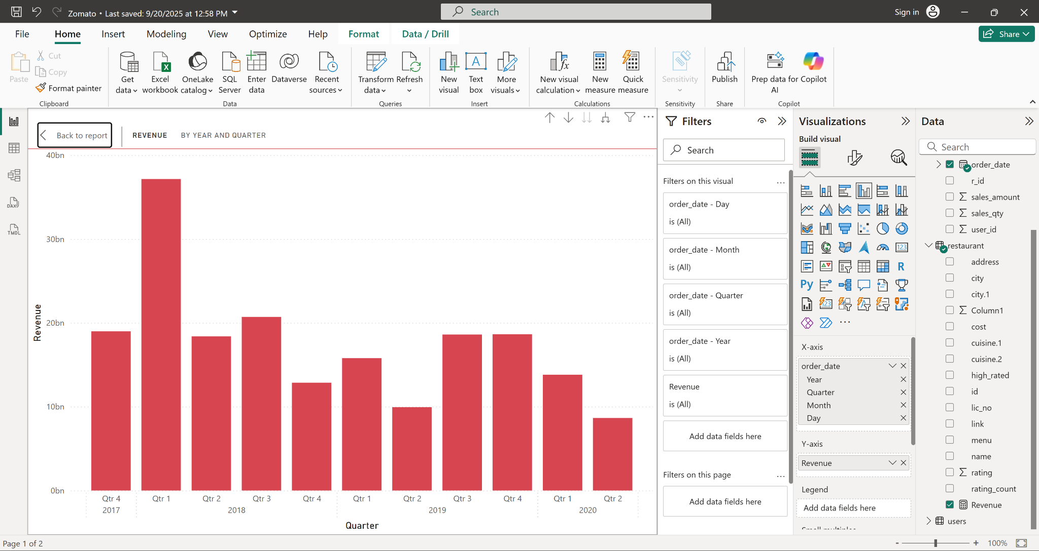

- Sales per year: This is a donut-chart, if you click on any of the year, the chart again drills down to the quarter and after that to months and then the date.
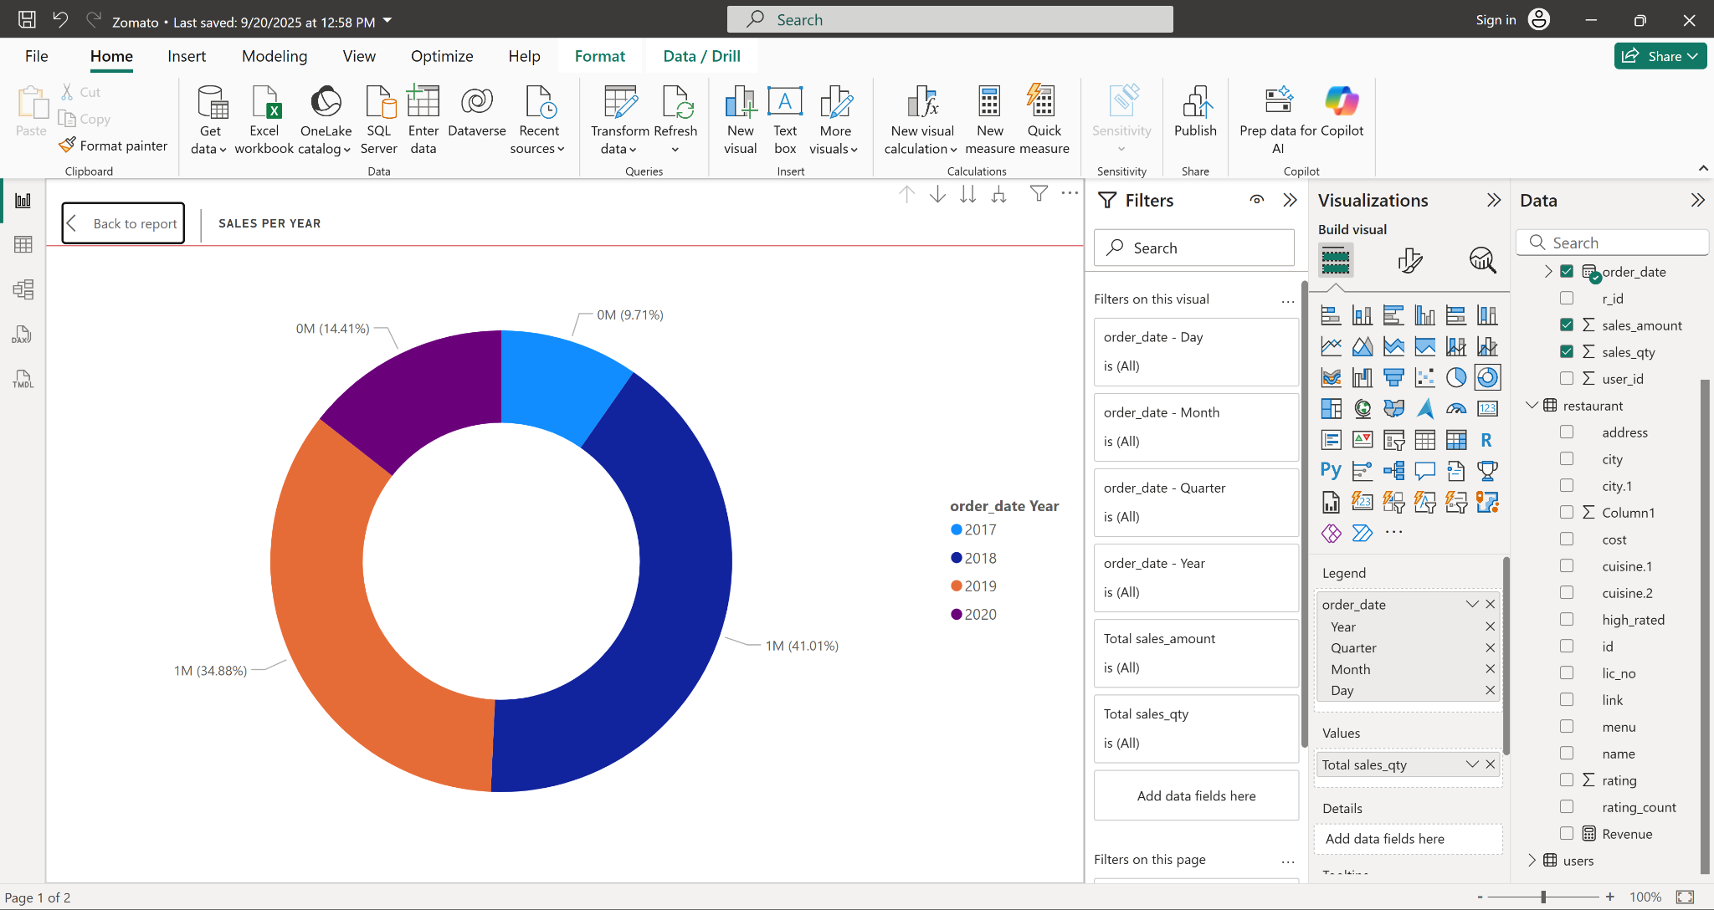

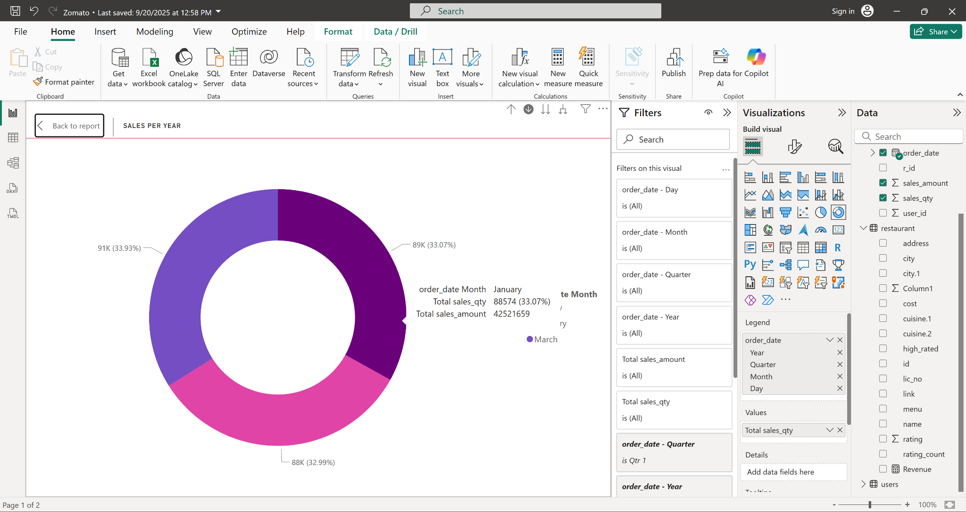

Key insight and visual analysis:
I have done the Restaurant Analysis and below are the key insights:

- The total number of restaurants are 148.43K in 552 cities in India. And it has total #112 cuisines.
- There are 209 restaurants which have 5 ratings and 4K+ restaurants have 4.5+ ratings.
- Bangalore leads with 14.9K restaurants, followed by delhi and pune.
- North-indian cuisine is the most common, followed by chinese cuisines.
- 2018-Q1 has the highest revenue ~ 37bn.
- 2018 has the highest sales-41%.

Recommendation:
- Expend in cities where it shows rapid growth like Bangalore and Delhi.
- Ask for more reviews and ratings after every order completion, as few restaurants have very few rating-counts.
- Check the pattern which month has highest sales, during that time do more promotions in less growth cities.

Conclusion:
The Zomoto dashboard provides powerful insights into the restaurant ecosystem across multiple cities for every year. The combination of interactivity and visual clarity enables stakeholders to explore business patterns, identify growth areas and access service quality metrics.
However, the dataset covers only 2017-2020 and may not fully represent the entire Indian market. Future enhancements could include expanding the dataset, integrating more demographic variables, and collecting user feedback to improve functionality.

