QUEEN-VISION
N-Queens Backtracking Visualizer
FINAL PROJECT REPORT

Academic Details | Information
Student name(s) and roll number(s) | [Enter student name(s) and roll number(s)]
Department | [Enter department]
College / institution | [Enter college name]
Project guide | [Enter guide name and designation]
Academic year | [Enter academic year]

Project repository: https://github.com/sardar000000/N-Queens-Visualizer
Prepared from the implemented source code and local verification run.

2. Abstract & Introduction

Abstract
QUEEN-VISION is an interactive educational application for exploring the N-Queens problem. A user selects a board size from 4 to 12 and chooses either the first-solution or all-solutions mode. A Python backtracking solver checks column and diagonal constraints while placing one queen per row. The application records structured events so placements, conflicts, completed boards, and backtracks can be replayed in a Streamlit interface. It also summarizes search statistics and exports results as JSON and CSV. The project is intended to make a recursive search process observable, testable, and easier to explain; it does not use a database or user authentication.

Introduction and problem background
The N-Queens puzzle asks how to place N queens on an N by N chessboard so that no two queens share a column or diagonal. A conventional solver can return an answer without exposing how it reached that answer. This makes recursion, pruning, and backtracking difficult for a learner to follow.

Proposed solution and purpose
The project combines a constraint-based backtracking solver with a replayable event trace and an interactive board. Its purpose is to demonstrate how a search algorithm accepts safe choices, rejects conflicting candidates, and reverses decisions when a branch cannot be completed.

3. Problem Statement, Objectives & Scope

Problem statement
Learners need a clear way to observe the decision sequence of an N-Queens search. A static final board does not show candidate checks, conflicts, or the undo operation that makes backtracking work.

Objectives
- Solve the N-Queens problem for supported board sizes N=4 through N=12.
- Offer first-solution and all-solutions search modes.
- Visualize placements, conflicts, and backtracks as a step-by-step trace.
- Report solution counts, candidate nodes, placements, conflicts, backtracks, recursion depth, and elapsed time.
- Export statistics as JSON and event/solution data as CSV.

Scope and target users
The current scope is a local, browser-based educational prototype. It supports one active run at a time, with results held in Streamlit session state and bounded trace recording. Target users include students learning recursion and constraint search, instructors demonstrating algorithms, and hackathon reviewers.

Out of scope
- Persistent user accounts, role management, and authentication.
- A database or long-term storage of runs; results are generated in memory and can be downloaded.
- Collaborative sessions, cloud deployment, and board sizes outside the validated 4-12 range.

4. Features & Functional Requirements
ID | Requirement | Current implementation
FR-01 | Choose board size | Slider accepts N from 4 to 12; solver rejects values outside this range.
FR-02 | Choose solve mode | First solution or all solutions.
FR-03 | Inspect search | Live board, step controls, current decision, event log, and conflict highlighting.
FR-04 | Inspect results | Solution gallery, metrics, depth/activity charts, and algorithm explanation.
FR-05 | Export results | Statistics JSON, trace CSV, and selected solution CSV.
FR-06 | Bound trace memory | Configurable event cap; truncation is reported while search results remain complete.

CRUD, authentication, and validation
Area | Status
Create / Read / Update / Delete | No persistent records exist. Users create an in-memory run, inspect it, change run settings, and reset the session. Downloaded files are user-managed.
Authentication | Not implemented; the prototype is a local educational tool.
Input validation | N is constrained to 4-12 in the UI and validated by NQueensSolver. Trace limit is bounded in the UI.

System requirements
- Python environment compatible with Streamlit; project dependencies are declared in requirements.txt.
- Web browser and local runtime; Windows run.bat and macOS/Linux run.sh launch scripts are provided.
- Core dependencies: Streamlit, pandas, and NumPy. No database server or external API is required.

5. Algorithms & Methodology

System workflow and data flow
Input | Processing | Algorithm | Output
N and solve mode | Validate N; initialize board and state sets | Row-wise backtracking with column/diagonal checks | Solutions, event trace, metrics, JSON/CSV downloads

- The user chooses N, solve mode, and the maximum trace length.
- The solver initializes an empty board and sets for occupied columns and diagonals.
- For the current row, each column is tested; unsafe candidates are recorded as conflicts.
- A safe candidate is placed and recursion advances to the next row.
- A completed board is recorded. The placement is then undone so search can continue when requested.
- The interface presents the event sequence, solutions, metrics, charts, and export controls.

Algorithm and complexity
The solver processes one row at a time. A position is safe when its column, row-minus-column diagonal, and row-plus-column diagonal are not already occupied. These set lookups make each safety check average O(1). The commonly stated worst-case time bound for the core search is O(N!), with O(N) recursive board/state space, excluding stored solutions and visualization events.
Core decision rule: SAFE(r,c) = column[c] unused AND diagonal_down[r-c] unused AND diagonal_up[r+c] unused.

Development and verification methodology
The implementation is separated into a solver module, export helpers, and a Streamlit interface. Verification uses known solution counts for N=4 and N=8, checks that returned arrangements satisfy column and diagonal constraints, exercises first/all modes and invalid bounds, and confirms trace-limit signaling. A Python syntax compilation check and a local Streamlit launch were also performed.

6. Technologies & Implementation
Layer | Technology | Role
Interface | Streamlit | Sidebar controls, tabs, board rendering, charts, and downloads.
Styling | Custom CSS and HTML fragments | QUEEN-VISION theme, chessboard styling, metrics, and event presentation.
Application logic | Python | Solver orchestration, session state, event trace, and exports.
Data presentation | pandas and NumPy | Metric/event tables and chart-ready data; NumPy is declared as a project dependency.
Persistence | None | Runs remain in memory; exports are generated as files on demand.
External APIs | None | No third-party service is needed for the core workflow.

Implementation details
- NQueensSolver keeps the board, occupied columns, two diagonal sets, solution list, event list, and counters.
- Each event stores action, row, column, board snapshot, recursion depth, and a readable message.
- The interface offers Live Visualizer, Solutions, Metrics, and Algorithm tabs with step navigation.
- Export helpers serialize statistics to JSON and trace/solution rows to CSV.
- The trace can be truncated at a configured cap to constrain visualization memory without stopping the search.

7. Results, Testing & Performance
Verification was performed against the current source in the local Python 3.14 virtual environment. The N=8 all-solutions run returned the established count of 92 and every arrangement passed column and diagonal uniqueness checks.

Measured solver results
Run | Solutions | Candidate nodes | Placements | Conflicts | Backtracks | Trace events | Observed time
N=4, all | 2 | 60 | 16 | 44 | 16 | 80 | 0.090 ms
N=8, first | 1 | 876 | 113 | 763 | 113 | 992 | 0.873 ms
N=8, all | 92 | 15720 | 2056 | 13664 | 2056 | 17870 | 18.524 ms

Timing is a single local observation of the solver core, not a benchmark; results vary with hardware and runtime. UI rendering and trace visualization are excluded.

Test cases
Test | Expected / check | Result
N=4, all solutions | 2 valid arrangements | PASS
N=8, all solutions | 92 valid arrangements; all satisfy constraints | PASS
N=8, first solution | Exactly one result returned | PASS
N=3 and N=13 | Rejected outside supported range | PASS
Trace cap at 1,000 events | Truncation flag set; solver completes | PASS
Python compileall | app.py and src modules compile | PASS
Streamlit smoke test | App starts locally and renders controls/results | PASS

Sample output
Figure 1. Valid N=8 arrangement returned by the solver. Queen columns by row: 1, 5, 8, 6, 3, 7, 2, 4.
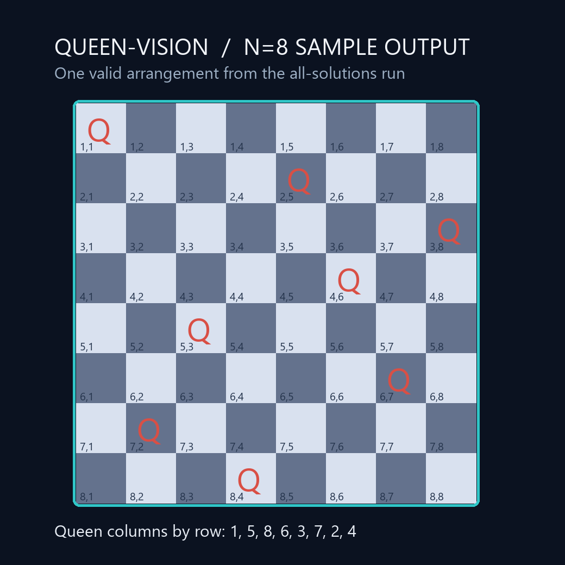
N=8 all-solutions summary: 92 solutions, 15,720 candidate nodes, 17,870 trace events, 0.0185 s observed core runtime.

8. Conclusion, Future Scope & References

Conclusion
QUEEN-VISION solves and visualizes the N-Queens search as an ordered series of decisions rather than only presenting a final board. The implementation combines a modular backtracking solver, a bounded event trace, useful execution statistics, and portable JSON/CSV exports. Tests confirmed expected N=4 and N=8 solution counts and validated the returned arrangements.

Future enhancements
- Add autoplay, playback speed control, and improved trace filtering/search.
- Add alternative solver strategies, such as bit-mask optimization, for larger N.
- Add unit tests and continuous integration across supported Python versions.
- Offer optional persistence, shareable run files, and hosted deployment; these are not part of the current prototype.
- Improve keyboard accessibility and provide configurable visual themes.

References and documentation
- Project source: https://github.com/sardar000000/N-Queens-Visualizer
- Python documentation: https://docs.python.org/3/
- Streamlit documentation: https://docs.streamlit.io/
- pandas documentation: https://pandas.pydata.org/docs/
- NumPy documentation: https://numpy.org/doc/
- Eight queens puzzle background: https://en.wikipedia.org/wiki/Eight_queens_puzzle

