⬆️ Full chart screenshot for DOWN trade

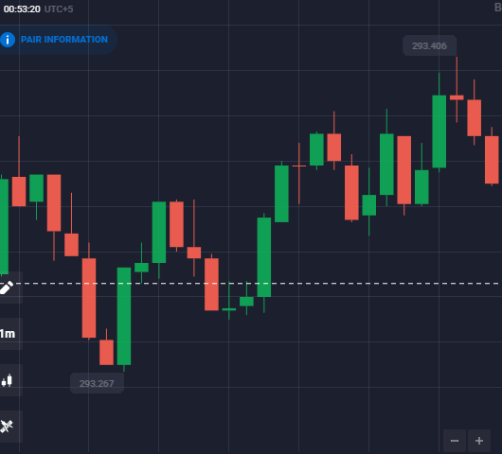

🔎 Cropped 4-candle screenshot for DOWN trade

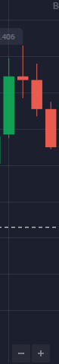

⬆️ Full chart screenshot for DOWN trade

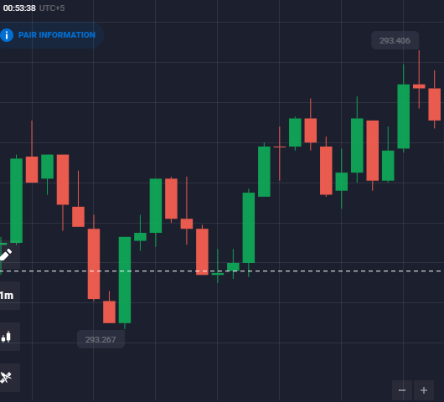

🔎 Cropped 4-candle screenshot for DOWN trade

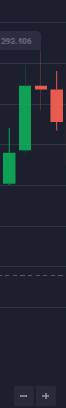

⬆️ Full chart screenshot for DOWN trade

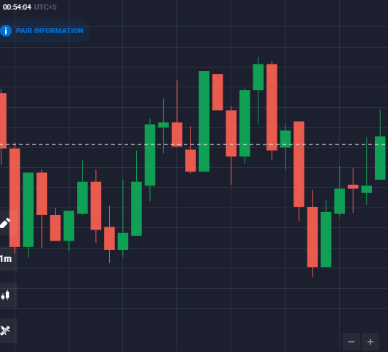

🔎 Cropped 4-candle screenshot for DOWN trade

