⬆️ Full chart screenshot for NO_SIGNAL trade

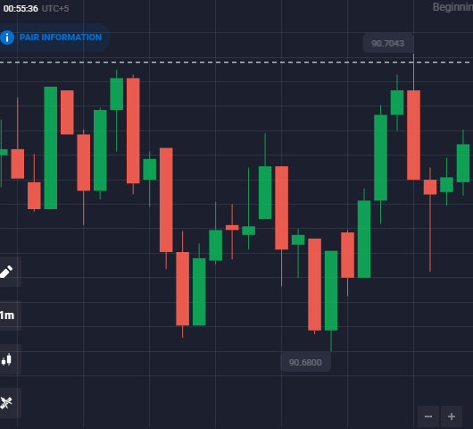

🔎 Cropped 4-candle screenshot for NO_SIGNAL trade

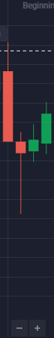

⬆️ Full chart screenshot for NO_SIGNAL trade

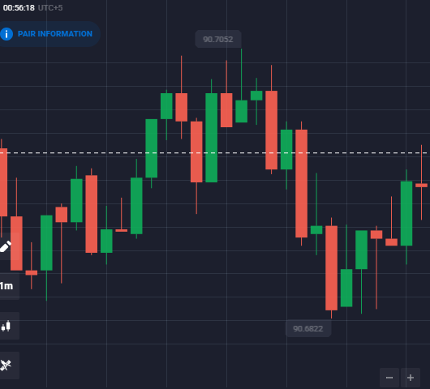

🔎 Cropped 4-candle screenshot for NO_SIGNAL trade

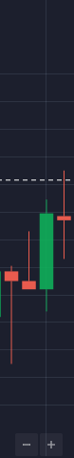

⬆️ Full chart screenshot for NO_SIGNAL trade

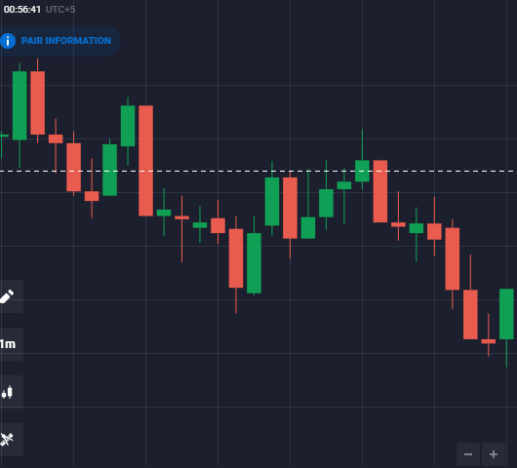

🔎 Cropped 4-candle screenshot for NO_SIGNAL trade

