⬆️ Full chart screenshot for UP trade

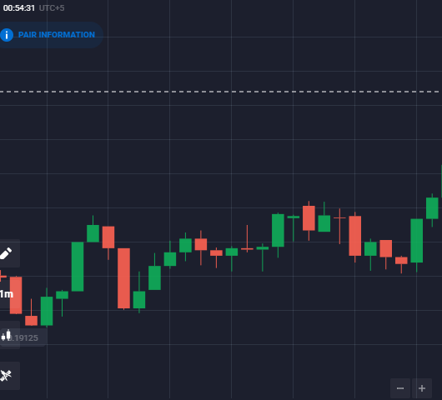

🔎 Cropped 4-candle screenshot for UP trade

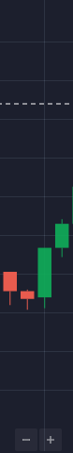

⬆️ Full chart screenshot for UP trade

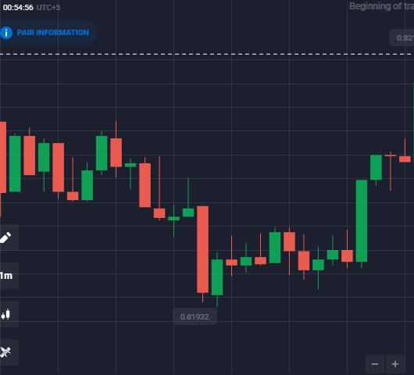

🔎 Cropped 4-candle screenshot for UP trade

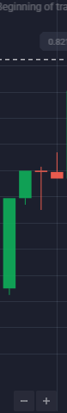

⬆️ Full chart screenshot for UP trade

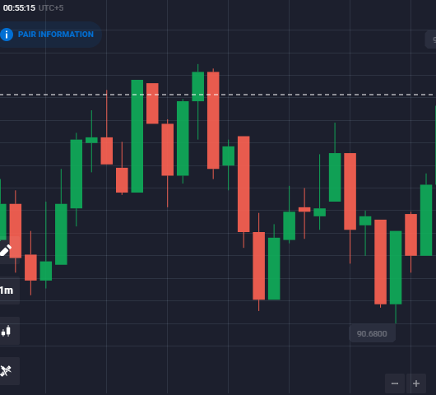

🔎 Cropped 4-candle screenshot for UP trade

