# Service page

1. Boundaries of First graphic should have foggy effect, check if it looks good, if not keep it as it is.
2. Our Expert – Web Developer, Web Designer, SEO Specialist
3. Alignment has to be corrected as explained.
4. Check why placement of PNGs, there are some issues with it. Screenshot attached.

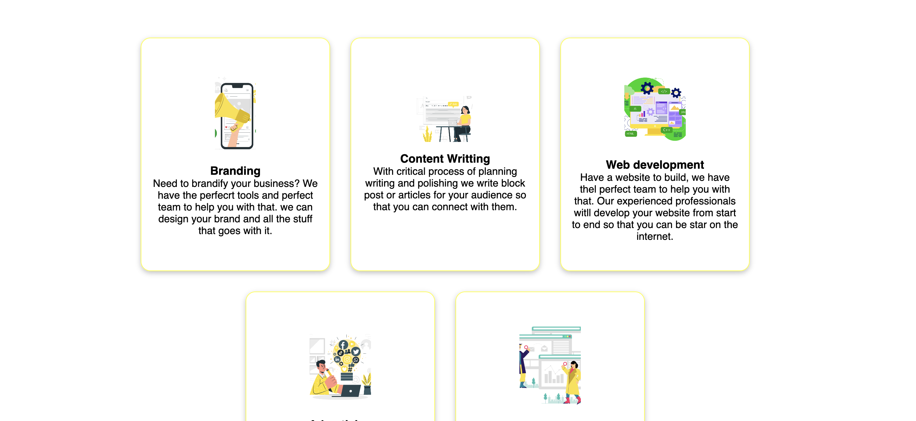

# Blog – Coming Soon.

# Careers page

1. “EveryEveryone” this has to be corrected.
2. Check alignment in “We look for” section.
3. Full Time & Internship section, PNGs has to be changed, pick good PNGs from freepik. Also, correct the placement, the gap between one listing and another is inconsistent.
4. Bold requirements.

# About Us

1. First graphic has to be removed.
2. Check grammar mistakes in the content.
3. Bold each heading of our principal section.
4. Why choose us – “At Surgeped, we stand out from the competition with our unrivaled expertise in SEO, providing customized and data-driven solutions that deliver measurable results. With a focus on transparency and collaboration, we prioritize our clients' success and strive to build lasting partnerships based on trust and excellence in digital marketing.”