**SPARES HUB**

**Developed By:**

**WAHEED KHALIL** 04-FBAS/BSIT04/F15

**M.JUNAID** 13-FBAS/BSIT04/F15

**Supervised By:**

Dr. Ayyaz Hussain

**Department of Computer Science and Software Engineering**

**Faculty of Basic and Applied Sciences International Islamic University Islamabad 2020**



A dissertation submitted to

**DEPARTMENT OF COMPUTER SCIENCE AND**

**SOFTWARE ENGINEERING INTERNATIONAL ISLAMIC UNIVERSITY ISLAMABAD,**

As partial fulfillment of the requirement of bachelor’s degree in Software Engineering

**Declaration**

We hereby declare that this application, neither as a whole nor as a part there of has been copied out from any source, it is further declared that I developed this application entirely on the basis of my personal efforts made under the sincere guidance of my supervisor and teachers.

No portion of the work presented in this report has been submitted in support of any application for any other degree or qualification of this or any other institute of learning.

**WAHEED KHALIL** 04-FBAS/BSIT04/F15

**M.JUNAID**

13-FBAS/BSIT04/F15

**Final Approval**

Faculty of Basic and Applied Sciences

Department of Computer Science and Software Engineering

International Islamic University Islamabad Pakistan

Dated:

**COMMITTEE**:

1. **External Examiner**

**Dr. Qaisar Javaid**

Assistant Professor,

DCS & SE, FBAS, International Islamic University, Islamabad

1. **Internal Examiner**

**Mr. Muhammad Sameer Akram**

Lecturer,

DCS & SE, FBAS, International Islamic University, Islamabad

1. **Supervisor**

**Dr. Ayyaz Hussain**

Associate Professor,

DCS & SE, FBAS, International Islamic University, Islamabad

**Preface**

This document is distributed into several chapters for the ease of understanding. The chapters are quite comprehensive and explain the terminologies require for the complete understanding of the project.

Following is the brief description of the chapters included in this report. Chapter 1: It gives the brief overview and introduction about the system. Chapter 2: It gives the analysis of requirements of the system.

Chapter 3: It presents the design process of the system. Chapter 4: It describes the system design and its components. Chapter 5: It describes the System Testing.

Chapter 6: It describes conclusion we derived from this project

**Acknowledgments**

First, I would like to thank my project supervisor **Dr. Ayyaz Hussain** for helping and his continuous guidance and support. Some other people that deserve greatly to be acknowledged that are Dr. Asim Munir, Mr. M. Nadeem, Dr. Qaiser Javaid, Dr. Muhammad Adeel, Mr. M. Imran Saeed, Mr. Zulqarnain Hashmi, Mr. Usman Nasir, Mr. Iftikhar Ali Khan are the best teachers who guided us in different situations and gives us good advices all the time.

A definition of acknowledgment is the act of accepting the truth. A fact is that over the couple of years we have been absorbed with our academic life due to the love of learning. The underlying truth is that my friends and family understood this and supported us. This was consistently (and still is) demonstrated by Dr. Ayyaz Hussain to whom we are grateful too.

Finally, the credit goes to all the members of Computer Science and Software Engineering department who taught us in past four years. All the teachers who taught us were very friendly and supportive because of their hard working, guidance and teachings today I am able to do my final year project confidently. We had a great company of the best teachers we ever had, as well as their encouragement to maintain our progress in track. I would like to appreciate the guidance given by other supervisor as well as the panels especially in my project presentation that has improved our presentation skills by their comment and tips

**Project in Brief**

|  |  |
| --- | --- |
| ***Project Title:*** | Spares Hub |
| ***Undertaken By:*** | WAHEED KHALIL  M.JUNAID |
| ***Supervised By:*** |  |
| ***Date Started:*** | 21/02/2018 |
| ***Date Completed:*** | 20/08/2018 |
| ***Tools,*** | Sqlyog, Visual Studio, Code, Wamp |
| ***language Used:*** | HTML, CSS, JavaScript, Php framework, Java, Laravel |
| ***System Used:*** | Core i5, 6gb RAM, Windows 8.1, Android 6.0 |

**Dedicated To**

Our beloved Parents, Teachers, Siblings and Friends

Without their immense support, endless prayers and strong belief in me, the completion of this project, which is a milestone towards the success they want us to achieve, would have been a mere dream.

**Table of Contents**

1. Introduction 1
   1. Abstract 2
   2. Existing System 2
      1. CUSTOMINK 2
      2. RUSHORDERTEES 2
   3. Problem Statement: 2
   4. Proposed Solution 3
   5. Project Scope: 3
2. System Analysis 4
   1. Requirement Analysis: 5
   2. Use-Case Model 6
      1. The basic method to identify use cases 6
   3. Use Case Diagrams: 8
   4. Use Cases: 9
      1. Initiates System 9
      2. Do Registration 9
      3. Do Login 9
      4. Use a Predesigned Shirt 10
      5. Custom Design Shirt 10
      6. Try Designed Shirt 10
      7. Save Design 11
      8. Confirming Order 11
      9. Payment Method 11
   5. Use case description in detailed expended format 11
      1. Initiates System 12
      2. Do Registration 13
      3. Do Login 14
      4. Use a Predesigned Shirt 15
      5. Custom Design Shirt 15
      6. Try Designed Shirt 16
      7. Save Design 17
      8. Confirming Order 18
      9. Payment Method 19
   6. System Sequence Diagrams 20
      1. Initiates System [ Main Success Scenario] 20
      2. Initiates System [ Alternative] 20
      3. Sign up [ Main Success Scenario] 21
      4. Sign up [ Alternative] 21
      5. Login [ Main Success Scenario] 22
      6. Login [ Alternative] 22
      7. Use Predesigned Shirt [ Main Success Scenario] 23
      8. Use Predesigned Shirt [ Alternative] 23
      9. Custom Design Shirt [ Main Success Scenario] 24
      10. Custom Design [ Alternative] 24
      11. Try Designed Shirt [ Main Success Scenario] 25
      12. Try Designed Shirt [ Alternative] 25
      13. Save Design [ Main Success Scenario] 26
      14. Save Design [ Alternative] 26
      15. Confirm Order [ Main Success Scenario] 27
      16. Confirm Order [ Alternative] 27
      17. Payment Method [ Main Success Scenario] 28
      18. Payment Method [ Alternative] 28
   7. Operation Contracts 29
      1. Initiate System 29
      2. SignUp 29
      3. Login 29
      4. Use a Predesigned Shirt 29
      5. Custom Design Shirt 30
      6. Try Designed Shirt 30
      7. Save Design 30
      8. Confirming Orders 31
      9. Payment Method 31
   8. Activity Diagrams: 32
      1. Sign up Activity 32
      2. Login Activity 33
      3. Predesigned/Custom Design 34
      4. Order Activity 35
3. System Design 36
   1. Communication Diagram 37
   2. Class Diagram 38
   3. SCHEMA or ERD 39
4. Implementation 40
   1. Component Diagram 41
   2. Deployment Diagram 42
5. Testing 43
   1. Methodology 44
   2. Black Box Testing 44
   3. White Box Testing 44
   4. Verification 45
   5. Validation 45
   6. Test Cases 45
      1. TC01: To test the Signup interface 45
      2. TC02: To test the Login interface 46
      3. TC03: Use a predesigned Shirt 46
      4. TC04: To Design Custom Shirts 47
      5. TC05: To Try Custom Designed Shirt 47
      6. TC06: To Save Custom Designed Shirt 48
      7. TC07: To Adding to Cart 48
      8. TC08: To Select Payment Method 49
6. Conclusion 50

Chapter 1

# Introduction:

## Abstract:

The purpose of **Spares Hub** is to provide reliable, convenient, easy and fast online appointment of Car washing and ordering of the spare parts of cars. Its main focus is on the users who needs to Order Spare parts of Automobile by simply on this Website and also make appointments related to their Automobile. This explains how the Spares Hub app will help its user to appoint and order the spare parts of their choice. Print-It is a client-server system to order spare parts of user’s like and choice and order them. These orders are saved in database and can be viewed according to specific user. The system supports real time view of the spare parts and provide complete information related to it.

## Existing System:

* + - **STS Global.**
    - **Alibaba.com**

### STS Global:

STS-Global is an international company with headquarter in Denmark and sister companies based in Houston, Texas USA and Atyrau, Kazakhstan. They are very good in what they do but they do not have any fast time and efficient way of providing availability to their customers as they ask for parts number, quantities and consignee details (final destination). STS-Global professional spare parts department will then send you prices and availability within 24 hours.

### Alibaba.com

Alibaba.com is another company they are also specialized in global trade, but its not only specific to automobiles so you have to search here for your required desire then you can contact to the supplier and if he answers your request then you can order it. They also lack the module which we are providing Real-Time website like time saving and Efficiency.

## Problem Statement:

The problem is an increase Ecommerce industry specially in Pakistan which mostly focuses on expanding their business and have no interest in making users happy. They mostly deliver wrong products, on wrong addresses or deliver low quality products. Now-a-days users wants to be sure of what they are buying in worthy enough. Also, people sometimes design what they think will look good on them but in reality, it does not reflect what they thought. There is a

need for a system which should be capable of showing a user that if User is requesting something will reflect its desires or not.

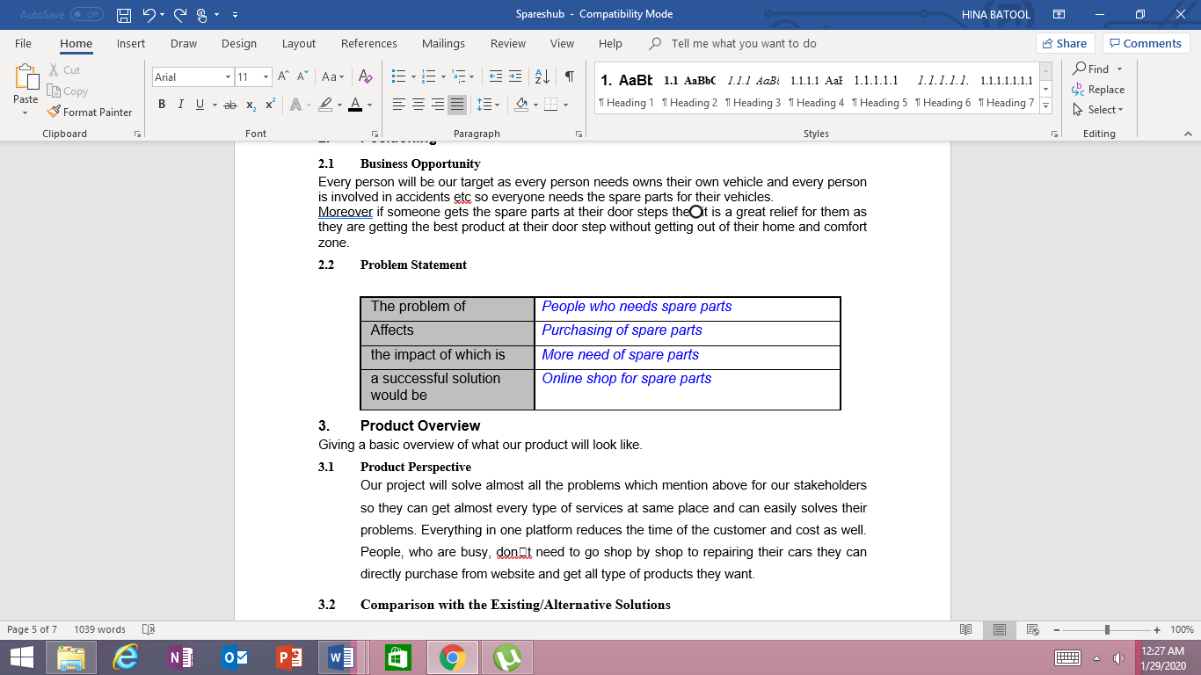

## Proposed Solution:

Our Design system works same as what other’s systems does with the help of our website customer can save their time he can’t go to shop by shop and first dealing with them and then their work will be done. With the help of our website customer make their choice easy. Our objective is to provide a one platform for our customer who wants to connect with us.

## Project Scope:

* This is a customer server framework which enables the user to make online appointment of car washing and order Spare parts of Automobile.
* If the user is registered, then he will be able to Make online Appointments related to his/her Automobile.
* Also, the user will be able to Order Spare parts of Automobiles using our Website.
* User will then be able to save his Appointments.
* System is very affordable all you need is internet connection and a laptop/pc or Mobile phone.
* The uniqueness of our website is that it is updated regularly also provides special discounts on festivals.

Chapter 2

# System Analysis

The preliminary step of SDLC is analysis. Requirements are the capabilities that are desired to be conveyed by the system (framework). We can't have a successful program that does not fulfil whatever the user required. Requirement analysis is the procedure of particular, demonstrating, finding and refinement. It might be capabilities required by the user or those limitations which are needed by the designer. For showing capabilities in better points of interest a requirement can be divided in several sub-requirements. Then we discover every requirement needed by the system, that is the point where we have the complete sketch of the required system. Today’s life has been progressed when we compare it with past. These days, we are moving towards computerization in relatively every part of our lives, we are making a group of more issues when taking care of a few issues.

Our system just free its users from hassles of appointing, ordering and then waiting for the shipment of product. We helps the user by a simple flow pattern which is understandable to user of every level of computer knowledge.

## Requirement Analysis:

Requirement analysis software engineering and system engineering, encloses those problems that effects in resolving the conditions or requirements that should be achieved for another or adjusted picture, assessing the perhaps conflicting requirements of the different partners, for example, clients or recipients. It is a starting time in the broader action of requirements engineering which encloses all exercises worried about archiving, approving, inspiring, dissecting and overseeing system and software requirements. Requirements analysis is important in the successful pursuit of systems or software venture. The requirement ought to be testable, traceable, quantifiable, noteworthy, recorded, identified with distinguished business needs or openings, and characterized to the level of subtle elements enough for system outline.

## Use-Case Model:

A use-case is a chart of actions or event steps typically defining the interactions between a role (known in the Unified Modeling Language as an actor) and a system to achieve a goal. That actor should be a human, external system or any other outer body which can impact on system. In systems engineering use cases are used at a higher level than within software engineering often representing missions or stakeholder goals. The detailed requirements may then be captured in the Systems Modeling Language (SML) or as contractual statements.

* Use case

A use-case is a flow chart of activities or actions that operated in an order while characterizing the flow of information between an actor and the system to accomplish an objective.

* Actor

A use-case differentiates the flow of information between outside bodies and the system under though to achieve a required functionality. On-screen characters must have the ability to decide, whether a human is required or not: “Action performing artist can be a man, organization or association, PC-program, equipment or any other software, or both.”

### 2.2.1 The basic method to identify use cases:

1. Identify System Boundary

Anything beyond the system boundary is not considered as part of system. Print-It encloses a Shirt Designing and Testing System, an Android Application, and a user.

1. Identify Actor
   * **User:**

He is the primary actor of the system. The initiator of the system

* + **Admin:**

It is a system developed in PHP for Customer Ordering of Spare Parts and Accessories also for Maintenance.

* + **Spares Hub App**

It is an application developed in Java, Php framework and Laravel to give user access to make Appointments and ordering conveniently and remotely.

1. Make Actor-Goal List

The main purpose of preparing an Actor-Goal list is to give an easy understanding of what a user will do i.e. action of an actor.

|  |  |
| --- | --- |
| **User** | 1. Initiates System 2. Do Registration 3. Login 4. Car wash Appointment. 5. Order spare parts and accessories. 6. Confirm Order 7. Chose Payment Method |

## Use Case Diagrams:

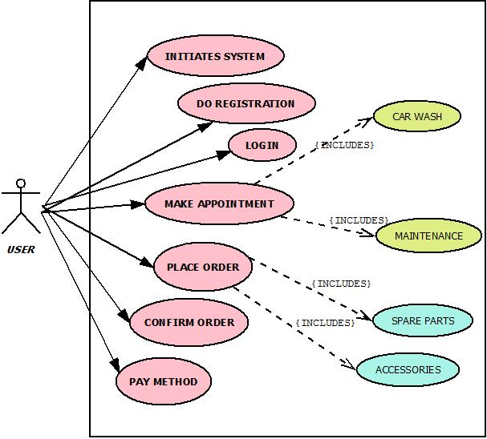

Fig. 2.3.1 Use case diagram for user as actor

## Use Cases:

**Use case description in brief format:**

Use cases of the diagram Fig 2.3.1 against User (actor)

### Initiates System

|  |  |
| --- | --- |
| **Use case ID:** | 1 |
| **Actor:** | User |
| **Type:** | Primary |
| **Description** | User can start |

### Do Registration

|  |  |
| --- | --- |
| **Use case ID:** | 2 |
| **Actor:** | User |
| **Type:** | Primary |
| **Description** | User has to register itself by providing his SignUp details as required by the system. |

### Login

|  |  |
| --- | --- |
| **Use case ID:** | 3 |
| **Actor:** | User |
| **Type:** | Primary |
| **Description** | User has to login itself with its pre-registered login details. |

### Make Appointment

|  |  |
| --- | --- |
| **Use case ID:** | 4 |
| **Actor:** | User |
| **Type:** | Primary |
| **Description** | User can now make appointments like car washing or maintenance. |

### Place Order

|  |  |
| --- | --- |
| **Use case ID:** | 5 |
| **Actor:** | User |
| **Type:** | Primary |
| **Description** | Now user can place the order of spare parts and accessories of automobile. |

### 

### 

### Confirming Order

|  |  |
| --- | --- |
| **Use case ID:** | 8 |
| **Actor:** | User |
| **Type:** | Primary |
| **Description** | User can choose products and other specification and confirm order. |

### Payment Method

|  |  |
| --- | --- |
| **Use case ID:** | 9 |
| **Actor:** | User |
| **Type:** | Primary |
| **Description** | User can choose cash on delivery or pre-pay method for payment. |

## Use case description in detailed expended format

An expanded form of UML is giving point to point detail of every use-case of the system. An extended use-case consist of all the abnormalities that can happen and their solution. There are two areas to the abnormal state use case which are a heading and a body. The heading gives the name, performers, depiction, kind of use case, and that's just the beginning. The

body portrays running of all operations and abnormalities and the solution needed for them. This holds at least two parts with a performing artist activity in one part and the framework reaction in the other part. Common occasions will happen at least 80% of the time and options will happen just 20% or very less time.

* Title of the activity.
* The actors involved with the initiator defined.
* The description of the activity from the high-level use case.
* Type of use case such as primary/secondary/system. By default, this is "primary, essential".
* Cross reference - any related system use cases.
* Pre-condition - Conditions that must be met before the starting of use-case.
* Post-condition –Changes that will be happen after the execution of that use-case.

### Initiates System

|  |  |  |
| --- | --- | --- |
| **Use case ID:** | 1 | |
| **Actor:** | User | |
| **Purpose** | To start the system | |
| **Overview** | User will initiate the system. | |
| **Type:** | Primary | |
| **Cross Reference:** | None | |
| **Pre-Conditions:** | User must have the internet to start the system. | |
| **Typical course of Events** | | |
| **Actor Actions** | | **System Response** |
| **1)** User starts the application | | Application starts successfully due to the  fulfilment of precondition. |
| **Post-Condition** | Application is started and showing its main display page. | |
|  | | |

|  |  |  |  |
| --- | --- | --- | --- |
|  | **Alternative course of Events** | |  |
| **Actor Actions** | **System Response** |
| 1.1) No internet connection. | Website will not be loaded and it will show internet connection not present  error. |

### Do Registration

|  |  |  |
| --- | --- | --- |
| **Use case ID:** | 2 | |
| **Actor:** | User | |
| **Purpose** | To register for the system | |
| **Overview** | User will be prompted to enter required details. | |
| **Type:** | Primary | |
| **Cross Reference:** | None | |
| **Pre-Conditions:** | User should must have started the application and choose  Signup option. | |
| **Typical course of Events** | | |
| **Actor Actions** | | **System Response** |
| **1)** User will enter all the required data in correct format. | | User is successfully added to the system  database. |
| **Post-Condition** | Application allow the user to access all the functionalities. | |
| **Alternative course of Events** | | |
| **Actor Actions** | | **System Response** |
| 1.1) No internet Connection | | Website will not be loaded and it will show internet connection not present  error. |

|  |  |  |  |
| --- | --- | --- | --- |
|  | 1.2) User inputs incorrect data or wrong entry | Tells the user to enter correct data according to the indicated validations. |  |

* + 1. **Login**

|  |  |  |
| --- | --- | --- |
| **Use case ID:** | 3 | |
| **Actor:** | User | |
| **Purpose** | To Login for the system | |
| **Overview** | User will input required data for Login. | |
| **Type:** | Primary | |
| **Cross Reference:** | None | |
| **Pre-Conditions:** | User should must have been registered in the system. | |
| **Typical course of Events** | | |
| **Actor Actions** | | **System Response** |
| **1)** User will input its email address and  password which he registered in the db before. | | System successfully login the user. |
| **Post-Condition** | Application is started giving all the functionalities to user. | |
| **Alternative course of Events** | | |
| **Actor Actions** | | **System Response** |
| 1.1) User is not registered | | Tells user to first register itself. |
| 1.2) User enters invalid data in login form. | | Tells the user to enter correct data which  he provided in the registration process. |

* + 1. **Make Appointment:**

|  |  |  |
| --- | --- | --- |
| **Use case ID:** | 4 | |
| **Actor:** | User | |
| **Purpose** | To allow the user to make appointment related to Automobile. | |
| **Overview** | User will make appointment like car washing or Maintenance. | |
| **Type:** | Primary | |
| **Cross Reference:** | None | |
| **Pre-Conditions:** | User must be logged in to the system | |
| **Typical course of Events** | | |
| **Actor Actions** | | **System Response** |
| **1)** User will make Appointment for washing of Automobile and for Maintenance. | | 1) Appointment will added to the system to respond. |
| **Post-Condition** | After making Appointment user have the Option to save the Appointment | |
| **Alternative course of Events** | | |
| **Actor Actions** | | **System Response** |
| 1.1) No internet Connection | | Website will not be loaded and it will show internet connection not present  error. |

* + 1. **Place order**

|  |  |
| --- | --- |
| **Use case ID:** | 5 |
| **Actor:** | User |
| **Purpose** | To allow user to place order. |
| **Overview** | User will have the option to place order of spare parts and Accessories. |
| **Type:** | Primary |

|  |  |  |  |  |
| --- | --- | --- | --- | --- |
|  | **Cross Reference:** | None | |  |
| **Pre-Conditions:** | User must be logged in to the system. | |
| **Typical course of Events** | | |
| **Actor Actions** | | **System Response** |
| **1)** User will place order of spare parts of Automobile or Accessories. | | order is successfully being added to Cart according to the information given. |
| **Post-Condition** | Order is successfully placed. | |
| **Alternative course of Events** | | |
| **Actor Actions** | | **System Response** |
| 1.1) No internet connection. | | Website will not be loaded and it will show internet connection not present  error. |

* + 1. **Save Design**

|  |  |  |
| --- | --- | --- |
| **Use case ID:** | 7 | |
| **Actor:** | User | |
| **Purpose** | To save the order or Appointment in database. | |
| **Overview** | User will manually save order. | |
| **Type:** | Primary | |
| **Cross Reference:** | None | |
| **Pre-Conditions:** | User must have placed the order and accessed save order  functionality. | |
| **Typical course of Events** | | |
| **Actor Actions** | | **System Response** |
| **1)** User will click save order button to  save his order. | | The placed order has been saved. |
| **Post-Condition** | User can see his saved order in a list. | |
|  | | |

|  |  |  |  |
| --- | --- | --- | --- |
|  | **Alternative course of Events** | |  |
| **Actor Actions** | **System Response** |
| 1.1) No internet connection | Website will not be loaded, and it will  show internet connection not present error. |

* + 1. **Confirming Order**

|  |  |  |
| --- | --- | --- |
| **Use case ID:** | 8 | |
| **Actor:** | User | |
| **Purpose** | To confirm the placed order. | |
| **Overview** | User will send the product to cart. | |
| **Type:** | Primary | |
| **Cross Reference:** | None | |
| **Pre-Conditions:** | User must have added the product in cart. | |
| **Typical course of Events** | | |
| **Actor Actions** | | **System Response** |
| **1)** User will press add to cart button. | | Items are successfully added to cart. |
|  | |  |
| **Post-Condition** | Items will be added in cart and their invoice will be created. | |
| **Alternative course of Events** | | |
| **Actor Actions** | | **System Response** |
| 1.1) No Internet connection | | Website will not be loaded and it will show internet connection not present  error. |
| 1.2) No items to order | | Cart is empty. |

* + 1. **Payment Method**

|  |  |  |
| --- | --- | --- |
| **Use case ID:** | 9 | |
| **Actor:** | User | |
| **Purpose** | Ask about the payment preference of user. | |
| **Overview** | User will be asked about the payment method and order will be  placed. | |
| **Type:** | Primary | |
| **Cross Reference:** | None | |
| **Pre-Conditions:** | User must have ordered something. | |
| **Typical course of Events** | | |
| **Actor Actions** | | **System Response** |
| **1)** User gives his email address | | Verifies the mail format. |
| **2)** User gives his phone number | | Verifies the number format. |
| **3)** User selects payment option | |  |
| **Post-Condition** | Order is successfully placed kindly wait for your order to be  delivered. | |
| **Alternative course of Events** | | |
| **Actor Actions** | | **System Response** |
| 2.1) No internet connection | | Website will not be loaded, and it will show internet connection not present  error. |

## System Sequence Diagrams:

### Initiates System [ Main Success Scenario]

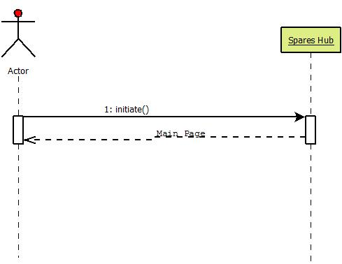

### Initiates System [ Alternative]

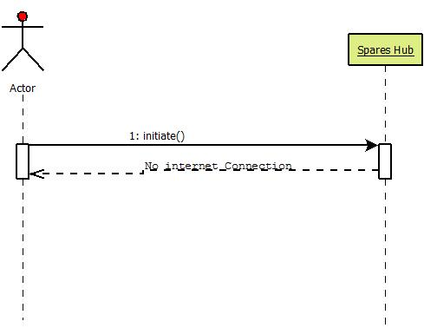

### Sign up [ Main Success Scenario]

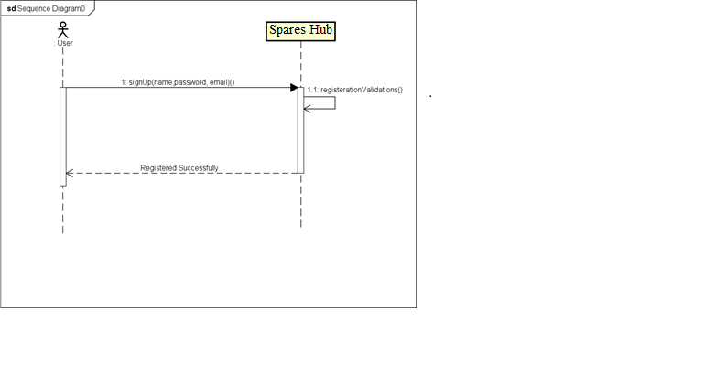

### Sign up [ Alternative]

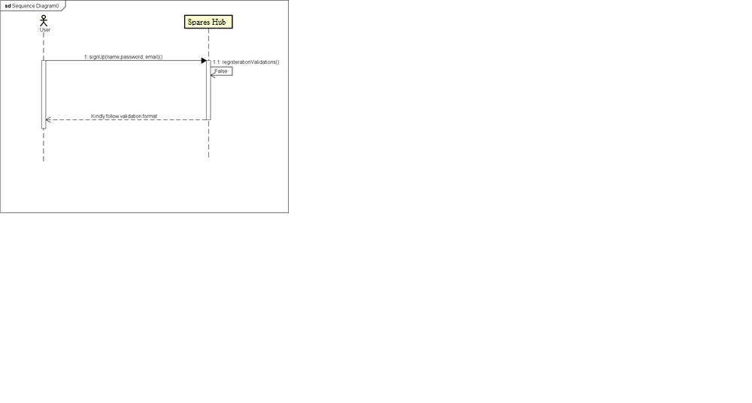

### Login [ Main Success Scenario]

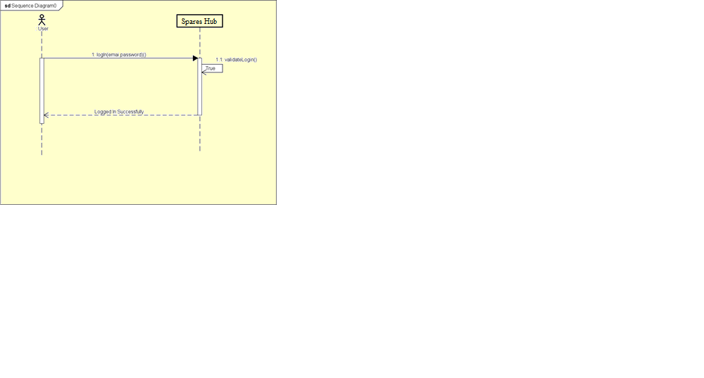

### Login [ Alternative]

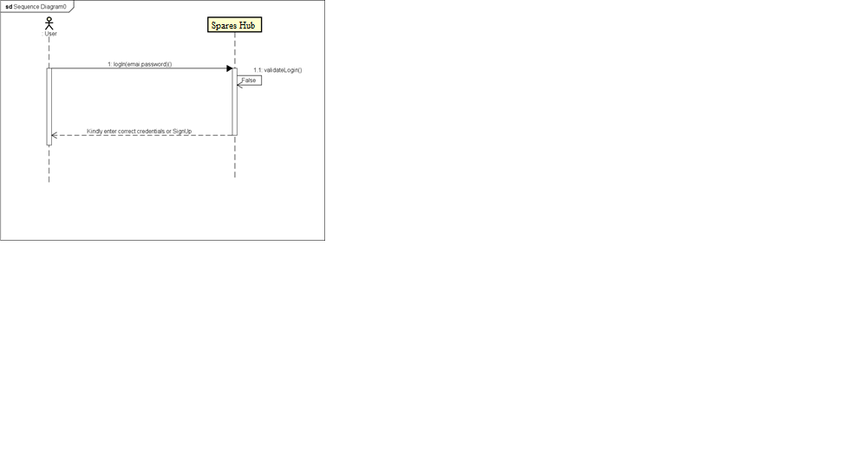

### Make Appointment [ Main Success Scenario]

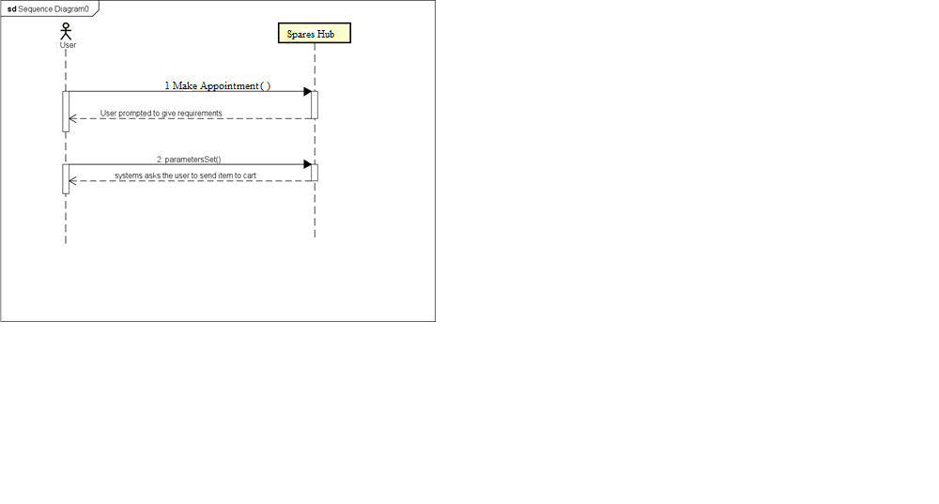

### Make Appointment [ Alternative]

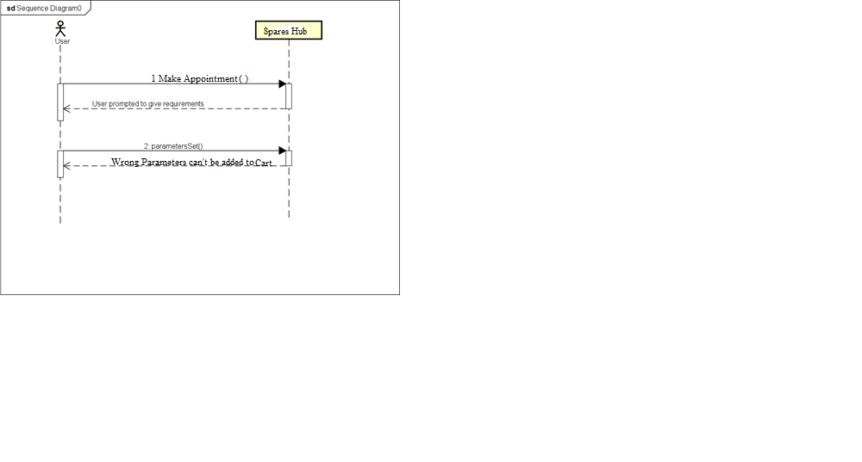

### Car Wash [ Main Success Scenario]

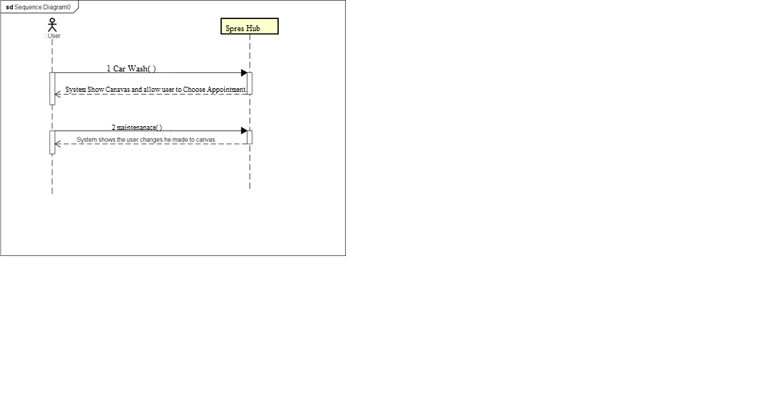

### Car Wash [ Alternative]



### Place order of Spare parts [ Main Success Scenario]

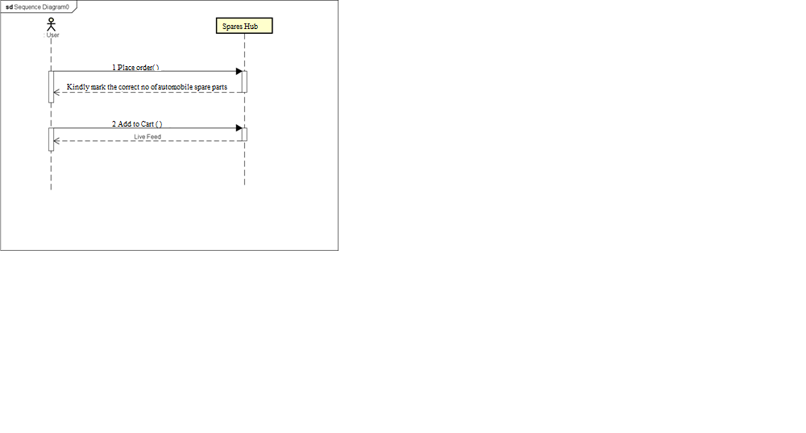

### Place order of Spare Parts [ Alternative]

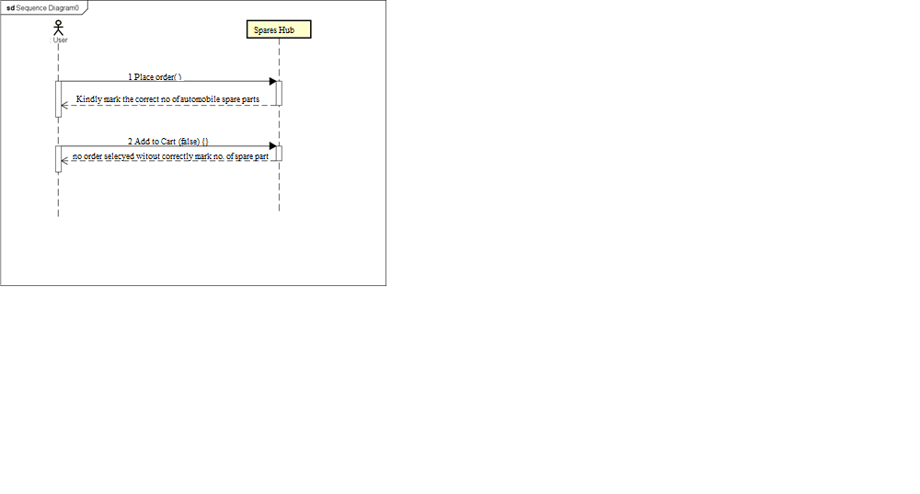

### Save Design [ Main Success Scenario]

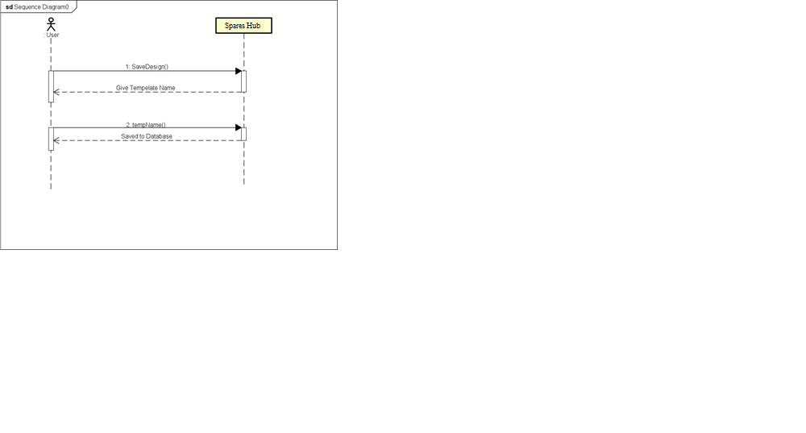

### Save Design [ Alternative]



### Payment Method [ Main Success Scenario]

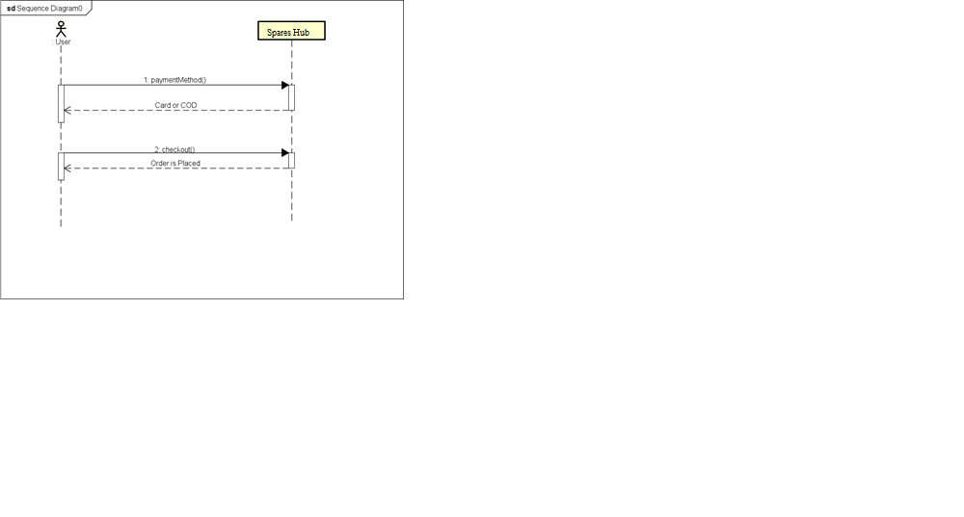

### Payment Method [ Alternative]

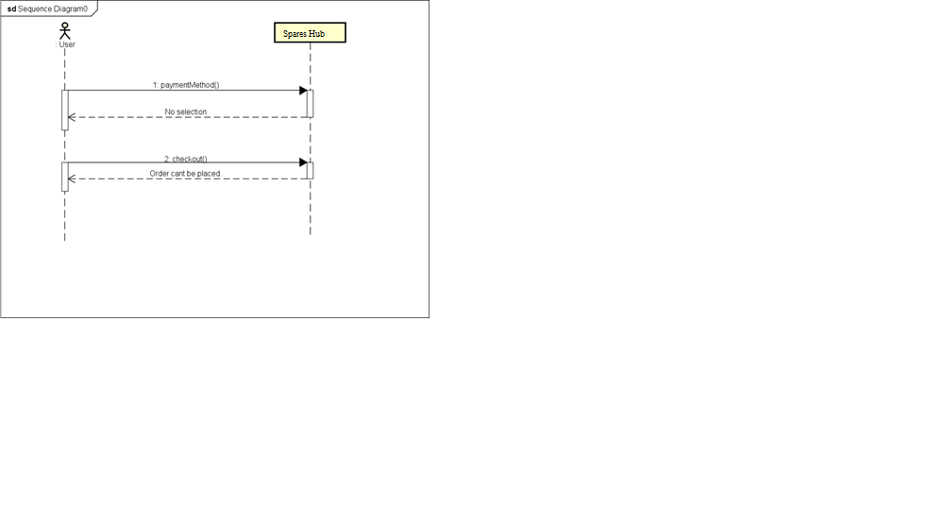

## Operation Contracts:

* + 1. **Initiate System Name:** Go to the website

**Responsibility:** To start the system

**Type:** System

**Pre-Conditions:** Must have internet and URL of system.

**Post-Conditions:** Main page is showed.

* + 1. **SignUp Name:** signUp()

**Responsibility:** Registration of the user in website.

**Type:** System

**Pre-Conditions:** User must click SignUp button.

**Post-Conditions:** An instance of registration form is created and MySQL database instance is also created to allow insertion of user data.

* + 1. **Login Name:** login()

**Responsibility:** Log Into the system

**Type:** System

**Pre-Conditions:** Must have clicked on the SignIn button.

**Post-Conditions:** Instance of MySQL is created. Instance of User Activity is created.

* + 1. **Make Appointment**

**Name:** addAppointment()

**Responsibility:** To make appointment of car washing or maintenance.

**Type:** System

**Pre-Conditions:** Must have logged into the system.

**Post-Conditions:** Instance of MySQL database is created. Instance of add shirt is created.

* + 1. **Car wash or Maintenance**

**Name:** car wash ( )

**Responsibility:** To make appointment of car wash or maintenance

**Type:** System

**Pre-Conditions:** Must have logged into the system and have clicked on Automobile Appointment.

**Post-Conditions:** Instance of MySQL database is created. Instance of make Appointment dialog is created.

* + 1. **Order Spare Parts of Automobile Name:** spare parts order()

**Responsibility:** To provide view of automobile Spare Parts.

**Type:** System

**Pre-Conditions:** Must have logged into the system and choose Spare parts and Accessories Option.

**Post-Conditions:** Instance of order spare part is created, and picture of feed is shown in cart.

* + 1. **Save Order Name:** saveOrder()

**Responsibility:** To save order in the database.

**Type:** System

**Pre-Conditions:** Must have internet, logged in and clicked on Save order button.

**Post-Conditions:** Instance of MySQL is created. Order is saved in the database.

* + 1. **Confirming Orders Name:** confirmOrder ()

**Responsibility:** To confirm orders of spare parts or maintenance and take user data for delivery.

**Type:** System

**Pre-Conditions:** Must have internet and add the products to cart.

**Post-Conditions:** Instance of MySQL database is created and item is stored in Cart for checkout.

* + 1. **Payment Method Name:** paymentOption()

**Responsibility:** To give payment options to user for order checkout.

**Type:** System

**Pre-Conditions:** Must have internet, logged into system and correct delivery details are provided.

**Post-Conditions:** Selected payment option is saved in database and order is placed wait for delivery.

## Activity Diagrams:

### Sign up Activity

### Login Activity

* + 1. **Predesigned/Custom Design**

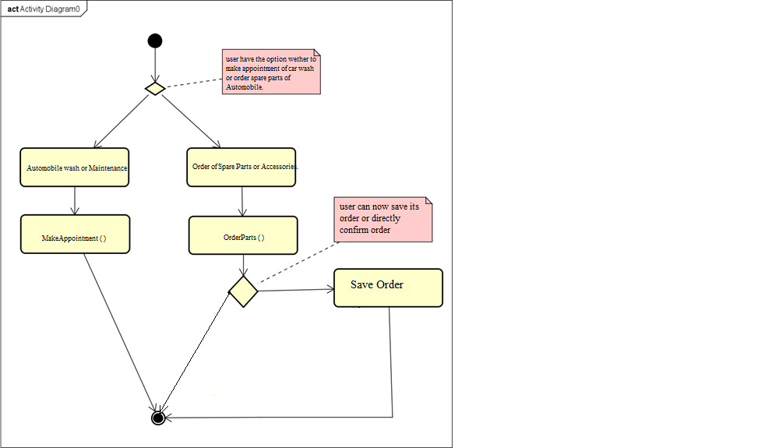

* + 1. **Order Activity**

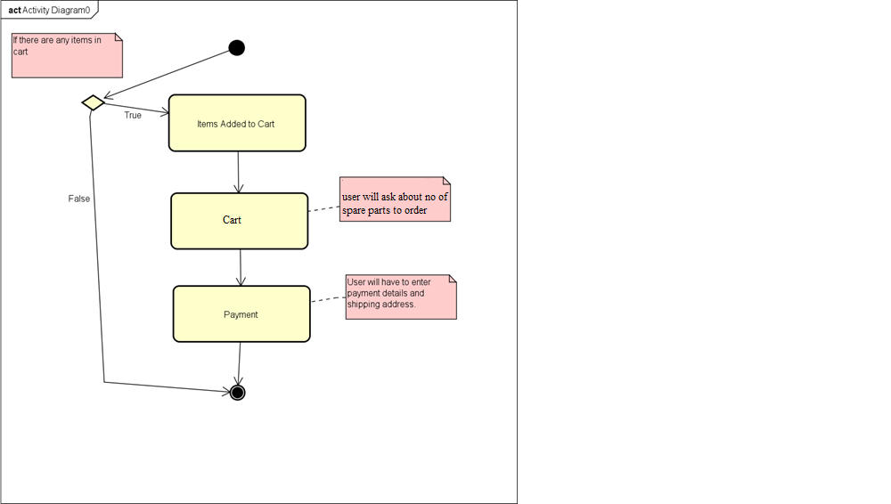

Chapter 3

# System Design

## Communication Diagram

Communication diagrams are comparatively identical to grouping diagrams in UML, however they emphasize a lot on how connections are made and how they compare and connect through messages in an arrangement as opposed to collaborations.

Communication diagrams offer benefits like successive diagrams. They can be a helpful reference for organizations, associations, and designers who need to envision and comprehend the physical communications inside a program. Take a stab at attracting a grouping outline to:

* + - To show top level methodology, task and capacity.
    - Differentiate how information is passed between components of a system.
    - To predict the results of the cooperation between different components of a system.
    - Program and envies the point to point usefulness of the present and future situation.

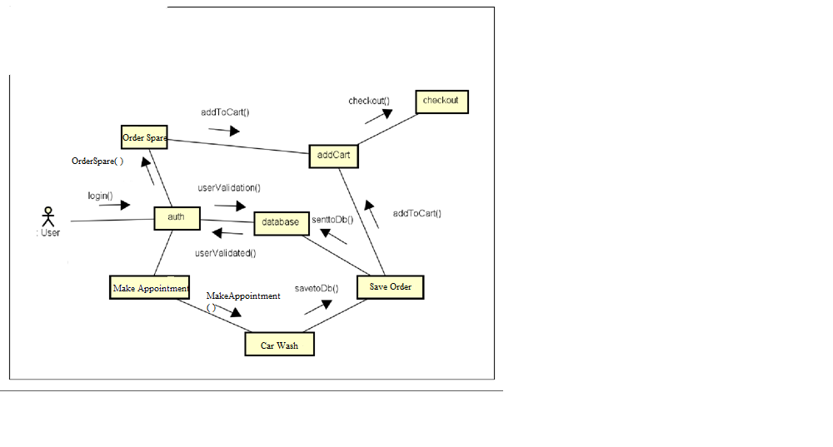

## Class Diagram

Class Diagram gives the static view of an application. A class diagram portrait the kinds of articles in the framework and the different sorts of connections that exist among them. This demonstrating strategy can keep running with all Object-Oriented Methods.

“UML Class Diagram gives a review of a product framework by showing classes, qualities, tasks, and their connections. This Diagram incorporates the class name, properties, and task in discrete assigned compartments. “

Fundamentals of Class Diagram

* + - Class Name
    - Attributes
    - Operations
    - Relations / Multiplicity

**Class Diagram for Print-It**

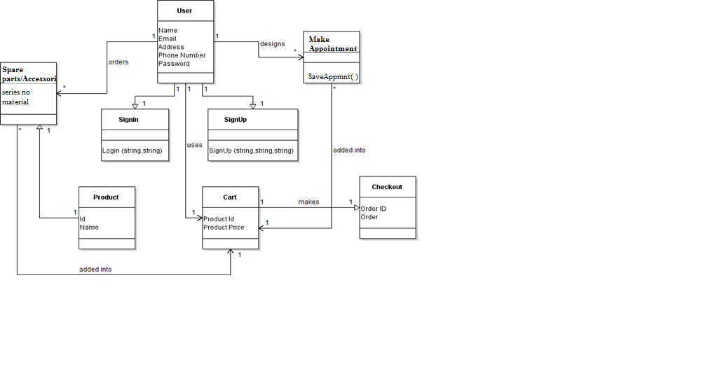

## SCHEMA or ERD

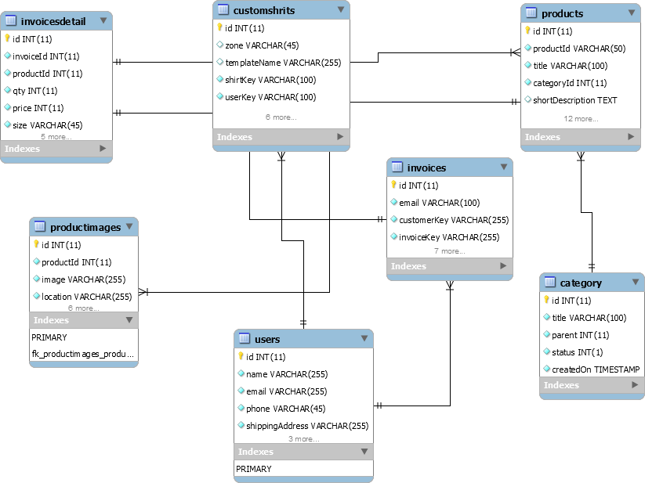

Chapter 4

# Implementation

## Component Diagram

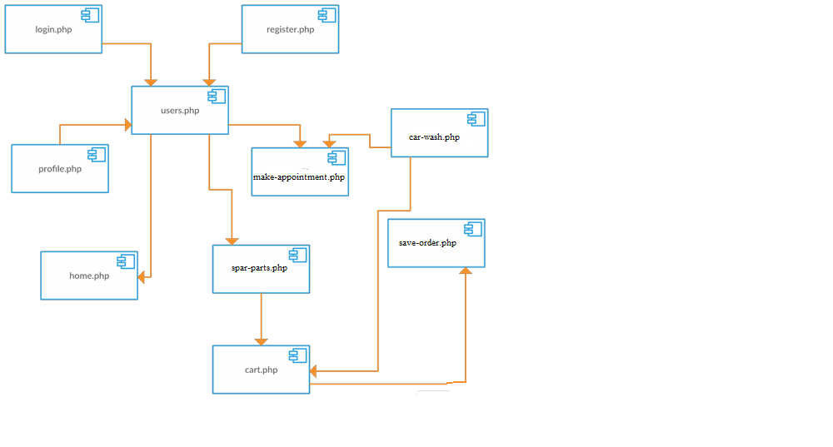

## Deployment Diagram

A UML deployment diagram is a diagram which elaborates the pattern of execution in preparing hubs and pieces that live on them. Deployment diagram is a type of pattern which shows the actual segments of a working system. They are used in routine by the system to perform its functionality.

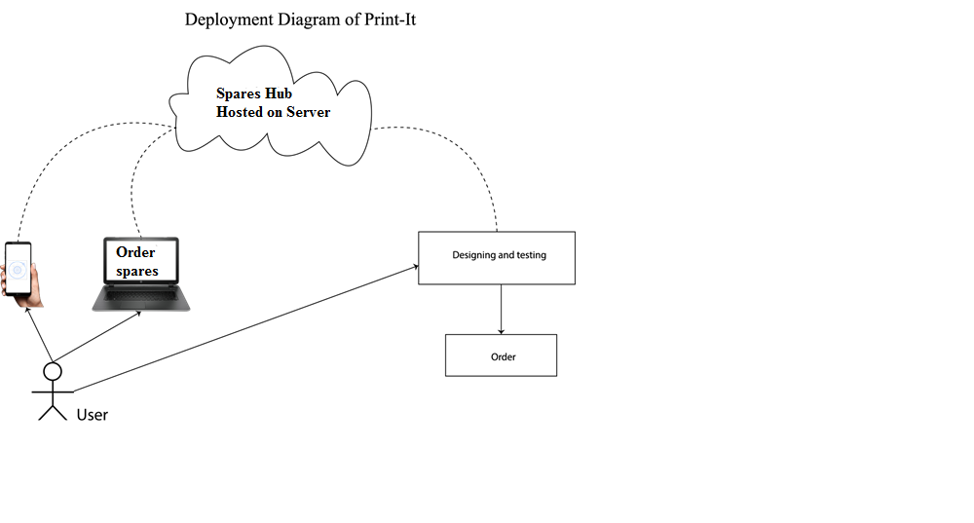

Chapter

# Testing

## Methodology

With this kind of testing approach, each and every bit of the specification is used for the model, and a sketch was then used to be shown up; the developer then starts modifying his/her code by taking in perspective the given test case whether its fulfilling it or not. Therefore, the specifications were applied on every model, and consisted testing was applied. This accordingly enclosed the testing that used to be implemented toward the total of the system lifecycle. In the meantime, all parts of the system were implemented.

* + - Begin with a base breaking point that you need to finish.
    - Make a record with the point by point fundamental definition, a development diagram with a depiction of stream, database tables to be utilized, a portion chart, and a delineation of each segment with the precondition and tables that would be influenced by the section.
    - Give the record to the analyzer, and work with the analyzer while he or she makes the code to check if the movement in the report can be executed and if the inevitable result of each utilization case can be master.
    - On the off chance that the analyzer finds a stage hard to execute or expect he or she is feeling the loss of extra data to understand the supportiveness, by then go to arrange 2 generally, go to organize 3.
    - Request that the analyzer sign on every last one of the slip-ups and burdens he or she experienced while dealing with the model utilize.
    - Once the model is done and the outcomes between the designer's model and analyzer's model match, handle the other need, and build up the model to definitive programming.
    - Right when the testing approach was executed, the going with upsides and drawbacks regarding the testing approach were made sense of it.

## Black Box Testing

It is a testing method in which all the inner details of code and design of the system are ignored and focuses on the result as per input. It is also known as behavioral or functional testing.

## White Box Testing

It is the method of testing in which each inner detail or logic of the system is tested. All the structure, procedures, loops are tested in white box testing. It is also known as glass box testing.

## Verification

This process is done to assure that the system is working as we need or as we assumed at the starting of implementing the system.

## Validation

This is the process to assure that we implemented the system as per user requirement and result are the same as end user want.

## Test Cases

### TC01: To test the Signup interface

|  |  |
| --- | --- |
| **Test case ID** | TC-01 |
| **Strategy** | White Box |
| **Test case Engineer** | Muhammad Abubakar Bin Shahid |
| **Test name** | Sign Up |
| **Objective** | The purpose of this test case is to register the user  successfully. |
| **Pre-condition** | User must be connected to internet. |
| **Steps to perform** | Give details for registration and Press the sign up  button |
| **Expected Result** | User should be successfully registered. |
| **Test result** | Passed. |

### TC02: To test the Login interface

|  |  |
| --- | --- |
| **Test case ID** | TC-02 |
| **Strategy** | White Box |
| **Test case Engineer** | Muhammad Abubakar Bin Shahid |
| **Test name** | LogIn |
| **Objective** | The purpose of this test case is to login the user successfully. |
| **Pre-condition** | User must be registered to the system and  connected to internet. |
| **Steps to perform** | Give login details Press the LogIn button |
| **Expected Result** | User should be successfully LogIn. |
| **Test result** | Passed. |

### TC03: Use a predesigned Shirt

|  |  |
| --- | --- |
| **Test case ID** | TC-03 |
| **Strategy** | Black Box |
| **Test case Engineer** | Muhammad Abubakar Bin Shahid |
| **Test name** | Use a predesigned Shirt |
| **Objective** | The purpose of this test case is to check if the  user is able to order a predesigned shirt. |
| **Pre-condition** | User must have successfully login. |
| **Steps to perform** | User will select the desired shirt and give  his/her specifications. |
| **Expected Result** | User can successfully be able to give its  requirements for a predesigned shirt. |
| **Test result** | Passed. |

### TC04: To Design Custom Shirts

|  |  |
| --- | --- |
| **Test case ID** | TC-04 |
| **Strategy** | White Box |
| **Test case Engineer** | Muhammad Abubakar Bin Shahid |
| **Test name** | Custom Design Shirt |
| **Objective** | The purpose of this test case is to give the user  ability to design its own shirt according to its liking. Design tools are given. |
| **Pre-condition** | User must have successfully login. |
| **Steps to perform** | User will have to use provided tools to design  custom shirts. |
| **Expected Result** | User can design shirts by choosing color  uploading its own image, text or icon. |
| **Test result** | Passed. |

### TC05: To Try Custom Designed Shirt

|  |  |
| --- | --- |
| **Test case ID** | TC-05 |
| **Strategy** | Black Box |
| **Test case Engineer** | Muhammad Abubakar Bin Shahid |
| **Test name** | Try Custom Designed Shirt |
| **Objective** | The purpose of this test case is to give the user ability to virtually try its design by giving  camera access. |
| **Pre-condition** | User must have successfully login and must  gave camera access to website. |
| **Steps to perform** | User will have to press preview button to its-  self virtually wearing the shirt. |

|  |  |  |
| --- | --- | --- |
|  | **Expected Result** | User will see itself in camera while that  custom designed shirt is virtually imposed. |
| **Test result** | Passed. |

### TC06: To Save Custom Designed Shirt

|  |  |
| --- | --- |
| **Test case ID** | TC-06 |
| **Strategy** | White Box |
| **Test case Engineer** | Muhammad Abubakar Bin Shahid |
| **Test name** | Save Custom Designed Shirt |
| **Objective** | The purpose of this test case is to test whether  the designed shirt is saved. |
| **Pre-condition** | User must have successfully login and must  have accessed the custom design module. |
| **Steps to perform** | User will have to press save button to save  design. |
| **Expected Result** | User will be able to save its design in  database. |
| **Test result** | Passed. |

### TC07: To Adding to Cart

|  |  |
| --- | --- |
| **Test case ID** | TC-07 |
| **Strategy** | Black Box |
| **Test case Engineer** | Muhammad Abubakar Bin Shahid |
| **Test name** | Adding Shirts to Cart |
| **Objective** | The purpose of this test case is to check if all the design or predesigned shirts are adding  into cart. |

|  |  |  |
| --- | --- | --- |
|  | **Pre-condition** | User must have successfully login and added  anything to cart. |
| **Steps to perform** | User will have to set dimensions for the shirt  and press add to cart button. |
| **Expected Result** | User will see items added to cart. |
| **Test result** | Passed. |

### TC08: To Select Payment Method

|  |  |
| --- | --- |
| **Test case ID** | TC-08 |
| **Strategy** | Black Box |
| **Test case Engineer** | Muhammad Abubakar Bin Shahid |
| **Test name** | Select Payment Method |
| **Objective** | The purpose of this test case is to give the user the option to whether check cash on delivery  or select payment through credit card. |
| **Pre-condition** | User must have successfully login and added  items to cart. |
| **Steps to perform** | User will have to press cart button to go there  and fill delivery details and then press checkout. |
| **Expected Result** | User will be able to checkout and confirm his  order. |
| **Test result** | Passed. |

Chapter 6

# Conclusion

Our final year project Print it- A real time Shirt Designing and Virtually Trying System has been completed successfully.

The Application has three major modules

* + - * Custom Designing and Virtually Trying T-Shirts
      * Web Application developed in Php
      * Android Application ported from Php using Cordova Framework

This has been made with a lot of hard work and its almost bug free. The main purpose of this website is to provide custom designing of T-Shirts in Pakistan a new perspective and also revolutionize the designing process by allowing the user to virtually try his design.

Our project has provided an opportunity to learn and experience many new things like working with **MySQL Database**, **image imposing on a real time video feed and Custom designing on a canvas**, **web development using PHP**. All of these technologies are quite popular in the software industry. We have learnt how professional methodologies work.