|  |
| --- |
| MAP-06 |
| Complete Android Jetpack Masterclass |
| Research Project |

|  |
| --- |
| Sardaryan, Elina  12-28-2022 |

MAP-06

Related Technologies for Multiplatform Applications

**Research Project**

Student:

Elina Sardaryan

Udemy tutorial “Complete Android Jetpack Masterclass”.

The link for the course: <https://www.udemy.com/course/android-jetpack-masterclass/>

The course covers

• Android Jetpack suite

• ViewBinding and Animation(Splash Screen)

• MVVM (Model View ViewModel)

• Permissions

• Glide

• ROOM Database

• LiveData, Lifecycles and ViewModels

• Navigation Component, Navigation Graph, Safe Args

*Project #1* **1_FavDish**

1. Open Android Studio and create a new project using **Bottom Navigation Activity.**
2. Name the application as **FavDish.**
3. Select language as **Kotlin** and click the finish button.
4. Now you are done with the project creation and as you can see there are many auto-added files by Android studio already. By default we have one main UI with three fragments(dashboard, home, notification) with their activities already included in the project. We will work with them later. In this current project we are going to set up the **color themes of the application.**
5. Go to res -> values -> themes and you will notice **themes.xml** with day and night combination. Here we will set the same color combination.
6. To choose a color combination you can go to the link <https://material.io/resources/color/#!/?view.left=0&view.right=0> and select the color combination that you want.
7. For this project we will use the primary color **Green 700** with all the combination shades. Add them to our application.
8. For secondary color we will use **Green 300** and add all the combinations to the **colors.xml** file. (Step 1 – for both primary and secondary colors)

<color name="primary_color">#388E3C</color>  
 <color name="primary_dark_color">#00600F</color>  
 <color name="primary_light_color">#6ABF69</color>  
   
<color name="secondary_color">#81C784</color>  
 <color name="secondary_dark_color">#519657</color>  
 <color name="secondary_light_color">#B2FAB4</color>

1. In **themes.xml** (day) we will change primary and secondary colors, as well as status bar color. (Step 2– for both primary and secondary colors)

<item name="colorPrimary">@color/primary_color</item>  
 <item name="colorPrimaryVariant">@color/primary_dark_color</item>

<item name="colorSecondary">@color/secondary_color</item>  
 <item name="colorSecondaryVariant">@color/secondary_dark_color</item>

<item name="android:statusBarColor" tools:targetApi="l">?attr/colorPrimaryVariant</item>

1. In **themes.xml** (night) we will change primary and secondary colors, as well as status bar color. (Step 3– for both primary and secondary colors)

<item name="colorPrimary">@color/primary_light_color</item>  
 <item name="colorPrimaryVariant">@color/primary_color</item>

<item name="colorSecondary">@color/secondary_light_color</item>  
 <item name="colorSecondaryVariant">@color/secondary_color</item>

<item name="android:statusBarColor" tools:targetApi="l">?attr/colorPrimaryVariant</item>

*Project # 2*  **2_ActivityLifecycle**

As a user navigates through, out of, and back to your app, the Activity instances in your app transition through different states in their lifecycle. The Activity class provides several callbacks that allow the activity to know that a state has changed: that the system is creating, stopping, or resuming an activity, or destroying the process in which the activity resides.

To navigate transitions between stages of the activity lifecycle, the Activity class provides a core set of six callbacks: onCreate(), onStart(), onResume(), onPause(), onStop(), and onDestroy(). The system invokes each of these callbacks as an activity enters a new state.

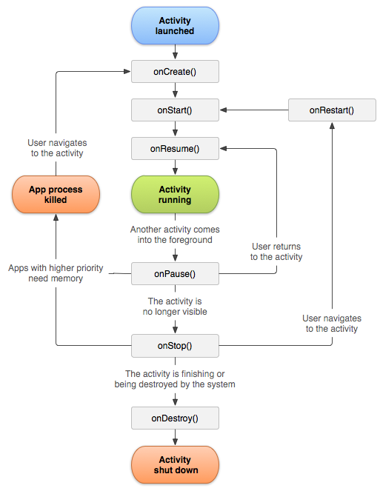

1. Open Android Studio and create a new project using **Empty Activity**,

2. Name the application as **ActivityLifecyle**.

3. Select language as **Kotlin** and click the finish button.

4. Override all the lifecycle methods and print the log in it.

override fun onStart() {  
 super.onStart()  
 Log.e("onStart method", "is called...")  
 }

override fun onResume() {  
 super.onResume()  
 Log.e("onResume method", "is called...")  
 }

override fun onPause() {  
 super.onPause()  
 Log.e("onPause method", "is called...")  
 }

override fun onStop() {  
 super.onStop()  
 Log.e("onStop method", "is called...")  
 }

override fun onRestart() {  
 super.onRestart()  
 Log.e("onRestart method", "is called...")  
 }

override fun onDestroy() {  
 super.onDestroy()  
 Log.e("onDestroy method", "is called...")  
 }

5. Run and see which log is printed at what time.

6. To see the Logs, go to Logcat and choose Error as we used Log.e

*Project # 3* **3_PassingDataToAnotherActivityWithPutExtra**

1. Continue working on **ActivityLifecyle** project.
2. Add a Button in activity_main.xml.
3. Add id for the TextView and for Button, and make the design adjustments
4. Access the button and add click event to it in Main Activity

val btnSubmit = findViewById<Button>(R.id.*btn_submit*)  
 btnSubmit.setOnClickListener **{}**

1. Create an Another Activity to launch it via Intent and to pass the data between two activities.
2. Add the TextView to the Another Activity to just see that it is launched.
3. Launch the Another Activity and pass the data using putExtra. Write this code in the button event listener.

val intent = Intent(this@MainActivity, AnotherActivity::class.*java*).*apply* **{**  
putExtra("key1", "Value1")  
 putExtra("key2", "Value2")  
 // You can add as many params as you want.  
 }

startActivity(intent)

1. Get the data in Another Activity from Main Activity and print it in the log.

val keyValue1 = *intent*.getStringExtra("key1")  
 Log.i("value 1", "$keyValue1")  
 val keyValue2 = *intent*.getStringExtra("key2")  
 Log.i("value 2", "$keyValue2")

*Project # 4* **4_FavDish – SplashScreen**

1. Use the project **FavDish** we created before.
2. Create a new package name as “activities.”
3. Create a new empty activity as Splash Screen with the name SplashActivity.
4. We are going to implement the **ViewBinding** concept.
5. Add the string value “Fav Dish” to the strings.xml file

<string name="splash_screen_title">Fav Dish</string>

1. Design the splash screen layout with one TextView and put string value to text.

android:text="@string/splash_screen_title"

1. Enable the ViewBinding in build.gradle(:app)

buildFeatures **{**  
viewBinding true  
 }

NOTE*** - when you create a new project using **Bottom Navigation Activity**, **ViewBinding** is already enabled by default.

1. Access the XML layout file using the ViewBiding.

val splashBinding: ActivitySplashBinding = ActivitySplashBinding.inflate(*layoutInflater*)

1. Update the content view using the ViewBinding

setContentView(splashBinding.*root*)

1. Create the SplashActivity as the launcher activity instead of MainActivity. So, go to AndroidManifest.xml and take <intent-filter> tag with its content from MainActivity and put it in SplashActivity, and also put exported as true in SplashActivity.

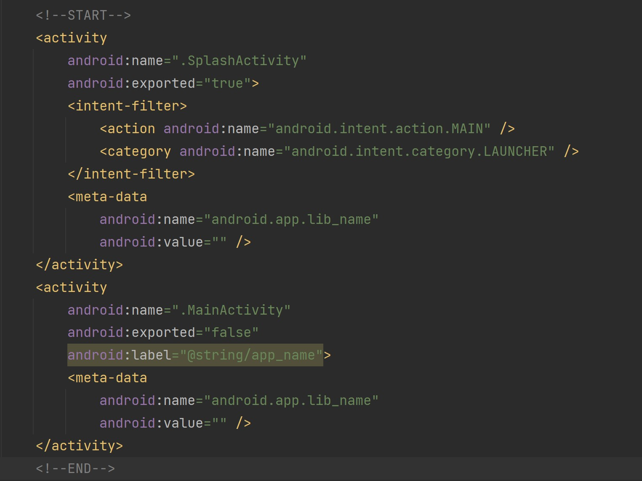

1. Run the application and see the changes.
2. As you can see the launcher screen is changed and it is stuck on the splash screen. We will animate and redirect it to the main screen in the next project.

*Project # 5* **5_FavDish - AnimatedSplashScreen**

1. Continue with the previous project **FavDish** where we created splash screen for our application.
2. Make the Splash Activity as a full screen view that means hide the Status Bar. So, first in SplashActivity we need to type:

if (Build.VERSION.*SDK_INT* >= Build.VERSION_CODES.*R*) {  
 *window*.*insetsController*?.hide( WindowInsets.Type.statusBars())  
 } else {  
 @Suppress("DEPRECATION")  
 *window*.setFlags(  
 WindowManager.LayoutParams.*FLAG_FULLSCREEN*,  
 WindowManager.LayoutParams.*FLAG_FULLSCREEN*  
)  
 }

Second, go to themes.xml and type:

<style name="Theme.FavDish.NoActionBar">  
 <item name="windowActionBar">false</item>  
 <item name="windowNoTitle">true</item>  
 </style>

<style name="Theme.FavDish.AppBarOverlay" parent="ThemeOverlay.AppCompat.Dark.ActionBar" />

<style name="Theme.FavDish.PopupOverlay" parent="ThemeOverlay.AppCompat.Light" />

Third, go to AndroidManifest.xml and update the splash activity theme, so type:

android:theme="@style/Theme.FavDish.NoActionBar"

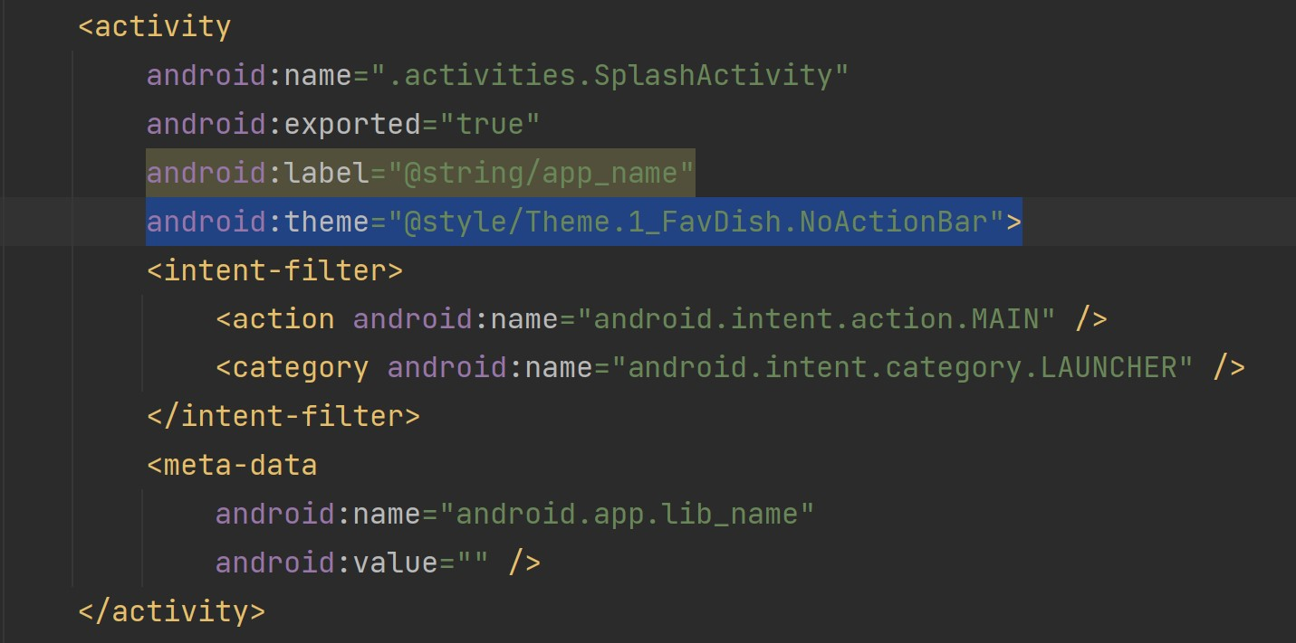

1. After updating the theme of SplashActivity in the manifest.xml file. Add the anim resource directory in the res folder.

1. After adding the anim directory in the res folder. Create a new Animation Resource File name as anim_splash.

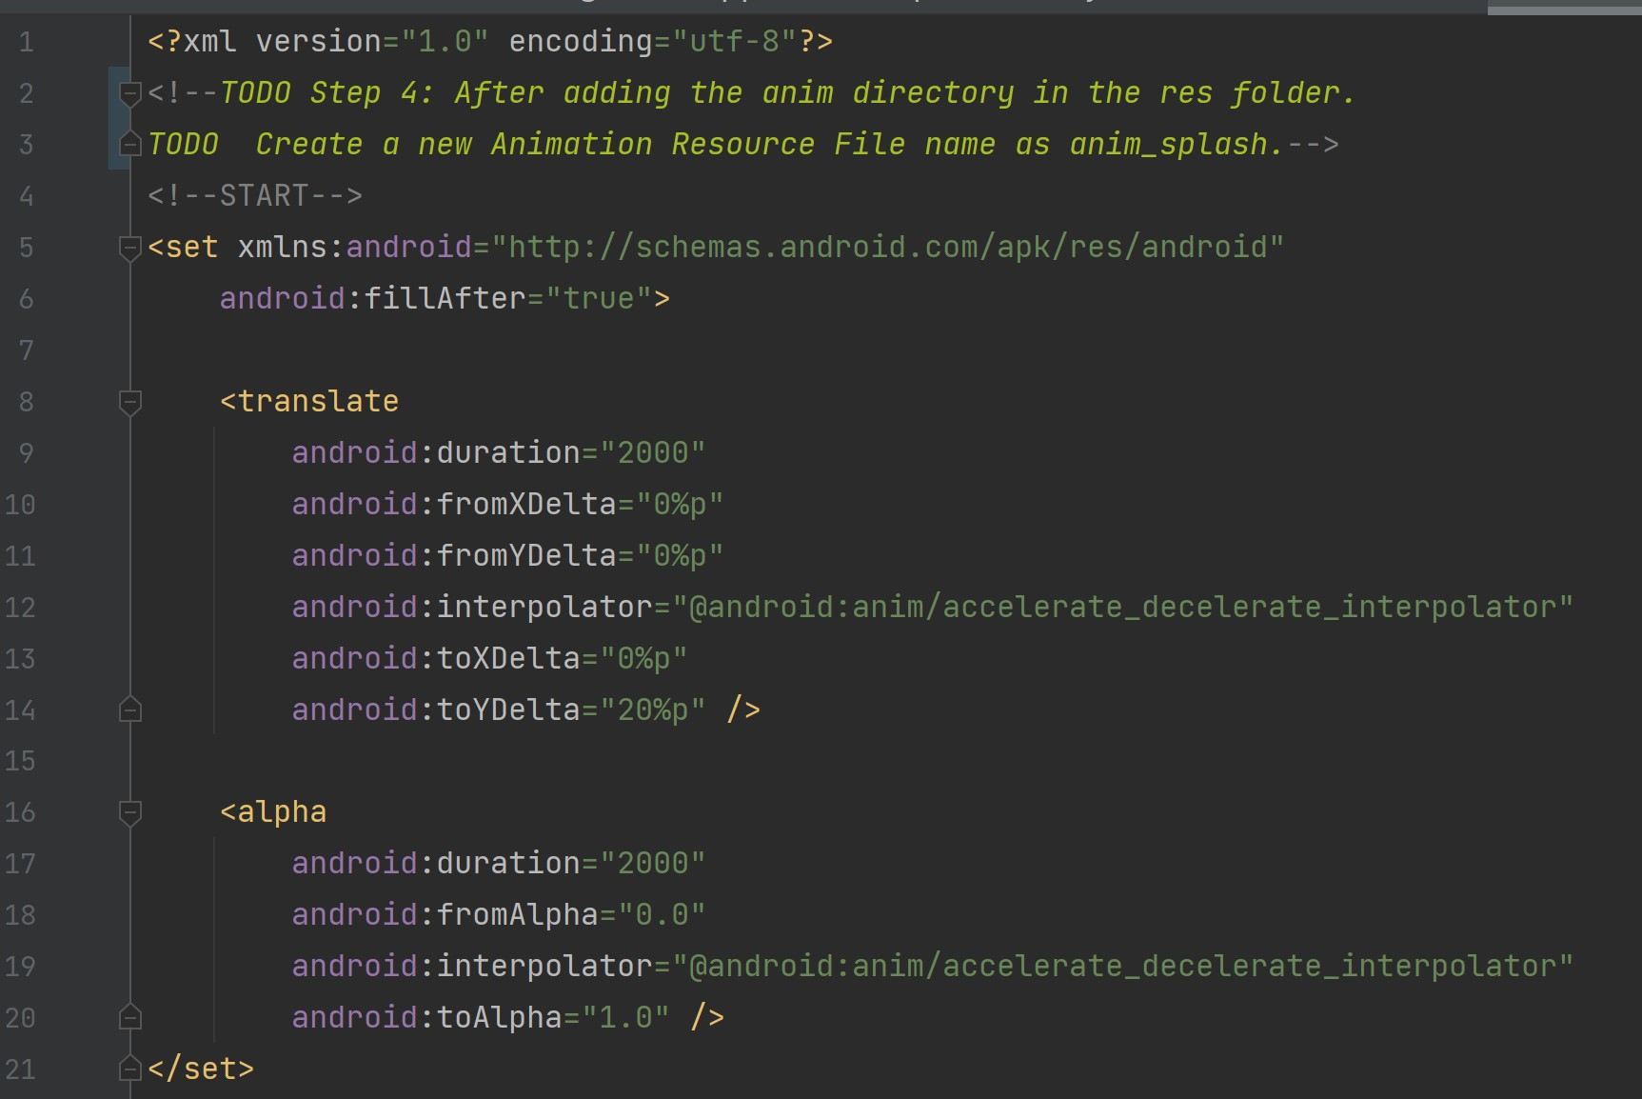

1. In Splash Activity Create an access variable for Animation as below.

val splashAnimation = AnimationUtils.loadAnimation(this@SplashActivity, R.anim.*anim_splash*)

1. Apply the animation to TextView

splashBinding.tvAppName.*animation* = splashAnimation

Note*** - tvAppName is id of TextView in activity_splash.xml layout.

1. Once the animation is completed, we will navigate it to the Main Activity with delay 1 second using Handler. We will use setAnimationListener as below:

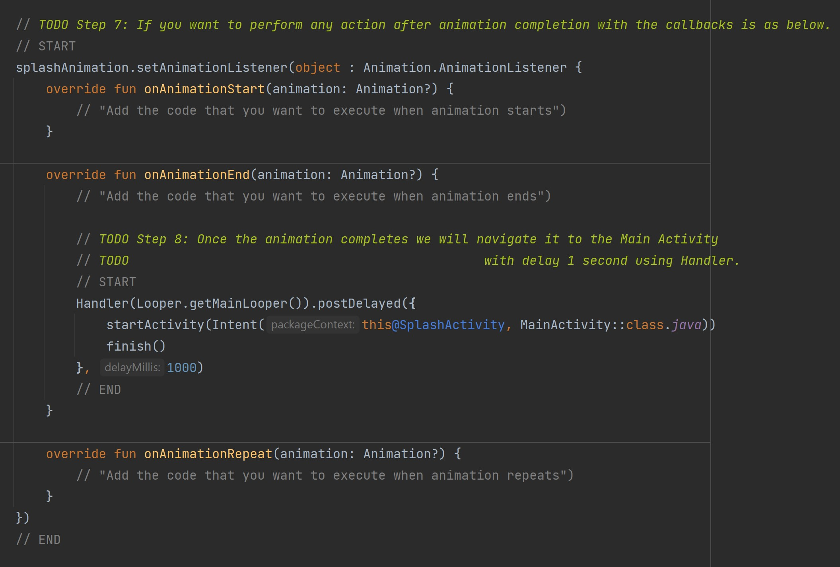

1. Run the application and see the changes.
2. You can get the animations online that you want or create your own as per your requirement. A reference link <https://www.raywenderlich.com/2785491-android-animation-tutorial-with-kotlin#toc-anchor-001>.
3. Next, we are going to create app icon using Android Studio.

First, download an icon you would like to use as your app icon.

Second, click anywhere in the Project and then go to **File -> New -> Image Asset**.

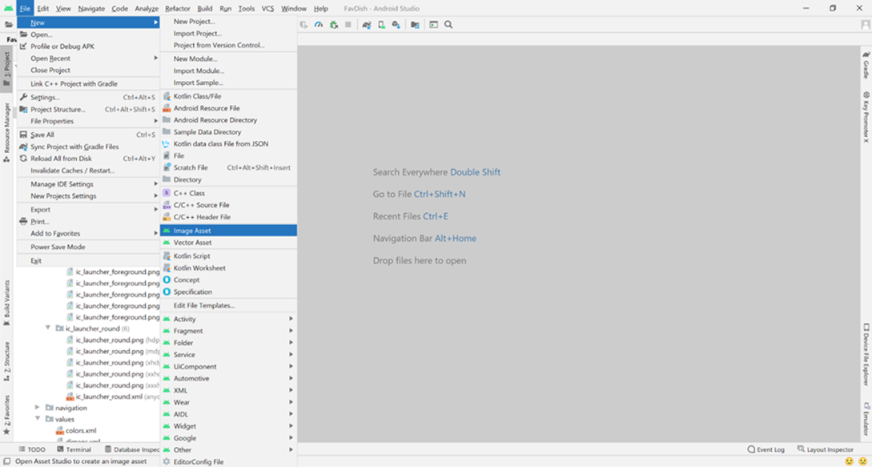

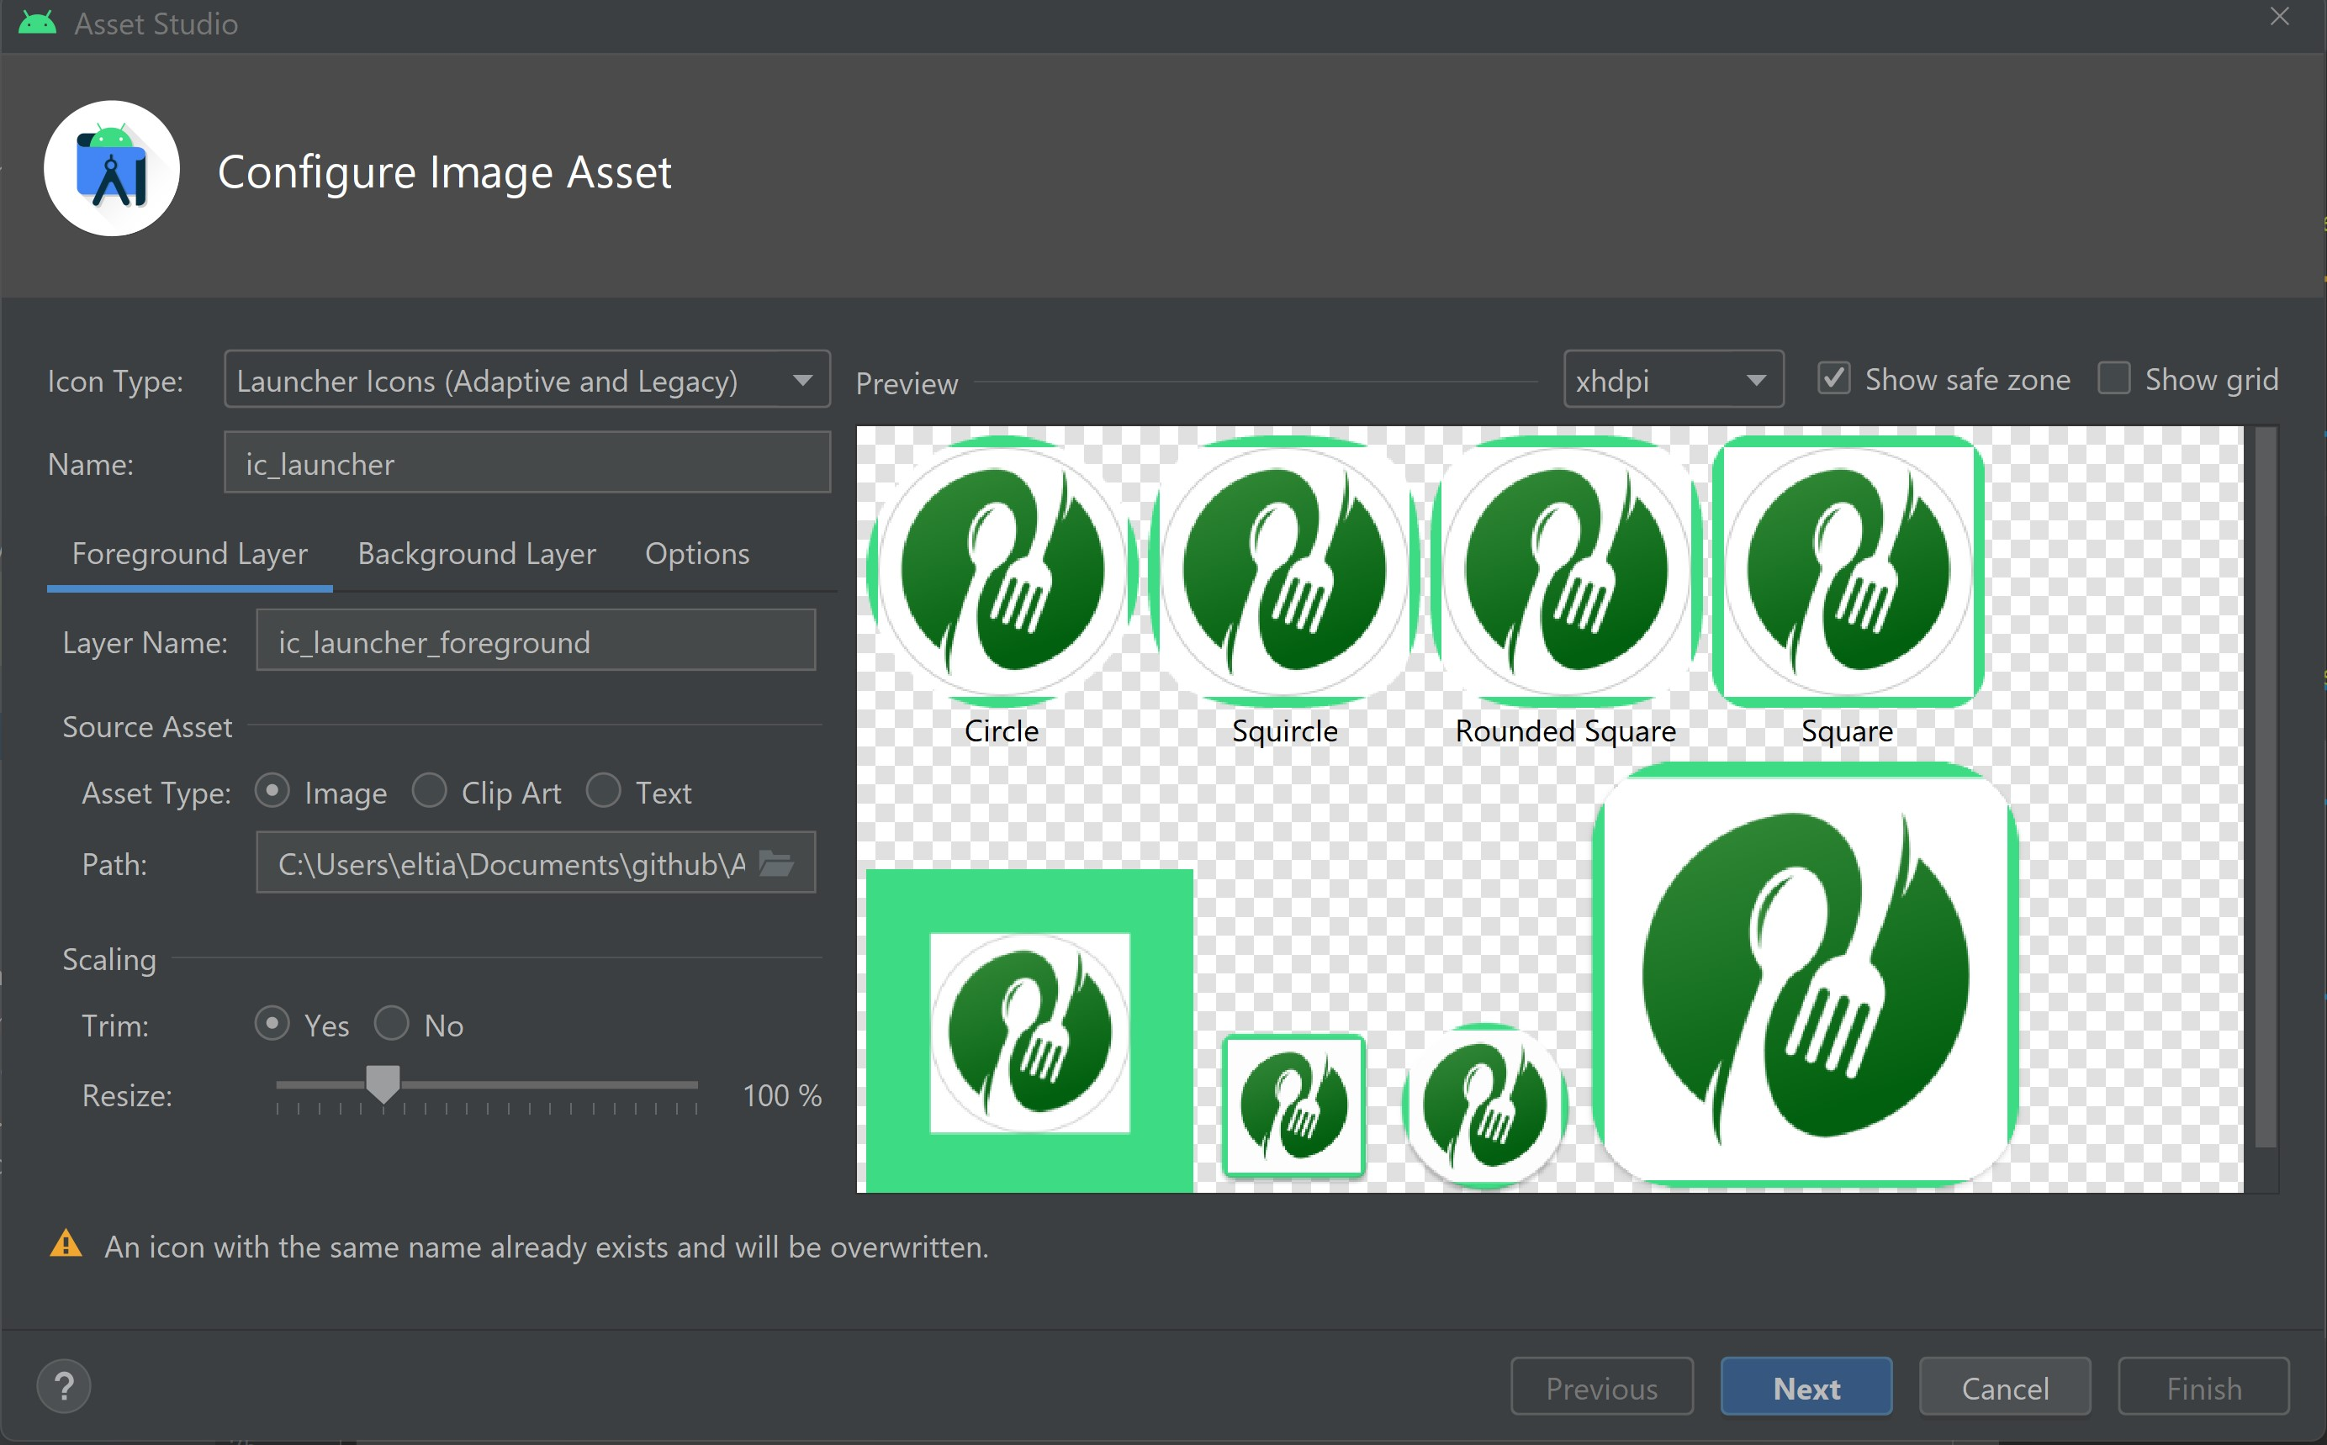Third, choose the path and select the image you want to use.

Fourth, you can choose to trim it or not. In this project we chose trim.

Fifth, go to Background Layer and choose color white “FFFFFF”. You can also use another image as background, but in this project, we will choose only the color white.

Sixth, go to Next and then Finish.

1. You will have the below app icon.

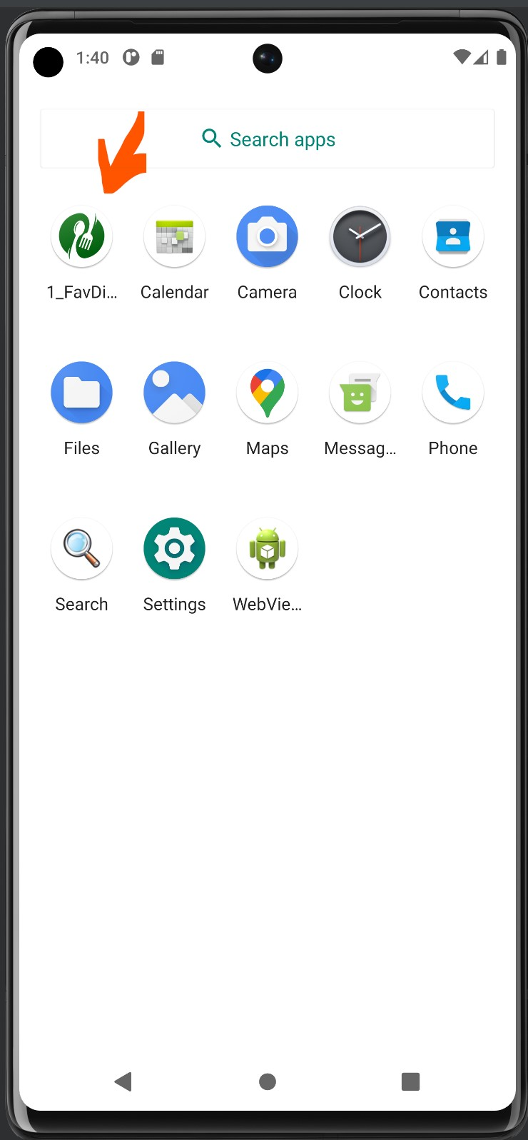

*Project # 6* **6_ElinaResearchProject**

In this project, we will refactor the folder structure in the java package.

1. Rename the **“ui”** package to **“view”.**
2. Move the **MainActivity.kt** to the “**activities”** package.
3. Create new packages as “**model”** and “**viewmodel”**.
4. Move the “**activities”** package to the **“view”** package.
5. Move all the view models as **DashBoardViewModel.kt**, **HomeViewModel.kt**, and **NotificationViewModel.kt** to the “**viewmodel”** package.
6. Create a new package as “**fragments”** in the “**view”** package.
7. Move all the fragments to it and delete the respective packages.
8. Now, create a new empty activity as **AddUpdateDishesActivity.kt** in the “**activities”** package.

The structure of the project now will be as below (MVVM):

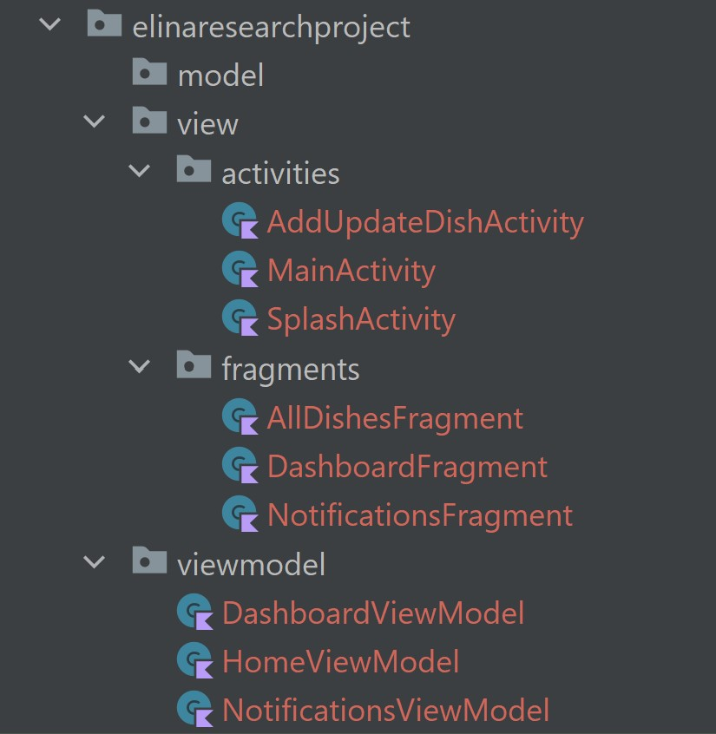

1. Make the style of **AddUpdateDishesActivity** activity with no action bar and also add alabel “Add Dish” in **AndroidManifest.xml**. Update the activity tag as below:

android:label="Add Dish"  
android:theme="@style/Theme.ElinaResearchProject.NoActionBar"

1. Rename the **HomeFragment.kt** as **AllDishesFragment.kt**.
2. Rename the **fragment_home.xml** file as **fragment_all_dishes.xml**.
3. Create a new icon for add in drawable. **New -> Vector Asset...**

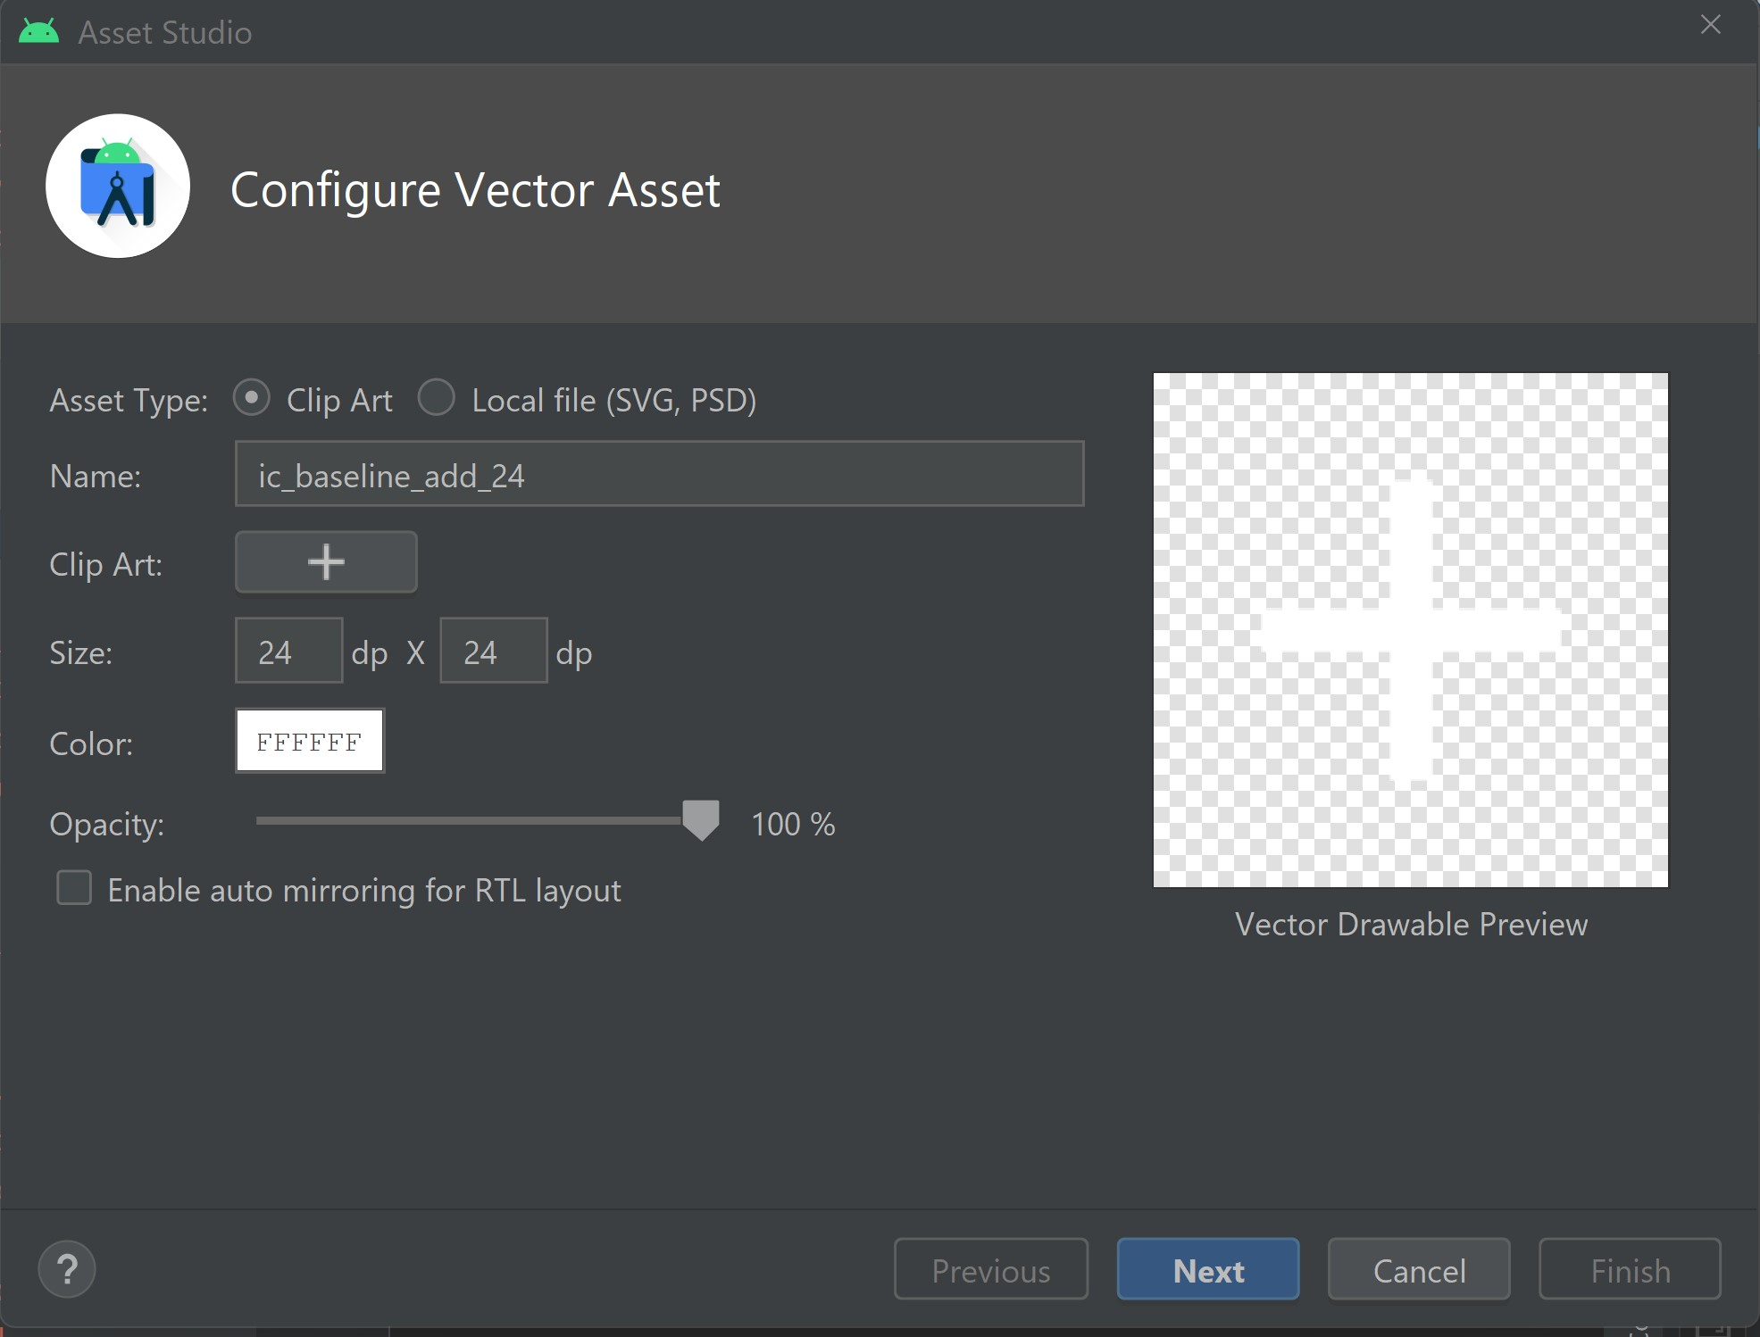

1. Name it as “**ic_add**”.
2. Change the color to white “**FFFFFF**”.
3. Click **Next** and then **Finish**.
4. When add icon is clicked, a new activity is launched. For now, it will be a blank activity, which we will modify in the next steps.
5. Create a menu file as **menu_all_dishes.xml** and add the item as below.

<item android:id="@+id/action_add_dish"  
 android:icon="@drawable/ic_add"  
 android:title="@string/action_add_dish"  
 app:showAsAction="always"/>

1. Add the code below in **strings.xml** file.

<string name="action_add_dish">Add Dish</string>

1. Override the **onCreate** function and enable **setHasOptionMenu** to add the action menu to Fragment.

override fun onCreate(savedInstanceState: Bundle?) {  
 super.onCreate(savedInstanceState)  
 setHasOptionsMenu(true)  
}

1. Override the **onCreateOptionMenu** and **onOptionsItemSelected** methods and launch the **AddUpdateDishActivity** on selection.

override fun onOptionsItemSelected(item: MenuItem): Boolean {  
  
 when (item.*itemId*) {  
 R.id.*action_add_dish* -> {  
 // requireActivity() will give us the fragment's activity, similar to "this"  
 startActivity(Intent(requireActivity(), AddUpdateDishActivity::class.*java*))  
 return true  
 }  
 }  
 return super.onOptionsItemSelected(item)  
}

*Project # 7*  **7_ElinaResearchProject**

In this project we will design the **activity_add_update_dish.xml** layout file using **ConstraintLayou**t, **ScrollView**, and **FrameLayout**.

1. Add the library for designing the better layout using dimensions in **build.gradle**(:app)

implementation 'com.intuit.sdp:sdp-android:1.1.0'

For more information, visit *https://github.com/intuit/sdp*

1. Create a new vector asset in drawable, which will be an icon to add a photo. So, right click on **drawable -> New -> Vector Asset**

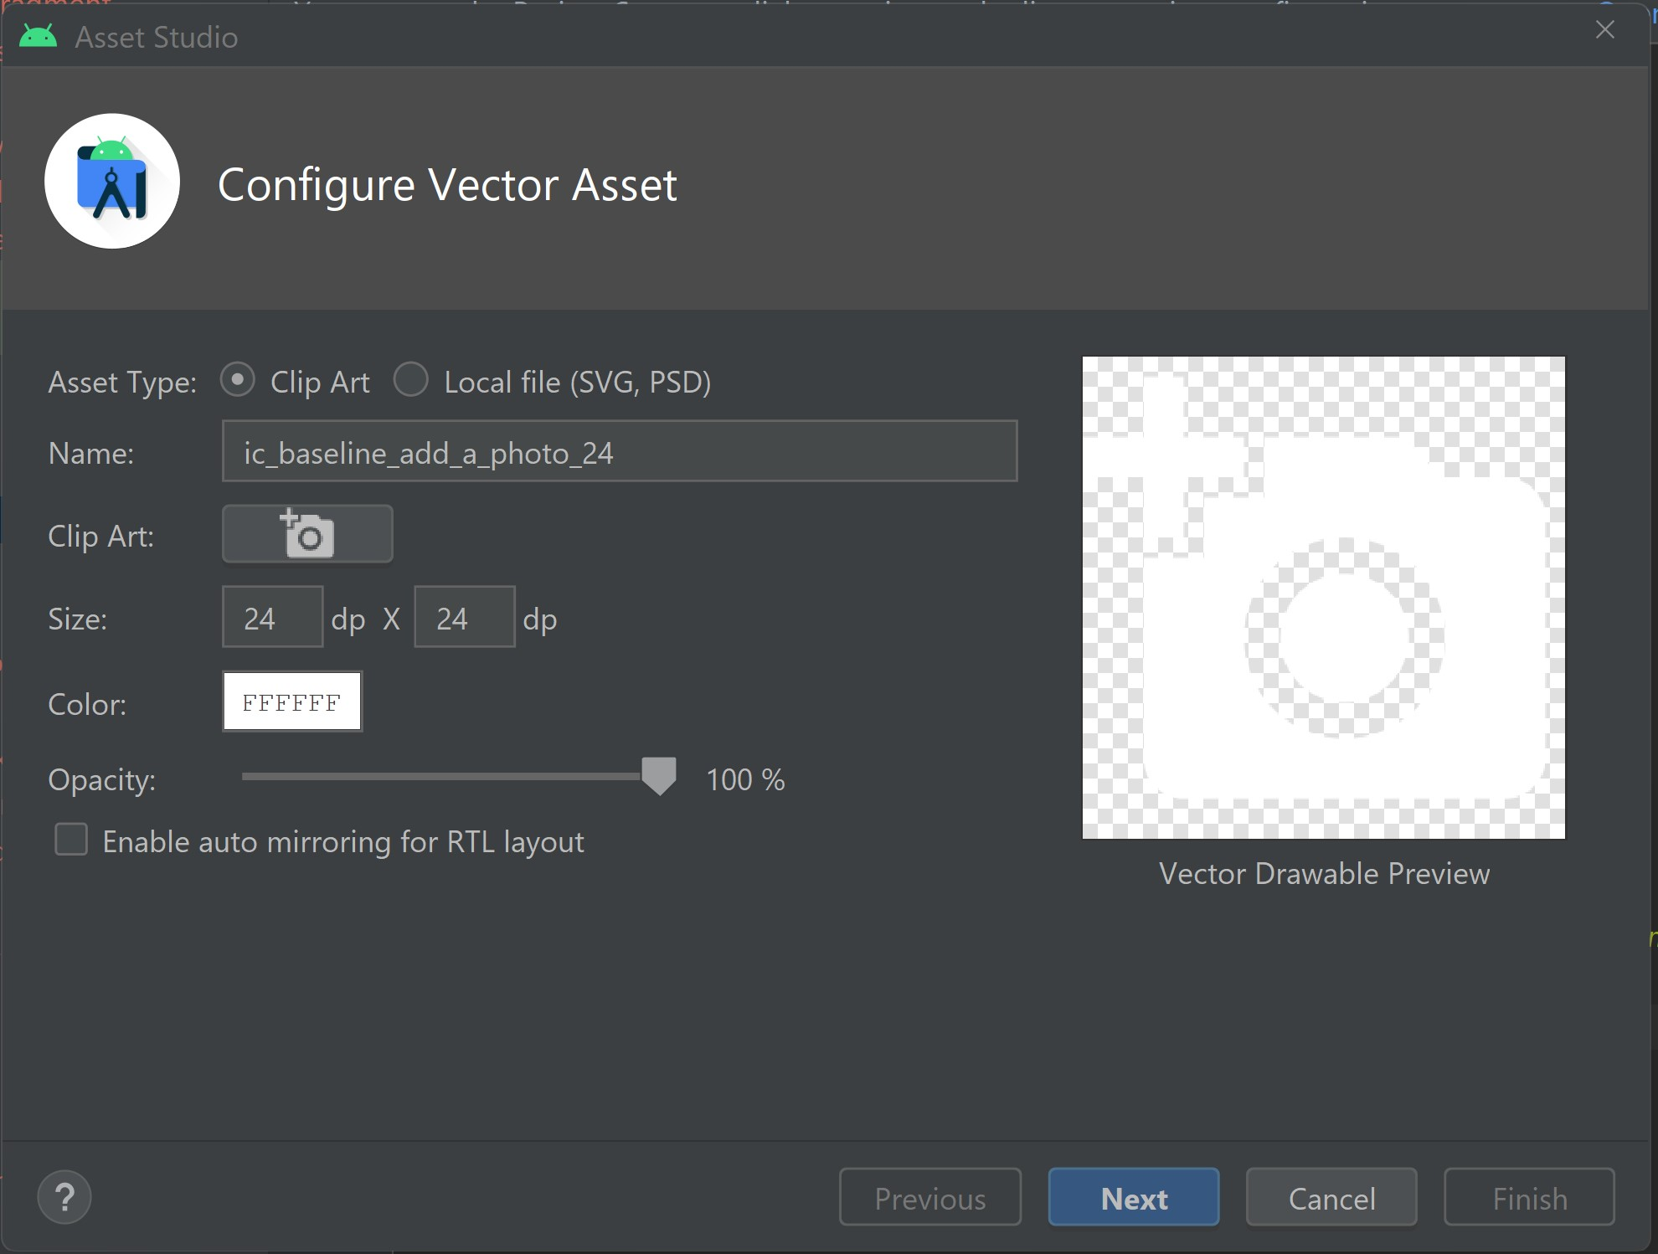

1. Find from **Clip Art** “add_a_photo” vector
2. Change the name to “**ic_add_a_photo**”
3. Change the color to white “**FFFFFF**”
4. Click on **Next** and then **Finish**
5. Add new string values in **strings.xml** as below:

<string name="image_contentDescription">image</string>  
<string name="lbl_title">Title</string>  
<string name="lbl_type">Type</string>  
<string name="lbl_category">Category</string>  
<string name="lbl_ingredients">Ingredients</string>  
<string name="lbl_cooking_time_in_minutes">Cooking Time In Minutes</string>  
<string name="lbl_direction_to_cook">Direction To Cook</string>  
<string name="lbl_add_dish">ADD DISH</string>

1. Add new color values in **colors.xml** as below:

<color name="dish_image_background">#E1E1E1</color>  
<color name="blue_grey_700">#37474f</color>  
<color name="grey_900">#212121</color>

1. Create new layout using constraints, views and view groups as below:

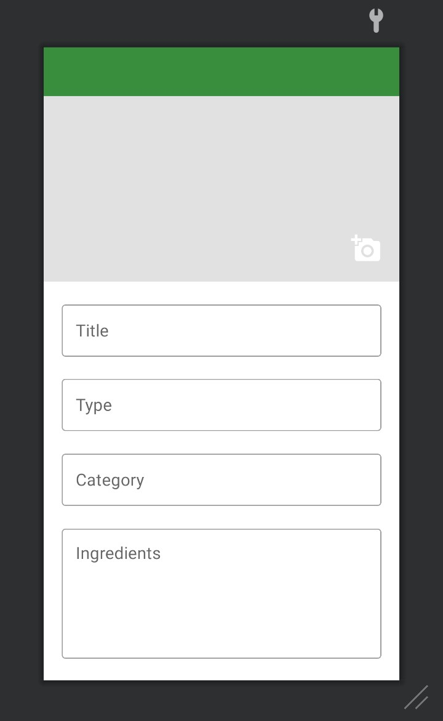

Note *** - use as a guide activity_add_update_dish.xml

1. Add the “**configChanges”** attribute in **AndroidManifest.xml** to allow layout to rotate it horizontally in the application if user rotates it. This will prevent the app from restarting when the screen orientation changes.

android:configChanges="orientation"

1. In **AddUpdateDishActivity.kt** create a global variable for layout ViewBinding

private lateinit var mBinding: ActivityAddUpdateDishBinding

1. Initialize the layout ViewBinding variable and set the contentView.

mBinding = ActivityAddUpdateDishBinding.inflate(*layoutInflater*)  
setContentView(mBinding.*root*)

1. Create a function to setup the ActionBar in **AddUpdateDishActivity.kt**

private fun setupActionBar() {  
 // action bar in xml -> id is toolbar_add_dish_activity  
 // we are assigning this bar using default method setSupportActionBar  
 setSupportActionBar(mBinding.toolbarAddDishActivity)  
  
 // this will allow us to have back button  
 *supportActionBar*?.setDisplayHomeAsUpEnabled(true)  
  
 // add click listener to back button  
 mBinding.toolbarAddDishActivity.setNavigationOnClickListener**{**

onBackPressed()

**}**  
**}**

1. Call the method of setupActionBar in onCreate in **AddUpdateDishActivity.kt**

setupActionBar()

*Project # 8*  **8_ElinaResearchProject**

In this project we will generate and add the back arrow icon for the action bar for the AddUpdateDishesActivity and assign the click event for ImageView.

1. Generate and add the back arrow icon for action bar home back icon. Right click on **drawable -> New -> Vector Asset**

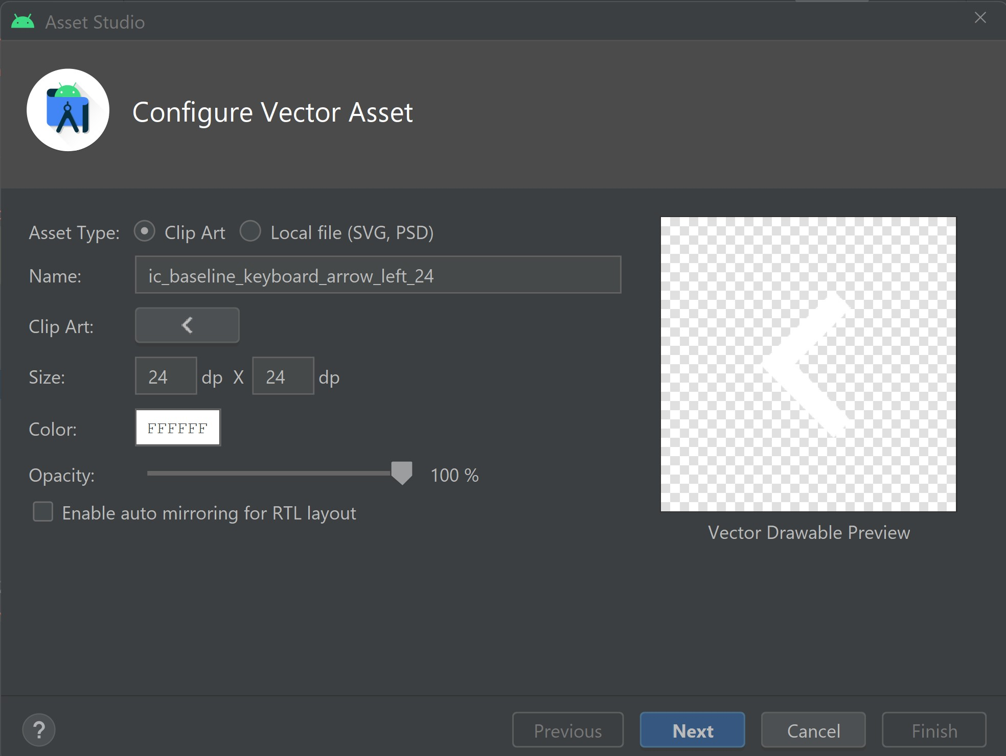

1. Find from **Clip Art** “ic_arrow_back” vector
2. Change the name to “**ic_arrow_back**”
3. Change the color to white “**FFFFFF**”
4. Click on **Next** and then **Finish**
5. Replace the back arrow icon of the action bar. In **AddUpdateDishActivity.kt** in replace back button in **setupActionBar** method as below:

*supportActionBar*?.setHomeAsUpIndicator(R.drawable.*ic_arrow_back*)

1. Implement the View.OnClickListener for **AddUpdateDishActivity**
2. Override the onclick listener method

override fun onClick(v: View) {}

1. Perform the action when user clicks on the *iv_add_dish_image* and show a Toast message

override fun onClick(v: View) {  
  
 when (v.*id*) {  
 R.id.*iv_add_dish_image* -> {  
 Toast.makeText(  
 this,  
 "You have clicked on the ImageView.",  
 Toast.*LENGTH_SHORT*  
).show()  
 return  
 }  
 }  
}

1. Assign the click event to the image button in onCreate method of **AddUpdateDishActivity**.

mBinding.ivAddDishImage.setOnClickListener(this)

*Project # 9*  **9_ElinaResearchProject**

In this project we will implement the *custom dialog* for image selection i.e either from **Camera** or **Gallery**.

1. Generate and add vector icon in drawable. Right click on **drawable -> New -> Vector Asset**

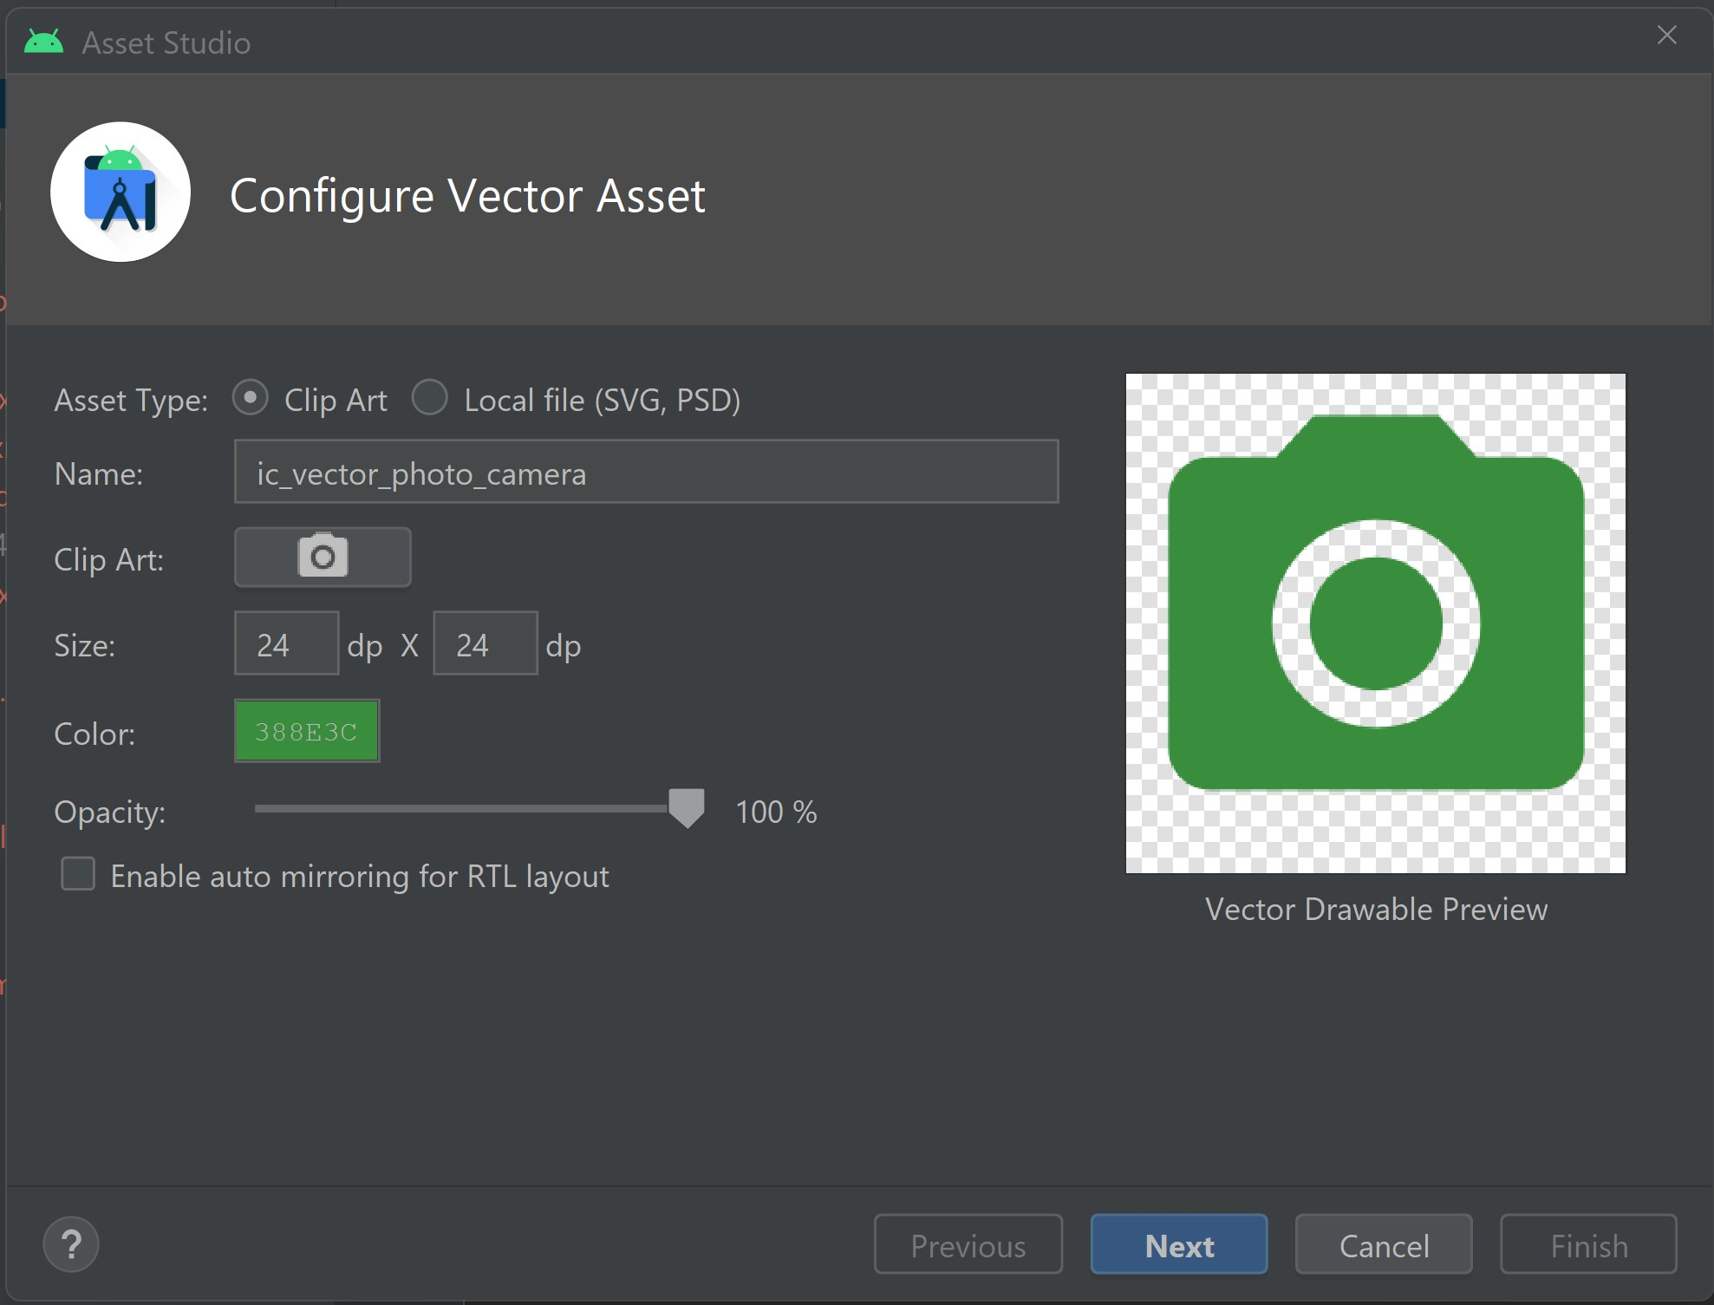

1. Find from **Clip Art** “camera alt” vector
2. Change the name to “**ic_vector_photo_camera**”
3. Change the color into “#388E3C”
4. Click on **Next** and then **Finish**
5. Generate and add another vector icon in drawable. Right click on **drawable -> New -> Vector Asset**

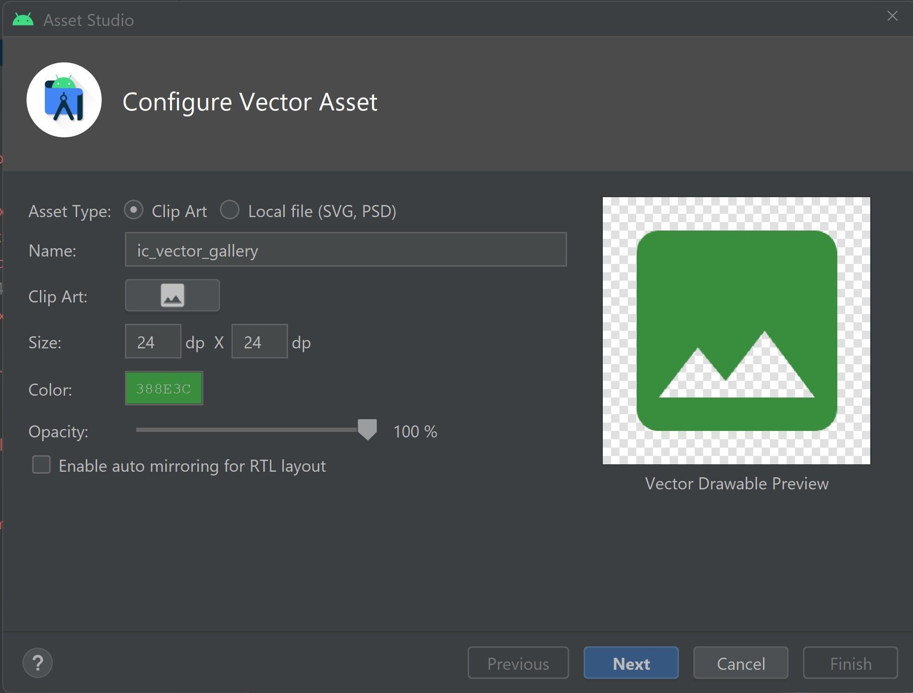

1. Find from **Clip Art** “image” vector
2. Change the name to “**ic_vector_gallery**”
3. Change the color into “#388E3C”
4. Click on **Next** and then **Finish**
5. Design a custom dialog using the constraint layout. (See dialog_custom_image_selection.xml)

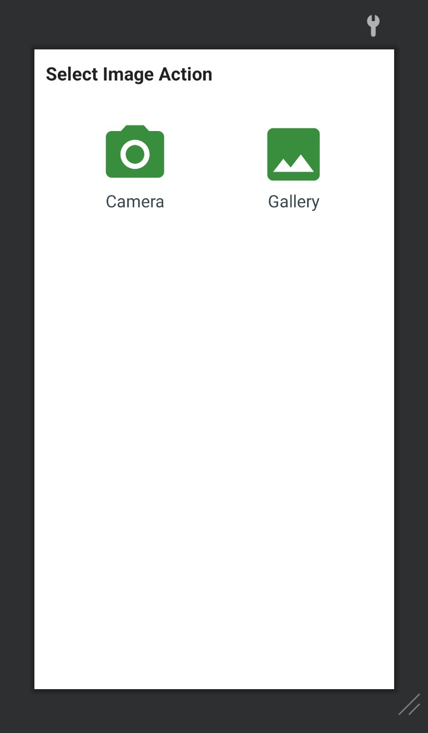

1. Add the string values to the strings.xml file.

<string name="title_select_image_action">Select Image Action</string>  
<string name="lbl_camera">Camera</string>  
<string name="lbl_gallery">Gallery</string>

1. Create a function customImageSelectionDialog() to launch a custom dialog

private fun customImageSelectionDialog() {  
 val dialog = Dialog(this)  
  
 val binding: DialogCustomImageSelectionBinding = DialogCustomImageSelectionBinding.inflate(*layoutInflater*)  
  
 /*Set the screen content from a layout resource.  
 The resource will be inflated, adding all top-level views to the screen.*/  
 dialog.setContentView(binding.*root*)  
  
 // *Assign the click for Camera and Gallery. Show the Toast message for now.*  
 binding.tvCamera.setOnClickListener **{**  
Toast.makeText(this, "You have clicked on the Camera.", Toast.*LENGTH_SHORT*).show()  
 dialog.dismiss()  
 **}**  
  
binding.tvGallery.setOnClickListener **{**  
Toast.makeText(this, "You have clicked on the Gallery.", Toast.*LENGTH_SHORT*).show()  
 dialog.dismiss()  
 **}**  
  
 //Start the dialog and display it on screen.  
 dialog.show()  
}

1. Replace the Toast Message in onClick() with the customImageSelectionDialog() function.