Home Page

There are three options

* Admin login
* Customer Login
* Register

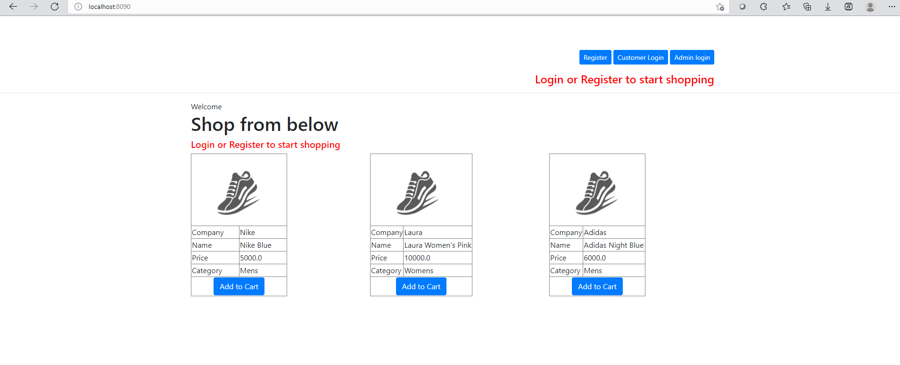

After login as Admin the three options are visible

* Manage Products
* Manage Customers
* View Purchase List

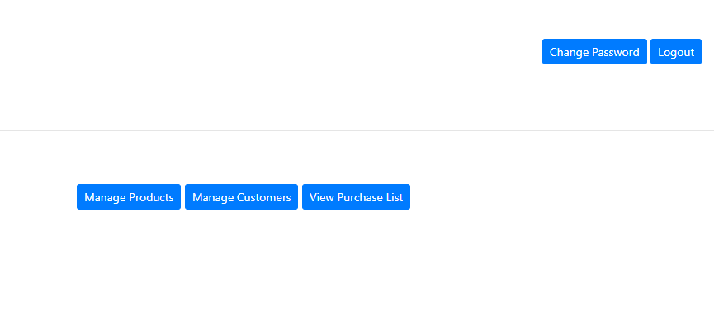

Admin Customer Management He could see the list of customer. He could delete the customer view orders by specific customers and also search for customers.

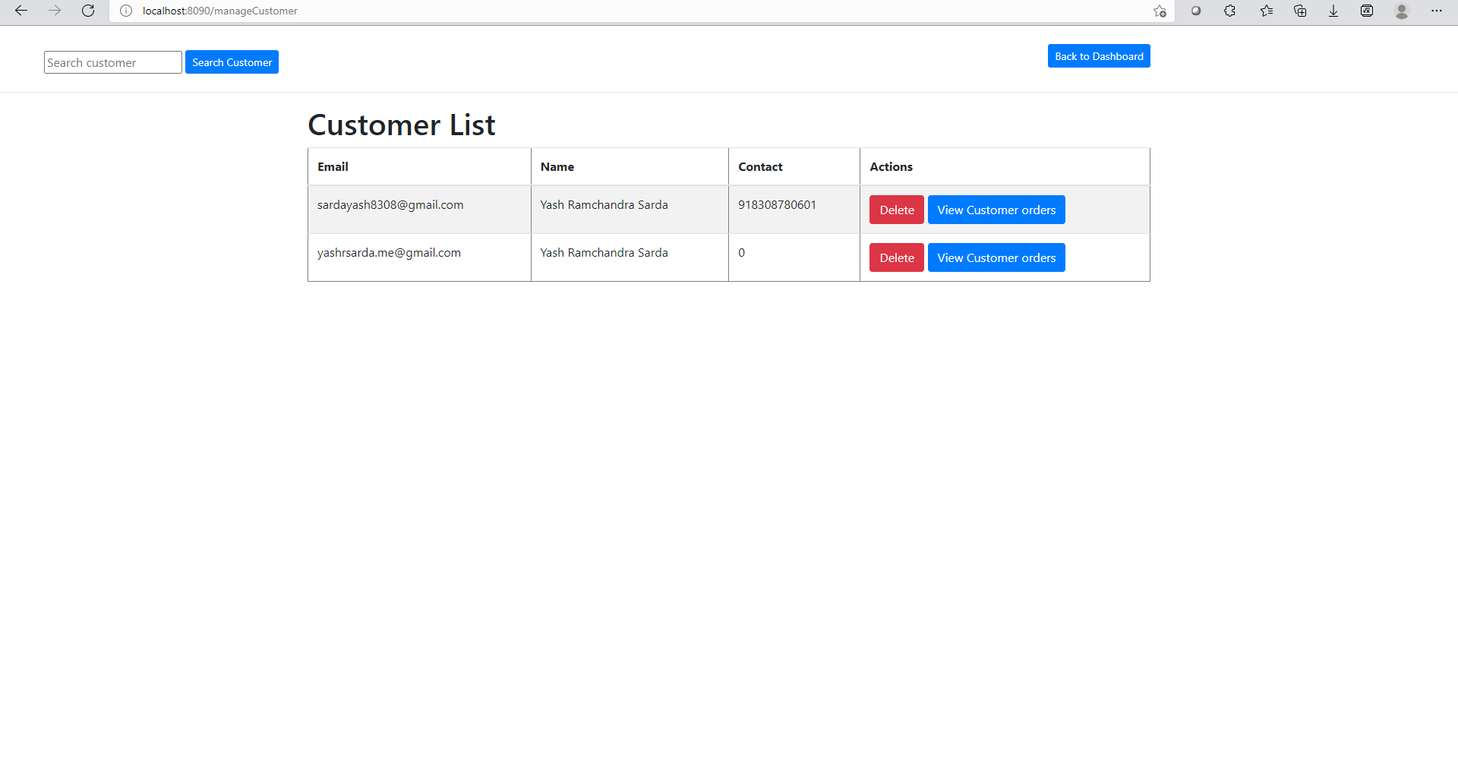

Admin Product Management

Here Admin can

* Update the existing products
* Delete the existing products
* Add new products
* View list of products
* Could update the category of the product, price of the product

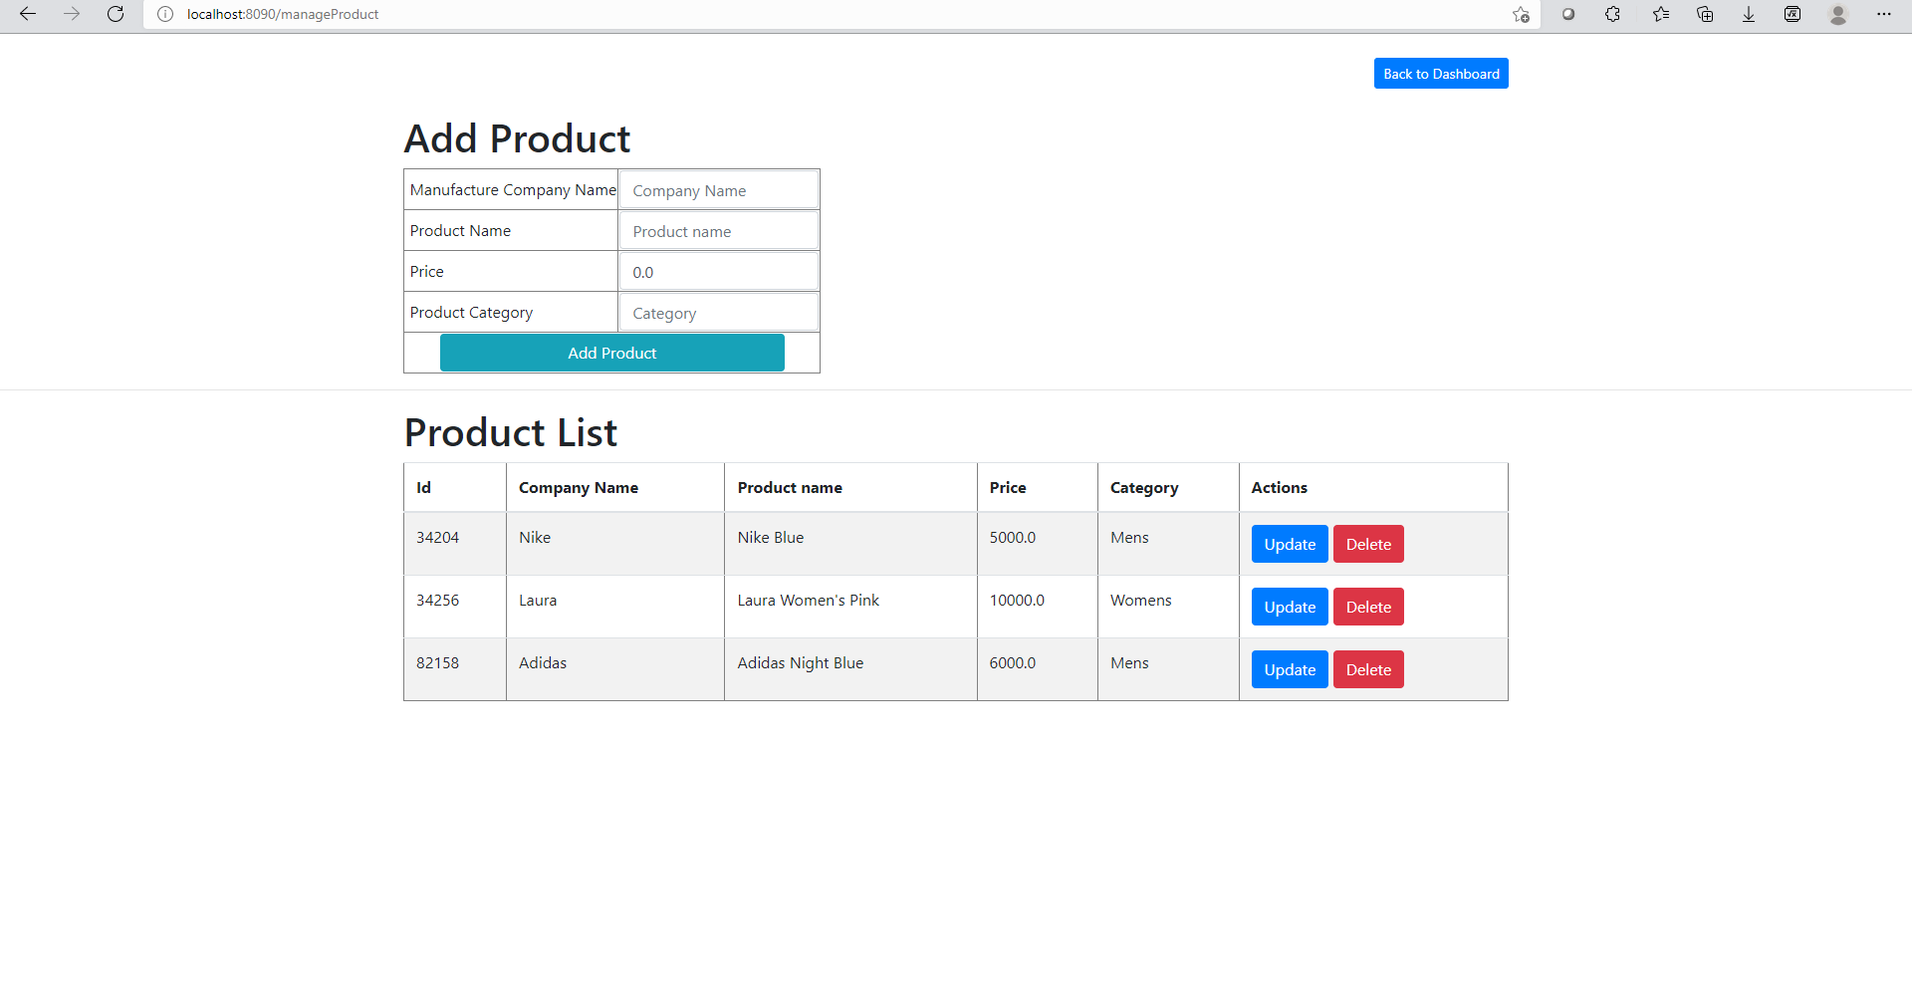

Admin View Purchase list

Here admin can

* View the purchase list
* View the purchase list of specific date
* View purchase list of specific category of product
* Delete the purchase of specific customer

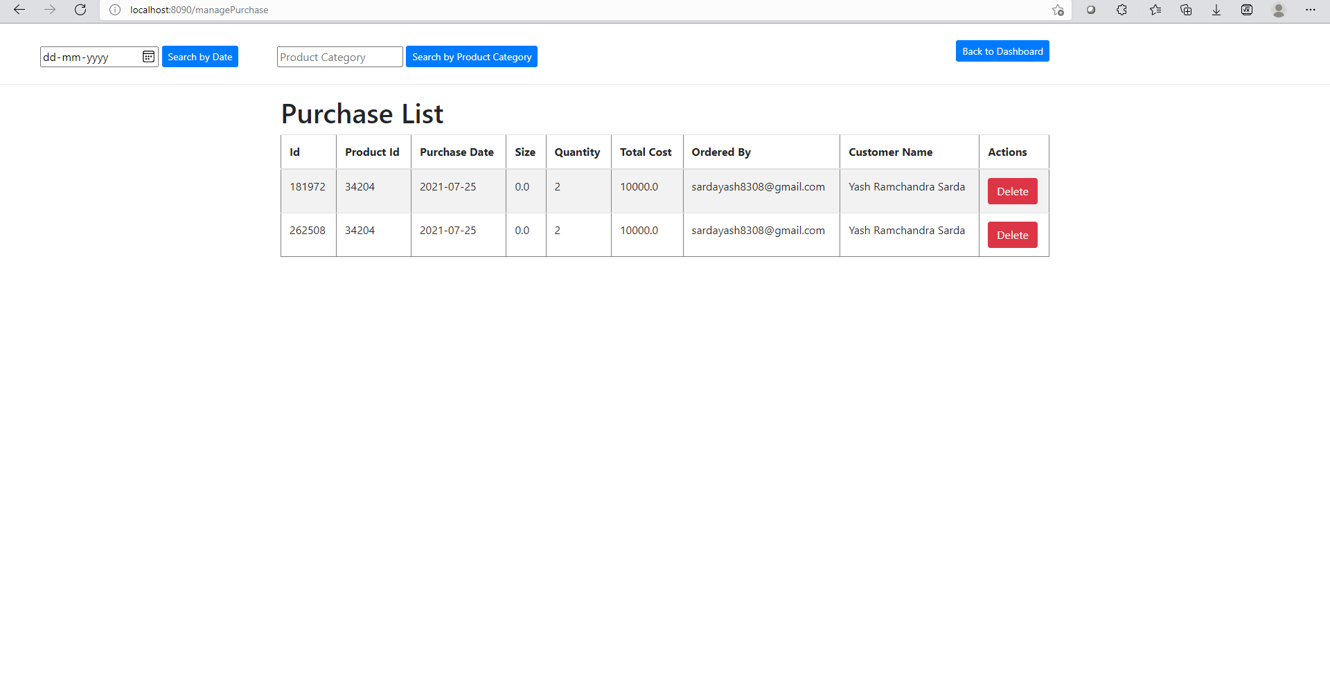

Customer Login Page

Customer must log in with valid credentials to purchase the products

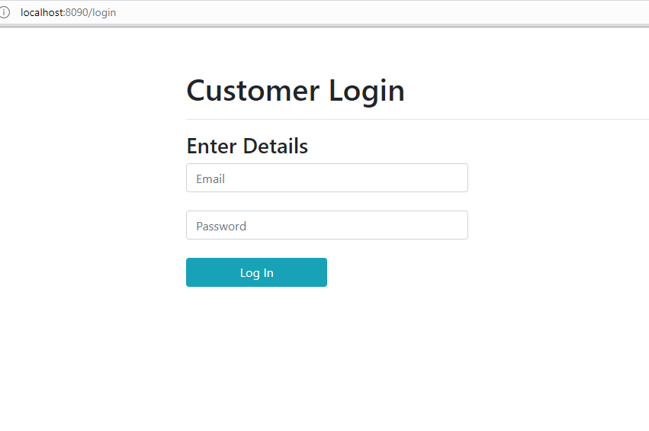

Register Customer

Customer can register self so they could purchase the product

The requiremet to register are in below image

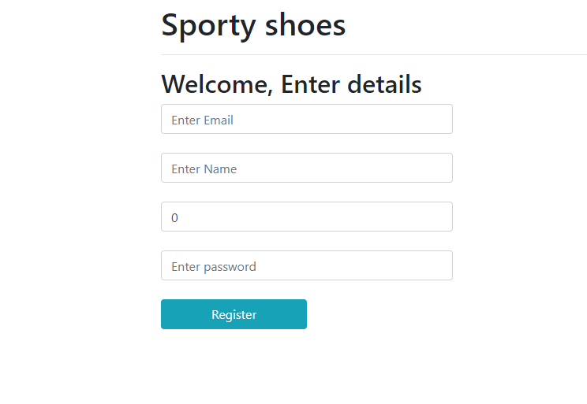

Customer Cart

Here customer could see the products in their cart.

Customer could also search for the products in cart and could edit the cart by deleting or updating the products

