**ECE 558 – Digital Imaging Systems**

**Project 01**

[mmsardes@ncsu.edu](mailto:mmsardes@ncsu.edu)

*Question 1.*

*Visualizing and checking the smoothness prior of an image.*

Input

1. Image
2. User input
   1. Selection of color space
   2. Selecting neighbor type – 4 and 8/d

Output

1. Histogram of squared difference of neighboring pixels

1.Grayscale 4 neighbors – (x,y) and (x+1, y) & (x,y) and (x, y+1)

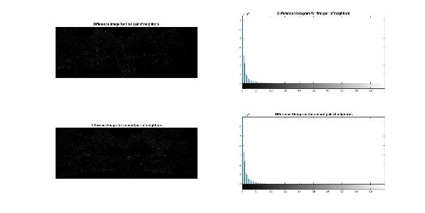

1. Grayscale 8 neighbors – (x,y) and (x+1, y+1) & (x,y) and (x-1, y-1)

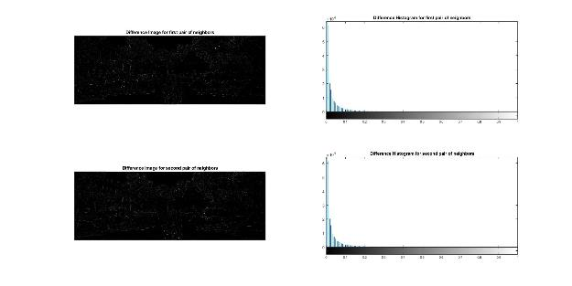

1. HSV 4 neighbor

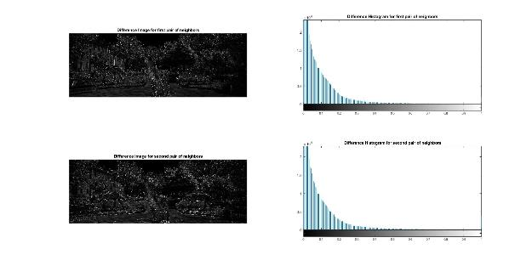

1. RGB 4 neighbors

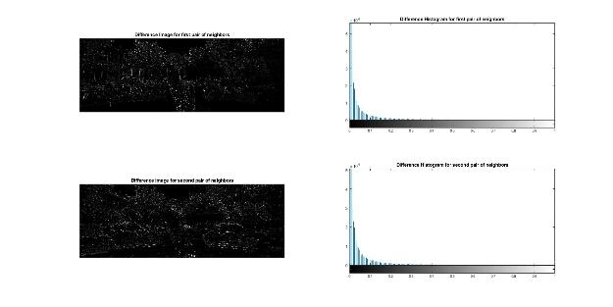

1. Grayscale 4 neighbors – Image ‘Hunt.jpg’

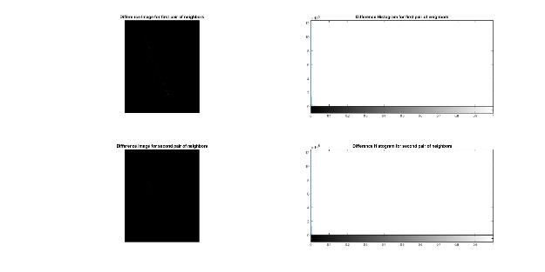

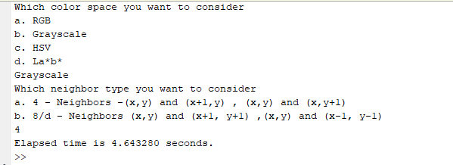

Fig. Recording the Runtime of the code.

*Question 2.*

*Find the shortest path*

