IT271 ENTERPRISE DATA WAREHOUSING · SEMESTER PROJECT
Disaster Response Intelligence Warehouse (DRIW)
Design, implementation and validation of an enterprise data warehouse for disaster impact, evacuation, relief and emergency-response analytics in the Philippines, 2020–2025

Author: Ivan Christian Salinas
Course: IT271 Enterprise Data Warehousing
Submitted: October 23, 2026
Repository: github.com/sardinexszc/NEUSTIT271_EDW_Project

Data notice: event names, dates and PSGC geography are real. All damage, evacuation, relief and response figures are synthetic, generated for demonstration.

Contents
Executive Summary 4
What is real and what is simulated 4
Results 4
How to read this report 4
Requirements Coverage 5
1. Business Case and Requirements Analysis 6
1.1 Enterprise domain 6
1.2 Stakeholders and BI objectives 6
1.3 Key business questions 6
1.4 Functional requirements 7
1.5 Non-functional requirements 7
1.6 Assumptions and constraints 8
2. Data Warehouse Design 9
2.1 Conceptual model 9
2.2 Logical model 9
2.3 Physical model 10
2.4 DRIW Dimensional Model 13
3. Data Dictionary and Metadata 16
3.1 Schemas (layers) 16
3.2 Lineage 16
3.3 dw · Star schema 17
3.4 mart · Data marts 21
3.5 Supporting layers 23
4. ETL Design 26
4.1 Overview 26
4.2 Data sources 26
4.3 Extract (raw layer) 27
4.4 Transform (staging and data-quality layers, dbt) 27
4.5 Load (warehouse and marts) 27
4.6 Orchestration, scheduling and error handling 28
4.7 Tools 28
5. Data Quality Framework 29
5.1 Where data quality happens 29
5.2 Severity policy 29
5.3 Key techniques 29
5.4 Proof: reconciliation against planted defects 30
5.5 Running 30
6. Data Governance, Security and Privacy 31
6.1 Roles 31
6.2 Row-level security (regional users) 31
6.3 Surviving rebuilds 32
6.4 Auditing access 32
6.5 Privacy 32
6.6 Supabase 33
6.7 Standards alignment 33
7. Analytics: OLAP and Dashboards 34
7.1 OLAP approach (ROLAP) 34
7.2 Dashboards and web application walkthrough 34
7.3 Sample findings (synthetic data) 47
8. Testing and Validation 49
8.1 Summary 49
8.2 What is validated 49
8.3 Defects found by testing (and fixed) 50
8.4 Known limitations 51
8.5 Query Performance Test Report 51
9. Implementation and Live Demo 53
9.1 Technology stack 53
9.2 Repository layout 53
9.3 Build and run 53
9.4 Live demo script 53
10. Enterprise Positioning and Data Exchange 55
10.1 Why an enterprise data warehouse has no content management system 55
10.2 Data exchange with LGUs and national agencies 56
10.3 Other ways in and out 59
10.4 Next steps 59
Appendix A. Sample Analytical Queries 60

Executive Summary
Problem. A Philippine typhoon or monsoon flood is reported by several agencies at once: NDRRMC (damage), DSWD (evacuation centers), NGOs and UN agencies (relief), PAGASA (the hazard) and LGUs (response requests). Their systems share no place codes, event names or units, so leadership cannot answer cross-agency questions such as "which provinces got the least relief per affected person?" without weeks of manual reconciliation.
Solution. DRIW, the Disaster Response Intelligence Warehouse, integrates the five sources into one dimensional model on PostgreSQL 17: four star schemas (transaction, periodic-snapshot and accumulating-snapshot facts) over nine conformed dimensions, including a Type 2 slowly changing location dimension. A Python and dbt ETL pipeline cleans and conforms the data with 41 data-quality rules; six ROLAP marts (GROUP BY CUBE and GROUPING SETS) feed Executive, Operations and Logistics dashboards. A PHP back-end on XAMPP serves them live through a read-only login, and row-level security limits regional users to their own region.

What is real and what is simulated
Real | Simulated (synthetic)
The architecture, ETL pipeline, data-quality rules, star schema, marts, security and dashboards: built and run exactly as they would be on agency data | Every damage, casualty, evacuation, relief and response figure in this report and on the dashboards
The 31 events (PAGASA names and dates, 2020–2025) | The source files themselves (CSV, Excel, JSON) and their data-entry defects
All geography: PSA PSGC, 17 regions, 81 provinces, 1,634 cities and municipalities, 42,046 barangays

Agency operational data is not public, so the figures are generated (seed 271), scaled to population and storm strength. The numbers demonstrate the warehouse; they are not findings about real disasters. Synthetic data has one advantage: 9,995 defects of 19 known types were planted on purpose, so the ETL can be proven correct by counting. Nothing in the pipeline depends on the data being synthetic: replacing the generator with real agency extracts changes the input files only (see the Privacy section of Chapter 6).

Results
Measure | Result
Source rows integrated | 85,841 from 5 systems in 4 formats
Planted defects detected | 19 of 19 types, each at the exact count (9,995 defects)
Location names matched to PSGC | 63,347 rows, 0 false matches
Automated checks | 99 dbt checks and 62 end-to-end, governance and API tests, all passing
Query performance | 14 of 14 sample queries within 1 s (slowest about 32 ms); marts about 78× faster than the facts
Access control | 4 roles; row-level security verified per role

How to read this report
The Requirements Coverage page that follows maps each item of the project brief to the chapter that meets it. Chapters 1–2 cover the business case and the design, 3–5 the metadata, ETL and data quality, 6 governance and privacy, 7 the analytics, 8 testing, and 9 how to run the live demo. Appendix A lists the sample queries.

Requirements Coverage
Each requirement of the IT271 semester project brief, and where this submission meets it.
Brief section | Requirement | Where it is met
1. Overview | Requirements gathering and BI objectives | Chapter 1 (Business Case), §2–§5
1. Overview | Data modeling: conceptual, logical, physical | Chapter 2 (Warehouse Design), §1–§3
1. Overview | ETL processes | Chapter 4 (ETL Design)
1. Overview | OLAP cube or star/snowflake schema | Chapter 2 (four star schemas); Chapter 7 (ROLAP cube)
1. Overview | Data governance and security | Chapter 6 (Governance, Security and Privacy)
1. Overview | Analytics, dashboards, reports | Chapter 7 (Analytics)
2A | Description of the enterprise domain | Chapter 1 §1
2A | Key business questions | Chapter 1 §3 (BQ1–BQ10)
2A | Functional and non-functional requirements | Chapter 1 §4 (FR1–FR12), §5 (NFR1–NFR9)
2A | Schema design: star or snowflake (fact + dimension tables) | Chapter 2 §2; Chapter 2 (dimensional model detail)
2A | ER/UML diagrams of the warehouse design | Chapter 2: conceptual diagram and four ER diagrams
2A | Data dictionary and metadata documentation | Chapter 3 (generated from the catalog; lineage, row counts, load times)
2A | ETL: sources of data (mock or real) | Chapter 4 §2
2A | ETL: transformation logic (cleaning, integration, aggregation) | Chapter 4 §4; Chapter 5
2A | ETL workflow diagram | Chapter 4 §1
2A | Governance: security, privacy, access controls | Chapter 6 (roles, row-level security, web login, Privacy section)
2A | Governance: data quality management strategy | Chapter 5 (Data Quality Framework)
2B | Warehouse on SQL Server, Oracle, PostgreSQL, MySQL or cloud DW | PostgreSQL 17 (Chapter 2 §3, Chapter 9)
2B | ETL pipelines (tools or custom Python/SQL) | Python + dbt, ingestion/pipeline.py (Chapter 4)
2B | OLAP cube / analytical queries | mart_impact_cube (CUBE), GROUPING SETS, 14 sample queries (Chapter 7, Appendix A)
2B | Reports/dashboards (Power BI, Tableau or similar) | Executive, Operations, Logistics dashboards on XAMPP, with a screenshot and discussion of every page (Chapter 7 §2)
2C | Validation of ETL: completeness, correctness, accuracy | Chapter 8 (99 dbt checks, 28 end-to-end, 19/19 reconciliation, 0 false matches)
2C | Test reports for data consistency and query performance | Chapter 8 (consistency); Query Performance Test Report
2D | Live demo | Chapter 9 §4 (demo script)
2D | Showcase of sample queries, OLAP analysis, dashboards | Appendix A, Chapter 7
2D | Defense of design choices | Chapter 2 (star vs snowflake, ROLAP), dimensional-model design decisions, Chapter 4 (full reload, quarantine)
2D | Enterprise positioning | Why an EDW needs no CMS; Excel data exchange with LGUs and agencies: templates, layout profiles, checked uploads, Excel export (Chapter 10)

1. Business Case and Requirements Analysis

1.1 Enterprise domain
Government: disaster risk reduction and management (DRRM) in the Philippines.
The Philippines is struck by around twenty tropical cyclones a year, plus monsoon floods. Responding to one event involves many agencies, each with its own system:
Organization | Role in a disaster | System of record (simulated)
NDRRMC / Office of Civil Defense | Consolidates damage and casualty figures | Situation reports (CSV), cumulative, re-issued per event
DSWD (DROMIC) | Runs and reports evacuation centers | Daily Excel workbooks per field office
NGOs and UN agencies (PRC, Caritas, WFP, UNICEF) and DSWD | Distribute relief goods | Partner reports (nested JSON) with their own item codes and units
PAGASA | Names and tracks hazard events | Weather bulletins (CSV)
LGUs / MDRRMOs | Rescue, evacuation, road clearing, relief delivery | Response request logs (CSV)

These systems share no place codes, event names or units. Leadership therefore cannot answer cross-agency questions without manual reconciliation in spreadsheets.
Scope. Tropical cyclones and southwest-monsoon floods, 2020–2025: 31 events. Event names and dates (PAGASA) and all geography (PSA PSGC: 17 regions, 81 provinces, 1,634 cities and municipalities, 42,046 barangays) are real. Operational figures are synthetic, generated with counted, planted defects (85,841 source rows; 9,995 defects of 19 types), because agency data is not public and known defects let the ETL be proven correct.

1.2 Stakeholders and BI objectives
Stakeholder | Needs | BI objective | Served by
Executive leadership (NDRRMC council, agency heads) | Overall impact, trends, where to invest | Single view of damage, casualties and relief across all agencies and years | Executive dashboard, mart_event_summary, mart_impact_cube
Operations managers (regional DRRM offices) | During and after an event: evacuation load, response speed | Per-event evacuation and response performance | Operations dashboard, secure.* views for their region
Logistics officers | Whether relief matched need | Relief by organization and resource, coverage per province | Logistics dashboard, mart_province_event_impact
Data analysts | Ad-hoc analysis, forecasting inputs | Clean, conformed star schema with history | dw.*, sample queries
Data stewards / IT | Data quality, reconciliation, operations | Measurable data quality with traceability to source | dq.*, quarantine, lineage

1.3 Key business questions
# | Business question | Answered by
BQ1 | Which events caused the most damage, deaths and displacement? | Q01, Q13; Executive dashboard
BQ2 | How does damage trend by year and category, and how did each year compare with the last? | Q02, Q05, Q12; Executive dashboard
BQ3 | Within an event, which regions, provinces and towns were hit hardest? | Q03 (drill-down)
BQ4 | Which regions suffer most from typhoons versus monsoon floods? | Q04, Q05 (cube); Executive dashboard
BQ5 | How many people were in evacuation centers at the peak, and for how long? | Q06; Operations dashboard
BQ6 | Which evacuation centers are repeatedly overcrowded? | Q07; Operations dashboard
BQ7 | How quickly are response teams dispatched, by request type and priority, and where is it slowest? | Q08, Q09; Operations dashboard
BQ8 | Did relief reach provinces in proportion to impact? Which were under-served? | Q10; Logistics dashboard
BQ9 | Which organizations delivered which kinds of relief? | Q11; Logistics dashboard
BQ10 | How reliable is the data: what was rejected, and why? | Q14; dq.dq_reconciliation

The Q-numbers refer to sample-queries.sql.

1.4 Functional requirements
# | Requirement | How it is met | Status
FR1 | Ingest data from the five agency systems in their native formats (CSV, Excel, JSON). | ingestion/load_raw.py lands every file in raw.* unchanged. | Met
FR2 | Keep lineage from every warehouse row to its source file and row. | meta.load_batch, _batch_id/_source_file/_row_number, dim_source_system. | Met
FR3 | Conform place names to the official PSGC codes. | stg_location_resolution: exact, normalized, fuzzy; 0 false matches on ground truth. | Met
FR4 | Conform event names, organizations and relief units across sources. | Event aliases with time windows; organization and item alias maps; unit conversion. | Met
FR5 | Detect, correct, flag or quarantine data-quality defects, with reasons. | 41 rules in dq_rules; dq_quarantine; 19/19 planted defect types reconciled. | Met
FR6 | Store integrated data in a dimensional model with conformed dimensions. | Star schema: 4 facts, 9 dimensions (docs/warehouse-design.md). | Met
FR7 | Preserve history when administrative boundaries change. | SCD Type 2 dim_location (2022 Maguindanao split). | Met
FR8 | Support OLAP analysis: roll-up, drill-down, slice, dice, pivot. | GROUP BY CUBE / ROLLUP / GROUPING SETS, marts, sample queries Q01–Q14. | Met
FR9 | Provide dashboards for executive, operational and logistics users. | Next.js dashboards on XAMPP: Executive, Operations, Logistics. | Met
FR10 | Let users filter by event, share views and export data. | ?event= links, CSV download on every chart table. | Met
FR11 | Restrict data by role, including region-level restriction. | 4 roles, row-level security, driw_web least-privilege login. | Met
FR12 | Rebuild the warehouse end to end with one command. | python ingestion/pipeline.py. | Met

1.5 Non-functional requirements
# | Requirement | Target | Evidence | Status
NFR1 | Data accuracy | Every planted defect type detected at the exact planted count | dq.dq_reconciliation: 19/19 match | Met
NFR2 | Query performance | Analytical queries under 1 second | docs/query-performance.md: 14/14, slowest about 32 ms | Met
NFR3 | Security | Least privilege; regional row-level restriction; no credentials in code | docs/governance.md; 21 per-role access tests + web-role test | Met
NFR4 | Privacy | No personal data in the warehouse; casualty data aggregated | docs/governance.md § Privacy | Met
NFR5 | Reliability | A failed source row never stops the load; rejected rows are kept with reasons | Quarantine design; staging keeps every row | Met
NFR6 | Reproducibility | Same inputs produce the same warehouse | Deterministic generator (seed 271); e2e test rebuilds from nothing | Met
NFR7 | Maintainability | Version-controlled, tested, documented | GitHub repo, dbt tests, CI on every push, generated data dictionary | Met
NFR8 | Usability and accessibility | Readable on desktop and phone; color-blind-safe charts; table view for every chart | Validated palette, legends, "Show table", responsive layout | Met
NFR9 | Portability | Run on the agency's own infrastructure without cloud services | Local PostgreSQL 17 + XAMPP (Apache, PHP); migrations also run on Supabase | Met

1.6 Assumptions and constraints
- Operational figures are synthetic; they are scaled to population and storm strength to be plausible, not to match official NDRRMC totals.
- City population is estimated from barangay counts, because the PSA workbook with census population could not be downloaded automatically.
- Loads are batch (full reload), not real time; near-real-time feeds are future work.
- Standards followed: UNDRR Global Framework for Disaster-Related Statistics, Sendai Framework 2015–2030, UNDRR Data Strategy and Roadmap 2023–2027, PSA PSGC, Data Privacy Act of 2012 (RA 10173).

2. Data Warehouse Design
The design moves from business concepts to tables in three levels. The logical level is detailed in dimensional-model.md (grains, bus matrix, SCD Type 2, design decisions); the full column list is in data-dictionary.md.

2.1 Conceptual model
The DRIW answers questions about four business processes, each recorded by a different agency. Every process involves the same core entities: a hazard event, a place, a date, the organizations involved and the source that reported it. These shared entities are what allow the processes to be analyzed together.
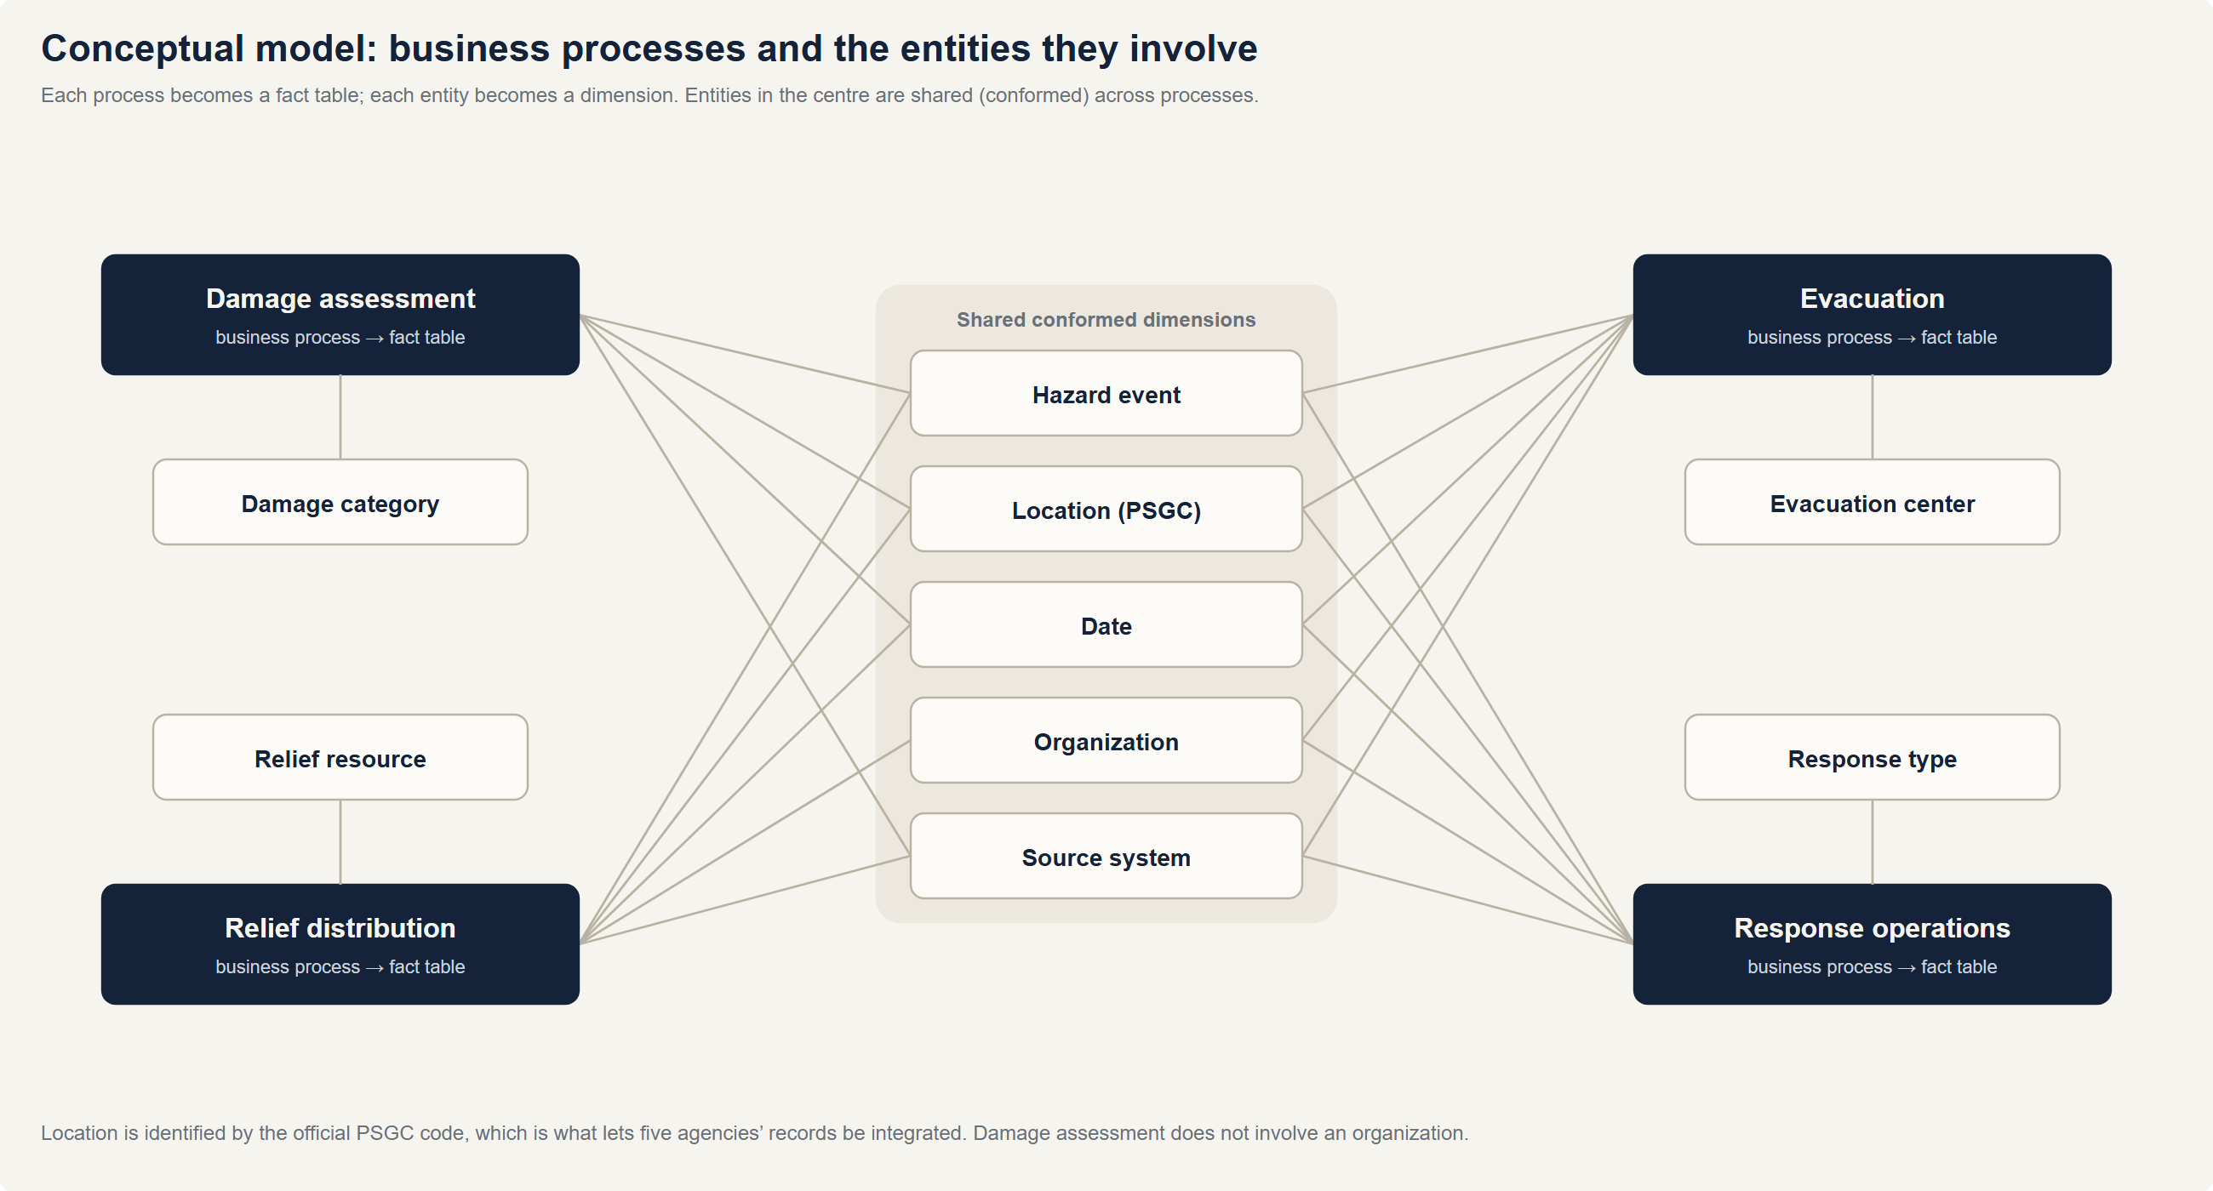
Figure: Conceptual model
Business process | Reported by | Key question it answers | Entities involved
Damage assessment | NDRRMC | How bad was it, and where? | Event, Location, Date, Damage category, Source
Evacuation | DSWD DROMIC | How many were displaced, and were centers adequate? | Event, Location, Date, Organization, Evacuation center, Source
Relief distribution | NGOs, UN agencies, DSWD | Did relief reach the people affected? | Event, Location, Date, Organization, Relief resource, Source
Response operations | LGUs / MDRRMOs | How fast did help arrive? | Event, Location, Date, Organization, Response type, Source

Why a dimensional (Kimball) design. The users ask aggregate, multi-perspective questions ("damage by region by year by hazard"), not transactional ones. A dimensional model makes those questions simple to write and fast to run, and conformed dimensions let the four processes be compared directly. The enterprise integration happens in the staging layer before data reaches the stars.

2.2 Logical model
Each business process becomes a fact table at a stated grain; each entity becomes a dimension. The model is a set of four star schemas sharing conformed dimensions (a "constellation").
Fact table | Type | Grain (one row per…) | Measures
fact_damage_assessment | Transaction | event × city/municipality × damage category | dead, injured, missing, affected families/persons, houses damaged, cost (PHP)
fact_evacuation_snapshot | Periodic snapshot | evacuation center × day × event | families inside, persons inside, capacity, over-capacity flag
fact_resource_distribution | Transaction | relief item in one distribution | quantity (standard unit), value (PHP), beneficiary families
fact_response_action | Accumulating snapshot | response request | hours to dispatch / arrive / on site / complete, personnel, completed flag

Dimension | Natural key | History | Hierarchy / notable attributes
dim_date | calendar date | Type 0 | year → quarter → month → day; typhoon season; -1 "Not yet occurred"
dim_location | PSGC code | Type 2 | region → province → city/municipality
dim_event | event code | Type 1 | hazard type → category → event
dim_organization | org code | Type 1 | org type → organization
dim_resource | item code | Type 1 | category → item
dim_evacuation_center | EC code | Type 1 | type, barangay, capacity
dim_damage_category | category | Type 0 | —
dim_response_type | type code | Type 0 | cluster → type
dim_source_system | batch id | — | lineage: source system → file

Star, not snowflake. Dimensions are kept denormalized (region and province names sit in dim_location rather than in separate region and province tables). This costs a little storage but keeps every query to one join per dimension, which suits the BI users, and the hierarchies are small. The PSGC master data itself stays normalized in ref.psgc, so the star is derived from a single authoritative source.
The bus matrix, measure additivity rules and the SCD Type 2 treatment of the 2022 Maguindanao split are in dimensional-model.md.

2.3 Physical model
Platform. PostgreSQL 17 (local; the same migrations run unchanged on Supabase). Database size about 80 MB.
Schemas as layers.
Schema | Contents | Built by | Materialization
raw | source data as received (text) | Python | tables, truncated and reloaded
ref, meta | master data, lineage, defect manifest | Python, dbt seeds | tables
staging | typed, conformed, quality-tagged data | dbt | tables
dq | rules, issue log, scorecard, quarantine, reconciliation | dbt | tables
dw | dimensions and facts | dbt | tables with PK/FK constraints and row-level security
mart | dashboard aggregates, CUBE, GROUPING SETS | dbt | materialized views
secure, governance | region-scoped views, role mapping | dbt, migration | views

Keys and data types.
- Surrogate keys are integers generated in dbt (row_number() over the natural key), so facts join on small integers. dim_date uses a smart key, YYYYMMDD.
- Natural keys are kept as attributes (psgc_code, event_code, ec_code, org_code, item_code) for traceability.
- Every dimension has a primary key; every fact has foreign keys to its dimensions (26 in total), declared as real constraints so ERD tools draw the schema and the database enforces referential integrity.
- Measures use numeric (exact money and counts) or integer; elapsed times are numeric(…, 2) hours; flags are boolean.
- Degenerate dimensions stay on the fact (sitrep_no, distribution_id + line_no, request_id, priority).
Performance. Dashboards read the marts (materialized views), not the facts: about 78× faster for the event summary. At the current volume every analytical query runs in well under 50 ms with sequential scans (see query-performance.md). The scale-up path is B-tree indexes on the most-filtered fact foreign keys and partitioning facts by event year.
Security objects. Row-level security policies on all four facts, grants declared in dbt (re-applied on every build), and the governance.my_regions view (see governance.md).

ER diagrams
Generated from the database catalog by docs/build/diagrams.py, so they always match the deployed schema.
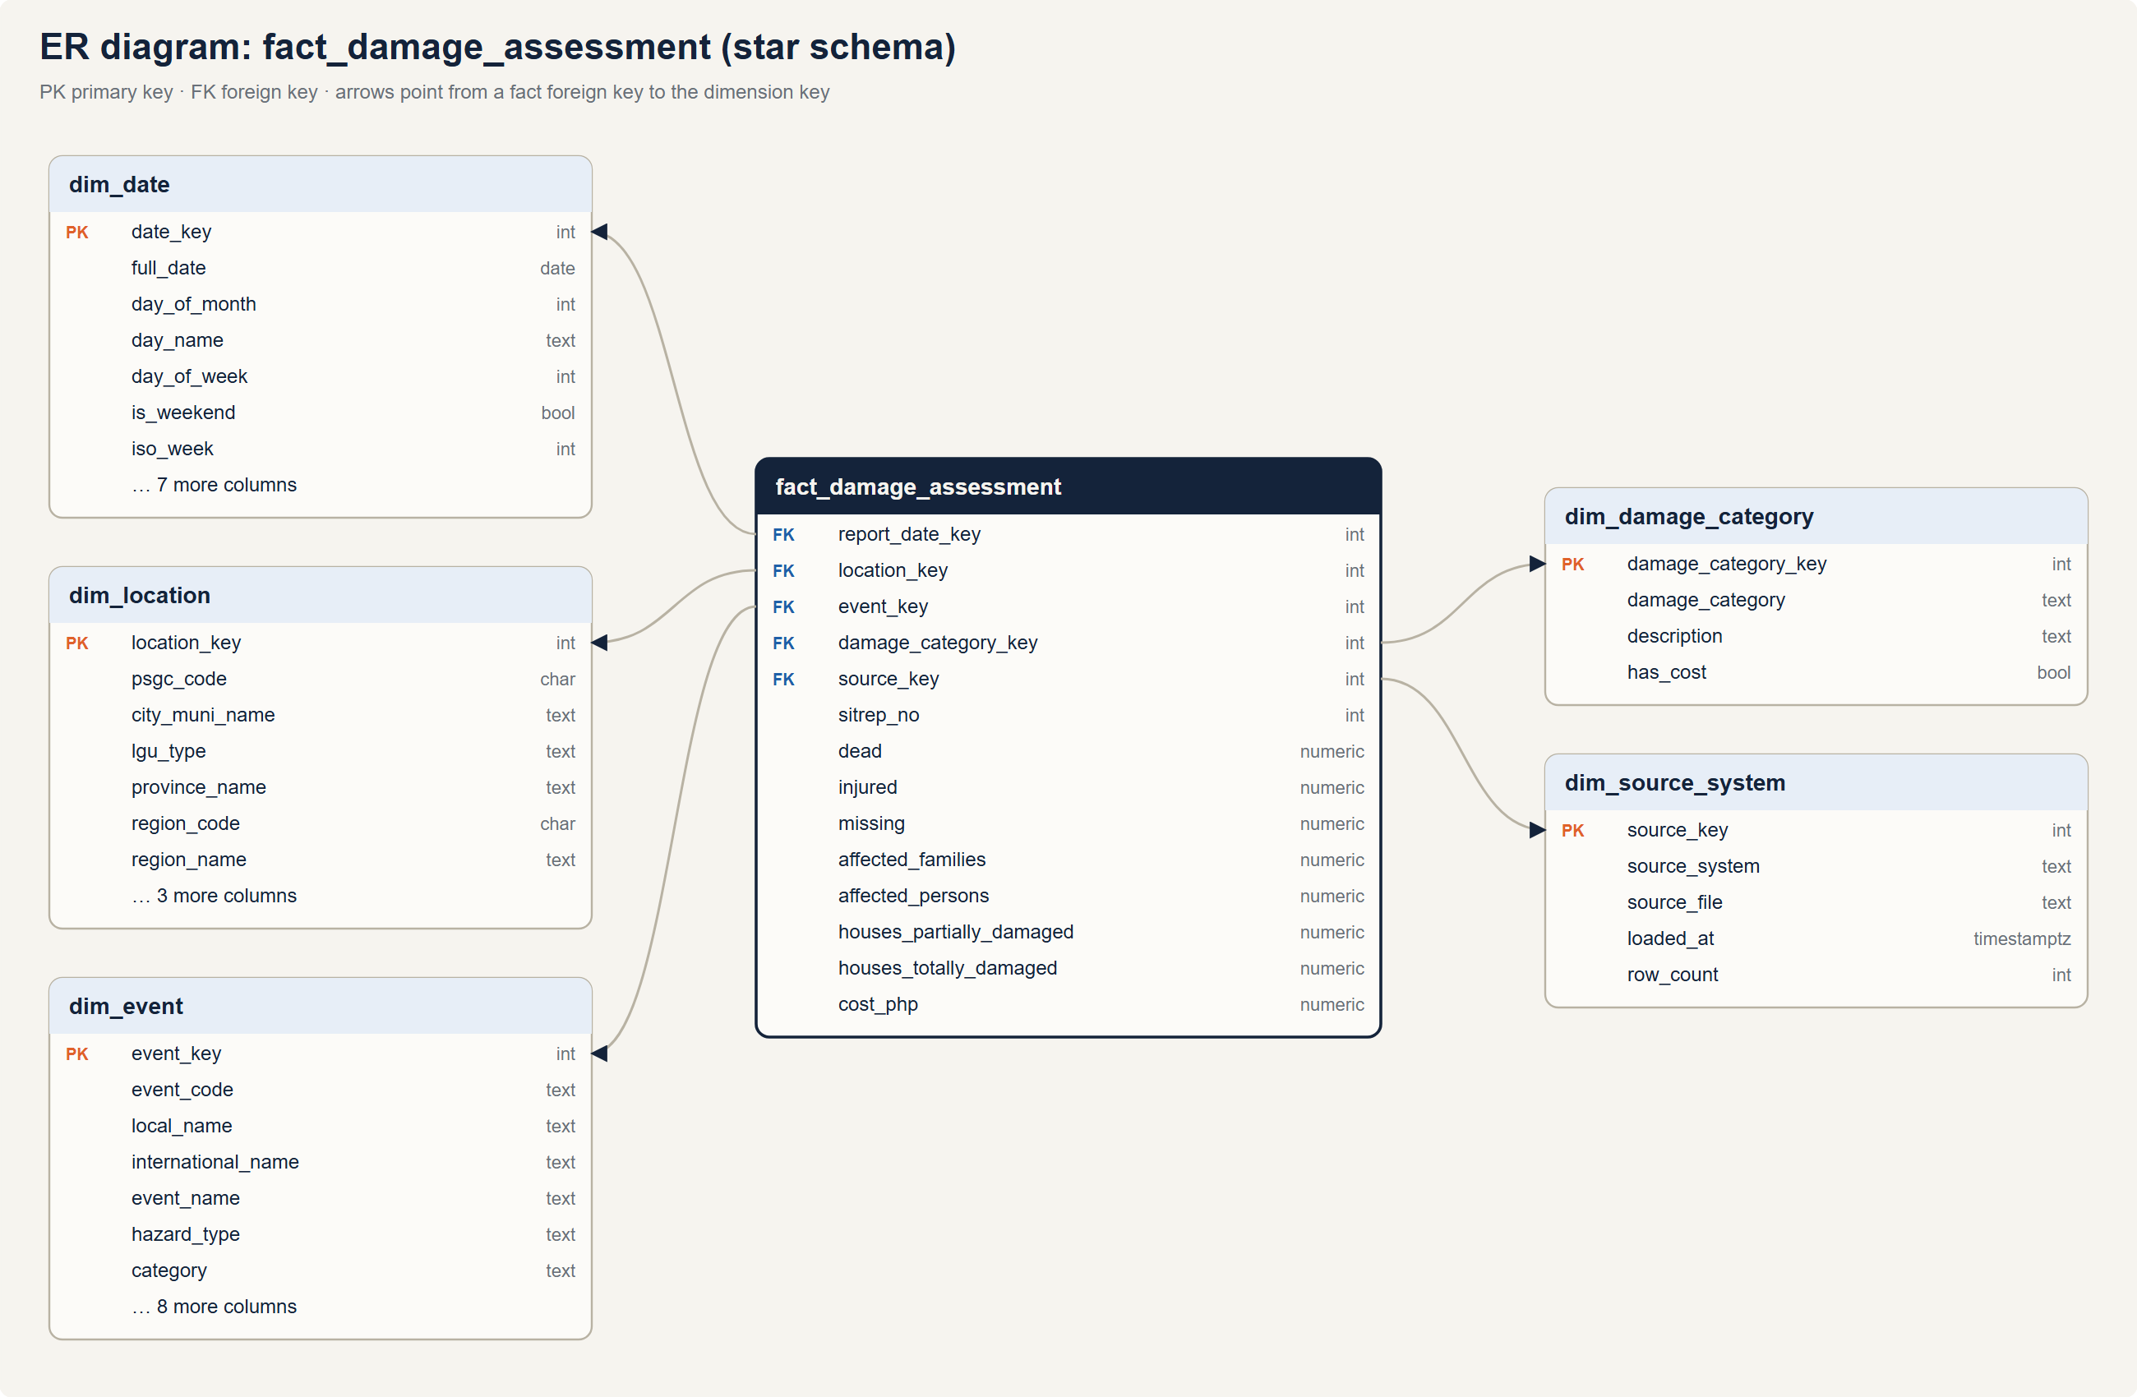
Figure: ER diagram: damage assessment star
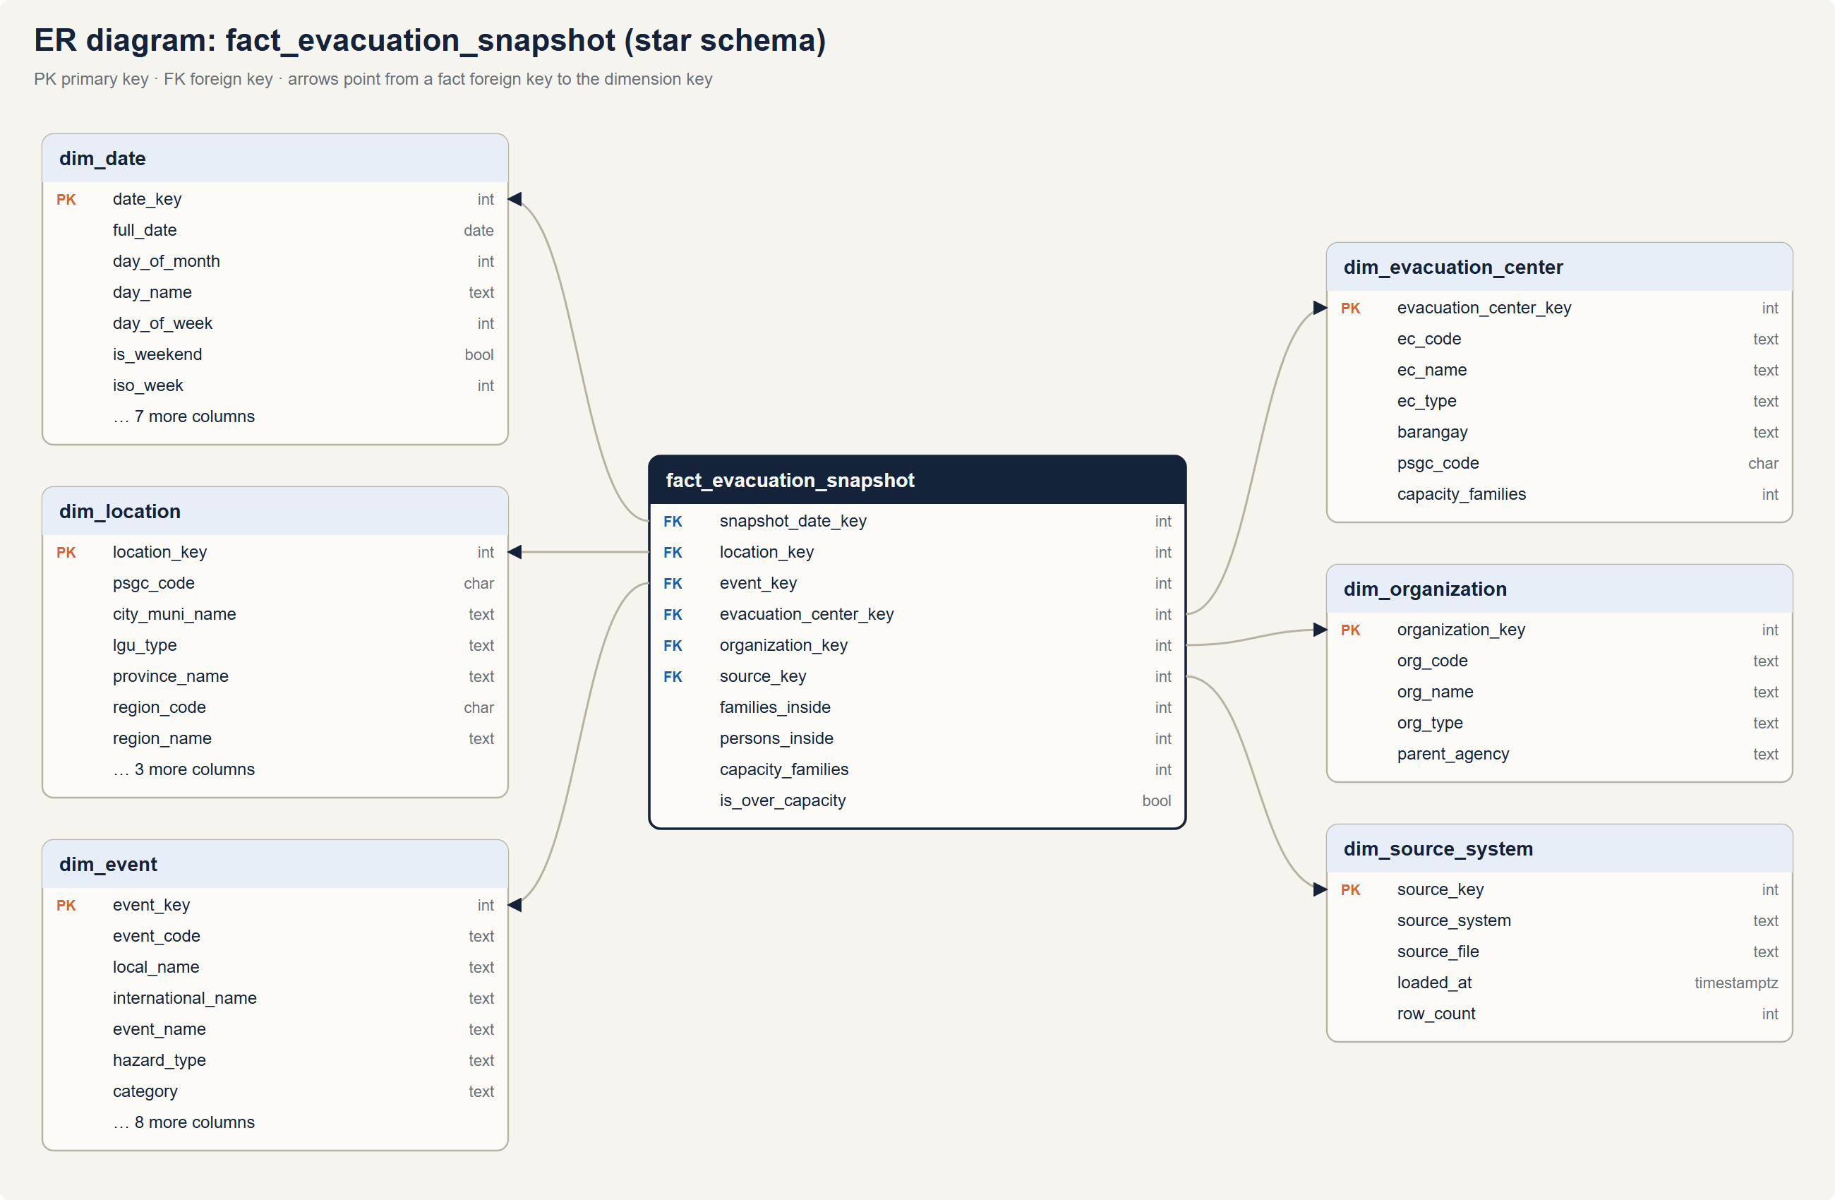
Figure: ER diagram: evacuation snapshot star
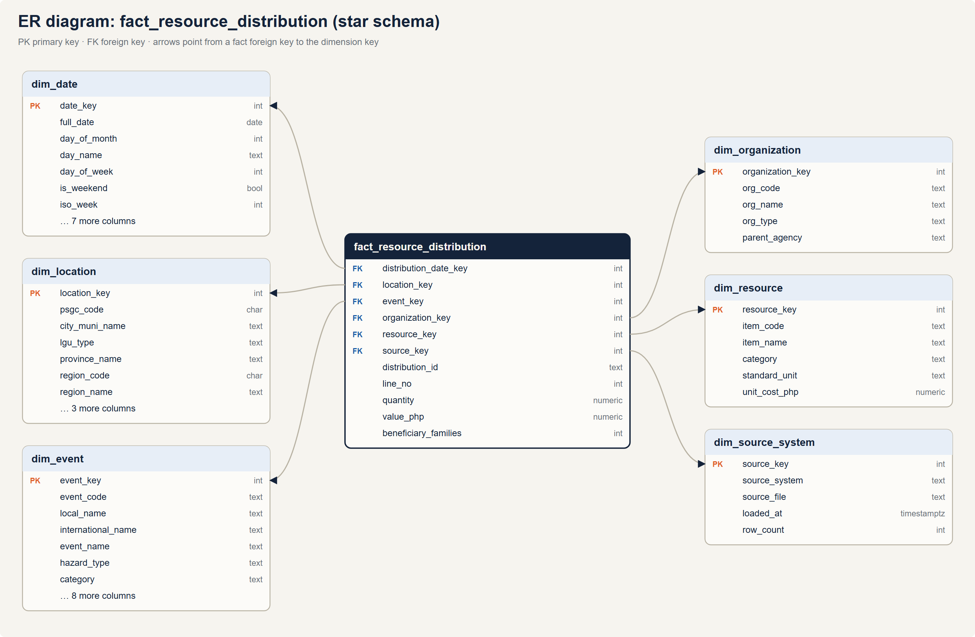
Figure: ER diagram: resource distribution star
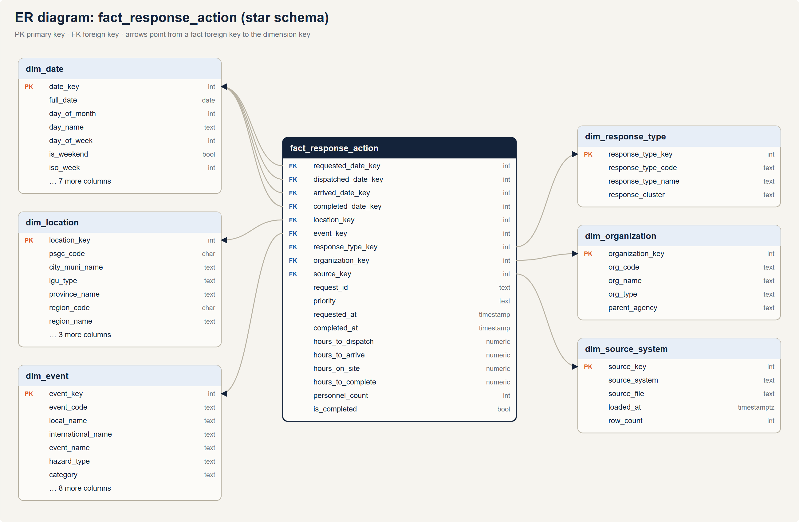
Figure: ER diagram: response action star

2.4 DRIW Dimensional Model
Star schema in the dw schema, built by dbt from the cleansed staging layer (only rows with dq_status valid or warning). All facts share conformed dimensions, so damage, evacuation, relief and response can be analyzed side by side for the same event and place.

Fact tables
Fact | Type | Grain (one row per…) | Rows* | Measures
fact_damage_assessment | Transaction | event × city/municipality × damage category | 8,806 | dead, injured, missing, affected families/persons, houses partially/totally damaged, cost (PHP)
fact_evacuation_snapshot | Periodic snapshot | evacuation center × day × event | 31,110 | families inside, persons inside, capacity, over-capacity flag
fact_resource_distribution | Transaction | distribution line item | 11,179 | quantity (standard unit), value (PHP), beneficiary families
fact_response_action | Accumulating snapshot | response request | 32,347 | hours to dispatch / arrive / on site / complete, personnel, completed flag

* Seed 271.

Design decisions
- Damage uses the latest sitrep only. NDRRMC situation reports are cumulative, so summing every sitrep would double-count. The fact keeps the latest valid sitrep per event × place × category.
- Evacuation grain includes the event. Overlapping events (Nika, Ofel and Pepito, Nov 2024) can fill the same center on the same day.
- Evacuation measures are semi-additive. Sum across centers or places for one day; across days use the peak (MAX of daily totals) or the average, never the sum.
- Header measures stay additive. beneficiary_families belongs to a whole distribution, so it is stored on the record's first valid line only.
- Open milestones. A response request not yet completed has completed_date_key = -1 ("Not yet occurred"), so foreign keys are never null; a later load fills it in.
- Degenerate dimensions: sitrep_no, distribution_id + line_no, request_id, priority.

Dimensions
Dimension | Natural key | Rows | Notes
dim_date | calendar date | 2,923 | 2019–2026 + member −1. Month, quarter, year, weekend, typhoon-season flag. Role-plays four times in fact_response_action.
dim_location | PSGC code | 1,671 | Region → province → city/municipality. SCD Type 2 (see below).
dim_event | event code (TC2024-KRISTINE) | 31 | Local + international name, hazard type, category and rank, max wind, max signal, dates, duration.
dim_organization | org code | 13 | Government, NGO, international, LGU; source name variants resolved via aliases.
dim_resource | item code | 10 | Category (Food, Water, Non-Food, Medical, Shelter), standard unit, unit cost.
dim_evacuation_center | EC code | 1,751 | Type, barangay, capacity, PSGC of its city/municipality. SCD Type 1.
dim_damage_category | category | 4 | Population, Housing, Infrastructure, Agriculture.
dim_response_type | type code | 5 | Response type and cluster (life-saving, logistics, access).
dim_source_system | batch id | per load | Lineage: source system and file each fact row came from.

SCD Type 2: dim_location
Provinces change. On 17 September 2022 a plebiscite ratified RA 11550, splitting Maguindanao into Maguindanao del Norte and Maguindanao del Sur. The change log dbt/seeds/psgc_changes.csv records each affected city/municipality with its new province and effective date (2022-09-18). dim_location turns it into versions:
psgc_code | city_muni_name | province_name | valid_from | valid_to | is_current
1903811000 | Parang | Maguindanao | 1900-01-01 | 2022-09-17 | false
1903811000 | Parang | Maguindanao del Norte | 2022-09-18 | 9999-12-31 | true

Facts join to the version valid on the fact's own date, so Typhoon Paeng (Oct 2022) reports under the new provinces, while any earlier event would still roll up to "Maguindanao". New PSGC releases are handled by appending rows to the change log.

Bus matrix
Fact \ Dimension | Date | Location | Event | Organization | Resource | Evac Center | Damage Cat | Response Type | Source
Damage Assessment | ✓ | ✓ | ✓ |  |  |  | ✓ |  | ✓
Evacuation Snapshot | ✓ | ✓ | ✓ | ✓ |  | ✓ |  |  | ✓
Resource Distribution | ✓ | ✓ | ✓ | ✓ | ✓ |  |  |  | ✓
Response Action | ✓ ×4 | ✓ | ✓ | ✓ |  |  |  | ✓ | ✓

Physical design and tests
Every dimension has a primary key and every fact has foreign keys to its dimensions (26 in total), so ERD tools such as pgAdmin or DBeaver draw the star directly. dbt tests check that:
- keys are unique and not null, and each fact has one row per declared grain;
- every row that passed data quality reaches its fact, so inner joins drop nothing silently;
- SCD2 versions never overlap or leave gaps, and exactly one version per place is current;
- Paeng's damage in the former Maguindanao rolls up to the new provinces.

Data marts (mart schema)
Materialized views refreshed by every dbt build, each shaped for a dashboard. A dbt test checks that every mart adds back up to the facts it summarizes.
Mart | Grain | Used by
mart_event_summary | event | Executive: headline figures from all four facts
mart_impact_cube | GROUP BY CUBE (year, region, hazard): every subtotal, labelled by grouping_level | Executive: region totals
mart_province_event_impact | event × province (SCD2 province at the time) | Logistics: relief vs impact
mart_evacuation_daily | event × day (sum across centers only) | Operations
mart_response_performance | GROUPING SETS over event, response type, priority (All = rolled up) | Operations
mart_relief_by_org_category | event × organization × resource category | Logistics

The dashboards read these marts live through the PHP API on XAMPP (/driw/api/marts.php), as the read-only role driw_web. A JSON snapshot of the marts (ingestion/export_marts.py → web/src/data/) is bundled as a fallback for when the warehouse is unreachable.

Example: OLAP with GROUP BY CUBE
select d.year_number, r.category, sum(f.value_php) as relief_value_php
from dw.fact_resource_distribution f
join dw.dim_date d on d.date_key = f.distribution_date_key
join dw.dim_resource r using (resource_key)
group by cube (d.year_number, r.category); -- every subtotal plus the grand total

3. Data Dictionary and Metadata
Generated from the live PostgreSQL catalog by docs/build/data_dictionary.py on 2026-10-23 22:59. Names, types, keys and nullability come from the database; descriptions are curated. Row counts are from the current build (seed 271).
Last successful load: 2026-10-23 22:54.

3.1 Schemas (layers)
Schema | Purpose | Objects
raw | Landing zone. Source extracts exactly as received, every business column as text, plus lineage columns _batch_id, _source_file, _row_number. Loaded by ingestion/load_raw.py (full reload). | 5
ref | Master and reference data: PSGC geography, canonical organizations and relief items, and the alias maps that conform source spellings to them. | 7
meta | Pipeline metadata: one row per loaded file (load_batch), applied migrations, and the defect manifest written by the synthetic generator. | 3
staging | Cleansed and conformed source data (dbt). Keeps every raw row and adds dq_issues (rules that fired) and dq_status (valid, warning, rejected, duplicate). | 7
dq | Data-quality layer (dbt): rule catalog, issue log, scorecard, quarantine and reconciliation. | 5
dw | Enterprise star schema (dbt): conformed dimensions and fact tables. Only valid/warning rows load. | 13
mart | Data marts (dbt materialized views) shaped for the dashboards, including ROLAP aggregates. | 6
secure | Region-scoped views for regional users; they run with the caller's rights (row-level security). | 2

3.2 Lineage
Source system | Source file(s) | Raw table | Staging model | Warehouse fact
NDRRMC situation reports | ndrrmc/sitreps_<event>.csv | raw.ndrrmc_damage_report | staging.stg_ndrrmc_damage | dw.fact_damage_assessment
DSWD DROMIC | dromic/dromic_<event>.xlsx | raw.dromic_evacuation | staging.stg_dromic_evacuation | dw.fact_evacuation_snapshot
NGO / agency partners | ngo/distributions_<year>.json | raw.ngo_distribution | staging.stg_ngo_distribution_line | dw.fact_resource_distribution
PAGASA | pagasa/tc_bulletins.csv | raw.pagasa_event | staging.stg_pagasa_event | dw.dim_event
LGU / MDRRMO | lgu/response_logs.csv | raw.lgu_response_log | staging.stg_lgu_response | dw.fact_response_action
PSA PSGC (community API) | psgc_api/*.json | ref.psgc | staging.stg_location_resolution | dw.dim_location

Every fact row carries source_key → dw.dim_source_system (the file and batch it came from), and every raw row keeps its _batch_id, _source_file and _row_number.

3.3 dw · Star schema

dw.dim_damage_category
Population, Housing, Infrastructure, Agriculture. table, 4 rows.
Column | Type | Key | Null | Description
damage_category_key | integer | PK | no | Surrogate key of dim_damage_category.
damage_category | text |  | yes | Population, Housing, Infrastructure or Agriculture.
description | text |  | yes | Description of the category.
has_cost | boolean |  | yes | Whether the category carries a PHP cost.

dw.dim_date
Calendar, 2019–2026, plus member -1 (“Not yet occurred”) for open milestones. Type 0. table, 2,923 rows.
Column | Type | Key | Null | Description
date_key | integer | PK | no | Surrogate key of dim_date, YYYYMMDD (-1 = not yet occurred).
full_date | date |  | yes | Calendar date.
day_of_month | integer |  | yes | Day of the month, 1–31.
day_name | text |  | yes | Weekday name.
day_of_week | integer |  | yes | ISO weekday, 1 (Monday) to 7 (Sunday).
is_weekend | boolean |  | yes | Saturday or Sunday.
iso_week | integer |  | yes | ISO week number.
month_number | integer |  | yes | Month, 1–12.
month_name | text |  | yes | Month name.
year_month | text |  | yes | YYYY-MM.
quarter_number | integer |  | yes | Quarter, 1–4.
quarter_name | text |  | yes | Q1–Q4.
year_number | integer |  | yes | Calendar year.
is_typhoon_season | boolean |  | yes | June–November.

dw.dim_evacuation_center
Evacuation centers from DROMIC reports. SCD Type 1 (latest attributes). table, 1,751 rows.
Column | Type | Key | Null | Description
evacuation_center_key | integer | PK | no | Surrogate key of dim_evacuation_center.
ec_code | text |  | yes | Evacuation-center code from DROMIC (natural key).
ec_name | text |  | yes | Evacuation-center name.
ec_type | text |  | yes | School, covered court, gymnasium, barangay hall or church.
barangay | text |  | yes | Barangay where the center is located.
psgc_code | character |  | yes | Philippine Standard Geographic Code, 10 digits (natural key).
capacity_families | integer |  | yes | Families the evacuation center can hold.

dw.dim_event
Hazard events (tropical cyclones and monsoon floods) from PAGASA bulletins. table, 31 rows.
Column | Type | Key | Null | Description
event_key | integer | PK | no | Surrogate key of dim_event.
event_code | text |  | yes | Event natural key, TC<year>-<LOCAL NAME> (e.g. TC2024-KRISTINE); 'All' in roll-up rows.
local_name | text |  | yes | PAGASA local storm name.
international_name | text |  | yes | International (JMA) storm name.
event_name | text |  | yes | Local name with international name, e.g. Kristine (Trami).
hazard_type | text |  | yes | Tropical Cyclone or Flood (southwest monsoon).
category | text |  | yes | Category: storm category for events, resource category for relief items.
category_rank | integer |  | yes | Storm category as a number, 1 (tropical depression) to 5 (super typhoon).
max_wind_kph | integer |  | yes | Maximum sustained winds, km/h.
max_signal | integer |  | yes | Highest tropical cyclone wind signal raised.
start_date | date |  | yes | First day of the event.
end_date | date |  | yes | Last day of the event.
duration_days | integer |  | yes | Event length in days, inclusive.
event_year | integer |  | yes | Year the event started.
affected_areas | text |  | yes | Provinces named in the PAGASA bulletin, as published.

dw.dim_location
City/municipality, keyed on PSGC code. SCD Type 2: one row per period of unchanged attributes (valid_from–valid_to). table, 1,671 rows.
Column | Type | Key | Null | Description
location_key | integer | PK | no | Surrogate key of dim_location (the SCD2 version valid on the fact's date).
psgc_code | character |  | yes | Philippine Standard Geographic Code, 10 digits (natural key).
city_muni_name | text |  | yes | Official PSGC name of the city or municipality.
lgu_type | text |  | yes | City or Municipality.
province_name | text |  | yes | Province in force on the fact's date (e.g. Maguindanao del Sur after Sep 2022).
region_code | character(10) |  | yes | PSGC region code.
region_name | text |  | yes | Region name.
valid_from | date |  | yes | SCD2: first day this version applies.
valid_to | date |  | yes | SCD2: last day this version applies (9999-12-31 = current).
is_current | boolean |  | yes | Whether this SCD2 version is the current one.

dw.dim_organization
Responding and reporting organizations (government, NGO, international, LGU). table, 13 rows.
Column | Type | Key | Null | Description
organization_key | integer | PK | no | Surrogate key of dim_organization.
org_code | text |  | yes | Organization code (natural key).
org_name | text |  | yes | Organization name.
org_type | text |  | yes | National Government, NGO, International or LGU.
parent_agency | text |  | yes | Department the organization belongs to.

dw.dim_resource
Relief items with category, standard unit and unit cost. table, 10 rows.
Column | Type | Key | Null | Description
resource_key | integer | PK | no | Surrogate key of dim_resource.
item_code | text |  | yes | Canonical relief item code.
item_name | text |  | yes | Relief item name.
category | text |  | yes | Category: storm category for events, resource category for relief items.
standard_unit | text |  | yes | Unit all quantities are converted to (pack, kg, liter, kit, piece).
unit_cost_php | numeric(12,2) |  | yes | Indicative unit cost, PHP.

dw.dim_response_type
Response request types and their cluster. table, 5 rows.
Column | Type | Key | Null | Description
response_type_key | integer | PK | no | Surrogate key of dim_response_type.
response_type_code | text |  | yes | Response type code, e.g. RESCUE.
response_type_name | text |  | yes | Response type name.
response_cluster | text |  | yes | Life-saving, Logistics, or Access and infrastructure.

dw.dim_source_system
Lineage: one row per loaded source file (batch). table, 703 rows.
Column | Type | Key | Null | Description
source_key | integer | PK | no | Surrogate key of dim_source_system (lineage to the loaded file).
source_system | text |  | yes | NDRRMC, DSWD_DROMIC, NGO, PAGASA or LGU.
source_file | text |  | yes | Source file name.
loaded_at | timestamp with time zone |  | yes | When the batch was loaded.
row_count | integer |  | yes | Rows in the source file.

dw.fact_damage_assessment
Grain: event × city/municipality × damage category (latest valid sitrep). Transaction fact. table, 8,806 rows.
Column | Type | Key | Null | Description
report_date_key | integer | FK → dim_date | yes | Date of the sitrep the figures come from (dim_date).
location_key | integer | FK → dim_location | yes | Surrogate key of dim_location (the SCD2 version valid on the fact's date).
event_key | integer | FK → dim_event | yes | Surrogate key of dim_event.
damage_category_key | integer | FK → dim_damage_category | yes | Surrogate key of dim_damage_category.
source_key | integer | FK → dim_source_system | yes | Surrogate key of dim_source_system (lineage to the loaded file).
sitrep_no | integer |  | yes | NDRRMC situation-report number (degenerate dimension).
dead | numeric |  | yes | Deaths.
injured | numeric |  | yes | Injured persons.
missing | numeric |  | yes | Missing persons.
affected_families | numeric |  | yes | Families affected (NDRRMC).
affected_persons | numeric |  | yes | Persons affected (NDRRMC).
houses_partially_damaged | numeric |  | yes | Houses partially damaged.
houses_totally_damaged | numeric |  | yes | Houses totally destroyed.
cost_php | numeric |  | yes | Damage cost, PHP (Housing, Infrastructure, Agriculture rows).

dw.fact_evacuation_snapshot
Grain: evacuation center × day × event. Periodic snapshot; occupancy measures are semi-additive (never sum across days). table, 31,110 rows.
Column | Type | Key | Null | Description
snapshot_date_key | integer | FK → dim_date | yes | Date of the snapshot (dim_date).
location_key | integer | FK → dim_location | yes | Surrogate key of dim_location (the SCD2 version valid on the fact's date).
event_key | integer | FK → dim_event | yes | Surrogate key of dim_event.
evacuation_center_key | integer | FK → dim_evacuation_center | yes | Surrogate key of dim_evacuation_center.
organization_key | integer | FK → dim_organization | yes | Surrogate key of dim_organization.
source_key | integer | FK → dim_source_system | yes | Surrogate key of dim_source_system (lineage to the loaded file).
families_inside | integer |  | yes | Families inside the center (semi-additive).
persons_inside | integer |  | yes | Persons inside the center (semi-additive).
capacity_families | integer |  | yes | Families the evacuation center can hold.
is_over_capacity | boolean |  | yes | Families inside exceeded the center's capacity.

dw.fact_resource_distribution
Grain: one relief item in one distribution. Transaction fact; quantities in standard units. table, 11,179 rows.
Column | Type | Key | Null | Description
distribution_date_key | integer | FK → dim_date | yes | Date of the distribution (dim_date).
location_key | integer | FK → dim_location | yes | Surrogate key of dim_location (the SCD2 version valid on the fact's date).
event_key | integer | FK → dim_event | yes | Surrogate key of dim_event.
organization_key | integer | FK → dim_organization | yes | Surrogate key of dim_organization.
resource_key | integer | FK → dim_resource | yes | Surrogate key of dim_resource.
source_key | integer | FK → dim_source_system | yes | Surrogate key of dim_source_system (lineage to the loaded file).
distribution_id | text |  | yes | Source distribution identifier (degenerate dimension).
line_no | integer |  | yes | Line number within the distribution.
quantity | numeric |  | yes | Quantity in the item's standard unit.
value_php | numeric |  | yes | Value of the line, PHP.
beneficiary_families | integer |  | yes | Families served by the whole distribution; stored on its first line only so it stays additive.

dw.fact_response_action
Grain: one response request. Accumulating snapshot with four milestone dates. table, 32,347 rows.
Column | Type | Key | Null | Description
requested_date_key | integer | FK → dim_date | yes | Date of the request (role-playing dim_date).
dispatched_date_key | integer | FK → dim_date | yes | Date a unit was dispatched (role-playing dim_date).
arrived_date_key | integer | FK → dim_date | yes | Date the responding unit arrived (role-playing dim_date; -1 = not yet).
completed_date_key | integer | FK → dim_date | yes | Date the request was completed (role-playing dim_date; -1 = not yet).
location_key | integer | FK → dim_location | yes | Surrogate key of dim_location (the SCD2 version valid on the fact's date).
event_key | integer | FK → dim_event | yes | Surrogate key of dim_event.
response_type_key | integer | FK → dim_response_type | yes | Surrogate key of dim_response_type.
organization_key | integer | FK → dim_organization | yes | Surrogate key of dim_organization.
source_key | integer | FK → dim_source_system | yes | Surrogate key of dim_source_system (lineage to the loaded file).
request_id | text |  | yes | Source request identifier (degenerate dimension).
priority | text |  | yes | P1 critical, P2 urgent, P3 routine ('All' in roll-up rows).
requested_at | timestamp without time zone |  | yes | Timestamp of the request.
completed_at | timestamp without time zone |  | yes | Timestamp the request was completed (null while open).
hours_to_dispatch | numeric |  | yes | Hours from request to dispatch.
hours_to_arrive | numeric |  | yes | Hours from dispatch to arrival.
hours_on_site | numeric |  | yes | Hours from arrival to completion.
hours_to_complete | numeric |  | yes | Hours from request to completion.
personnel_count | integer |  | yes | Personnel sent on the request.
is_completed | boolean |  | yes | Whether the request has been completed.

3.4 mart · Data marts

mart.mart_evacuation_daily
Evacuation-center load per event per day (summed across centers only). materialized view, 372 rows.
Column | Type | Key | Null | Description
event_code | text |  | yes | Event natural key, TC<year>-<LOCAL NAME> (e.g. TC2024-KRISTINE); 'All' in roll-up rows.
snapshot_date | date |  | yes | Date of the daily snapshot.
day_of_event | integer |  | yes | Days since the event started (negative = pre-emptive evacuation).
centers_open | bigint |  | yes | Evacuation centers with evacuees that day.
families_inside | bigint |  | yes | Families inside the center (semi-additive).
persons_inside | bigint |  | yes | Persons inside the center (semi-additive).
capacity_families | bigint |  | yes | Families the evacuation center can hold.
centers_over_capacity | bigint |  | yes | Centers where families inside exceeded capacity that day.
occupancy_rate | numeric |  | yes | Families inside divided by capacity, across open centers.

mart.mart_event_summary
One row per event: headline damage, evacuation, relief and response figures. materialized view, 31 rows.
Column | Type | Key | Null | Description
event_code | text |  | yes | Event natural key, TC<year>-<LOCAL NAME> (e.g. TC2024-KRISTINE); 'All' in roll-up rows.
event_name | text |  | yes | Local name with international name, e.g. Kristine (Trami).
local_name | text |  | yes | PAGASA local storm name.
international_name | text |  | yes | International (JMA) storm name.
hazard_type | text |  | yes | Tropical Cyclone or Flood (southwest monsoon).
category | text |  | yes | Category: storm category for events, resource category for relief items.
category_rank | integer |  | yes | Storm category as a number, 1 (tropical depression) to 5 (super typhoon).
max_signal | integer |  | yes | Highest tropical cyclone wind signal raised.
start_date | date |  | yes | First day of the event.
end_date | date |  | yes | Last day of the event.
event_year | integer |  | yes | Year the event started.
dead | numeric |  | yes | Deaths.
injured | numeric |  | yes | Injured persons.
missing | numeric |  | yes | Missing persons.
affected_families | numeric |  | yes | Families affected (NDRRMC).
affected_persons | numeric |  | yes | Persons affected (NDRRMC).
houses_partially_damaged | numeric |  | yes | Houses partially damaged.
houses_totally_damaged | numeric |  | yes | Houses totally destroyed.
damage_cost_php | numeric |  | yes | Total damage cost, PHP.
housing_cost_php | numeric |  | yes | Housing damage, PHP.
infrastructure_cost_php | numeric |  | yes | Infrastructure damage, PHP.
agriculture_cost_php | numeric |  | yes | Agricultural damage, PHP.
cities_municipalities_affected | bigint |  | yes | Distinct cities/municipalities with reported damage.
provinces_affected | bigint |  | yes | Distinct provinces with reported damage.
peak_persons_in_centers | bigint |  | yes | Highest daily total of persons in centers (sum across centers, max across days).
peak_families_in_centers | bigint |  | yes | Highest daily total of families in centers.
days_with_evacuees | bigint |  | yes | Days on which any center held evacuees.
centers_used | bigint |  | yes | Distinct evacuation centers used during the event.
over_capacity_center_days | bigint |  | yes | Center-days in which a center was over capacity.
relief_value_php | numeric |  | yes | Relief value, PHP (standard quantity × unit cost).
families_served | bigint |  | yes | Sum of beneficiary families over distributions (a family can be served more than once).
distributions | bigint |  | yes | Number of distinct distributions.
relief_php_per_affected_person | numeric |  | yes | Relief value divided by persons affected, PHP.
response_requests | bigint |  | yes | Number of response requests.
median_hours_to_dispatch | numeric |  | yes | Median hours from request to dispatch.
median_hours_to_arrive | numeric |  | yes | Median hours from dispatch to arrival.
completion_rate | numeric |  | yes | Share of requests completed, 0–1.

mart.mart_impact_cube
GROUP BY CUBE over year × region × hazard type: every subtotal, labelled by grouping_level. materialized view, 160 rows.
Column | Type | Key | Null | Description
grouping_level | text |  | yes | Which dimensions a CUBE row is broken down by: year, region, hazard, combinations, or grand_total.
event_year | integer |  | yes | Year the event started.
region_name | text |  | yes | Region name.
hazard_type | text |  | yes | Tropical Cyclone or Flood (southwest monsoon).
events | bigint |  | yes | Number of distinct events.
dead | numeric |  | yes | Deaths.
affected_persons | numeric |  | yes | Persons affected (NDRRMC).
houses_totally_damaged | numeric |  | yes | Houses totally destroyed.
damage_cost_php | numeric |  | yes | Total damage cost, PHP.

mart.mart_province_event_impact
Event × province impact next to relief delivered (coverage). materialized view, 168 rows.
Column | Type | Key | Null | Description
event_code | text |  | yes | Event natural key, TC<year>-<LOCAL NAME> (e.g. TC2024-KRISTINE); 'All' in roll-up rows.
event_name | text |  | yes | Local name with international name, e.g. Kristine (Trami).
event_year | integer |  | yes | Year the event started.
region_name | text |  | yes | Region name.
province_name | text |  | yes | Province in force on the fact's date (e.g. Maguindanao del Sur after Sep 2022).
dead | numeric |  | yes | Deaths.
affected_persons | numeric |  | yes | Persons affected (NDRRMC).
affected_families | numeric |  | yes | Families affected (NDRRMC).
houses_totally_damaged | numeric |  | yes | Houses totally destroyed.
damage_cost_php | numeric |  | yes | Total damage cost, PHP.
relief_value_php | numeric |  | yes | Relief value, PHP (standard quantity × unit cost).
families_served | bigint |  | yes | Sum of beneficiary families over distributions (a family can be served more than once).
relief_php_per_affected_person | numeric |  | yes | Relief value divided by persons affected, PHP.
family_coverage_ratio | numeric |  | yes | Family servings divided by affected families.

mart.mart_relief_by_org_category
Relief delivered per event × organization × resource category. materialized view, 730 rows.
Column | Type | Key | Null | Description
event_code | text |  | yes | Event natural key, TC<year>-<LOCAL NAME> (e.g. TC2024-KRISTINE); 'All' in roll-up rows.
org_code | text |  | yes | Organization code (natural key).
org_name | text |  | yes | Organization name.
org_type | text |  | yes | National Government, NGO, International or LGU.
resource_category | text |  | yes | Food, Water, Non-Food, Medical or Shelter.
distributions | bigint |  | yes | Number of distinct distributions.
line_items | bigint |  | yes | Number of distribution lines.
relief_value_php | numeric |  | yes | Relief value, PHP (standard quantity × unit cost).
families_served | bigint |  | yes | Sum of beneficiary families over distributions (a family can be served more than once).

mart.mart_response_performance
Response timeliness with GROUPING SETS roll-ups; 'All' marks a rolled-up value. materialized view, 671 rows.
Column | Type | Key | Null | Description
event_code | text |  | yes | Event natural key, TC<year>-<LOCAL NAME> (e.g. TC2024-KRISTINE); 'All' in roll-up rows.
response_type | text |  | yes | Response type name ('All' in roll-up rows).
priority | text |  | yes | P1 critical, P2 urgent, P3 routine ('All' in roll-up rows).
requests | bigint |  | yes | Number of requests.
median_hours_to_dispatch | numeric |  | yes | Median hours from request to dispatch.
p90_hours_to_dispatch | numeric |  | yes | 90th-percentile hours from request to dispatch.
median_hours_to_arrive | numeric |  | yes | Median hours from dispatch to arrival.
median_hours_to_complete | numeric |  | yes | Median hours from request to completion.
completion_rate | numeric |  | yes | Share of requests completed, 0–1.
personnel_deployed | bigint |  | yes | Total personnel sent.

3.5 Supporting layers
Column-level detail for these layers is in the database itself; summarized here.
Object | Kind | Rows | Columns
raw.dromic_evacuation | table | 31,241 | report_date, disaster_name, region, province, municipality, barangay, ec_code, ec_name, ec_type, capacity_families, families_inside, persons_inside, _batch_id, _source_file, _row_number
raw.lgu_response_log | table | 32,749 | request_id, incident, province, lgu_name, request_type, priority, requested_at, dispatched_at, arrived_at, completed_at, responding_unit, personnel_count, _batch_id, _source_file, _row_number
raw.ndrrmc_damage_report | table | 16,151 | sitrep_no, report_date, incident_name, region, province, city_muni, damage_category, dead, injured, missing, affected_families, affected_persons, houses_partial, houses_total, cost_php, remarks, _batch_id, _source_file, _row_number
raw.ngo_distribution | table | 5,661 | record, _batch_id, _source_file, _row_number
raw.pagasa_event | table | 39 | local_name, international_name, category, max_wind_kph, max_signal, start_date, end_date, affected_areas, _batch_id, _source_file, _row_number
ref.location_alias | table | 0 | alias_name, alias_scope, psgc_code, match_method
ref.organization | table | 13 | org_code, org_name, org_type, parent_agency
ref.organization_alias | table | 42 | alias_name, org_code
ref.psgc | table | 43,793 | psgc_code, name, geographic_level, region_code, province_code, city_muni_code, city_class, income_class, urban_rural, population, population_census, publication, province_name
ref.psgc_changes | table | 37 | psgc_code, city_muni_name, attribute, old_value, new_value, effective_date, reference
ref.resource_item | table | 10 | item_code, item_name, category, standard_unit, unit_cost_php
ref.resource_item_alias | table | 25 | source_item_code, item_code, source_unit, to_standard_factor
meta.defect_manifest | table | 19 | source_system, defect, planted_count, seed, loaded_at
meta.load_batch | table | 703 | batch_id, source_system, source_file, row_count, started_at, finished_at, status, origin
meta.schema_migration | table | 7 | version, applied_at
staging.stg_dromic_evacuation | table | 31,241 | _batch_id, _source_file, _row_number, raw_report_date, date_format, dominant_date_format, report_date, disaster_name, province, raw_municipality, barangay, raw_ec_code, ec_name, ec_type, capacity_families, families_inside, persons_inside, psgc_code, location_match_method, event_key, ec_code, dq_issues, dq_status
staging.stg_event_alias | table | 124 | event_key, alias, start_date, end_date
staging.stg_lgu_response | table | 32,749 | _batch_id, _source_file, _row_number, request_id, incident, province, raw_lgu_name, raw_request_type, request_type, priority, requested_at, dispatched_at, arrived_at, completed_at, responding_unit, personnel_count, psgc_code, location_match_method, event_key, org_code, hours_to_dispatch, hours_to_arrive, hours_on_site, hours_to_complete, dq_issues, dq_status
staging.stg_location_resolution | table | 2,969 | raw_province, raw_name, psgc_code, official_name, match_method, edit_distance
staging.stg_ndrrmc_damage | table | 16,151 | _batch_id, _source_file, _row_number, copy_number, sitrep_no, report_date, incident_name, province, raw_city_muni, damage_category, dead, injured, missing, affected_families, affected_persons, houses_partial, houses_total, cost_php, remarks, raw_dead, raw_injured, raw_missing, raw_affected_families, raw_affected_persons, raw_houses_partial, raw_houses_total, raw_cost_php, psgc_code, location_match_method, event_key, dq_issues, dq_status
staging.stg_ngo_distribution_line | table | 11,529 | _batch_id, _source_file, _row_number, line_no, distribution_id, distributed_on, event_key, raw_event_ref, org_code, raw_organization, psgc_code, province, raw_municipality, location_match_method, beneficiary_families, item_code, source_item_code, source_unit, source_quantity, to_standard_factor, standard_unit, quantity_standard, value_php, header_issues, line_issues, dq_issues, dq_status
staging.stg_pagasa_event | table | 39 | _batch_id, _source_file, _row_number, local_name, international_name, category, max_wind_kph, max_signal, start_date, end_date, affected_areas, event_key, copy_number, key_rank, dq_issues, dq_status
dq.dq_issue_log | table | 17,722 | source_system, rule_code, field_name, severity, _batch_id, _source_file, _row_number, line_no
dq.dq_quarantine | table | 925 | source_system, _source_file, _row_number, line_no, reject_reasons, all_issues, batch_source, batch_loaded_at
dq.dq_reconciliation | table | 19 | source_system, planted_defect, detected_by, planted_count, detected_count, reconciliation_status
dq.dq_rule_summary | table | 41 | source_system, rule_code, severity, action, description, issue_count, affected_rows, source_rows, pct_rows_affected
dq.dq_rules | table | 41 | source_system, rule_code, severity, action, description, planted_defect
secure.regional_event_impact | view | 168 | event_code, event_name, region_name, province_name, dead, affected_persons, houses_totally_damaged, damage_cost_php, relief_value_php, family_servings
secure.regional_response_summary | view | 450 | event_code, event_name, region_name, response_type, requests, median_hours_to_dispatch, completion_rate

4. ETL Design

4.1 Overview
The ETL is a set of custom Python and SQL scripts: Python for extraction and loading, and dbt for transformation, data-quality rules and tests. One command runs the whole pipeline:
.venv/Scripts/python ingestion/pipeline.py # migrate → reference → psgc → generate → raw → dbt → export

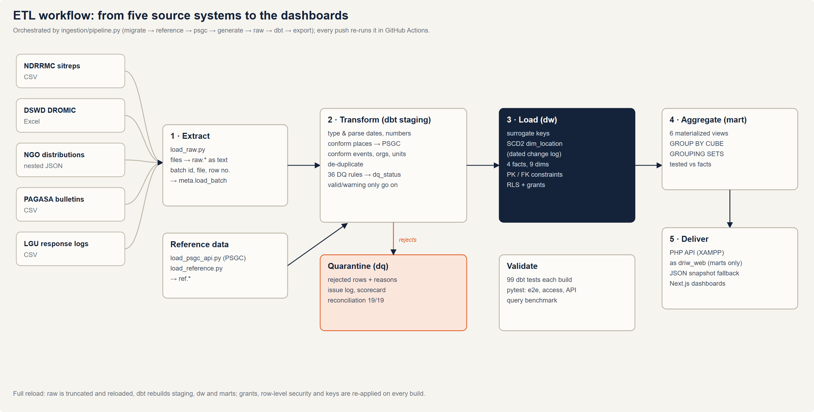
Figure: ETL workflow

4.2 Data sources
Source system | Format | Files | Rows landed | Typical defects (planted and counted)
NDRRMC situation reports | CSV | 31 (one per event) | 16,151 | duplicate rows, blanks and "N/A", thousands separators, negative costs, swapped figures, misspelled towns
DSWD DROMIC evacuation reports | Excel (.xlsx) | 31 | 31,241 | mixed date formats per field office, missing center codes, overcrowding, misspelled towns
NGO / agency relief distributions | nested JSON | 6 (one per year) | 5,661 records | organization aliases, partner item codes and units, missing locations, unknown items
PAGASA bulletins | CSV | 1 | 39 | re-issued (duplicate) bulletins, local vs international names
LGU / MDRRMO response logs | CSV | 1 | 32,749 | non-standard request types, arrival before dispatch, open requests, misspelled towns
PSA PSGC geography | JSON (community API mirror of PSA codes) | 6 | 43,793 units | — (master data)
Hand-curated reference data | CSV | 3 | events, 13 organizations, 10 relief items | —

Mock vs real. Event names, dates and geography are real; operational figures are synthetic, produced by ingestion/generate_sources.py with seed 271 (deterministic). The generator records each defect it plants in _defect_manifest.json so the transformation can be proven against it.

4.3 Extract (raw layer)
- load_raw.py reads each file in its native format (csv module, openpyxl, json) and bulk-loads it with PostgreSQL COPY into raw.<source>.
- Every business column is stored as text, so values like "1,234", "N/A" or "23-Oct-2024" are never rejected at load: nothing is lost before the quality rules run.
- Each file becomes a batch in meta.load_batch; each row keeps _batch_id, _source_file and _row_number (lineage).
- Strategy: full reload (truncate and reload), appropriate for a batch analytical warehouse of this size and simplest to make repeatable.

4.4 Transform (staging and data-quality layers, dbt)
Cleaning
- Parse numbers (strip thousands separators; "N/A", "-", "TBD" → null), dates in four formats (ISO, US, DD-Mon-YYYY, Excel serial numbers) and timestamps.
- Trim and normalize text; map non-standard codes (RESQ → RESCUE, Medical → MEDEVAC).
- Remove exact duplicates (sitrep rows, re-issued bulletins).
- Impute a missing evacuation-center code when the same place, name and barangay always carry one code.
Integration (conformance)
- Places → PSGC (stg_location_resolution): exact name, then normalized name, then fuzzy match (Levenshtein ≤ 2) within the reported province; ties are left for a steward. 0 false matches against ground truth across 63,347 rows.
- Events: local name, international name, TY <NAME> or code, matched within the event's time window (PAGASA reuses names).
- Organizations and relief items: alias tables in ref; partner quantities converted to a standard unit (e.g. 1 sack of rice = 50 kg).
- NGO JSON is flattened from one record per distribution to one row per item line.
Data-quality rules. 41 rules in dq_rules with severity info (corrected), warning (kept, flagged) or reject (quarantined). Every staging row gets dq_issues and dq_status; staging never drops a row. Details: data-quality-framework.md.
Aggregation. Facts keep detail at their grain; aggregation happens in the marts (materialized views) with GROUP BY CUBE and GROUPING SETS, and in dashboard queries.

4.5 Load (warehouse and marts)
- Dimensions load first: surrogate keys by row_number(); dim_location built as SCD Type 2 from ref.psgc plus a dated change log (psgc_changes).
- Facts load only valid and warning rows and look up each dimension key; locations are looked up as of the fact's date (SCD2). Damage keeps the latest valid sitrep per event × place × category (sitreps are cumulative).
- Open milestones (a request not yet completed) point to date key -1, so foreign keys are never null.
- After each model: primary/foreign keys, grants and row-level-security policies are re-applied (post-hooks).
- Marts refresh as materialized views; export_marts.py writes the dashboards' fallback snapshot.

4.6 Orchestration, scheduling and error handling
Concern | Design
Orchestration | ingestion/pipeline.py runs the steps in order; any step can be run alone (pipeline.py dbt export).
Scheduling | Batch, on demand or by a scheduler (Windows Task Scheduler / cron) running pipeline.py; GitHub Actions runs the full pipeline on every push.
Idempotency | Full reload plus dbt's rebuild make every run produce the same warehouse from the same inputs (tested).
Row-level errors | Never stop the load: bad rows go to dq.dq_quarantine with their reasons and source file and row.
Step failures | pipeline.py stops at the first failing step; dbt build fails if any of its 99 tests fail, so a bad build is never published.
Monitoring | dq.dq_rule_summary (scorecard), dq.dq_reconciliation, meta.load_batch (row counts and times per file).

4.7 Tools
Purpose | Tool
Extraction and loading | Python 3.13, psycopg 3 (COPY), openpyxl
Transformation, data quality, tests | dbt Core 1.12 with dbt-postgres
Warehouse | PostgreSQL 17
Orchestration and CI | pipeline.py, GitHub Actions
Delivery | PHP 8.1 API on XAMPP (Apache), Next.js dashboards

5. Data Quality Framework
How DRIW detects, corrects, flags and quarantines bad source data before it reaches the star schema, and how we prove the rules work.

5.1 Where data quality happens
raw.* ──▶ staging.stg_* ──────────────▶ dw.* (valid + warning rows only)
(text, typed, conformed, every row
as-is) tagged with dq_issues/dq_status
│
├──▶ dq.dq_issue_log one row per issue (rule, field, source file, row)
├──▶ dq.dq_rule_summary scorecard per rule
├──▶ dq.dq_quarantine rejected rows + reasons
└──▶ dq.dq_reconciliation planted vs detected (synthetic-data proof)

Staging models never drop rows. Each raw row keeps its lineage (_batch_id, _source_file, _row_number) and gets:
Column | Meaning
dq_issues | Array of rule codes that fired, e.g. {LOC_NAME_VARIANT, MISSING_VALUE:dead}
dq_status | valid · warning · rejected · duplicate

5.2 Severity policy
Severity | Action | Reaches the warehouse? | Example
info | Corrected automatically | Yes | Naga City → PSGC City of Naga; 1,234 → 1234; R50 sacks → kg
warning | Kept and flagged | Yes | Evacuation center over capacity; required measure blank
reject | Quarantined in dq.dq_quarantine | No | Negative cost; arrival before dispatch; unknown item code

The full catalog (41 rules across 5 sources) is dbt/seeds/dq_rules.csv. A dbt test fails the build if a staging model emits a rule that is not in the catalog, or if a row's dq_status disagrees with the severities of its issues.

5.3 Key techniques
Location conformance (PSGC). Every distinct (province, city/municipality) pair from all sources is resolved once in stg_location_resolution, always within the reported province:
1. Exact official name.
2. Normalized: case, spacing, ñ→n, City of X / X City, Sto./Sta..
3. Fuzzy: Levenshtein distance ≤ 2 on normalized and letters-only keys. The best candidate must be unique; ties (e.g. Malniao is equally close to Malinao and Manito) stay unmatched for a data steward instead of being guessed.
Accuracy is verified against ground truth embedded in LGU request IDs and DROMIC center codes: 0 false matches across ~63,000 checked rows (assert_location_matching_is_accurate).
Event conformance. Sources refer to events by local name (Kristine), international name (Trami), TY KRISTINE or the key TC2024-KRISTINE. stg_event_alias lists every form; matches must also fall within the event's time window, because PAGASA reuses names.
Unit standardization. Partner item codes map to canonical items with a conversion factor (R50: 1 sack = 50 kg), so quantities and PHP values are comparable across organizations.
Imputation. A missing evacuation-center code is recovered when the same place + center name + barangay always carries a single code elsewhere; otherwise it's rejected.
De-duplication. Exact duplicate sitrep rows and re-issued PAGASA bulletins are marked duplicate and excluded.

5.4 Proof: reconciliation against planted defects
The synthetic generator records every defect it plants in _defect_manifest.json (loaded to meta.defect_manifest). dq.dq_reconciliation compares that with detected issues:
Result (seed 271)
Defect types planted | 19
Exactly reconciled | 19 / 19
Rejected rows not explained by a planted defect | 0

Load rates after data quality: NDRRMC 98.2%, DROMIC 99.6%, NGO lines 97.0%, LGU 98.8%.
A warn-level test (warn_unplanted_rejections) flags reject rules firing with no planted cause. During development it caught a real parsing bug: monsoon incidents named "Southwest Monsoon (Habagat) Carina (Gaemi)" were matched on the first parentheses instead of the last, wrongly rejecting 1,244 rows.

5.5 Running
.venv/Scripts/python ingestion/pipeline.py # everything
.venv/Scripts/python ingestion/pipeline.py dbt # rebuild staging + dq and run all tests

Useful queries:
select * from dq.dq_reconciliation; -- planted vs detected
select * from dq.dq_rule_summary where issue_count > 0; -- scorecard
select * from dq.dq_quarantine limit 50; -- what was rejected and why

6. Data Governance, Security and Privacy
Who may see what in DRIW, how it is enforced inside PostgreSQL, and how it is tested. Everything is enforced by the database itself, so it holds for any client: dashboards, SQL tools, BI software or scripts.

6.1 Roles
Access is granted to group roles that describe a job. People (or service accounts) are made members of a group; nobody is granted on objects directly.
Role | Stakeholder (proposal §4.1) | Can read | Cannot read
driw_executive | Executive leadership | mart.* aggregates | warehouse detail, staging, raw, quarantine
driw_analyst | Data analysts | dw.* (all rows), mart.*, secure.*, DQ scorecards (dq_rule_summary, dq_reconciliation) | raw, staging, quarantine
driw_regional | Operational managers in a region | dw.* and secure.*, only rows in their own region(s) | marts (cross-region), other regions, the region mapping
driw_steward | Support staff / data engineers | raw, staging, ref, meta, all of dq incl. quarantine; may edit alias maps in ref | dw, mart

This follows least privilege: executives see conclusions, analysts see detail, regional officers see their own area, and stewards work on data quality without browsing the finished warehouse.
Demo personas used in tests and the presentation (NOLOGIN, used with SET ROLE): driw_demo_executive, driw_demo_analyst, driw_demo_bicol, driw_demo_cagayan, driw_demo_steward.

The web back-end's login
The PHP API (web/php/api, served by XAMPP) connects as driw_web, a LOGIN role whose only membership is driw_executive. A bug or an injection in the web tier can therefore reach the aggregated marts but never warehouse detail, raw data or quarantine (tested in tests/test_php_api.py). It also has a 10-second statement timeout and a 20-connection limit. Its password lives only in the git-ignored .env and in a PHP config outside the web root (C:\xampp\driw-config\config.php), both written by ingestion/setup_web_role.py.

6.2 Row-level security (regional users)
governance.region_access maps a role to the region(s) it may see:
role_name | region_code | region
driw_demo_bicol | 0500000000 | Bicol Region
driw_demo_cagayan | 0200000000 | Cagayan Valley

Each fact table has row-level security enabled with two policies (dbt/macros/row_security.sql):
create policy analyst_all_rows on dw.fact_damage_assessment
for select to driw_analyst using (true);

create policy regional_own_region on dw.fact_damage_assessment
for select to driw_regional
using (location_key in (
select l.location_key from dw.dim_location l
where l.region_code in (select region_code from governance.my_regions)));

- Default deny. A regional user not yet mapped to a region sees zero rows, not everything.
- The mapping stays private. governance.my_regions is a view that shows each user only their own regions. Inside a view current_user is the querying user, while the view reads the mapping table with its owner's rights. A SECURITY DEFINER function was tried first and rejected: inside one, current_user is the function's owner, so no user ever matched (the governance tests caught this).
- Secure views inherit it. The views in secure (regional_event_impact, regional_response_summary) are security_invoker, so the same view shows Bicol to the Bicol officer, Cagayan Valley to the Cagayan officer, and everything to an analyst.
- Marts are excluded on purpose. Materialized views cannot carry row-level security, so regional users are not granted the marts; the secure views serve them instead.
Granting a new regional officer:
grant driw_regional to new_officer;
insert into governance.region_access (role_name, region_code) values ('new_officer', '0800000000');

6.3 Surviving rebuilds
dbt rebuilds tables on every run, which would normally drop privileges. Grants are declared in dbt_project.yml (+grants) and row-level security is a post-hook on each fact, so both are re-applied on every build. The end-to-end tests run a second dbt build and check that policies and grants are still in place.

6.4 Auditing access
governance.v_access_matrix lists, for every role and every object, whether the role can actually read it (schema USAGE and object SELECT) and whether row-level security applies. It is the access matrix above, generated from the database itself:
select role_name, schema_name, count(*) filter (where can_select) as readable, count(*) as objects
from governance.v_access_matrix group by 1, 2 order by 1, 2;

6.5 Privacy
The governing law is the Data Privacy Act of 2012 (Republic Act 10173) and its implementing rules. DRIW is designed so that it holds no personal information at all.
Data classification
Class | Examples in DRIW | Handling
Public | Event names and dates, PSGC geography, organization names | No restriction
Internal (aggregated operational) | Damage costs, relief values, response times | Role-based access (Executive, Analyst)
Sensitive (aggregated) | Deaths, injured, missing, persons in evacuation centers, by city/municipality | Analysts and the region's own officers only (row-level security); executives see marts only
Personal information | Names, addresses, contact details or health data of affected people or responders | Not collected. Never enters the warehouse.

Privacy principles applied
- Data minimization. Sources are reduced to counts at the lowest level the analysis needs (city/municipality, evacuation center, request). No evacuee rosters, victim lists or patient records are loaded; a response request carries a request id, type, timestamps and team size, never the requester's identity.
- Aggregation and small counts. Casualty figures are aggregated per city/municipality and event. Before any public release, counts below 5 should be suppressed or rounded to prevent re-identification in small barangays (a reporting rule for published outputs).
- Purpose limitation. Data is used only for disaster-response analysis and planning, as stated in the business case.
- Least privilege and need to know. Four roles; regional officers see only their region; the web back-end logs in as driw_web, which can read only aggregated marts.
- Security of processing. Credentials are never in source code (git-ignored .env, PHP config outside the web root); the API accepts only allow-listed, validated GET requests; all access is enforced inside PostgreSQL, so it holds for every client.
- Retention. Raw extracts are replaced on every load (full reload). Warehouse history is kept for the analysis period (2020 onwards); source files under data/sources/ are regenerable and not retained in version control.
- Transparency. Every published figure is traceable to its source file and row (lineage), and every rejected row is kept with its reasons (quarantine).
- Synthetic data. In this implementation all operational figures are synthetic; no real person's data was processed at any stage.
If real data is onboarded: sign data-sharing agreements with each agency, register the processing with the National Privacy Commission where required, appoint a data protection officer, run a privacy impact assessment, and enable PostgreSQL connection and statement logging (log_connections, pgaudit) for an access audit trail.

6.6 Supabase
The same migrations run on Supabase. There, signed-in users connect as Supabase's authenticated role, so the regional mapping would key on the user's id (auth.uid()) or a JWT claim instead of current_user; the policies keep the same shape.

6.7 Standards alignment
This supports the UNDRR Data Strategy and Roadmap 2023–2027 emphasis on data governance: defined roles and responsibilities (stewardship), controlled access to sensitive operational data (casualties by locality), and auditable, reproducible data handling.

7. Analytics: OLAP and Dashboards

7.1 OLAP approach (ROLAP)
DRIW implements OLAP relationally (ROLAP) in PostgreSQL rather than with a separate MOLAP cube engine. The star schema is the cube: facts hold the measures, dimensions hold the hierarchies, and SQL's OLAP operators produce the cube's cells.
OLAP operation | How it is done | Example
Roll-up | GROUP BY ROLLUP, or grouping at a higher hierarchy level | Q02: damage by year with yearly subtotals
Drill-down | Group by a lower level of a hierarchy (region → province → city/municipality) | Q03
Slice | Fix one dimension value (WHERE) | Q07 over-capacity centers; Q09 life-saving requests
Dice | Filter on several dimensions at once | Q11 organization × resource category
Pivot | Turn dimension values into columns (FILTER) | Q04 cyclone vs flood per region
Cube | Every combination of dimensions with subtotals (GROUP BY CUBE) | Q05; mart.mart_impact_cube
Grouping sets | Chosen roll-ups in one pass | mart.mart_response_performance

Pre-aggregation. Six materialized views in the mart schema hold the aggregates the dashboards need. They refresh on every build and are tested to add back up to the facts. Reading a mart is about 78× faster than aggregating the facts (see query-performance.md).
The full set of sample analytical queries, each tied to a business question, follows this chapter and is in sample-queries.sql.

7.2 Dashboards and web application walkthrough
The web application is the warehouse's presentation layer. It is built with Next.js and served by Apache (XAMPP) at http://localhost/driw/. A PHP API (/driw/api/) reads the marts live from PostgreSQL as the read-only role driw_web; if the warehouse is unreachable, the pages fall back to a bundled snapshot of the same marts. This section shows every page and explains what each part of it means. All figures shown are synthetic (see the notice on every page).

Elements common to every page
Element | What it means
Navigation bar | Executive, Operations and Logistics (one per audience), Data exchange (templates, checked uploads and Excel export for LGUs and agencies, see Chapter 10) and About.
Yellow notice | States which data is real (event names, dates, PSGC geography) and which is synthetic (all operational figures), so no figure is mistaken for an official statistic.
Event selector | On Operations and Logistics. The choice is kept in the address (for example ?event=TC2024-KRISTINE), so a view can be bookmarked, shared or reloaded. Selecting an event is an OLAP slice.
Show table | Every chart has a table with the exact numbers: the accessible, color-free way to read it.
Download CSV | Exports the rows behind the chart with raw, unformatted values; the file opens directly in Excel.
Footer | Says where the numbers came from: "Live from the PostgreSQL warehouse … as read-only role driw_web", or that the bundled snapshot is being shown.

Executive overview
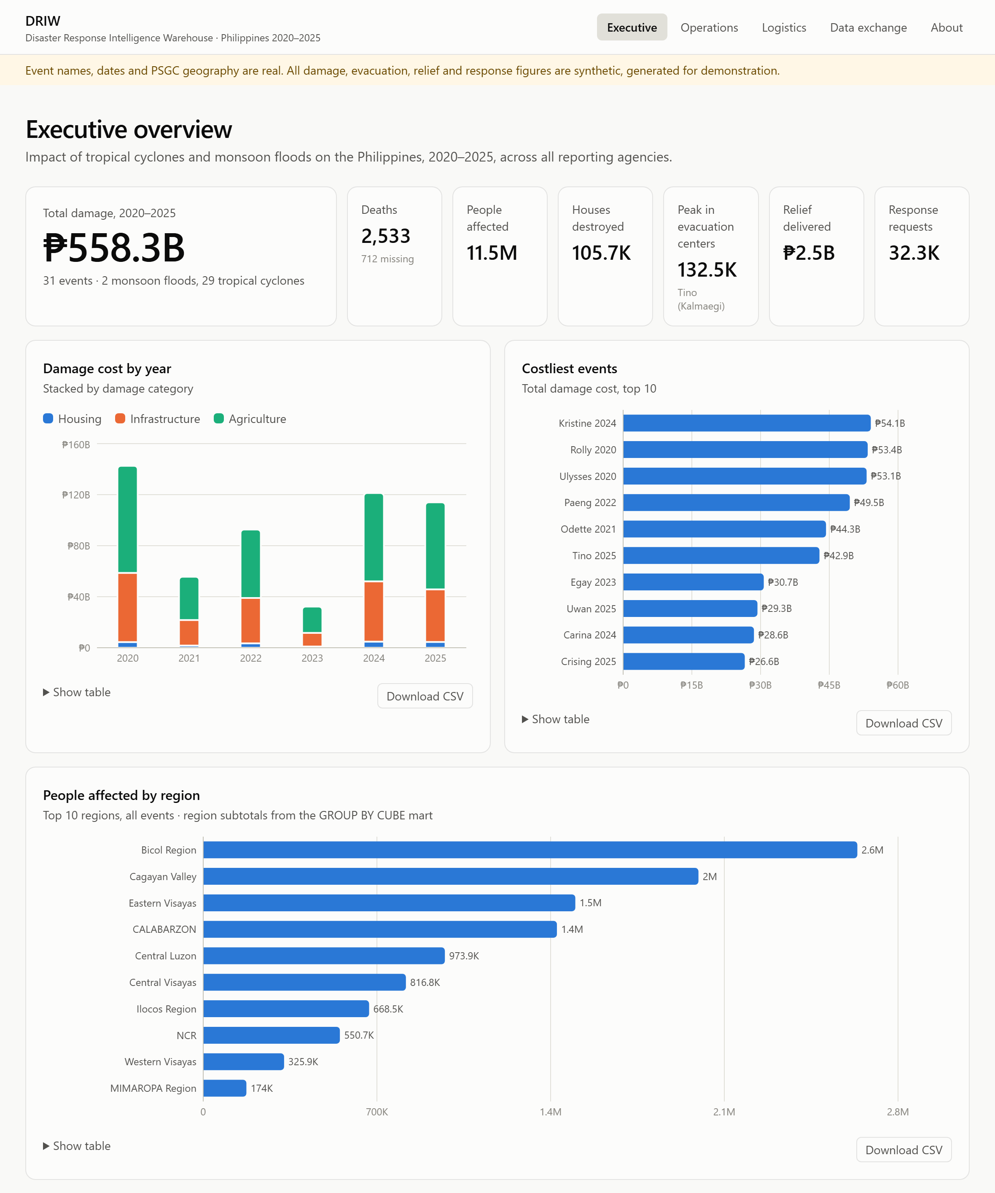
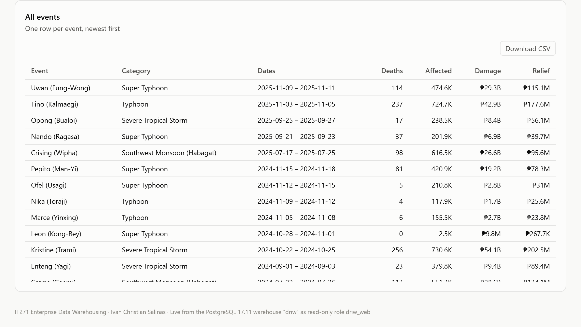
Figure: Executive dashboard: headline figures, damage by year, costliest events and people affected by region
Audience and purpose. Leadership (NDRRMC council, regional directors) needs the six-year picture on one screen: how bad it was, when, and where. Answers BQ1, BQ2 and BQ4. Data comes from mart_event_summary (one row per event) and mart_impact_cube (the GROUP BY CUBE mart).
Part of the screen | What it shows and how to read it
Hero figure | ₱558.3B total damage across 31 events (29 tropical cyclones, 2 monsoon floods), the sum of the latest valid situation report per place and category.
Headline tiles | Deaths (2,533, with 712 missing), people affected (11.5M), houses destroyed (105.7K), relief delivered (₱2.5B) and response requests (32.3K) are sums over events. Peak in evacuation centers (132.5K, Tino 2025) is different: evacuee counts are semi-additive, so it is the highest single-day total, not a sum of days.
Damage cost by year | Stacked columns by damage category. 2020 was the costliest year (₱142.6B, four events) and 2023 the lightest (₱32.2B). Agriculture is the largest category every year (₱83.9B of 2020's total), then infrastructure; housing is the smallest.
Costliest events | The ten events ranked by damage: Kristine 2024 (₱54.1B), Rolly 2020 (₱53.4B) and Ulysses 2020 (₱53.1B) lead. Three of the top five struck in 2020.
People affected by region | Region subtotals read straight from the CUBE mart: Bicol Region (2.64M people, ₱145.4B), then Cagayan Valley (2.00M) and Eastern Visayas (1.50M).
All events table | One row per event; its CSV carries 24 measures per event for further analysis.

What it means for decisions. Damage is concentrated in a few strong typhoons and in a few regions, Bicol above all. Agriculture absorbs the largest share of losses, so preparedness spending on crop protection and post-disaster agricultural recovery gives the most return.

Operations (one event)
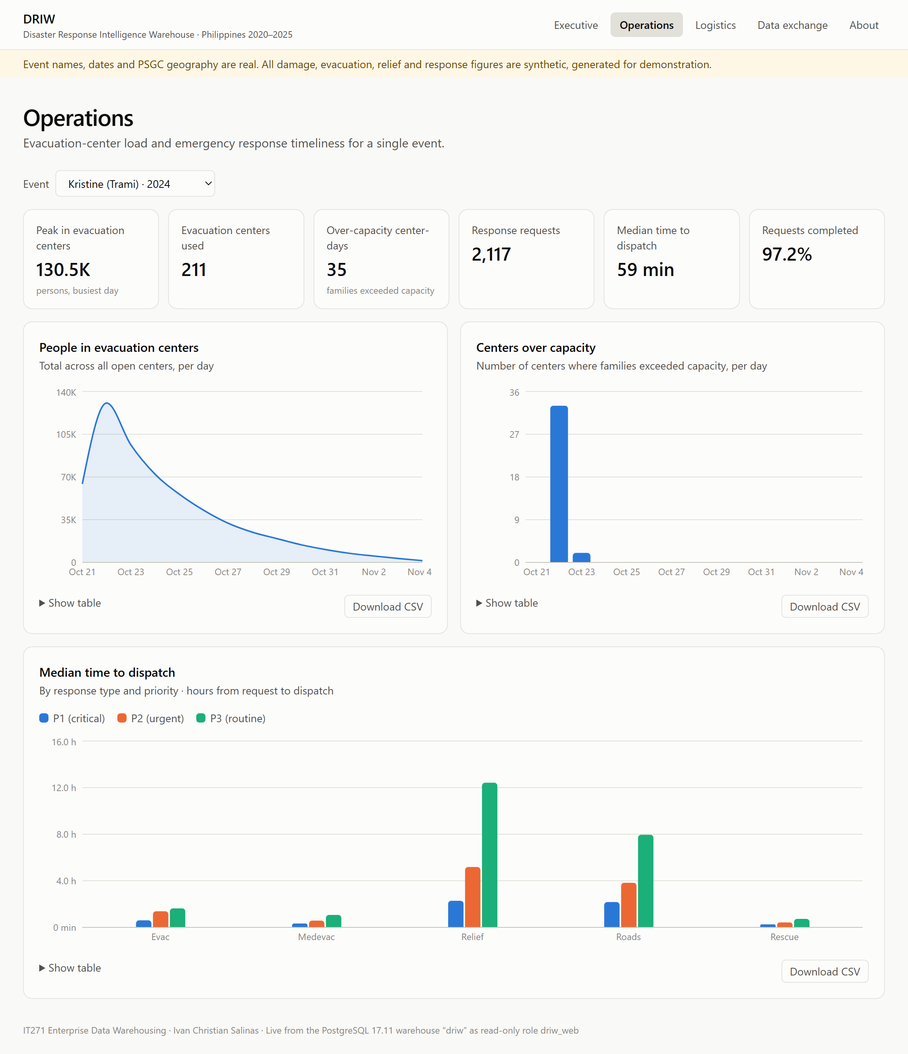
Figure: Operations dashboard for Typhoon Kristine: evacuation curve, overcrowded centers and dispatch times
Audience and purpose. Regional operations managers and incident commanders. For one event, it shows how many people were sheltered, where centers were overcrowded, and how fast teams were dispatched. Answers BQ5, BQ6 and BQ7. Shown here for Kristine (October 2024); data comes from mart_event_summary, mart_evacuation_daily and mart_response_performance.
Part of the screen | What it shows and how to read it
Headline tiles | Peak evacuees 130.5K on the busiest day; 211 evacuation centers used; 35 center-days over capacity; 2,117 response requests; median 59 minutes from request to dispatch; 97.2% of requests completed.
People in evacuation centers | Total evacuees across all open centers, per day. It rises from 64,326 on 21 October (pre-emptive evacuation) to the peak of 130,515 on landfall day (22 October), then decays over about two weeks as families go home.
Centers over capacity | Number of centers whose families exceeded capacity, per day: 33 centers on landfall day, 2 the day after, then none. Overcrowding is a one-to-two-day problem.
Median time to dispatch | Grouped columns by response type and priority (P1 critical, P2 urgent, P3 routine). Life-saving work goes fastest: search-and-rescue P1 in 0.26 h (about 16 minutes), medical evacuation P1 in 0.33 h. Relief delivery and road clearing wait longest, especially when routine: 12.4 h and 7.9 h at P3.

What it means for decisions. Overflow centers must be ready before landfall, because nearly all overcrowding happens on that one day. Priority triage works for life-saving requests; the slow lanes are logistics (relief delivery, road clearing), where pre-positioned stock and equipment would cut waiting most.

Logistics (all events)
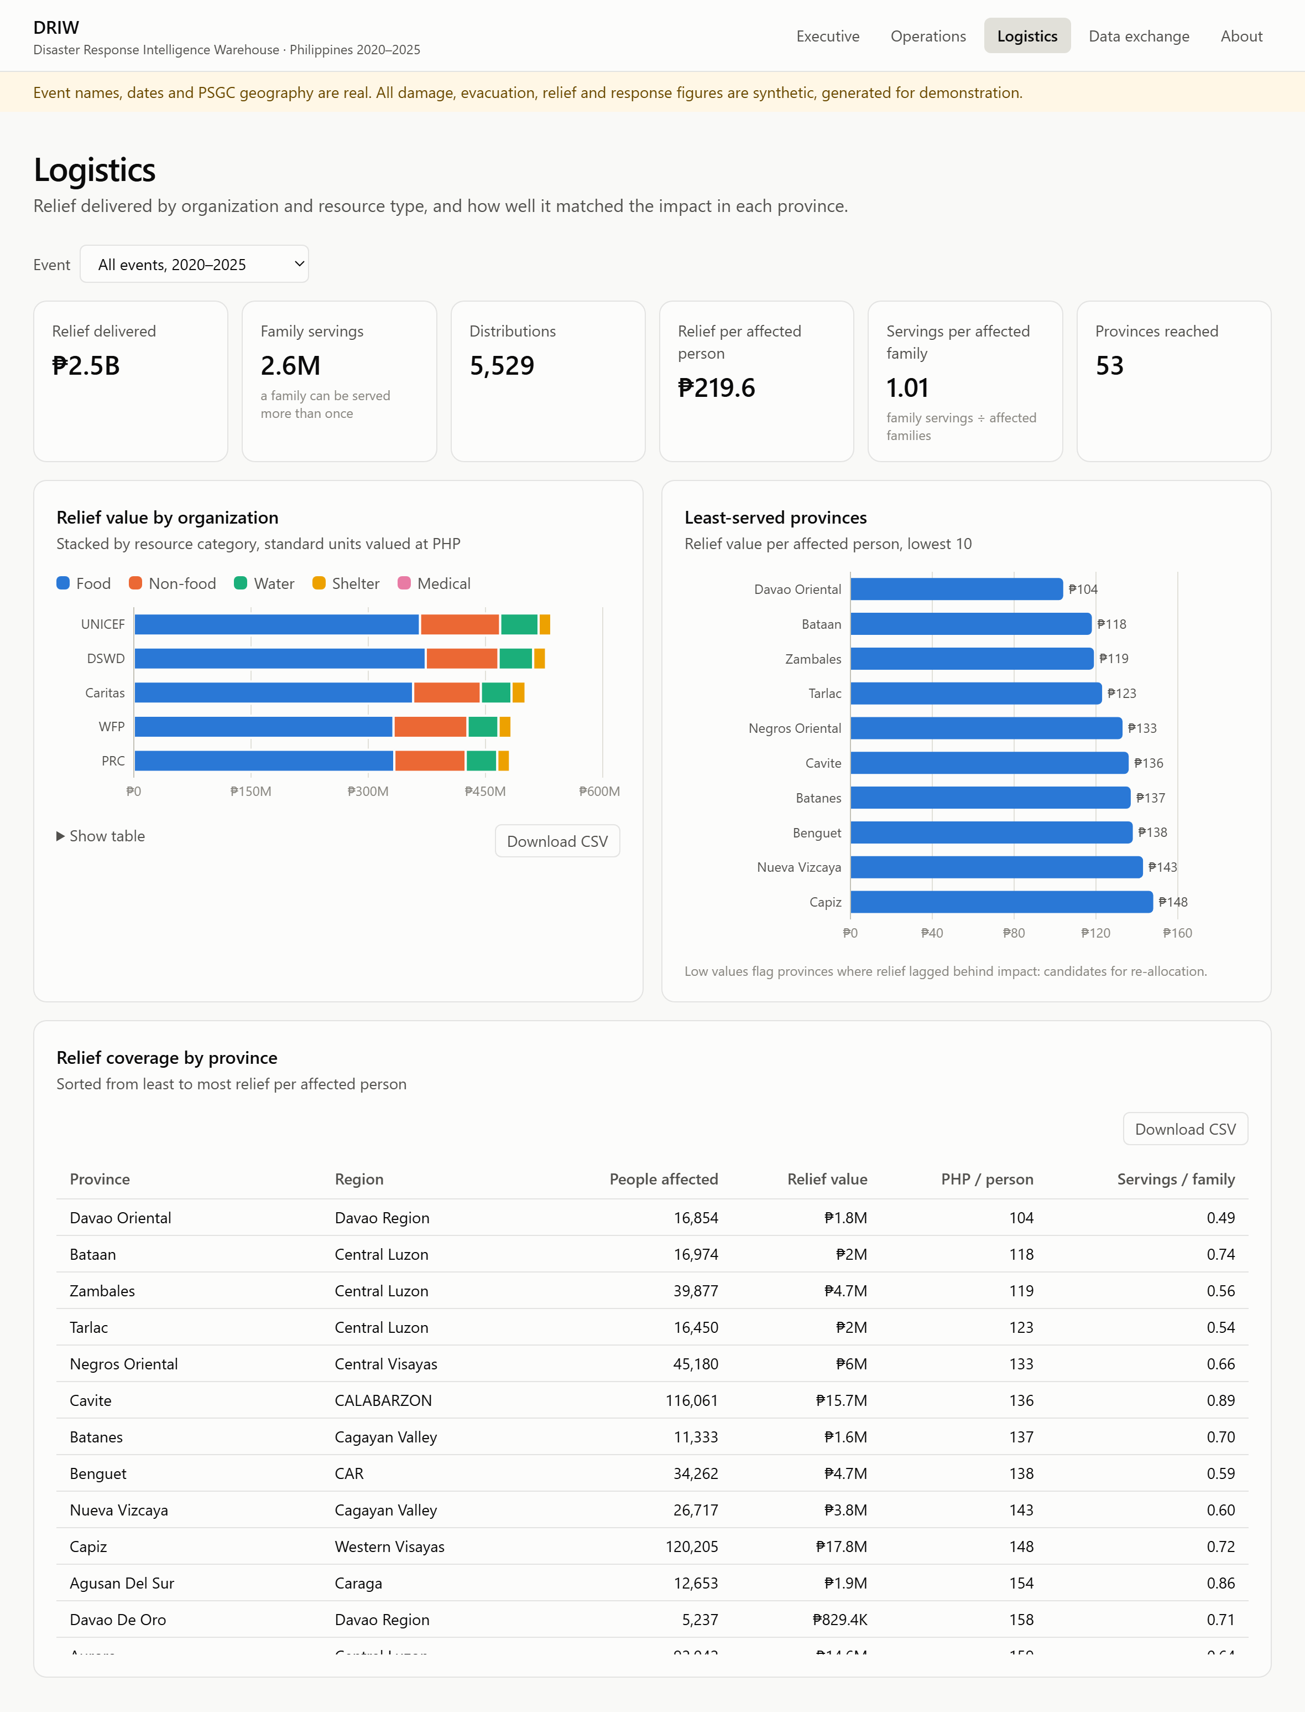
Figure: Logistics dashboard for all events: relief by organization and least-served provinces
Audience and purpose. Relief and logistics officers of DSWD and partner NGOs. It shows who delivered what, and whether relief reached provinces in proportion to the impact. Answers BQ8 and BQ9. Data comes from mart_relief_by_org_category, mart_province_event_impact and mart_event_summary.
Part of the screen | What it shows and how to read it
Headline tiles | ₱2.5B of relief in 5,529 distributions; 2.6M family servings (a family served twice counts twice); ₱219.6 per affected person; 1.01 servings per affected family; 53 provinces reached.
Relief value by organization | One bar per organization, stacked by resource category in standard units valued at PHP. The five partners each delivered between ₱483M and ₱535M; food is 68–71% of every partner's value.
Least-served provinces | The ten provinces with the lowest relief value per affected person. Davao Oriental is lowest at about ₱104, roughly half the overall average of ₱219.6.
Relief coverage by province | Every province, sorted from least to most relief per person, with servings per affected family.

What it means for decisions. Relief is spread evenly across partners, but not across provinces: the bottom of the coverage ranking is where the next allocation should go first.

Logistics filtered to one event
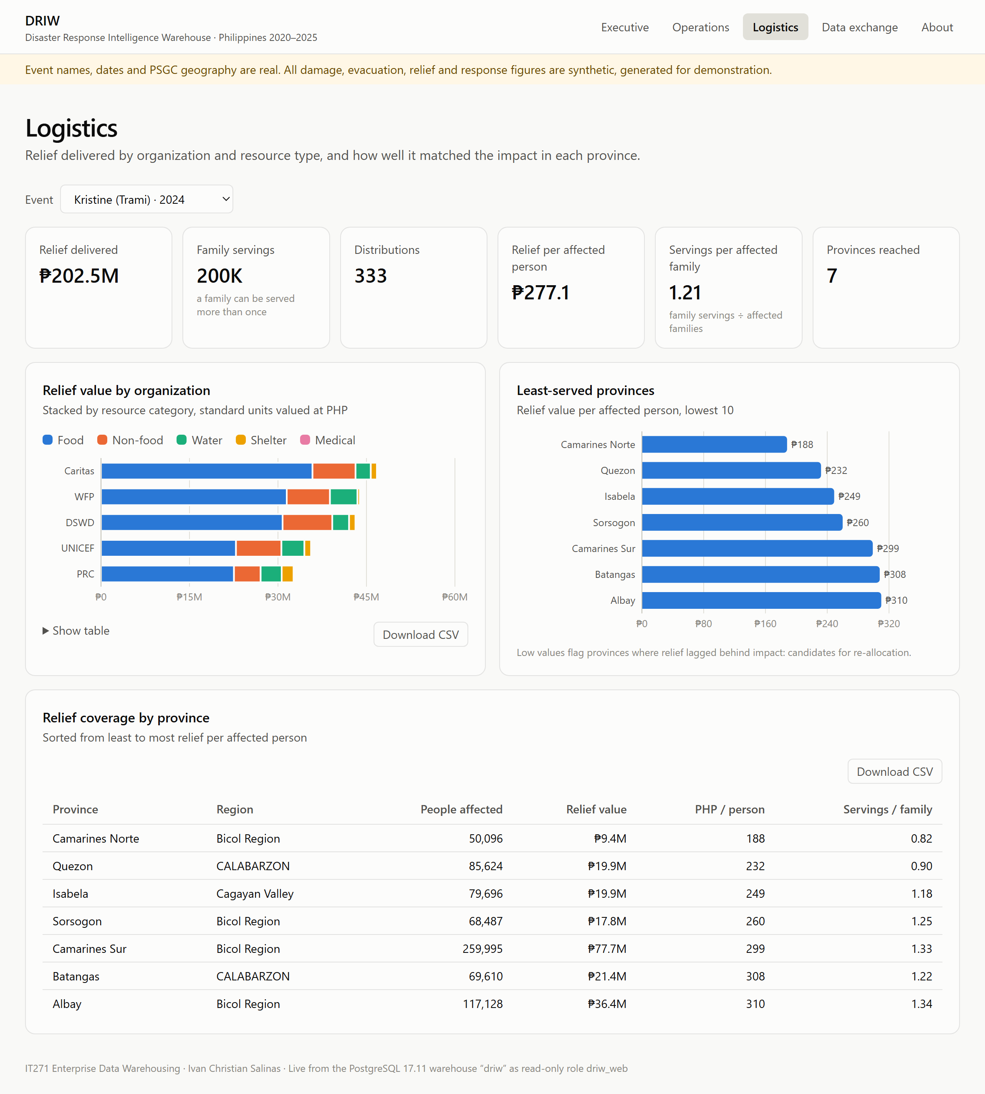
Figure: Logistics dashboard filtered to Typhoon Kristine
The same page sliced to Kristine through the event selector (/logistics/?event=TC2024-KRISTINE). Every tile, chart and table re-computes for that event: ₱202.5M in 333 distributions across 7 provinces, ₱277.1 per affected person. Within one storm the gap is sharper: Camarines Norte received ₱188 per person and 0.82 servings per affected family, while Albay received ₱310 and 1.34. A logistics officer reading this during the response would redirect the next convoys to Camarines Norte.

About the warehouse
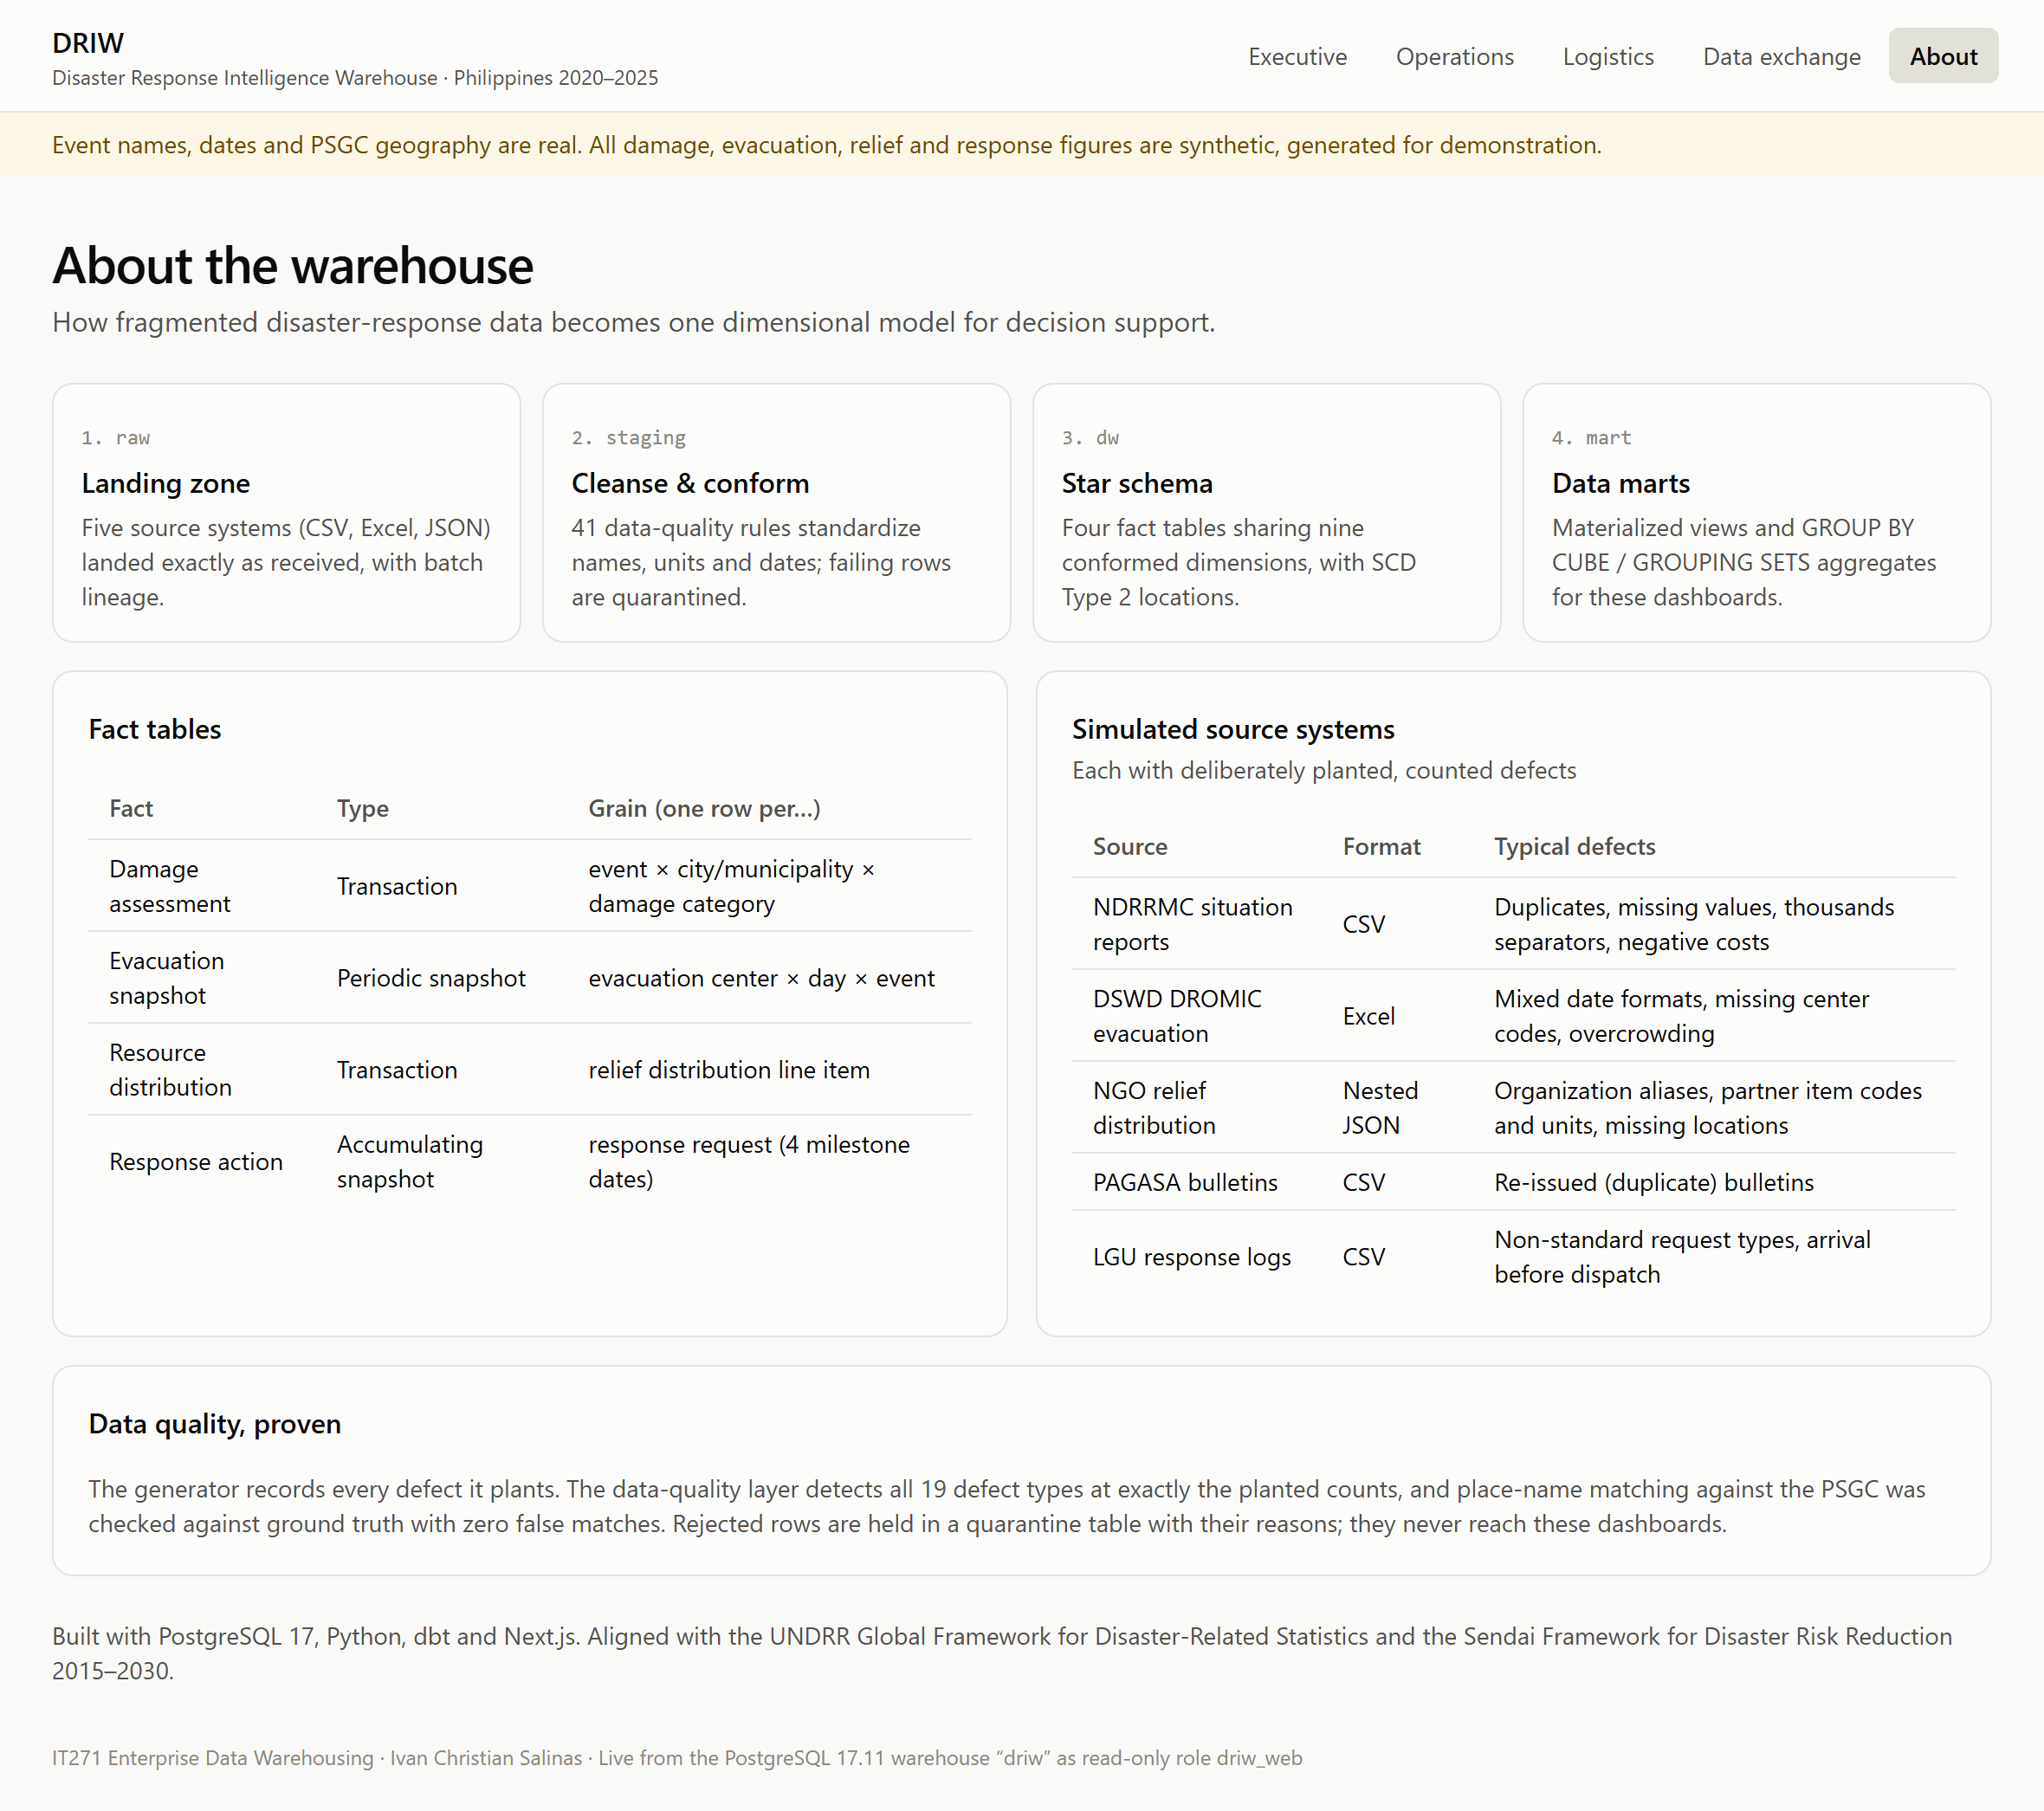
Figure: About page: architecture layers, fact tables, source systems and data-quality proof
A plain-language explanation of the system for any visitor, especially non-technical stakeholders: the four layers (raw, staging, dw, mart), the four fact tables and their grain, the five source systems with the defects each one carries, and the data-quality result (all 19 planted defect types detected exactly; zero false place-name matches). It answers "can I trust these numbers?" before anyone asks.

The PHP API (back-end)
Figure: API health check
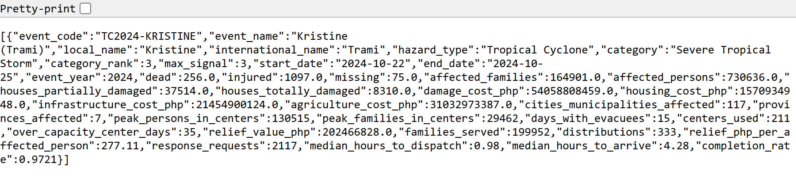
Figure: API response: the event summary for Kristine
The dashboards are static pages; their data comes from two PHP endpoints. health.php (first image) confirms the connection: database driw, PostgreSQL 17.11, connected as driw_web. That role is a member of driw_executive only, so the web server can read the marts and nothing else (least privilege). marts.php (second image) returns one mart as JSON, here mart_event_summary for Kristine. Any other system can consume the same endpoint: an agency information system, or Excel and Power BI through a web query.

Narrow screens
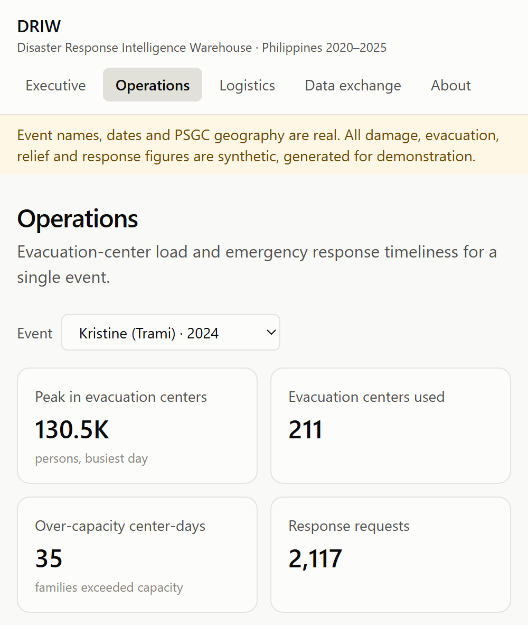
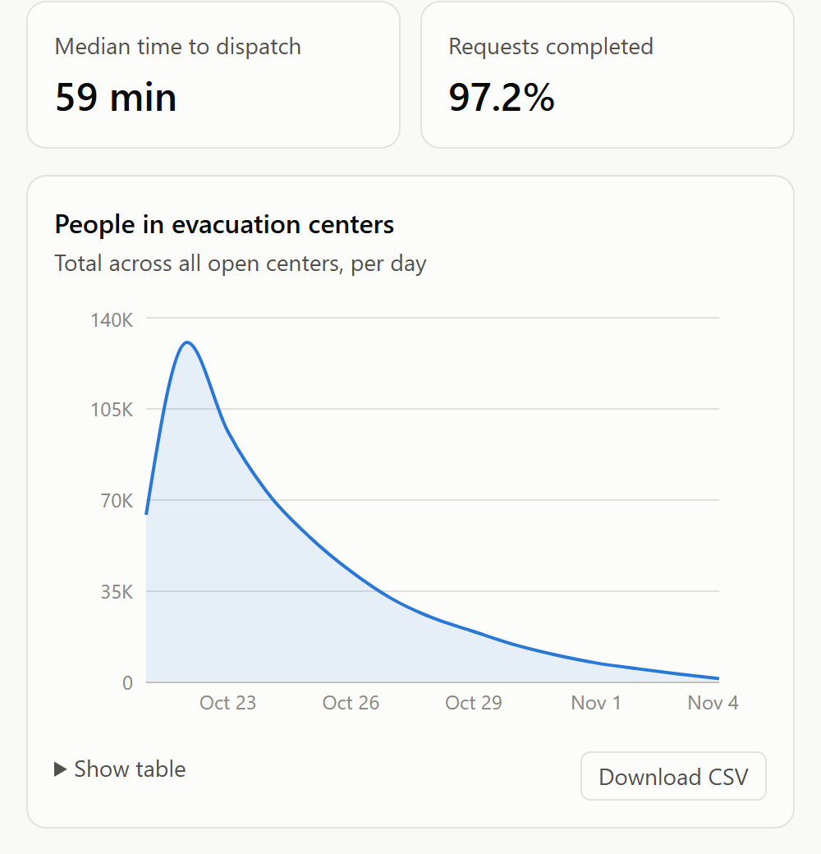
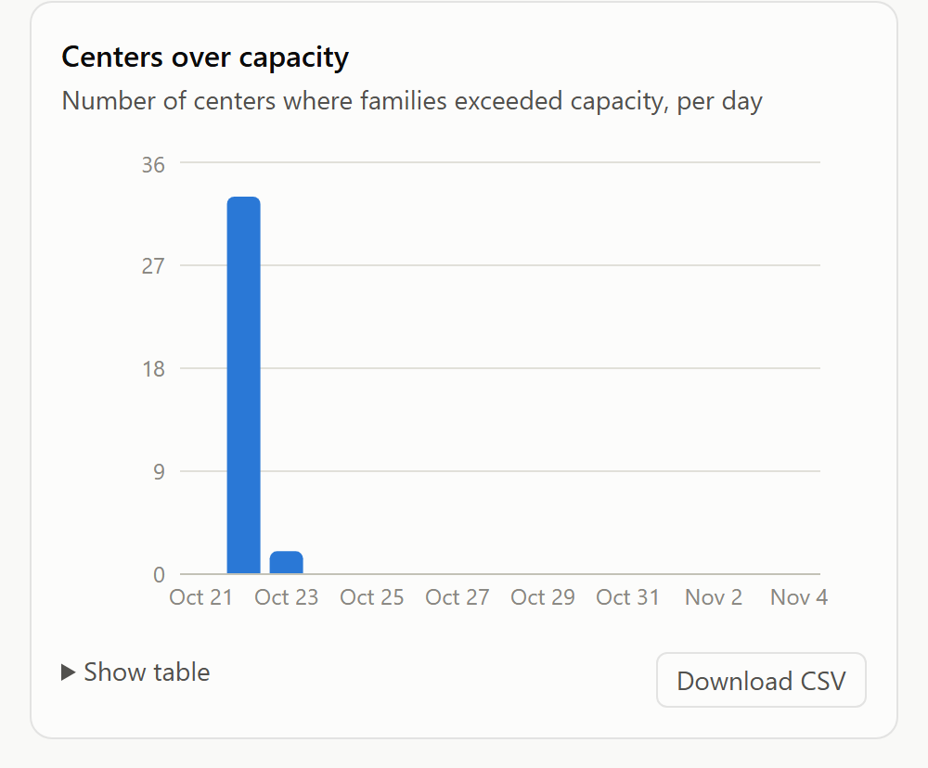
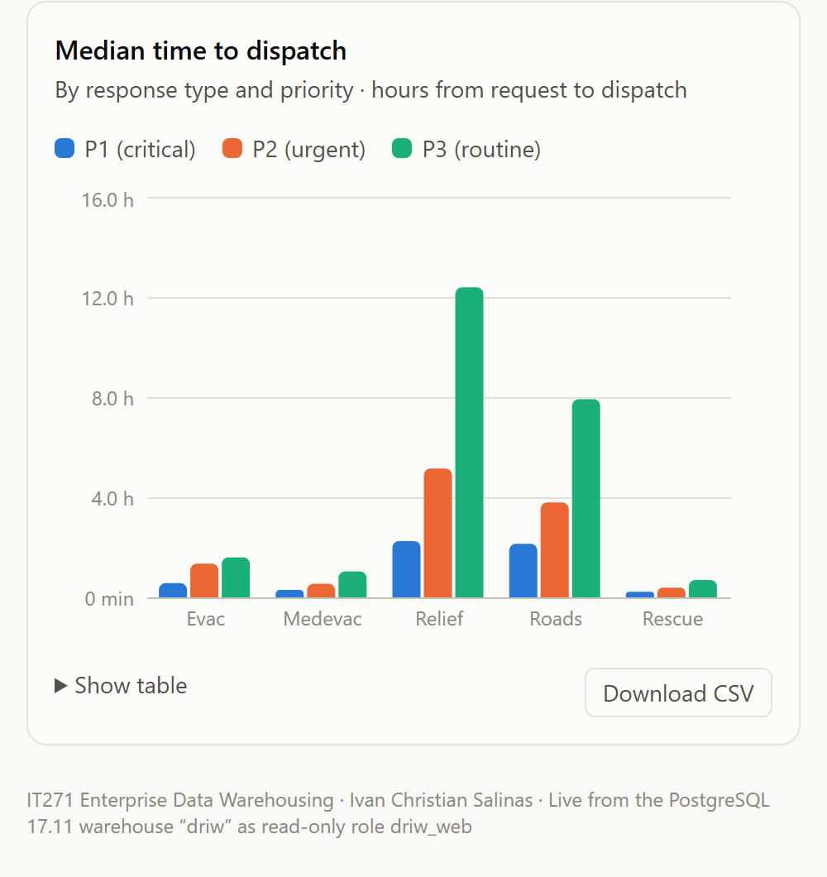
Figure: Operations page on a narrow screen
The same Operations page on a narrow screen. Tiles fall into two columns and charts stack in one column, with no sideways scrolling, so field staff can use the dashboards on a tablet or phone during operations.

7.3 Sample findings (synthetic data)
- Kristine (2024) was the costliest event at about ₱54 billion; total damage across the 31 events is ₱558.3 billion.
- Bicol Region had the most people affected (about 2.6 million), mainly from tropical cyclones.
- Evacuation peaks on landfall day and decays over about two weeks; overcrowding is concentrated in the first two days, which is when extra centers should open.
- Relief delivery and road clearing wait longest for dispatch, especially at routine priority; rescues go out fastest.
- Davao Oriental received the least relief per affected person (about ₱104), a candidate for re-allocation.
These figures come from synthetic operational data and illustrate the analysis, not real outcomes.

8. Testing and Validation
How DRIW was tested, and the results. Data seed 271, run on PostgreSQL 17.11.

8.1 Summary
Suite | Checks | Result
dbt build (models + data tests) | 99 | 99 pass
End-to-end tests (tests/test_end_to_end.py) | 28 | 28 pass
Governance tests (tests/test_governance.py) | 21 | 21 pass
PHP API tests (tests/test_php_api.py) | 13 | 13 pass (skipped where PHP is not installed, e.g. CI)
Data exchange tests (tests/test_intake.py) | 13 | 13 pass
Query performance (ingestion/benchmark_queries.py) | 14 queries | 14 within the 1 s budget, slowest about 32 ms
Dashboards (npm run lint, npm run build) | lint + type check + static build | pass

Run everything with .venv/Scripts/python -m pytest tests. It builds a brand-new database (driw_e2e) from nothing through the whole pipeline (migrations, reference data, PSGC, generation, raw load, dbt, export), runs every check, then rebuilds dbt a second time. Duration: about one and a half minutes. GitHub Actions runs the same suite and the dashboard build on every push (.github/workflows/ci.yml). Query timings are in query-performance.md.

8.2 What is validated

1. Completeness: nothing is lost between layers
- Every raw row reaches staging (5 sources; NGO checked at item-line level).
- Every staged row has a status; every rejected row is in quarantine.
- Every valid/warning row reaches its fact table (dbt assert_facts_reconcile_to_staging).
- Every layer, fact and mart is non-empty.

2. Correctness: data quality is proven, not assumed
- 19/19 planted defect types detected at exactly the planted count (dq.dq_reconciliation).
- Place-name matching checked against ground truth: 0 false matches across ~63,000 rows.
- Every rejection traces to a planted defect (warn_unplanted_rejections).

3. Consistency: aggregates agree with detail
- Damage totals are equal in facts, the event mart and the CUBE grand total.
- Every mart adds back up to its facts (assert_marts_reconcile_to_facts).
- Exported JSON row counts equal mart row counts, and the dashboard data committed in web/src/data/ is identical to a fresh build (fails if someone forgets to re-export).

4. Model integrity
- Primary and foreign keys on the star schema (9 PKs, 26 FKs).
- One row per declared grain in each fact.
- SCD Type 2: no overlapping or missing validity periods, exactly one current version; Typhoon Paeng (Oct 2022) rolls up to Maguindanao del Norte/del Sur.

5. Reproducibility
- The generator is deterministic: two runs with the same seed produce identical content.
- A fresh database built from scratch matches the working database row for row (83,442 fact rows, 1,548 Bicol damage rows in both).
- A second dbt build gives identical fact counts and keeps grants and row-level security.

6. Data exchange (see Chapter 10)
- Every Excel template has its instructions, the expected headings and drop-down lists.
- The Albay sample, in Albay's own layout, gets the expected verdict on every one of its 10 rows.
- Checking a file never changes the warehouse; a file missing required columns is refused whole.
- A submitted file loads with every warehouse check still passing: valid rows reach the facts, the rest are quarantined with reasons, and the synthetic-data reconciliation stays 19/19.
- Submitting the same file again replaces it instead of duplicating it.
- The Excel export has every mart, a data dictionary, frozen headings and filters.

7. Security (see governance.md)
- Executive reads marts only; denied on warehouse detail, staging, raw, quarantine.
- Analyst sees every fact row, marts and DQ scorecards; denied raw and quarantine.
- Regional officers (Bicol, Cagayan Valley) see exactly their region's rows in all four facts and in the secure views, and zero rows from other regions.
- An unmapped regional user sees zero rows (default deny).
- Regional users cannot read the mapping, grant themselves roles, or edit their mapping.
- Stewards work on raw, staging and quarantine, may fix alias maps, and are denied the warehouse.

8.3 Defects found by testing (and fixed)
Testing earned its keep. Each of these was caught by a test, not by inspection:
Found by | Problem | Fix
DQ reconciliation | Generator counted the placeholder "-" as a negative number | Count only real numbers as negative
Unplanted-rejection check | Monsoon incidents named "Southwest Monsoon (Habagat) Carina (Gaemi)" matched the first parentheses; 1,244 rows wrongly rejected | Match the last parentheses
Location accuracy test | Letter swaps inside "City of" (e.g. "Cityo f Legazpi") went unmatched | Letters-only fuzzy key
Governance tests | Regional users saw zero rows: a SECURITY DEFINER function sees its owner as current_user | Region lookup moved into a view
Governance tests | SET ROLE escalation test passed for the wrong reason (checked against the session user) | Test escalation via GRANT and mapping writes instead
Browser review | "Family coverage 101%" double-counted repeat distributions | Relabeled "servings per affected family"
Paper review | Logistics "Distributions" counted a distribution once per resource category (9,782 instead of 5,529) | Count from the event summary
Data exchange test | One impossible date ("10/32/2024") in a submitted file made to_date fail the whole staging model, which would block every load | Error-tolerant meta.try_to_date / try_to_timestamp and a range-checked integer cast; the row is flagged instead
Data exchange test | Rows that synthetic data never contains could break or silently drop out of a load (unknown responding unit, dispatch before request, unknown damage category, conflicting event dates) | Five new reject rules (36 → 41)
Browser test | Re-checking an already submitted file flagged all its rows as already reported | A resubmission now replaces its earlier version

8.4 Known limitations
- All operational figures are synthetic; magnitudes are calibrated to look plausible, not to match official NDRRMC totals.
- City population is estimated from barangay counts (the PSA workbook with census population could not be downloaded automatically).
- The PSGC source predates the 2022 Maguindanao split; the split is applied through the SCD2 change log.
- Seven misspelled place names are equally close to two real towns and stay unmatched by design, for a data steward to resolve.
- On XAMPP the dashboards read the marts live through the PHP API; elsewhere (a static host) they show the bundled snapshot.
- The Data exchange upload is limited to the server itself until the site has sign-in.

8.5 Query Performance Test Report
Generated by ingestion/benchmark_queries.py on 2026-10-16 12:41.

Method
- Every query in sample-queries.sql runs once to warm the cache, then 5 times under EXPLAIN (ANALYZE). Times are server-side planning + execution, in milliseconds.
- Acceptance criterion (NFR2, business case): every analytical query completes in under 1000 ms.
- Environment: PostgreSQL 17.11 on Windows 11 (AMD64), local laptop.
- Data volume: fact_damage_assessment 8,806 rows, fact_evacuation_snapshot 31,110 rows, fact_resource_distribution 11,179 rows, fact_response_action 32,347 rows.

Results
Query | Business question | OLAP operation | Rows | Median ms | Slowest ms | Within budget
Q01 | Costliest events and their human toll (BQ1) | Ranking (top-N) | 10 | 3.60 | 3.73 | Yes
Q02 | Damage by year and category, with yearly subtotals (BQ2) | Roll-up (GROUP BY ROLLUP) | 31 | 4.57 | 4.74 | Yes
Q03 | Drill-down: region -> province -> city/municipality for one event (BQ3) | Drill-down | 15 | 1.21 | 1.28 | Yes
Q04 | Tropical cyclone vs monsoon flood impact per region (BQ4) | Pivot (FILTER) / dice | 15 | 4.08 | 4.70 | Yes
Q05 | Every subtotal of impact by year x region x hazard (BQ2, BQ4) | Cube (GROUP BY CUBE) | 160 | 11.48 | 11.63 | Yes
Q06 | Peak evacuees per event (semi-additive measure) (BQ5) | Aggregate over a snapshot | 10 | 4.74 | 5.13 | Yes
Q07 | Evacuation centers most often over capacity (BQ6) | Slice (is_over_capacity) | 10 | 17.54 | 18.16 | Yes
Q08 | Dispatch time by response type and priority (BQ7) | Accumulating snapshot analysis | 15 | 30.84 | 31.27 | Yes
Q09 | Slowest-responding cities/municipalities for life-saving requests (BQ7) | Slice + ranking | 10 | 31.98 | 32.94 | Yes
Q10 | Least relief per affected person, by province (BQ8) | Integration of two facts | 10 | 6.91 | 8.30 | Yes
Q11 | Relief mix by organization and resource category (BQ9) | Dice (org x category) | 25 | 5.82 | 5.93 | Yes
Q12 | Year-over-year change in damage cost (BQ2) | Window function (LAG) | 6 | 2.44 | 2.61 | Yes
Q13 | Dashboard query served from a mart (BQ1, BQ5, BQ8) | Pre-aggregated ROLAP mart | 10 | 0.05 | 0.05 | Yes
Q14 | What data was rejected, and why? (BQ10) | Data-quality audit | 12 | 0.23 | 0.24 | Yes

Findings
- 14 of 14 queries meet the 1000 ms budget on every run; the slowest single run was Q09 at 32.9 ms.
- Marts pay off: the event headline read from mart.mart_event_summary (Q13, 0.05 ms) is about 75× faster than aggregating the same figures from the fact table (Q01, 3.60 ms). This is why the dashboards read marts, not facts.
- Sequential scans are the right plan at this size. With tens of thousands of rows per fact, PostgreSQL reads each table in a few milliseconds and chooses sequential scans over indexes. At national scale (millions of rows) the next step is B-tree indexes on the fact foreign keys most used in filters (event_key, location_key, date keys) and partitioning facts by event year; this benchmark is the baseline to measure that against.
- Plans per query (scan types used):
- Q01: Seq Scan
- Q02: Seq Scan
- Q03: Seq Scan
- Q04: Seq Scan
- Q05: Seq Scan
- Q06: Seq Scan
- Q07: Seq Scan
- Q08: Seq Scan
- Q09: Seq Scan
- Q10: Seq Scan
- Q11: Seq Scan
- Q12: Seq Scan
- Q13: Seq Scan
- Q14: Seq Scan

9. Implementation and Live Demo

9.1 Technology stack
Layer | Technology
Data warehouse | PostgreSQL 17.11 (local)
ETL | Python 3.13 (extraction, loading), dbt Core 1.12 (transformation, data quality, tests)
OLAP | ROLAP in PostgreSQL: star schema, materialized views, CUBE / ROLLUP / GROUPING SETS
Back-end | PHP 8.1 on XAMPP (Apache) with pdo_pgsql
Dashboards | Next.js (static build) served by Apache
Version control and CI | GitHub (sardinexszc/NEUSTIT271_EDW_Project), GitHub Actions

9.2 Repository layout
Folder | Contents
ingestion/ | Python pipeline: migrations, reference loads, synthetic generator, raw loader, export, benchmark, web role
supabase/migrations/ | SQL schema history (schemas, raw tables, reference tables, roles, governance)
dbt/ | Staging, data-quality, warehouse and mart models; tests; rule catalog
data/reference/ | Real reference data (events, PSGC-derived geography, organizations, relief items)
web/ | Dashboards (Next.js) and the PHP API (web/php/api)
tests/ | End-to-end, governance and API tests (pytest)
docs/ | This documentation, diagrams and their generators

9.3 Build and run
# 1. Python environment and database connection (.env holds PG* settings)
python -m venv .venv
.venv/Scripts/pip install -r requirements.txt

# 2. Build the warehouse end to end (about 1 minute)
.venv/Scripts/python ingestion/pipeline.py

# 3. Validate
.venv/Scripts/python -m pytest tests

# 4. Excel templates and the Data exchange catalog (after the warehouse is built)
.venv/Scripts/python ingestion/intake.py templates

# 5. Web back-end login + PHP config (once), then publish to XAMPP
.venv/Scripts/python ingestion/setup_web_role.py
cd web && npm install && npm run deploy:xampp

XAMPP's php.ini needs extension=pdo_pgsql and extension=pgsql enabled, and Apache restarted.

9.4 Live demo script
1. Warehouse. In pgAdmin or psql, show the layers (raw → staging → dw → mart) and the ER diagram of a star (pgAdmin draws it from the real PK/FK constraints).
2. Data quality. select * from dq.dq_reconciliation; shows all 19 planted defect types detected at the exact count; select * from dq.dq_quarantine limit 10; shows rejected rows with reasons.
3. OLAP. Run Q02 (roll-up), Q03 (drill-down), Q05 (cube) and Q06 (semi-additive peak) from docs/sample-queries.sql.
4. SCD Type 2. select * from dw.dim_location where city_muni_name = 'Parang' and psgc_code like '19038%'; shows Maguindanao before and Maguindanao del Norte after 18 Sep 2022.
5. Security. begin; set local role driw_demo_bicol; select count(*) from dw.fact_damage_assessment; rollback; returns only Bicol's rows; as driw_demo_executive the same query is refused.
6. Dashboards. Open http://localhost/driw/: Executive, then Operations for Kristine (/driw/operations/?event=TC2024-KRISTINE), then Logistics. Point out the footer ("Live from the PostgreSQL warehouse … as read-only role driw_web") and Download CSV.
7. Data exchange. Open http://localhost/driw/exchange/, download a template, then check data/intake-samples/albay-pdrrmo-kristine-evacuation.xlsx with the Albay PDRRMO layout: the report shows names matched to the PSGC, a recovered center code, overcrowding, and three rejected rows with reasons. Download the Excel workbook for Kristine.
8. API. http://localhost/driw/api/health.php and http://localhost/driw/api/marts.php?name=mart_event_summary.

10. Enterprise Positioning and Data Exchange

10.1 Why an enterprise data warehouse has no content management system
A content management system (CMS) is for creating and editing content: web pages, documents, records typed in by users. An enterprise data warehouse (EDW) has a different job. It receives data from the systems where data is entered, integrates it, keeps its history, and serves it for analysis. The three kinds of system sit in a chain:
Stage | Purpose | In disaster response
Source (operational) systems | Where data is entered and edited day to day | DROMIC workbooks, NDRRMC situation reports, LGU response logs, NGO distribution records, PAGASA bulletins
Enterprise data warehouse | Integrate, clean, historize and govern; read-only for its users | DRIW
Business intelligence | Present and explore | The DRIW dashboards, CSV and API exports

DRIW deliberately has no data-entry screens. Data can enter only through the controlled ETL pipeline, so every value is validated by the 41 data-quality rules, traceable to the file and row it came from, and reproducible by re-running the pipeline. A screen that let users edit warehouse figures would break all three guarantees. Where a CMS or portal belongs is upstream, as a way for an LGU to submit a file, which is what the Data exchange page in §2 provides, or downstream, to publish reports. It is never the warehouse itself.

What makes DRIW an enterprise data warehouse
Inmon's classic definition calls a data warehouse subject-oriented, integrated, time-variant and non-volatile. DRIW meets each one:
Characteristic | Evidence in DRIW
Subject-oriented | Organized around four subjects of disaster response (damage, evacuation, relief, response), not around any one agency's forms.
Integrated | Five sources in three formats conformed to one geography (PSGC codes), one event list (PAGASA names and aliases), one set of organizations and one set of relief units.
Time-variant | Six years of events (2020–2025); every fact is dated; locations keep their history (SCD Type 2, e.g. the 2022 Maguindanao split).
Non-volatile | Users can only read; loads happen through the pipeline; a full rebuild reproduces the same warehouse (a test enforces this).

"Enterprise" means the warehouse serves the whole organization, across agencies, from one governed model. DRIW has the capabilities that implies:
Enterprise capability | Where it is in DRIW
Integration of many source systems | Five simulated agency systems (Chapter 4)
Conformed dimensions across subjects | Bus matrix: date, location and event shared by all four facts (Chapter 2)
Metadata and lineage | Data dictionary generated from the catalog; every row traces to its source batch (Chapter 3)
Data-quality management | Rule catalog, quarantine, reconciliation 19/19 (Chapter 5)
Security and governance | Four roles, row-level security by region, read-only web role (Chapter 6)
Serving many audiences | Executive, Operations and Logistics dashboards; CSV, Excel and API exports (Chapter 7, §2 below)
Data exchange with LGUs and agencies | Excel templates, layout profiles, checked uploads, Excel export (§2 below)
Reliability | 174 automated checks (99 dbt, 75 pytest), run on every change (Chapter 8)
Room to grow | Standard PostgreSQL; the same migrations run on a cloud database such as Supabase

10.2 Data exchange with LGUs and national agencies
DRIW exchanges data with LGUs and national DRRM offices in Excel. An office downloads a template (or keeps its own layout), checks its report against the warehouse rules, submits it, and downloads the warehouse's data back as a formatted workbook. All of it happens on one page of the web application, Data exchange (http://localhost/driw/exchange/).
Capability | How it works | Where
Excel templates | One workbook per report type (evacuation center report, damage and casualty sitrep, response operations log, hazard event bulletin, relief distribution report). Each has an Instructions sheet (every column, whether it is required, an example), a Report sheet with the headings, and drop-down lists of official names taken from the warehouse: provinces, cities and municipalities (PSGC), events, organizations, relief item codes and units. | web/public/templates/, generated by ingestion/intake.py templates
Layout profiles | An office whose report has its own headings, title rows, missing columns or its own codes is described once in a small file: which of its headings means which standard column, default values for columns it leaves out (e.g. province), and translations of its values (e.g. "Critical" → P1, "QC Rescue" → MDRRMO Rescue Team). Two examples ship: the Albay PDRRMO evacuation report and the Quezon City CDRRMO incident log. | ingestion/intake_profiles/*.json
Check | The upload is read with its layout, then checked in two stages. Submission rules catch problems that would break or distort a load: required values, unreadable or out-of-range dates, IDs repeated in the file or already in the warehouse, and evacuation reports already filed. Then the warehouse's own data-quality rules run on it: the rows are loaded into a separate sandbox database and the same dbt staging models run there, so the verdict is exactly what the warehouse would decide. Checking never changes the warehouse. | ingestion/intake.py validate, web/php/api/intake.php
Per-row report | Every row gets a status (accepted, corrected, warning, rejected, duplicate) and plain-language reasons: what was matched ("Legaspi City" → City of Legazpi), recovered, converted or translated by the layout, and why a row was rejected. The submitting office can download the report as CSV. | Data exchange page
Submit | The file is checked again, saved in the standard layout under data/intake/, and the warehouse is reloaded with all its tests. Valid rows reach the fact tables; rejected rows go to quarantine with their reasons. Submitting a corrected file with the same name replaces the earlier version. | ingestion/intake.py submit
Excel export | All six data marts as one workbook, live from the warehouse, for all events or one: an About sheet, one sheet per mart with styled, frozen headings, filters and number formats (pesos, percentages, hours), and a Data dictionary sheet describing every column. | ingestion/export_xlsx.py, web/php/api/export.php

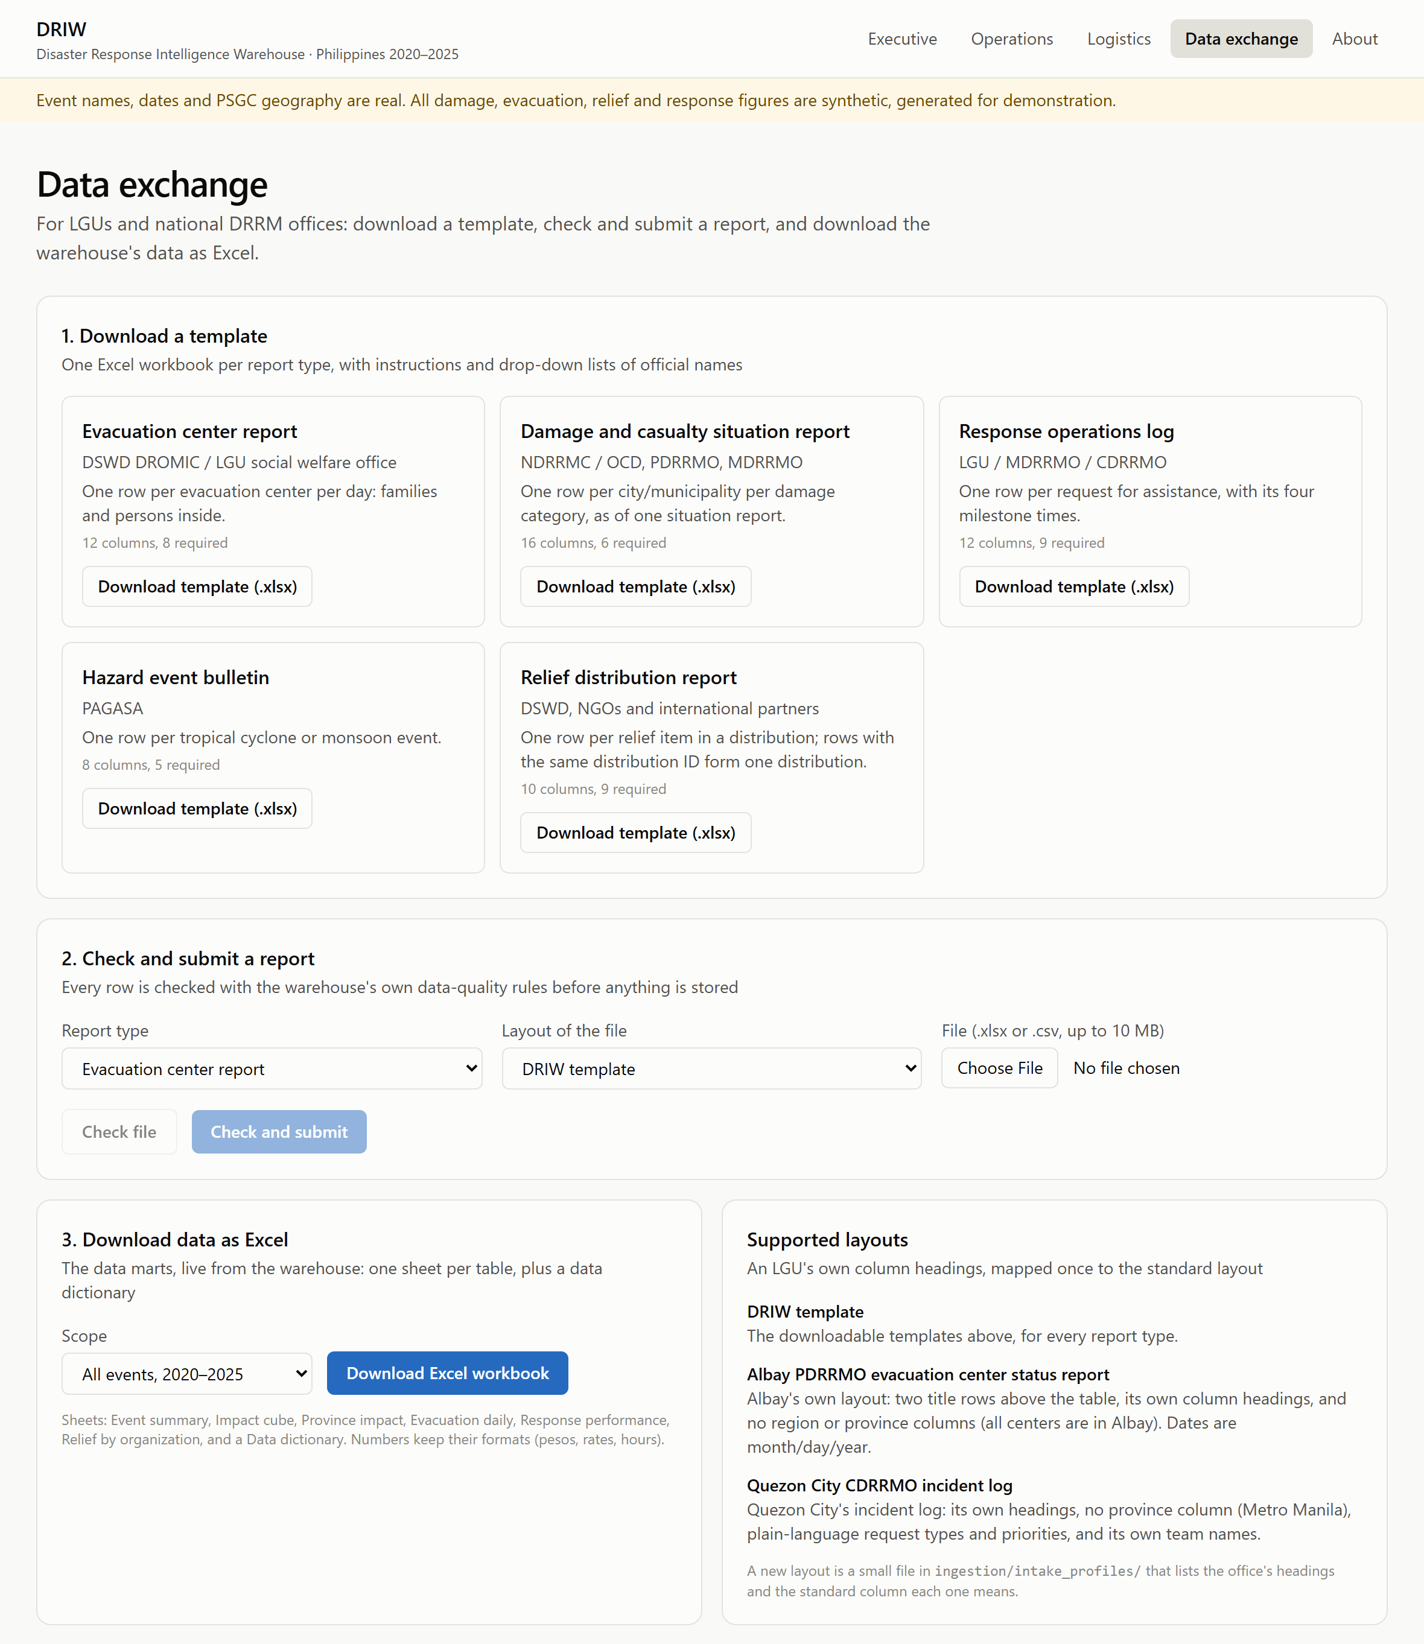
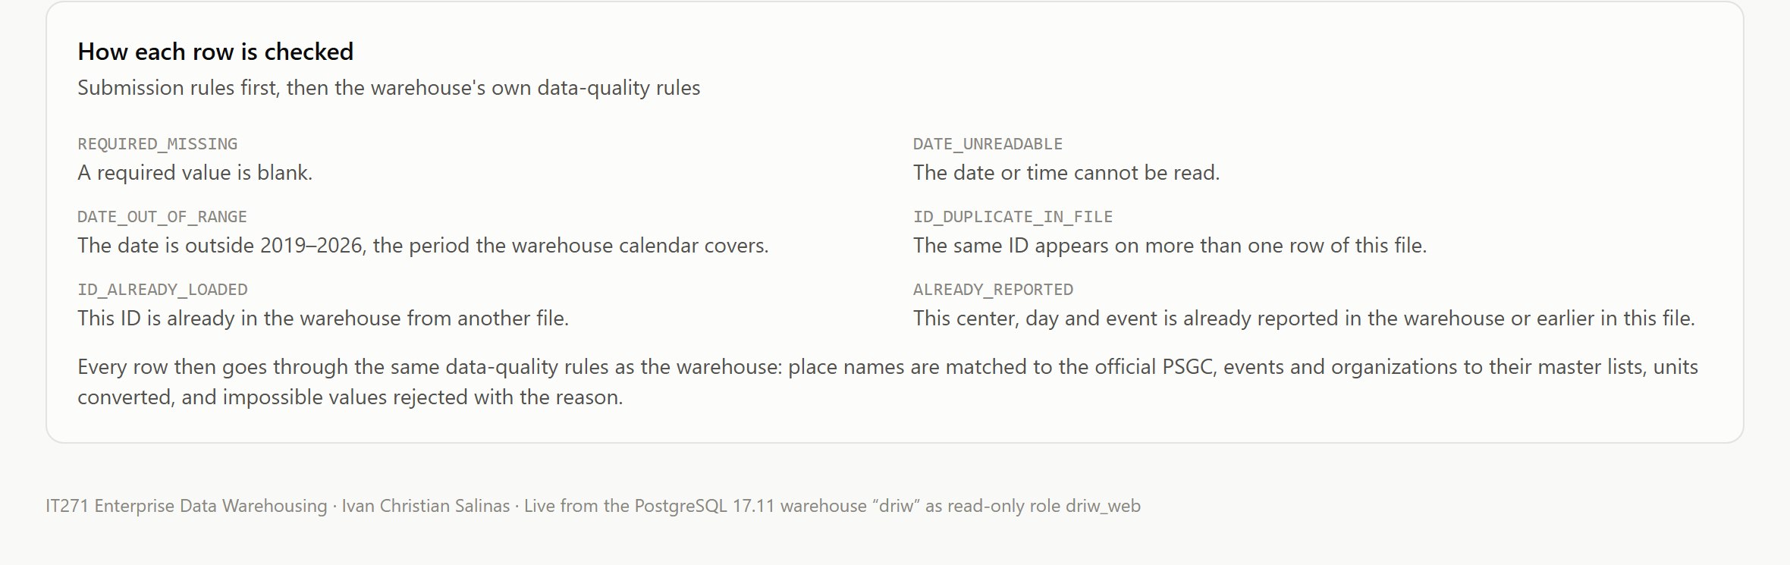
Figure: Data exchange page: templates, the upload form, Excel export, supported layouts and the checking rules

Example: an LGU report in its own layout
The Albay PDRRMO keeps its evacuation report in its own workbook: two title rows, its own column headings, no region or province columns, and dates written month/day/year. With the Albay layout selected, DRIW reads it unchanged and returns this report:
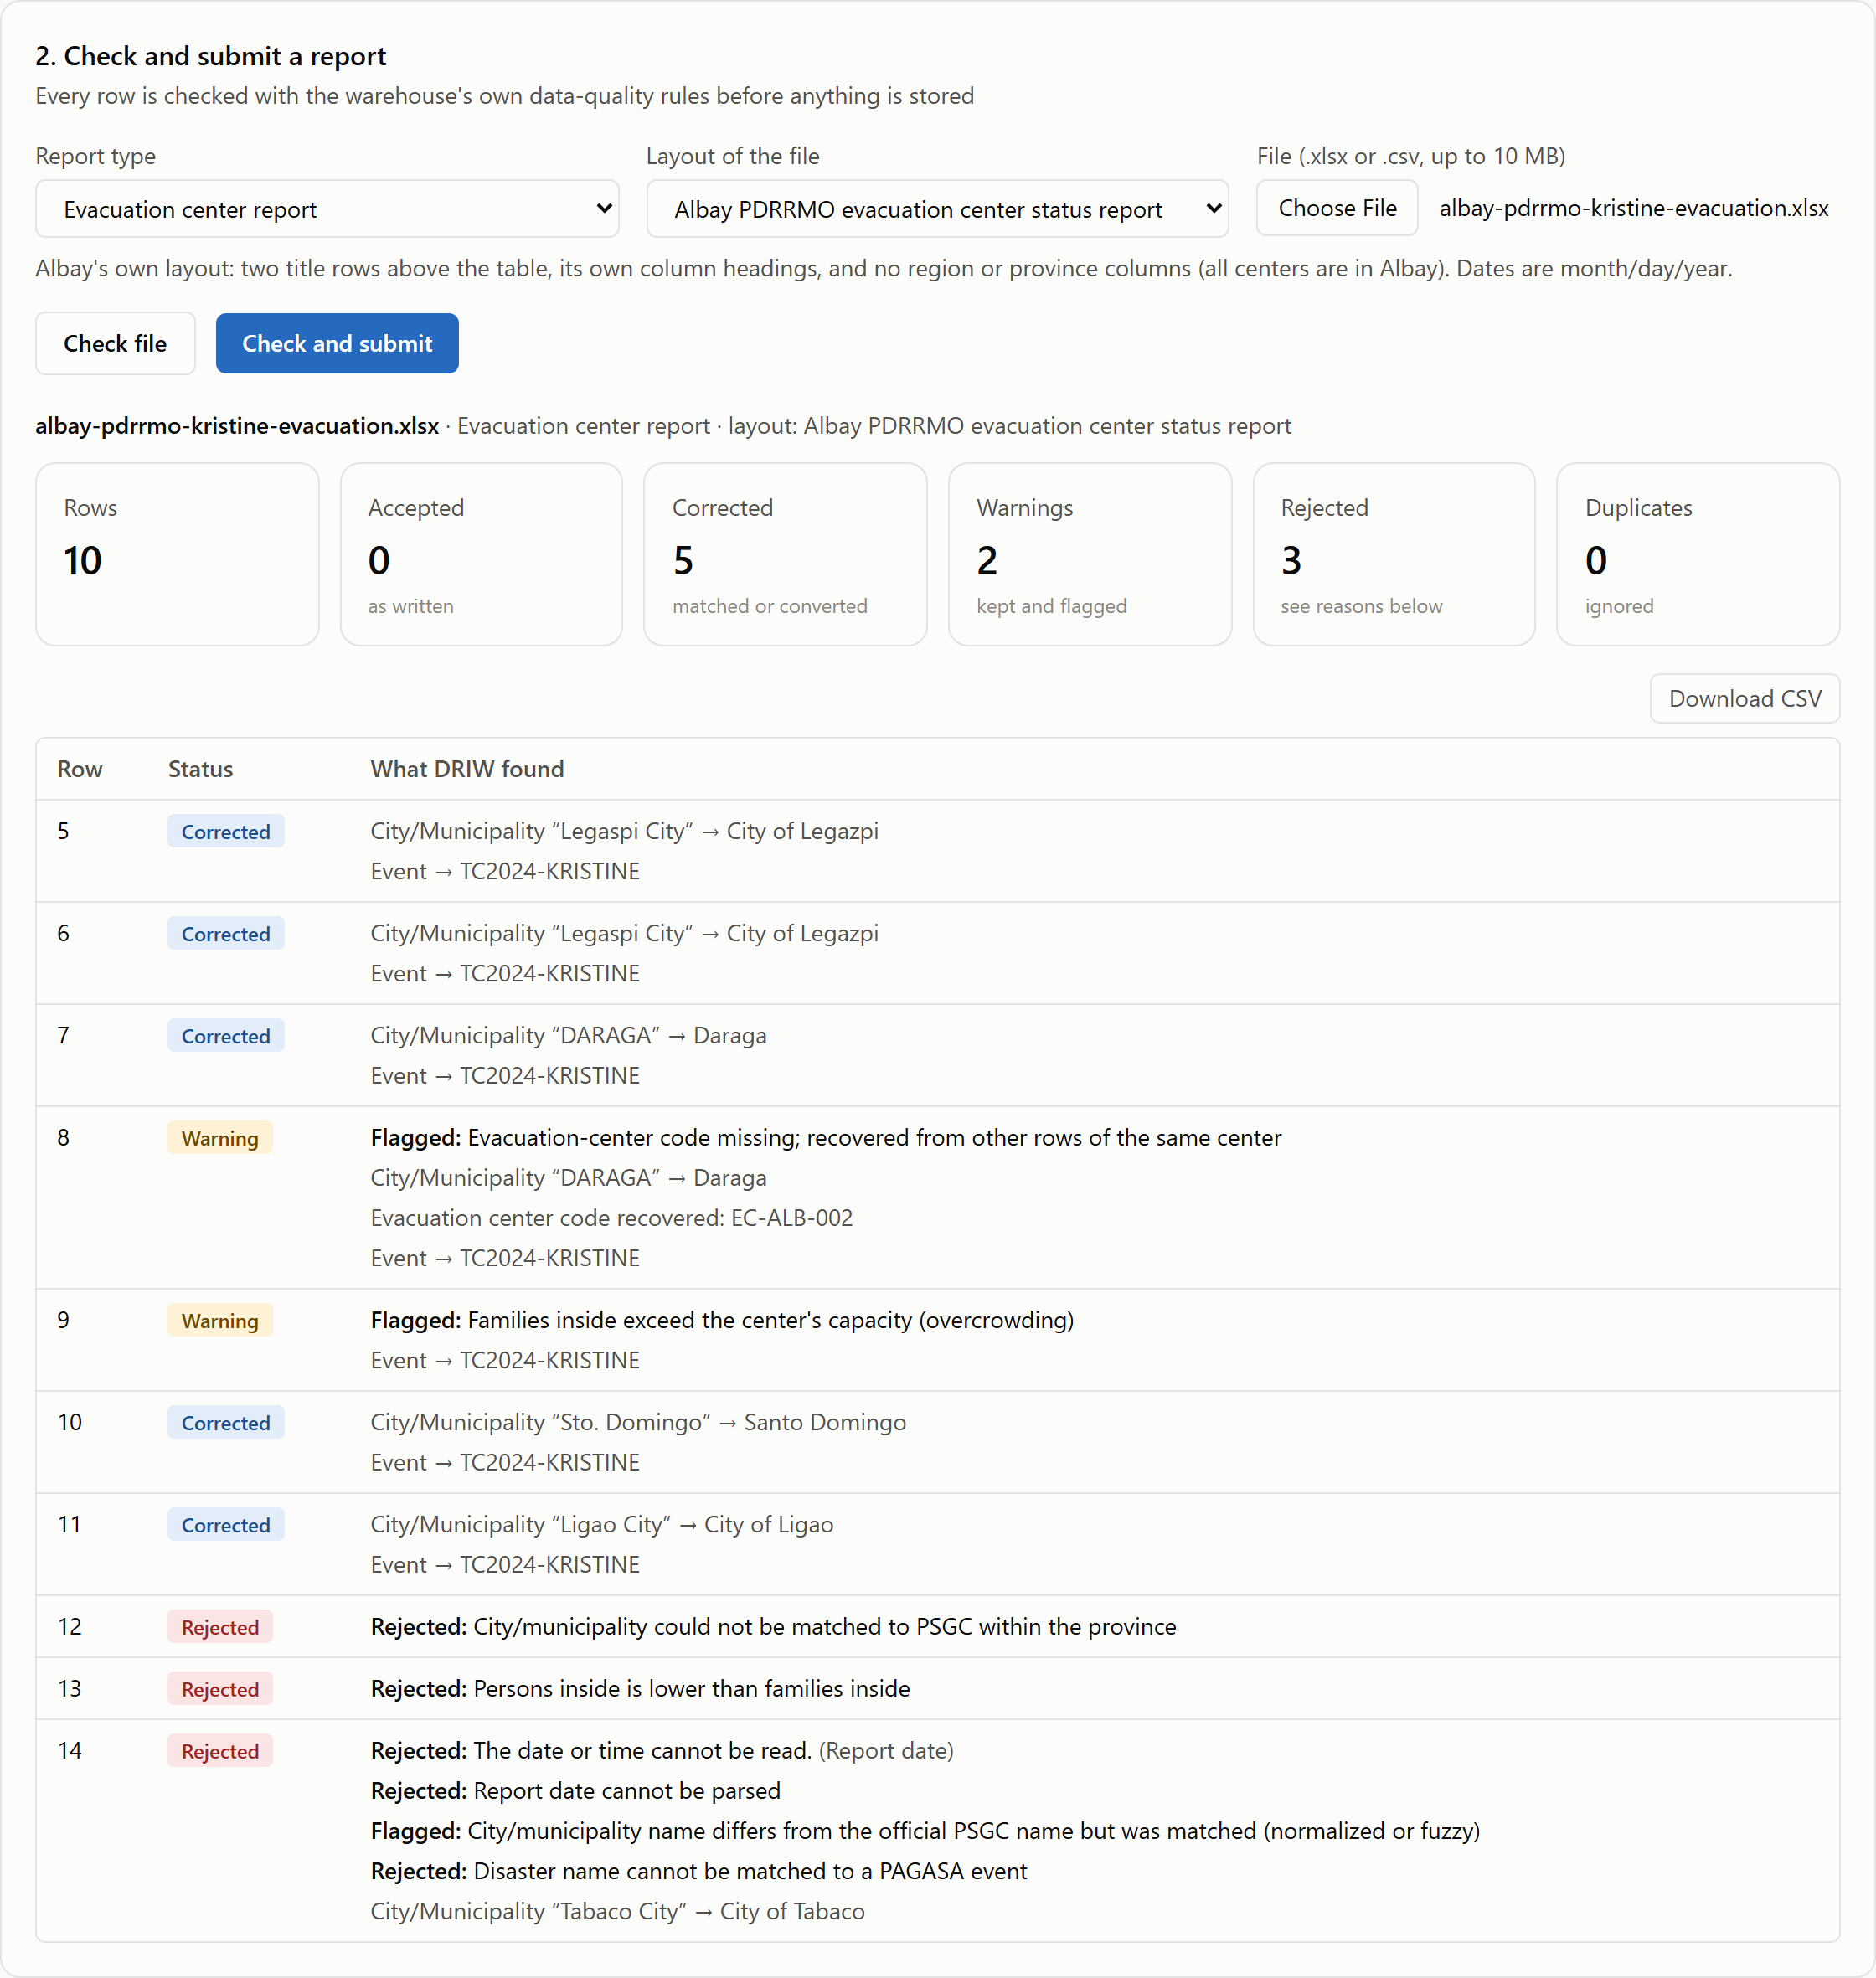
Figure: Check of the Albay PDRRMO report: summary and the verdict on every row
Row | Verdict | Why
5–7, 10, 11 | Corrected | Town names written differently from the PSGC were matched: "Legaspi City" → City of Legazpi, "DARAGA" → Daraga, "Sto. Domingo" → Santo Domingo, "Ligao City" → City of Ligao.
8 | Warning | The center code was blank; DRIW recovered EC-ALB-002 from the same center's other row.
9 | Warning | 97 families in a center for 80: overcrowding, kept and flagged for operations.
12 | Rejected | "Malniao" is equally close to two Albay towns (Malinao and Manito); DRIW does not guess.
13 | Rejected | 61 persons for 64 families: the counts are likely swapped.
14 | Rejected | "10/32/2024" is not a date.

The Quezon City incident log goes through the same rules. Its plain-language request types, priorities and team names are translated by its layout. An unknown team ("Barangay Tanod"), a team recorded as arriving before it was dispatched, and an unclassified request are rejected, and a ticket number used twice is not stored. Submitted in testing, its five valid requests reached the response fact table, its three rejected rows went to quarantine, and all 99 warehouse checks still passed.

Safeguards
- Same rules, separate sandbox. Checking runs the warehouse's own staging models against a separate database, so a file can be checked any number of times without touching the warehouse.
- A bad file cannot break a load. Five rules were added for problems synthetic data never had but real files do (unknown responding unit, dispatch before request, completion before arrival, unknown damage category, an event redefined with different dates), and impossible dates or numbers now become flagged blanks instead of database errors.
- The synthetic-data proof stays clean. Submitted batches are marked origin = 'intake'; the planted-defect reconciliation (19/19) and the ground-truth matching test only consider the synthetic extracts.
- Submitted data stays private. Files in data/intake/ are excluded from Git; uploads are stored outside the web root and deleted after checking; the PHP endpoint passes arguments without a shell and accepts only .xlsx and .csv files up to 10 MB.
- Uploads only from the server itself until the site has sign-in (configurable), because an open upload form must not be reachable from the network.

10.3 Other ways in and out
Direction | Channel | Notes
In | Standard files placed in data/sources/<type>/ | The synthetic extracts, or any file already in the standard layout; loaded by pipeline.py raw dbt
Out | Download CSV on every dashboard table | Raw values; opens directly in Excel
Out | PHP API (/driw/api/marts.php) | JSON for other systems, or Excel and Power BI through a web query
Out | Direct SQL by role | ODBC/JDBC from Excel, Power BI or Tableau; analysts see all rows, regional officers their region

10.4 Next steps
Extension | What it adds
Sign-in mapped to roles | LGU officers log in, upload from anywhere, and see only their region, using the row-level security already in the database
Submission tracking | A dashboard of which LGUs have reported for each event, and which are late or missing
Scheduled, incremental loads | Load new submissions on a schedule and add only what changed, instead of a full reload per submission
Layout profiles from the page | Let a steward map a new office's headings on screen instead of editing a file
Open-data publication | Aggregated, anonymized figures in the shape of UNDRR / Sendai Framework indicators

Appendix A. Sample Analytical Queries
Each query answers a key business question (section 1.3) and demonstrates an OLAP operation. Timings are in the Query Performance Test Report (Chapter 8). Source: docs/sample-queries.sql.

Q01. Costliest events and their human toll (BQ1)
OLAP operation: Ranking (top-N)
select e.event_name,
e.category,
sum(f.cost_php) as damage_cost_php,
sum(f.dead) as dead,
sum(f.affected_persons) as affected_persons
from dw.fact_damage_assessment f
join dw.dim_event e using (event_key)
group by e.event_name, e.category
order by damage_cost_php desc
limit 10;

Q02. Damage by year and category, with yearly subtotals (BQ2)
OLAP operation: Roll-up (GROUP BY ROLLUP)
select coalesce(e.event_year::text, 'All years') as event_year,
coalesce(dc.damage_category, 'All categories') as damage_category,
sum(f.cost_php) as damage_cost_php
from dw.fact_damage_assessment f
join dw.dim_event e using (event_key)
join dw.dim_damage_category dc using (damage_category_key)
group by rollup (e.event_year, dc.damage_category)
order by e.event_year nulls last, dc.damage_category nulls last;

Q03. Drill-down: region -> province -> city/municipality for one event (BQ3)
OLAP operation: Drill-down
select l.region_name,
l.province_name,
l.city_muni_name,
sum(f.affected_persons) as affected_persons,
sum(f.cost_php) as damage_cost_php
from dw.fact_damage_assessment f
join dw.dim_location l using (location_key)
join dw.dim_event e using (event_key)
where e.event_code = 'TC2024-KRISTINE'
group by l.region_name, l.province_name, l.city_muni_name
order by affected_persons desc
limit 15;

Q04. Tropical cyclone vs monsoon flood impact per region (BQ4)
OLAP operation: Pivot (FILTER) / dice
select l.region_name,
sum(f.affected_persons) filter (where e.hazard_type = 'Tropical Cyclone')
as cyclone_affected,
sum(f.affected_persons) filter (where e.hazard_type = 'Flood')
as flood_affected,
sum(f.affected_persons) as total_affected
from dw.fact_damage_assessment f
join dw.dim_event e using (event_key)
join dw.dim_location l using (location_key)
group by l.region_name
order by total_affected desc;

Q05. Every subtotal of impact by year x region x hazard (BQ2, BQ4)
OLAP operation: Cube (GROUP BY CUBE)
select e.event_year, l.region_name, e.hazard_type,
grouping(e.event_year, l.region_name, e.hazard_type) as grouping_id,
sum(f.dead) as dead,
sum(f.affected_persons) as affected_persons,
sum(f.cost_php) as damage_cost_php
from dw.fact_damage_assessment f
join dw.dim_event e using (event_key)
join dw.dim_location l using (location_key)
group by cube (e.event_year, l.region_name, e.hazard_type);

Q06. Peak evacuees per event (semi-additive measure) (BQ5)
OLAP operation: Aggregate over a snapshot
select e.event_name,
max(daily.persons) as peak_persons_in_centers,
count(*) as days_with_evacuees
from (
-- sum across centers per day
select event_key, snapshot_date_key, sum(persons_inside) as persons
from dw.fact_evacuation_snapshot
group by event_key, snapshot_date_key
) daily
join dw.dim_event e using (event_key)
group by e.event_name -- then MAX over days, never SUM
order by peak_persons_in_centers desc
limit 10;

Q07. Evacuation centers most often over capacity (BQ6)
OLAP operation: Slice (is_over_capacity)
select c.ec_name, c.ec_type, l.province_name,
count(*) filter (where f.is_over_capacity) as over_capacity_days,
max(f.families_inside) as max_families,
c.capacity_families
from dw.fact_evacuation_snapshot f
join dw.dim_evacuation_center c using (evacuation_center_key)
join dw.dim_location l using (location_key)
group by c.ec_name, c.ec_type, l.province_name, c.capacity_families
having count(*) filter (where f.is_over_capacity) > 0
order by over_capacity_days desc, max_families desc
limit 10;

Q08. Dispatch time by response type and priority (BQ7)
OLAP operation: Accumulating snapshot analysis
select rt.response_type_name,
f.priority,
count(*) as requests,
round(percentile_cont(0.5) within group (order by f.hours_to_dispatch)::numeric, 2)
as median_hours_to_dispatch,
round(percentile_cont(0.9) within group (order by f.hours_to_dispatch)::numeric, 2)
as p90_hours_to_dispatch,
round(100.0 * avg(f.is_completed::int), 1) as pct_completed
from dw.fact_response_action f
join dw.dim_response_type rt using (response_type_key)
group by rt.response_type_name, f.priority
order by rt.response_type_name, f.priority;

Q09. Slowest-responding cities/municipalities for life-saving requests (BQ7)
OLAP operation: Slice + ranking
select l.province_name, l.city_muni_name,
count(*) as life_saving_requests,
round(percentile_cont(0.5) within group (order by f.hours_to_dispatch)::numeric, 2)
as median_hours_to_dispatch
from dw.fact_response_action f
join dw.dim_response_type rt using (response_type_key)
join dw.dim_location l using (location_key)
where rt.response_cluster = 'Life-saving'
group by l.province_name, l.city_muni_name
having count(*) >= 20
order by median_hours_to_dispatch desc
limit 10;

Q10. Least relief per affected person, by province (BQ8)
OLAP operation: Integration of two facts
with impact as (
select l.province_name, sum(f.affected_persons) as affected
from dw.fact_damage_assessment f join dw.dim_location l using (location_key)
group by l.province_name
), relief as (
select l.province_name, sum(f.value_php) as relief_php
from dw.fact_resource_distribution f join dw.dim_location l using (location_key)
group by l.province_name
)
select i.province_name, i.affected, coalesce(r.relief_php, 0) as relief_php,
round(coalesce(r.relief_php, 0) / nullif(i.affected, 0), 2) as relief_php_per_person
from impact i left join relief r using (province_name)
order by relief_php_per_person
limit 10;

Q11. Relief mix by organization and resource category (BQ9)
OLAP operation: Dice (org x category)
select o.org_name, r.category,
sum(f.quantity) as quantity_standard_units,
sum(f.value_php) as relief_value_php
from dw.fact_resource_distribution f
join dw.dim_organization o using (organization_key)
join dw.dim_resource r using (resource_key)
group by o.org_name, r.category
order by o.org_name, relief_value_php desc;

Q12. Year-over-year change in damage cost (BQ2)
OLAP operation: Window function (LAG)
select event_year,
damage_cost_php,
round(100.0 * (damage_cost_php - lag(damage_cost_php) over (order by event_year))
/ nullif(lag(damage_cost_php) over (order by event_year), 0), 1)
as pct_change_vs_prior_year
from (
select e.event_year, sum(f.cost_php) as damage_cost_php
from dw.fact_damage_assessment f join dw.dim_event e using (event_key)
group by e.event_year
) yearly
order by event_year;

Q13. Dashboard query served from a mart (BQ1, BQ5, BQ8)
OLAP operation: Pre-aggregated ROLAP mart
select event_name, damage_cost_php, peak_persons_in_centers, relief_php_per_affected_person
from mart.mart_event_summary
order by damage_cost_php desc
limit 10;

Q14. What data was rejected, and why? (BQ10)
OLAP operation: Data-quality audit
select source_system, reject_reasons, count(*) as rows_quarantined
from dq.dq_quarantine
group by source_system, reject_reasons
order by rows_quarantined desc;

