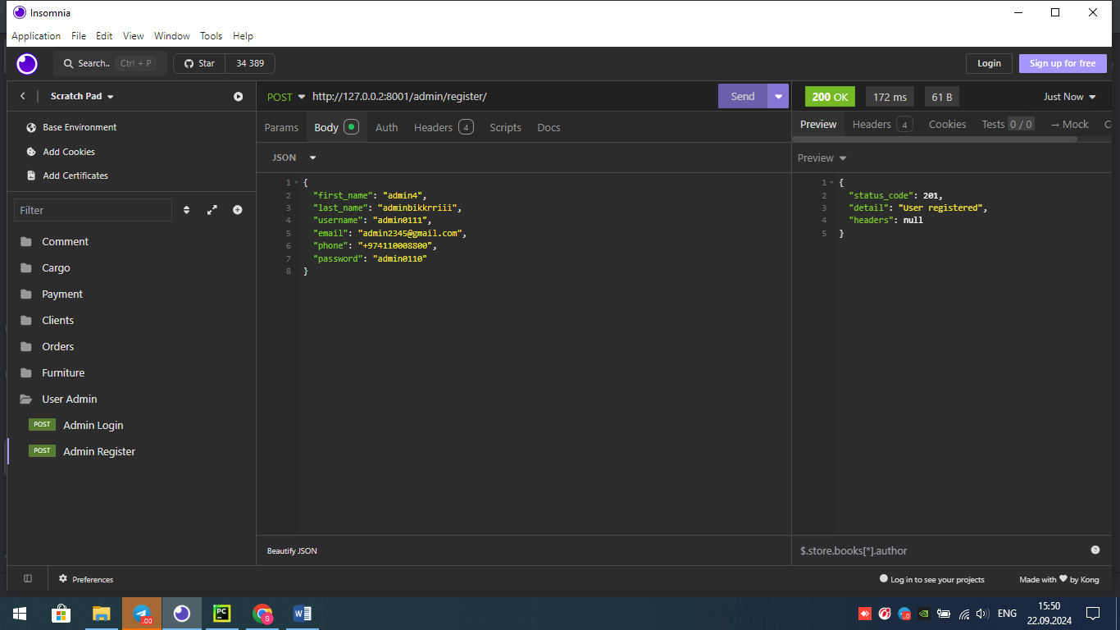

ADMIN register

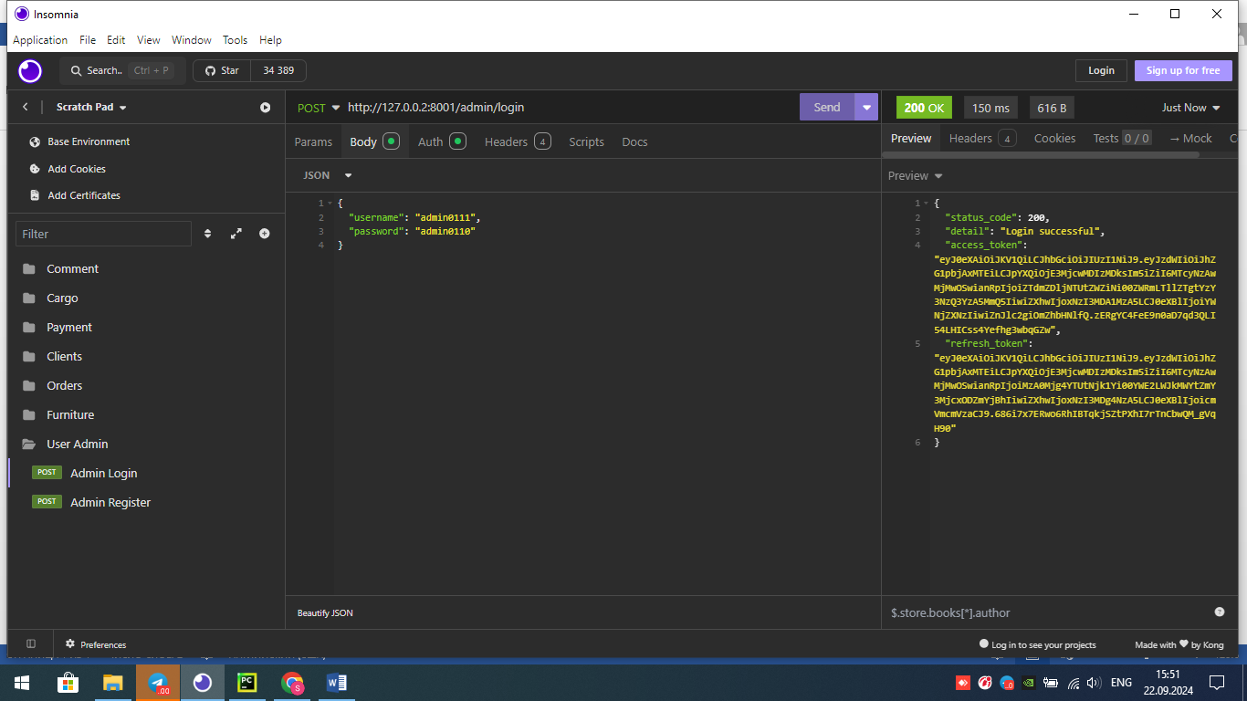

ADMIN login

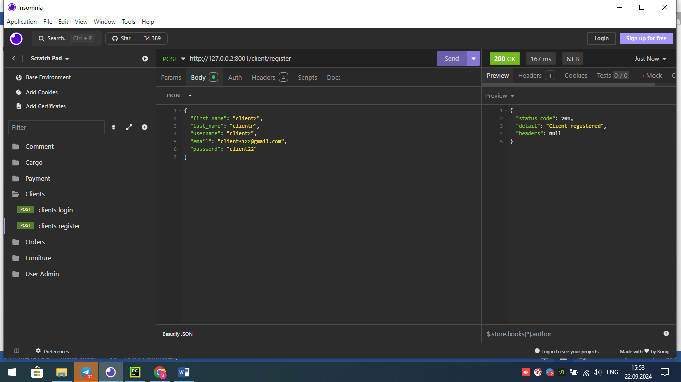  
  
  
CLIENT register

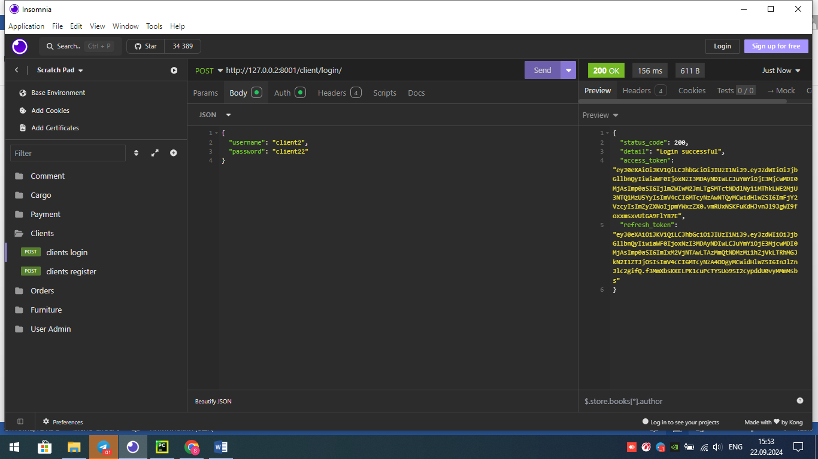  
  
  
CLIENT login

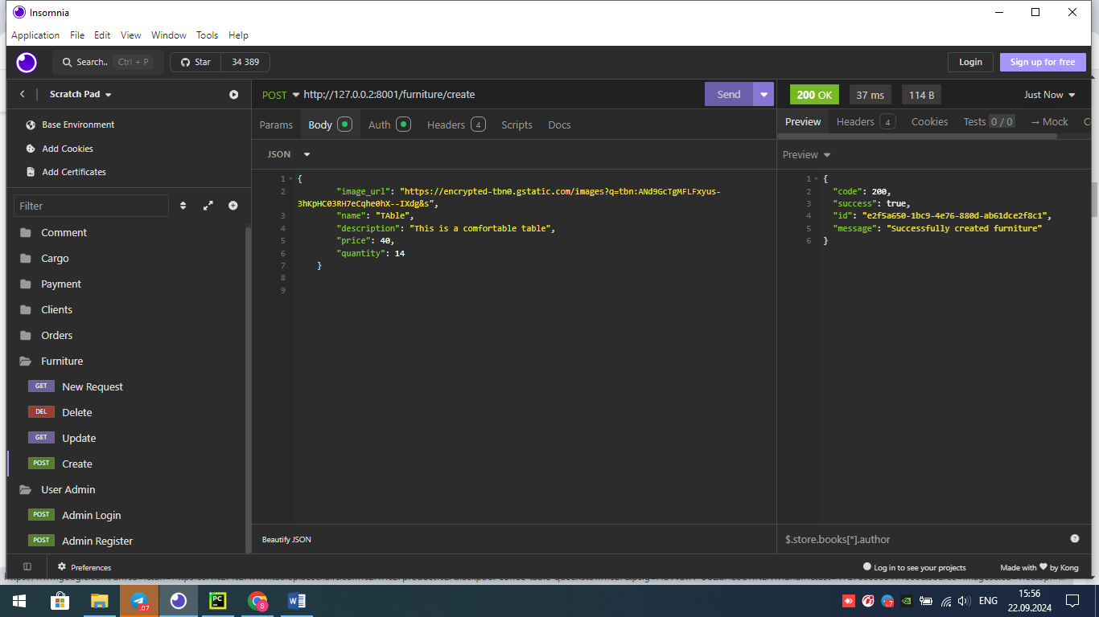

FURNITURE Create. Albatta admin user tokeni bulsa va vaqti tugamagan bulsagina yarata oladi

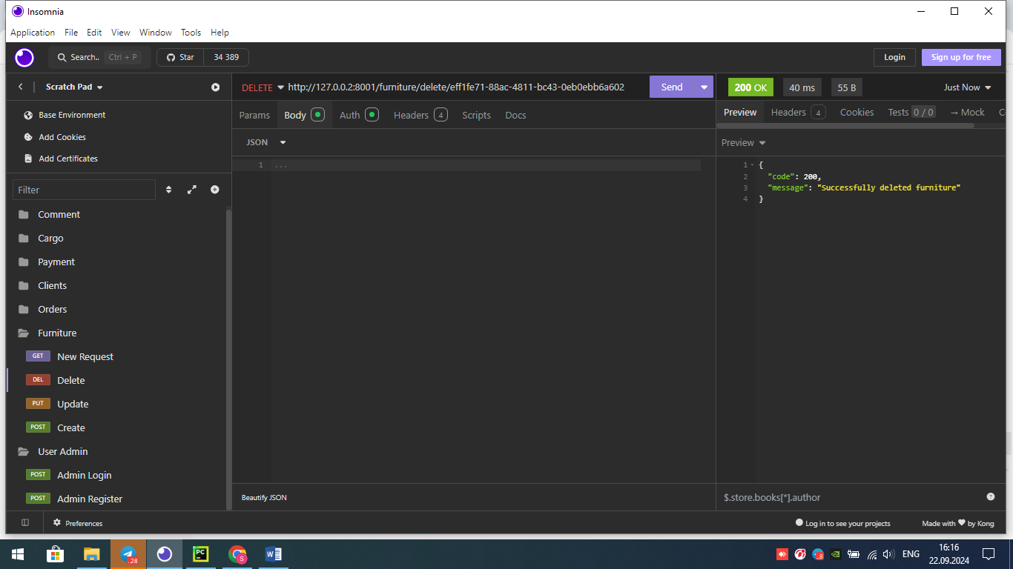

ID raqami orqali Admin tokini bor foydalanuvchilar furnitureni delete qilishi

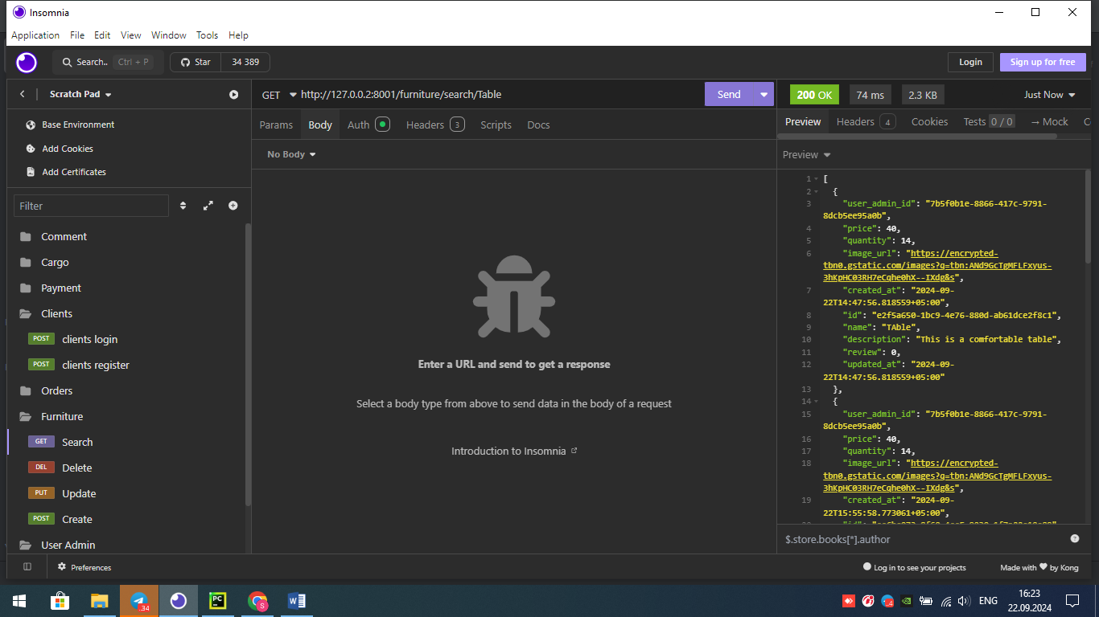

Furniture name orqali search qilish.albatta tokeni bulgan clientlar

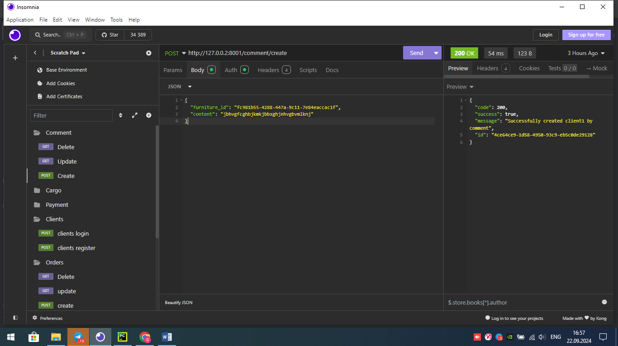

Comment Create