FIRST STEPS TOWARDS A COMPUTATIONAL APPROACH TO AFGHAN ART MUSIC

|  |  |  |
| --- | --- | --- |
|  | Mathieu Clavel |  |
|  | **EPFL  mathieu.clavel@epfl.ch** |  |

ABSTRACT

This paper seeks to set the base for studies of Afghan instrumental art music relying on the computational analysis of notated material; an attempt motivated by the dire situation of this intangible musical heritage which has suffered from political turmoil within its land of origin over the last four decades. It does so by laying out a pipeline for processing such data in its own representation. A dataset of 43 compositions is then fed to it, and a few exploratory analysis tasks are performed out of it to highlight the singularities of the melodic material contained in some of its various modes; namely pitch class distributions, conditional transition matrices and pitch class entropy distributions. This prior analysis goes to the extent of computing entropy scores for the overall corpus and the individual modes, scores that are then tested against similarly obtained entropy measures from different datasets, showing that they are significantly lower in the case of Afghan music.

1. INTRODUCTION
   1. Afghan art music and the rubâb

The origins of what is known as Afghan art music are traced back to the second half of the 19th century, when Sher Ali Khan, ruler of Kabul and patron of arts, brought back musicians to his court from a visit to India. A type of art music was eventually produced which was distinctly Afghan in style, blending elements of Hindustani and Persian culture into a vocal music form and its instrumental counterpart, the latter being known as *naghmeh-ye kashâl* (extended instrumental piece). Later on, with the advent of Radio Kabul, then Radio Afghanistan, this music became blended with elements of folk music from the various heterogeneous regions of the country, creating a unique national style that became a vector of unity among its people upon the national broadcast channels.[1]

The *rubâb* is a major instrument of Afghan music, considered as the national instrument of Afghanistan, and for which the compositions of the dataset are designed. It is a fretted lute with 3 melodic strings tuned in fourths with only 4 frets, offering a comfortable range of 1.5 octave, extensible up to 2. Its deep body implies a “broken wrist” hand position that creates a disbalance in sound between strong downstrokes and weak upstrokes. This, together with drone strings techniques, creates many opportunities for playing rhythm patterns on top of melodies, a characteristic element of the *rubâb*.

http://i.creativecommons.org/l/by/3.0/88x31.png © Mathieu Clavel

Licensed under a Creative Commons Attribution 4.0 International License (CC BY 4.0).

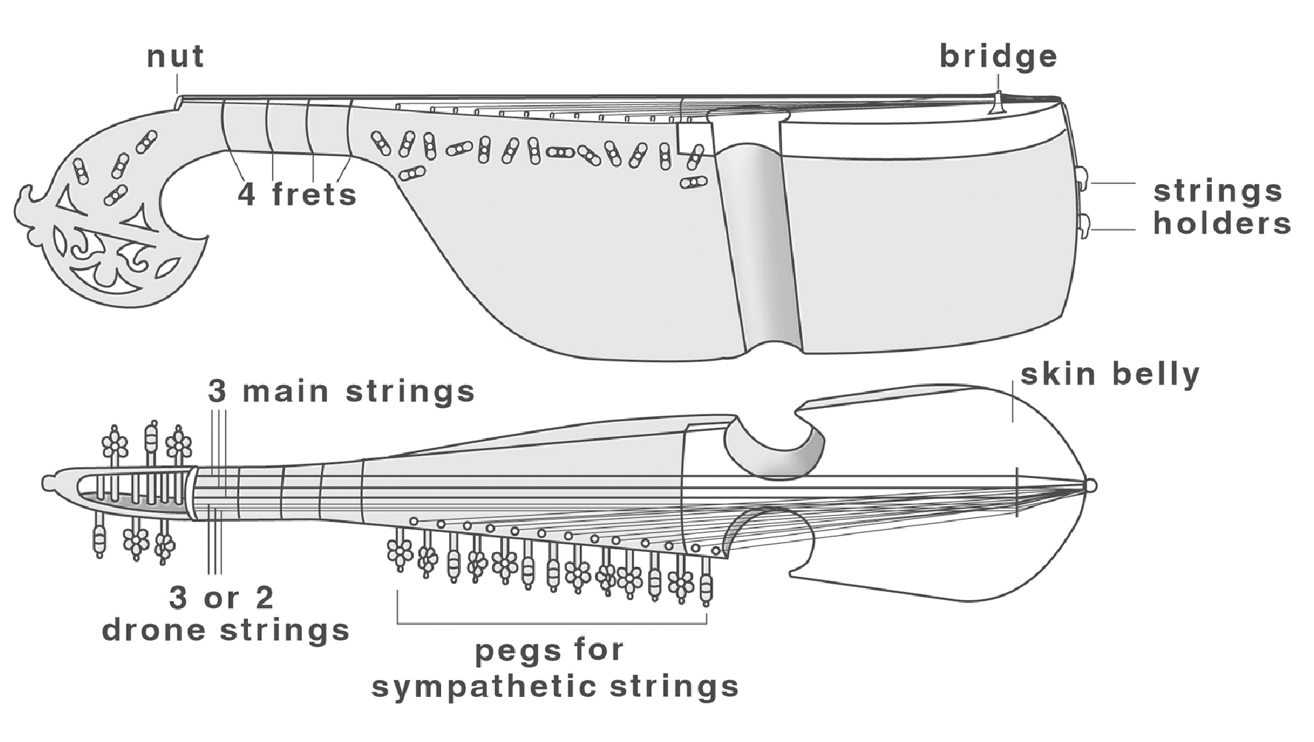

**Figure 1**. Overview of the rubâb

* 1. An endangered heritage

To this day, Afghanistan has known over 42 years of almost interrupted conflict which have caused incredible harm to its population, and equally important damages to its culture. At times, music was eventually completely banned by extreme ruling; instruments broken to bits, recordings burned down and music simply forbidden to air. There was little chance for the tradition to pass on down the new generations, and this has taken a serious toll to its integrity, to the point that not many are the musicians who still master this art today, known as *Ustad*s.[2] Afghan people themselves, especially among the diaspora, seem to relate less to it than foreigners to this culture do, privileging instead pop music.[3]

* 1. An important form to study

Because Afghan art music has been studied very little over the last decades when ethnomusicology rose in importance, and because of the dire state of its existence, it appears essential that studies be conducted about it, to hopefully engage movement against its decay. The present work is rooted in this conviction, and aims at opening paths towards a renewed interest by beginning, no matter how lightly, to put its richness and beauty forward.

1. DATA GATHERING

The dataset considered is a collection of classical instrumental compositions for the Afghan *rubâb* notated in the local notation system, a variation on the Indian Saregam notation. It comes from a document compiled by Prof. John Baily of Goldsmith University, one of the foremost specialist of Afghan music, intended as a supporting teaching material for the 2014 Winter School of the Afghan National Institute of Music (ANIM) in Kabul. All the compositions were notated directly by Prof. Baily from his numerous field recordings, and the lessons he received from *Ustad*s. The document was obtained privately from him. One of the difficulties encountered when attempting to conduct large scale studies on Afghan notated music corpora lies in the inexistence of any such corpus publicly available. The music itself is seldom written down, and when it is the purpose is merely to serve as a memory aid, to remember the compositions, never to be used for performing the pieces..

|  |  |  |  |  |  |
| --- | --- | --- | --- | --- | --- |
| Sa | Ra | Re | Ga | Ge | Ma |
| C | Db | D | Eb | E | F |

|  |  |  |  |  |  |
| --- | --- | --- | --- | --- | --- |
| Me | Pe | Da | De | Na | Ni |
| F# | G | Ab | A | Bb | B |

**Table 1.** Equivalence of Saregam/Western pitch cat.

There are 43 compositions in the dataset, of various lengths (from a single rythmic cycle to a dozen) and divided in various movements which correspond loosely to movements of Hindustani dhrupad music (*Astai, Antara, Paltas*...). In total, it amounts to 5200 symbols (pitches or silences, either quarter or eighth notes), covering 15 different melodic modes, or *râga*. It should be accounted that this limited range of modes does not include all modes that are considered to be most relevant to Afghan musical identity (including *Bhairavi* or *Pilo*)[4]. The pieces come in several rythmic cycles, or *tâla*, although most are set in the main cycle of Hindustani classical music, in 16 beats (*tintal*). There are also pieces in 15 beats (*pancham savari*), 12 beats (*jhaptal*) and 10 beats (*ektal*). This is again a fraction of the rythmic cycles practiced in Hindustani music, while it does not account for the cycles used in folk music (4, 6,7 or 8 beats).

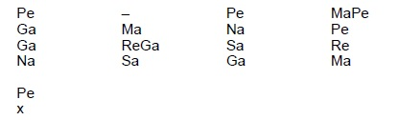

**Figure 2**. Example composition in 16 beats (*Astai* of *naghmeh-ye kashâl* in *Raag Bhimpalasi*)

This notation system gives a canonical representation of the compositions, which are in practice performed with much ornamental and rhythmic variations (a trait emphasized by the instrument playing style) as well as melodic improvisations. Nonetheless, the canonical form is supposed to account for the fundamental features of the pieces.

|  |  |  |  |  |  |
| --- | --- | --- | --- | --- | --- |
| Râga | pieces | cycles | Râga | pieces | cycles |
| AhirBhairav | 7 | 31 | **Chandrakauns** | 3 | 10 |
| Asa | 3 | 13 | **Des** | 2 | 12 |
| Bagheshri | 2 | 10 | **Kalavati** | 1 | 8 |
| Bhairav | 3 | 8 | **Kausieh** | 2 | 17 |
| Bhimpalasi | 3 | 12 | **Kesturi** | 2 | 13 |
| Bhopali | 3 | 49 | **Khamaj** | 2 | 14 |
| Bihag | 2 | 10 | **Pari** | 3 | 14 |
|  |  |  | **Purya Kalyan** | 5 | 12 |

**Table 2.** Number of pieces and cycles by modes

Considering the relatively small size of the present dataset, a computational analysis could not reasonably produce meaningful results. Nonetheless, it is suggested that a larger dataset, once available, could be processed through the same pipeline, hence not necessarily undermining the validity of the present approach.

1. Exploratory Analysis
   1. Pitch distributions

The first perspective of the exploratory analysis is to compute pitch distribution over the whole corpus by counting the occurences of notes. In this first step chroma is considered together with height so as to give a representation of melody development on the *rubâb*. This shows that although the instrument offers the possibility to play over two octaves, by reaching above the fourth fret on the third string in the unfretted area, melody development in the high octave remains anecdotical.

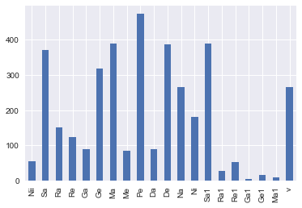

**Figure 3**. Pitch class distribution over the whole corpus

The importance of the tonic “*Sa*” at both the base octave and high octave, as arches of stability, together with a peak of the dominant “*Pe*” at the core of the structure is striking, and corroborates the pitch hierarchy principle. Although it is meaningful to observe the low proportion of chromatic tones, one must acknowledge that the proportion of accidentals is also highly dependent on the mode distribution of the corpus.

Furthermore, the same features are computed individually for each mode, yielding each time a completely differently shaped signature distribution representing the aggregated and normalized pitch material for each mode. Yet a fraction of the whole modal spectrum of Afghan art music, it already shows a highly varied content. Those pitch class distributions for each mode can be seen in appendix 1.

Those distributions do not necessarily follow the *vadi*/*samvadi* principle of each *râga* (dominant/mediant relationships), which specifies pitches that should stand out when presenting a particular *râga*. It is however probably a consequence of the limited data and could prove otherwise with a sufficient corpus, under a “law of large numbers”, but would be interesting to question nonetheless.

* 1. Transition Matrices

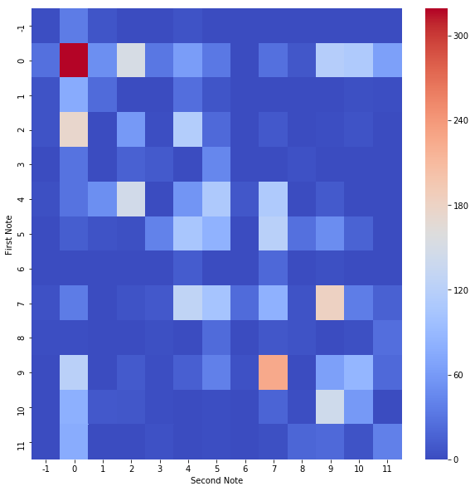

**Figure 4**. Transition matrix computed from the whole corpus

The exploration of the melodic material is continued with the analysis of interval successions, using Markov models. A transition matrix is built from the full corpus, clearly showing from the diagonal how melodies are constructed with a strong continuity in pitches and much more rarely with jumps between pitch classes, if not from the tonic. This is again coherent with the principles of modal music. It also highlights frequent repetitions of the tonic.

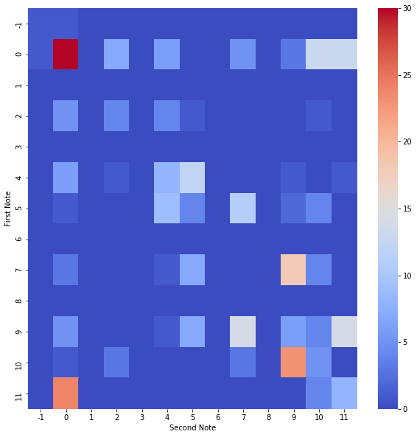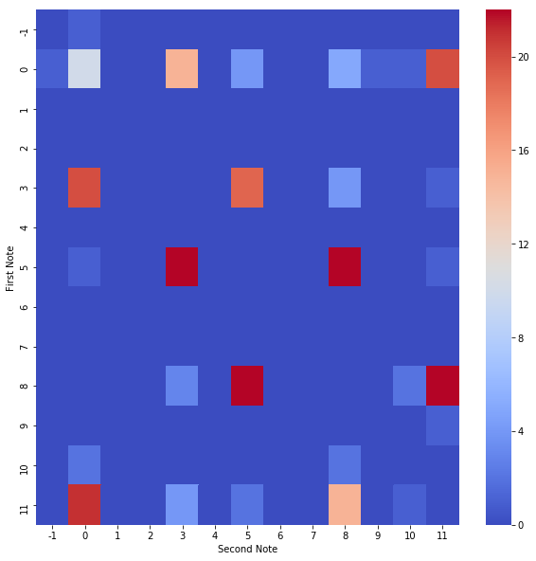

**Figure 5**. Ex. transition matrices for *Kesturi* (top) and *Chandrakauns* (down)

Once again the same visualization is done for each of the modes, offering a strong sense of the underlying note succesions rules of each mode, and how they differ from each other. Indeed, there are no two modes which display a similar transition matrix. Some display weak rules, such as *Kesturi*, while other such as *Chandrakauns* seem to have very deterministic melody building principles, as is shown in the next figure.

* 1. Conditional distribution of interval successions

Finally, the conditional distribution of interval succesions is represented yet as another heatmap.

The strongest probability lies in the succession between class -1 and class 0. Class -1 corresponds to the open first string of the *rubâb*, a note that is almost always played in an oscillating movement around the tonic. Jumps from this note to the others strings are seldom used in classical compositions.

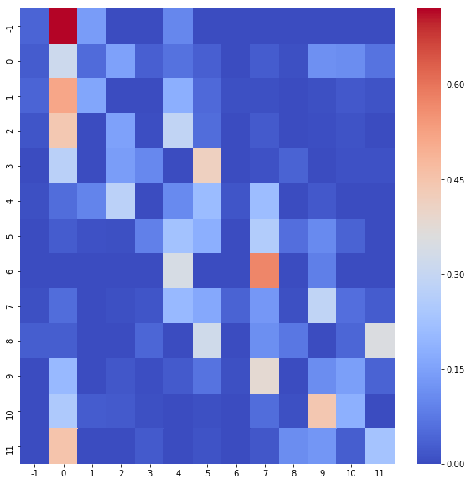

**Figure 6**. Conditional distribution of interval successions computed from the whole corpus

1. Further analysis: Entropy

An interesting, deeper measure of the data lies in the expected information content, or entropy.

C:\Users\Mathieu\AppData\Local\Microsoft\Windows\INetCache\Content.Word\entropy.png

This measure offers a quantification of the information embedded in the transition matrices presented before, and allows to consider how expectation is at play in the music. From the conditional interval distributions of each pitch class computed from the aggregated dataset, we find entropy values ranging from a minimum 0.871 (pitch class -1) to a maximum value of 2.101 for the tonic (pitch class 1). The second and third highest entropies are associated with the dominant (pitch class 7) with a value of 1.956 and the mediant (pitch class 5) with a value of 1.927. Unsurprisingly, this finding is coherent with the previous figures of pitch importance and highlights the coherent hierarchical architecture of this modal system, having the tonic, dominant and mediant as the centers of melodic development. The lowest entropy is coherent with what appeared in fig. 6. The first appendix shows the entropies for the conditional interval distributions of each pitch, together with their entropy values.

A better sense of the measure is obtained by comparison with values obtained from different datasets. For instance, an early work on musical entropy computed from Western classical music pieces such as Youngblood’s gives average entropy values around 3.05 from works of Mendelsohn, Schumann and Schubert.[5] This is significantly higher than the present results. It was also tested against the Essen Folksong Collection dataset. With a t-statistic of 3.3 with pvalue of 0.003, the null hypothesis may be rejected at 0.01. Therefore it may be claimed that the two groups are significantly different, meaning that entropies computed from this dataset are also found to be significantly lower than entropies computed for the Essen Folksong Collection.

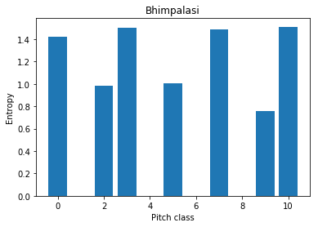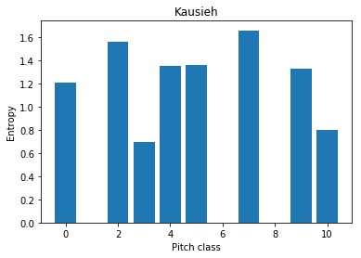

**Figure 7**. Ex. pitch class entropy distribution for Bhimpalasi (top) and Kausieh (down)

At last, considering the distributions of entropy values per pitch class per mode offers another way to represent the diverse internal structures of the modes. Certain modes such as Bhopali exhibit lower global entropies, hence demonstrating lesser uncertainty in their development. For reference, these distributions are shown in appendix 2.

1. Limits of the approach

It was already mentioned that Afghan art music is not a music that is traditionally written down, apart from its canonical, simplified forms for memory and learning purposes. As such notated compositions hardly present a comprehensive display of the true content of a performance of Afghan instrumental music, enriched with both melodic and rythmic variations, together with a lot of improvisation as is typically found in Hindustani music, and which may temper with the low entropy scores. The extent of what can be learned from a dataset such as the present one is therefore constrained by this fact, and a fitter dataset would rather be constructed from notated performances; a tedious and time consuming task to say the least.

Another approach could use signal processing of audio material, yet for the benefits it may have weaknesses arise as well: beyond the state-of-the-art limited capabilities, recordings of Afghan art music are scarcely available, often in poor digital conditions. Beside, as most of the available material was usually recorded in radio or television broadcast settings, it is also subject to constraints linked to these media; particularly time constraints, resulting in shortened performance deprived of lengthy improvisations. Indeed, there are many factors to consider in the choice of the right dataset.

1. CONclusion

A corpus of notated compositions of Afghan instrumental music for the lute *rubâb* was obtained, then transformed to be processed into a pipeline of data analysis.Exploratory analysis was conducted to get a sense of such data. This beginning step already revealed the diversity of modal melodic content of Afghan art music in a series of visualizations of pitch class distributions, conditional transition matrices and pitch class entropy distributions., that can lead to further analysis in a mode-specific study. The entropy values were then tested against similar values obtained from different datasets, one of classical Western music and the other of folk songs from the World, resulting in both case in a significantly lower average entropy in the case of Afghan music. Finally, inherent limits to this approach were considered, as this data captures only a fraction of what this music really is.

1. REFERENCES
2. J. Baily: *Music of Afghanistan. Professional Musicians in the City of Herat* Cambridge University Press, 1988
3. J. Baily: *War, Exile and the Music of Afghanistan : The ethnographer’s tale*, Ashgate, Coll. « SOAS Musicology Series », 2015
4. J. Baily: “Two Different Worlds: Afghan Music for Afghanistanis and Kharejis”, Ethnomusicology Forum, 19:1, 69-88, 2010
5. J.Baily: “A System of Modes Used in the Urban Music of Afghanistan”. Ethnomusicology, 25(1), 1. 1981
6. J.E. Youngblood; Style as information. J. Music Theory, 2, 24-35, 1958

**APPENDIX**

Relative pitch class distribution per mode, order from left to right from class -1 to class 11, plus silences.

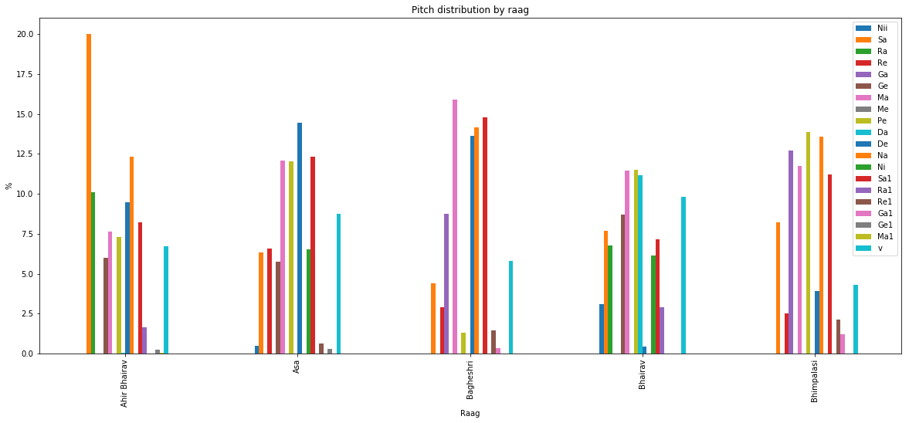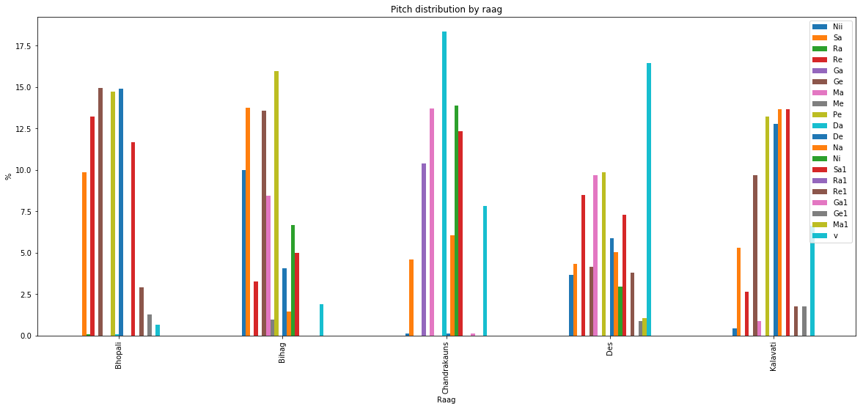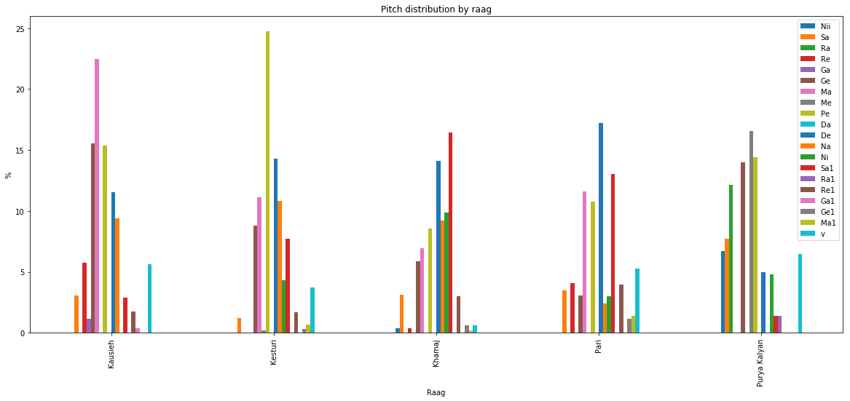

2. Conditional interval distributions and their entropies on the whole corpus, for each pitch class.

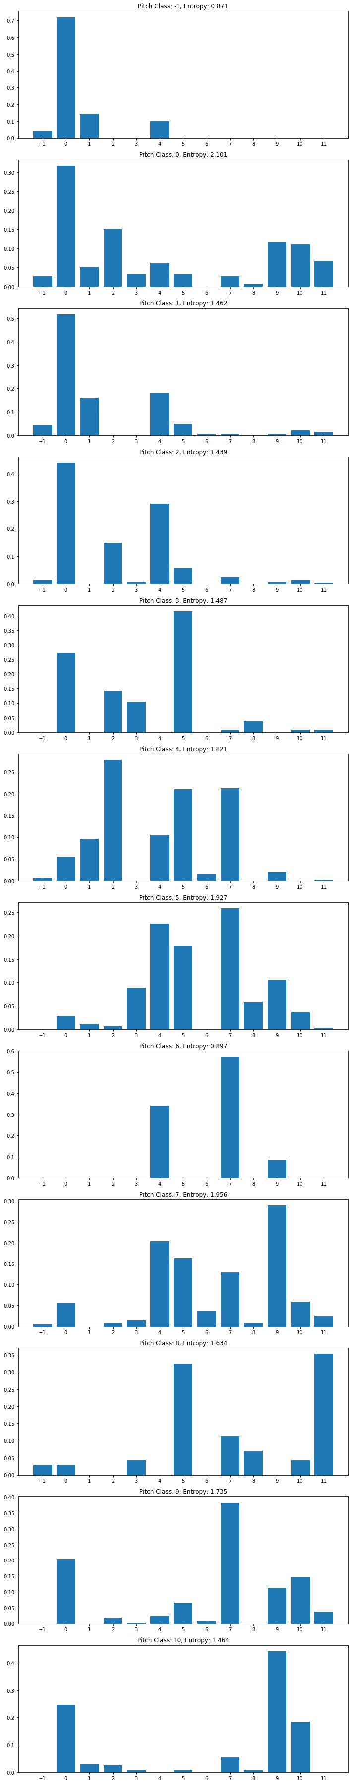



3. Pitch class entropies per mode for each modes

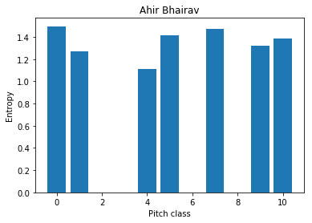

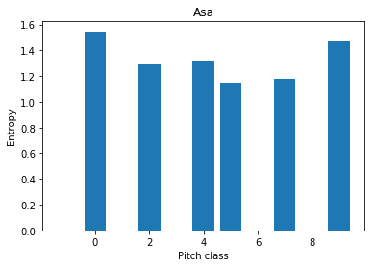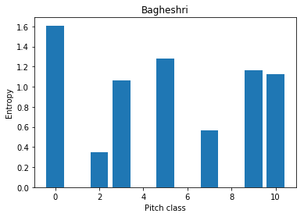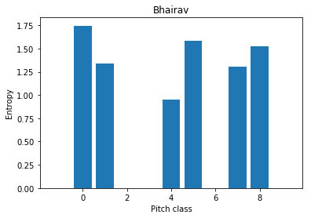

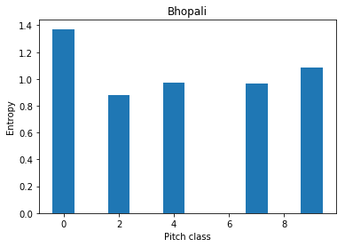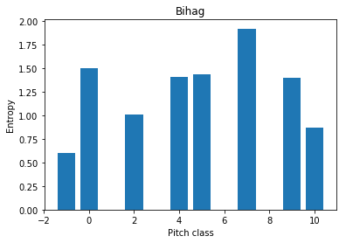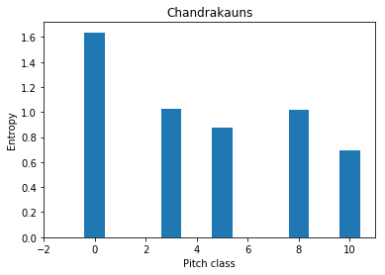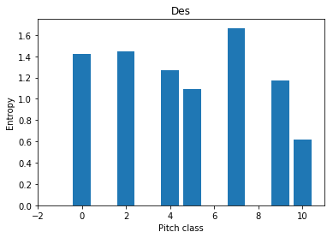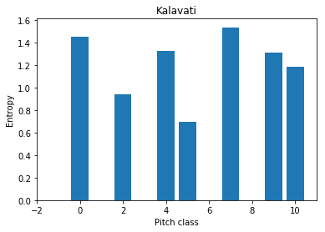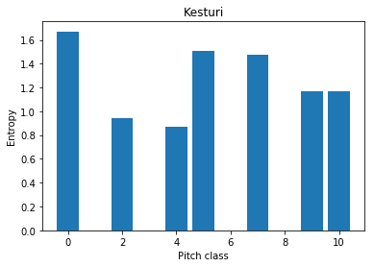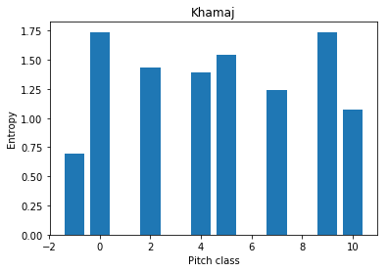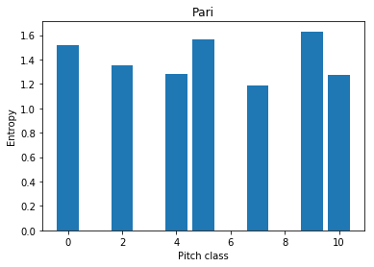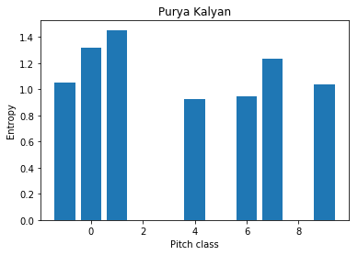

4. Transition matrices for each mode

Ahir Bhairav

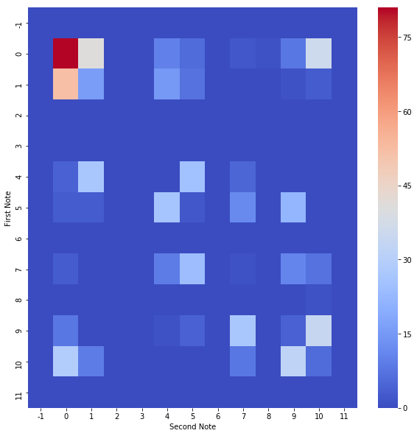

Asa

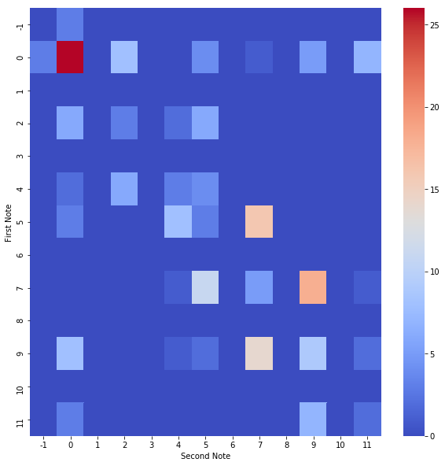

Bagheshri

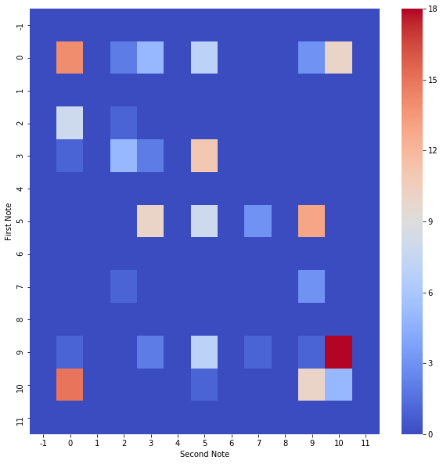

Bhairav

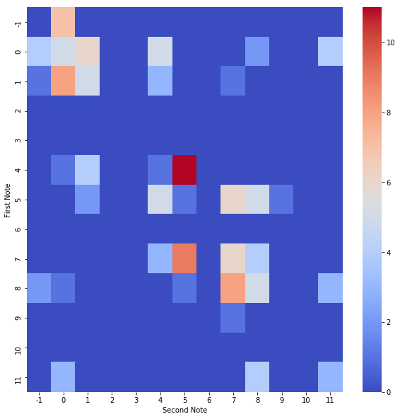

Bhimpalasi

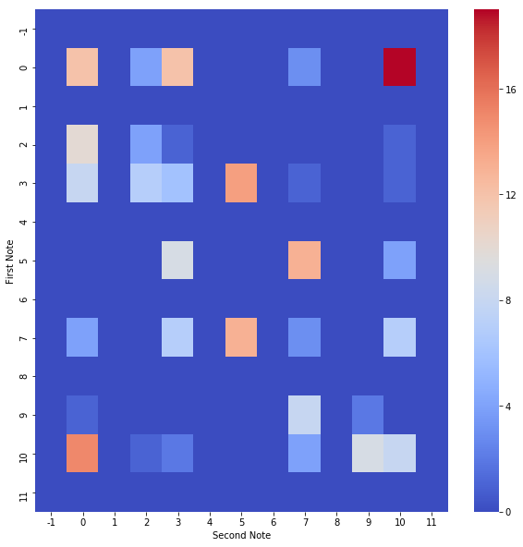

Bhopali

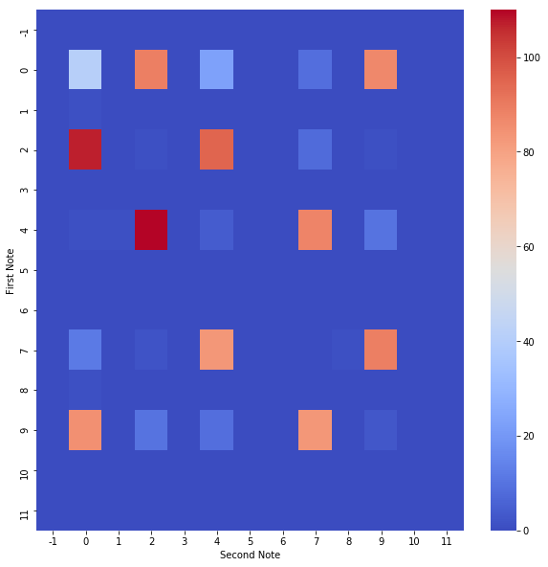

Bihag

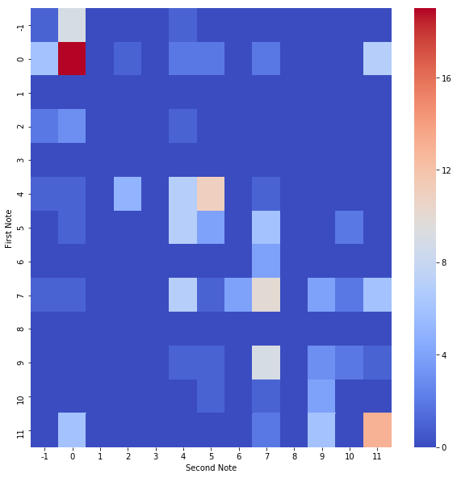

Chandrakauns



Des

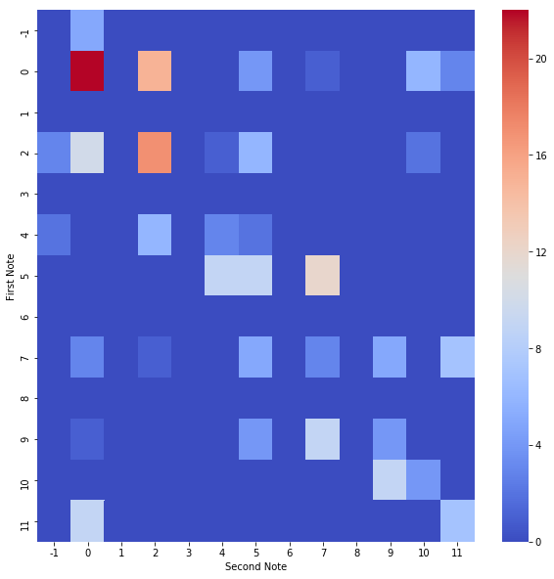

Kalavati

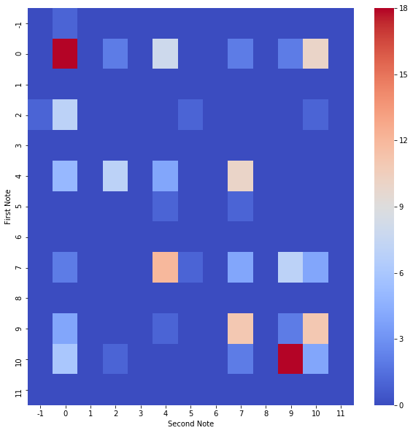

Kausieh

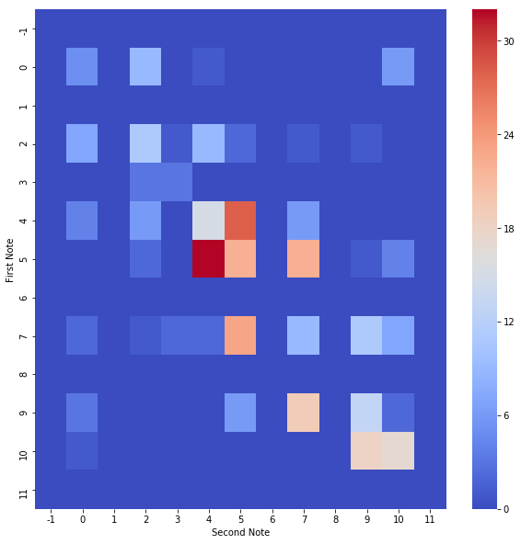

Kesturi



Khamaj

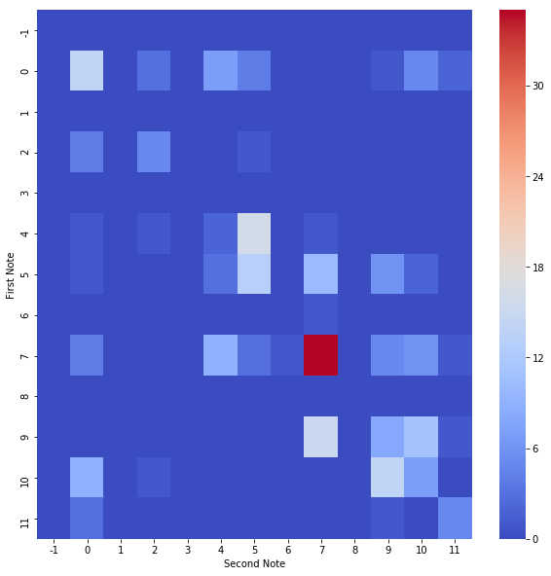

Pari

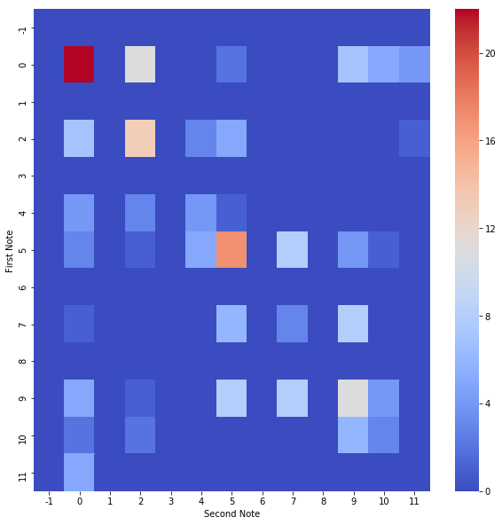

Purya Kalyan

