**Gift Wrap Extension**

# **Product specification**

Gift Wrap Extension is a Magento 2 extension developed by PIT solutions which helps shop owners to present the option of gift wrap to their customers. Customers can choose the gift wrap option and get their shopped items delivered gift wrapped with custom messages to their friends and family.

Gift Wrap Extension is a helpful extension that adds convenience and personalization to online shopping experiences. In addition, Gift Wrap Extension offers peace of mind for shoppers, as they know that their gifts will arrive wrapped and ready to go. This can be especially helpful for those who live far away from loved ones or who have busy schedules.

Overall, Gift Wrap Extension is a simple yet effective tool that enhances the online shopping experience by adding a personal touch and making gift-giving hassle-free.

# **Features**

1. Customer can wrap single product or wrap all products in the order.
2. Customer can attach a gift message to every gift wrap.
3. Customer can wrap their products/order in the cart page and checkout page.
4. Enable/ Disable the extension.
5. Access control for admin users.

## **Screenshots / Video**

# Configuration

From the admin backend, go to Stores > Configuration>PITS Configuration > GiftWrap

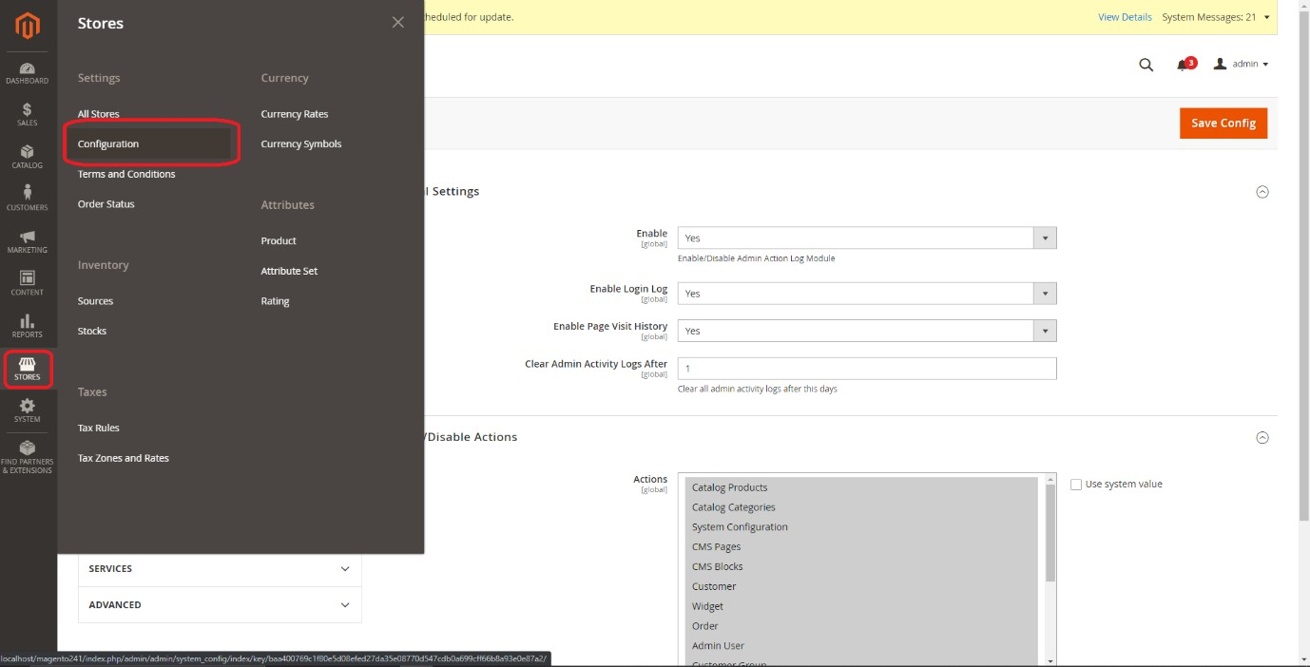

General Settings

1. Select Yes in the Enable drop-down option to enable the extension.
2. Enter the gift wrap fee in the Gift Wrap Fee field.

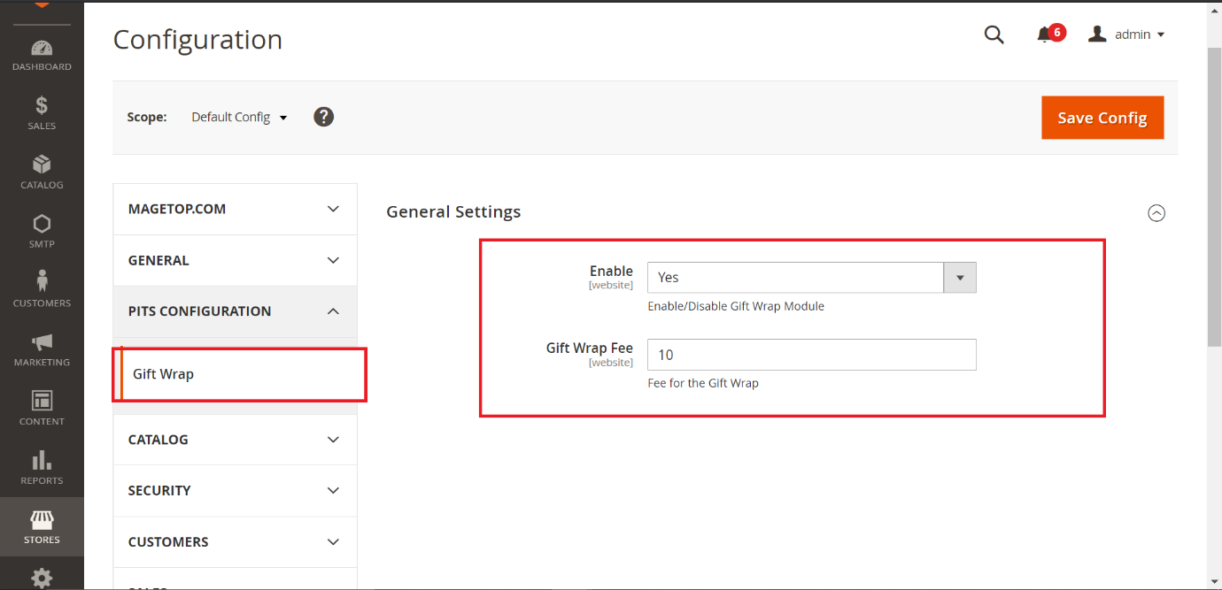

**Manage User Role**

Step 1: Go to Admin > System > User Roles

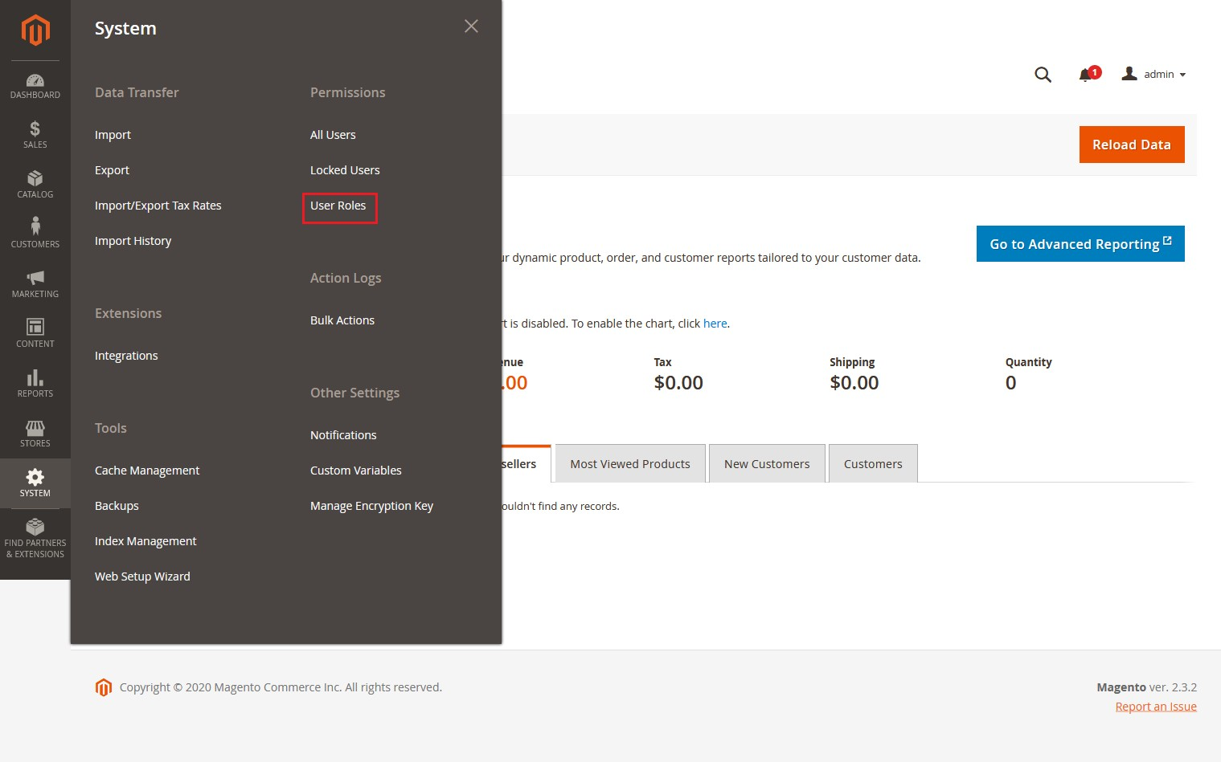

Step 2: Add a new role resource. Fill in the role information section. Select **Gift Wrap Configuration** at Role Resources section.

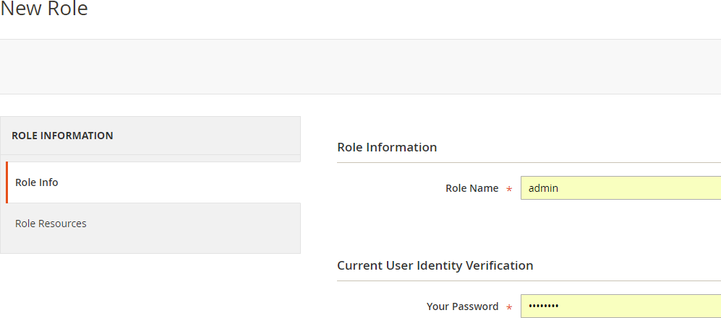Step 3: Set role users for admin accounts, thin click on Save Role to finish.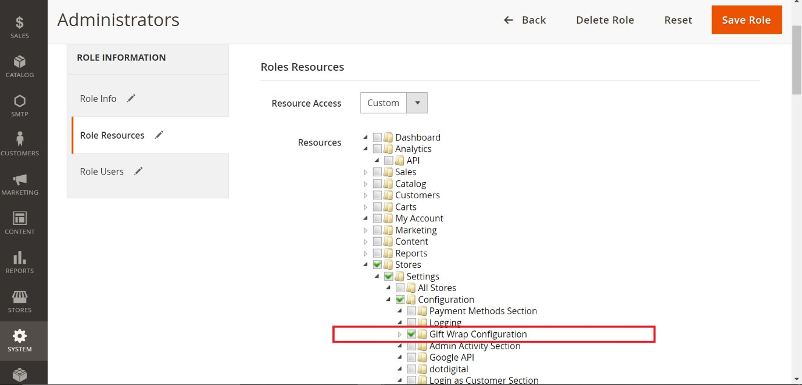

## Adding Gift Wrap to Products/Order

In the Cart Page

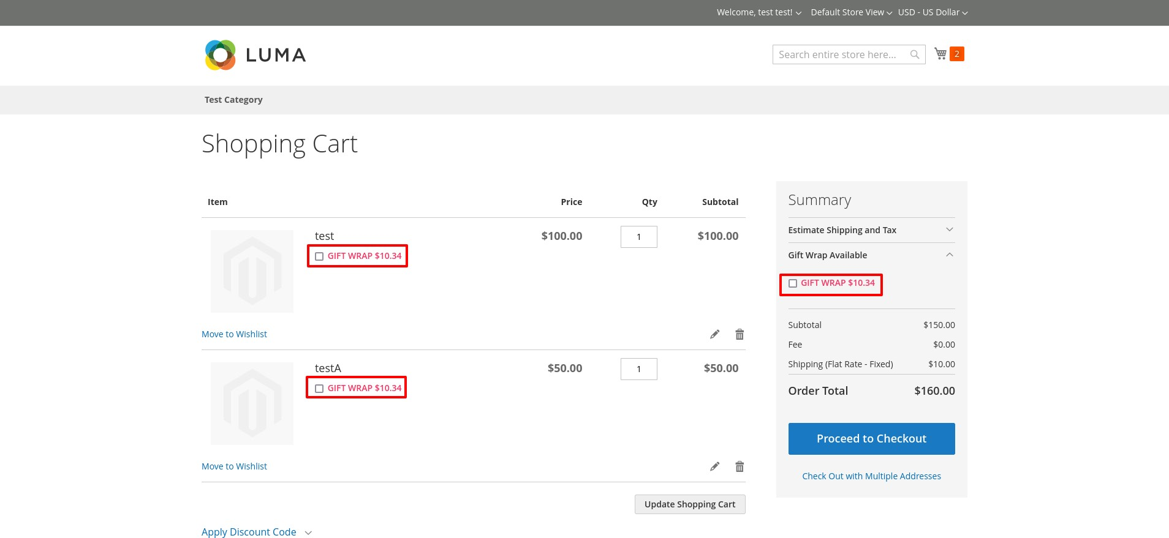

1. Add the required product to the cart and go to the cart page

2. If gift wrap is required for the product click the GIFT WRAP checkbox under the product name,

if gift wrap is required for the entire order click the GIFT WRAP checkbox in the Summary section.

(If only one product is in the cart, then the gift wrap option is only available in the summary section.)

3. If a gift message is to be attached to the order, click the ADD GIFT MESSAGE checkbox and enter

the message in there.

4. Then place the order.

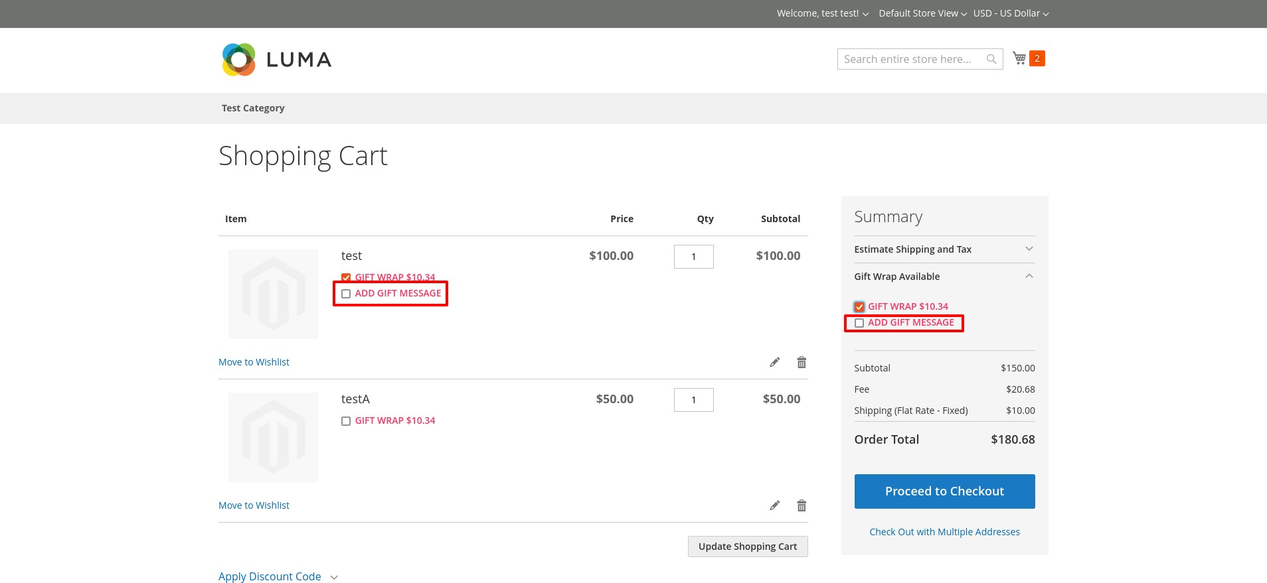

In the Checkout Page

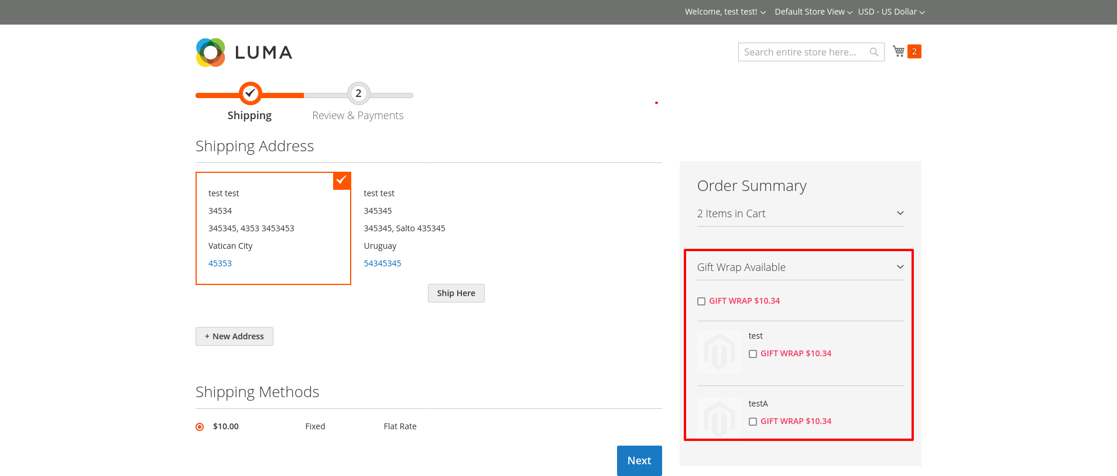

1. Add the required product to the cart and go to the checkout page
2. If gift wrap needed for the product click the GIFT WRAP checkbox under the product name in order summery section, if gift wrap needed for the entire

order click the GIFT WRAP checkbox in the top of Summary section. (If only one product is in the cart, then the gift wrap option is only available in the top of

Summary section.)

1. If a gift message to attach to the gift wrap, click the ADD GIFT MESSAGE

checkbox and enter the message in there.

1. Then place the order

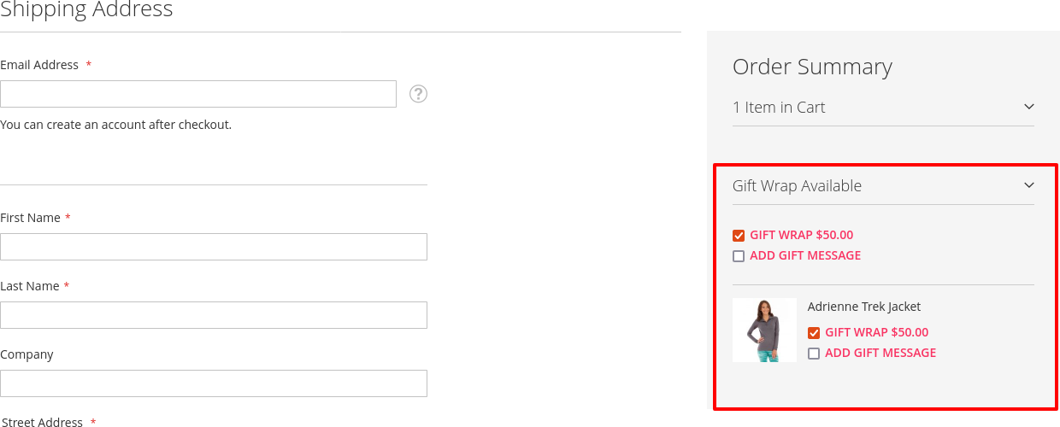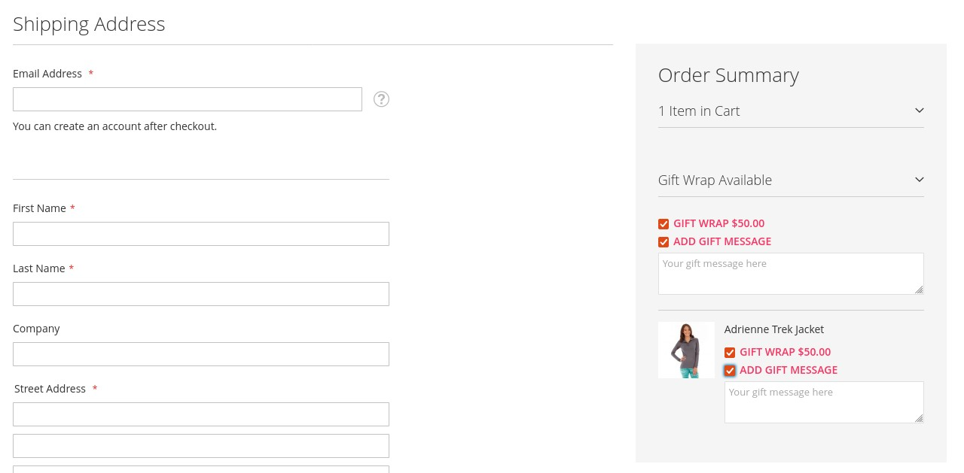

In My-account page

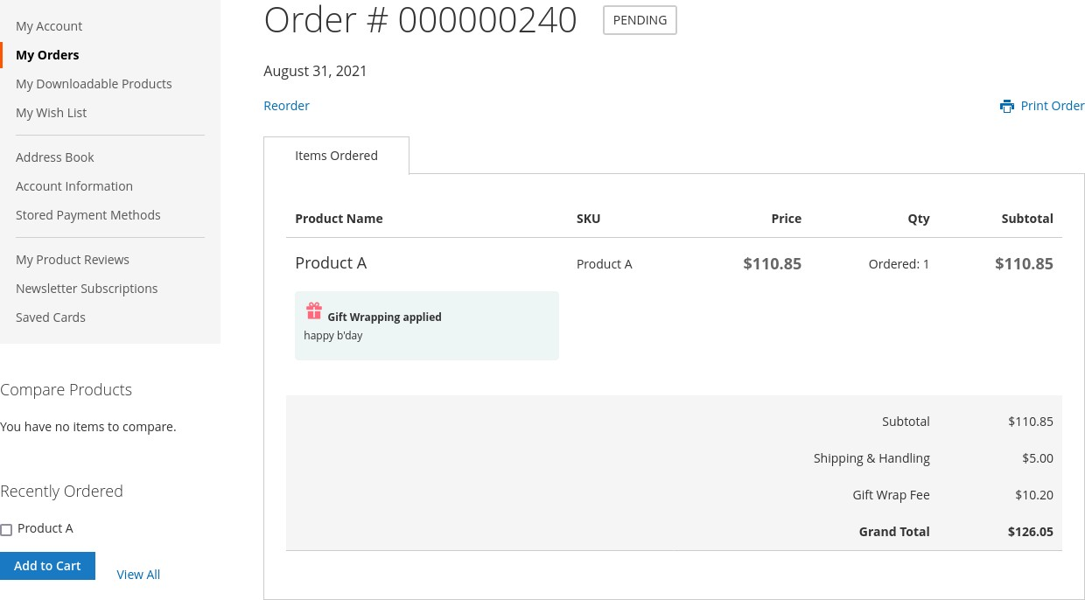

In Multi - Address Shipping

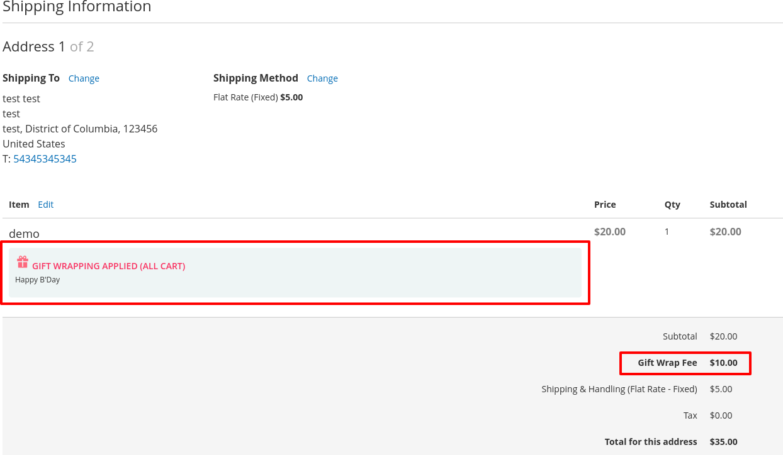

## Order Grid

There will be a gift icon in the order grid for the orders which have gift wrap items.

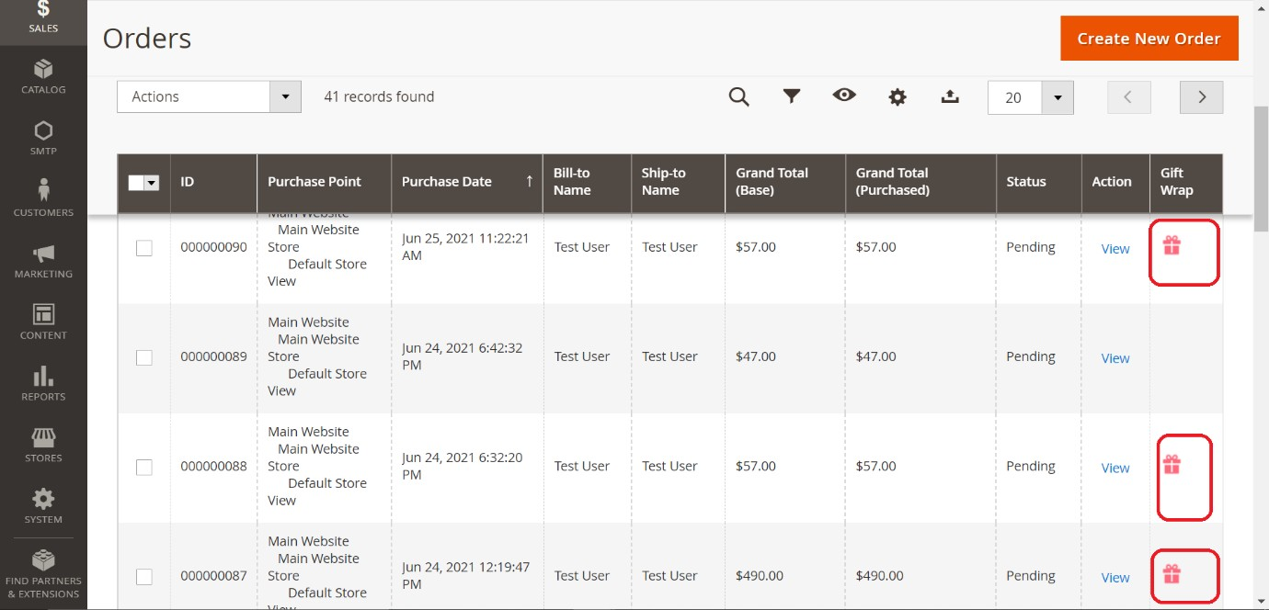

## Order View Page

If an order has a gift wrap for the entire order, gift wrap icon and gift message will be visible before the Items Ordered section. If no gift message is provided, then only gift wrap icon will be the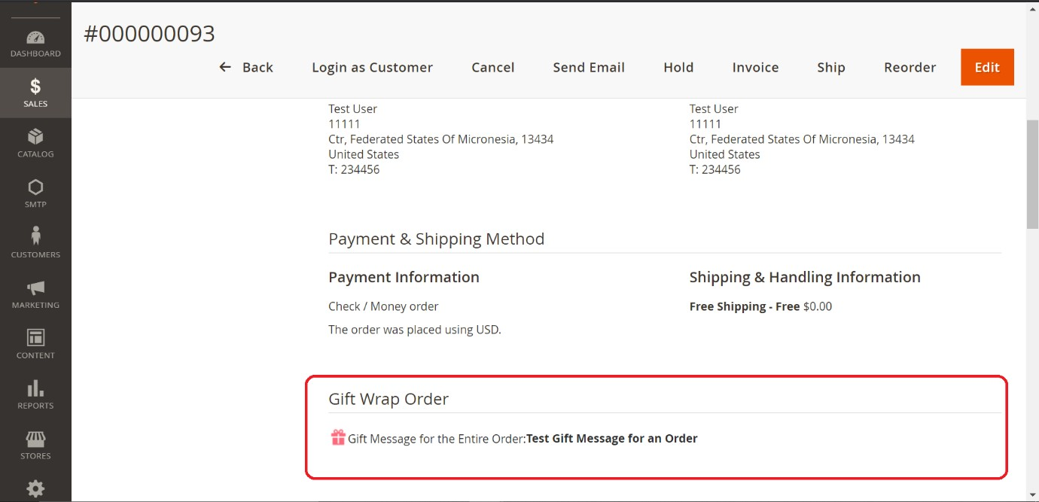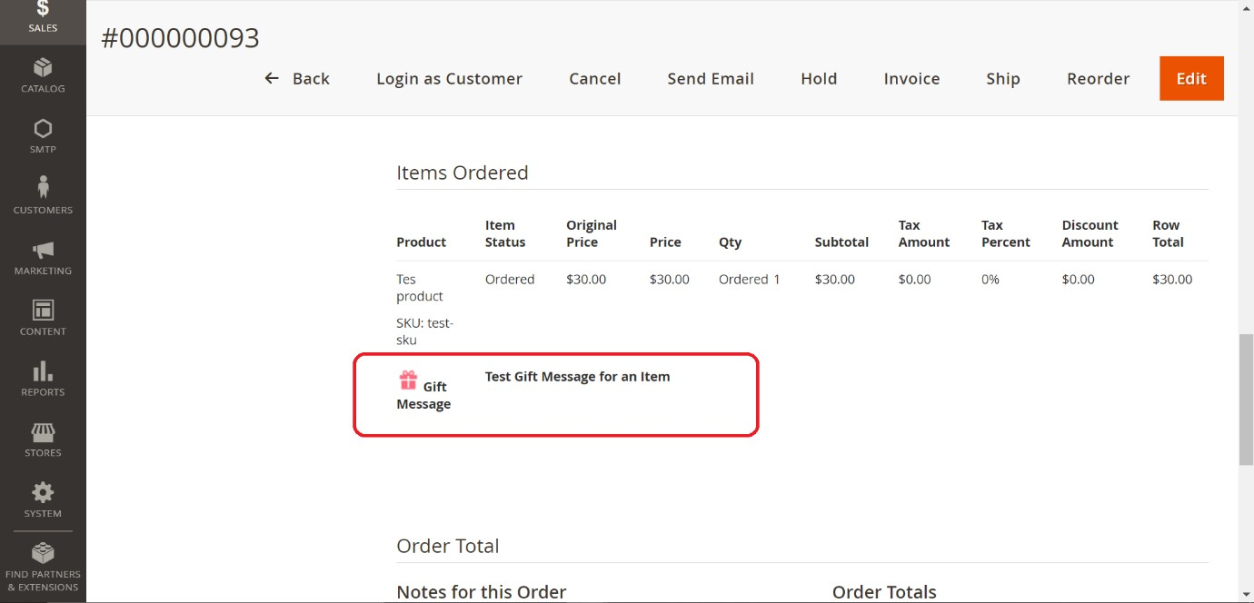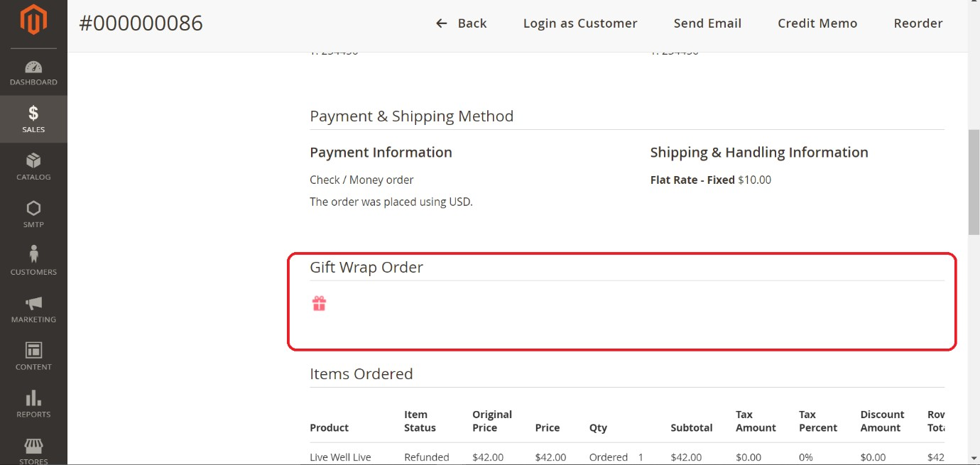

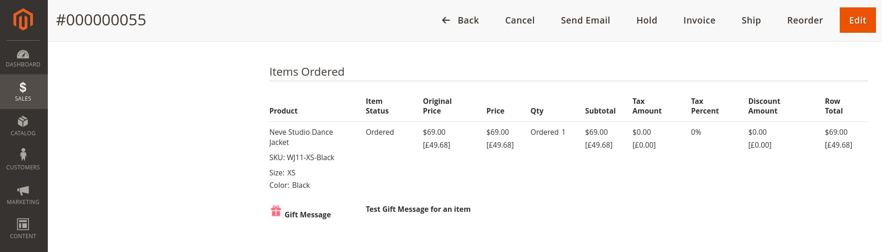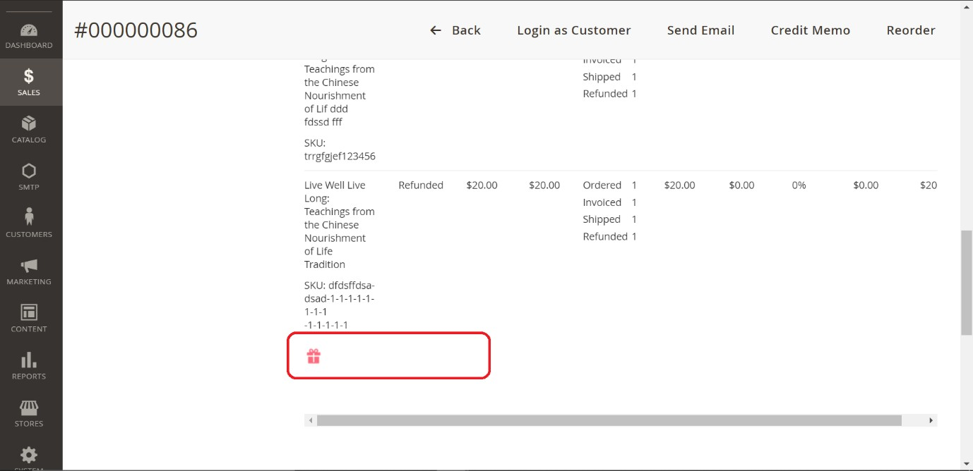

If an order has a gift wrap for an order item, gift wrap icon and gift message will be visible under the product in the Items Ordered section. If no gift message is provided, then only gift wrap icon will be there.

Gift Wrap fee can be seen in the order totals.

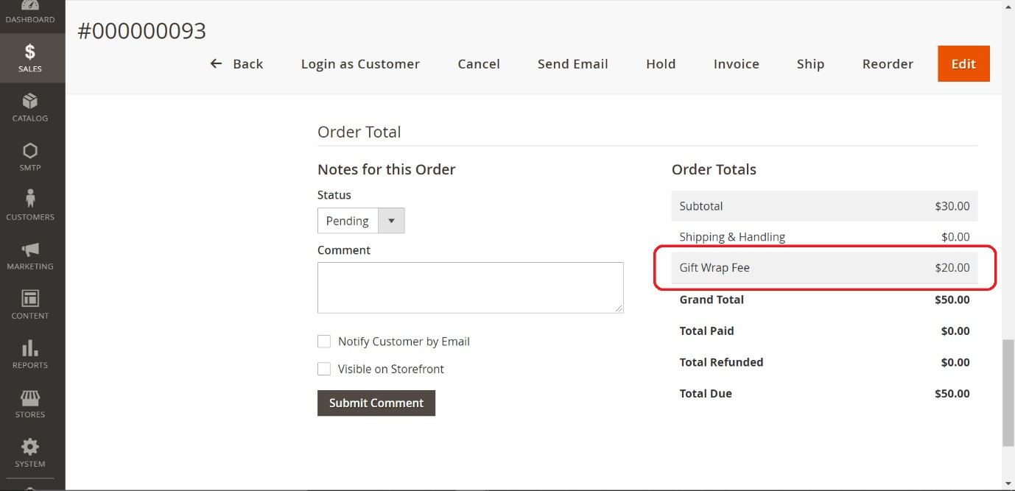

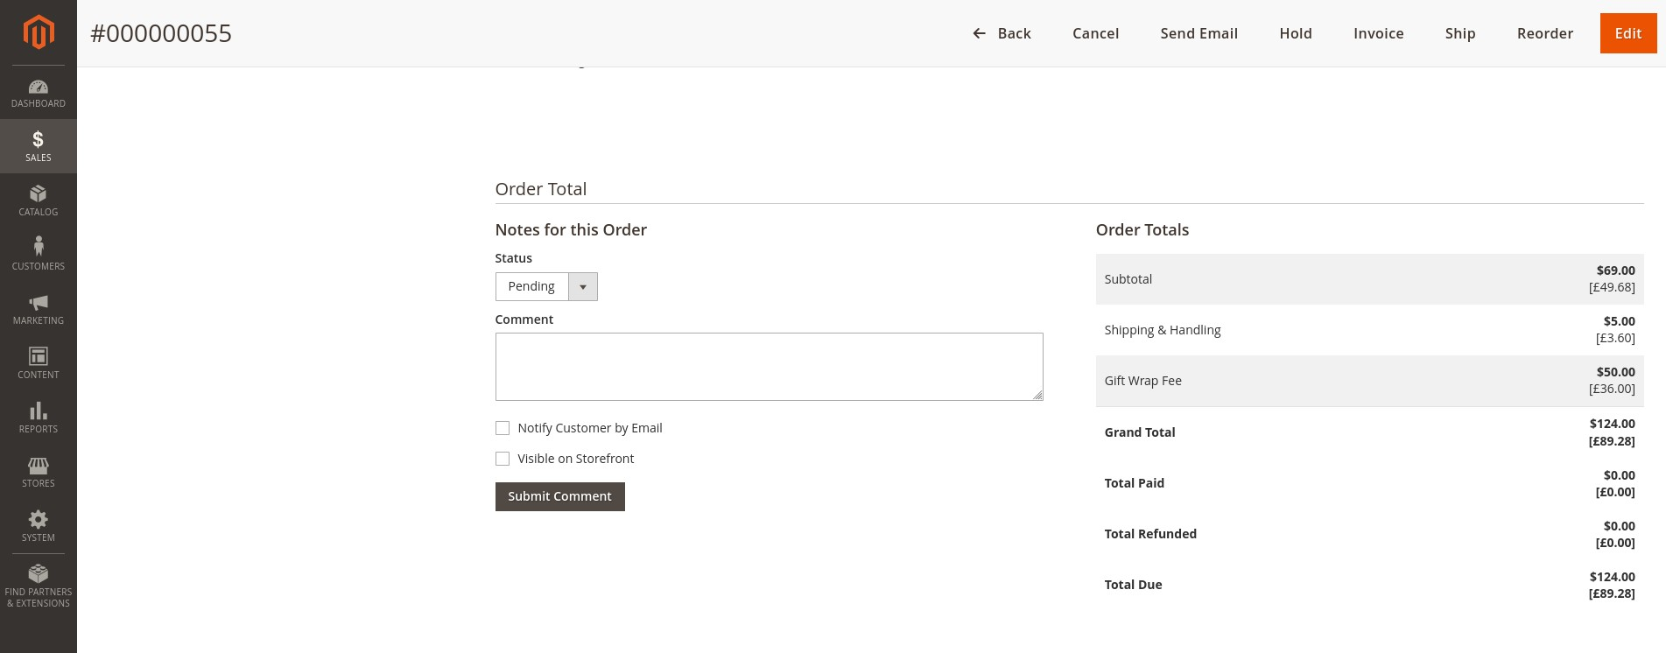

## Other Areas

Gift wrap fee can also see in the Invoices, Credit memos, pdf files and order mails

* **Invoice 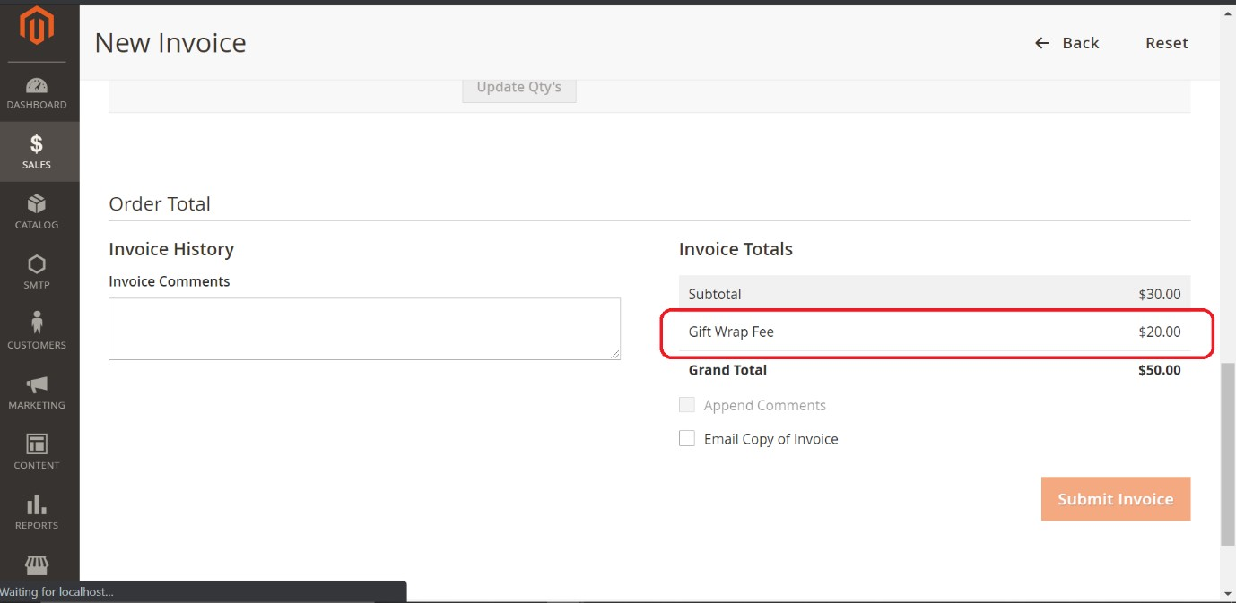Pages**

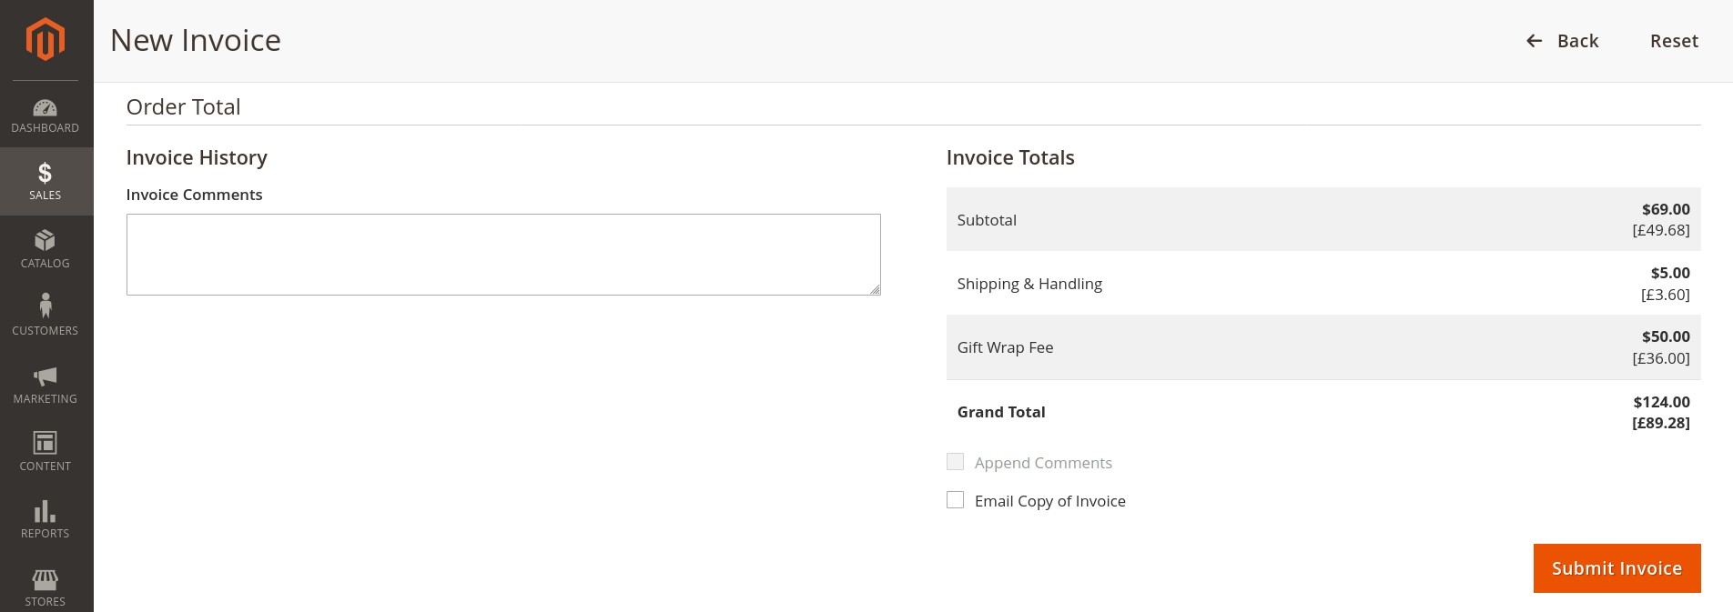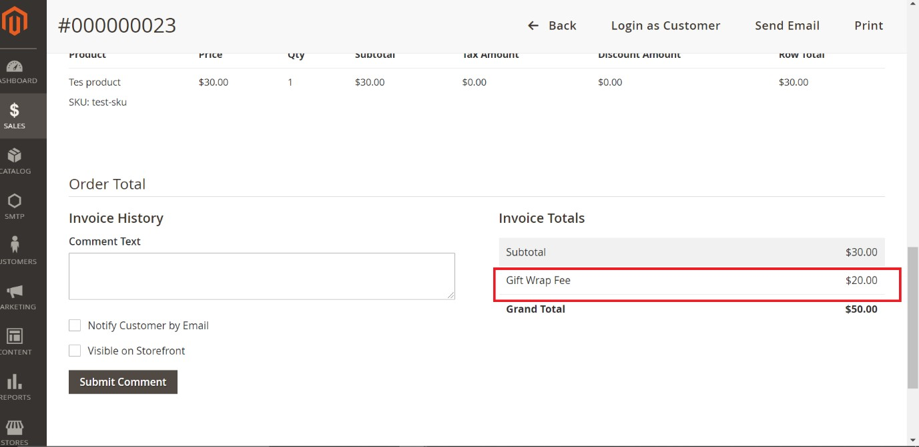

**Credit memo 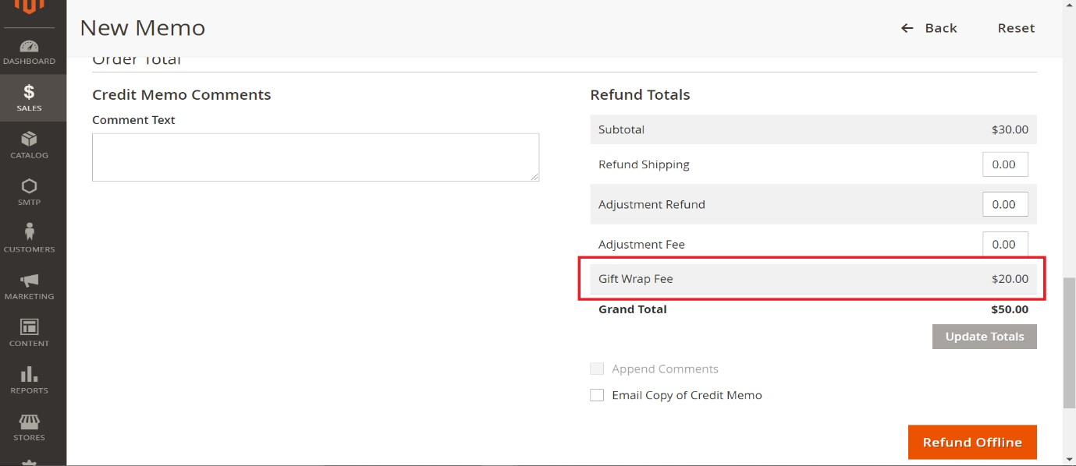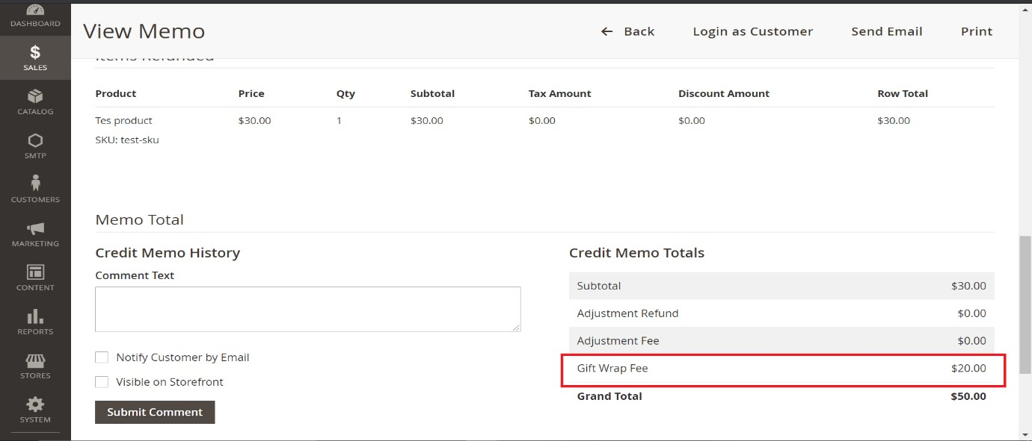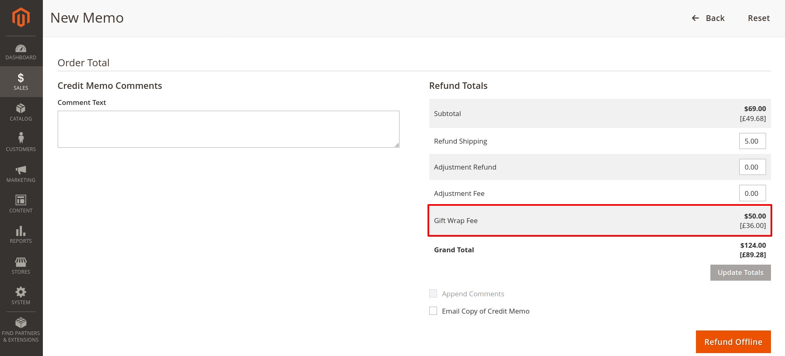pages**

* **Invoice Pdf**

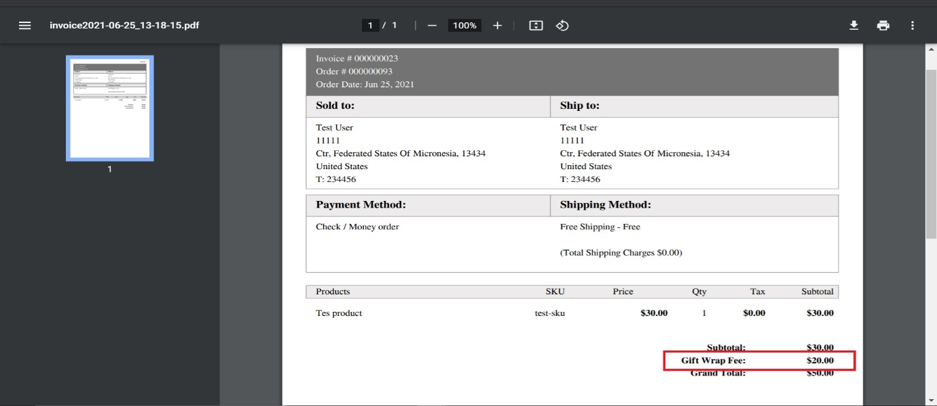

* **Credit memo Pdf**

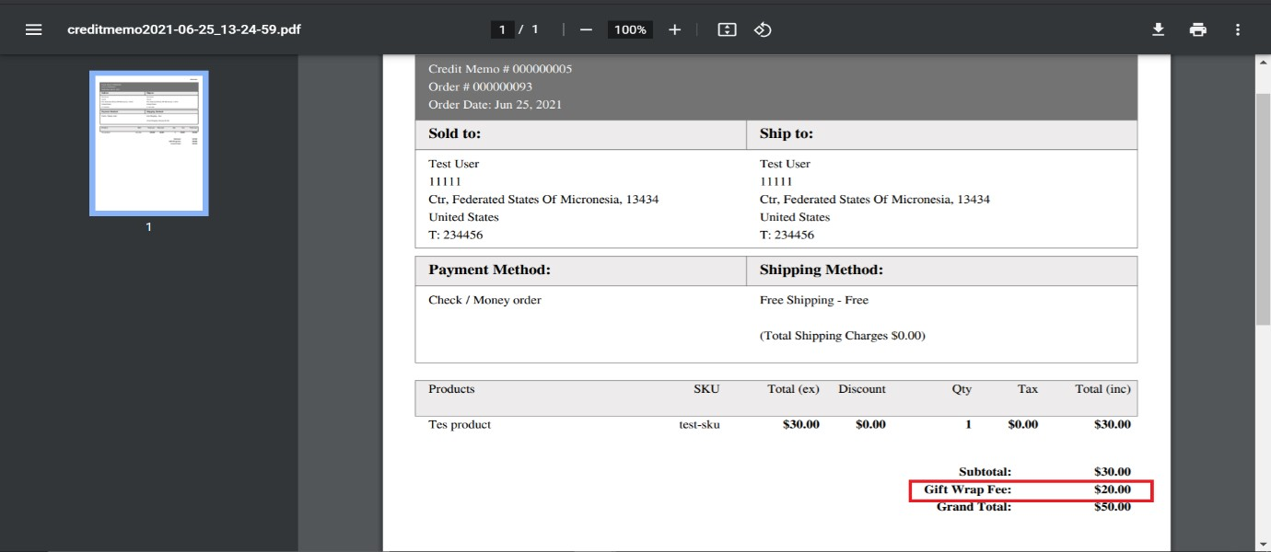

* **Order mail**

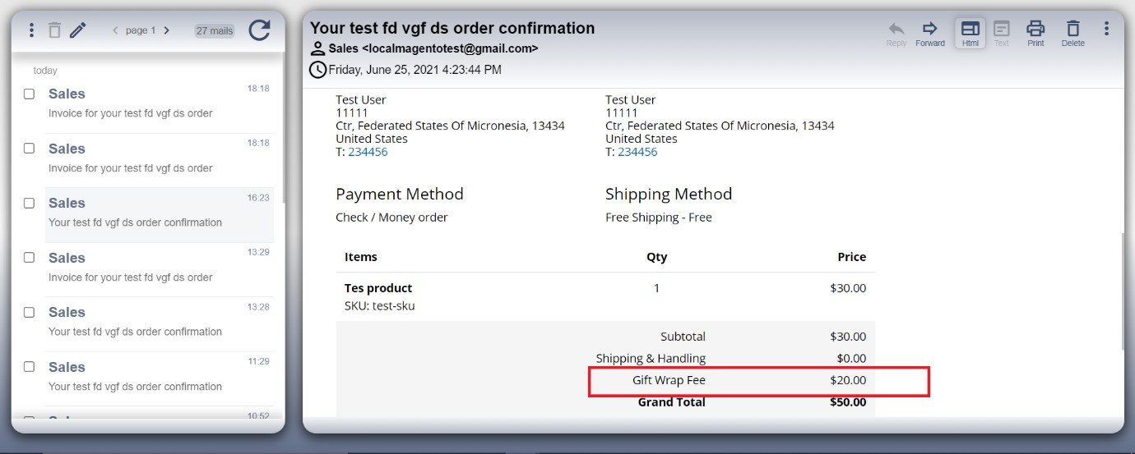

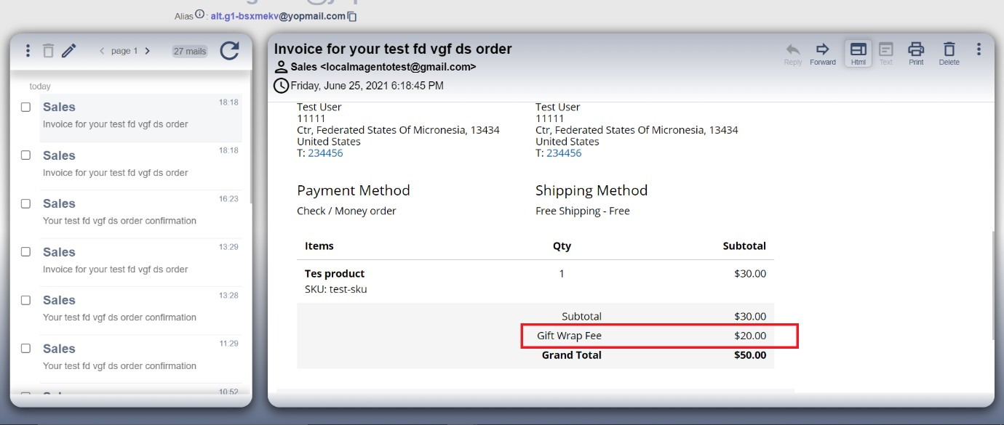

* **Invoice mail**
* **Credit memo mail**

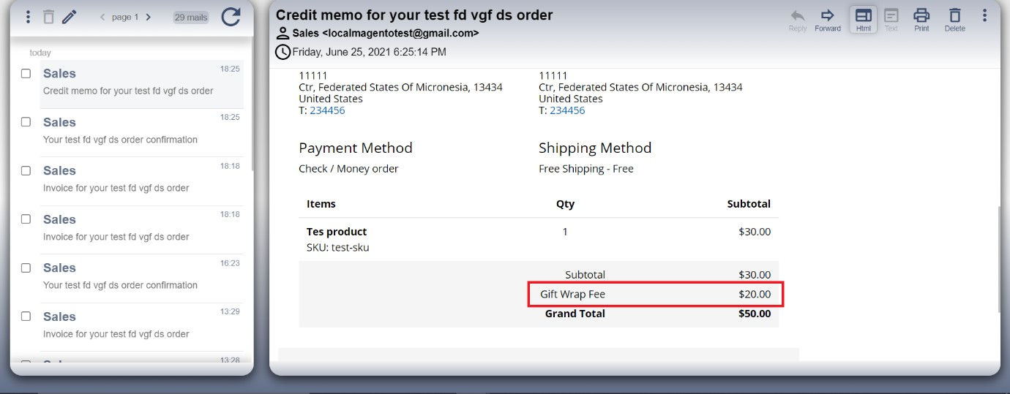

## **Important Notes**

* Gift wrap fee can be refunded, only if the item/order is not shipped.

**Technical Requirements / Compatible with:**

Magento Open Source 2.3.x or 2.4.x

**Supported Languages**

English, German.

## **Change Log / Release Notes**

Version: 1.0.1: Apr 24, 2023

* Compatible with Magento Open Source 2.4.6

Version: 1.0.0: Dec 7, 2022

* Compatible with Magento version 2.4.5
* Customer can wrap single product or wrap all products in the order.
* Customer can attach a gift message to every gift wrap.
* Customer can wrap their products/order in the cart page and checkout page.
* Added admin configuration option to enable or disable the module.
* Added access control for admin users.
* The module supports the multi-currency store.
* The module supports the multi-shipping checkout.

# Support

If you have questions, use our contact form in [webshopextension.com](https://www.webshopextension.com/) or email to support@webshopextension.com