Sareera Inam Afridi

Software Engineering

Fatima Jinnah Women University

**Todo App Displays**

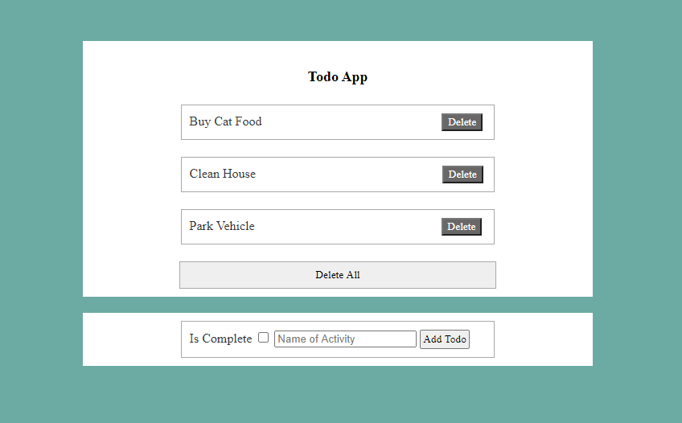

If we hover he mouse on any of the boxes.

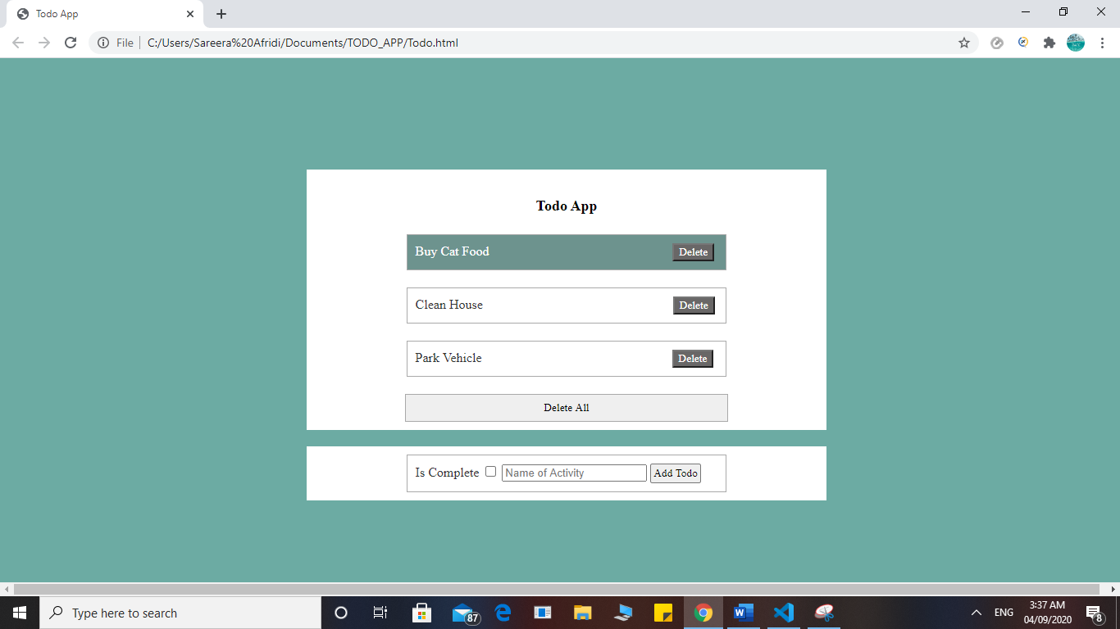

If we hover the mouse on any of the three “Delete” buttons.

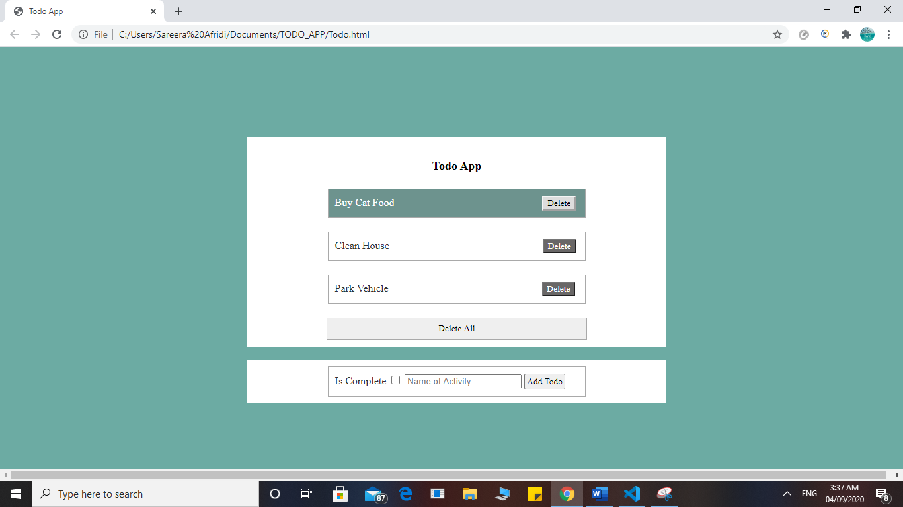

If we hover the mouse on the “Delete All” button.

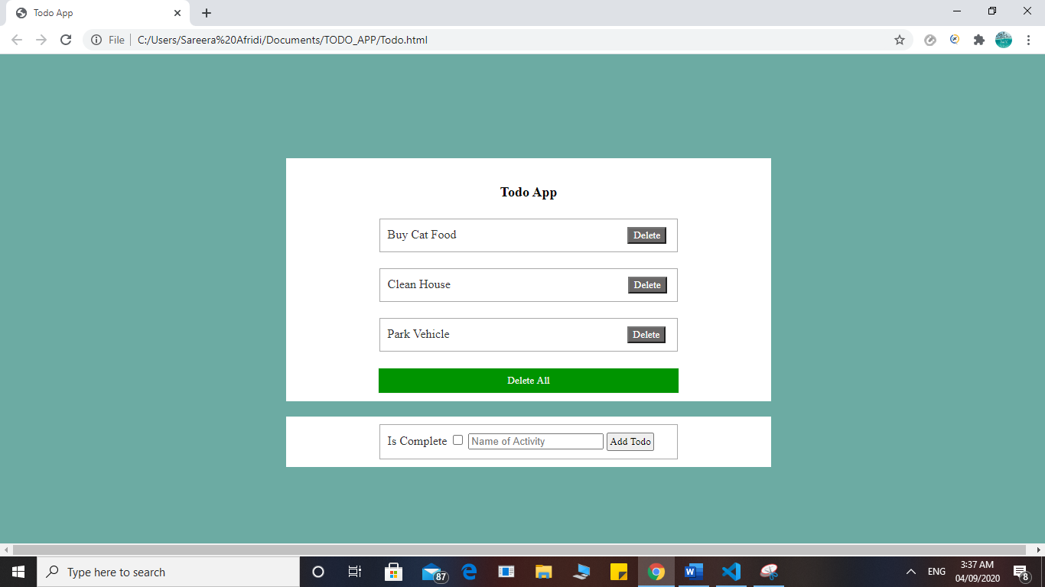

If we hover the mouse on the “Add Todo” button.

