Untitled

## R Markdown

This is an R Markdown document. Markdown is a simple formatting syntax for authoring HTML, PDF, and MS Word documents. For more details on using R Markdown see <http://rmarkdown.rstudio.com>.

When you click the **Knit** button a document will be generated that includes both content as well as the output of any embedded R code chunks within the document. You can embed an R code chunk like this:

x <- rnorm(1000,0,1)  
head(x)

## [1] -1.89323957 -1.18762188 0.05554800 2.28718809 -0.07913698 -0.81980256

## Including Plots

You can also embed plots, for example:

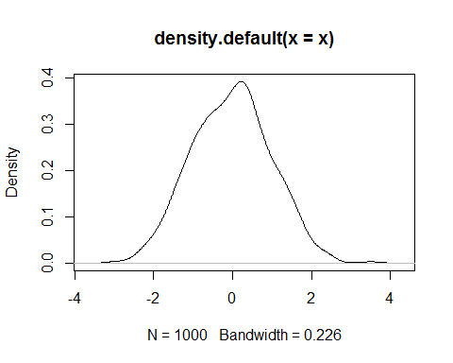

Note that the echo = FALSE parameter was added to the code chunk to prevent printing of the R code that generated the plot.