Customer Purchase Pattern Analysis
Online retail transactions, 1 December 2010 to 9 December 2011
512,044 Line items | 19,384 orders | 4,292 customers | 30 countries

Analysis Report
Submitted by: Sare Savithri
Institute: DataMites
Date:6-10-2026

1. Executive summary
This report analyses 512,044 transaction lines from an online retailer over just over twelve months. It looks at when customers buy, what they buy, where they are located, and how concentrated revenue is among customers. The main findings are:
- Strong seasonality. September to November 2011 produced 35% of all revenue, with November peaking at 1.41M.
- UK-Centre. The United Kingdom provides 88% of revenue and 92% of orders. The Netherlands is the largest export market (284K).
- Concentrated customers. The top 10% of identified customers generate 61% of revenue, and the top 20% generate 74%.
- Wholesale-style baskets. The average order contains 26 distinct products and 277 units. Average order value is 511, against a median of 301.
- Weekday daytime trading. 78% of orders occur between 10:00 and 15:59, Thursday is the busiest day, and no orders are recorded on Saturdays.
Note: the file does not state a currency, so monetary values are shown without a symbol.

Key figures
Metric | Value
Total revenue | 9,900,630
Orders (bills) | 19,384
Line items | 512,044
Units sold | 5,375,547
Distinct products | 3,996
Identified customers | 4,292
Countries | 30
Average order value | 511
Median order value | 301
Period | 1 Dec 2010 – 9 Dec 2011

2. Sales trends

2.1 Revenue by month
Revenue held between roughly 490K and 760K per month through the first eight months, then climbed from September, reaching 1.41M in November 2011. February 2011 was the weakest month (489K), so November was almost three times larger. December 2011 is incomplete because the data ends on 9 December, and should not be compared with full months.
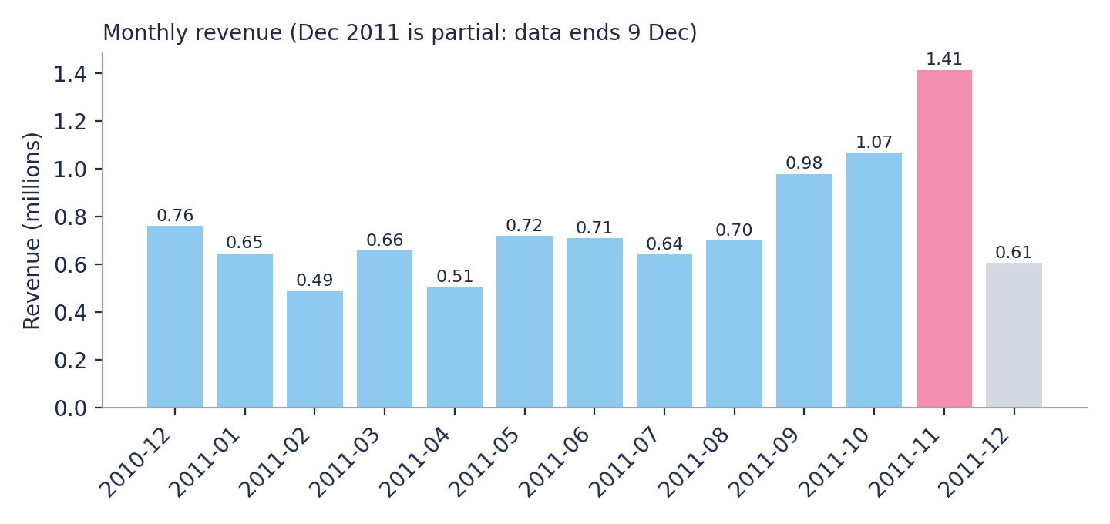
Figure 1. Monthly revenue (millions). November highlighted; December 2011 partial.

2.2 Day of week and time of day
Thursday is the busiest day with 4,120 orders, followed by Wednesday (3,596) and Tuesday (3,446). Sunday is the quietest trading day at 2,178 orders, and there are no Saturday transactions. Within the day, orders build from 09:00, peak at 12:00 (3,147 orders), and fall away after 16:00. Between 10:00 and 15:59 the business takes 78% of its orders.
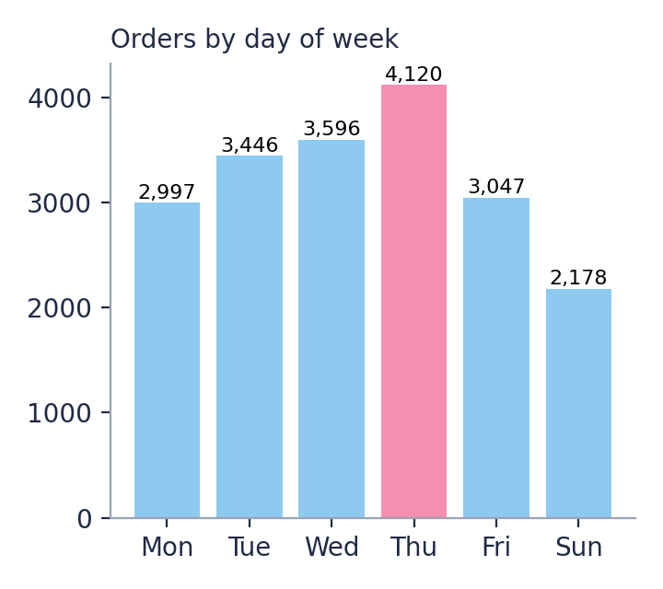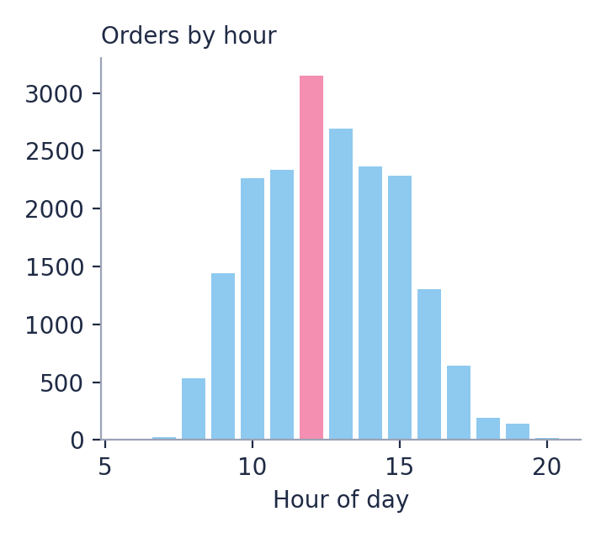
Figure 2. Orders by day of week (left) and by hour of day (right).

3. Products

3.1 Revenue leaders
Paper Craft, Little Birdie appears first by revenue (168K) but comes from a single order of 80,995 units placed on 9 December 2011, which is likely an anomaly and should be verified. Excluding it, Regency Cakestand 3 Tier leads with 165K, followed by White Hanging Heart T-Light Holder (103K), Party Bunting (97K) and Jumbo Bag Red Retrospot (93K).
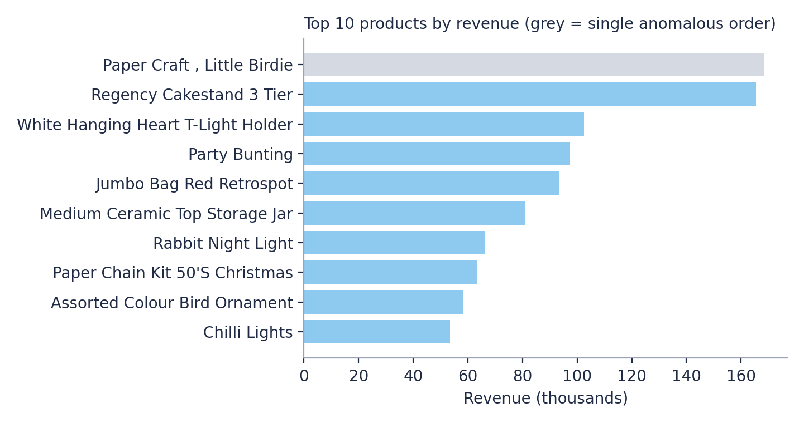
Figure 3. Top 10 products by revenue (thousands).

3.2 Most frequently purchased
Measured by the number of orders containing the item, the most popular products are home décor, party and bag items. White Hanging Heart T-Light Holder appears in 2,198 orders.
Product | Orders | Units | Revenue
White Hanging Heart T-Light Holder | 2,198 | 36,504 | 102,532
Jumbo Bag Red Retrospot | 2,061 | 47,895 | 93,236
Regency Cakestand 3 Tier | 1,904 | 13,094 | 165,412
Party Bunting | 1,655 | 17,796 | 97,308
Lunch Bag Red Retrospot | 1,541 | 18,759 | 34,832
Assorted Colour Bird Ornament | 1,431 | 35,986 | 58,292
Set Of 3 Cake Tins Pantry Design | 1,346 | 6,989 | 35,916
Pack Of 72 Retrospot Cake Cases | 1,279 | 34,380 | 20,216

4. Customers and markets

4.1 Geography
The UK accounts for 8.72M of 9.90M revenue. Outside the UK, the Netherlands, Germany, France and Australia lead. The Netherlands and Australia each have only 9 customers but high revenue per order, suggesting a few large trade buyers. Germany (94 customers) and France (87) have the broadest export customer bases.
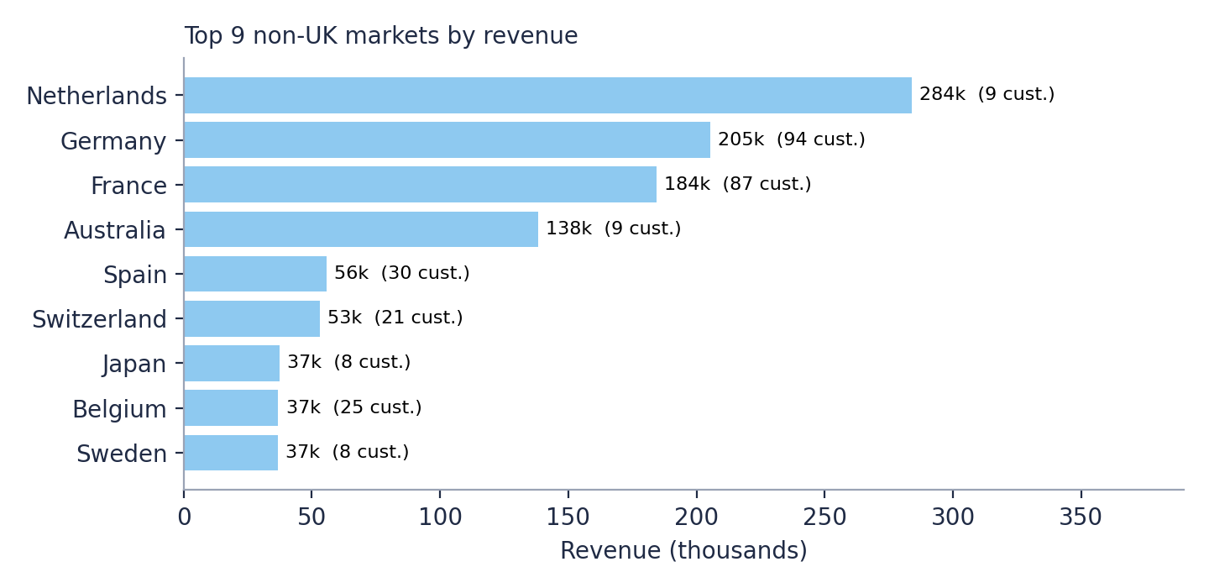
Figure 4. Top 9 non-UK markets by revenue, with customer counts.
Country | Revenue | Share % | Orders | Customers
United Kingdom | 8,723,506 | 88.1 | 17,901 | 3,916
Netherlands | 283,889 | 2.9 | 93 | 9
Germany | 205,381 | 2.1 | 443 | 94
France | 184,486 | 1.9 | 382 | 87
Australia | 138,104 | 1.4 | 56 | 9
Spain | 55,707 | 0.6 | 88 | 30
Switzerland | 53,066 | 0.5 | 50 | 21
Japan | 37,416 | 0.4 | 19 | 8

4.2 Customer behaviour
Of 4,292 identified customers, 65% placed more than one order, and the average customer placed 4.2 orders worth 1,958 in total. Revenue is concentrated: the top 10% of customers account for 61% of identified revenue. The five largest customers are shown below.
Customer ID | Revenue | Orders
14646 | 279,138 | 72
18102 | 259,657 | 60
17450 | 194,391 | 46
16446 | 168,473 | 2
12415 | 124,565 | 20

4.3 Order size
The average order has 26 distinct products and 277 units. The average order value (511) is well above the median (301) because a minority of very large orders pulls the mean up, so the median is a better indicator of a typical order.

5. Recommendations
- Plan inventory and staffing for September to November. Build stock and fulfilment capacity ahead of the autumn surge.
- Protect the highest-value customers. Offer account management, loyalty terms or early access to the top 10% who drive 61% of revenue.
- Grow export markets selectively. Use the Germany and France customer base as a model, and nurture the large Netherlands and Australia accounts.
- Time campaigns to peak trading. Concentrate promotions on Tuesday to Thursday between 10:00 and 15:00, and test weekend offers where activity is low.
- Lift mid-sized orders. Bundles or tiered discounts could raise the many orders around the 301 median.

6. Data notes and limitations
- Partial final month: December 2011 covers 1 to 9 December only.
- Extreme orders: two orders of 80,995 and 74,215 units add 245K revenue. Excluding them, total revenue is 9.65M.
- Missing customer IDs: 25.5% of rows have no customer ID, so customer-level metrics cover about 85% of revenue.
- Currency: not stated in the file.
- Single year of data: only one November is observed, so seasonality cannot be confirmed across years.

