ASSIGNMENT 04

Computer Science & Engineering Department

National Institute of Technology, Delhi



NETWORK PROGRAMMING

Submitted To Submitted By:
Dr Ravi Arya MD SARFARAJ ALAM
(Assistant Professor) Roll NO:171210037
NIT DELHI Branch CSE
Date: 30/05/2020

Implement multithreaded (using pthread library)client-server with TCP to allow multiple (2) clients to connect/interact with the server simulataneously.

STEP 1 -- Create VM instance on gcloud

I have already created VM instance

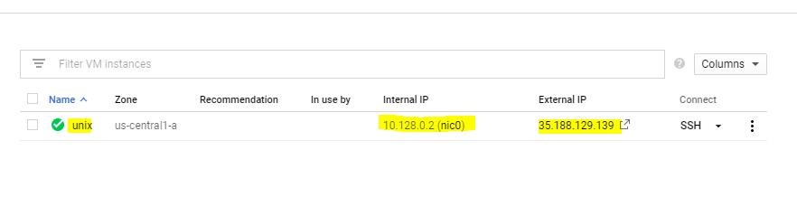

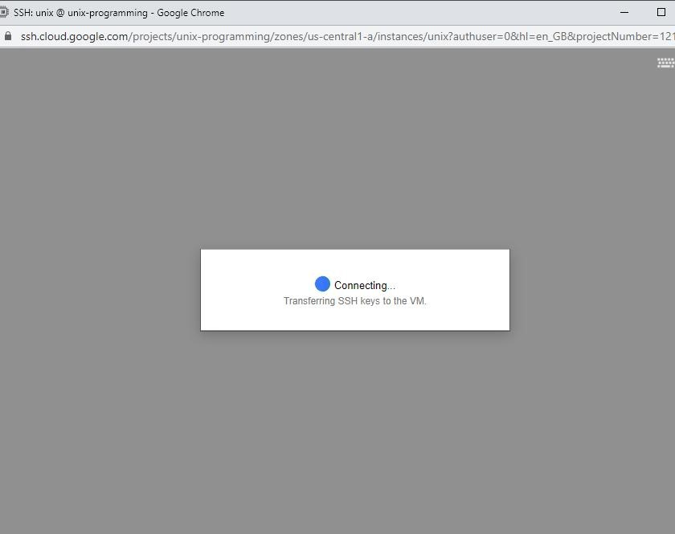

STEP 2-- Run VM and Install g++ and pthread library

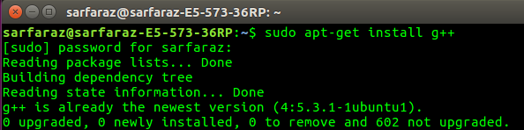
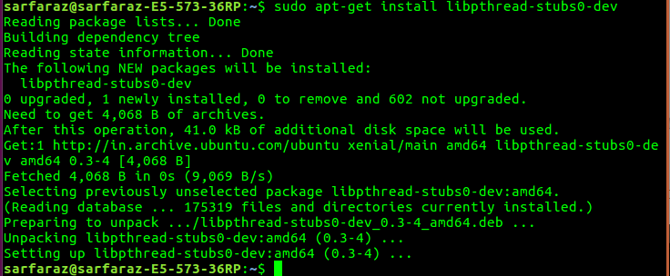
STEP 3 -- Upload server_.c and client_.c file to VM.

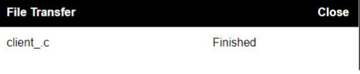
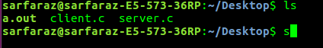

STEP 4 -- Compile and run server_.c file using gcc -pthread
server.c
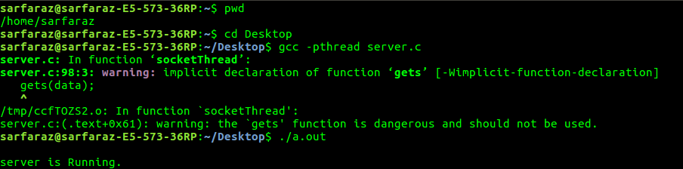

Step 5--Create multiple client and make themcommunicate
with server

a) Server:
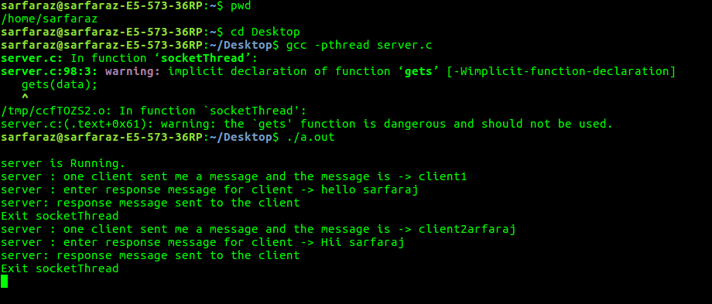
b) Both client 1 and client 2
