*Blistering Disorders*

-Bullous pemphigus

-Pemphigoid vulgaris

-Porphyria cutanea tarda

-Epidermolysis bullosa

-Dermatitis herpetiformis

*Skin Cancer*

-Actinic keratosis

-BCC

-SCC

-Melanoma

-Cutaneous T-cell lymphoma

*Autoimmune Disorders*

-Behcet’s disease

-Dermatomyositis

-Lichen Planus

-Lupus of the skin

-Scleroderma

*Allergic Disorders*

-Eczema/ atopic dermatitis

-Allergic dermatitis

-Irritant dermatitis

-Urticaria

-Angioedema

*Infections*

-Shingles

-Verruca vulgaris

-Condyloma accuminata

-Cellulitis

-Folliculitis

*Wounds*

-Venous ulcer

-Diabetic ulcer

-Pressure ulcer

-Hidradenitis suppurativa

-Pyoderma gangrenosum

*Pediatrics*

-Impetigo

-Molluscum contagiosum

-Acne

-Seborrheic dermatitis

-Coxsackievirus/ hand food mouth

For each condition search in 🡪 <https://dermnetnz.org>

Order of priority:

15 pictures

When possible- even split of Fitzpatrick score < 3 and > 3

When possible- 3 pictures of face, back, abdomen, arms/hands, legs/feet

Enter pictures into -> <https://www.firstderm.com/ai-dermatology/>

Fitzpatrick Score

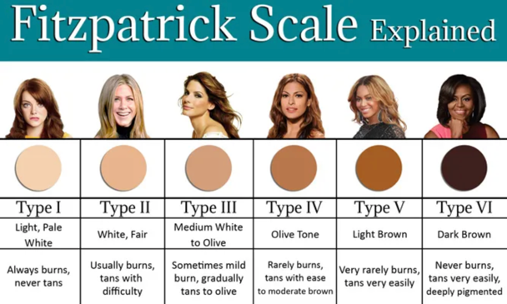

BLISTERING DISORDERS

**Bullous pemphigus**

*Pictures + unique code:*

*List of conditions:*

**Pemphigoid vulgaris**

*Pictures + unique code:*

*List of conditions:*

**Porphyria cutanea tarda**

*Pictures + unique code:*

*List of conditions:*

**Epidermolysis bullosa**

*Pictures + unique code:*

*List of conditions:*

**Dermatitis herpetiformis**

SKIN CANCER

**Actinic keratosis**

*Pictures + unique code:*

*List of conditions:*

**BCC**

*Pictures + unique code:*

*List of conditions:*

**SCC**

*Pictures + unique code:*

*List of conditions:*

**Melanoma**

*Pictures + unique code:*

*List of conditions:*

**Cutaneous T-cell lymphoma**

*Pictures + unique code:*

*List of conditions:*

AUTOIMMUNE DISORDERS

**Behcet’s disease**

*Pictures + unique code:*

*List of conditions:*

**Dermatomyositis**

*Pictures + unique code:*

*List of conditions:*

**Lichen Planus**

*Pictures + unique code:*

*List of conditions:*

**Lupus of the skin**

*Pictures + unique code:*

*List of conditions:*

**Scleroderma**

*Pictures + unique code:*

*List of conditions:*

ALLERGIC DISORDERS

**Eczema/ atopic dermatitis**

*Pictures + unique code:*

*List of conditions:*

**Allergic dermatitis**

*Pictures + unique code:*

*List of conditions:*

**Irritant dermatitis**

*Pictures + unique code:*

*List of conditions:*

**Urticaria**

*Pictures + unique code:*

*List of conditions:*

**Angioedema**

*Pictures + unique code:*

*List of conditions:*

INFECTIONS

**Shingles**

*Pictures + unique code:*

*List of conditions:*

**Verruca vulgaris**

*Pictures + unique code:*

*List of conditions:*

**Condyloma accuminata**

*Pictures + unique code:*

*List of conditions:*

**Cellulitis**

*Pictures + unique code:*

*List of conditions:*

**Folliculitis**

*Pictures + unique code:*

*List of conditions:*

WOUNDS

**Venous ulcer**

*Pictures + unique code:*

*List of conditions:*

**Diabetic ulcer**

*Pictures + unique code:*

*List of conditions:*

**Pressure ulcer**

*Pictures + unique code:*

*List of conditions:*

**Hidradenitis suppurativa**

*Pictures + unique code:*

*List of conditions:*

**Pyoderma gangrenosum**

*Pictures + unique code:*

*List of conditions:*

PEDIATRICS

**Impetigo**

*Pictures + unique code:*

*List of conditions:*

**Molluscum contagiosum**

*Pictures + unique code:*

*List of conditions:*

**Acne**

*Pictures + unique code:*

*List of conditions:*

**Seborrheic dermatitis**

*Pictures + unique code:*

*List of conditions:*

**Coxsackievirus/ hand food mouth**

*Pictures + unique code:*

*List of conditions:*