*Blistering Disorders*

-Bullous pemphigus vs pemphigoid

-Pemphigoid vulgaris vs pemphigus

-Porphyria cutanea tarda <https://dermnetnz.org/topics/porphyria-cutanea-tarda>

Not present in image gallery

-Epidermolysis bullosa (not in image gallery <https://dermnetnz.org/topics/epidermolysis-bullosa> got images from this article)

-Dermatitis herpetiformis

*Skin Cancer*

-Actinic keratosis

-BCC

-SCC

-Melanoma

-Cutaneous T-cell lymphoma

*Autoimmune Disorders*

-Behcet’s disease

-Dermatomyositis

-Lichen Planus

-Lupus of the skin

-Scleroderma not found

*Allergic Disorders*

-Eczema/ atopic dermatitis

-Allergic dermatitis

-Irritant dermatitis

-Urticaria

-Angioedema

*Infections*

-Shingles

-Verruca vulgaris -> only 3 images found under common warts name

Other were verruca plantaris

Verruca plana

-Condyloma accuminata -> not found

-Cellulitis -> only found 3 images on <https://dermnetnz.org/topics/cellulitis>

Not found in image gallery

-Folliculitis

*Wounds*

-Venous ulcer

<https://dermnetnz.org/topics/leg-ulcer> 3 images found

-Diabetic ulcer <https://dermnetnz.org/topics/diabetic-foot-ulcer> 6 images found

-Pressure ulcer

<https://dermnetnz.org/topics/pressure-ulcer>

6 images found

-Hidradenitis suppurativa

-Pyoderma gangrenosum

*Pediatrics*

-Impetigo

-Molluscum contagiosum

-Acne

-Seborrheic dermatitis

-Coxsackievirus/ hand food mouth

For each condition search in 🡪 <https://dermnetnz.org>

Order of priority:

15 pictures

When possible- even split of Fitzpatrick score < 3 and > 3

When possible- 3 pictures of face, back, abdomen, arms/hands, legs/feet

Enter pictures into -> <https://www.firstderm.com/ai-dermatology/>

Fitzpatrick Score

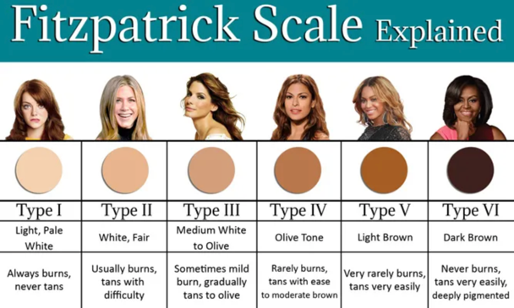

BLISTERING DISORDERS

**Bullous pemphigus**

*Pictures + unique code:*

*List of conditions:*

**Pemphigoid vulgaris**

*Pictures + unique code:*

*List of conditions:*

**Porphyria cutanea tarda**

*Pictures + unique code:*

*List of conditions:*

**Epidermolysis bullosa**

*Pictures + unique code:*

*List of conditions:*

**Dermatitis herpetiformis**

SKIN CANCER

**Actinic keratosis**

*Pictures + unique code:*

*List of conditions:*

**BCC**

*Pictures + unique code:*

*List of conditions:*

**SCC**

*Pictures + unique code:*

*List of conditions:*

**Melanoma**

*Pictures + unique code:*

*List of conditions:*

**Cutaneous T-cell lymphoma**

*Pictures + unique code:*

*List of conditions:*

AUTOIMMUNE DISORDERS

**Behcet’s disease**

*Pictures + unique code:*

*List of conditions:*

**Dermatomyositis**

*Pictures + unique code:*

*List of conditions:*

**Lichen Planus**

*Pictures + unique code:*

*List of conditions:*

**Lupus of the skin**

*Pictures + unique code:*

*List of conditions:*

**Scleroderma**

*Pictures + unique code:*

*List of conditions:*

ALLERGIC DISORDERS

**Eczema/ atopic dermatitis**

*Pictures + unique code:*

*List of conditions:*

**Allergic dermatitis**

*Pictures + unique code:*

*List of conditions:*

**Irritant dermatitis**

*Pictures + unique code:*

*List of conditions:*

**Urticaria**

*Pictures + unique code:*

*List of conditions:*

**Angioedema**

*Pictures + unique code:*

*List of conditions:*

INFECTIONS

**Shingles**

*Pictures + unique code:*

*List of conditions:*

**Verruca vulgaris**

*Pictures + unique code:*

*List of conditions:*

**Condyloma accuminata**

*Pictures + unique code:*

*List of conditions:*

**Cellulitis**

*Pictures + unique code:*

*List of conditions:*

**Folliculitis**

*Pictures + unique code:*

*List of conditions:*

WOUNDS

**Venous ulcer**

*Pictures + unique code:*

*List of conditions:*

**Diabetic ulcer**

*Pictures + unique code:*

*List of conditions:*

**Pressure ulcer**

*Pictures + unique code:*

*List of conditions:*

**Hidradenitis suppurativa**

*Pictures + unique code:*

*List of conditions:*

**Pyoderma gangrenosum**

*Pictures + unique code:*

*List of conditions:*

PEDIATRICS

**Impetigo**

*Pictures + unique code:*

*List of conditions:*

**Molluscum contagiosum**

*Pictures + unique code:*

*List of conditions:*

**Acne**

*Pictures + unique code:*

*List of conditions:*

**Seborrheic dermatitis**

*Pictures + unique code:*

*List of conditions:*

**Coxsackievirus/ hand food mouth**

*Pictures + unique code:*

*List of conditions:*