MLOps Workflow:
FLIGHT PREDICTION MODEL

Covering:
• REST API Development
• Streamlit App Interface
• Docker Containerization
• Kubernetes Orchestration
• Apache Airflow Scheduling
• CI/CD Pipeline
• MLflow Experiment Tracking

1. MLOps Overview
MLOps (Machine Learning Operations) is a set of practices that combines Machine Learning, DevOps, and Data Engineering to deploy and maintain ML systems in production reliably and efficiently.

This document walks through the complete MLOps pipeline for the Flight Price Prediction project, covering all key stages from model serving to monitoring.

MLOps Pipeline Summary
REST API → Streamlit App → Docker → Kubernetes → Airflow → CI/CD → MLflow Tracking

2. REST API

A REST API (Representational State Transfer) exposes the trained ML model as an HTTP service. Clients send feature data as JSON and receive predictions in return.

2.1 Architecture
The REST API is built using FastAPI or Flask, providing endpoints to accept flight feature inputs and return predicted prices. The model is loaded from disk (pickle/joblib) at startup.

Step | Action / Description
1 | Train and serialize the ML model using joblib or pickle
2 | Create a FastAPI/Flask application with a /predict POST endpoint
3 | Define a Pydantic request schema for input validation
4 | Load the model at app startup and invoke it on each request
5 | Return JSON response with predicted price and confidence
6 | Add /health and /docs endpoints for monitoring and exploration

2.2 Key Endpoint
POST /predict
{
"airline": "IndiGo",
"source": "Delhi",
"destination": "Cochin",
"total_stops": 1,
"journey_date": "2024-03-15",
"dep_time": "09:25",
"arrival_time": "16:30"
}

Response: { "predicted_price": 5230.50, "currency": "INR" }

2.3 Screenshot — REST API in Action

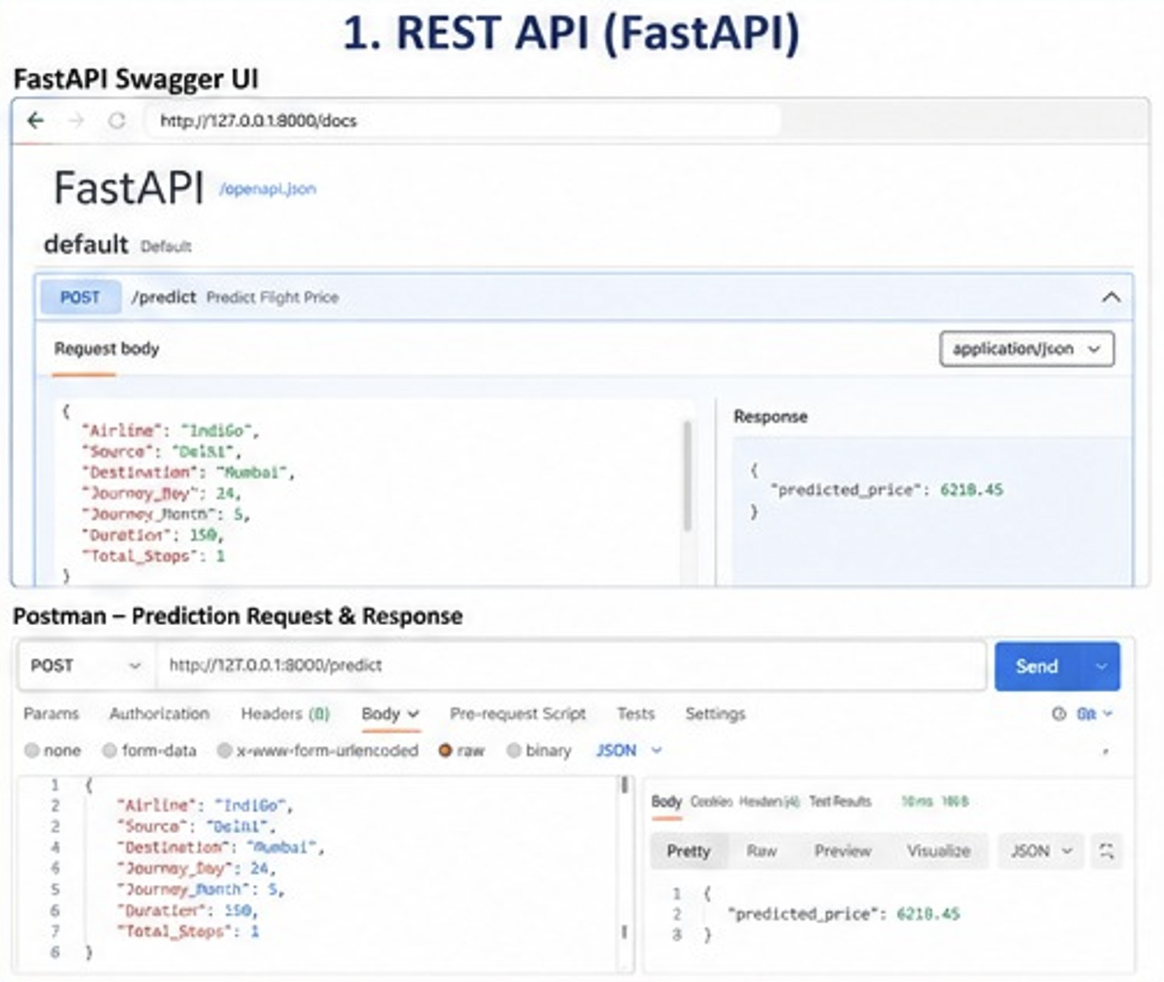

3. Streamlit App

Streamlit provides an interactive web interface for end users to interact with the ML model without writing any code. It wraps the REST API with a friendly UI.

3.1 App Workflow
Step | Action / Description
1 | User opens the Streamlit app in a browser (default: http://localhost:8501)
2 | User fills in flight details via form widgets (dropdowns, date pickers, sliders)
3 | On clicking 'Predict Price', the app calls the REST API endpoint
4 | The API response is displayed as a formatted price prediction with visualizations
5 | Historical price trend charts are shown alongside the prediction
6 | Users can explore feature importance and model explanation (SHAP values)

3.2 Run Command
# Install dependencies
pip install streamlit requests plotly

# Launch the app
streamlit run app.py --server.port 8501

# Access in browser
http://localhost:8501

3.3 Screenshots — Streamlit Interface

4. Docker Deployment

Docker containerizes both the REST API and Streamlit app into portable, reproducible images. Containers ensure consistent behavior across development, staging, and production environments.

4.1 Docker Architecture
Two images are built: one for the FastAPI model server and one for the Streamlit frontend. Docker Compose orchestrates them as a multi-container application.

Docker Components
Dockerfile (API) | Dockerfile (Streamlit) | docker-compose.yml | .dockerignore | requirements.txt

4.2 Dockerfile — Model API
FROM python:3.10-slim
WORKDIR /app
COPY requirements.txt .
RUN pip install --no-cache-dir -r requirements.txt
COPY . .
EXPOSE 8000
CMD ["uvicorn", "main:app", "--host", "0.0.0.0", "--port", "8000"]

4.3 Build and Run Commands
# Build images
docker build -t flight-api:latest -f Dockerfile.api .
docker build -t flight-ui:latest -f Dockerfile.ui .

# Run with Docker Compose
docker-compose up --build -d

# Check running containers
docker ps

# View logs
docker-compose logs -f

4.4 Screenshots — Docker Deployment

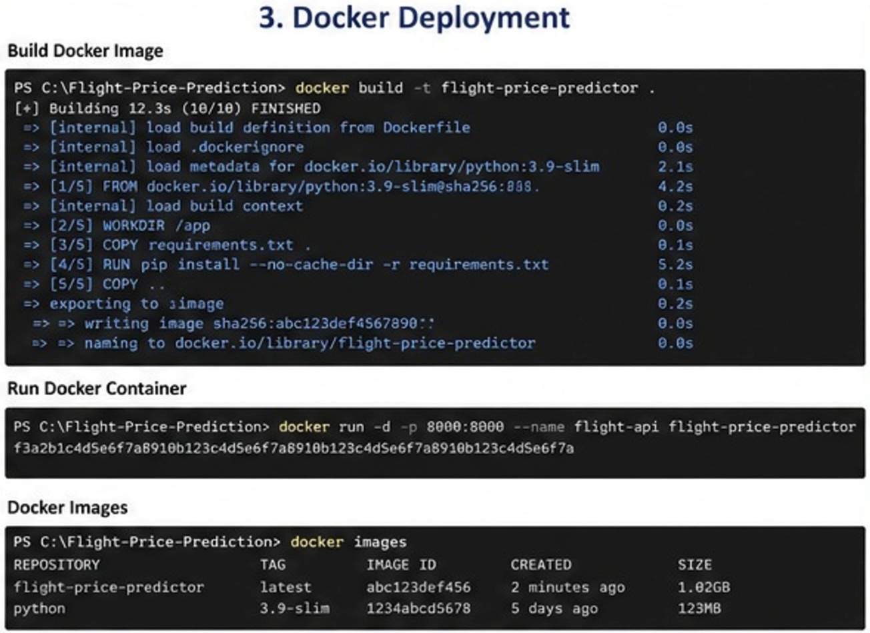

5. Kubernetes Deployment

Kubernetes (K8s) orchestrates containerized workloads at scale, providing automatic scaling, self-healing, rolling updates, and service discovery for the ML application.

5.1 K8s Resource Architecture
Step | Action / Description
1 | Deployment: Defines desired state — 3 replicas of the API pod
2 | Service: Exposes pods via ClusterIP or LoadBalancer for internal/external access
3 | ConfigMap: Stores non-sensitive environment config (model path, log level)
4 | Secret: Stores sensitive credentials (database URIs, API keys)
5 | HPA (HorizontalPodAutoscaler): Auto-scales pods based on CPU/memory
6 | Ingress: Routes external traffic to appropriate services

5.2 Deployment Manifest
apiVersion: apps/v1
kind: Deployment
metadata:
name: flight-api-deployment
spec:
replicas: 3
selector:
matchLabels:
app: flight-api
template:
metadata:
labels:
app: flight-api
spec:
containers:
- name: flight-api
image: flight-api:latest
ports:
- containerPort: 8000
resources:
requests: { memory: '256Mi', cpu: '250m' }
limits: { memory: '512Mi', cpu: '500m' }

5.3 kubectl Commands
# Apply all manifests
kubectl apply -f k8s/

# Check deployment status
kubectl get deployments
kubectl get pods
kubectl get services

# Scale deployment
kubectl scale deployment flight-api --replicas=5

# Rolling update
kubectl set image deployment/flight-api flight-api=flight-api:v2

5.4 Screenshots — Kubernetes Dashboard

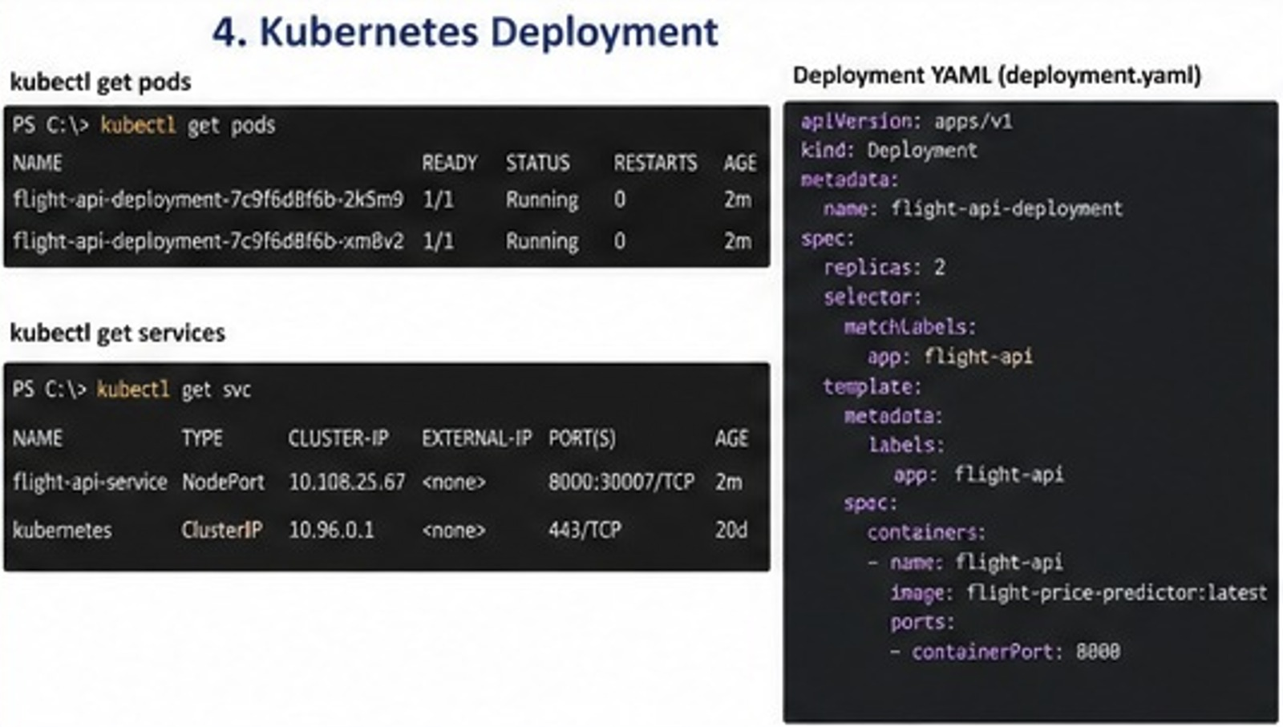

6. Scheduling in Apache Airflow

Apache Airflow orchestrates the ML pipeline as a Directed Acyclic Graph (DAG), scheduling tasks like data ingestion, feature engineering, model retraining, and deployment on defined intervals.

6.1 DAG Structure
Flight Price Prediction — Airflow DAG Tasks
ingest_data → validate_data → feature_engineering → retrain_model → evaluate_model → register_model → deploy_model

Step | Action / Description
1 | ingest_data: Pull fresh flight data from source API or database
2 | validate_data: Run Great Expectations checks for data quality
3 | feature_engineering: Transform raw data into model features
4 | retrain_model: Fit RandomForest/XGBoost on latest data
5 | evaluate_model: Compute RMSE, MAE, R2 on holdout set
6 | register_model: Log metrics and artifact to MLflow Registry
7 | deploy_model: Update the serving API with the new model version

6.2 DAG Definition
from airflow import DAG
from airflow.operators.python import PythonOperator
from datetime import datetime, timedelta

default_args = {
'owner': 'mlops-team',
'retries': 2,
'retry_delay': timedelta(minutes=5),
}

with DAG('flight_price_pipeline',
schedule_interval='@daily',
start_date=datetime(2024, 1, 1),
catchup=False,
default_args=default_args) as dag:

ingest = PythonOperator(task_id='ingest_data', python_callable=ingest_fn)
train = PythonOperator(task_id='retrain_model', python_callable=train_fn)
deploy = PythonOperator(task_id='deploy_model', python_callable=deploy_fn)

ingest >> train >> deploy

6.3 Screenshots — Airflow UI

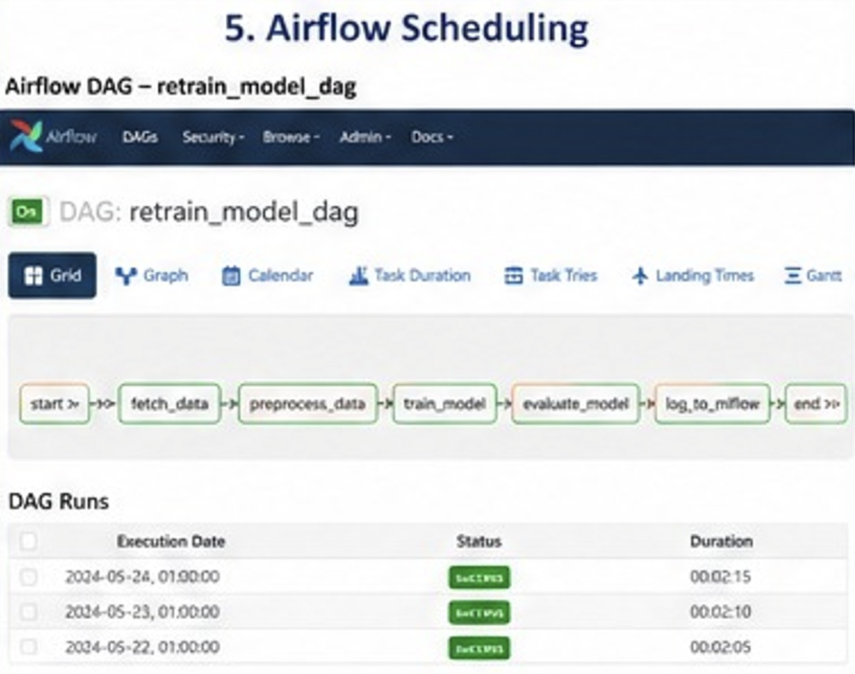

7. CI/CD Pipeline

Continuous Integration / Continuous Deployment (CI/CD) automates testing, building, and deploying the ML application whenever code changes are pushed to the repository.

7.1 Pipeline Stages
Step | Action / Description
1 | Source: Developer pushes code to GitHub/GitLab feature branch
2 | CI — Lint & Test: Run flake8, black, and pytest unit/integration tests
3 | CI — Model Tests: Validate model performance benchmarks on holdout set
4 | CI — Build Docker: Build API and UI Docker images and run container tests
5 | CI — Security Scan: Run Trivy/Snyk vulnerability scan on Docker images
6 | CD — Push Images: Tag and push validated images to Docker Registry (ECR/DockerHub)
7 | CD — Deploy Staging: Deploy to staging Kubernetes namespace
8 | CD — Integration Tests: Run end-to-end tests against staging environment
9 | CD — Deploy Production: Rolling update to production Kubernetes cluster

7.2 GitHub Actions Workflow
name: MLOps CI/CD Pipeline

on:
push:
branches: [main, develop]
pull_request:
branches: [main]

jobs:
test:
runs-on: ubuntu-latest
steps:
- uses: actions/checkout@v3
- name: Set up Python
uses: actions/setup-python@v4
with: { python-version: '3.10' }
- run: pip install -r requirements.txt
- run: pytest tests/ -v --cov=src

build-and-push:
needs: test
runs-on: ubuntu-latest
steps:
- name: Build Docker image
run: docker build -t $IMAGE_TAG .
- name: Push to registry
run: docker push $IMAGE_TAG

deploy:
needs: build-and-push
runs-on: ubuntu-latest
steps:
- name: Deploy to K8s
run: kubectl set image deployment/flight-api ...

7.3 Screenshots — CI/CD Pipeline

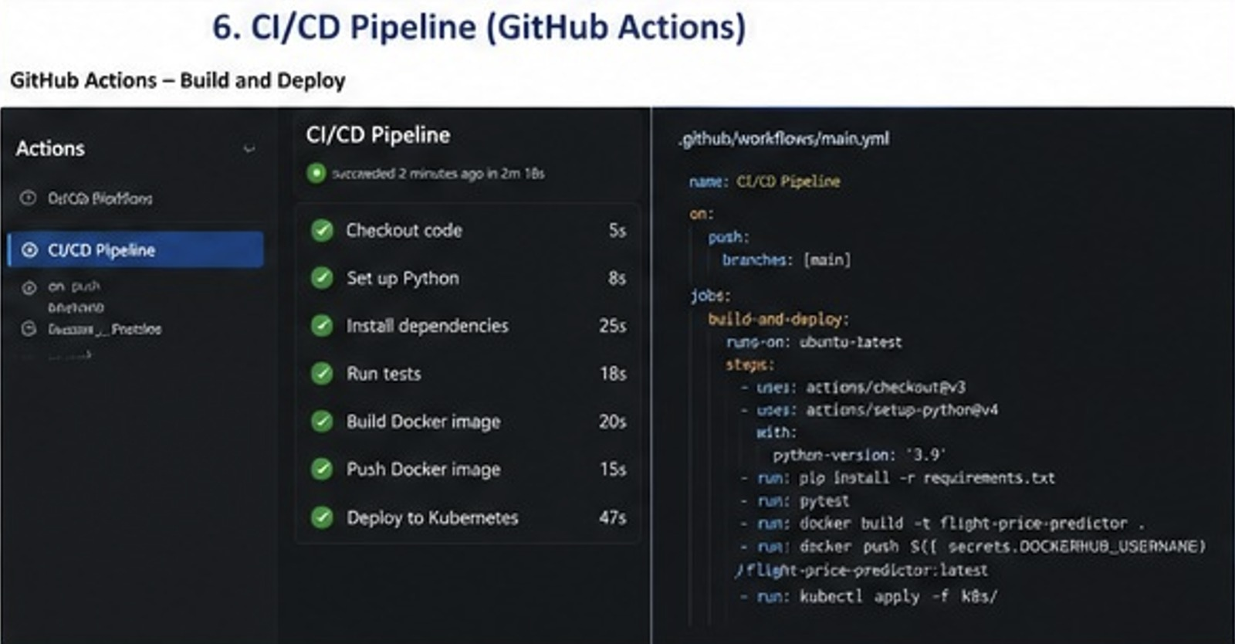

8. MLflow Experiment Tracking

MLflow tracks ML experiments, logs hyperparameters, metrics, and artifacts, manages the model registry, and provides a web UI to compare model runs and manage model versions.

8.1 MLflow Components
Step | Action / Description
1 | Tracking Server: Logs experiments, runs, parameters, and metrics
2 | Artifact Store: Persists trained models, plots, and feature data
3 | Model Registry: Manages model lifecycle (Staging / Production / Archived)
4 | MLflow UI: Web dashboard to compare runs and visualize metrics
5 | Projects: Reproducible packaging of ML code for reuse
6 | Models: Standardized model format for deployment across frameworks

8.2 Tracking Code
import mlflow
import mlflow.sklearn

mlflow.set_experiment('flight_price_prediction')

with mlflow.start_run(run_name='rf_v3_tuned'):
# Log hyperparameters
mlflow.log_param('n_estimators', 200)
mlflow.log_param('max_depth', 10)
mlflow.log_param('min_samples_split', 5)

# Train model
model.fit(X_train, y_train)

# Log metrics
mlflow.log_metric('rmse', rmse)
mlflow.log_metric('mae', mae)
mlflow.log_metric('r2_score', r2)

# Log model artifact
mlflow.sklearn.log_model(model, 'flight_price_model')

# Log feature importance plot
mlflow.log_artifact('feature_importance.png')

8.3 Model Registry
# Register model from best run
model_uri = f'runs:/{best_run_id}/flight_price_model'
mlflow.register_model(model_uri, 'FlightPricePredictor')

# Promote to Production
client = mlflow.tracking.MlflowClient()
client.transition_model_version_stage(
name='FlightPricePredictor',
version=3,
stage='Production'
)

8.4 Screenshots — MLflow UI

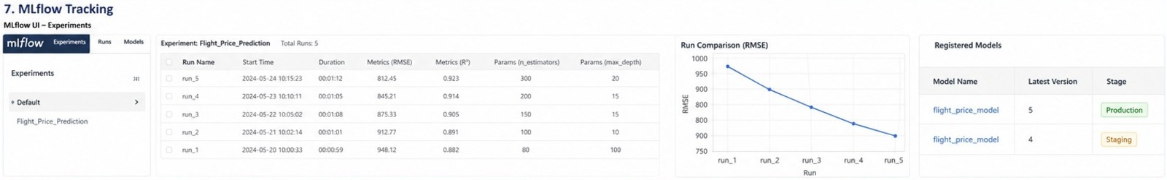

9. MLOps Stage Summary

The following table summarizes each MLOps stage, its primary tool, purpose, and key output:

Stage | Tool | Purpose | Key Output
REST API | FastAPI / Flask | Expose model as HTTP service | JSON prediction endpoint
UI | Streamlit | Interactive user interface | Web app at port 8501
Container | Docker | Package app reproducibly | Docker images + compose
Orchestration | Kubernetes | Scale and manage containers | Pods, Services, HPA
Scheduling | Apache Airflow | Automate ML pipeline | DAG with scheduled runs
CI/CD | GitHub Actions | Automate test and deploy | Green pipeline on merge
Tracking | MLflow | Log experiments and models | Model registry versions

