Name:- Sarfarz Khan
Roll No : - 14CO42
Experiment 1
Aim : - Case Study on NPL/Expert System

HINDI TO ENGLISH MACHINE TRANSLATION USING NATURAL LANGUAGE PROCESSING

ABSTRACT :-

The present work focuses on developing a hybrid approach for developing a machine translation (MT) scheme for automatic translation of Hindi sentences to English. Development of machine translation (MT)
systems for Indian languages to English almost invariably suffers from the limited availability of linguistic resources.
As a consequence, statistical, rule-based or example-based approaches have not been found to generate good quality translation for all types of sentences. Moreover, purely statistical or example based schemes do not leverage the semantic association (i.e. association of the noun case-endings (karakas)) with each other and also with the verb phrase to generate the English translation. The scheme proposed in this work is based on the syntactic and semantic roles of the phrases of an input Hindi Sentence. The proposed solution is a hybrid scheme involving phrase-based, rule-based and statistical translation approaches. In our approach we try to identify the difficulties associated with the translation of different types of input sentences, viz. simple declarative, negative and interrogative sentences and propose a translation approach for them.

1.INTRODUCTION

Past works on machine translation for Indian languages had mostly focused on translating English sentences to Indian languages. Not much work is found in the reverse direction i.e. from Indian languages to English.The primary reason for this may be attributed to the lack of resources for processing Indian languages. The situation becomes even more difficult because of the lack of existing parallel corpus essential for different translation paradigms, such as, example based machine translation (EBMT), statistical machine translation (SMT), among others.

2. PREVIOUS WORK

Over the last two decades' machine translation using Indian languages made some significant progress. Perhaps the most notable among them is the AnglaBharati system which uses rules developed based on structural patterns to translate English sentences into different Indian languages. However, several other systems have been developed prior to it, following different translation paradigms. The most notable among them are mentioned below.Anusaaraka, a translation system for mutual translation between different Indian languages is developed using the “direct translation” approach maintaining the grammatical structure of the source language. Hence the output is often syntactically incorrect when the source and target language grammars differ. The Mantra machine translation system was developed using the transfer based approach. Here Tree Adjoining Grammar based taggers and parsers are used for transferring English text structure to Hindi to achieve translation. Anubharati followed a hybrid approach where example based scheme was aided by statistical analysis corpora and linguistic rules.
Another EBMT system Anubaad also followed EBMT approach for translating English news sentences into Hindi. More recently many other systems have been made available for translating between various Indian languages. Some of them are: Punjabi to Hindi MT system , Hindi to Punjabi MT UNLBased systems for translating from English to Hindi, Bengali and Marathi, EBMT systems for translating between Hindi, Kannada and Tamil .Barring the Hinglish translation system none of the above translation schemes attempted to translate Hindi to English. The existing schemes focus mostly in translating English to Indian language, or between pairs of Indian languages. Very recently in WMT14 shared task, attempt has been done to develop statistical systems for Hindi to English, and English to Hindi translation. The core components of the translation systems are Phrase Based (Hindi-English) and factor based (English to Hindi). The work focuses on the usage of number, case, and Tree Adjoining Grammar information for translation. There is also a pre and post processing step involved to adjust the translation output for structural divergence between Hindi and English sentences. Also, there are a very limited set of rules which play the role in translating Hindi to English. Another translation system was developed by in WMT2014 where apart from various other language pairs, Hindi -English translation has also been considered. This is based on string to tree system, where some improvements were done for out of vocabulary word translation through transliteration.Apart from the WMT shared task translation systems presented a hybrid machine translation architecture guided by syntax. In this work, the authors develop a hybrid translation system guided by the rule based machine translation engine and, before transference , few partial candidate translations given by the statistical translation schemes. These partial candidate translations are used to enrich the tree-based representation. The final hybrid translation is created by choosing the most probable combination among the available subsets with a statistical decoder.

3.PROPOSED APPROACH

The translation approach followed in this work is a hybrid of phrase-
based, rule-based and statistical approache of machine translation. The strengths of each of the following approaches are used, to generate a hybrid scheme for machine translation.

3.1. Phrase-based Approach

This approach translates a given sentence phrase wise, and then recombines the individual translated phrases to generate the complete translation of the whole sentence. In the present work the phrases considered are the syntactic phrases derived from the LTRC Hindi Shallow Parser.

3.2Rule-based Approach

The translation of each phrase is recombined based on certain rules, designed specifically to solve the given sentence structure. The basis of these rules is derived from .The translation pattern followed for Hindi to English with respect to various कारक(karaka) (noun case-ending)
present in the Hindi Sentence. Type of the sentence (simple declarative, negative or interrogative) Once these कारक(karaka) (noun case-ending) and the sentence type are identified properly, the
translation of a Hindi Sentence can be achieved using some transfer rules explained in the Section 6.

3.3 Statistical Approach

Each phrase is translated using statistical techniques. The two well-
known statistical translation techniques used for the current work are:

3.3.1 MOSES

Moses is a statistical machine translation system. MOSES allows the language models for any language pair to be trained using a collection of parallel corpus. A parallel corpus consists of a set of translated texts of the two languages under consideration called the source and the target language. Word alignment of the parallel data is established using GIZA++. Using these inputs trained target language model is generated using a toolkit called SRILM(SRI Language Modelling Toolkit), which ensures the fluency of the output. Using the language model generated by SRILM, any search algorithm can be used for finding the highest probability translation from among the number of choices available. One such efficient search algorithm used widely is the beam search.

3.3.2 Google translator

Google Translator is autility provided by Google to translate written text from one language to another. This is one of the most popular and well known translators available currently. The overall translation flow proposed is shown in Figure 1. Each step of the flow is explained as follows:
a)Parsing and Sentence Type identification of the Hindi sentence
The first step for translation of any Hindi sentence through the proposed scheme is parsing it. With this the syntactic phrases and the sentence type are identified. The parsing is done using the LTRC shallow parser:
1.To identify syntactic phrases from the given Hindi sentence.
2.To identify the sentence type; positive, negative, or interrogative.
For example, consider the sentence पृथ्वी हर १२ महीने मेंसूरज का एक चक्कर लगाती है (prithvii har 12 mahine mein suraj kaa ek chakkar lagaatii hai ) ~ The earth rotates around the sun once in every 12 months.The parse output for the sentence is shown in Table 2. In Table 2, NP signifies the Noun Phrase, and VGF signifies the finite verb phrase.In the given example five syntactic phrases are identified which are
1.पृथ्वी(prithvii)~ (Earth)
2.हर १२ महीने में (har 12 mahine mein) (in every 12 months)
3.सूरज का (suraj kaa) (of the sun)
4.एक चक्कर(ek chakkar)(one round)
5.लगाती है( lagaatii hai ) (takes)
The NEG (Negative) and WQ (Question Word) POS tags are used to signify negative and interrogative sentences. Example of the parse output of a negative Hindi sentence
राम खाना नहीींखाता है ( Raam khaanaa nahii khaataa hai)~ Ram does not eat food
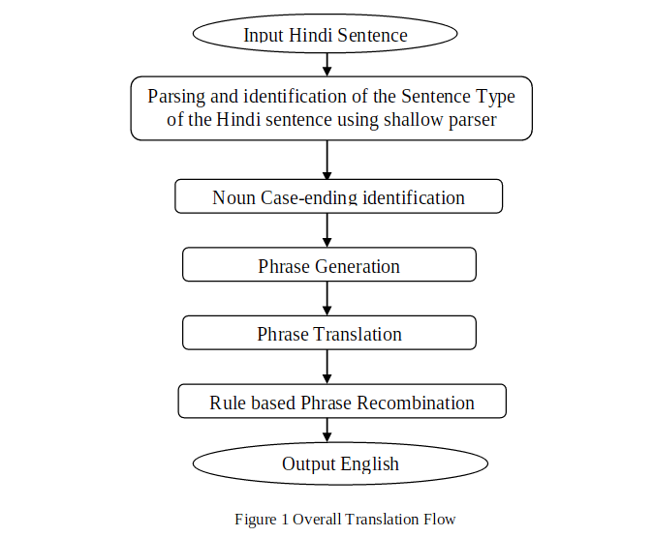
and Interrogative Hindi sentence राम ने क्या खाया (Raam ne kyaa khaayaa) ~ What did Ram eat

