Name :- Sarfaraz Khan
Roll No - 14CO42
Batch :- 3
Experiment : - 2

1.Start Graphic Window for taking input and showing output
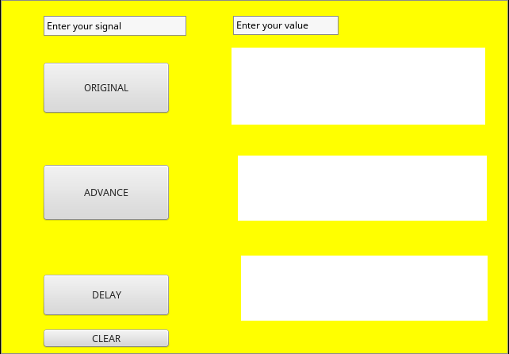

2 . Input :-
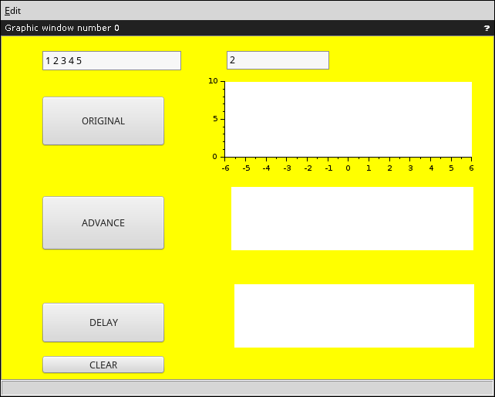

3. Original graph plot
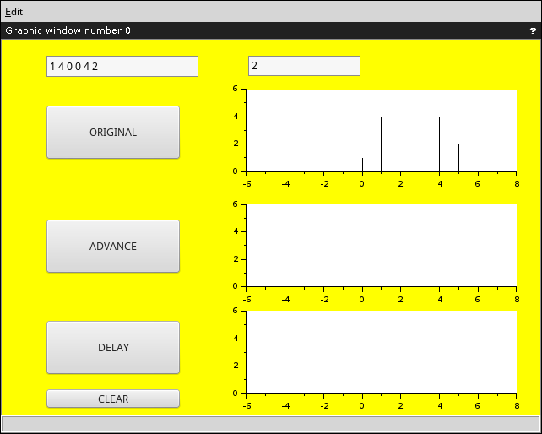

4. Advance graph plot
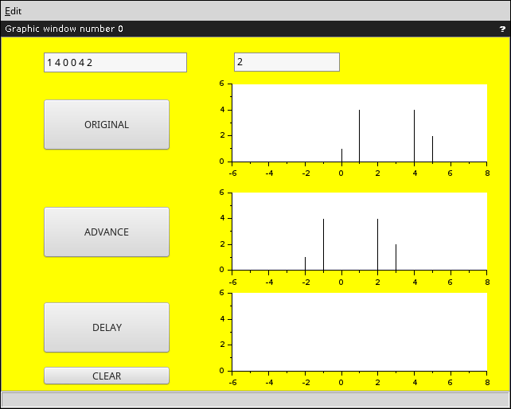
5. Delay graph plot
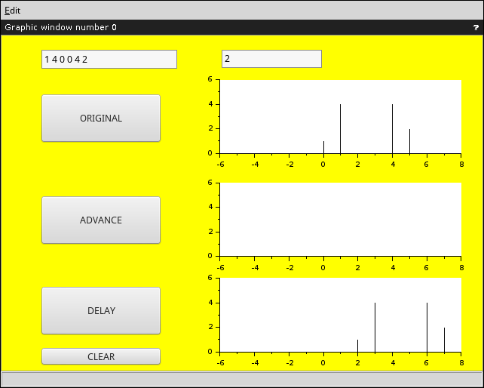
6. Original Advance Delay graph plot
