Name :- Sarfaraz Khan
Roll No :- 14co42
B.E - C.O
Experiment 1

AIM : - Generation of sine wave and to view it in CT and DT form

clc;clf;
disp " hello world"
x=[0:0.1:2*%pi]';
y=[1 4 0 0 4 2 ]

subplot(221)
plot(sin(x))

subplot(222)
plot2d3(sin(x))

subplot(223)
plot(y)

subplot(224)
plot2d3(y)
Output:-
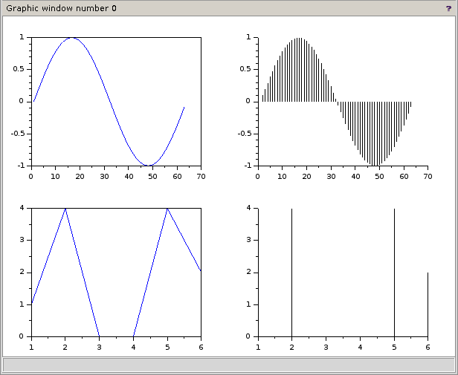
sci>>> hello world

