Name : - Sarfaraz Khan
Roll No : - 14CO42
Batch : - 3
Experiment 6

Aim : - MIM(Man In Middle ) attack using ARP spoofy.
- Urlsnarf
- Driftnet
- Ettercap

Theory :-

# In Middle Attack: -
The man-in-the-middle attack (often abbreviated MITM, MitM, MIM, MiM, MITMA) in cryptography and computer security is a form of active eavesdropping in which the attacker makes independent connections with the victims and relays messages between them, making them believe that they are talking directly to each other over a private connection, when in fact the entire conversation is seen by the attacker.
The attacker must be able to intercept all relevant messages passing between the two victims and inject new ones. This is straightforward in many circumstances; for example, an attacker within reception range of an unencrypted wireless access point (Wi-Fi) can insert himself as a man-in-the-middle.
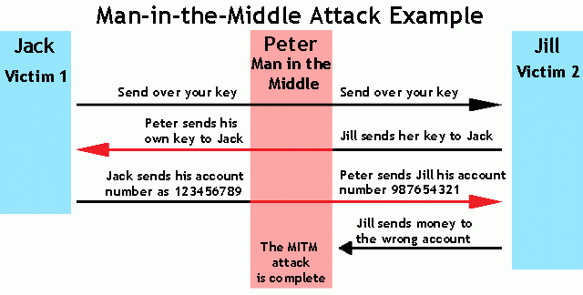

1. urlsnarf :-
urlsnarf outputs all requested URLs sniffed from HTTP traffic in CLF (Common Log Format, used by almost all web servers), suitable for offline post-processing with your favorite web log analysis tool (analog, wwwstat, etc.).

Syntax : -
url snarf [-n] [-i interface | -p pcapfile] [[-v] pattern [expression]]
2. driftnet :-

Driftnet ia tool used to See What Images Your the victim Is Looking at Online net and it was developed by Chris Lightfoot and is packaged with both Kali and BackTrack. Although far from perfect, it gives us the capability to sniff the wire for graphics, audio, or MPEG4 images and display them to an X window.
3. ethercap : -
Ettercap stands for Ethernet Capture.Ettercap is a comprehensive suite for man in the middle attacks.It features sniffing of live connections, content filtering on the fly and many other interesting tricks. It supports active and passive dissection of many protocols and includes many features for network and host analysis. Ettercap works by putting the network interface into promiscuous mode and by ARP poisoning the target machines. Thereby it can act as a ‘man in the middle’ and unleash various attacks on the victims. Ettercap has plugin support so that the features can be extended by adding new plugins.

CONCLUSION:-

OUTPUT :-
1.Setting up arpspoof between victim and router.
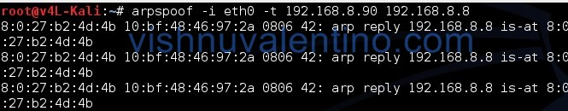
2. Setting up arpspoof from to capture all packet from router to victim.
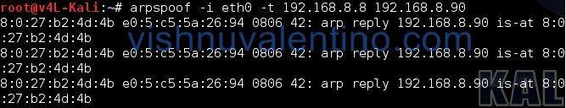
3. After step three and four, now all the packet sent or received by victim should be going through attacker machine.
4. Now we can try to use driftnet to monitor all victim image traffic
5.To run driftnet, we just run this
driftnet -i eth0


To stop driftnet, just close the driftnet window or press CTRL + C in the terminal
6. For the next step we will try to capture the website information/data by using urlsnarf. To use urlsnarf, just run this code.
urlsnarf -i eth0
and urlsnarf will start capturing all website address visited by victim machine.
9. When victim browse a website, attacker will know the address victim visited.
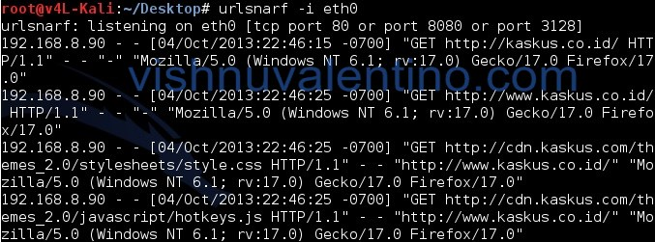
10.

