Cloud Computing Lab Assignment -3
(Sarfraaz Shaikh AIIT BCA SEM-3 054)
Write the process for creating resources for Azure for the following :
- Creating a Virtual Machine (VM) in Azure
• Login to Azure Portal → portal.azure.com.
• In the search bar, type Virtual Machines and select it.
• Click + Create → Azure Virtual Machine.
• Select Subscription and Resource Group.
• Enter Virtaul Machine name.

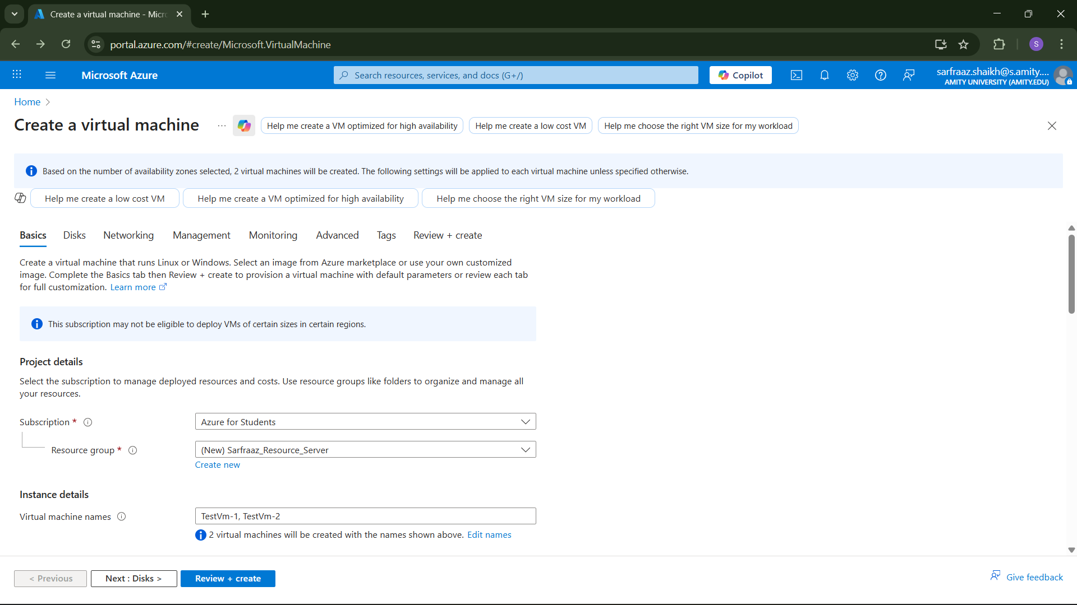

• Choose Region.
• Select Availability options (availability zone or set).
• Choose Image (e.g., Windows Server, Ubuntu). • Also choose VM Architecture as x64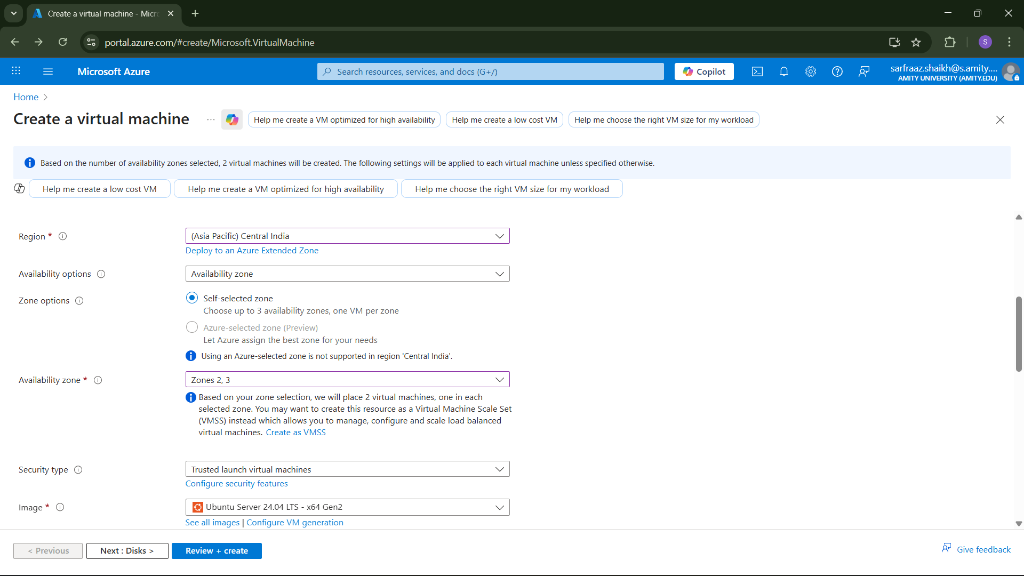

• Select Size (based on CPU/RAM needs).
• In administrator account, enter the authentication type as SSH public key.
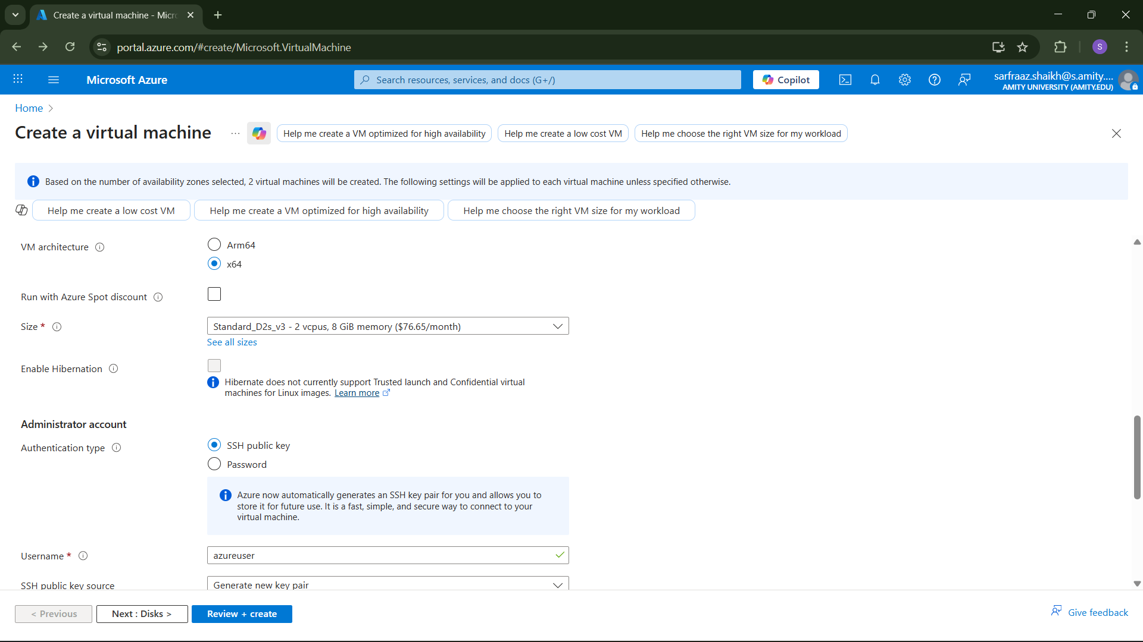

• Enter username, SSH public key source and SSH key type as RSA SSH Format. 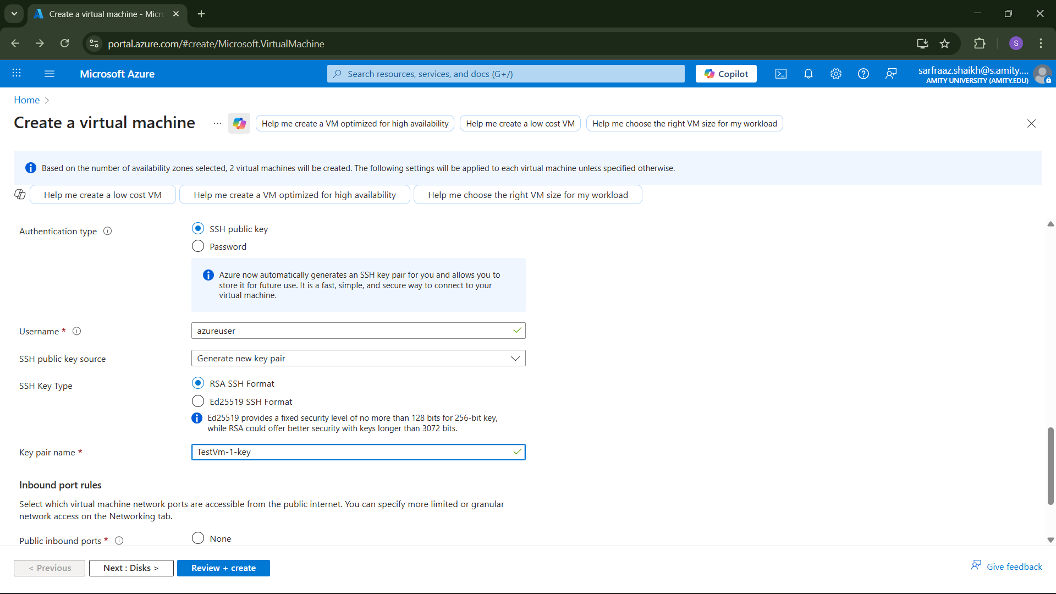

• Enter Key pair name.
• Choose public inbound ports as Allow selected ports.
• Select inbound ports as HTTP(80).

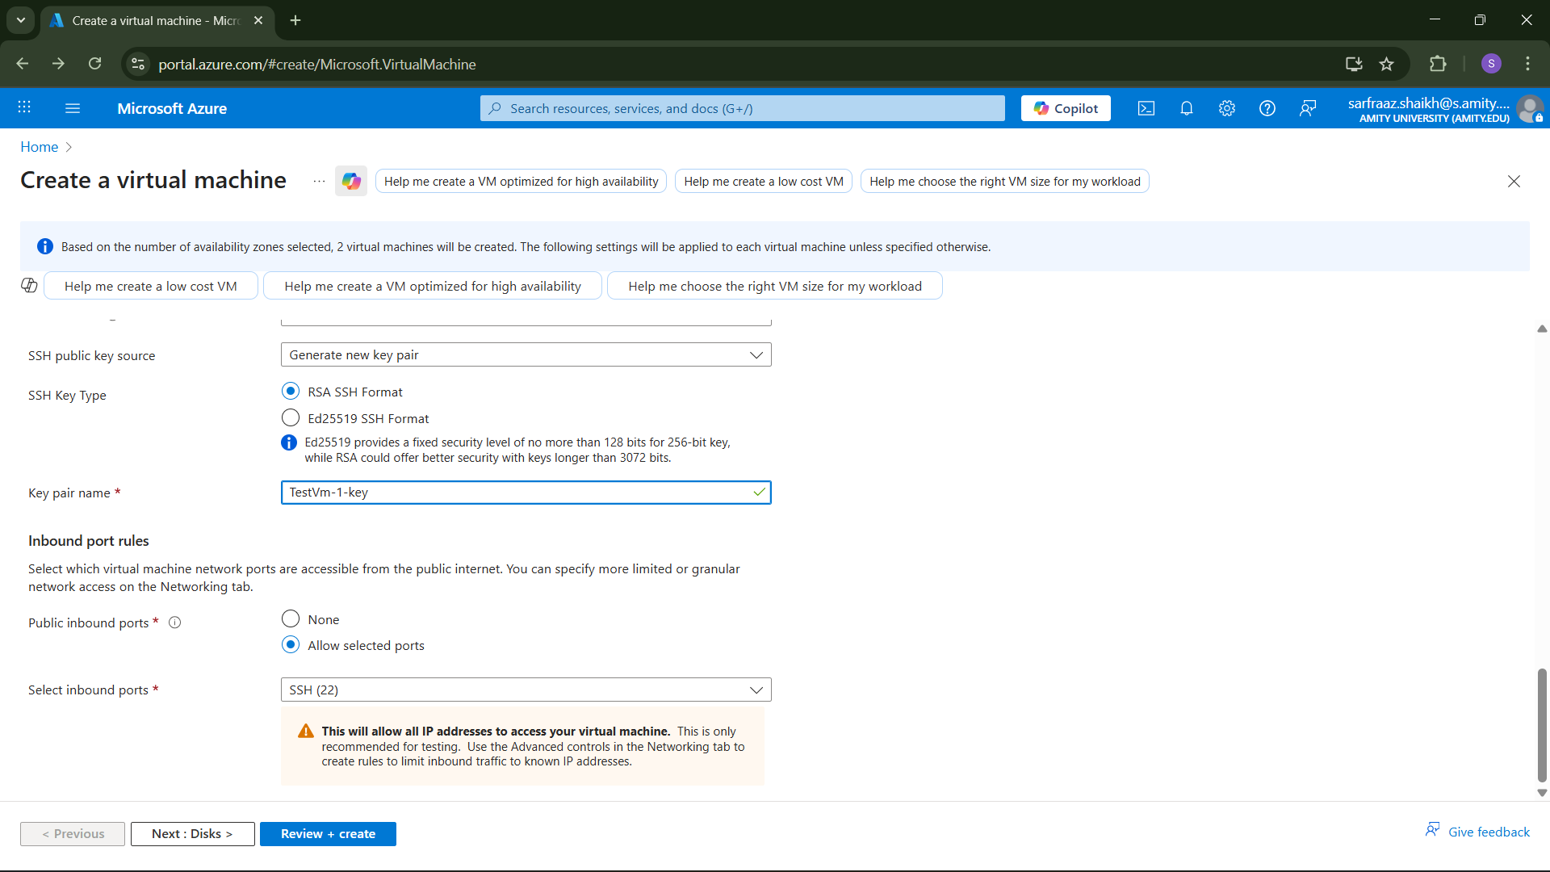
Review + Create: Validate the configuration
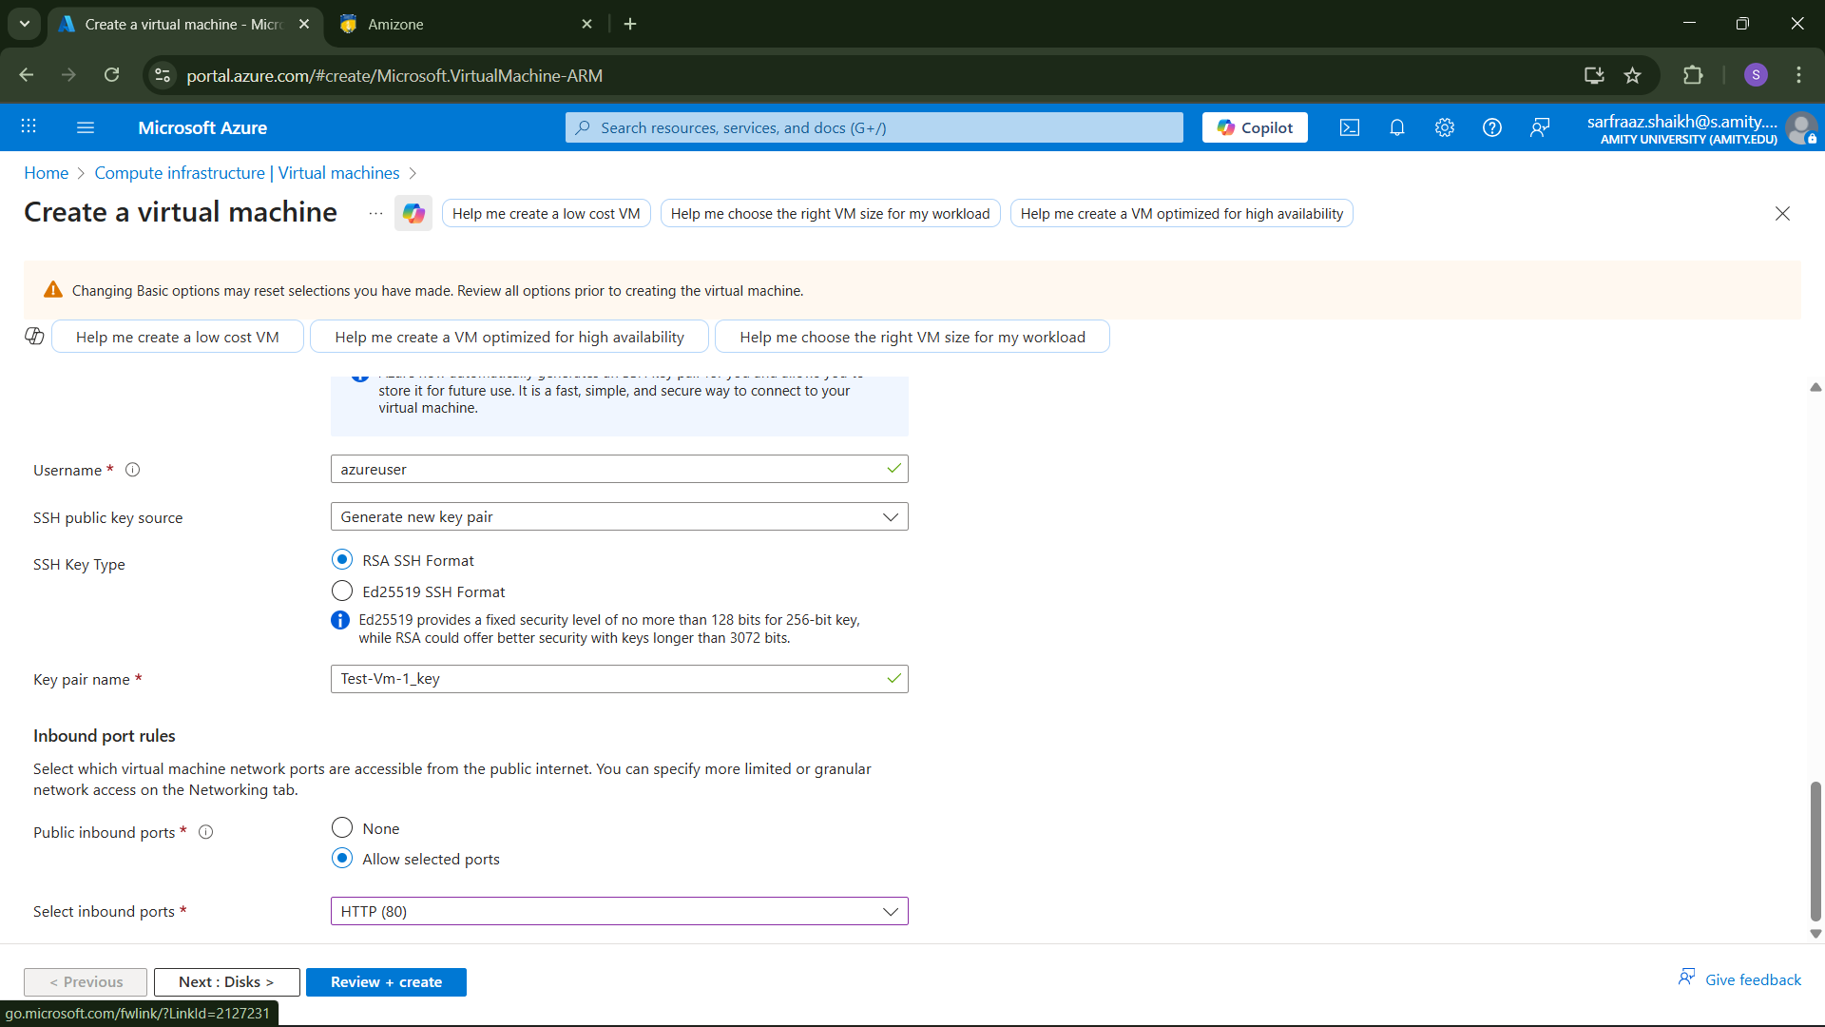
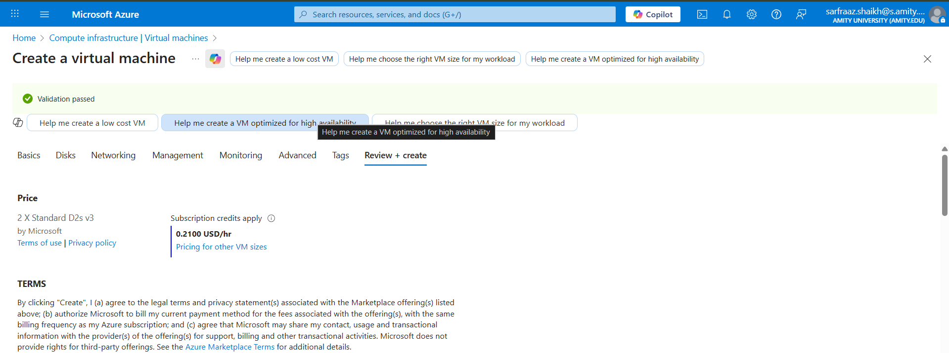
• Enter create.
• Select Download private key and create resource.
• Deployment will take a few minutes.
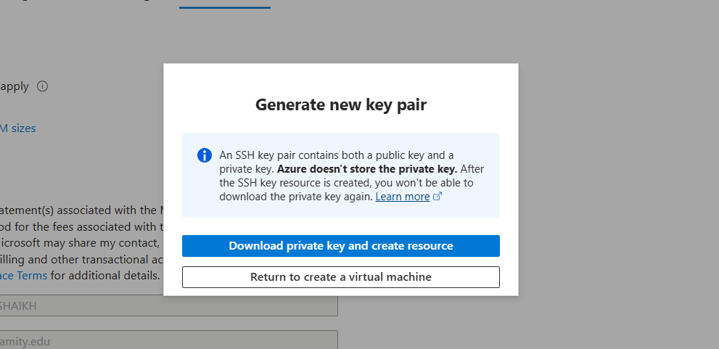
• Your deployment of virtual machine is completed.
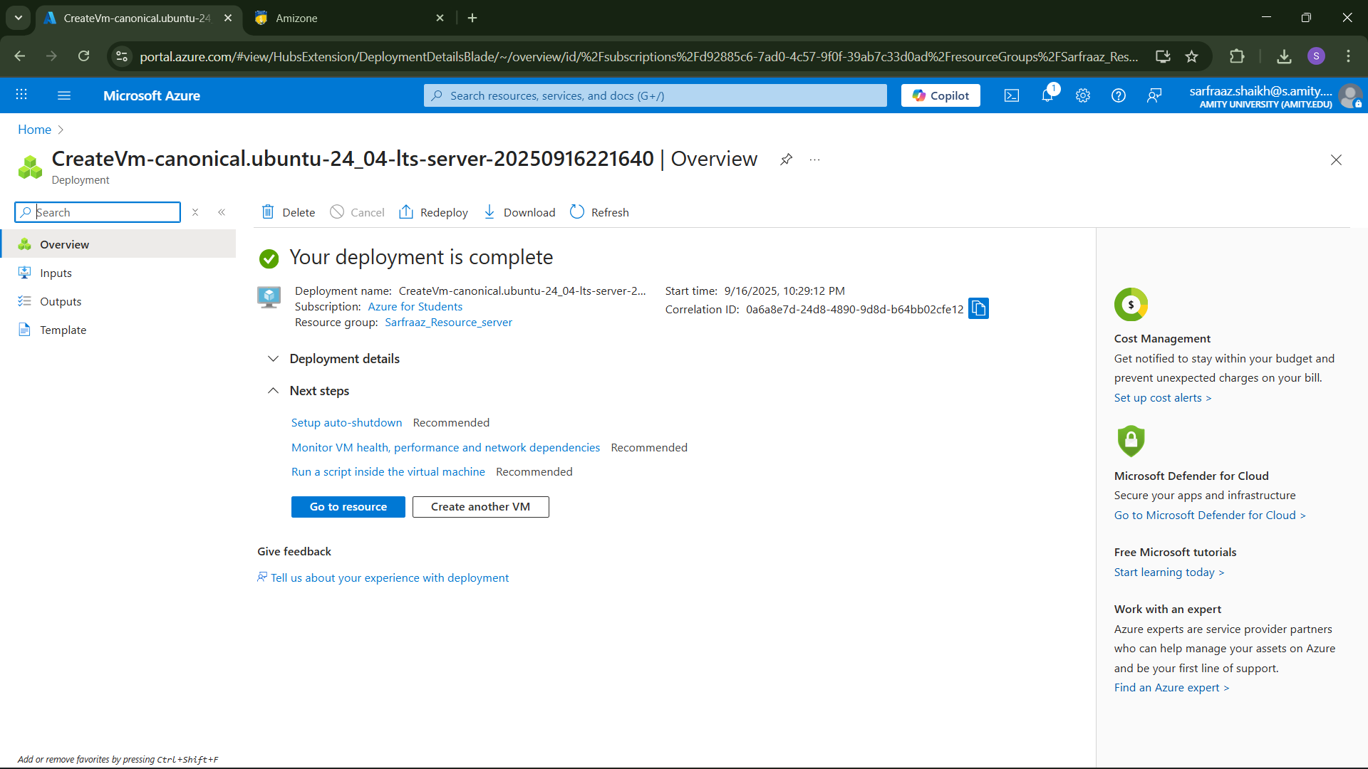
• After deployment → Go to the VM resource, use Connect to access via RDP (Windows) or SSH (Linux).
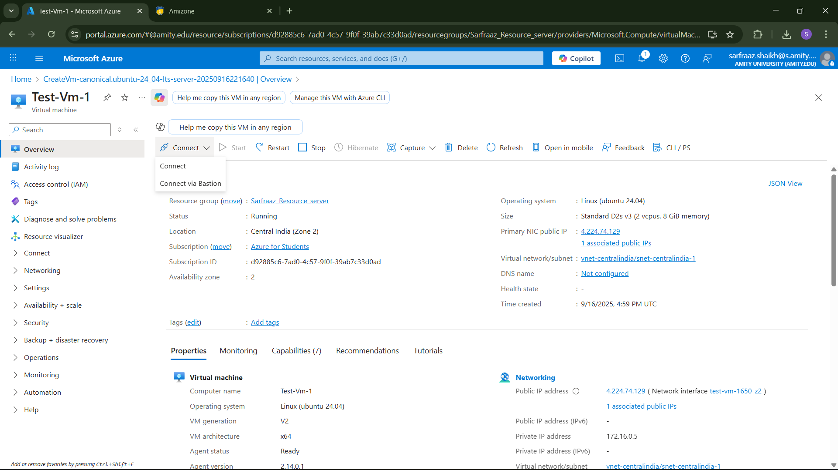

- Creating a Storage Account in Azure
• Go to Azure Portal.
• In the search bar, type Storage accounts and select it. • Click + Create.
• Choose Subscription and Resource Group.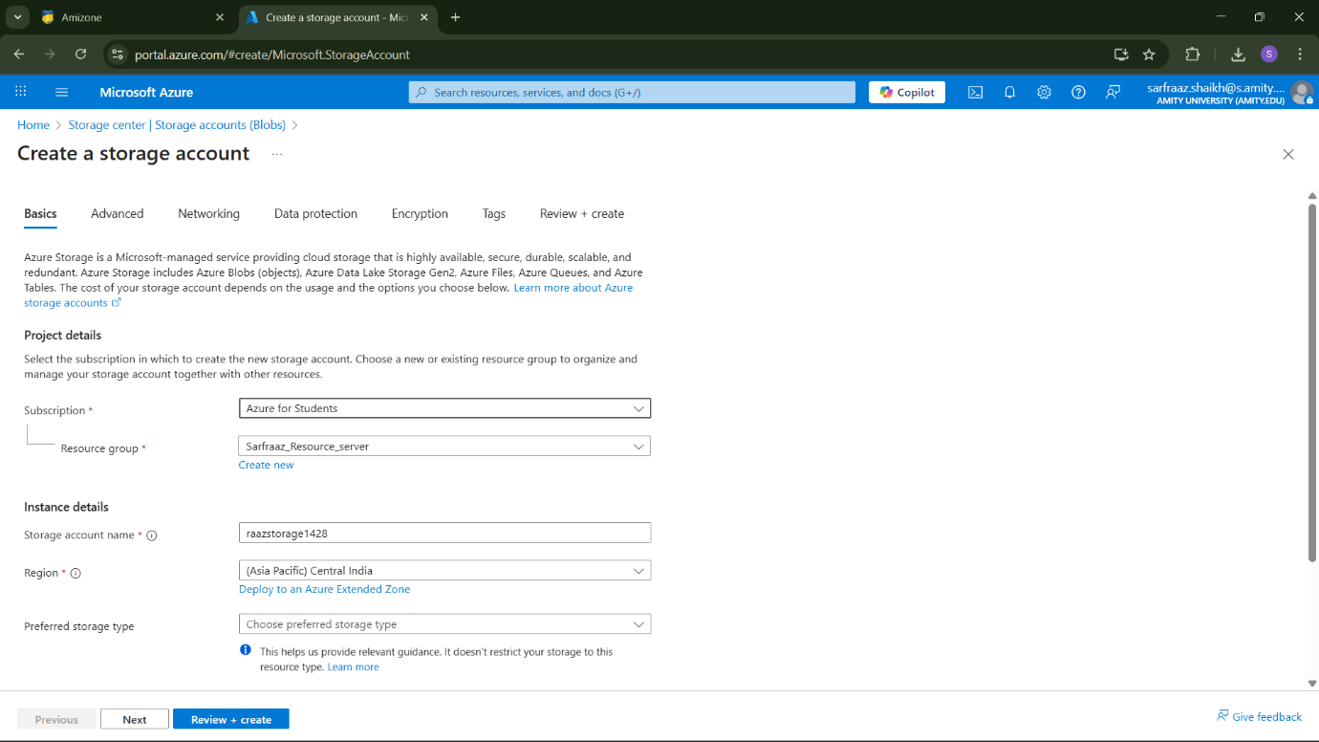
• Enter Storage account name (must be globally unique).
• Select Region.
• Choose Performance (Standard/Premium).
• Select Redundancy option (LRS, GRS, ZRS).
• Click on Review + Create.
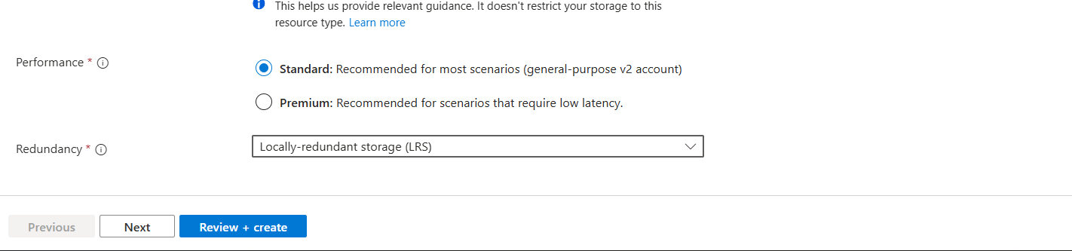

• Click on create. Deployment will take some time
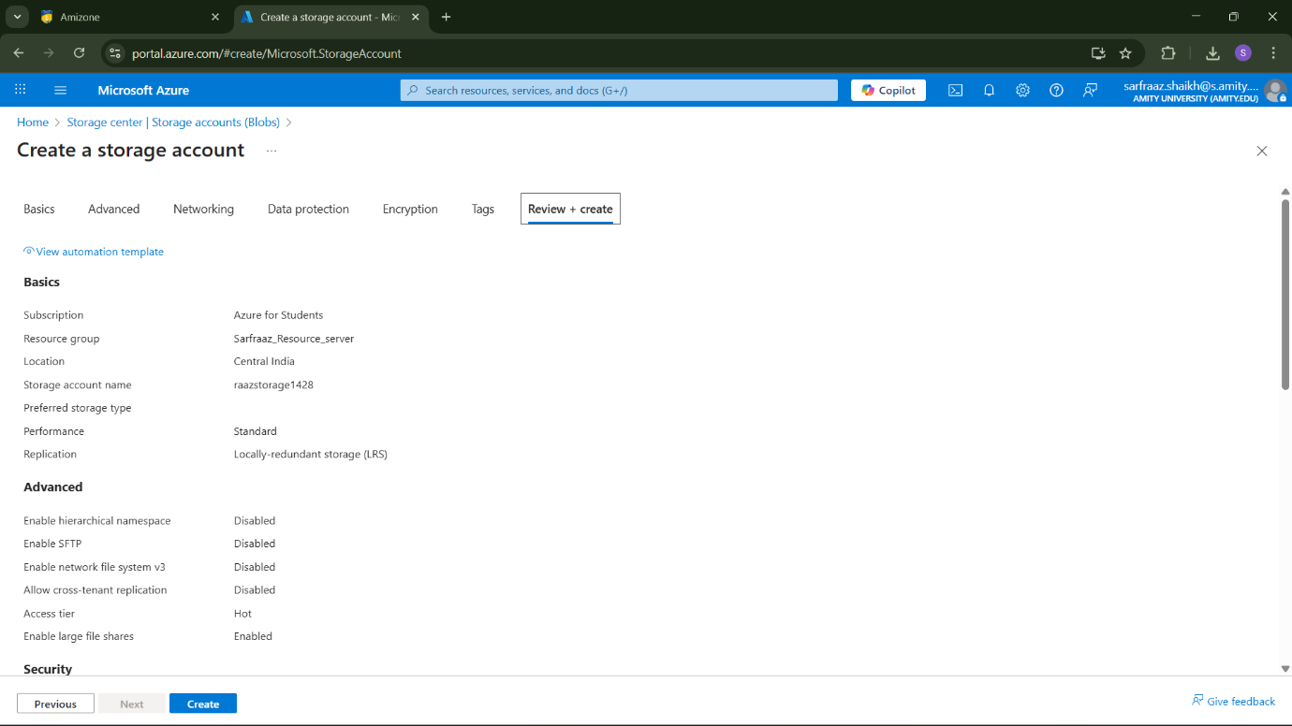
• Your deployment is completed.
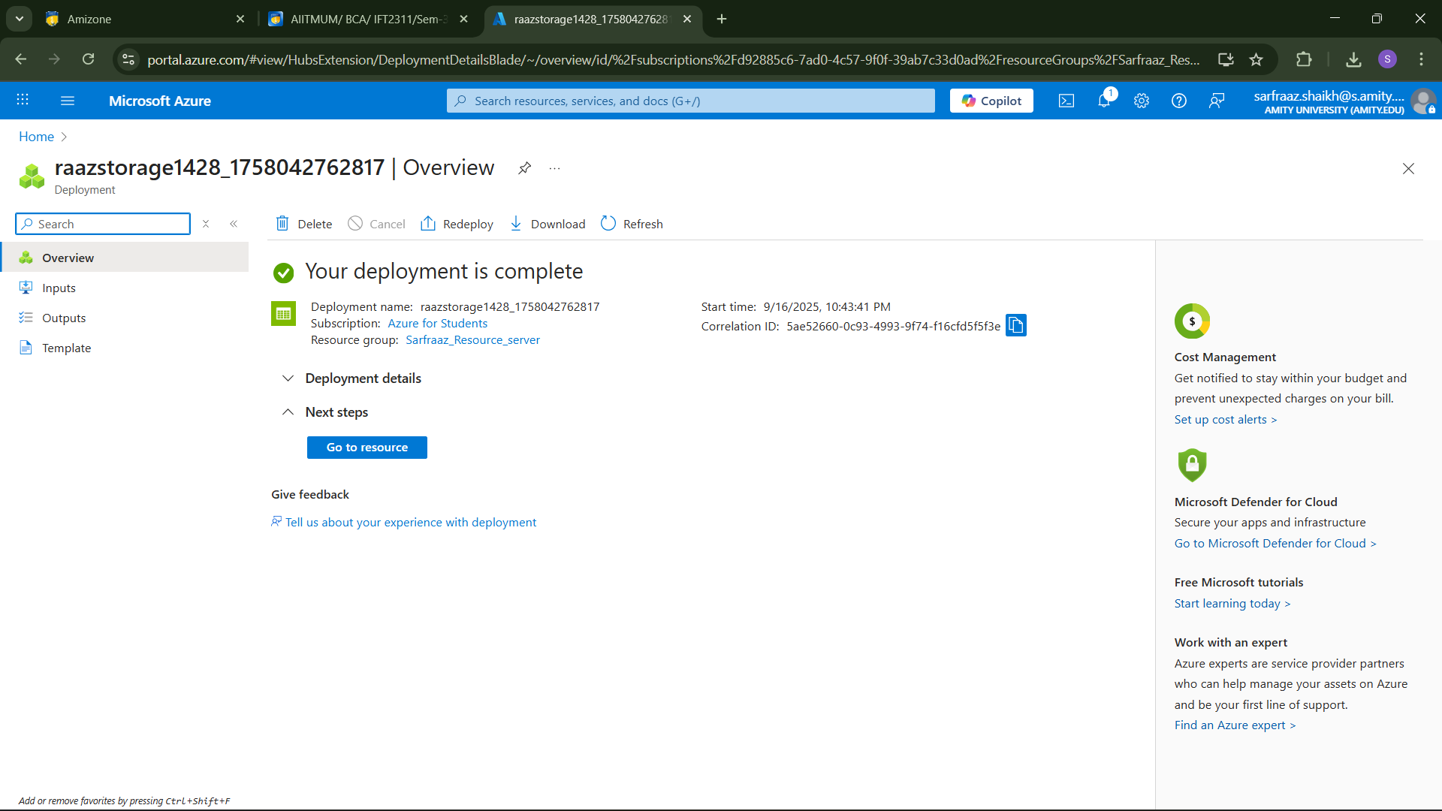

- Creating Azure Machine Learning Resources:
• Go to Azure Portal.
• Search for Machine Learning and select it. • Click + Create Azure Machine Learning.
• Select Subscription and Resource Group.
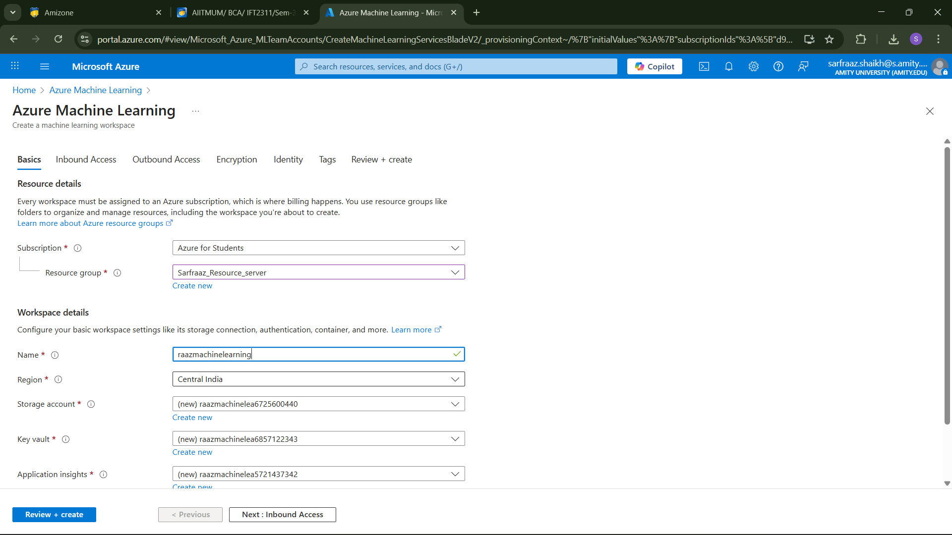
• Enter Workspace name.
• Choose Region.
• Select/create Storage account, Key Vault, Application Insights, and Container Registry (Azure auto-creates them if not chosen).
• Click Review + Create → Create.


Click on Create.

.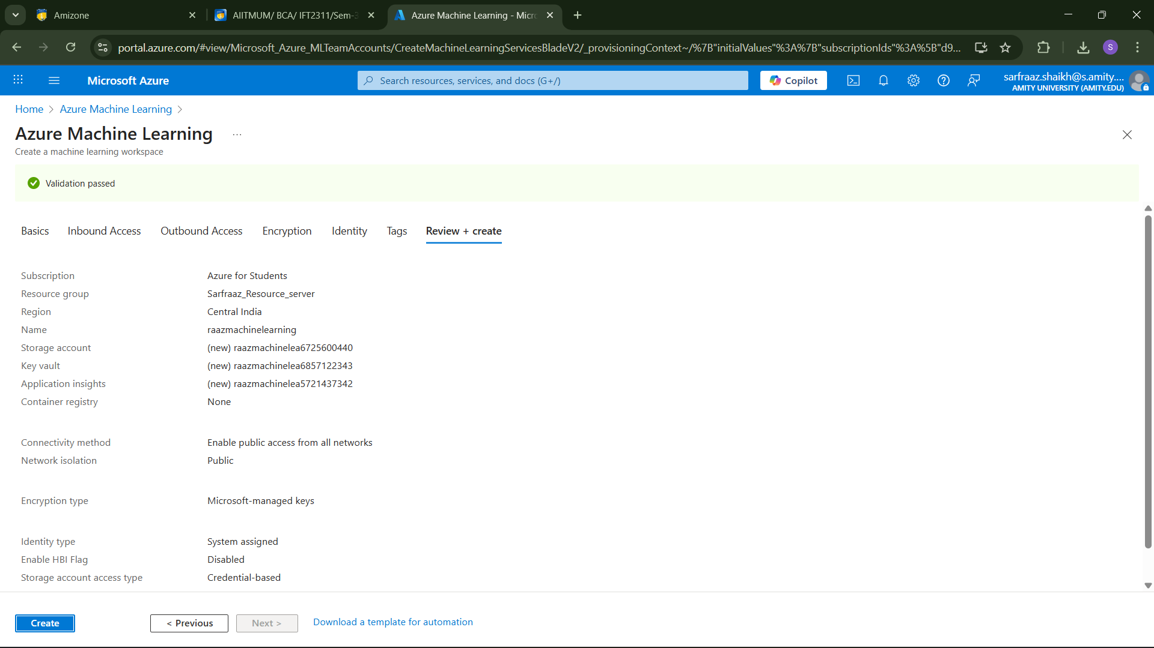
• Your Deployment is completed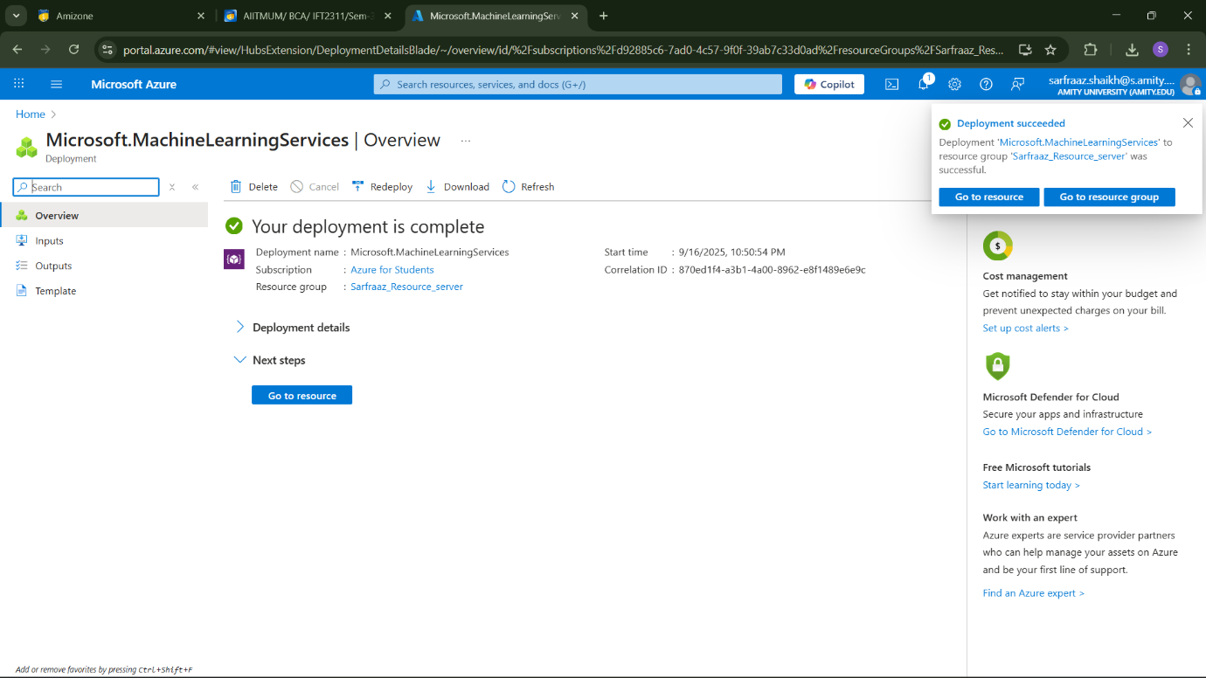
• All the 3 resouces are created successfully.