Assignment no: 1
Q1 A software project is estimated to be 450 KLOC (thousands of lines of code) using basic COCOMO model.
- Classify the project as Organic, Semi-Detached, or Embedded based on the description.
- Justify your choice of project type.
- Calculate the Effort, development time, average staff size, and productivity of the project.

Q.2 A software project is estimated to be 2.5 KLOC (thousands of lines of code) using basic COCOMO model.
- Classify the project as Organic, Semi-Detached, or Embedded based on the description.
- Justify your choice of project type.
- Calculate the Effort, development time, average staff size, and productivity of the project.

Q.3 Answer following:
A) What is Function Point Analysis (FPA) in Software Project Management?
B) Given a small project with External Inputs (EI) is 3, External Outputs (EO) is 4, External Inquiries (EQ) is 2, Internal Logical Files (ILF) is 4, External Interface Files (EIF) is 4, how would you calculate the unadjusted function points, Function Point Analysis (FPA) if all CAF and WAF is average.
Q.4 Answer following:
A) Explain how to calculate the cyclomatic complexity of a program and describe three different methods for computing it.
B) Calculate cyclomatic complexity for following graph. (using 3 methods).
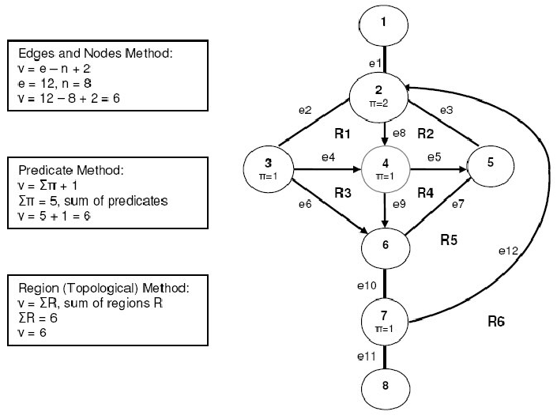

C) Calculate cyclomatic complexity. (using 3 methods).
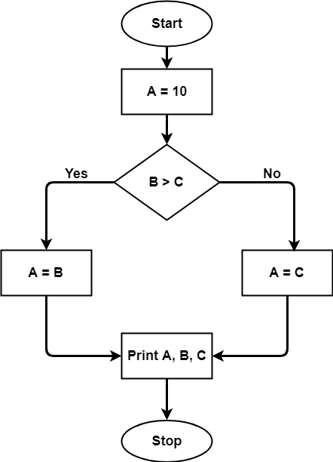

Q. test case Login Functionality

