  - HD MARKETING CRM

Lead Import, Assignment, Export & Supabase
  - Technical Documentation and Read-only Source Review
Prepared 13 October 2026 · Asia/Karachi
Workspace snapshot: hd-marketing-crm · local migrations 001–019
The source proves an API/RPC import into shared PostgreSQL tables. Assigned “files” are database groups. Agents open filtered records; no agent spreadsheet import/export button was found. Original lead spreadsheets are not persisted in Storage.
Evidence boundary: this report reviews the current local source and declared SQL schema. No live Supabase project, credentials, environment files or customer data were inspected. Local production-fix work was already in progress before this documentation task; its presence is not evidence of hosted installation or completed release acceptance.
Deliverable: CRM_Lead_Import_Export_Supabase_Technical_Documentation.docx

Contents
Select a section to jump to it. Headings also appear in Word’s Navigation pane. Footer page fields are calculated by Word when opened or printed. Mermaid source for all eight diagrams is included in Appendix B.
1. Executive summary and evidence boundary
2. Technology and application architecture
3. Admin upload: complete call chain
4. PostgreSQL insertion, partial failures and retries
5. Admin-to-agent assignment
6. What agents actually open, import or export
7. Declared database inventory and relationships
8. Spreadsheet storage versus real Storage objects
9. Security: server authorization, RLS and privileged access
10. Persistence, synchronization and concurrent access
11. Fictional end-to-end example
12. Code reference index and API contract
13. Findings, limitations and recommendations
Appendix A. Safe read-only SQL inspection queries
Appendix B. Original Mermaid diagram sources
Appendix C. Verification method and source snapshot
Glossary

1. Executive summary and evidence boundary
Question | Finding from this source snapshot
What is uploaded? | One CSV, XLSX or legacy XLS file, at most 5 MiB, 1,000 lead rows and 32 columns.
Where is parsing done? | The Express server: csv-parse/sync for CSV; SheetJS CE for the first Excel worksheet.
Where do leads persist? | public.leads; normalized unique phone identity in crm_private.lead_phones; membership in leads.import_id.
Where is the original file? | Selected File in the browser and Multer Buffer in server memory during requests. No persistent original-spreadsheet upload/download path was found.
What is a file card? | A public.lead_imports metadata record plus the reader’s currently owned member leads, not a Storage object.
How is ownership represented? | leads.assigned_agent → profiles.id → auth.users.id; public.assignments stores historical assignment events.
Can agents import/export leads? | No such action found in current routes/screens. Agents click Open leads, which reads existing rows.
What does Export CSV do? | Admin Reports produces metric,value aggregates, downloaded to the device; no customer-lead export.
Is the live schema verified? | No. All table/policy/bucket descriptions are declarations in repository migrations, not inspected hosted state.
Source: client/src/pages/admin/Leads.jsx:66; server/src/services/leadImport.js:100; server/src/services/importFiles.js:41; supabase/migrations/014_import_files_and_assignments.sql:51; client/src/components/leads/ImportedFiles.jsx:181; server/src/routes/crm.routes.js:485

Evidence labels
- Verified source fact: directly present in a route, component, helper or migration reviewed here. It does not mean a live deployment was exercised.
- Strongly supported inference: a consequence of the discovered implementation, such as a lost HTTP response leaving a committed import unknown to the browser. It is labelled as an inference.
- Unverified live item: hosted migration installation, policies/default grants, records/counts, bucket contents, deployed build/configuration and real multi-connection execution. No customer identities or secrets are included.
Method: recursively inventoried and searched 151 source/configuration/migration/test files, inspected the functional call chains in detail, and read all 19 migrations. Dependencies, generated build artifacts and actual environment files were excluded. No application code, database, environment or existing documentation was changed for this investigation. Documentation generation tools and diagrams were isolated under /private/tmp.
The prior working tree includes P2 phone-protection additions in migration 019. Earlier VERIFICATION.md and the older generated complete manual describe earlier checkpoints. This report gives precedence to the current source, flags that drift and makes no new full-regression or browser-acceptance claim.
Source: VERIFICATION.md:186; docs/PRODUCTION_FIXES.md:5; supabase/migrations/019_protected_phone_numbers.sql:1

2. Technology and application architecture
Layer | Actual implementation / locked version | Role
Frontend | React/React DOM 19.3.0; Vite 7.3.7; Router 7.18.4 | SPA, protected routes, shared admin/agent screens.
Client state/forms | React Query 5.104.1; React Hook Form 7.89.0; Zod 4.6.5 | In-memory data cache, invalidation, strict form/API validation.
API | Node ≥22.12; Express 5.2.1 | Bearer-authorized JSON/multipart API; loopback listener.
Spreadsheet processing | csv-parse 7.0.3; SheetJS CE xlsx 0.20.3 | Server-side UTF-8 CSV and genuine XLSX/XLS parsing.
Supabase SDK | @supabase/supabase-js 2.117.3 | Browser Auth; server Auth administration, PostgREST/RPC and Storage.
HTTP protection | Multer 2.4.0; Helmet 8.3.0; CORS 2.8.6; express-rate-limit 8.7.1 | In-memory upload bounds, headers, origin allowlist and IP rate limits.
Database | PostgreSQL; local config major version 15 | Numbered SQL migrations, constraints, triggers, security-definer RPCs.
Background/testing | Jobs runner; Vitest 5.0.3; PGlite 0.5.8; Supertest/Testing Library | Stale assignment/reminders/cleanup and isolated regression tests.
Versions above come from package-lock.json, not the wider compatible ranges in package.json. The report did not update packages. No ORM schema, generated database types, application SQL views, Supabase Edge Function directory/invocations, campaign_id model or CRM Realtime channel subscriptions were found. Similar route files such as leads.routes.js and reports.routes.js re-export crmRouter; app.js mounts that shared router.
Source: package-lock.json:1; package.json:1; client/package.json:1; server/package.json:1; server/src/routes/leads.routes.js:1; server/src/app.js:32; supabase/config.toml:2
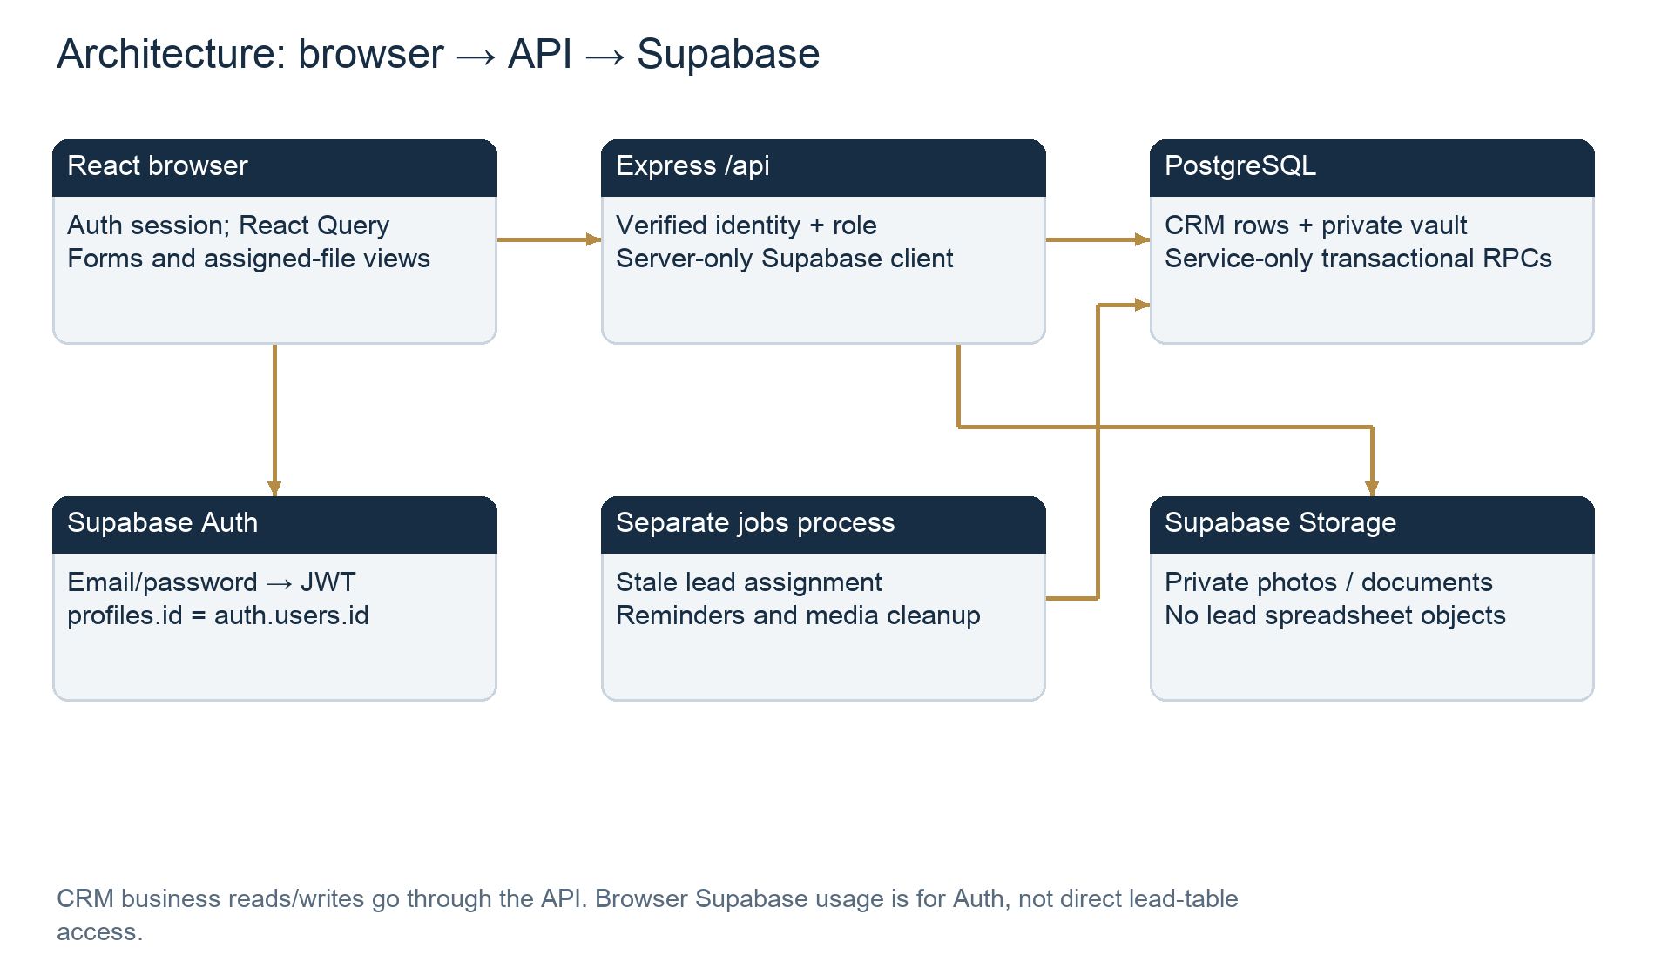
Figure 1. Architecture: browser → API → Supabase

Configuration and session initialization
client/src/lib/supabase.js creates the main browser Auth client from VITE_SUPABASE_URL and VITE_SUPABASE_ANON_KEY. A candidate login client has persistence, token refresh and URL detection disabled. signInToPortal authenticates in that isolated client, calls /api/me?portal=agent|admin with its token, then installs tokens only after the active profile’s role matches. Server getAdmin() reads SUPABASE_URL and SUPABASE_SERVICE_ROLE_KEY and disables server session persistence. Actual environment values were neither read nor reproduced.
Vite’s dev proxy reads only the root PORT setting and proxies /api. The local Supabase configuration exposes public and graphql_public, not crm_private; it enables Auth/Storage and disables public signup. These local declarations do not verify hosted dashboard settings. The main SDK Auth session may persist through SDK defaults; that is separate from lead import File objects and revealed phone component memory.
Source: client/src/lib/supabase.js:1; client/src/lib/portalLogin.js:6; server/src/config/supabaseAdmin.js:2; client/vite.config.js:4; supabase/config.toml:5; client/src/context/AuthContext.jsx:57

3. Admin upload: complete call chain
Step | Source location and action | Persistence / result
1. Pick file | Leads.jsx:209–228 → importInput.current.click(); onChange importLeads (66). | Native chooser accepts .csv/.xlsx/.xls. File is browser memory, not a server path.
2. Local checks | importLeads:71–79 checks extension and 5 MiB. | Readable error; file input reset permits choosing the same file again.
3. Submit multipart | submitImport:87–99; api.js:2–21. | FormData file plus optional JSON mapping; Bearer session; browser sets multipart boundary.
4. Authorize/bound upload | app.js:32; crm.routes.js:133–138; Multer config:56–59. | Active profile, adminOnly and sensitiveLimit before memoryStorage single(file); 5 MiB / one file.
5. Parse file | importLeadFile → parseLeadImport:280; csvRecords:100 or excelRecords:116. | Synchronous backend parsing; no Edge Function, job queue, disk spool or Storage upload.
6. Resolve headers | leadRows:165–238; IMPORT_COLUMNS_REQUIRED response. | Unknown/duplicate/missing required headings open mapping without database writes.
7. Re-submit mapping | Leads.jsx:145–173; mappingSchema and indices checks. | The same File object is uploaded again with field→zero-based-column mapping.
8. Validate rows | resolveImportAgents:320; leadCreate; normalizePhone; importFiles.js:47–75. | Each row becomes validated data + private normalized phone, or a safe row error.
9. Persist one RPC | importFiles.js:85 → import_leads (014:51). | Batch + accepted leads + private phones + assignment/audit history commit together; row subtransactions allow partial acceptance.
10. Return/display | importFiles.js:93; Leads.jsx:436–489. | import_id, filename/format/worksheet, accepted IDs/errors/warnings and skipped headings. React Query invalidated; page reset.
Source: client/src/pages/admin/Leads.jsx:66; client/src/lib/api.js:2; server/src/routes/crm.routes.js:56; server/src/routes/crm.routes.js:133; server/src/services/importFiles.js:41; server/src/services/leadImport.js:280; supabase/migrations/014_import_files_and_assignments.sql:51
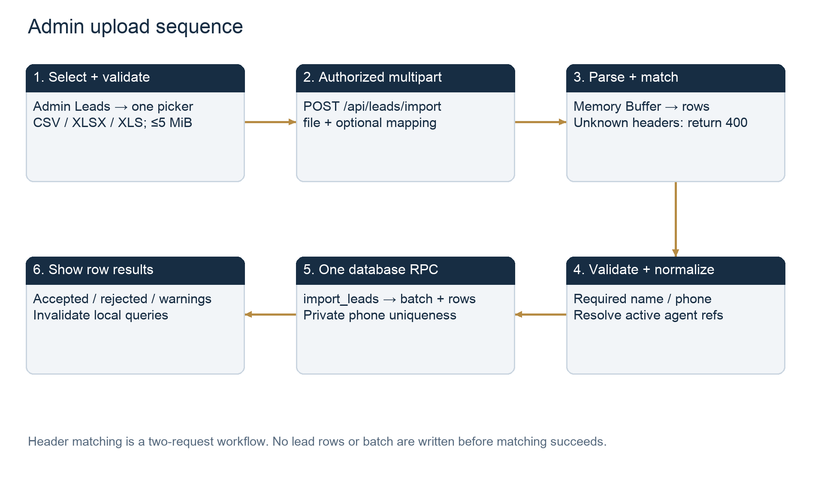
Figure 2. Admin upload sequence

Validation details and supported column mapping
Field / rule | Actual behavior
name; phone | Required. Name 1–200 characters; input phone 10–30 characters then normalized to +10–15 digits and SQL nonzero country-code format.
email | Optional blank or a Zod-valid email; blank persists as NULL via create_lead.
budget_min; budget_max | Coerced numeric PKR, 0–10¹³; min defaults to zero, max optional/null and cannot be below min.
preferred_location | Optional text up to 4,000 characters. preferred_area is a recognized alias; city alone is not a separate stored field.
property_id | Optional CRM property UUID; database FK requires an existing property. A title/external property reference is not automatically resolved.
assigned_agent | Optional active agent UUID or exact normalized name. NFKC/case/whitespace normalized; missing, ambiguous, admin or inactive references leave the row unassigned with a warning.
source | A supported mapping field, but spreadsheet imports force source=CSV for CSV, XLSX and XLS. File format remains separately stored.
Headers | NFKC + lowercase + strip non-letter/digits; aliases for full name, mobile, contact no, email address, budget min/max PKR, preferred area etc. Explicit matching uses zero-based indices 0–31; one index per field.
Extra fields | External lead_id, city/country as separate fields, property_type, priority, arbitrary status/notes etc. are not created as new columns. They must map to supported semantics or be skipped.
CSV validation | Fatal UTF-8 decode; BOM supported; trimmed cells; quoted records and blank lines; strict parse errors become safe Invalid CSV. Physical line number info retained.
Excel validation | ZIP signature for XLSX; OLE compound or legacy BIFF for XLS. Unencrypted first worksheet only; 1,002-row parse bound detects excess, physical range ≤row 1001 and <32 columns.
Cell values | Plain-text headers. Matched formula cells reject their row; formulas are not executed. Only text/numeric matched cells accepted. Skipped formulas do not become CRM data.
Numeric phones | Use Excel Text format. Leading-zero formatted numeric strings can be retained; unsafe integer/truncated short numeric values are rejected rather than guessed.
MIME versus content | Chooser accept advertises MIME hints, but the lead backend has no mimetype allowlist/fileFilter. Extension + parser/signatures enforce format. Photo/document uploads have different MIME/signature checks.
Source: server/src/services/leadImport.js:6; server/src/services/leadImport.js:18; server/src/services/leadImport.js:84; server/src/services/leadImport.js:116; server/src/services/leadImport.js:165; server/src/services/leadImport.js:242; server/src/services/leadImport.js:320; server/src/utils/validators.js:103; server/src/routes/crm.routes.js:56
Phone normalization removes spaces, parentheses, plus signs, dots and hyphens, strips a leading 00, converts an initial 0 to country prefix 92, then requires 10–15 digits and prepends +. This is a format normalizer, not telecom validation. It assumes any local leading-zero number is Pakistani; users should supply explicit country codes for other countries. The private phone text is unique across every lead, not just a file or an agent. The SQL import check also rejects a normalized country code beginning with zero.
Source: server/src/utils/phoneMask.js:1; supabase/migrations/002_leads.sql:2; supabase/migrations/014_import_files_and_assignments.sql:74

4. PostgreSQL insertion, partial failures and retries
No new table is created per upload. importLeadFile sends prepared rows to the service-only public.import_leads function. It takes advisory transaction lock 873420, checks the active admin and file/array bounds, creates one lead_imports UUID, then processes each row. create_lead inserts public.leads, crm_private.lead_phones and a create audit; if assigned_agent was supplied it calls assign_lead, then import_leads writes leads.import_id to connect the new lead to this batch.
For each row, an EXCEPTION block is a PostgreSQL subtransaction. A duplicate unique phone rolls back that row and reports Duplicate phone; other database failures for that row report Row rejected. Already-invalid prepared rows are counted without inserts. Successful rows survive other row rejections, subject to the overall RPC transaction committing. The batch count invariant imported_count + rejected_count = total_rows is finalized and an import audit is inserted before the RPC returns.
A failure outside those per-row handlers, including final audit failure, aborts the whole transaction: batch, accepted rows, phones and their audits are not independently committed. Conversely, an all-rejected but otherwise valid import still persists one batch with zero accepted leads, and the Task assign button is disabled for that batch.
Source: server/src/services/importFiles.js:85; supabase/migrations/010_atomic_operations.sql:14; supabase/migrations/014_import_files_and_assignments.sql:51; client/src/components/leads/ImportedFiles.jsx:165
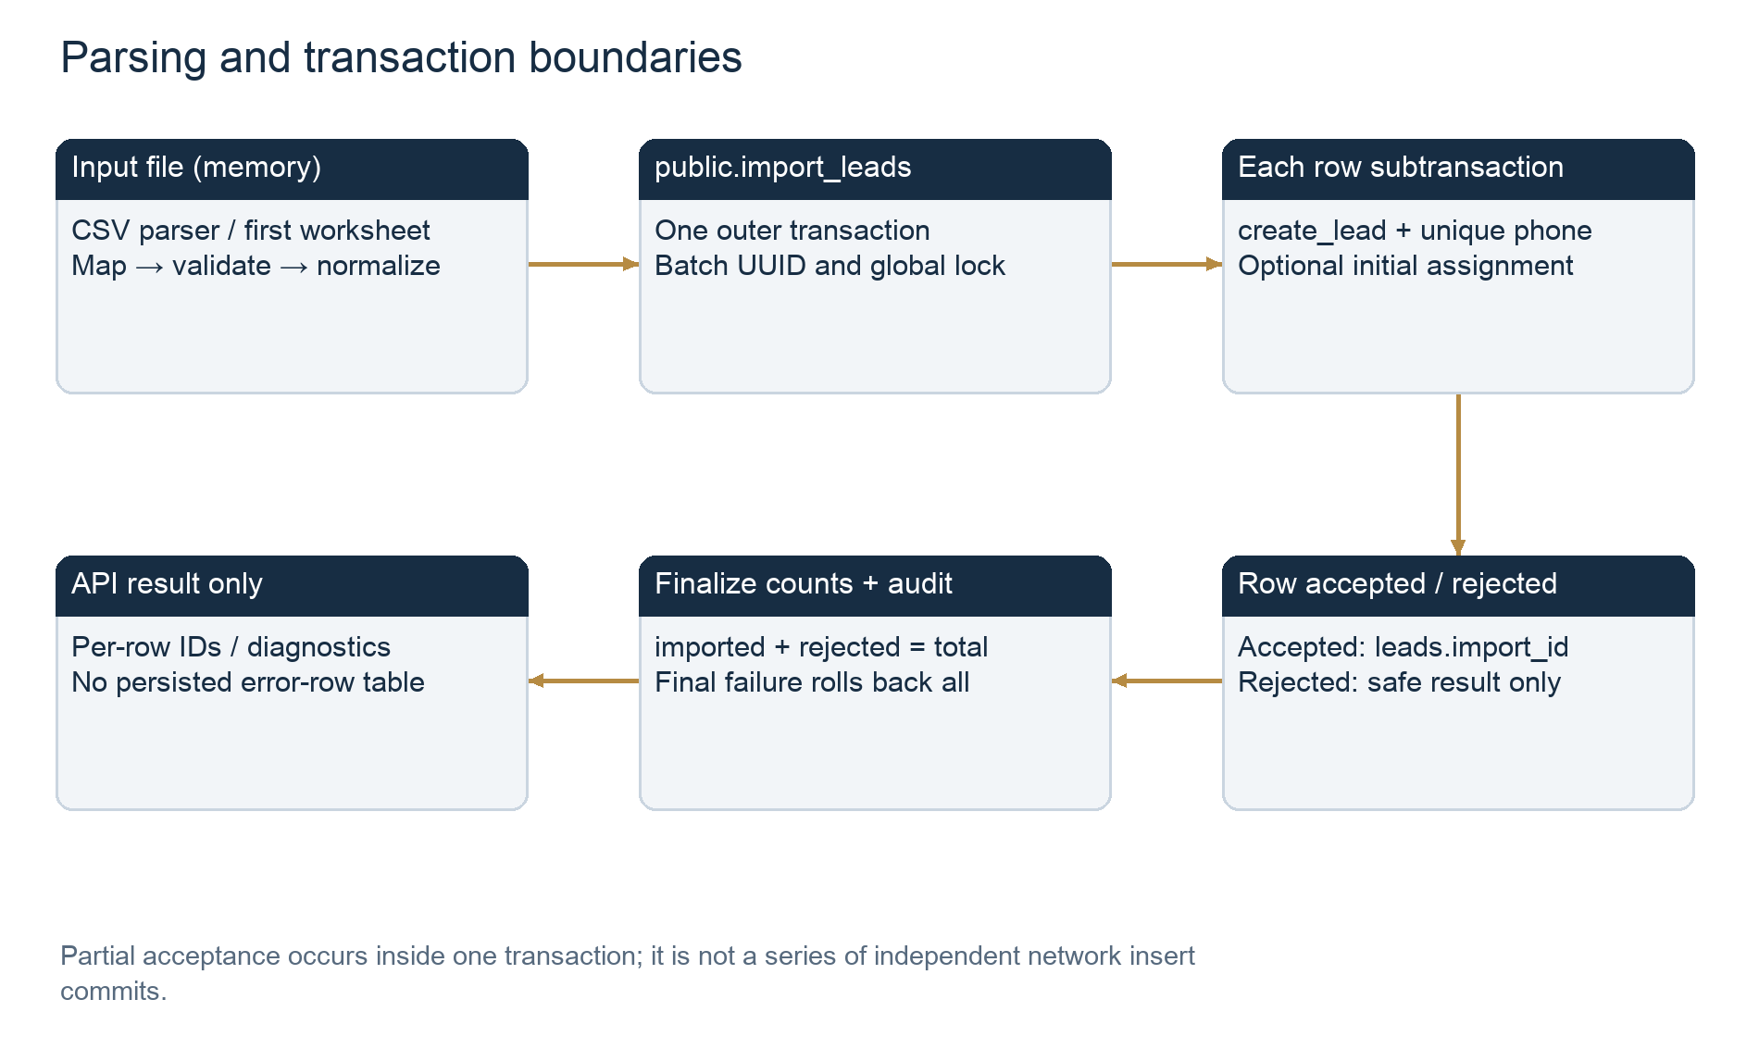
Figure 3. Parsing and transaction boundaries
Scenario | What persists / user-visible outcome
Bad extension, corrupt file, missing header, mapping needed, row/size limit | Request fails before import_leads; no new import batch or lead writes.
Some invalid rows / duplicates | One batch with aggregate counts; accepted new leads and phone identities; rejected rows have no new lead. Row-by-row diagnostics are returned to the UI only.
Active-agent lookup unavailable | 503 before import RPC; safe message says no leads imported.
Upload repeated unchanged | New batch each time; existing normalized phones reject rather than update or move those leads. Original leads retain original import_id. There is no file-hash deduplication or request idempotency key.
Failed rows corrected then re-uploaded | Another new batch; corrected genuinely new phones accepted. Already accepted identities are rejected as duplicates; no merge into the original batch.
Response lost after database commit — inference | Browser may show network error even though transaction committed. Retrying can create a rejected-only batch. Check history before retrying; no idempotent upload receipt reconciliation exists.
Reload/close result dialog | Database history and accepted records remain; transient per-row results, ignored columns and mapping selections are not persisted.
Progress | Importing… disables the import action; a results dialog shows counts/warnings/errors. No percentage, upload progress callback, streaming progress, cancelable worker or background import status exists.
Source: server/src/services/leadImport.js:336; supabase/migrations/014_import_files_and_assignments.sql:66; supabase/migrations/014_import_files_and_assignments.sql:85; client/src/pages/admin/Leads.jsx:87; client/src/pages/admin/Leads.jsx:436

5. Admin-to-agent assignment

Whole-file assignment through Task assign
App routes /tasks through Protected role=admin and renders ImportedFiles assignable. The component fetches /lead-imports and the admin-only /users directory. Each nonempty row has Assign file. Opening the modal selects one active agent; the modal explicitly warns that all file members, including those assigned to someone else, will move to the selected agent. assignFile posts {agent_id} to /lead-imports/:id/assign, then invalidates the browser queries and shows File assigned.
The API validates UUIDs and strict body shape, and applies adminOnly/sensitiveLimit. assign_lead_import uses lock 873420, validates active admin and active agent, locks the batch and all member leads in ID order, calls assign_lead for members whose owner differs, updates batch-level assignment metadata and appends assign_file audit. A failure propagates and rolls the entire operation back. It does not split a file by a numeric count, exclude won/lost leads or leave already-owned leads unchanged when another owner is selected.
Source: client/src/App.jsx:55; client/src/components/leads/ImportedFiles.jsx:20; client/src/components/leads/ImportedFiles.jsx:48; client/src/components/leads/ImportedFiles.jsx:205; server/src/routes/crm.routes.js:167; supabase/migrations/014_import_files_and_assignments.sql:146
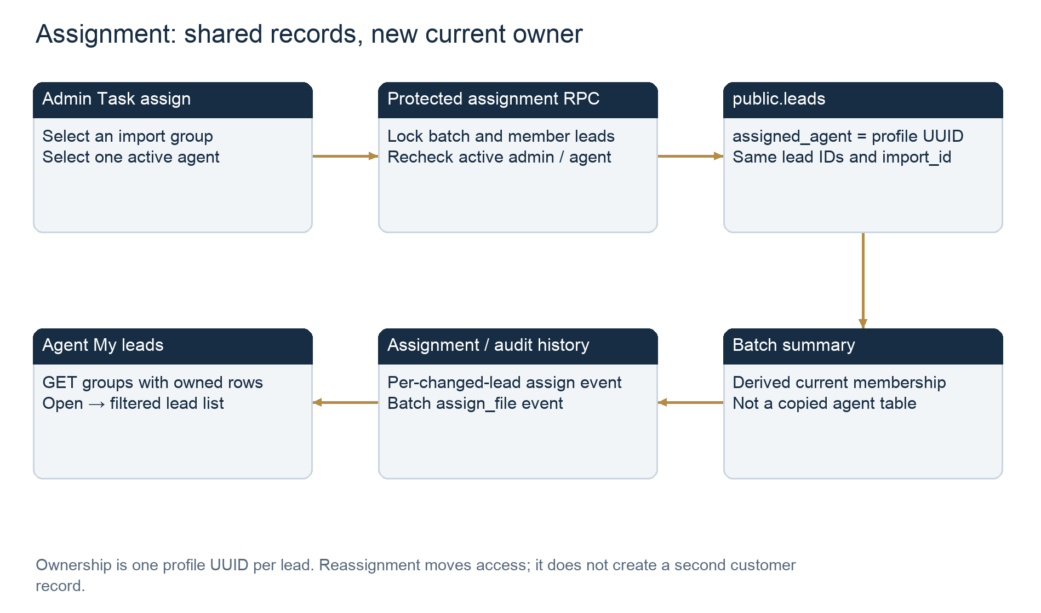
Figure 4. Assignment: shared records, new current owner

Individual assignment, upload-time assignment and mixed groups
- During upload: matched assigned_agent cells resolve to one active profile per row; blank/unmatched references leave that row unassigned. Thus a single imported group can contain different owners from the outset.
- On a profile: Assign / round-robin opens a select; choosing an agent calls POST /leads/:id/assign. A blank/null target means round-robin, not unassignment. The SQL chooses an active agent by oldest/latest assignment history (max(assignments.created_at) NULLS FIRST, then ID), not by least current workload.
- No numeric bulk split UI exists. To make a 100/150 split from one file, provide per-row ownership on import or make individual administrative reassignments. Whole-file assignment always assigns every accepted member to one agent.
- leads.assigned_agent is the current authority. assignments is append-only by application behavior, with agent and actor history; it is not the access-control join table. Unlike audit_log, assignments has no declared immutable trigger.
- lead_imports.assigned_agent/by/at record the last whole-file operation. The summary recomputes current owners from leads, so direct individual changes can make that stored summary metadata stale. Mixed assignment is derived, not an independent assignment group table.
- Repeating whole-file assignment to the same target skips unchanged per-lead assignment records but updates the batch timestamp and writes another assign_file audit with assigned_count=0. Repeating individual assignment does write another assignment event even when the owner is unchanged. Neither creates duplicate leads.
Source: server/src/services/leadImport.js:320; client/src/pages/agent/LeadDetail.jsx:288; server/src/services/leadAssignment.js:1; supabase/migrations/010_atomic_operations.sql:1; supabase/migrations/014_import_files_and_assignments.sql:103; supabase/migrations/014_import_files_and_assignments.sql:158

Notifications and activity after assignment
Assignment writes update the lead activity timestamp, append assignment history and audit records, and become visible in the profile timeline. There is no assignment email, WhatsApp, push notification or dedicated assignment reminder insertion in this call chain. Follow-up reminders are a separate job. Existing calls, followups, visits and deals retain their historical agent_id when the current lead owner changes; assign_lead does not transfer those columns or existing reminders.
The job for stale open leads can round-robin up to 100 eligible records per tick when configured and running. Disabling an agent sets profiles.active=false through PIN-gated Accounts and denies future API requests; the inspected update_account function does not immediately return its leads or transfer pending follow-ups/visits. That is pending P3 work, not an existing guarantee.
Source: supabase/migrations/010_atomic_operations.sql:9; server/src/routes/crm.routes.js:218; supabase/migrations/011_jobs_and_events.sql:16; server/src/jobs/runner.js:10; supabase/migrations/016_accounts_and_security.sql:118

6. What agents actually open, import or export
No agent export/import button or downstream spreadsheet-write workflow was found. The agent’s default /leads route renders ImportedFiles. Its file card is a React Router Link to /leads?import_id=<batch UUID> and says Open leads →. That URL renders LeadList and requests GET /leads with import_id. It also reads the authorized batch summary. Both operations read already existing database rows; no Storage file, download generator, lead insert or assignment mutation is triggered.
Proposed interpretation | Supported? | Actual behavior
A. Download original spreadsheet | No | Original spreadsheet bytes are not stored and there is no lead-file download route.
B. Generate new lead CSV/Excel | No | No customer-lead export handler. Admin report CSV contains aggregates only.
C. Import a file into agent leads | No | Open leads navigates to a filtered shared-table view; no personal lead-copy table exists.
D. Create new leads | No | Agent cannot call admin import/create routes; opening a card only issues GET requests.
E. Change ownership / assignment | No | File click does not call assign routes; admin operations perform ownership changes separately.
F. Combined import/export | No | The discovered agent action is read/navigation, while Admin import and Admin report export are separate functions.
Source: client/src/pages/admin/Leads.jsx:36; client/src/components/leads/ImportedFiles.jsx:181; client/src/pages/admin/Leads.jsx:175; server/src/routes/crm.routes.js:540; server/src/routes/crm.routes.js:133
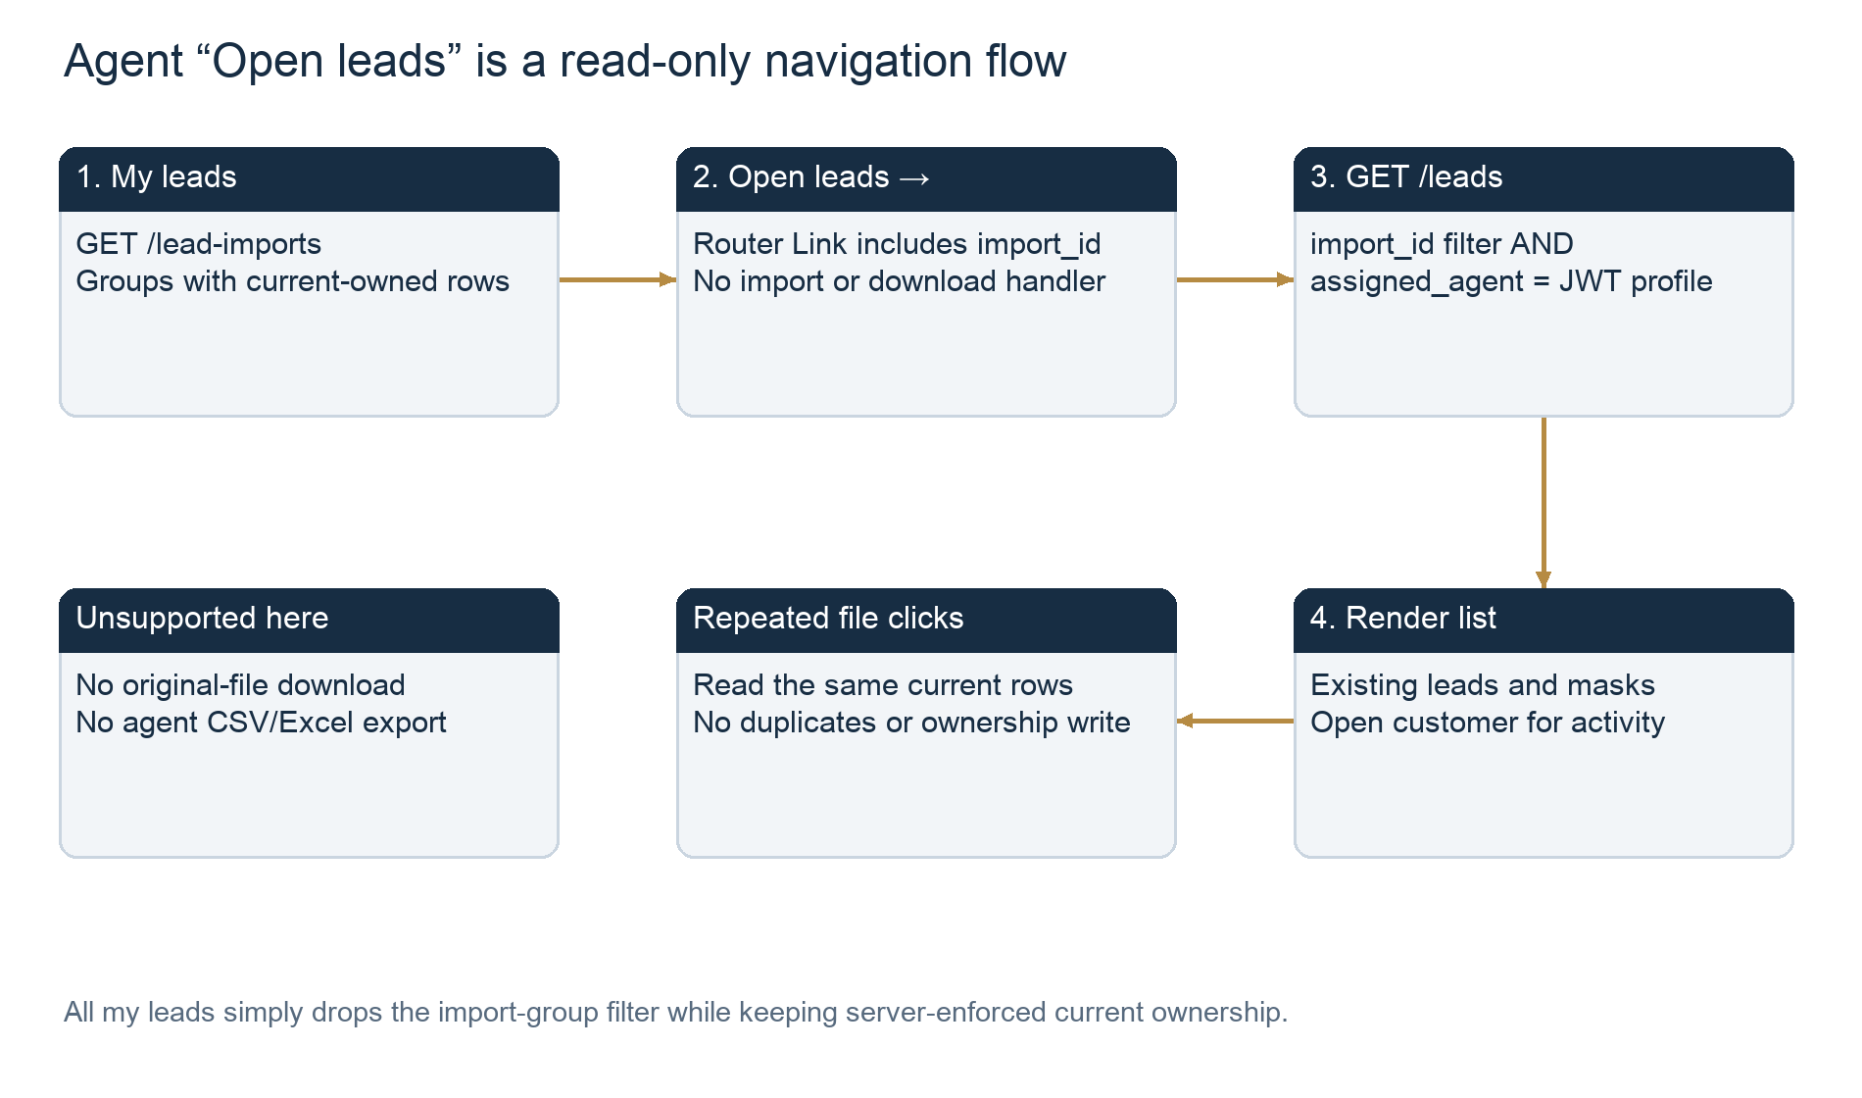
Figure 5. Agent “Open leads” is a read-only navigation flow

Admin CSV export and shared document download are different actions
Admin → Reports → Export CSV calls api(/reports/export?... , {download:true}). The server admin-only endpoint invokes crm_metrics using validated date/agent/source filters, keeps numeric values and serializes metric,value rows with csvCell escaping. The filename is hd-marketing-report.csv. api() reads the response as a Blob; download() creates a temporary object URL, clicks an anchor with a download filename and revokes the URL after one second. No database rows, assignments or Storage objects are created/updated/deleted by this handler; repeated export downloads a fresh aggregate snapshot. The export path has no explicit export audit insertion.
Both roles also have Documentation & policies attachment downloads. Those retrieve existing PDF/DOC/DOCX binaries from knowledge-files via an authorized server route, write download_file audit and save a Blob on the device. This is neither the original lead spreadsheet nor an import into My leads; those supported document MIME types do not include XLS/XLSX/CSV.
Source: client/src/pages/admin/Reports.jsx:33; server/src/routes/crm.routes.js:485; server/src/utils/phoneMask.js:12; client/src/lib/api.js:49; client/src/pages/shared/Documentation.jsx:437; server/src/routes/documents.routes.js:165

7. Declared database inventory and relationships
The repository declares 26 application tables across public and crm_private, plus references to Supabase-managed auth.users and storage.buckets. The following inventory is derived from ordered migrations 001–019, not a live catalog. Detailed dictionaries below include every declared application table to make the boundaries clear. Original import rows, assigned lead copies, campaigns, upload blobs and export receipts have no separate declared tables.
Table | Purpose | Main write/read path
public.profiles | CRM identity/active role; UUID equals Auth user UUID. | Auth profile trigger; auth middleware and agent resolution read it; PIN-gated Accounts updates it.
public.lead_imports | Filename/format/worksheet/count history and last whole-file assignment metadata. | import_leads inserts/finalizes; page/summary read; assign_lead_import updates. No source blob/path.
public.leads | Shared canonical customer metadata, current ownership and batch membership. | create_lead/import_leads insert; list/ownedLead/metrics read; assign_lead and crm_mutate update. No lead-delete route.
crm_private.lead_phones | Unique normalized full phone identity, separated from lead mask. | create_lead inserts; reveal_phone/private_phone read; no CRM phone-edit endpoint.
public.assignments | Per-lead assignment events, target agent and actor. | assign_lead inserts; timeline and round-robin selection read. No agent assignment writes.
public.audit_log | Append-only request-linked business action history. | Protected functions/server audit insert; Admin audit page reads; immutable trigger blocks UPDATE/DELETE.
public.lead_status_history | Prior/new lead stage, actor/loss reason/request. | Status-change trigger inserts; timeline reads. Not imported spreadsheet status.
public.notes | Customer notes with historical responsible agent. | crm_mutate inserts; owned timeline reads.
public.calls | Provider/mock/manual call timing, result and historical agent. | crm_mutate/log_manual_call/provider event update; timeline/metrics/review read.
public.followups | Scheduled follow-up activity and historical agent. | crm_mutate inserts/updates; lead-scoped lists and reminder job read.
public.visits | Property visits, schedule/status and historical agent. | crm_mutate inserts/updates; lists/metrics read.
public.reminders | Follow-up due notifications per agent and due timestamp. | run_crm_job inserts; own reminder endpoint reads/marks read. Not assignment notification records.
public.deals | At most one deal per customer, property and responsible agent. | crm_mutate inserts/updates; lists/report aggregates read.
public.properties | Shared property inventory linked by interested property, visit and deal FKs. | Admin mutations and eligible deletion; shared role reads. Import can only reference an existing UUID.
public.property_photos | Private photo path metadata, unrelated to lead spreadsheet files. | Admin photo routes insert/delete; authorized reader gets signed URL.
crm_private.recordings | Private recording storage/provider reference and deletion state. | Provider event/recording RPCs; admin playback, retention deletion. Manual call logs create no binary recording.
public.knowledge_documents | Shared written documentation/category/search fields. | Admin document RPC writes; active-team list/detail reads; no lead_id in this snapshot.
public.knowledge_files | Metadata/path for PDF/DOC/DOCX attachments. | attach/delete RPCs; server download joins document/file identity and reads Storage.
public.knowledge_file_cleanup | Durable document upload reservation/deletion queue. | Upload reservation and delete RPCs insert; cleanup job removes Storage and then queue records.
public.property_photo_cleanup | Durable deletion queue for property images. | Property delete RPC queues; cleanup helper removes images and queue rows.
crm_private.phone_reveals | P2 successful reveal ledger; per-agent distinct Pakistan-day quota. | reveal_phone inserts; own usage/limit functions read. Present locally; hosted installation unverified.
public.security_alerts | P2 number-access warnings/limit notices and review state. | reveal_phone inserts; admin-only RPC page/count/review. Not import/export data.
public.targets | Agent-month goals used with aggregate actuals. | Admin crm_mutate writes; overview/targets read.
public.integration_events | Provider/event deduplication key. | Signed mock event path inserts/checks; not import idempotency tracking.
public.account_security | Personal admin PIN hash/version/failures/lockout. | Accounts security RPCs read/write; no spreadsheet content or export metadata.
public.account_unlocks | Hashed temporary session-bound Accounts grants. | Unlock/lock/gated account functions; not lead ownership.

Relationship meaning
profiles.id references auth.users.id. A lead can have zero or one import group, current assigned profile and interested property. Each lead has at most one private phone row by primary key; create_lead writes one for every successfully created customer. A group contains many leads. assignments contains many historical events per lead and references the target and actor profiles. These relationships implement a shared-table view, not agent-specific copies.
Activities reference the lead and a historical profile, and visits/deals also reference properties. Audit entity/entity_id are generic labels/text, not foreign keys to each business table. Storage-path metadata references a text object path by convention; it is not a database FK to storage.objects. Cleanup queues deliberately do not require the original deleted entity to remain. Auth/Storage managed schemas are outside the full DDL supplied in this repo; their complete columns/indices were not inferred.
Source: supabase/migrations/001_users_and_roles.sql:2; supabase/migrations/002_leads.sql:1; supabase/migrations/004_properties.sql:2; supabase/migrations/014_import_files_and_assignments.sql:3; supabase/migrations/008_audit_log.sql:1
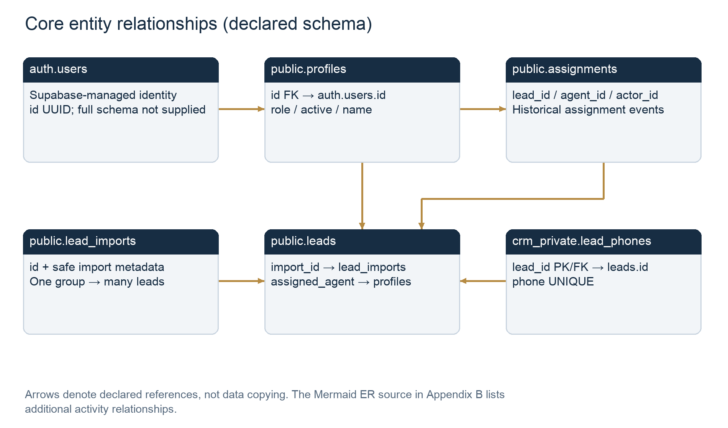
Figure 6. Core entity relationships (declared schema)

Column dictionaries, final constraints and indexes
Notation: omitted NOT NULL means nullable unless the column is a primary key; omitted DEFAULT means no declared default. UUIDs without explicit generation are supplied by the caller/FK. PK and UNIQUE create their own database indexes. References shown below default to NO ACTION unless ON DELETE is explicitly stated. Column definitions incorporate known later additions; final replacement checks and named indexes follow each table.

public.profiles
Column | Type | Nullability / default / key / check
id | uuid | primary key references auth.users(id)
name | text | not null
role | text | not null default 'agent' check(role in ('admin','agent'))
active | boolean | not null default true
created_at | timestamptz | not null default now()
role admin/agent, defaults agent. Auth insert trigger creates name/active profile; 016’s replacement respects trusted crm_provisioning app metadata by creating a temporarily inactive profile. No email column; Auth owns email. No updated_at column.
Source: supabase/migrations/001_users_and_roles.sql:2

public.lead_imports
Column | Type | Nullability / default / key / check
id | uuid | primary key default gen_random_uuid()
file_name | text | not null check(length(file_name) between 1 and 200)
file_format | text | not null check(file_format in ('csv','xlsx','xls','legacy'))
worksheet | text | Nullable; Nullable; no declared default
total_rows | integer | not null check(total_rows>=0)
imported_count | integer | not null default 0 check(imported_count>=0)
rejected_count | integer | not null default 0 check(rejected_count>=0)
created_by | uuid | Nullable; references public.profiles(id)
created_at | timestamptz | not null default now()
assigned_agent | uuid | Nullable; references public.profiles(id)
assigned_by | uuid | Nullable; references public.profiles(id)
assigned_at | timestamptz | Nullable; Nullable; no declared default
legacy | boolean | not null default false
Table constraints: check(imported_count+rejected_count=total_rows)
CHECK imported_count+rejected_count=total_rows. file_format: csv/xlsx/xls/legacy; filename 1–200; counts ≥0. Index lead_imports_created(created_at DESC,id). No content hash, source path, campaign ID, saved mapping or error-detail column.
Source: supabase/migrations/014_import_files_and_assignments.sql:3

public.leads
Column | Type | Nullability / default / key / check
id | uuid | primary key default gen_random_uuid()
name | text | not null check(length(name)>0)
masked_phone | text | not null
email | text | Nullable; Nullable; no declared default
source | text | not null default 'manual' check(source in ('manual','CSV','Meta','WhatsApp','other'))
property_id | uuid | Nullable; Nullable; no declared default
budget_min | numeric | not null default 0 check(budget_min>=0)
budget_max | numeric | Nullable; check(budget_max>=budget_min)
preferred_location | text | Nullable; Nullable; no declared default
assigned_agent | uuid | Nullable; references public.profiles(id)
status | text | not null default 'new' check (final stages listed below)
created_at | timestamptz | not null default now()
updated_at | timestamptz | not null default now()
last_activity_at | timestamptz | not null default now()
lost_reason | text | Nullable; Nullable; no declared default
lost_note | text | Nullable; Nullable; no declared default
lost_at | timestamptz | Nullable; Nullable; no declared default
import_id | uuid | Nullable; references public.lead_imports(id)
Final status CHECK after 012: new, contacted, interested, visit_scheduled, visit_done, negotiation, won, lost. lost_reason nullable: price, location, budget, not_interested, no_response, bought_elsewhere, wrong_number, other; lost_note ≤500; lost status requires a reason. property_id FK added by 004. Indexes: leads_agent_status(assigned_agent,status), leads_created(created_at), leads_activity(last_activity_at), leads_search GIN(to_tsvector('simple',name)), leads_lost_reason partial WHERE status='lost', leads_import_assignment(import_id,assigned_agent). Name list search uses ILIKE, not this FTS expression.
Source: supabase/migrations/002_leads.sql:1

crm_private.lead_phones
Column | Type | Nullability / default / key / check
lead_id | uuid | primary key references public.leads(id) on delete cascade
phone | text | not null unique
phone UNIQUE; lead_id PK/FK ON DELETE CASCADE. Private schema/table revokes and service role protect access; no explicit RLS enable declaration for this private table. Cascade alone is not a lead-delete product feature.
Source: supabase/migrations/002_leads.sql:2

public.assignments
Column | Type | Nullability / default / key / check
id | uuid | primary key default gen_random_uuid()
lead_id | uuid | not null references public.leads(id)
agent_id | uuid | Nullable; references public.profiles(id)
actor_id | uuid | Nullable; references public.profiles(id)
created_at | timestamptz | not null default now()
No declared uniqueness per lead/agent and no immutable trigger. Reassignment intentionally adds history; repeats of individual assignment add more events. No standalone assignment index beyond PK is declared.
Source: supabase/migrations/002_leads.sql:3

public.audit_log
Column | Type | Nullability / default / key / check
id | bigint | generated always as identity primary key
actor_id | uuid | Nullable; references public.profiles(id)
action | text | not null
entity | text | not null
entity_id | text | Nullable; Nullable; no declared default
request_id | text | Nullable; Nullable; no declared default
metadata | jsonb | not null default '{}'
created_at | timestamptz | not null default now()
audit_immutable BEFORE UPDATE OR DELETE calls block_audit_changes(). entity_id is text, with no per-entity FK. There is no dedicated entity/request index in the inspected declarations.
Source: supabase/migrations/008_audit_log.sql:1

public.lead_status_history
Column | Type | Nullability / default / key / check
id | uuid | primary key default gen_random_uuid()
lead_id | uuid | not null references public.leads(id)
from_status | text | Nullable; Nullable; no declared default
to_status | text | not null
actor_id | uuid | Nullable; references public.profiles(id)
lost_reason | text | Nullable; Nullable; no declared default
request_id | text | Nullable; Nullable; no declared default
created_at | timestamptz | not null default now()
Index lead_status_history_lead_created(lead_id,created_at DESC); prepare_lead_status and record_lead_status_change manage loss fields/history on public.leads.
Source: supabase/migrations/012_pipeline_and_lost_reasons.sql:12

public.notes
Column | Type | Nullability / default / key / check
id | uuid | primary key default gen_random_uuid()
lead_id | uuid | not null references public.leads(id)
agent_id | uuid | not null references public.profiles(id)
body | text | not null
created_at | timestamptz | not null default now()
body text NOT NULL; no declared length CHECK beyond API limits; agent_id records the agent when created. No note UPDATE/DELETE handler or standalone note index is declared.
Source: supabase/migrations/002_leads.sql:4

public.calls
Column | Type | Nullability / default / key / check
id | uuid | primary key default gen_random_uuid()
lead_id | uuid | not null references public.leads(id)
agent_id | uuid | not null references public.profiles(id)
provider_call_id | text | Nullable; unique
status | text | not null default 'initiated' check(status in ('initiated','ringing','completed','failed'))
started_at | timestamptz | not null default now()
ended_at | timestamptz | Nullable; Nullable; no declared default
duration_seconds | integer | not null default 0 check(duration_seconds>=0)
outcome | text | Nullable; check(outcome in ('No answer','Busy','Wrong number','Interested','Not interested','Follow-up required','Site visit scheduled','Deal discussion'))
notes | text | Nullable; Nullable; no declared default
deal_tags | text[] | not null default '{}'
outcome_submitted_at | timestamptz | Nullable; Nullable; no declared default
missing_outcome | boolean | not null default false
created_at | timestamptz | not null default now()
method | text | not null default 'provider' check(method in ('provider','mock','manual'))
answered | boolean | Nullable; Nullable; no declared default
018 adds method CHECK provider/mock/manual and calls_manual_values_check: valid manual answered/outcome/time/duration state; calls_method_created(method,created_at DESC). Base index calls_agent_started(agent_id,started_at). provider_call_id UNIQUE. No updated_at column.
Source: supabase/migrations/003_calls.sql:1

public.followups
Column | Type | Nullability / default / key / check
id | uuid | primary key default gen_random_uuid()
lead_id | uuid | not null references public.leads(id)
agent_id | uuid | not null references public.profiles(id)
due_at | timestamptz | not null
notes | text | Nullable; Nullable; no declared default
status | text | not null default 'pending' check(status in ('pending','completed','cancelled'))
created_at | timestamptz | not null default now()
updated_at | timestamptz | not null default now()
Status pending/completed/cancelled; followups_due(agent_id,status,due_at). touch_updated on update. Ownership changes do not rewrite historical agent_id.
Source: supabase/migrations/006_followups_and_visits.sql:1

public.visits
Column | Type | Nullability / default / key / check
id | uuid | primary key default gen_random_uuid()
lead_id | uuid | not null references public.leads(id)
property_id | uuid | not null references public.properties(id)
agent_id | uuid | not null references public.profiles(id)
scheduled_at | timestamptz | not null
status | text | not null default 'scheduled' check(status in ('scheduled','completed','cancelled','no-show'))
notes | text | Nullable; Nullable; no declared default
created_at | timestamptz | not null default now()
updated_at | timestamptz | not null default now()
Status scheduled/completed/cancelled/no-show; visits_scheduled(agent_id,scheduled_at). touch_updated on update.
Source: supabase/migrations/006_followups_and_visits.sql:2

public.reminders
Column | Type | Nullability / default / key / check
id | uuid | primary key default gen_random_uuid()
agent_id | uuid | not null references public.profiles(id)
followup_id | uuid | not null references public.followups(id)
due_at | timestamptz | not null
read_at | timestamptz | Nullable; Nullable; no declared default
created_at | timestamptz | not null default now()
Table constraints: unique(followup_id,due_at)
UNIQUE(followup_id,due_at). A preexisting reminder keeps its stored agent_id when the lead moves; the job uses ON CONFLICT DO NOTHING.
Source: supabase/migrations/006_followups_and_visits.sql:3

public.deals
Column | Type | Nullability / default / key / check
id | uuid | primary key default gen_random_uuid()
lead_id | uuid | not null unique references public.leads(id)
property_id | uuid | not null references public.properties(id)
agent_id | uuid | not null references public.profiles(id)
stage | text | not null check(stage in ('discussion','negotiation','won','lost'))
expected_value | numeric | not null check(expected_value>=0)
close_date | date | Nullable; Nullable; no declared default
notes | text | Nullable; Nullable; no declared default
created_at | timestamptz | not null default now()
updated_at | timestamptz | not null default now()
lost_reason | text | Nullable; Nullable; no declared default
lost_note | text | Nullable; Nullable; no declared default
Table constraints: check(stage<>'won' or close_date is not null)
UNIQUE lead_id; stages discussion/negotiation/won/lost; won requires close_date. 012 adds supported loss-reason set, lost_note≤500 and reason required for lost. deals_agent_close(agent_id,close_date). touch_updated on update.
Source: supabase/migrations/007_deals.sql:1

public.properties
Column | Type | Nullability / default / key / check
id | uuid | primary key default gen_random_uuid()
title | text | not null
description | text | not null default ''
location | text | not null
price | numeric | not null check(price>=0)
type | text | not null
area | numeric | not null check(area>0)
area_unit | text | not null check(area_unit in ('sq ft','marla','kanal'))
availability | text | not null default 'available' check(availability in ('available','reserved','sold','archived'))
created_at | timestamptz | not null default now()
updated_at | timestamptz | not null default now()
price≥0; area>0; area_unit sq ft/marla/kanal; availability available/reserved/sold/archived. touch_updated. Eligible delete blocked by linked leads/visits/deals.
Source: supabase/migrations/004_properties.sql:1

public.property_photos
Column | Type | Nullability / default / key / check
id | uuid | primary key default gen_random_uuid()
property_id | uuid | not null references public.properties(id)
storage_path | text | not null unique
created_at | timestamptz | not null default now()
storage_path UNIQUE; FK property_id has no cascade. Property deletion RPC removes metadata and queues paths explicitly.
Source: supabase/migrations/004_properties.sql:3

crm_private.recordings
Column | Type | Nullability / default / key / check
call_id | uuid | primary key references public.calls(id)
storage_path | text | Nullable; Nullable; no declared default
provider_ref | text | Nullable; Nullable; no declared default
created_at | timestamptz | not null default now()
deleted_at | timestamptz | Nullable; Nullable; no declared default
deletion_attempts | int | not null default 0
last_error | text | Nullable; Nullable; no declared default
call_id PK/FK. No browser schema/table access; no explicit RLS enable declaration for this private table. Retention job defaults 7 days, supported 1–7.
Source: supabase/migrations/003_calls.sql:2

public.knowledge_documents
Column | Type | Nullability / default / key / check
id | uuid | primary key default gen_random_uuid()
title | text | not null check(length(btrim(title)) between 1 and 200)
category | text | not null check (final categories listed below)
content | text | not null check(length(btrim(content)) between 1 and 50000)
created_by | uuid | not null references public.profiles(id)
updated_by | uuid | not null references public.profiles(id)
created_at | timestamptz | not null default now()
updated_at | timestamptz | not null default now()
property_name | text | not null default '' check(length(property_name)<=200)
keywords | text | not null default '' check(length(keywords)<=500)
017 final category CHECK: documentation/policy/property_deeds/legal_noc/client_kyc/tenancy_agreements. property_name≤200; keywords≤500. knowledge_documents_updated(updated_at DESC,id). No lead_id or assigned-agent audience link.
Source: supabase/migrations/015_documentation_and_policies.sql:3

public.knowledge_files
Column | Type | Nullability / default / key / check
id | uuid | primary key default gen_random_uuid()
document_id | uuid | not null references public.knowledge_documents(id)
file_name | text | not null check(length(file_name) between 1 and 200)
mime_type | text | not null check(mime_type in ('application/pdf','application/msword','application/vnd.openxmlformats-officedocument.wordprocessingml.document'))
size_bytes | integer | not null check(size_bytes between 1 and 10485760)
storage_path | text | not null unique
created_by | uuid | not null references public.profiles(id)
created_at | timestamptz | not null default now()
Allowed PDF/DOC/DOCX MIME types; size 1–10,485,760 bytes; storage_path UNIQUE; knowledge_files_document(document_id,created_at). Does not store imported lead spreadsheets.
Source: supabase/migrations/015_documentation_and_policies.sql:18

public.knowledge_file_cleanup
Column | Type | Nullability / default / key / check
id | uuid | primary key default gen_random_uuid()
document_id | uuid | not null
storage_path | text | not null unique
not_before | timestamptz | not null default now()
created_at | timestamptz | not null default now()
storage_path UNIQUE; knowledge_file_cleanup_due(not_before). document_id is deliberately not a FK, allowing deletion cleanup after the document disappears.
Source: supabase/migrations/015_documentation_and_policies.sql:31

public.property_photo_cleanup
Column | Type | Nullability / default / key / check
id | uuid | primary key default gen_random_uuid()
property_id | uuid | not null
storage_path | text | not null unique
created_at | timestamptz | not null default now()
storage_path UNIQUE; property_photo_cleanup_created(created_at). property_id is deliberately not a FK.
Source: supabase/migrations/013_property_deletion.sql:6

crm_private.phone_reveals
Column | Type | Nullability / default / key / check
id | uuid | primary key default gen_random_uuid()
user_id | uuid | not null references public.profiles(id)
lead_id | uuid | not null references public.leads(id)
revealed_at | timestamptz | not null default now()
phone_reveals_user_time(user_id,revealed_at) INCLUDE lead_id. Repeats persist as events; quota counts distinct lead_id in the Pakistan-day window. RLS enabled in 019.
Source: supabase/migrations/019_protected_phone_numbers.sql:4

public.security_alerts
Column | Type | Nullability / default / key / check
id | uuid | primary key default gen_random_uuid()
type | text | not null
severity | text | not null check (severity in ('info','warning','critical'))
user_id | uuid | not null references public.profiles(id)
message | text | not null
metadata | jsonb | not null default '{}'::jsonb
created_at | timestamptz | not null default now()
reviewed_at | timestamptz | Nullable; Nullable; no declared default
reviewed_by | uuid | Nullable; references public.profiles(id)
Table constraints: check ((reviewed_at is null) = (reviewed_by is null))
severity info/warning/critical; reviewed_at/reviewed_by must both be null or both set. Index created_at DESC and partial unreviewed index. Partial unique phone_alerts_user_day(user_id,type,Pakistan date) for warning/limit types.
Source: supabase/migrations/019_protected_phone_numbers.sql:15

public.targets
Column | Type | Nullability / default / key / check
id | uuid | primary key default gen_random_uuid()
agent_id | uuid | not null references public.profiles(id)
month | date | not null check(extract(day from month)=1)
calls | int | not null default 0 check(calls>=0)
visits | int | not null default 0 check(visits>=0)
deals | int | not null default 0 check(deals>=0)
revenue | numeric | not null default 0 check(revenue>=0)
created_at | timestamptz | not null default now()
Table constraints: unique(agent_id,month)
UNIQUE(agent_id,month); month must be first of month; nonnegative calls/visits/deals/revenue. created_at added by 011.
Source: supabase/migrations/005_targets.sql:1

public.integration_events
Column | Type | Nullability / default / key / check
provider | text | not null
event_id | text | not null
created_at | timestamptz | not null default now()
Table constraints: primary key(provider,event_id)
Composite PK(provider,event_id) for provider events. No relationship to uploaded filename or import request idempotency.
Source: supabase/migrations/008_audit_log.sql:2

public.account_security
Column | Type | Nullability / default / key / check
admin_id | uuid | primary key references public.profiles(id)
pin_hash | text | not null check(length(pin_hash) between 50 and 500)
version | uuid | not null default gen_random_uuid()
failed_attempts | integer | not null default 0 check(failed_attempts between 0 and 5)
locked_until | timestamptz | Nullable; Nullable; no declared default
updated_at | timestamptz | not null default now()
admin_id PK/FK; pin_hash length50–500; failed_attempts0–5; version rotates on PIN change. Hash values are sensitive and not selected in this report’s queries.
Source: supabase/migrations/016_accounts_and_security.sql:3

public.account_unlocks
Column | Type | Nullability / default / key / check
token_hash | text | primary key check(length(token_hash)=64)
admin_id | uuid | not null references public.profiles(id)
session_hash | text | not null check(length(session_hash)=64)
pin_version | uuid | not null
expires_at | timestamptz | not null
token_hash PK; token/session hashes length64; account_unlocks_admin(admin_id,expires_at). No plain grant token or PIN values are included here.
Source: supabase/migrations/016_accounts_and_security.sql:11
Source: supabase/migrations/012_pipeline_and_lost_reasons.sql:62; supabase/migrations/014_import_files_and_assignments.sql:19; supabase/migrations/017_document_categories.sql:3; supabase/migrations/018_manual_call_logging.sql:4; supabase/migrations/011_jobs_and_events.sql:1

8. Spreadsheet storage versus real Storage objects
Data | Actual location | Retention / access
Original CSV/XLS/XLSX | User device original; browser File; request-scoped Multer Buffer. | No persistent server filesystem or Storage upload. No original-file download for agents.
Import identity/summary | public.lead_imports; leads.import_id | Persistent PostgreSQL metadata and accepted membership; no spreadsheet bytes or object URL.
Customer identity/ownership | public.leads + crm_private.lead_phones + public.assignments | Persistent shared records. Agent reads current-owned leads; no per-agent copies.
Row diagnostics / mapping | React state / HTTP response | Transient; filename/counts persist but rejected values/results/mapping do not.
Report CSV | HTTP response / browser Blob / device download | Generated on demand; not uploaded to Storage or stored in a report table.
Property images | Private property-photos bucket; property_photos.storage_path | Actual binary upload; signed 60-second URLs; explicit removal and durable queue cleanup.
Documents | Private knowledge-files bucket; knowledge_files.storage_path | Actual PDF/DOC/DOCX uploads; authenticated API binary download, audited; deletion cleanup queue.
Recordings | Private recordings bucket if populated; crm_private.recordings.storage_path/provider_ref | Bucket declared, playback and retention paths exist. Real calling/recording ingestion is unconnected; populated live objects not verified.
Source: server/src/routes/crm.routes.js:56; server/src/services/importFiles.js:77; supabase/migrations/014_import_files_and_assignments.sql:3; server/src/routes/crm.routes.js:403; server/src/routes/documents.routes.js:128; supabase/migrations/004_properties.sql:4
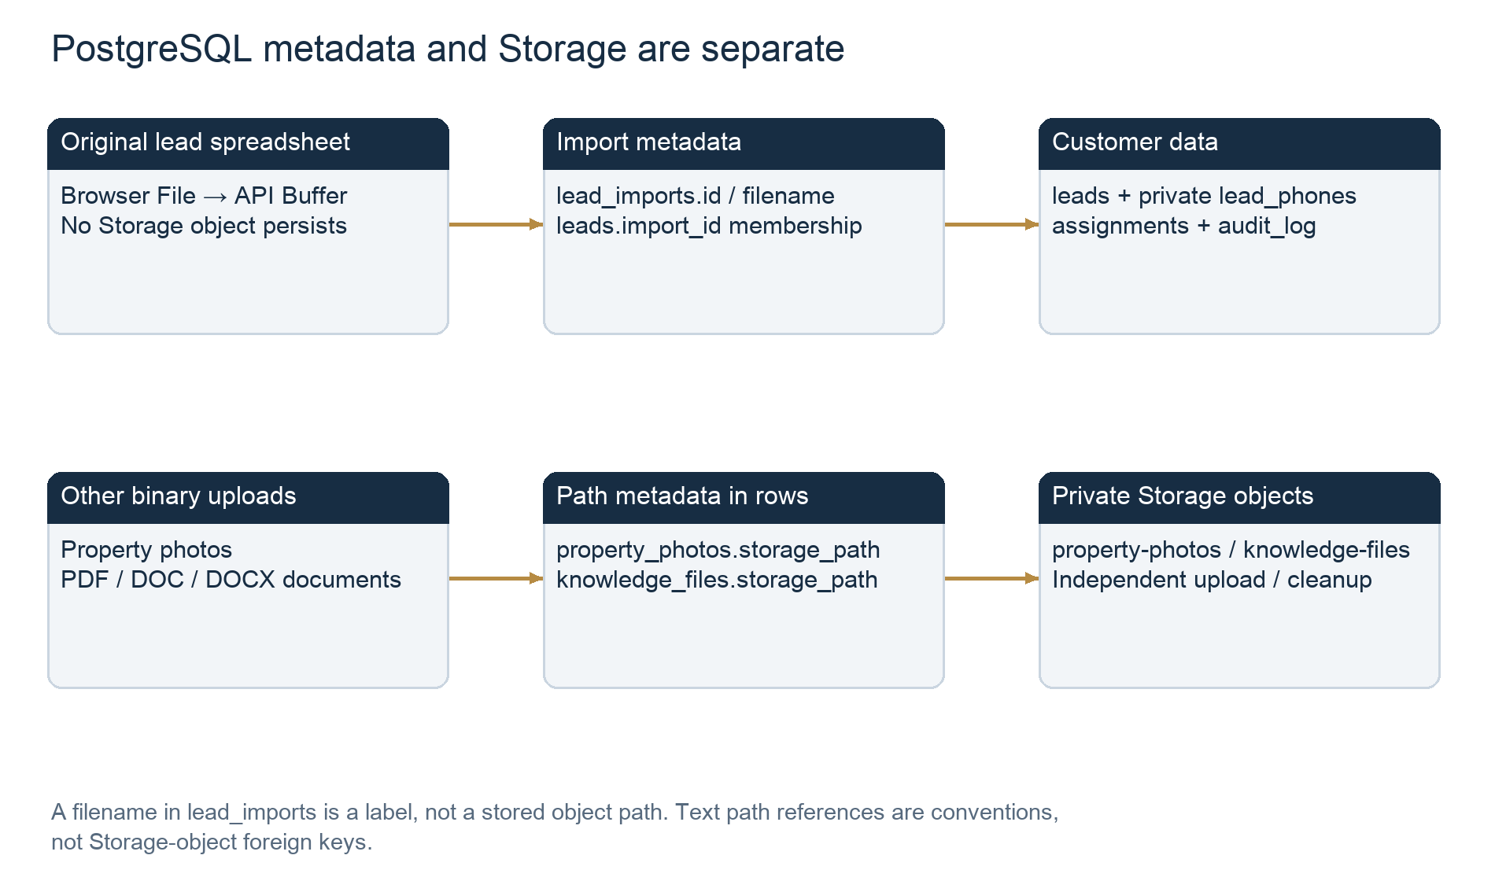
Figure 7. PostgreSQL metadata and Storage are separate

Bucket details
Bucket | Declared settings | Paths / reads / cleanup
property-photos | Private; 5,242,880 bytes; JPEG/PNG/WebP | <property UUID>/<random UUID>; no extension required. Server MIME/signature checks. Photo metadata gives signed URL for 60 seconds to both roles. Deletion routes and cleanupPropertyPhotos remove objects.
knowledge-files | Private; 10,485,760 bytes; PDF/DOC/DOCX | <document UUID>/<random UUID>; file name/MIME/size/path in knowledge_files. Reservation before upload; attached RPC finalizes; server downloads authenticated bytes and audits; queue retries deletion.
recordings | Private; 52,428,800 bytes; MPEG/WAV/OGG | storage_path optional or external provider_ref. Playback signs stored path after checks. No implemented lead-spreadsheet or manual-call binary upload. deleteOldRecordings supports 1–7 day retention.
Migrations declare no browser Storage policies. The server’s privileged Storage client mediates operations. A signed photo/recording URL is a short-lived bearer URL once issued. Changing a PostgreSQL row does not itself delete an object; the explicit cleanup paths are needed. A manually removed object can leave metadata pointing to missing bytes; the app cannot reconstruct an original spreadsheet from Storage because none was stored.
Source: supabase/migrations/004_properties.sql:4; supabase/migrations/015_documentation_and_policies.sql:43; server/src/routes/crm.routes.js:422; server/src/routes/documents.routes.js:128; server/src/jobs/cleanupKnowledgeFiles.js:1; server/src/jobs/cleanupPropertyPhotos.js:3; server/src/jobs/deleteOldRecordings.js:3

9. Security: server authorization, RLS and privileged access
Every /api CRM request passes auth(db): extract Bearer token, call Supabase Auth getUser(token), fetch profiles by the verified user ID and require active=true. Request parameters never supply the actor for an assignment/import RPC; req.user.id does. Frontend Protected and hidden admin buttons are convenience guards; the API and mutation functions provide the actual business boundaries.
Boundary | Declared enforcement | Important limitation
Admin upload/assignment/export | adminOnly on upload, file/individual assignment and report export. SQL import/assignment also rechecks active admin. | Server service client is privileged. A new handler without checks could bypass intended access.
Agent lead reads | Lead list ANDs assigned_agent=current verified profile; import_id narrows it further. ownedLead checks id and owner; missing/other-owner becomes 404. | List is privileged REST, so current-owner filtering is in Express, not a per-agent RLS SELECT policy.
Agent group reads | lead_imports_page and lead_import_summary recheck active actor and require a currently owned member lead. | Agent can still receive whole-batch total/imported/rejected counts alongside own lead_count. No other customer rows are returned.
Agent writes | Strict stage/loss fields; crm_mutate locks affected row/lead and checks current owner. Assignment/import RPCs are not executable by browser roles. | No optimistic version/ETag conflict check; authorized later writes to the same field may replace earlier ones.
Public CRM tables | RLS enabled; anon/authenticated table privileges revoked. New sensitive public tables also revoke PUBLIC. No CREATE POLICY statements in repo. | No browser SELECT/INSERT/UPDATE/DELETE policy is declared. Hosted extra grants/policies/default privileges were not inspected.
Private phone/recording tables | crm_private schema/table access revoked from PUBLIC, anon/authenticated; service role granted. Local API schemas exclude crm_private. | No explicit RLS enable for lead_phones/recordings in migrations. Protection here is schema/table ACL and server-only use; distinguish from RLS-enabled phone_reveals.
SQL functions | SECURITY DEFINER; empty search_path; protected function EXECUTE revoked from browser roles and granted to service_role. | Some trusted helpers, e.g. private_phone, rely on that service-only boundary rather than an actor parameter.
Storage | Private declared buckets and no browser policies; admin uploads; server-mediated download/signed URLs. | Private bucket alone does not validate document audiences. Current Client KYC is shared with active agents; no lead_id restriction yet.
Credentials | Server reads SUPABASE_SERVICE_ROLE_KEY; browser source reads public VITE connection variables only. Vite config loads only PORT from root. | Actual environment/deployed bundle was deliberately not read. No claim that all live secret configuration is correct.
Errors/rate/cache | No-store API responses and request IDs; general 300/15min and sensitive 30/min IP limits; safe row/DB error messages. | In-memory rate store and no explicit trust-proxy config in current app. Deployment/shared-IP behavior still needs P6 review.
Source: server/src/middleware/auth.js:1; server/src/middleware/role.js:1; server/src/routes/crm.routes.js:43; server/src/routes/crm.routes.js:540; supabase/migrations/009_row_level_security.sql:1; supabase/migrations/014_import_files_and_assignments.sql:173; server/src/config/supabaseAdmin.js:2; server/src/middleware/rateLimit.js:1
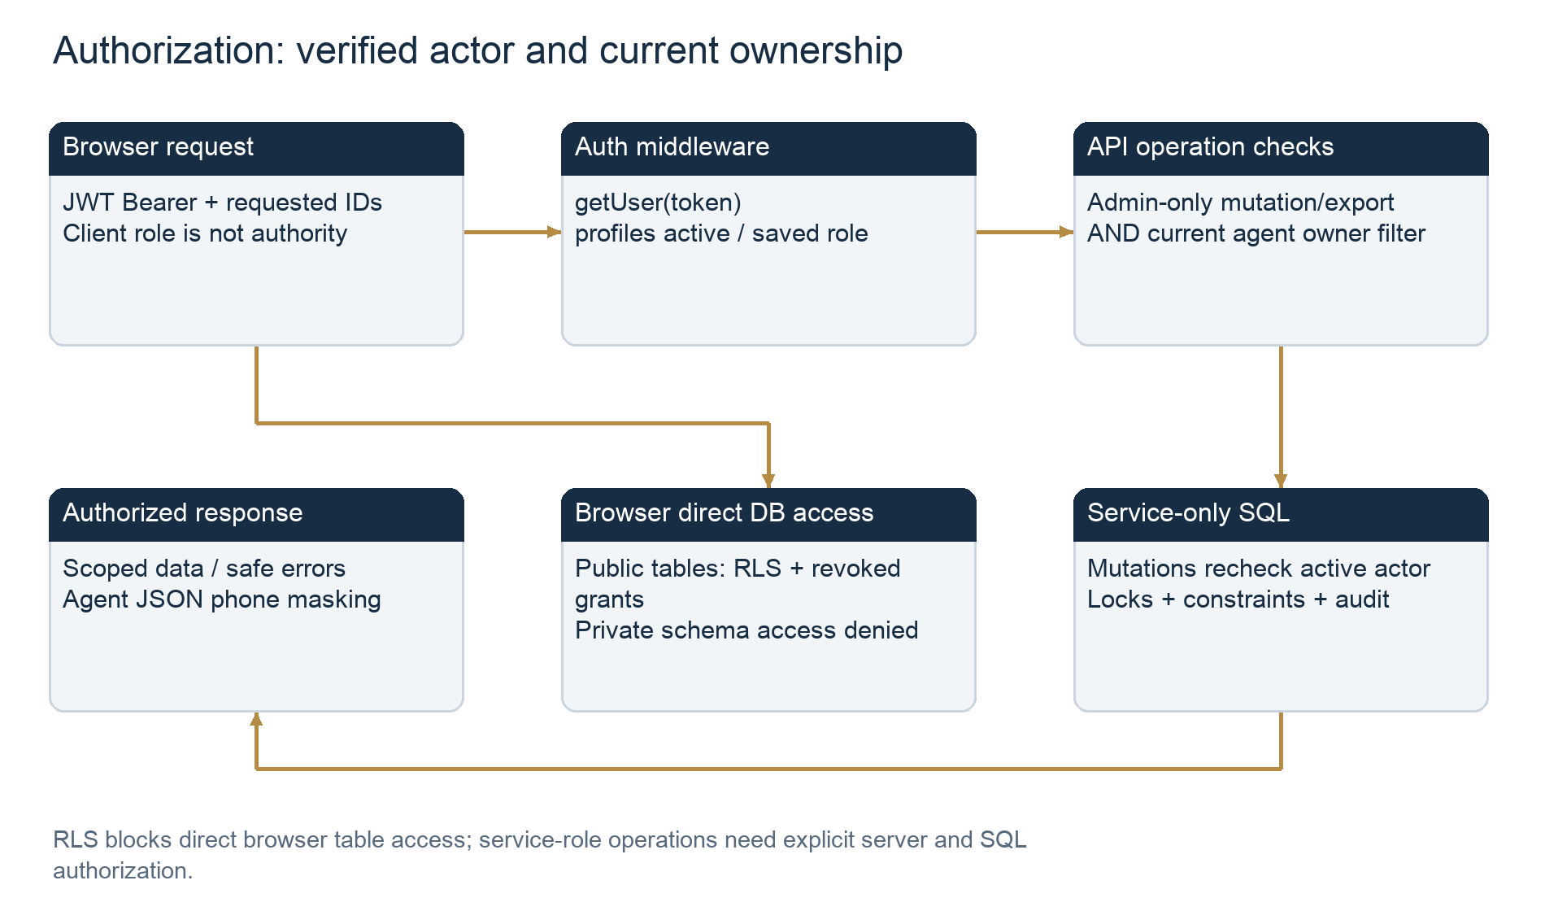
Figure 8. Authorization: verified actor and current ownership

P2 phone behavior present in this local snapshot
LeadPhone now renders masks only; PhoneReveal explicitly requests one current-owned number, keeps it outside Query/localStorage and hides it after two minutes or unmount/identity changes. GET /leads/:id/phone calls reveal_phone, defaulting to 80 distinct leads per Pakistan day; repeated same-lead reads do not add a distinct lead. Admins are unlimited but audited. Successful responses alone bypass agent JSON phone masking. Batch POST /leads/phones was removed. Admin warning/critical alerts and their review are separate from import/assignment metadata.
Source presence is verified, but the preceding P2 task had not completed its full-release verification/documentation checkpoint when this read-only investigation began. Hosted migration 019 and real multi-connection quota behavior are unverified here. P2 does not redact original binary documents or eliminate a person’s ability to copy an already revealed number; common-format JSON masking is not OCR.
Source: client/src/components/leads/LeadPhone.jsx:1; client/src/components/leads/PhoneReveal.jsx:8; server/src/routes/crm.routes.js:186; server/src/middleware/phoneProtection.js:1; supabase/migrations/019_protected_phone_numbers.sql:57

10. Persistence, synchronization and concurrent access
Event | Persistent state | Temporary/UI effects and limits
New upload | Batch metadata, accepted leads, unique phones, optional assignments and safe audit. | Browser/server file buffers and row results are transient; no async import recovery record.
Assign file | Same lead rows get new current owner; changed members add history; batch last-assignment and audit commit. | Current browser invalidates queries; other sessions have no CRM Realtime subscription.
Distribute among agents | Per-row import owners or individual reassignment changes the same leads. | Each owner sees their subset of a shared group. No count-based split wizard or copies.
Agent opens file / All my leads | No database or Storage writes. | GET group/lead reads; repeated opening has no duplicate-write effect.
Agent stage update | Authorized crm_mutate UPDATE, loss rules/history/audit, activity timestamp. | React Query invalidation refreshes local screen; historical assignment and import membership stay.
Reassign lead | leads.assigned_agent changes; history/audit appended. | Old owner loses future API access; a mounted stale screen may retain prior data until a refresh/recheck. Previously read data cannot be revoked from human memory/device.
Repeat upload | Another batch; normalized phone uniqueness prevents duplicate customer creation. | Same-phone row is rejected, not merged or overwritten; no saved mapping/result recovery.
Refresh / sign out | PostgreSQL and Storage unchanged. | Query cache is in memory; refresh recreates it. Sidebar logout signs out and clears Query cache; mapping/result/phone component state disappears.
Lead/import deletion | No implemented lead or import hard-delete API. | Schema FKs generally restrict deletion; private phone FK alone has ON DELETE CASCADE. Do not infer a delete feature from that FK.
Property/document deletion | Authorized deletion and cleanup metadata/queue transactions; Storage removal separately retried. | Network object deletion is outside SQL atomicity. No equivalent spreadsheet deletion lifecycle exists.
Concurrency | Assignment/import lock 873420; lead row locks; unique phone constraint; transactional mutation/audit. | Concurrent new duplicate phones cannot both persist. Global lock serializes unrelated import/assignment work and may become a throughput bottleneck.
Two edits to a current-owned lead | Row locks serialize updates and owner recheck prevents a transferred-away actor’s later mutation. | No version compare; later authorized edit of the same submitted field can overwrite the earlier value. Independent PostgreSQL-connection tests not performed in this report.
Source: supabase/migrations/010_atomic_operations.sql:1; supabase/migrations/012_pipeline_and_lost_reasons.sql:133; supabase/migrations/014_import_files_and_assignments.sql:51; client/src/main.jsx:10; client/src/components/layout/Layout.jsx:170; client/src/context/AuthContext.jsx:79
React Query’s global defaults are retry=1, staleTime=15 seconds and refetchOnWindowFocus=true. Import/assignment/status actions invalidate queries in the initiating browser. Lead/file lists have no explicit polling interval or subscription; Auth revalidation every 60 seconds is not a lead synchronization channel. Status/profile/timeline keys are not all user-scoped, whereas lead/file list keys include user ID and role. Explicit sidebar sign-out clears the cache; changes of account/role through other lifecycle paths deserve additional regression review. This is a cache-review finding, not proof of a cross-account exploit.
Current-owner report aggregation also uses historical activity.agent_id. Reassignment does not transfer old call/visit/deal attribution. As a result, historical actor metrics and current-owned customer scope can diverge. Follow-up reminders are unique by followup_id,due_at: an existing reminder is not re-targeted by ON CONFLICT DO NOTHING after ownership moves. Recommendations appear below; no synchronization code was changed.
Source: client/src/pages/admin/Leads.jsx:183; client/src/pages/agent/LeadDetail.jsx:36; client/src/components/leads/ImportedFiles.jsx:32; client/src/components/layout/Layout.jsx:170; supabase/migrations/010_atomic_operations.sql:47; supabase/migrations/011_jobs_and_events.sql:20

11. Fictional end-to-end example
All names, counts, IDs and numbers in this example are invented. They are not production database counts or real accounts. A phone marked as a placeholder must never be used to call someone.

500 input leads with a 100/150 assignment split
- An admin prepares campaign_october.csv with 500 fictional rows and supported name/phone columns. To assign 100 to Agent A and 150 to Agent B in this one import, include assigned_agent values matching each active agent’s exact unique CRM name or UUID; leave 250 blank. This uses the existing per-row importer, not a bulk-split screen.
- If all rows are valid and phones are unique, one batch B is created: total_rows=500, imported_count=500, rejected_count=0, file_format=csv. Five hundred public.leads rows reference B; 500 private phone rows are inserted. There is no campaign table despite the filename.
- The 100 A-owned and 150 B-owned rows receive assignment events. The remaining 250 have assigned_agent=NULL. Batch assigned_agent/by/at remain NULL because no whole-file assignment occurred. The summary derives mixed_assignment=true for the admin from current lead ownership.
- Agent A’s My leads shows one campaign_october.csv card with lead_count=100; B sees its 150. Each may also receive the original batch’s aggregate total/imported/rejected counts, but their GET /leads?import_id=B returns only currently owned records.
- Clicking Open leads reads those existing rows. Neither agent imports them again, exports a spreadsheet or modifies assignment. They may open an authorized customer, request its number and update activity/stage.
- If the admin later uses Assign file → Agent B on batch B, all 500 leads move to B, including A’s 100 and previously unassigned 250. Unchanged B-owned rows do not receive a second per-lead event; changed=350. A’s next group/lead requests lose access.
- Uploading the same unchanged file again creates a different batch B2 with total=500, imported=0, rejected=500 Duplicate phone. It does not overwrite the original records or shift their original import_id. B2 appears to admin as rejected-only and is not assignable.
Source: server/src/services/leadImport.js:320; supabase/migrations/014_import_files_and_assignments.sql:66; supabase/migrations/014_import_files_and_assignments.sql:103; supabase/migrations/014_import_files_and_assignments.sql:146

One lead’s exact record linkage
Fictional labels (not SQL variables):
Admin = 10000000-0000-4000-8000-000000000001
Agent A = 10000000-0000-4000-8000-000000000002
Batch B = 20000000-0000-4000-8000-000000000001
Lead L = 30000000-0000-4000-8000-000000000001

Record | Fictional values / relationship
auth.users | Agent A exists with id 10000000-0000-4000-8000-000000000002; other managed Auth fields not invented here.
public.profiles | id=Agent A; name=Example Agent A; role=agent; active=true.
public.lead_imports | id=Batch B; file_name=campaign_october.csv; file_format=csv; worksheet=NULL; total_rows=500; imported_count=500; rejected_count=0; created_by=Admin; assigned_agent/by/at=NULL initially.
public.leads | id=Lead L; name=Fictional Customer 001; masked_phone=+92******001; source=CSV; import_id=Batch B; assigned_agent=Agent A; status=new; property_id=NULL; budget_min=0; budget_max=NULL.
crm_private.lead_phones | lead_id=Lead L; phone=+923000000001 (synthetic explanatory placeholder, never dial). Uniqueness is global, not per batch.
public.assignments | Generated id; lead_id=Lead L; agent_id=Agent A; actor_id=Admin; created_at=transaction timestamp.
public.audit_log | create entry for Lead L and assign entry with agent_id; import entry for Batch B and counts; shared request_id ties the request together. entity_id is text.
Storage | No campaign_october.csv object; no bucket path exists for this import; File and request Buffer are temporary.
After whole-file reassignment to B, the existing leads row keeps id=Lead L and import_id=Batch B; assigned_agent changes to B and an assignment/audit event is appended. The private phone row remains the same. This is reassignment of one identity, not insertion into an agent-specific table.

12. Code reference index and API contract
Workflow | File:line / symbol | Purpose / database interaction
Admin upload picker | client/src/pages/admin/Leads.jsx:66  importLeads / submitImport / LeadList | Single picker, client bounds, multipart submit, mapping/result state  POST /leads/import; query invalidation
Column matching UI | client/src/pages/admin/Leads.jsx:129  matchImportColumn / importMatchedColumns | Unique selected fields; required name/phone  Same File submitted with field-index mapping
HTTP encoding/download | client/src/lib/api.js:2  api / download | Bearer Auth; FormData/JSON; Blob/anchor download  /api routes only; no direct table insert
Upload API | server/src/routes/crm.routes.js:133  crmRouter import route | Active admin + sensitive limiter + memory upload  importLeadFile
CSV / Excel parser | server/src/services/leadImport.js:100  csvRecords / excelRecords / leadRows / parseLeadImport | UTF-8/format bounds, first sheet, headings, rows  Memory parsing only
Agent references | server/src/services/leadImport.js:320  resolveImportAgents | One active-agent directory lookup as needed  profiles read; UUID/name resolution
Validated row preparation | server/src/services/importFiles.js:41  importLeadFile / fileRpc | Strict schemas, normalize phones, filename sanitation  RPC import_leads
Phone identity | server/src/utils/phoneMask.js:1  normalizePhone / phoneMask / csvCell | Normalization, mask, CSV output escaping  Private phone UNIQUE; no in-place identity editor
Strict validation | server/src/utils/validators.js:103  leadCreate / listQuery / agentLeadUpdate | Allowed fields, budgets, IDs, filters/status/loss  Data validated before protected writes
Batch persistence/history | supabase/migrations/014_import_files_and_assignments.sql:51  import_leads | Batch + per-row subtransactions + summary audit  lead_imports, leads, lead_phones, assignments, audit_log
Lead insertion | supabase/migrations/010_atomic_operations.sql:14  create_lead | Atomic metadata, vault, audit and optional assignment  leads / lead_phones / audit_log
Task assign + agent cards | client/src/components/leads/ImportedFiles.jsx:20  ImportedFiles / assignFile | One active agent for entire group; agent Router Link  GET lead-imports; POST assign only for admin
Assignment API | server/src/routes/crm.routes.js:167  crmRouter file/individual assign handlers | Admin/UUID/body checks; actor from verified profile  assign_lead_import / assign_lead RPCs
Whole-file transaction | supabase/migrations/014_import_files_and_assignments.sql:146  assign_lead_import | Current group locks + changed-member loop + audit  leads owners / assignments / batch metadata
Individual/round-robin | supabase/migrations/010_atomic_operations.sql:1  assign_lead | Active agent by explicit UUID or assignment recency  Current owner + assignment/audit insert
Individual assignment UI | client/src/pages/agent/LeadDetail.jsx:288  LeadDetail assign RecordForm | Admin-only select; blank means round-robin  POST leads/:id/assign
Agent lead screen alias | client/src/pages/agent/MyLeads.jsx:1  Compatibility re-export | Actual route uses shared Leads component  No independent agent database/table
Agent list and profile | server/src/routes/crm.routes.js:540  crmRouter list loop / ownedLead | Current owner applied before results/pagination  REST read leads with assigned_agent and import_id
Group visibility | supabase/migrations/014_import_files_and_assignments.sql:103  lead_import_summary / lead_imports_page | Active reader and currently owned membership  Read-only derived batch summary
Agent overview | client/src/pages/admin/Dashboard.jsx:20  Dashboard | Shared role-aware dashboard queries  reports / targets / followups / visits / leaderboard
Report export UI | client/src/pages/admin/Reports.jsx:33  Reports onClick | Admin CSV aggregates download  GET reports/export
Report export backend | server/src/routes/crm.routes.js:485  crmRouter report export | Numeric metric,value; no Storage/lead mutation  crm_metrics reads current-scoped records
Document download UI | client/src/pages/shared/Documentation.jsx:437  Documentation attachment onClick | Download PDF/DOC/DOCX to device  GET documents/:id/files/:file/download
Actual Storage upload/download | server/src/routes/documents.routes.js:128  documentsRouter | Reservation, upload, attach, audited binary download  knowledge-files + knowledge_files metadata
Property Storage | server/src/routes/crm.routes.js:403  Photo API handlers | Magic/MIME match; random paths; signed URLs  property-photos + property_photos
Browser Supabase initialization | client/src/lib/supabase.js:1  supabase / createLoginClient | Public config; main/candidate Auth clients  Auth sessions, no direct lead-table import
Server privileged client | server/src/config/supabaseAdmin.js:2  getAdmin | Server-only service credential variables  Auth, REST, RPC, Storage service calls
Authentication / portal guard | server/src/middleware/auth.js:1  auth / adminOnly / Protected | getUser then active profile; selected portal is not role grant  profiles read; API protected
Session/cache lifecycle | client/src/context/AuthContext.jsx:7  AuthProvider | Restore/auth-event/profile checks every minute  Auth session + /me; no lead Realtime subscription
RLS and private boundary | supabase/migrations/009_row_level_security.sql:1  SQL revokes / RLS declarations | No direct browser table grants/policies  service_role access; private vault restricted
Auth↔profile trigger | supabase/migrations/016_accounts_and_security.sql:26  create_profile replacement | Trusted provisioning may start inactive  profiles.id FK auth.users.id
Stage persistence | supabase/migrations/012_pipeline_and_lost_reasons.sql:133  crm_mutate / status triggers | Ownership locks, allowed fields, history/audit  leads / lead_status_history / audit_log
Jobs | server/src/jobs/runner.js:10  tick / reassignStaleLeads | Separate runner; not a spreadsheet import worker  run_crm_job + Storage cleanup helpers
Phone reveal (local P2) | server/src/routes/crm.routes.js:186  reveal_phone / PhoneReveal | Explicit no-store current-owned contact  phone_reveals / security_alerts / audit
Local schemas/bundling | scripts/build-sql.js:16  SQL bundle generator | Ordered migration text + seed; do not run for review  Fresh setup only; no ORM/generated types found
Edge functions / agent export | client/src/App.jsx:30  Repository absence finding | No Edge Function invoke or agent lead export route found  No downstream write/storage action to document

Relevant route permissions and request shapes
Endpoint | Actor / input | Database or output
POST /api/leads/import | Admin; multipart file + optional mapping JSON | import_leads; summary + per-row result JSON
GET /api/lead-imports | Active admin/agent; page/limit/search | lead_imports_page; authorized group metadata
GET /api/lead-imports/:id | Active admin/agent with member access | lead_import_summary; otherwise 404
POST /api/lead-imports/:id/assign | Admin; {agent_id: UUID} | assign_lead_import; whole-file owner changes
GET /api/leads | Admin/agent; page default1/limit20 max100; name/status/source/loss/import filter | Agent owner always forced; ordinary lead payload includes mask
GET /api/leads/:id; /timeline | Admin/current assigned agent | Lead details or per-type latest100 history rows
POST /api/leads/:id/assign | Admin; agent_id UUID/null/omitted | Explicit target or round-robin; null is not unassignment
PATCH /api/leads/:id | Admin metadata/status; agent status/loss only | crm_mutate transaction, history and audit
GET /api/reports | Active account; from/to required, optional agent/source | crm_metrics; an agent’s requested actor scope is forced to self in SQL
GET /api/reports/export | Admin; validated report filters | Generated aggregate CSV; read-only, no explicit export audit
GET /api/documents/:id/files/:file/download | Any active team member in current source | Audited PDF/DOC/DOCX binary from knowledge-files
POST /api/leads/phones | No implemented handler | Removed in current local P2; generic 404
GET /api/leads/:id/phone | Admin/current assigned agent; no client quota parameters | Local P2 single audited reveal and quota/alert logic

13. Findings, limitations and recommendations

Verified source facts
- The durable lead workflow is shared PostgreSQL rows plus batch metadata and owner/history links. No original spreadsheet Storage object, agent-specific customer table or agent lead import/export action was found.
- The admin report export is aggregate-only and read-only; it does not create leads. Shared document downloads are real binary Storage downloads, but unrelated to source lead spreadsheets.
- Global phone uniqueness prevents repeated normalized customer identities, while every parsed/validated import attempt can create a new history UUID. There is no upload hash or idempotency receipt.
- Whole-file assignment is transactional and deliberately changes every accepted member’s owner. Mixed ownership is supported through row assignment and summarized dynamically; no count-based splitting UI exists.
- RLS and revoked browser grants are declared for public CRM tables. Private lead_phones/recordings rely on explicit schema/table revokes without a declared RLS enable. No browser Storage policies are declared.
- KYC document category currently shares active-team access; no assigned-lead link is declared. Agent JSON phone masking does not redact downloaded original PDF/DOC/DOCX bytes.
- Current update_account does not immediately return a disabled agent’s leads. Assignment does not transfer existing pending activity.agent_id or reminders.
- scripts/verify-live.js:46 still expects an assigned agent phone request to return 403, which conflicts with current explicit authorized P2 reveal behavior. Existing server/import-files test wording also refers to older automatic contacts. Those files were not changed or executed in this review.
- The working tree contains migration019/P2 code, while the last recorded full regression and older generated manual are earlier checkpoints. Source presence, recorded test success and live deployment state must remain separate.
Source: scripts/verify-live.js:46; server/tests/import-files.test.js:352; supabase/migrations/016_accounts_and_security.sql:118; supabase/migrations/017_document_categories.sql:49; VERIFICATION.md:186

Strongly supported inferences and practical risks
- A lost response after commit can cause an operator to re-upload a committed file, producing another rejected-only batch. The UI cannot reconcile that by a saved idempotency key.
- Synchronous Excel parsing has compressed-input and event-loop cost despite byte/row/column bounds. Global advisory lock873420 serializes import and assignment operations across unrelated batches. Higher volumes merit measurements before proposing workers/streaming.
- Name search uses ILIKE %query% but the declared GIN index is to_tsvector(name); this index does not directly serve that query shape. Exact count pagination and per-batch derived summary scans can become expensive as history grows.
- Current-owned metrics intersect with historical activity agent IDs; changing ownership can change visible historical metrics without transferring attribution. Existing reminder ownership can be stale after reassignment.
- Lists have no cross-client push synchronization. An old page can retain previously received data until re-fetch; the next server request still enforces current ownership. Row locks do not provide optimistic conflict messages for same-field edits.
- Service-role access makes correct API/SQL checks essential. No source-only review can establish the absence of unsafe hosted grants/policies, credential misconfiguration or out-of-repo endpoints.
- Agents receive batch aggregate counts in addition to own lead_count. Confirm that the business intends to disclose group-level upload/rejection totals.
- Cache keys on all record/timeline queries are not uniformly tied to account/role. Explicit sidebar logout clears cache, but account/role changes through other lifecycle paths need focused regression tests.

Recommendations — documentation only, not implemented
Priority | Recommendation | Why / evidence
High | Reconcile deployed migrations, source and acceptance scripts before release. | Local019 is not live evidence; stale verify-live phone assertion and earlier manual may mislead operators.
High | Complete disabled-agent lead return and pending activity/reminder transfer policy. | Current update_account denies access but retains lead ownership; assign_lead does not transfer activities.
High | Restrict Client KYC to an appropriate customer/audience model. | Current team-wide document download can expose sensitive binaries regardless of JSON phone masks.
High | Add an explicit import receipt/idempotency design if retries must be safe at batch level. | Phone uniqueness protects identity but not batch proliferation or operator reconciliation.
Medium | Persist safe row diagnostics/mapping version if failed-row correction and replay are operational requirements. | Current UI-only errors disappear after reload; counts alone cannot recreate rejected input.
Medium | Clarify labels: assigned “file” means group, “Open leads” means read, “Export CSV” means aggregate report. | Prevents mistaken assumptions about source-file retention or agent copies.
Medium | Measure parsing/lock/summary/search behavior before increasing batch size. | 5MiB/1,000-row synchronous parser and global lock are deliberate current bounds.
Medium | Define assignment audit retention, export audit requirements, cache lifecycle and optimistic edit conflict behavior. | Historical events, download copies and concurrent updates have different durability/access semantics.
Optional | If original spreadsheet retention is required, design a separate private bucket, object metadata/access/retention lifecycle. | No such retention feature currently exists; it should not be inferred from lead_imports.file_name.

Unverified items and exact additional evidence needed
- A read-only hosted catalog export: pg_class RLS flags, pg_policies, table/column/constraint/index catalogs and browser/service role privileges for public/crm_private/storage. Appendix A provides safe queries.
- Applied hosted migration list (where the Supabase migration history table exists) and deployed function definitions/signatures for import_leads, assign_lead_import, assign_lead, create_lead, crm_mutate and reveal_phone; definitions must be compared with repository hashes.
- Bucket settings, Storage policies and aggregate object counts by the three declared bucket IDs, without customer filenames, content, paths or PII. Do not request service-role secrets in chat.
- Aggregate import/lead/owner counts plus counts of missing/out-of-sync metadata, not actual names, emails, phones or document contents.
- Deployed commit/build identifier and confirmation that public browser variables contain only public keys; actual server secret values are not needed.
- Controlled, non-customer test accounts and explicit approval for live acceptance if runtime proof is later required: duplicate retry, cross-agent direct access, reassignment during writes, separate-connection concurrency and Storage failure cleanup. None was performed for this report.

Appendix A. Safe read-only SQL inspection queries
These statements are inspection templates only and were not executed against any database. They contain no DDL/DML or customer names, emails, full phones, text notes, PIN hashes, token hashes or file paths. Run catalog queries first, then application count queries only if the declared tables exist. A trusted SQL-console reader is required; normal browser roles intentionally lack table access. Schema/function definitions can be reviewed locally without sending row data.

A1. List declared-schema tables actually present
SELECT table_schema, table_name, table_type
FROM information_schema.tables
WHERE table_schema IN ('public','crm_private')
ORDER BY table_schema, table_name;

A2. Inspect columns, types, nullability and defaults
SELECT table_schema, table_name, ordinal_position, column_name,
data_type, udt_name, is_nullable, column_default
FROM information_schema.columns
WHERE table_schema IN ('public','crm_private')
ORDER BY table_schema, table_name, ordinal_position;

A3. Primary keys, unique and check constraints
SELECT n.nspname AS schema_name, c.relname AS table_name,
x.conname, x.contype, pg_get_constraintdef(x.oid) AS definition
FROM pg_constraint x
JOIN pg_class c ON c.oid=x.conrelid
JOIN pg_namespace n ON n.oid=c.relnamespace
WHERE n.nspname IN ('public','crm_private')
ORDER BY 1,2,3;

A4. Foreign keys and declared indexes
SELECT n.nspname AS schema_name, c.relname AS table_name,
x.conname, pg_get_constraintdef(x.oid) AS foreign_key
FROM pg_constraint x
JOIN pg_class c ON c.oid=x.conrelid
JOIN pg_namespace n ON n.oid=c.relnamespace
WHERE x.contype='f' AND n.nspname IN ('public','crm_private')
ORDER BY 1,2,3;

SELECT schemaname, tablename, indexname, indexdef
FROM pg_indexes
WHERE schemaname IN ('public','crm_private')
ORDER BY 1,2,3;

A5. Aggregate lead, import and assignment counts
SELECT (SELECT count(*) FROM public.leads) AS leads,
(SELECT count(*) FROM public.lead_imports) AS import_groups,
(SELECT count(*) FROM public.assignments) AS assignment_events,
(SELECT count(*) FROM crm_private.lead_phones) AS phone_identities;

A6. Membership count per import without filenames or record IDs
SELECT i.file_format, i.legacy,
(i.created_at AT TIME ZONE 'Asia/Karachi')::date AS import_day,
i.total_rows, i.imported_count, i.rejected_count,
count(l.id) AS member_leads,
count(l.assigned_agent) AS assigned_member_leads,
count(DISTINCT l.assigned_agent) AS current_owners
FROM public.lead_imports i
LEFT JOIN public.leads l ON l.import_id=i.id
GROUP BY i.id
ORDER BY i.created_at DESC, i.id
LIMIT 50;

A7. Count one fictional batch (adapt UUID only)
-- Replace this fictional UUID with a known batch ID locally.
SELECT count(*) AS member_leads,
count(assigned_agent) AS assigned_leads,
count(DISTINCT assigned_agent) AS distinct_owners
FROM public.leads
WHERE import_id='20000000-0000-4000-8000-000000000001'::uuid;

A8. Per-agent counts using anonymous numbered labels
WITH owners AS (
SELECT p.id, p.active, count(l.id) AS assigned_leads
FROM public.profiles p
LEFT JOIN public.leads l ON l.assigned_agent=p.id
WHERE p.role='agent'
GROUP BY p.id,p.active
)
SELECT 'Agent ' || row_number() OVER (ORDER BY id) AS anonymous_agent,
active, assigned_leads
FROM owners
ORDER BY id;

SELECT count(*) AS unassigned_leads
FROM public.leads WHERE assigned_agent IS NULL;

A9. Import history aggregate and stored/current-owner discrepancies
SELECT file_format, legacy, count(*) AS imports,
sum(total_rows) AS attempted_rows,
sum(imported_count) AS accepted_rows,
sum(rejected_count) AS rejected_rows
FROM public.lead_imports GROUP BY file_format,legacy ORDER BY 1,2;

SELECT count(*) AS batch_markers_with_different_current_members
FROM public.lead_imports i
WHERE i.assigned_agent IS NOT NULL AND EXISTS (
SELECT 1 FROM public.leads l WHERE l.import_id=i.id
AND l.assigned_agent IS DISTINCT FROM i.assigned_agent
);

A10. Duplicate/consistency counts without exposing phone values
SELECT count(*) AS duplicate_phone_groups
FROM (
SELECT 1 FROM crm_private.lead_phones
GROUP BY phone HAVING count(*)>1
) duplicates;

SELECT count(*) AS leads_without_private_phone
FROM public.leads l
LEFT JOIN crm_private.lead_phones p ON p.lead_id=l.id
WHERE p.lead_id IS NULL;

SELECT count(*) AS import_count_mismatches
FROM public.lead_imports
WHERE imported_count+rejected_count<>total_rows;

A11. RLS flags, policies and table privileges
SELECT n.nspname AS schema_name, c.relname AS table_name,
c.relrowsecurity AS rls_enabled,
c.relforcerowsecurity AS rls_forced
FROM pg_class c JOIN pg_namespace n ON n.oid=c.relnamespace
WHERE n.nspname IN ('public','crm_private','storage')
AND c.relkind IN ('r','p')
ORDER BY 1,2;

SELECT schemaname,tablename,policyname,roles,cmd,qual,with_check
FROM pg_policies
WHERE schemaname IN ('public','crm_private','storage')
ORDER BY 1,2,3;

SELECT table_schema,table_name,grantee,privilege_type
FROM information_schema.role_table_grants
WHERE table_schema IN ('public','crm_private','storage')
AND grantee IN ('anon','authenticated','service_role','PUBLIC')
ORDER BY 1,2,3,4;

A12. Protected function signatures and execution access
SELECT n.nspname,p.proname,
pg_get_function_identity_arguments(p.oid) AS arguments,
p.prosecdef AS security_definer,p.proconfig,
has_function_privilege('anon',p.oid,'EXECUTE') AS anon_exec,
has_function_privilege('authenticated',p.oid,'EXECUTE') AS browser_exec,
has_function_privilege('service_role',p.oid,'EXECUTE') AS server_exec
FROM pg_proc p JOIN pg_namespace n ON n.oid=p.pronamespace
WHERE n.nspname='public' AND p.proname IN (
'create_lead','import_leads','assign_lead','assign_lead_import',
'lead_import_summary','lead_imports_page','crm_mutate','crm_metrics',
'reveal_phone','phone_reveal_status'
) ORDER BY 2,3;

A13. File-path metadata presence, without revealing paths or filenames
SELECT 'property_photos' AS metadata_table, count(*) AS records,
count(*) FILTER (WHERE storage_path IS NOT NULL) AS path_references
FROM public.property_photos
UNION ALL
SELECT 'knowledge_files',count(*),
count(*) FILTER (WHERE storage_path IS NOT NULL)
FROM public.knowledge_files
UNION ALL
SELECT 'recordings',count(*),
count(*) FILTER (WHERE storage_path IS NOT NULL)
FROM crm_private.recordings;

SELECT column_name,data_type
FROM information_schema.columns
WHERE table_schema='public' AND table_name='lead_imports'
ORDER BY ordinal_position;

A14. Bucket settings and object counts only
-- Supabase-managed catalogs; run only if these schemas exist.
SELECT b.id,b.public,b.file_size_limit,b.allowed_mime_types,
count(o.id) AS object_count
FROM storage.buckets b
LEFT JOIN storage.objects o ON o.bucket_id=b.id
WHERE b.id IN ('property-photos','recordings','knowledge-files')
GROUP BY b.id,b.public,b.file_size_limit,b.allowed_mime_types
ORDER BY b.id;

A15. Migration-history availability and optional version list
SELECT to_regclass('supabase_migrations.schema_migrations')
AS migration_history_table;

-- Only if the previous query confirms this managed table exists:
SELECT version FROM supabase_migrations.schema_migrations ORDER BY version;

A14/A15 reference Supabase-managed catalog shapes rather than application DDL. Confirm those managed columns with information_schema.columns before running them if using a different Supabase version. SQL-editor manual pastes may not populate managed migration-history records, so absence of a version there does not itself prove a feature migration is absent. Do not run setup.sql, seed.sql, migration scripts, provisioning scripts or verify-live.js as part of this read-only review.

Appendix B. Original Mermaid diagram sources
Eight readable native PNG diagrams are embedded in the body. A Mermaid renderer was not available locally; the diagrams were drawn with Pillow for this report. The original Mermaid notation below preserves editable architecture/sequence/ER definitions and includes extended relationships. Names such as auth_users/lead_phones in Mermaid are diagram aliases for the fully qualified tables identified in section7, not new SQL tables.

Architecture: browser → API → Supabase
flowchart LR
Browser[React browser] -->|Bearer API requests| API[Express /api]
Browser -->|Password and session| Auth[Supabase Auth]
API -->|getUser plus profiles lookup| Auth
API -->|Service client: REST and RPC| PG[(PostgreSQL)]
API -->|Photos and document binaries| Storage[(Private Storage)]
Jobs[Separate jobs runner] --> PG
Jobs --> Storage
Original[Lead spreadsheet] -->|Memory only| API

Admin upload sequence
sequenceDiagram
actor Admin
participant UI as Leads.jsx
participant API as Express
participant Parser as leadImport.js
participant DB as PostgreSQL
Admin->>UI: Select CSV/XLSX/XLS
UI->>API: POST /leads/import (file, optional mapping)
API->>API: Auth, active admin, rate and byte limits
API->>Parser: parseLeadImport(buffer, mapping)
alt Unknown or ambiguous headings
Parser-->>UI: 400 IMPORT_COLUMNS_REQUIRED
UI->>API: Same file plus confirmed mapping
end
API->>DB: import_leads(prepared rows, actor, request)
DB-->>API: import_id and row results
API-->>UI: Counts, warnings, skipped columns
UI->>UI: Invalidate queries

Parsing and transaction boundaries
flowchart LR
File[Spreadsheet in memory] --> Parse[Parse and validate]
Parse -->|One RPC| Batch[Create lead_imports]
Batch --> Row{Each row subtransaction}
Row -->|Valid| Lead[create_lead]
Lead --> Vault[(Unique private phone)]
Lead --> Member[Set leads.import_id]
Row -->|Invalid or duplicate| Error[Safe transient row result]
Member --> Final[Finalize counts and import audit]
Error --> Final
Final -->|Commit succeeds| Response[Return batch and results]
Final -->|Outer failure| Rollback[Roll back whole RPC]

Assignment: shared records, new current owner
flowchart LR
Admin[Admin selects file and agent] --> API[POST lead-imports/:id/assign]
API --> RPC[assign_lead_import: active checks and locks]
RPC -->|Changed members| Assign[assign_lead]
Assign --> Current[(leads.assigned_agent)]
Assign --> History[(assignments + audit_log)]
RPC --> Batch[(lead_imports assignment metadata)]
Current --> Agent[Agent filtered reads]
Agent -->|Open group| List[Existing lead rows only]

Agent “Open leads” is a read-only navigation flow
flowchart LR
Agent[Agent My leads] --> Groups[GET /lead-imports]
Groups --> Link[Open leads: Router Link]
Link --> URL[leads?import_id=batch]
URL --> Read[GET /leads]
Read --> Scope[Current owner AND batch filters]
Scope --> Render[Render existing lead list]
Render --> Profile[GET /leads/:id]
Note[No spreadsheet import, export or insertion] -.-> Link

Core entity relationships (declared schema)
erDiagram
auth_users ||--o| profiles : "id"
profiles o|--o{ leads : "assigned_agent"
lead_imports o|--o{ leads : "import_id"
leads ||--o| lead_phones : "lead_id PK"
leads ||--o{ assignments : "lead_id"
profiles o|--o{ assignments : "agent_id / actor_id"
profiles o|--o{ lead_imports : "created_by / assigned_agent / assigned_by"
leads ||--o{ notes : "lead_id"
leads ||--o{ calls : "lead_id"
leads ||--o{ followups : "lead_id"
leads ||--o{ visits : "lead_id"
leads ||--o| deals : "lead_id UNIQUE"
followups ||--o{ reminders : "followup_id"
properties o|--o{ leads : "property_id"
properties ||--o{ visits : "property_id"
properties ||--o{ deals : "property_id"
properties ||--o{ property_photos : "property_id"
knowledge_documents ||--o{ knowledge_files : "document_id"
leads ||--o{ phone_reveals : "lead_id"
profiles ||--o{ phone_reveals : "user_id"

PostgreSQL metadata and Storage are separate
flowchart LR
Sheet[Original CSV/XLS/XLSX] --> Memory[Browser File and API Buffer]
Memory --> Parser[Parse rows]
Parser --> Imports[(lead_imports metadata)]
Imports -->|leads.import_id| Leads[(leads + lead_phones)]
Leads --> Assign[(assignments)]
Photos[Image binaries] --> PhotoBucket[(property-photos)]
PhotoMeta[(property_photos.storage_path)] -.-> PhotoBucket
Docs[PDF/DOC/DOCX binaries] --> DocBucket[(knowledge-files)]
DocMeta[(knowledge_files.storage_path)] -.-> DocBucket
Note[No lead spreadsheet bucket/path] -.-> Memory

Authorization: verified actor and current ownership
flowchart LR
Browser[Browser JWT and requested IDs] --> Auth[getUser and active profile]
Auth --> API{Server role / ownership check}
API -->|Denied| Error[401 / 403 / 404]
API -->|Read| Filter[Privileged query with current-owner scope]
API -->|Mutation| RPC[Service-only RPC; actor and ownership rechecks]
RPC --> Lock[Locks + constraint checks + audit]
Filter --> Response[Scoped no-store response]
Lock --> Response
Direct[Browser database call] --> Deny[No grants / no RLS policies / private schema
revoked]

Appendix C. Verification method and source snapshot
Verification for this deliverable checks that the Word document exists, its ZIP package passes CRC tests, XML/relationships/images parse, python-docx reopens it and macOS textutil extracts readable text. Every cited path and line number is checked against this local snapshot. The report’s SQL examples are static read-only templates; they were not executed. No migration, Supabase connection, Auth login, Storage upload, application build or CRM acceptance test was run for this documentation task.
Source coverage: 151 recursively inventoried/searched implementation, SQL, configuration and test files; 19 ordered migrations; 26 declared application tables; 8 embedded diagrams. Searches found no application ORM, generated TypeScript database schema, CRM Realtime subscription, Edge Function invoke or campaign_id. That is a repository absence finding; it cannot exclude out-of-repo infrastructure.
Existing tests inspected, not rerun: server lead-import tests cover genuine workbook parsing, formula rejection, alias/mapping, row errors, duplicate handling and admin upload denial; server import-files tests cover batch persistence, reassignment access, audit rollback, inactive targets and legacy grouping; client tests cover single picker/matching and file assignment/navigation. Prior test results remain historical evidence in VERIFICATION.md; no new pass count is asserted here.
Source: server/tests/lead-import.test.js:88; server/tests/lead-import.test.js:460; server/tests/import-files.test.js:179; client/tests/lead-import.test.jsx:106; client/tests/import-files.test.jsx:195; VERIFICATION.md:186
Selected source hashes (SHA-256) identify the exact reviewed files. A future source edit may change line references and behavior; compare hashes before treating this report as current.
client/src/pages/admin/Leads.jsx
e9933e22a43221350ee76ec0d497cafb42e17b541d184ac2a1b3cdfdce9214b8

client/src/components/leads/ImportedFiles.jsx
36da294102f3cf050d3a6486a5236a1e9e15cff1b24ce1622b1f254f038f16f8

server/src/services/leadImport.js
ac4660d23292a79f47ba61920089d624968d661cb6794b4f2fe43f15534aea20

server/src/services/importFiles.js
46bc1dfafe0a5e15ca39a9f777bdd53bda5c14d74bf19293cf08164d5c16503a

server/src/routes/crm.routes.js
05a67632fe6030a958f3e008e12791eee42d23fbb6bfe3118f8173dfd619baf6

supabase/migrations/010_atomic_operations.sql
c67860e7ee2067ecf190319a8a70d59938b622458274ebdbee4c6792f35cb6e6

supabase/migrations/014_import_files_and_assignments.sql
8ca2001a525d85d03db82bc62e5057a040c4310e4e18cf2cb7bcbf961f433095

supabase/migrations/019_protected_phone_numbers.sql
4d273fd5c2548c12fbaac498033a6685259b75febec2f72a632838eba99656d9

package-lock.json
3dd0adc63930fb92959d7c103fb7ae1f810f20d3db5e49393295127b58d03aa8

All prior project files were fingerprinted after the read-only request began and are compared again after document generation. Only this new report is a workspace deliverable; temporary generator, diagrams, manifest and extracted text live outside the CRM directory. Production-fix edits present before this request have been left intact and paused.

Glossary
Term | Meaning in this CRM
Import | Admin spreadsheet rows parsed and inserted as new canonical leads, with duplicate rejection.
Import group / batch / assigned file | lead_imports metadata and leads.import_id membership; not a retained spreadsheet object.
Assignment | Current owner UUID in leads.assigned_agent plus historical assignments/audit events.
Open leads | Agent navigation to GET-filtered existing lead rows; no new import/export.
Export CSV | Admin-generated metric,value report downloaded to a device; no customer-lead CSV export.
PostgreSQL row | Structured durable record with constraints/FKs; different from uploaded binary file bytes.
Storage object / bucket | Binary data and object key in Supabase Storage; used here for photos/documents/recordings, not lead spreadsheets.
RPC / security definer | Server invokes a SQL function; protected functions execute with their owner privileges and explicit business checks.
RLS / ACL | Row policies versus schema/table/function grants; both matter and service-role queries are privileged.
JWT / profile | Auth-verified identity token; profiles stores CRM role and active access by the same UUID.
Transaction / subtransaction | Outer atomic database change; per-row exception block can roll back one rejected import row before outer commit.
Idempotency / uniqueness | Idempotency reuses an operation receipt; uniqueness prevents duplicate phone identities. They are different guarantees.
React Query cache | In-memory frontend request cache; not a database table or persistent source spreadsheet store.
Signed URL | Temporary bearer link for a private object; distinct from a server-authenticated binary download.
Declared / live schema | Migration intent in source versus actual catalog state in a specific hosted Supabase project.

