Reverse Engineering of AI_Y2 — Complete Technical Analysis
OralScan AI System | Model architecture, dataset engineering, training methodology, evaluation, and inference workflow
I have examined both uploaded files:
- ai_y2(1).pt — The trained AI_Y2 deep-learning model checkpoint (approximately 52 MB).
- ai_y2(2).ipynb — The Google Colab notebook containing 23 cells documenting dataset preparation, segmentation training, validation, testing, hard-example mining, and model refinement.
These two files represent different parts of the same machine-learning system.
File | Technical role
.pt | Contains the trained neural network, including serialized architecture and learned parameters
.ipynb | Documents the procedures used to prepare data, train, evaluate, and improve the model

1. What is AI_Y2?
AI_Y2 is a YOLO26-M-based instance segmentation model developed for identifying oral processing areas and oral lesions in images.
It is a detection and segmentation model, not a five-class disease classifier.
AI_Y2 MODEL CONTRACT | Value
Architecture family | YOLO26-M Segmentation
Nominal input resolution | 640 × 640
Number of classes | 2
Primary task | Instance segmentation
Class 0 | processing_area
Class 1 | lesion

The model has two primary responsibilities.
Processing-area segmentation: Identify the relevant oral tissue region so that subsequent analysis can focus on the appropriate anatomical area.
Lesion segmentation: Identify suspicious regions or visible abnormalities within oral images and estimate their boundaries.
The model produces bounding boxes, class labels, confidence values, and segmentation masks. It does not independently determine whether a lesion is Cancer, Leukoplakia, an Ulcer, or another disease category.

2. Overall system architecture

Diagram 1 — AI_Y2 inference architecture
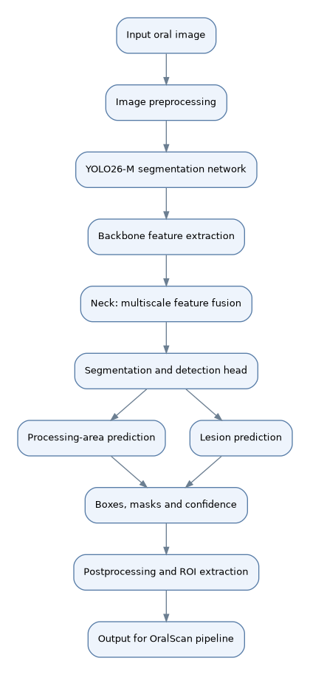

Conceptual architecture reconstructed from the notebook and checkpoint structure. The internal features are not separate individually deployed models.
The inference sequence is:
- An oral image is provided to the model.
- The image is resized and prepared for neural-network processing.
- The backbone extracts visual features.
- The neck combines features from different spatial scales.
- The prediction head estimates object classes, bounding boxes, and segmentation masks.
- Postprocessing produces usable regions for downstream software.
This makes AI_Y2 a region-localization component in OralScan, rather than the final diagnostic decision-maker.

3. Reverse engineering the .pt model
A PyTorch .pt file stores information that can be used to reconstruct or load a trained model.
The uploaded checkpoint is a serialized PyTorch archive. Inspection of its internal structure identifies the following network components:
Component identified | Function
SegmentationModel | Main Ultralytics segmentation-model container
Conv and Conv2d | Learn visual features through convolutions
BatchNorm2d | Normalize intermediate feature activations
SiLU | Introduce nonlinear activation
C3k2 and C3k | Feature extraction and efficient feature aggregation
Bottleneck | Transform features through compact convolutional blocks
SPPF | Aggregate spatial context at different receptive-field sizes
C2PSA and Attention | Enhance feature representation using attention mechanisms
Upsample and Concat | Combine feature maps from different resolutions
Segment26 | YOLO26 segmentation prediction head
Proto26 | Generate mask-prototype representations
DWConv | Apply depthwise convolution efficiently
ConvTranspose2d | Support feature-map upsampling

These component names were recovered from the checkpoint serialization, while the notebook identifies the intended YOLO26-M family.

Backbone, neck, and head

Diagram 2 — Internal neural network structure
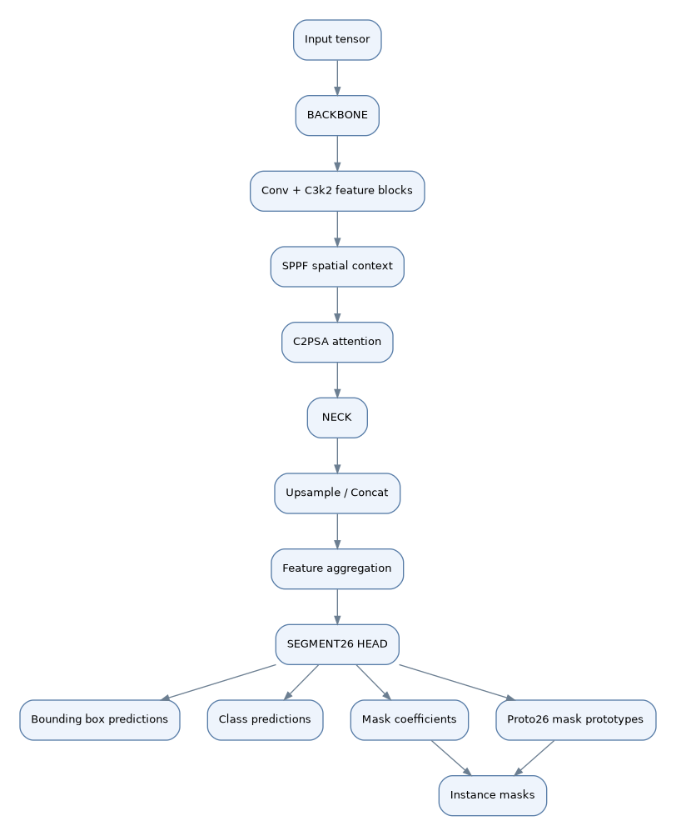
Backbone: Extracts increasingly abstract features, such as edges, textures, local tissue appearance, and contextual image patterns. Its learned filters may respond to color variations, irregular shapes, and suspicious regions. However, exactly what an individual filter has learned requires activation or attribution analysis.
Neck: Combines high-resolution features, which are useful for boundaries, with lower-resolution features, which carry broader contextual information. This multiscale processing matters because oral lesions can vary significantly in size and appearance.
Detection and segmentation head: Converts fused feature representations into object-level predictions. Its class output distinguishes processing_area from lesion, while its mask output estimates the spatial extent of individual predicted regions.

How mask generation works
In prototype-based segmentation, a network generates shared mask prototypes and object-specific coefficients. Their combination can be represented conceptually as:
Mᵢ = σ(∑ₖ₌₁ᴷ aᵢₖ Pₖ)
- Mᵢ: Predicted mask for object i
- Pₖ: Shared mask prototype k
- aᵢₖ: Mask coefficient for object i
- K: Number of prototypes
- σ: Sigmoid activation
The mask is then spatially processed and mapped to the corresponding image region. This is the conceptual mechanism; the exact head implementation depends on the installed Ultralytics version.

4. What the notebook reveals about training
The notebook documents a considerably more involved process than simply training YOLO on a collection of images.

Diagram 3 — Complete development workflow
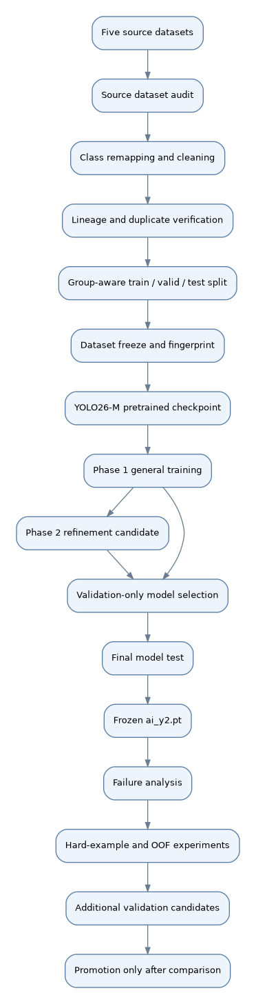
The notebook's corrected final split contains:
Training | Validation | Testing
865 (75.0%) | 173 (15.0%) | 115 (10.0%)

Final dataset: 1,153 images. The notebook records zero lineage leakage and zero exact-MD5 cross-split leakage after the corrected dataset construction.
An important methodological strength is that the notebook does not treat source images as independent when they belong to the same underlying image lineage. Related or augmented images are grouped to reduce the risk of an overly optimistic evaluation.
The notebook also includes an initial 1,166-image audit and an intermediate 1,153-image split. Those intermediate results are superseded by the corrected 865/173/115 split used for model development.

5. Detailed explanation of training methodology
The notebook uses a pretrained segmentation network followed by fine-tuning on the oral dataset.

Phase 1 — General segmentation training
Parameter | Notebook setting
Starting weights | yolo26m-seg.pt
Optimizer | AdamW
Maximum epochs | 350
Early-stopping patience | 55
Initial learning rate | 0.0004
Final LR factor | 0.01
Batch size | 16
Image size | 640
Weight decay | 0.0005
Mask ratio | 2
Mixed precision | Enabled
Mosaic augmentation | 0.10

The purpose of Phase 1 is to adapt the pretrained segmentation network to the image characteristics of the oral dataset.
This process is called transfer learning. Instead of teaching every visual pattern from scratch, the model begins with pretrained representations and updates its weights using oral images and their annotated regions.
A supervised training iteration works conceptually as follows:
θₜ₊₁ = θₜ − ηₜ · Δₜ
Here, θₜ represents the model parameters, ηₜ the learning rate, and Δₜ the optimizer-computed update based on gradients and optimizer state.
The optimizer adjusts the network to reduce a combination of detection, classification, and segmentation training losses.

Phase 2 — Boundary refinement
The second training phase starts from the best Phase 1 checkpoint rather than from the original pretrained model.
Parameter | Phase 1 | Phase 2
Maximum epochs | 350 | 120
Initial learning rate | 0.0004 | 0.0001
Patience | 55 | 30
Rotation augmentation | 8° | 3°
Translation | 0.04 | 0.02
Scale | 0.12 | 0.05
Mosaic | 0.10 | 0
Mask ratio | 2 | 2

Phase 2 deliberately reduces the learning rate and image transformations to emphasize controlled fine-tuning.
This matters for medical imagery because strong geometric augmentation can produce anatomically implausible examples or distort lesion boundaries.
The notebook ultimately selected Phase 1 for the frozen AI_Y2 model, rather than automatically promoting Phase 2. That decision was made using validation results and targeted lesion-detection behavior, not simply by assuming that additional training improves the model.

6. Evaluation and performance results
The notebook includes a final held-out test of the selected Y2 model, using 115 images.
Final test metric | Result
Mask precision | 65.50%
Mask recall | 59.40%
Mask mAP@50 | 48.35%
Mask mAP@50:95 | 21.78%
Bounding-box precision | 81.92%
Bounding-box recall | 72.70%
Processing-area mask mAP@50:95 | 25.39%
Lesion mask mAP@50:95 | 18.17%

These are segmentation/detection metrics reported by the notebook, not diagnostic sensitivity, disease-classification accuracy, or clinical validation outcomes.

Understanding the evaluation metrics
Precision measures the proportion of predicted positives that are correct, under the applicable matching criteria.
Precision = TP / (TP + FP)
Recall measures the proportion of ground-truth positives that were detected.
Recall = TP / (TP + FN)
Intersection over Union (IoU) measures the overlap between a predicted region and the ground-truth annotation:
IoU = |M_prediction ∩ M_ground truth| / |M_prediction ∪ M_ground truth|
mAP@50 summarizes detection performance at an IoU threshold of 0.50, while mAP@50:95 averages performance across progressively stricter thresholds from 0.50 to 0.95.
That distinction matters here: AI_Y2 is much stronger at finding that a lesion exists somewhere in the image than at producing highly accurate pixel-level lesion boundaries.

Lesion-presence detection versus exact segmentation
The notebook reports additional task-specific behavior at confidence threshold 0.25.
Test behavior | Result
Lesion-positive test images | 89
Lesion-positive images with a detected lesion | 82
Lesion-image recall | 92.13%
Lesion-positive images without a detected lesion | 7
False-lesion images | 2
False-lesion image rate on lesion-negative images | 7.69%
Processing-area presence rate | 98.26%

These results illustrate why two different measures are necessary.
- A model can detect a lesion somewhere in the image but outline it imperfectly.
- A high image-level detection rate does not guarantee that the resulting crop fully contains the pathology.
- Pixel-accurate segmentation is particularly important when downstream classification depends on a correctly extracted lesion ROI.
The important limitation is that the segmentation results are considerably weaker than image-level lesion detection. Consequently, the model should not be described as providing highly precise segmentation simply because its lesion-image recall exceeds 90%.

7. Hard-example mining and refinement experiments
After the initial model was frozen, the notebook continued with several candidate-improvement experiments.

Hard-example mining
Hard-example mining focuses training on examples the model finds difficult, including:
- Missed lesions.
- False lesion predictions.
- Low-IoU lesion masks.
- Low-IoU processing-area masks.
The objective is to expose the neural network to more challenging examples without altering its two-class output contract.

Out-of-fold (OOF) evaluation

Diagram 4 — Five-fold out-of-fold hard-case mining
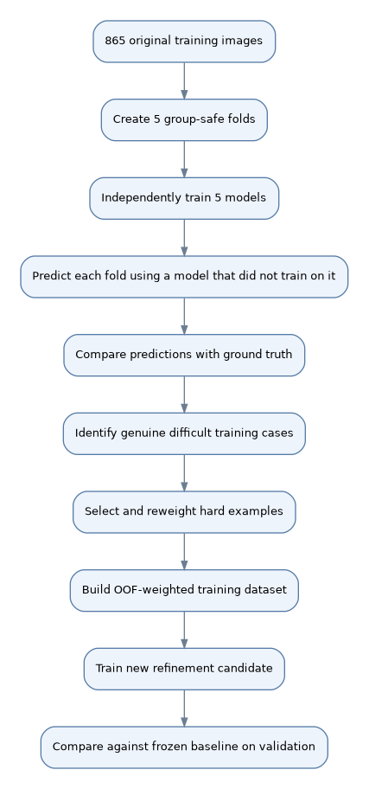
A critical methodological detail is that the notebook trains independent fold models from the original pretrained checkpoint, not from the already-trained AI_Y2 model.
This avoids using a model that has previously seen the same image to generate supposedly unseen predictions.
The five-fold procedure produced out-of-fold predictions for all 865 original training images.
The next dataset-generation step selected 345 additional hard-example copies, resulting in:
Partition | Images
OOF-weighted training set | 1,210
Original validation set | 173
Original test set | 115

The weighted training set therefore represents 865 original training images plus 345 selected repetitions—not 1,210 independent original images.

Did OOF fine-tuning improve the model?
The notebook's final recorded validation comparison shows mixed results.
Metric | Frozen Y2 | OOF candidate
Mask precision | 73.38% | 69.57%
Mask recall | 63.93% | 65.93%
Overall mask mAP@50:95 | 26.29% | 26.51%
Processing-area mask mAP@50:95 | 24.34% | 29.31%
Lesion mask mAP@50:95 | 28.23% | 23.70%

The OOF candidate improved overall mask recall and processing-area mask quality, but its lesion mask mAP declined. The notebook explicitly avoids replacing the frozen production model automatically.
That is particularly relevant to OralScan, where accurately retaining lesion information for the classifier may be more important than improving the processing-area metric alone.

8. Integration of AI_Y2 into OralScan
AI_Y2 can supply regions of interest to the separate classifier, which is responsible for disease classification.

Diagram 5 — Integration with downstream classification
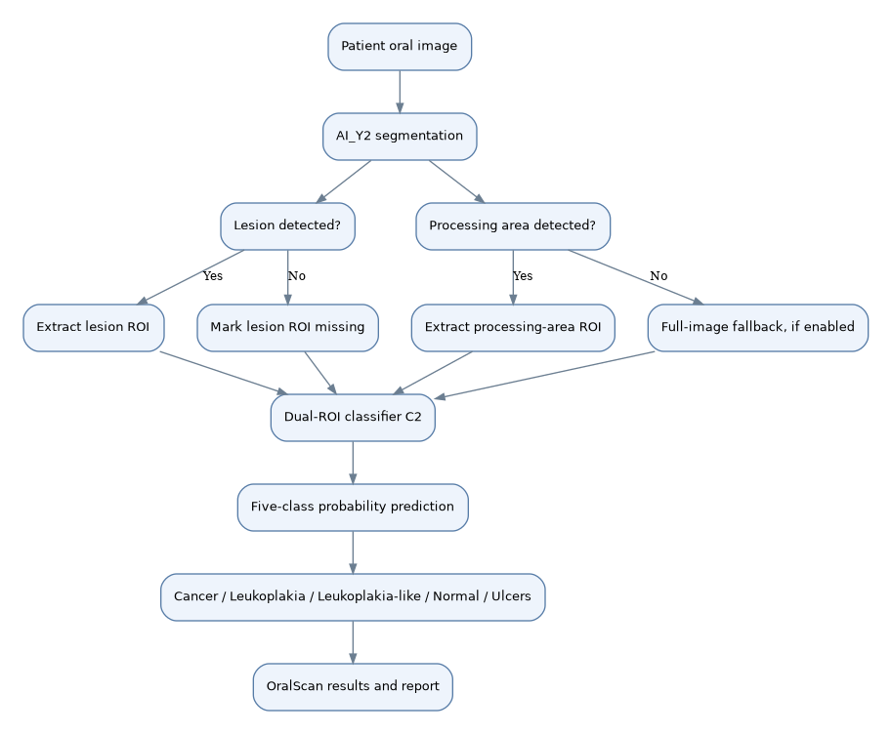
This is the proposed integration based on the established OralScan design, not a claim that the supplied AI_Y2 training notebook itself implements the C2 classifier or report generation.
The most important separation is:
AI_Y2 detector | C2 classifier
Finds processing areas | Analyzes relevant oral image regions
Finds visible lesions | Predicts disease classes
Generates masks and bounding boxes | Generates class probability scores
Two segmentation classes | Five disease classes
Used for localization | Used for classification

Correct ROI extraction and failure handling are necessary because errors in the detector can propagate into the classifier.

9. What reverse engineering can and cannot establish
Established from the uploaded files
The model archive uses Ultralytics segmentation components, including SegmentationModel, Segment26, Proto26, C3k2, SPPF, and C2PSA. The notebook documents the two-class contract, training configurations, dataset history, candidate selection, and reported evaluation metrics.
Not independently established
The exact layer-by-layer computational graph, individual tensor dimensions and weights, verified execution of the uploaded .pt file, numerical parity between the checkpoint and notebook results, and clinical performance on external patient populations.
I inspected the serialized checkpoint structure without executing its embedded Python objects. A full architecture reconstruction would require loading the model in a trusted, compatible Ultralytics environment and examining its model graph and parameter shapes. The notebook's reported metrics should therefore be understood as recorded experimental results, rather than as results independently reproduced from the uploaded checkpoint.

10. Final technical conclusions
AI_Y2 has a structured development history involving data cleaning, class remapping, source-aware splitting, transfer learning, validation-driven checkpoint selection, held-out testing, and subsequent hard-case refinement.
The strongest aspects of the documented methodology are its compatibility controls, lineage-aware data splitting, preservation of the test partition, and explicit comparison of refined models against the frozen baseline.
Its principal technical limitation is lesion boundary accuracy. The held-out test reports 92.13% lesion-image recall but only 18.17% lesion mask mAP@50:95. These quantities measure different capabilities, yet their difference indicates that finding a lesion and accurately outlining it remain distinct challenges.
For OralScan, the next meaningful evaluation would therefore be to measure not only YOLO segmentation performance but also how segmentation errors affect downstream C2 classification, especially missed lesions, incomplete lesion crops, false lesion regions, and cases with no detected processing area.
Overall: The uploaded files document a two-class oral-image segmentation system with a carefully controlled experimental workflow. They support a detailed architectural and methodological explanation, but they do not establish clinical-grade diagnostic reliability or prove that the detector-classifier pipeline is accurate end to end.

