Reverse Engineering Report — OralScan AI C2
Technical architecture analysis • Model checkpoint + Google Colab training notebook
I inspected both uploaded files and reconstructed the design of the OralScan C2 system from the actual notebook code and checkpoint metadata.
The analysis covers the model architecture, neural network layers, training methodology, preprocessing, lesion handling, classification logic, calibration, and inference pipeline.

1. Understanding the two files
File | Type | Purpose
ai_c2(1).pt | PyTorch checkpoint (~54 MB) | Contains trained neural network weights, model configuration, validation metrics, and inference policy
ai_c2(2).ipynb | Jupyter notebook (~16 MB) | Contains dataset preparation, model implementation, training, experiments, evaluation, and inference code

The notebook contains 35 cells, including the complete C2 model definition, training experiments, comparison with C1, calibration, and standalone inference functions.
The .pt file identifies its model as ai_c2, using the OralScanC2 architecture.

2. What type of AI model is C2?
OralScan C2 is a dual-region-of-interest (Dual-ROI), hierarchical deep-learning image classifier, built on EfficientNetV2-B3.
It is not a standalone lesion detector. Its job is to classify oral tissue using image regions provided through the preprocessing and detection pipeline.

Overall system architecture
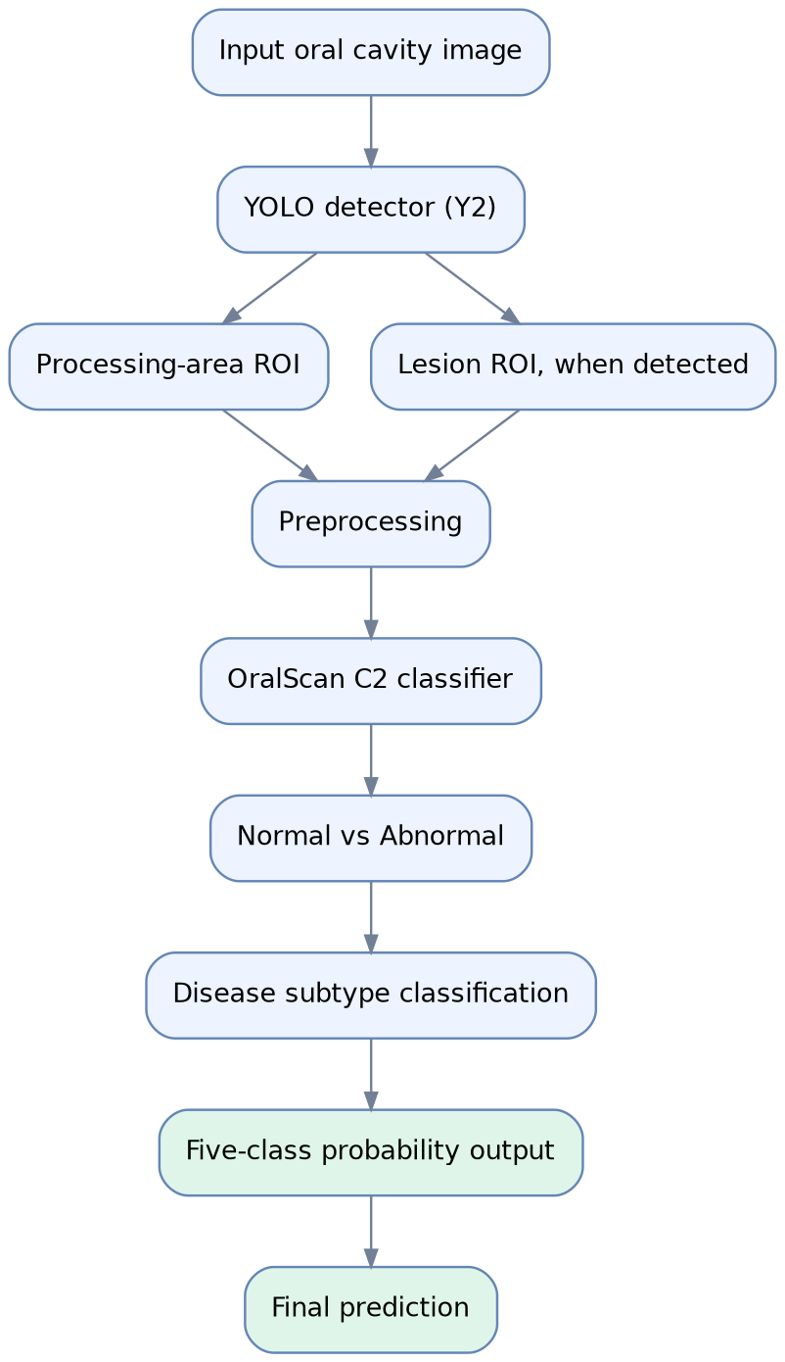
Y2 detects the regions; C2 performs the classification. They are separate models, so the C2 checkpoint does not contain the Y2 detector's weights.

Exact C2 configuration
Component | Confirmed implementation
Framework | PyTorch
Architecture | OralScanC2
Backbone | tf_efficientnetv2_b3
Network family | Convolutional Neural Network
ROI inputs | Processing area + lesion
Feature dimension | 1,536
Image input size | 300 × 300
Feature fusion | Learned gated fusion
Classification | Hierarchical, two-stage
Output classes | 5
Missing lesion handling | Learned embedding
Model dropout | 0.30
Calibration temperature | 1.31822886

3. Internal neural network architecture
The classifier processes two regions using a shared EfficientNetV2-B3 backbone.
This means the processing-area and lesion branches use the same feature-extraction weights, rather than two independent copies of EfficientNet.

Detailed C2 architecture diagram
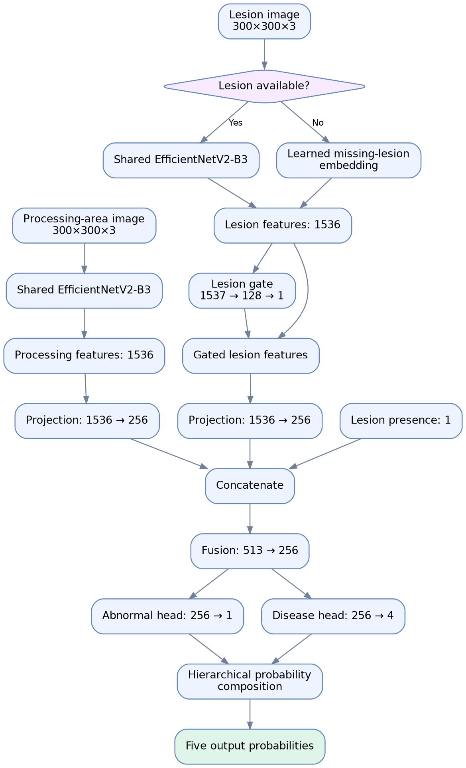
The feature sizes and layer connections are reconstructed from the notebook implementation and checkpoint structure.

How each stage works
Stage A — Feature extraction
EfficientNetV2-B3 extracts a 1,536-dimensional visual representation from each available ROI. These learned features encode image characteristics relevant to the classification task.
Stage B — Missing-lesion representation
When no lesion is supplied, C2 uses a trainable missing_lesion_embedding. It does not assume that a missing lesion automatically means the image is normal.
Stage C — Lesion attention gate
A learned sigmoid gate determines how strongly lesion features contribute to classification. Its output lies between 0 and 1.
Stage D — Feature fusion
The model combines:
- 256 processing-area features
- 256 lesion features
- 1 lesion-presence indicator
The resulting 513-dimensional vector is transformed into a fused 256-dimensional representation.
Stage E — Hierarchical prediction
Two classification heads operate on the fused features. One estimates abnormality; the second estimates which of four disease types is present.

4. Hierarchical classification — mathematical theory
Unlike a conventional five-class softmax classifier, C2 follows a hierarchical classification strategy.

Hierarchical classification tree
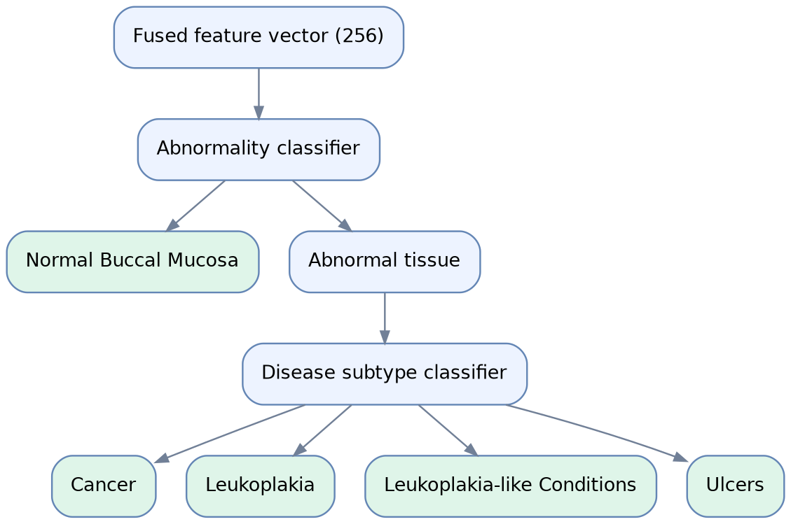
The first head estimates:
p_A = σ(z_A)
where p_A is the predicted probability of abnormal tissue.
The second head produces disease subtype probabilities:
q_i = softmax(z_D)_i
The final probabilities are calculated as:
P(Normal) = 1 − p_A
P(Disease_i) = p_A × q_i
The five probabilities sum to one.
For example, suppose the model predicts an 80% abnormality probability and the disease head assigns 60% of the abnormal probability to Cancer. The final Cancer probability would be 0.8 × 0.6 = 0.48, or 48%.
The exact class-ID arrangement is:
Class ID | Output class
0 | Cancer
1 | Leukoplakia
2 | Leukoplakia-like Conditions
3 | Normal Buccal Mucosa
4 | Ulcers

Although Normal has class ID 3 in the output, it is handled by the binary abnormality head, not by the four-class disease head.

5. Reverse engineering the training notebook
The notebook documents how the training data was prepared, how C2 was trained, and how candidate checkpoints were evaluated and selected.

Complete training workflow
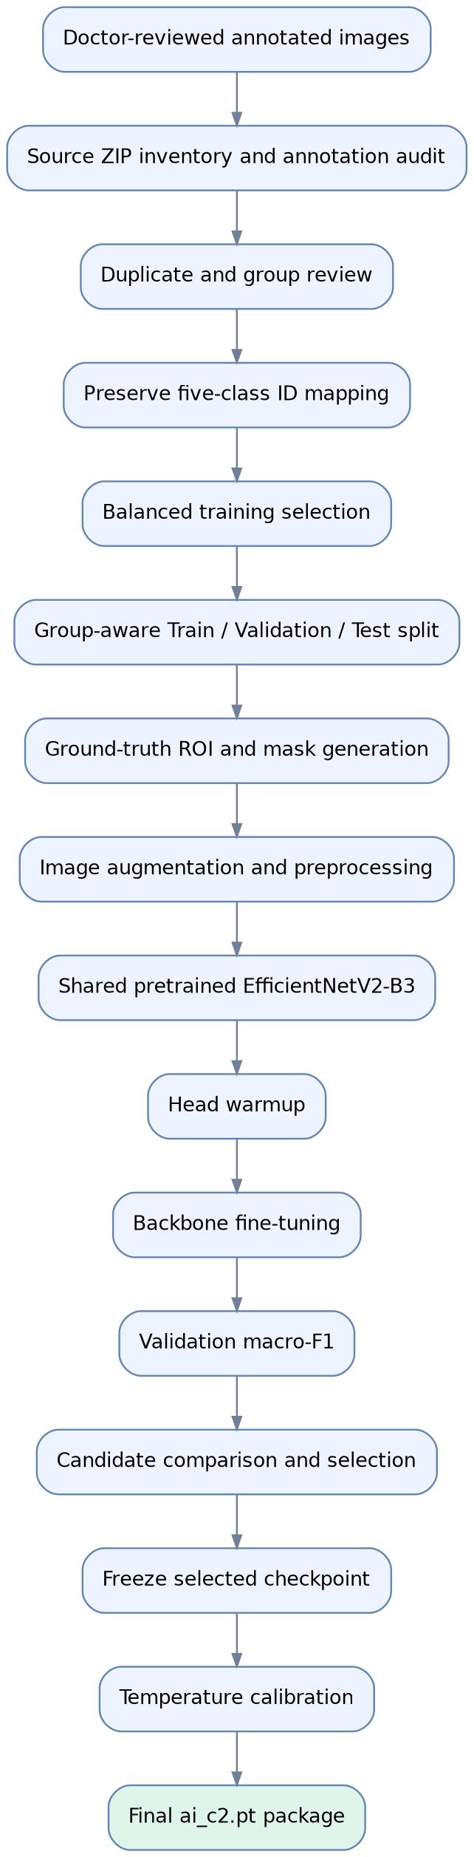

Training data methodology
The notebook uses existing annotations to generate ground-truth training crops rather than generating training crops from YOLO predictions.
The prepared dataset has 717 samples across five classes.
Dataset partition | Samples
Training | 425
Validation | 144
Test | 148
Total | 717

Training was balanced at 85 samples per class. The validation and test partitions were not perfectly class-balanced.
An important architectural choice is that detector-prediction errors are excluded from ground-truth crop creation, while predicted Y2 regions are examined separately to test deployment behavior.

Training configuration of the selected candidate
Hyperparameter | Value
Random seed | 42
Maximum epochs | 60
Warmup epochs | 5
Early-stopping patience | 10
Batch size | 16
Classification-head learning rate | 0.0001
Backbone learning rate | 0.000005
Weight decay | 0.0005
Label smoothing | 0.05
Lesion branch dropout | 0.15

The notebook first trains the classification components and subsequently fine-tunes the backbone. Its code also preserves pretrained backbone batch-normalization statistics during training.
The loss is hierarchical negative log-likelihood, with the probability distribution generated by the binary and disease heads.

6. How C2 handles missing detections
This is an especially important part of the implementation because a detector can fail to identify a lesion even when disease is present.
Detector result | C2 behavior
Processing area and lesion detected | Use both ROI branches
Processing area detected, lesion missing | Use processing ROI and learned missing-lesion embedding
Processing area missing | Use full-image fallback
Lesion extends beyond processing crop | Apply conditional geometry expansion

The checkpoint defines a geometry-expansion policy. If the processing crop contains less than 90% of predicted lesion pixels, the system expands the processing crop to include the relevant lesion area, with padding.
The stored settings specify 12% processing-area padding and 30% lesion padding, with 12% padding for the expanded union region.

Inference decision flow
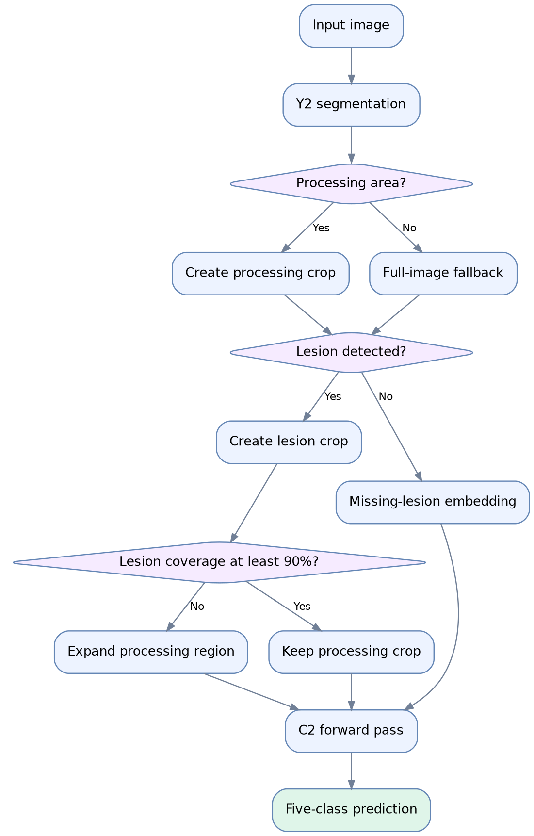
This design does not guarantee correct classification after a detector failure, but it allows the classifier to operate when a lesion crop is unavailable.

7. Inference preprocessing
Both branches use the preprocessing settings embedded in the checkpoint.
- RGB image format
- Bilinear resizing to 300 × 300
- Mean normalization (0.5, 0.5, 0.5)
- Standard deviation (0.5, 0.5, 0.5)
- No center crop
- No blur preprocessing
The normalized image tensor is computed as:
x′ = (x − 0.5) / 0.5
where image pixel intensities have first been converted to the range [0,1].
These settings must be preserved when deploying the checkpoint; switching to another normalization configuration can affect predictions.

8. Temperature calibration
The final model contains a calibrated probability transformation.

Calibration results
Temperature | Calibration samples
1.3182 | 144

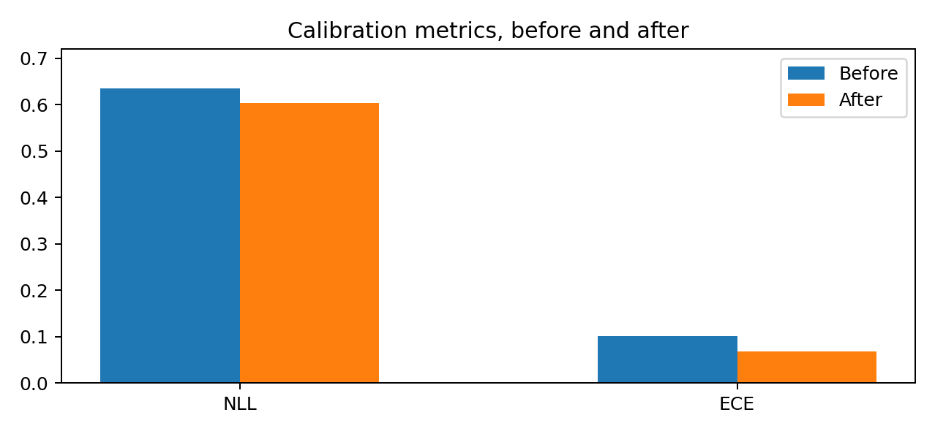
Lower values are better. Measurements are on the calibration validation set.
The temperature scales the model's hierarchical class log probabilities before renormalization. Since the fitted temperature is above one, it generally softens the probability distribution.
The checkpoint reports that the predicted class labels remained unchanged after calibration.
Limitation: These calibration numbers were measured on the same 144-image validation set used for fitting calibration, so they should not be interpreted as independent evidence of generalization.

9. What the checkpoint confirms about performance
Validation accuracy | Validation macro-F1 | Cancer recall | Learnable parameters
83.33% | 84.56% | 89.66% | 13.95M

These figures are recorded in the selected checkpoint's validation metadata. They are not independent clinical test-set metrics.
The final checkpoint reports a validation disease-to-normal error rate of approximately 0.89% and a normal-to-disease error rate of 12.5%.
Its metadata also reports an expanded-Y2 validation macro-F1 of approximately 84.06%, from the predicted-ROI selection workflow.
A particularly important finding is that test_evaluated is set to False, and independent final evaluation is marked as pending. The original test set was also described in metadata as previously inspected during development.
Therefore, the checkpoint supports conclusions about the model's structure and recorded validation performance, but not a claim of independently verified clinical accuracy.

10. Relationship between the .pt file and .ipynb file
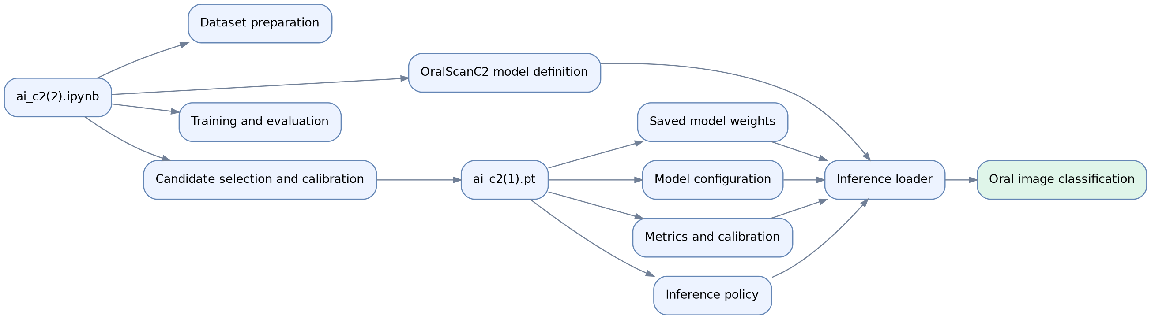
The notebook is the development and training implementation. The checkpoint is the resulting deployable classifier artifact.
The checkpoint contains 645 entries in its model state dictionary, including learnable weights and non-trainable network state. It has 13,946,918 learnable parameters.
The last standalone inference implementation in the notebook defines an OralScanC2 loader compatible with this checkpoint structure, alongside code for other models.

11. Technical conclusion
Reverse engineering confirms that OralScan C2 is more sophisticated than a conventional image classification CNN in several ways:
1. It incorporates both the surrounding processing region and the lesion region.
2. It shares a pretrained feature extractor between the two image branches.
3. It learns how much attention to assign to lesion information through a feature gate.
4. It separates normal-versus-abnormal recognition from disease subtype recognition.
5. It uses a trainable representation for missing lesions rather than relying solely on a black placeholder.
6. It includes a detector-aware ROI expansion policy.
7. It applies post-training probability calibration.
The model's most important distinction is its combination of Dual-ROI feature fusion and hierarchical five-class classification.
The architecture, code, and selected checkpoint are identifiable and consistent at the main structural level. The remaining question is not how the model works, but how reliably it generalizes to previously unseen patients, different imaging conditions, and detectors other than the evaluated Y2 configuration.
This reverse engineering reconstructs the documented computational design and stored training metadata; it does not reveal the complete original training images or independently establish medical diagnostic effectiveness.

13. Final technical definition
OralScan AI C2 can be defined as:
A five-class oral mucosal image classifier based on EfficientNetV2-B3, using two spatially distinct RGB regions with shared convolutional feature extraction, branch-specific projections, a learned missing-lesion representation, scalar-gated feature fusion, and a hierarchical probabilistic classification head. The model combines normal-versus-abnormal estimation with conditional disease subtype probabilities and applies post-training temperature calibration at inference.
Its prediction is a five-element probability vector, but those probabilities are model estimates rather than confirmed disease diagnoses.

