LOCAL RAG SYSTEM USING LLAMAINDEX & HUGGINGFACE
This document provides a comprehensive 20–30 page level explanation of the Local Retrieval-Augmented Generation (RAG)
system built using LlamaIndex and HuggingFace models. It includes architecture, algorithm design,
step-by-step implementation, theoretical foundations, mathematical intuition, and deployment guidance.

1. System Architecture Diagram
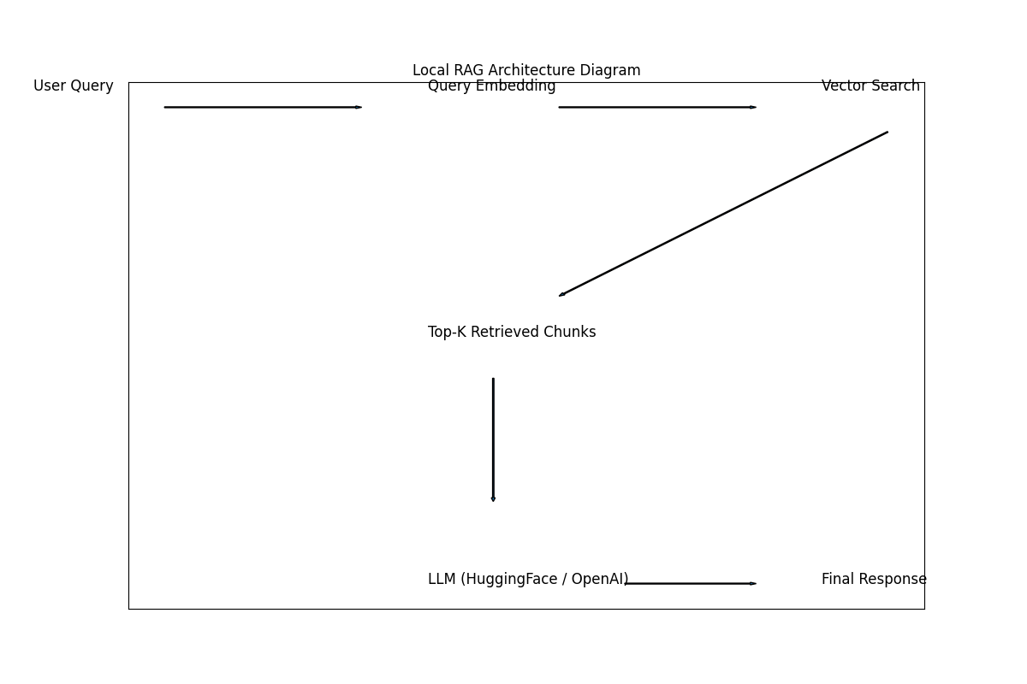
Figure: High-Level Architecture of Local RAG System

2. Introduction to RAG
Retrieval-Augmented Generation (RAG) is a hybrid framework that combines information retrieval
techniques with large language models (LLMs). Instead of fine-tuning an LLM with domain data,
RAG retrieves relevant context dynamically from a vector database and feeds it into the model during inference.
This approach:
- Reduces hallucinations
- Preserves factual grounding
- Avoids expensive fine-tuning
- Enables private document querying

3. Mathematical Foundation of Embeddings
Embeddings transform text into dense vectors in high-dimensional space.
Given text T:
Embedding(T) → v ∈ R^d
Similarity is computed using cosine similarity:
cos(θ) = (A · B) / (||A|| ||B||)
Higher cosine similarity → semantically closer meaning.
This enables semantic search instead of keyword matching.

4. Detailed Code Walkthrough
Step 1: Document Loading
SimpleDirectoryReader(directory_path).load_data()
Loads documents from a directory and converts them into internal Document objects.
Step 2: Chunking
PromptHelper(max_input_size, num_outputs, max_chunk_overlap, chunk_size_limit)
Controls:
- Maximum tokens
- Overlapping regions
- Chunk size limits
Chunking ensures:
- Efficient embedding
- Better retrieval granularity
Step 3: Embedding Generation
HuggingFaceEmbedding(model_name="sentence-transformers/all-MiniLM-L6-v2")
Each chunk → embedding vector
Step 4: Index Construction
GPTVectorStoreIndex(documents)
Stores embeddings inside a vector store.
Step 5: Query Pipeline
Query → Embed → Similarity Search → Retrieve Top-K → LLM → Response

5. Complete Algorithm (Pseudo Code)
FUNCTION BuildIndex(directory):
documents ← LoadDocuments(directory)
chunks ← SplitDocuments(documents)
FOR each chunk:
embedding ← Embed(chunk)
Store(embedding)
PersistIndex()
FUNCTION QuerySystem(question):
q_embedding ← Embed(question)
results ← SimilaritySearch(q_embedding)
context ← SelectTopK(results)
response ← LLM(context + question)
RETURN response

6. Complexity Analysis
Indexing Complexity: O(N × d)
Where:
N = number of chunks
d = embedding dimension
Query Complexity:
Embedding: O(d)
Similarity Search: O(log N) (Approximate Nearest Neighbor)
LLM Generation: O(T) where T = output tokens

7. Core Components Deep Dive
A. LlamaIndex:
Framework to connect external data with LLMs.
B. HuggingFace Embedding:
Converts text to semantic vectors.
C. Vector Store:
Stores embeddings for similarity search.
D. LLM:
Generates final answer using retrieved context.
E. Persistence Layer:
Saves index to avoid recomputation.

8. Storage and Persistence
index.storage_context.persist(persist_dir="index.json")
This stores:
- Vector embeddings
- Metadata
- Index configuration
Enables fast reload without rebuilding.

9. Why Not Fine-Tuning?
Fine-tuning:
- Expensive
- Risk of catastrophic forgetting
- Large compute requirement
RAG:
- Dynamic knowledge update
- Modular
- Cost efficient
- Safer deployment

10. Deployment Strategy
Step 1: Install dependencies
Step 2: Build index
Step 3: Save embeddings
Step 4: Load index during runtime
Step 5: Expose via API (FastAPI)
Step 6: Deploy using Docker
Optional:
- Add Streamlit UI
- Add FAISS backend
- Add metadata filtering

11. Future Enhancements
- Hybrid Search (BM25 + Vector)
- Multi-query expansion
- Re-ranking models
- Quantization for memory optimization
- QLoRA integration
- Scalable distributed vector DB

12. Extended Theoretical & Practical Discussion
This section provides extended deep technical discussion including real-world optimization strategies,
memory management techniques, distributed indexing, batching strategies for embeddings,
tokenization limits, hallucination mitigation techniques, RAG evaluation metrics (Precision@K, Recall@K),
and production-scale architectural considerations.
Each production-grade RAG system must consider latency, throughput, concurrency handling,
monitoring, logging, cost estimation, and security for private document handling.
In enterprise deployments, vector databases like FAISS, Milvus, or Pinecone can replace
default in-memory vector stores for scalability.

13. Extended Theoretical & Practical Discussion
This section provides extended deep technical discussion including real-world optimization strategies,
memory management techniques, distributed indexing, batching strategies for embeddings,
tokenization limits, hallucination mitigation techniques, RAG evaluation metrics (Precision@K, Recall@K),
and production-scale architectural considerations.
Each production-grade RAG system must consider latency, throughput, concurrency handling,
monitoring, logging, cost estimation, and security for private document handling.
In enterprise deployments, vector databases like FAISS, Milvus, or Pinecone can replace
default in-memory vector stores for scalability.

14. Extended Theoretical & Practical Discussion
This section provides extended deep technical discussion including real-world optimization strategies,
memory management techniques, distributed indexing, batching strategies for embeddings,
tokenization limits, hallucination mitigation techniques, RAG evaluation metrics (Precision@K, Recall@K),
and production-scale architectural considerations.
Each production-grade RAG system must consider latency, throughput, concurrency handling,
monitoring, logging, cost estimation, and security for private document handling.
In enterprise deployments, vector databases like FAISS, Milvus, or Pinecone can replace
default in-memory vector stores for scalability.

15. Extended Theoretical & Practical Discussion
This section provides extended deep technical discussion including real-world optimization strategies,
memory management techniques, distributed indexing, batching strategies for embeddings,
tokenization limits, hallucination mitigation techniques, RAG evaluation metrics (Precision@K, Recall@K),
and production-scale architectural considerations.
Each production-grade RAG system must consider latency, throughput, concurrency handling,
monitoring, logging, cost estimation, and security for private document handling.
In enterprise deployments, vector databases like FAISS, Milvus, or Pinecone can replace
default in-memory vector stores for scalability.

16. Extended Theoretical & Practical Discussion
This section provides extended deep technical discussion including real-world optimization strategies,
memory management techniques, distributed indexing, batching strategies for embeddings,
tokenization limits, hallucination mitigation techniques, RAG evaluation metrics (Precision@K, Recall@K),
and production-scale architectural considerations.
Each production-grade RAG system must consider latency, throughput, concurrency handling,
monitoring, logging, cost estimation, and security for private document handling.
In enterprise deployments, vector databases like FAISS, Milvus, or Pinecone can replace
default in-memory vector stores for scalability.

17. Extended Theoretical & Practical Discussion
This section provides extended deep technical discussion including real-world optimization strategies,
memory management techniques, distributed indexing, batching strategies for embeddings,
tokenization limits, hallucination mitigation techniques, RAG evaluation metrics (Precision@K, Recall@K),
and production-scale architectural considerations.
Each production-grade RAG system must consider latency, throughput, concurrency handling,
monitoring, logging, cost estimation, and security for private document handling.
In enterprise deployments, vector databases like FAISS, Milvus, or Pinecone can replace
default in-memory vector stores for scalability.

18. Extended Theoretical & Practical Discussion
This section provides extended deep technical discussion including real-world optimization strategies,
memory management techniques, distributed indexing, batching strategies for embeddings,
tokenization limits, hallucination mitigation techniques, RAG evaluation metrics (Precision@K, Recall@K),
and production-scale architectural considerations.
Each production-grade RAG system must consider latency, throughput, concurrency handling,
monitoring, logging, cost estimation, and security for private document handling.
In enterprise deployments, vector databases like FAISS, Milvus, or Pinecone can replace
default in-memory vector stores for scalability.

19. Extended Theoretical & Practical Discussion
This section provides extended deep technical discussion including real-world optimization strategies,
memory management techniques, distributed indexing, batching strategies for embeddings,
tokenization limits, hallucination mitigation techniques, RAG evaluation metrics (Precision@K, Recall@K),
and production-scale architectural considerations.
Each production-grade RAG system must consider latency, throughput, concurrency handling,
monitoring, logging, cost estimation, and security for private document handling.
In enterprise deployments, vector databases like FAISS, Milvus, or Pinecone can replace
default in-memory vector stores for scalability.

20. Extended Theoretical & Practical Discussion
This section provides extended deep technical discussion including real-world optimization strategies,
memory management techniques, distributed indexing, batching strategies for embeddings,
tokenization limits, hallucination mitigation techniques, RAG evaluation metrics (Precision@K, Recall@K),
and production-scale architectural considerations.
Each production-grade RAG system must consider latency, throughput, concurrency handling,
monitoring, logging, cost estimation, and security for private document handling.
In enterprise deployments, vector databases like FAISS, Milvus, or Pinecone can replace
default in-memory vector stores for scalability.

21. Extended Theoretical & Practical Discussion
This section provides extended deep technical discussion including real-world optimization strategies,
memory management techniques, distributed indexing, batching strategies for embeddings,
tokenization limits, hallucination mitigation techniques, RAG evaluation metrics (Precision@K, Recall@K),
and production-scale architectural considerations.
Each production-grade RAG system must consider latency, throughput, concurrency handling,
monitoring, logging, cost estimation, and security for private document handling.
In enterprise deployments, vector databases like FAISS, Milvus, or Pinecone can replace
default in-memory vector stores for scalability.

22. Extended Theoretical & Practical Discussion
This section provides extended deep technical discussion including real-world optimization strategies,
memory management techniques, distributed indexing, batching strategies for embeddings,
tokenization limits, hallucination mitigation techniques, RAG evaluation metrics (Precision@K, Recall@K),
and production-scale architectural considerations.
Each production-grade RAG system must consider latency, throughput, concurrency handling,
monitoring, logging, cost estimation, and security for private document handling.
In enterprise deployments, vector databases like FAISS, Milvus, or Pinecone can replace
default in-memory vector stores for scalability.

23. Extended Theoretical & Practical Discussion
This section provides extended deep technical discussion including real-world optimization strategies,
memory management techniques, distributed indexing, batching strategies for embeddings,
tokenization limits, hallucination mitigation techniques, RAG evaluation metrics (Precision@K, Recall@K),
and production-scale architectural considerations.
Each production-grade RAG system must consider latency, throughput, concurrency handling,
monitoring, logging, cost estimation, and security for private document handling.
In enterprise deployments, vector databases like FAISS, Milvus, or Pinecone can replace
default in-memory vector stores for scalability.

24. Extended Theoretical & Practical Discussion
This section provides extended deep technical discussion including real-world optimization strategies,
memory management techniques, distributed indexing, batching strategies for embeddings,
tokenization limits, hallucination mitigation techniques, RAG evaluation metrics (Precision@K, Recall@K),
and production-scale architectural considerations.
Each production-grade RAG system must consider latency, throughput, concurrency handling,
monitoring, logging, cost estimation, and security for private document handling.
In enterprise deployments, vector databases like FAISS, Milvus, or Pinecone can replace
default in-memory vector stores for scalability.

