Sargam Naik Dessai

Computer Engineer (B.E) | [sargamnd@gmail.com](mailto:sargamnd@gmail.com%20) | +91 9527317890

DOB- 19th Aug 1998 |LinkedIn - <https://www.linkedin.com/in/sargam-naik-dessai-b24021194/>

Portfolio Link - <https://sargam98.github.io/SargamNaikDessai-Portfolio/>

GitHub - <https://github.com/sargam98>

**Objective:**

A highly motivated and curious student looking for a technical position allowing me to utilize my education, showcase my skillset and gain valuable work experience in a team-oriented environment.

**Education:**

**B.E Computer Engineering** (Agnel Institute of Technology & Design), Goa2016-2020 Graduated with 68.76% (First Class) from **Goa University**

**Vasantrao Dempo Higher Secondary School (Goa Board), Goa** 2014-2016 Graduated with 67.33% in 12th standard Goa Board examination

**Sharada Mandir School (ICSE), Goa** 2010-2014 Graduated with 83.5% in 10th standard ICSE board examination

**Experience:**



Internship at **Internshala** on BOLT IOT Module with basics of Python and JavaScript for a period of 30 days (2019).

Worked as an Intern at **Svastek** as Web development with HTML, CSS and Bootstrap, Goa for a period of 14 days (2018).

**Technical Skills:**

Knowledgeable in Web development with HTML, CSS, PHP, JavaScript

Tools Known: Visual Studio, Eclipse, Geany, Photoshop, Firebase, Git

**Project:**



**Healthcare Management System**

A Web-app and an Android App created to help facilitate the easy functioning between hospitals, doctors and patients mainly via 5 modules: E-prescription, Doctors Appointment, Patient Portfolio, Blood Donor Availability and Ambulance Locator Module.

**Publication:** 

Healthcare Management System.

**International Journal of Compliance Engineering (IJCENG)**

Volume 11, Issue 5, May 2020 ISSN No: 0898-3577, Impact Factor: 6.2

**DOI:16.10089.CEJ.2020.V11I4.285311.3067**

<http://ijceng.com/gallery/33-cej-2935.f.pdf>

**Co & Extra Curricular Activities:**

Workshop attended on **Linux Training**, which was hosted online via Spoken tutorial by IIT-Bombay.

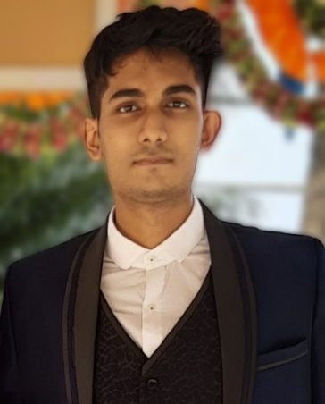

**Address**:

B-25, Nishigandha

La-Campala Colony

Miramar, Panaji,

Goa - 403001

**Programming:**

C

C++ Java

Basic Assembly language Python

**Communication Skills:**

Fluent in English, Hindi, Konkani and Marathi

**Hobbies:**

Travelling

Web Surfing

Community Involvement Watching TV shows

**References:**

Available on request.