|  |  |  |
| --- | --- | --- |
| Cards | | |
| Input | Process | Output |
| Nothing | Make two arrays one a 2d array with all the numbers and the other with the suits | When you open the new file made it will have all the card suits in it |

#include <iostream>  
#include <string>  
#include <fstream>  
  
  
using namespace std;  
  
void Cards();  
  
int main() {  
  
 Cards();  
  
  
 return 0;  
}  
void Cards()  
{  
  
 const int Rows=4 , Columns= 13;  
 string Suits[4]={ "Clubs", "Hearts","Spades","Diamonds"};  
 string Deck[Rows][Columns] = {{"Ace","2","3","4","5","6","7","8","9","10","Jack","Queen","King" },  
 {"Ace","2","3","4","5","6","7","8","9","10","Jack","Queen","King" },  
 {"Ace","2","3","4","5","6","7","8","9","10","Jack","Queen","King" },  
 {"Ace","2","3","4","5","6","7","8","9","10","Jack","Queen","King" }};  
 ofstream Cards_File;  
 Cards_File.open("Cards_File.txt");  
 if (Cards_File.is_open())  
 {  
 for (int i = 0; i <Rows ;i++) {  
  
 for (int j = 0; j < Columns; j++) {  
 Cards_File<<Deck[i][j]<<" of " << Suits[i]<<" ";  
 Cards_File<<endl;  
 }  
  
 }  
  
 Cards_File.close();  
 }  
 else{  
 cout << "Unable to open file";  
 }  
}

|  |  |  |
| --- | --- | --- |
| Cards | | |
| Input | Process | Output |
| Nothing | Make two arrays one a with all the numbers and the other with the suits | It shows what card you drew |

#include <iostream>  
#include <string>  
#include <ctime>  
#include <cstdlib>  
  
  
using namespace std;  
  
string Cards();  
  
int main() {  
cout<<"Your Card is \n"  
 << Cards();  
  
  
 return 0;  
}  
string Cards()  
{  
  
  
 string Suits[]={ "Clubs", "Hearts","Spades","Diamonds"};  
 string Deck[] = {"Ace","2","3","4","5","6","7","8","9","10","Jack","Queen","King" };  
 string card;  
 srand(time(0));   
 int DeckValue = 1+(rand() % 13);  
 int CardSuit = 1+(rand() % 4);  
 card += Deck[DeckValue];  
 card += " of ";  
 card += Suits[CardSuit];  
 return card;  
  
  
}

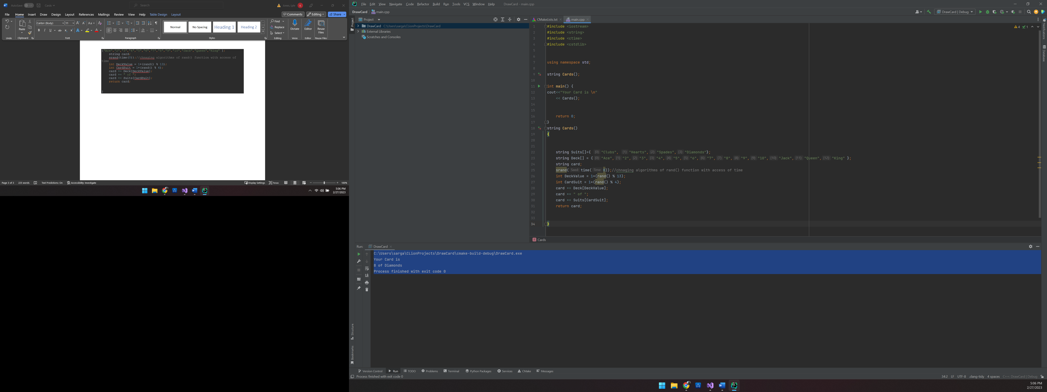

C:\Users\sarga\CLionProjects\DrawCard\cmake-build-debug\DrawCard.exe

Your Card is

8 of Diamonds

Process finished with exit code 0

|  |  |  |
| --- | --- | --- |
| Memory | | |
| Input | Process | Output |
| Select the row and column | COMPARE the row and column to see if they match | To see if they match or not  Variables |

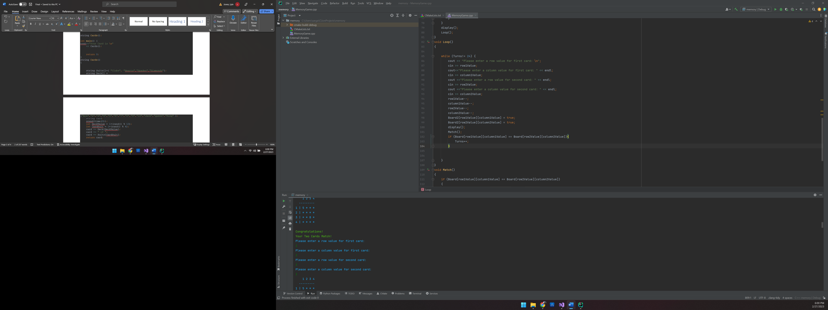

Please enter a row value for first card:

2

Please enter a column value for first card:

3

Please enter a row value for second card:

2

Please enter a column value for second card:

1

1 2 3 4

---------

1 | 5 5 * *

2 | 4 8 7 *

3 | 8 * 8 *

4 | 5 * * *

Oh No!

Your Two Cards Do Not Match!

Please enter a row value for first card:

2

Please enter a column value for first card:

4

Please enter a row value for second card:

3

Please enter a column value for second card:

1

1 2 3 4

---------

1 | 5 5 * *

2 | * 8 * 6

3 | 8 * 8 *

4 | 5 * * *

Oh No!

Your Two Cards Do Not Match!

Please enter a row value for first card:

3

Please enter a column value for first card:

2

Please enter a row value for second card:

1

Please enter a column value for second card:

3

1 2 3 4

---------

1 | 5 5 2 *

2 | * 8 * *

3 | * 7 8 *

4 | 5 * * *

Oh No!

Your Two Cards Do Not Match!

Please enter a row value for first card:

3

Please enter a column value for first card:

1

Please enter a row value for second card:

3

Please enter a column value for second card:

3

1 2 3 4

---------

1 | 5 5 * *

2 | * 8 * *

3 | 8 * 8 *

4 | 5 * * *

Congratulations!

Your Two Cards Match!

Please enter a row value for first card:

4

Please enter a column value for first card:

1

Please enter a row value for second card:

4

Please enter a column value for second card:

2

1 2 3 4

---------

1 | 5 5 * *

2 | * 8 * *

3 | 8 * 8 *

4 | 5 7 * *

Oh No!

Your Two Cards Do Not Match!

Please enter a row value for first card:

4

Please enter a column value for first card:

2

Please enter a row value for second card:

3

Please enter a column value for second card:

2

1 2 3 4

---------

1 | 5 5 * *

2 | * 8 * *

3 | 8 7 8 *

4 | * 7 * *

Congratulations!

Your Two Cards Match!

Please enter a row value for first card:

4

Please enter a column value for first card:

1

Please enter a row value for second card:

1

Please enter a column value for second card:

1

1 2 3 4

---------

1 | 5 5 * *

2 | * 8 * *

3 | 8 7 8 *

4 | 5 7 * *

Congratulations!

Your Two Cards Match!

Please enter a row value for first card:

4

Please enter a column value for first card:

3

Please enter a row value for second card:

4

Please enter a column value for second card:

4

1 2 3 4

---------

1 | 5 5 * *

2 | * 8 * *

3 | 8 7 8 *

4 | 5 7 6 7

Oh No!

Your Two Cards Do Not Match!

Please enter a row value for first card:

4

Please enter a column value for first card:

4

Please enter a row value for second card:

4

Please enter a column value for second card:

2

1 2 3 4

---------

1 | 5 5 * *

2 | * 8 * *

3 | 8 7 8 *

4 | 5 7 * 7

Congratulations!

Your Two Cards Match!

Please enter a row value for first card:

3

Please enter a column value for first card:

4

Please enter a row value for second card:

4

Please enter a column value for second card:

3

1 2 3 4

---------

1 | 5 5 * *

2 | * 8 * *

3 | 8 7 8 4

4 | 5 7 6 7

Oh No!