|  |  |  |
| --- | --- | --- |
| Parking Fee | | |
| Input | Process | Output |
| 1. Have them in put hours | 1. Have the hours sorted by the amount of time. 2. Use formula to come up with the fee. 3. F=Parkedtime * ( hours +1) | The amount you owe for parking will show up as an int. |

|  |  |  |
| --- | --- | --- |
| Novel | | |
| Input | Process | Output |
| 1. Need to input which option you want 2. Need to know the number of books sold 3. Need to know the price | 1. Select option. 2. Add 5000+20000 3. Have the price of book * the percentage. 4. Multiply that number by number of books sold 5. Any thing over 4000 * other percentage | The amount the author will make for the books |

#include <iostream>  
using namespace std ;  
int main() {  
 int ContractOption ;  
 cout << "What contract option would you like to explore ?";  
 cin >> ContractOption;  
 float PercentOption2 = .125, PercentOption3 = .1, PercentOption3_2nd = .14;  
 int Option1 = 5000 + 20000;  
 switch (ContractOption ) {  
  
 case 1:  
  
 cout << "Here is the first contract option. $" << Option1;  
 break;  
 case 2:  
 float PriceOfNovel, NumberOfNovels, TotalProfit;  
 cout << "Enter The Price per Novel." << endl;  
 cin >> PriceOfNovel;  
 cout << "Enter the number of novels you think will sell." << endl;  
 cin >> NumberOfNovels;  
 TotalProfit = (PriceOfNovel * PercentOption2) * NumberOfNovels;  
  
 cout << "Here is the profit from option 2. $" << TotalProfit << endl;  
 break;  
 case 3:  
 cout << "Enter the amount the Novel will cost" << endl;  
 float NumberNovels, PriceNovels;  
 cin >> PriceNovels;  
 cout << "What is amount of Novels you think will sell?" << endl;  
 cin >> NumberNovels;  
 float TotalMade1, TotalMade2, TotalMade;  
 TotalMade1 = (PriceNovels * PercentOption3) * NumberNovels;  
 TotalMade = TotalMade1 + TotalMade2;  
 TotalMade2 = (PriceNovels * PercentOption3_2nd) * (NumberNovels - 4000);  
 cout << "Total profit is. $" << TotalMade;  
 break;  
  
 default:  
 cout<<"Is not an option ";  
  
 }  
  
 return 0;  
}

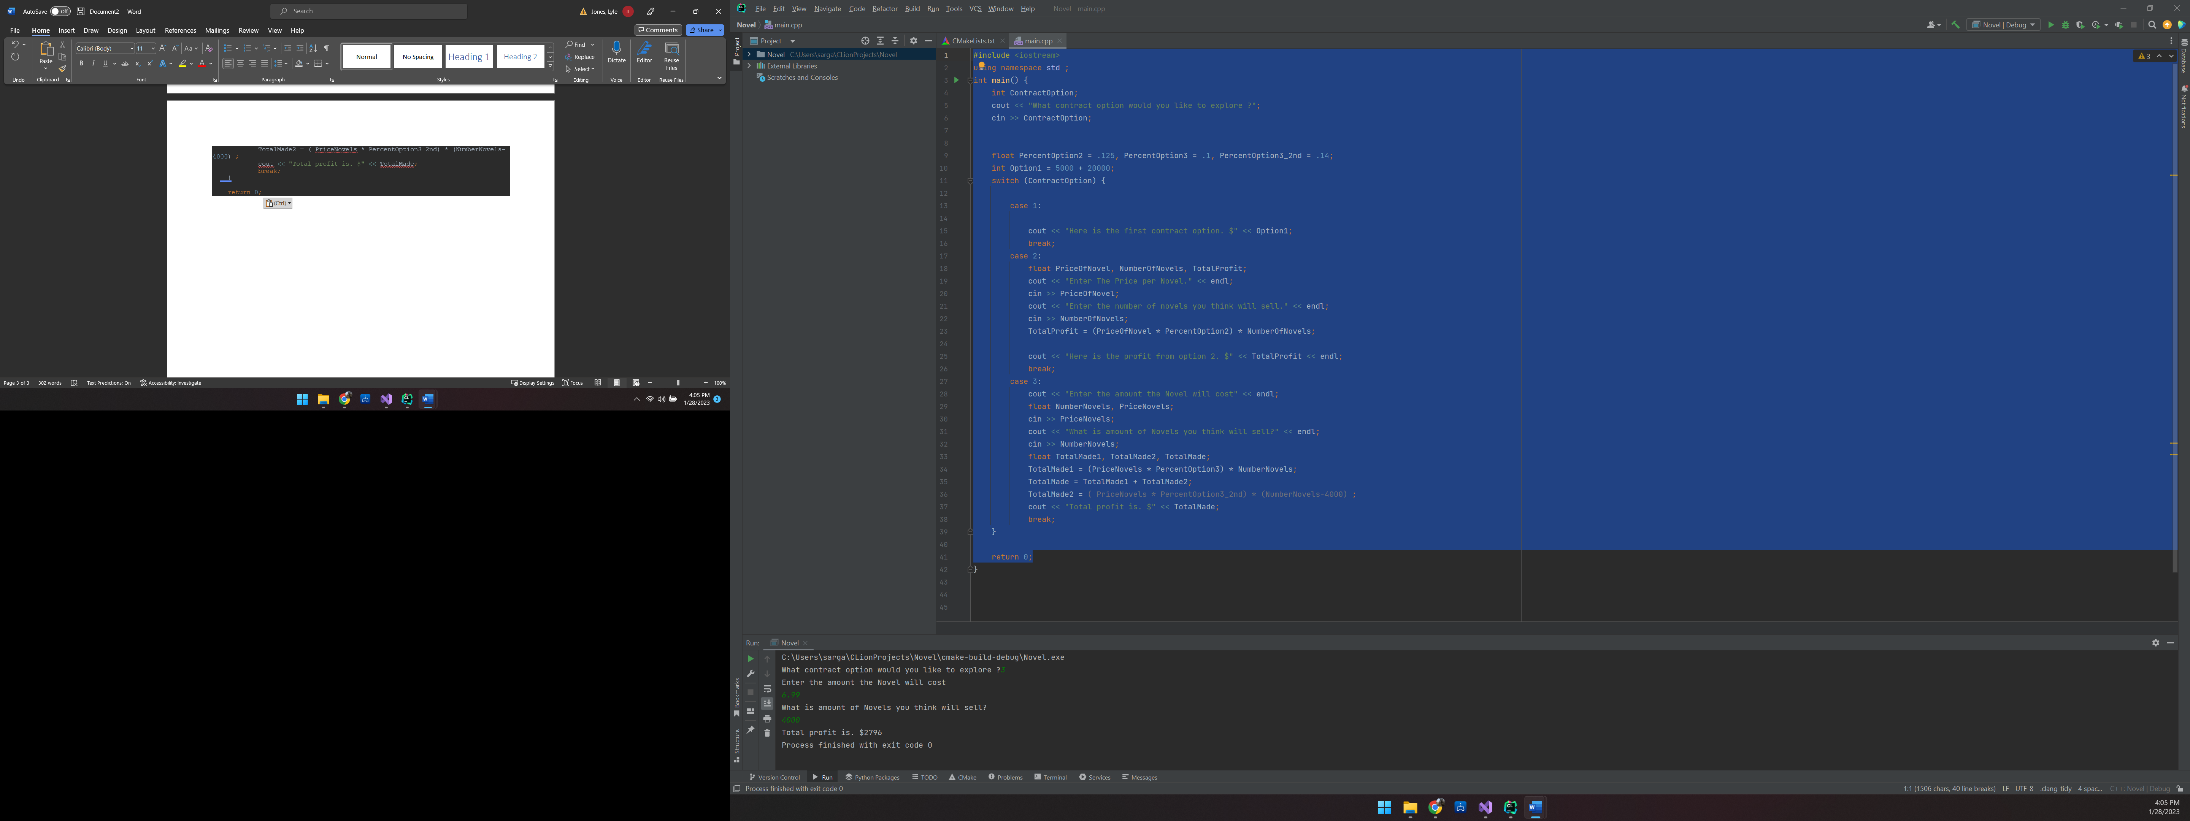

|  |  |  |
| --- | --- | --- |
| BMI | | |
| Input | Process | Output |
| 1. Need to know if female or male 2. Need to know body weight, wrist measurement, waist measurement , hip measurement, and forearm measurement. | 1. Take inform form male or female and calculate body fat and body fat percentage | Show the BMI whether its male or female |

#include <iostream>  
#include <string>  
using namespace std;  
  
int main() {  
 float bodyWeight_F , Wrist , Waist, Hip , Forearm,bodyWeight_M ;  
 float W_Number1= .732 , W_Number2 = 8.987 , W_Number3 =3.14 , W_Number4 = .157 , W_Number5 =.249 , W_Number6 = .434; // numbers for calculating female BMI  
 float A1= (bodyWeight_F * W_Number1)+ W_Number2 , A2= Wrist/W_Number3 , A3 = Waist * W_Number4, A4 =Hip* W_Number5 ,A5 = Forearm * W_Number6 ;  
 float Female_B =A1+A2 -A3-A4+A5 , BodyFat_female =bodyWeight_F - Female_B ;  
 float BodyFatPercentage = (BodyFat_female *100) / bodyWeight_F;  
 float M_Number1 = 1.082 , M_Number2 = 94.42 , M_Number3 = 4.15 ;  
 int Percentage= 100;  
 int Identity ;  
 cout<< "Is the person male or female (1 for male, 2 for female) ?";  
 cin>> Identity ;  
  
 switch ( Identity ) {  
 case 1:  
 cout<<"What is the body weight? \n";  
 cin>>bodyWeight_M;  
 cout<<"What is the wrist measurement? \n";  
 cin>>Wrist;  
 float Mens_A1,Mens_B ,Mens_A2, Mens_BodyFat, BodyFatPercentage_Men;  
 Mens_A2= Wrist * M_Number3,  
 Mens_A1 = (bodyWeight_M * M_Number1)+M_Number2,  
 Mens_B=Mens_A1-Mens_A2;  
 Mens_BodyFat = bodyWeight_M-Mens_B;  
 BodyFatPercentage_Men= (Mens_BodyFat * Percentage) / bodyWeight_M;  
 cout<<"The persons body fat is"<< Mens_BodyFat <<endl  
 <<"The persons body fat percentage is"<< BodyFatPercentage_Men<<"%";  
 break;  
 case 2:  
 cout<< "What is the body weight? \n";  
 cin>>bodyWeight_F;  
 cout<< "What is the wrist measurement? \n";  
 cin>> Wrist;  
 cout<<"What is the waist measurement ? \n";  
 cin>> Waist;  
 cout<<"What is the hip measurement? \n";  
 cin>>Hip;  
 cout<<"What is the forearm measurement? \n";  
 cin>> Forearm;  
 Female_B =A1+A2 -A3-A4+A5,BodyFat_female =bodyWeight_F - Female_B;  
 BodyFatPercentage = (BodyFat_female *Percentage) / bodyWeight_F;  
 cout<<"The persons body fat is" <<BodyFat_female<<endl  
 <<"The persons body fat percentage is "<< BodyFatPercentage<<"%";  
 break;  
 default:  
 cout<< " You didn't pick a valid option!!!";  
  
  
 }  
  
  
 return 0;  
}

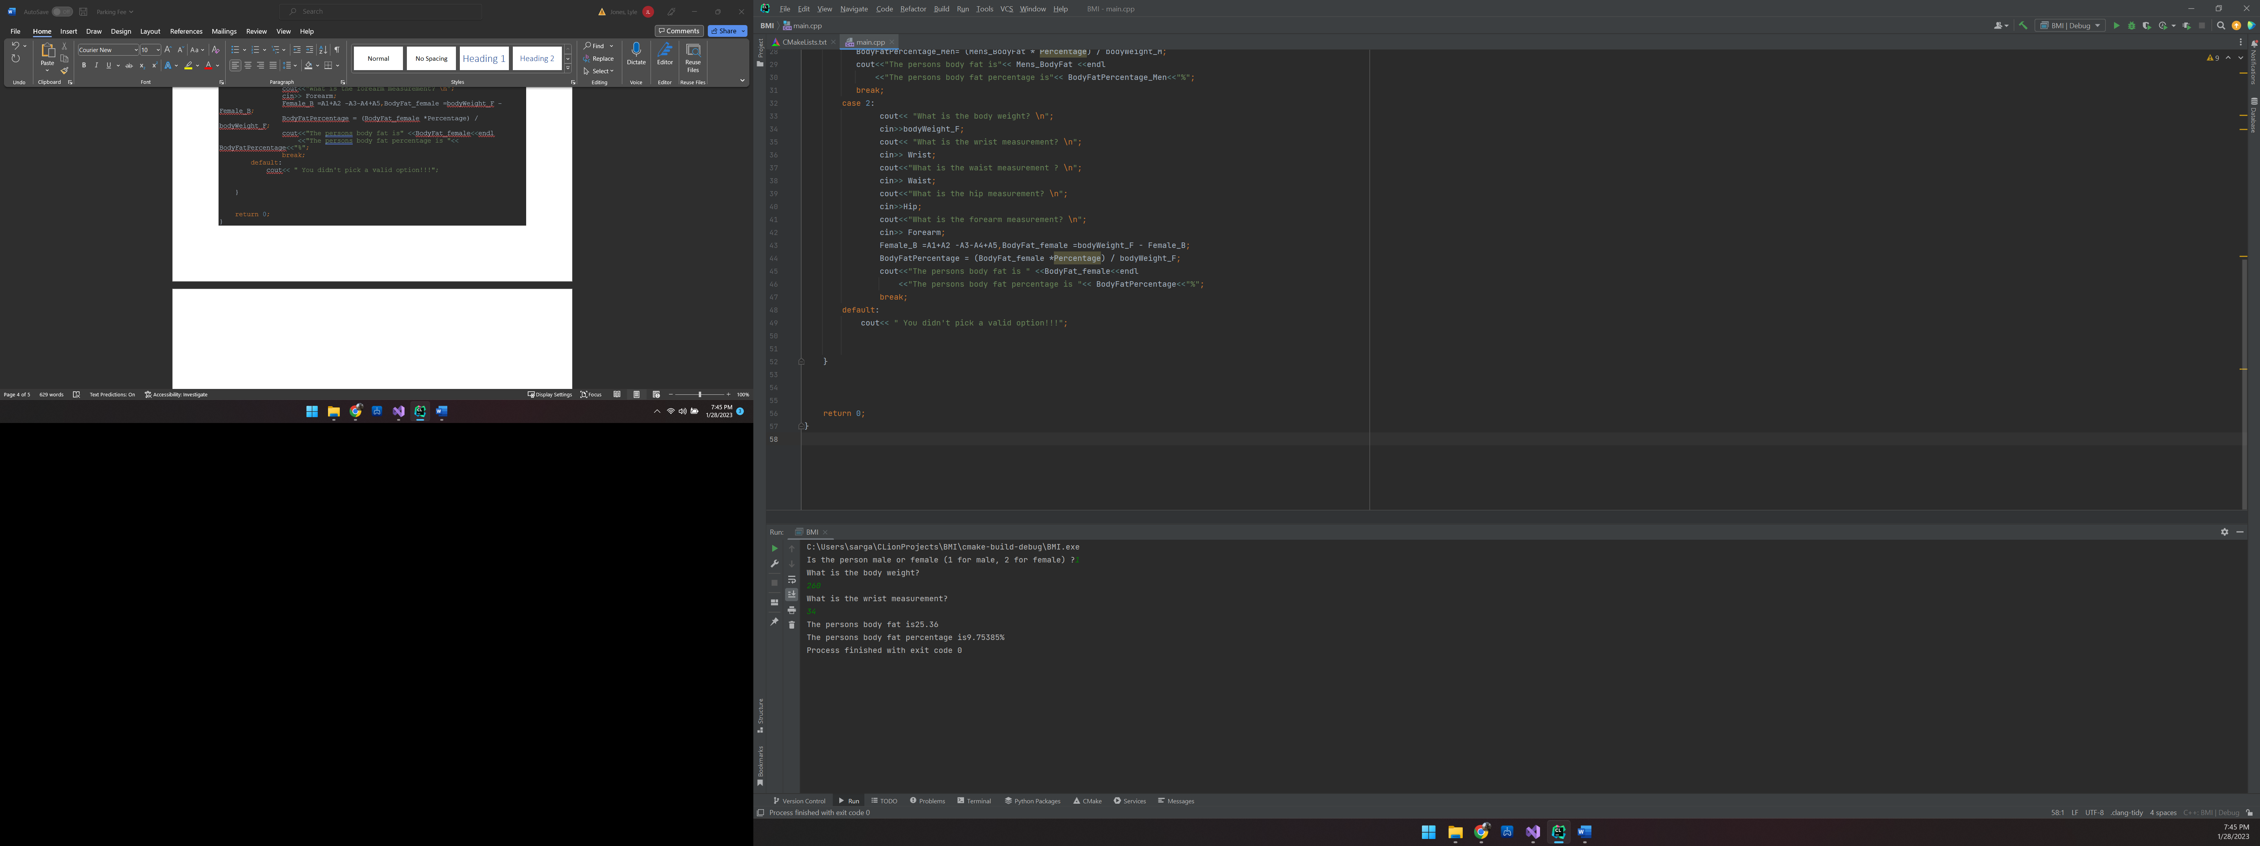

|  |  |  |
| --- | --- | --- |
| Hotel | | |
| Input | Process | Output |
| 1. the cost of the hotel 1 room 2. The number of rooms booked. 3. How many nights you are staying 4. The sales tax in % | 1. Take the cost *number of nights 2. Take #1 * discount if there is one * number of rooms discount if there is one 3. Take #2 * sales tax 4. add #3 with sales tax to come up with total cost | Show discounts if there are any and show sales taxes with total cost |

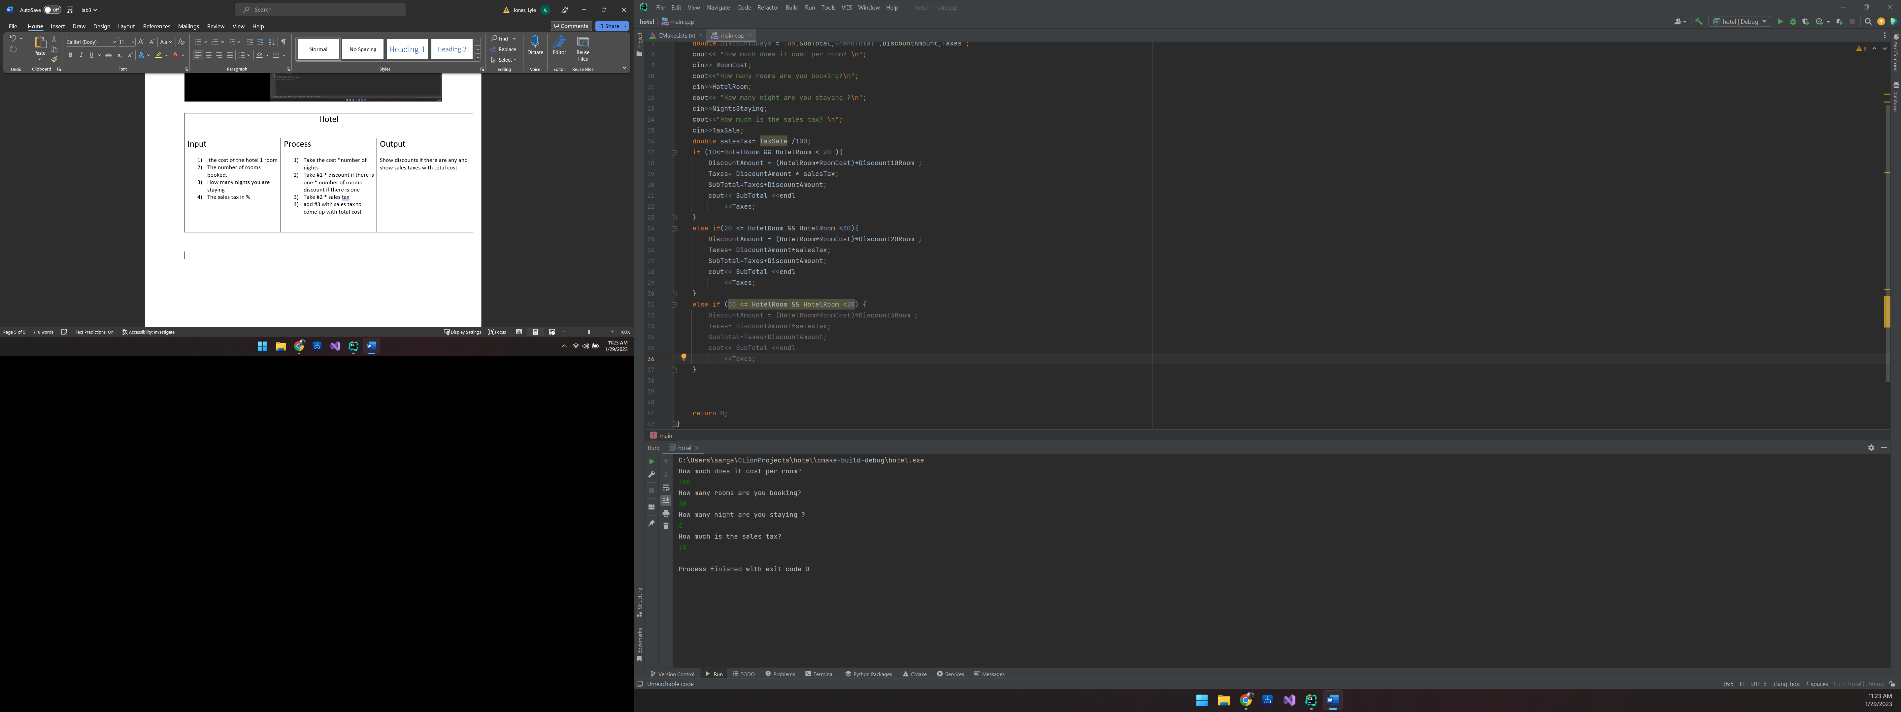

#include <iostream>  
using namespace std;  
int main() {  
 int HotelRoom, NightsStaying,TaxSale,RoomCost ;  
 double Discount10Room = .10 , Discount20Room = .20 ;  
 double Discount3Room = .30 ;  
 double Discount3Days = .05,SubTotal,GrandTotal ,DiscountAmount,Taxes ;  
 cout<< "How much does it cost per room? \n";  
 cin>> RoomCost;  
 cout<<"How many rooms are you booking?\n";  
 cin>>HotelRoom;  
 cout<< "How many night are you staying ?\n";  
 cin>>NightsStaying;  
 cout<<"How much is the sales tax? \n";  
 cin>>TaxSale;  
 double salesTax= TaxSale /100;  
 if (10<=HotelRoom && HotelRoom < 20 ){  
 DiscountAmount = (HotelRoom*RoomCost)*Discount10Room ;  
 Taxes= DiscountAmount * salesTax;  
 SubTotal=Taxes+DiscountAmount;  
 cout<< SubTotal <<endl  
 <<Taxes;  
 }  
 else if(20 <= HotelRoom && HotelRoom <30){  
 DiscountAmount = (HotelRoom*RoomCost)*Discount20Room ;  
 Taxes= DiscountAmount*salesTax;  
 SubTotal=Taxes+DiscountAmount;  
 cout<< SubTotal <<endl  
 <<Taxes;  
 }  
 else if (30 <= HotelRoom && HotelRoom <20) {  
 DiscountAmount = (HotelRoom*RoomCost)*Discount3Room ;  
 Taxes= DiscountAmount*salesTax;  
 SubTotal=Taxes+DiscountAmount;  
 cout<< SubTotal <<endl  
 <<Taxes;  
 }  
  
  
  
 return 0;