|  |  |  |
| --- | --- | --- |
| Phone numbers | | |
| Input | Process | Output |
| 1. Phone number in letters | 1. Make a lop for the letters being typed. 2. Make a case statement for the upper and lower case letters | The phone numbers that they wanted |

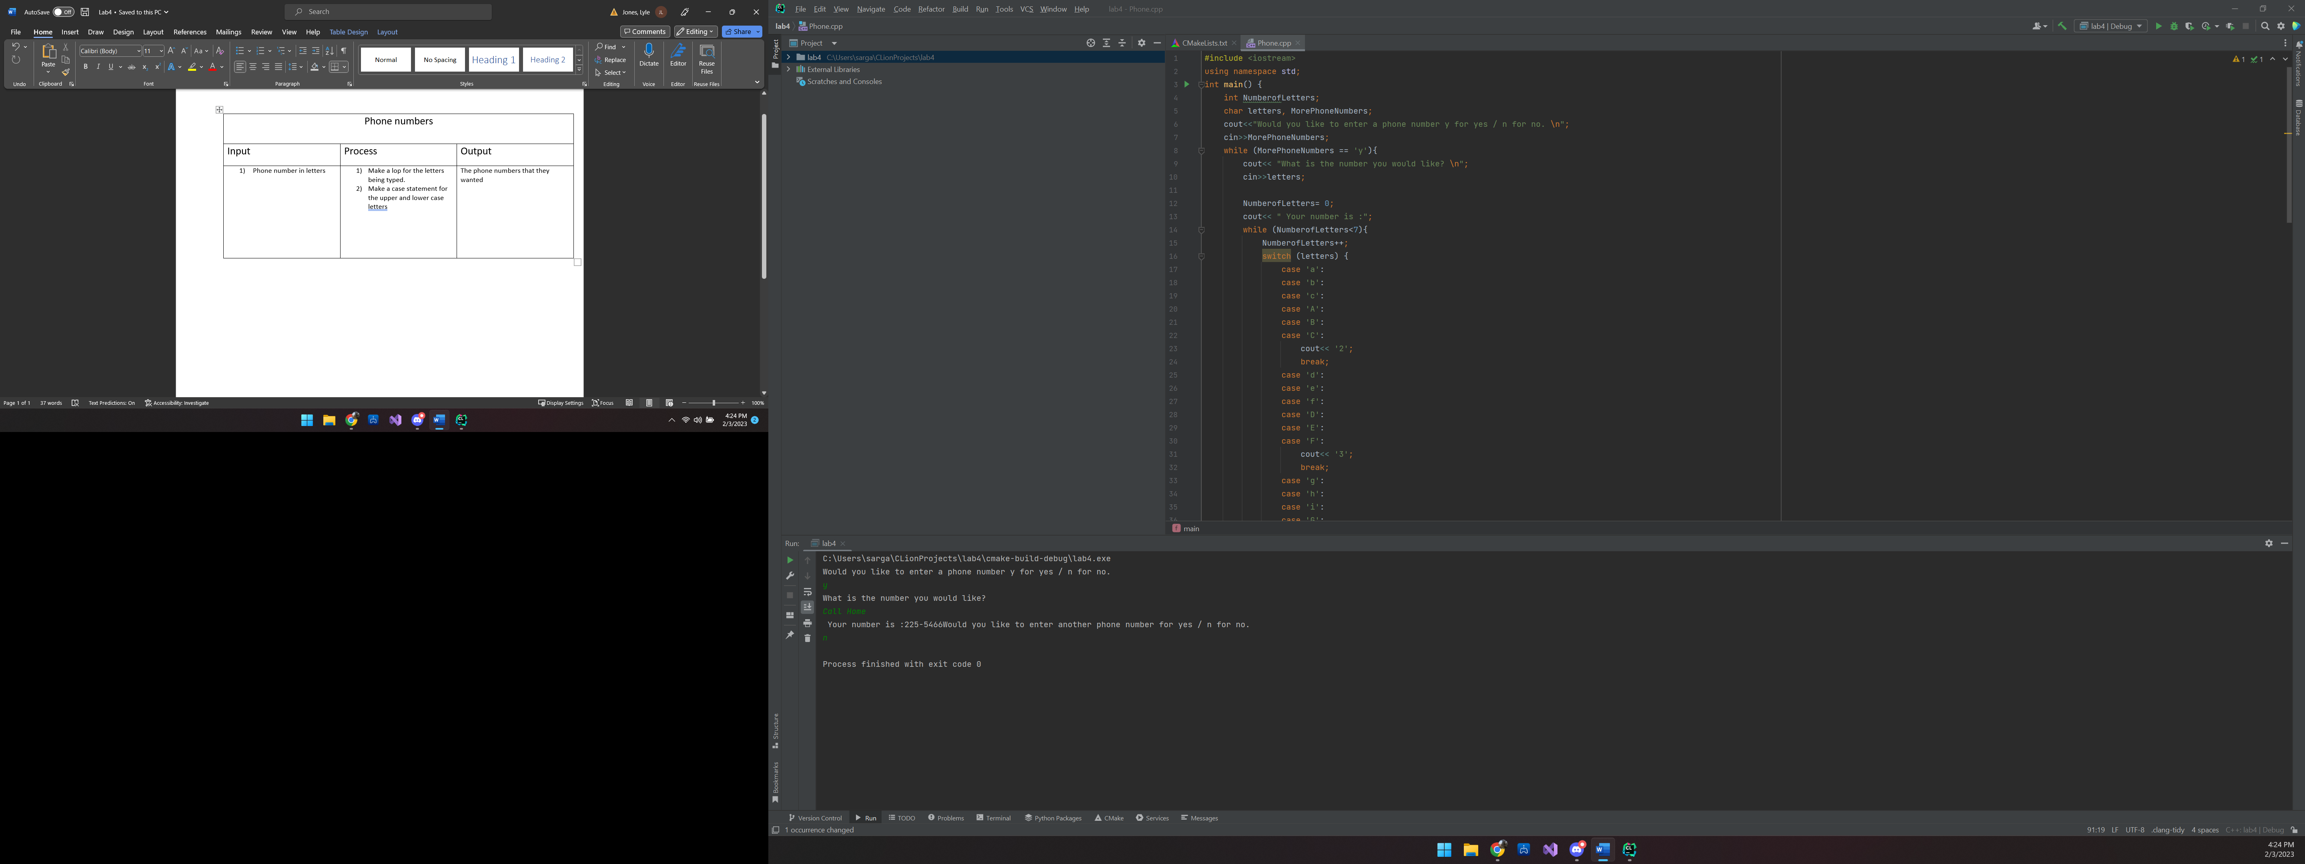

C:\Users\sarga\CLionProjects\lab4\cmake-build-debug\lab4.exe

Would you like to enter a phone number y for yes / n for no.

y

What is the number you would like?

Call Home

Your number is :225-5466Would you like to enter another phone number for yes / n for no.

n

Process finished with exit code 0

#include <iostream>  
using namespace std;  
int main() {  
 int NumberofLetters;  
 char letters, MorePhoneNumbers;  
 cout<<"Would you like to enter a phone number y for yes / n for no. \n";  
 cin>>MorePhoneNumbers;  
 while (MorePhoneNumbers == 'y'){  
 cout<< "What is the number you would like? \n";  
 cin>>letters;  
  
 NumberofLetters= 0;  
 cout<< " Your number is :";  
 while (NumberofLetters<7){  
 NumberofLetters++;  
 switch (letters) {  
 case 'a':  
 case 'b':  
 case 'c':  
 case 'A':  
 case 'B':  
 case 'C':  
 cout<< '2';  
 break;  
 case 'd':  
 case 'e':  
 case 'f':  
 case 'D':  
 case 'E':  
 case 'F':  
 cout<< '3';  
 break;  
 case 'g':  
 case 'h':  
 case 'i':  
 case 'G':  
 case 'H':  
 case 'I':  
 cout<< '4';  
 break;  
 case 'j':  
 case 'k':  
 case 'l':  
 case 'J':  
 case 'K':  
 case 'L':  
 cout<< '5';  
 break;  
 case 'm':  
 case 'n':  
 case 'o':  
 case 'M':  
 case 'N':  
 case 'O':  
 cout<< '6';  
 break;  
 case 'p':  
 case 'q':  
 case 'r':  
 case 's':  
 case 'P':  
 case 'Q':  
 case 'R':  
 case 'S':  
 cout<< '7';  
 break;  
 case 't':  
 case 'u':  
 case 'v':  
 case 'T':  
 case 'U':  
 case 'V':  
 cout<< '8';  
 break;  
 case 'w':  
 case 'x':  
 case 'y':  
 case 'z':  
 case 'W':  
 case 'X':  
 case 'Y':  
 case 'Z':  
 cout<< '9';  
 break;  
 }  
 if (NumberofLetters == 3)  
 cout<< '-';  
 cin>>letters;  
 }  
cin.ignore(100,'\n');  
 cout<< "\nWould you like to enter another phone number for yes / n for no. \n";  
 cin>>MorePhoneNumbers;  
  
 }  
  
 return 0;  
}

|  |  |  |
| --- | --- | --- |
| Population | | |
| Input | Process | Output |
| 1. The population of Town A 2. The population of Town B | 1. Take the population and multiply it by the growth rate 2. Add the new population 3. Compare the new populations between Town A and town B until they are equal 4. Count the amount of times it takes | It puts out how many years it will take for Town A to reach a equal or larger population  It will also put out the populations of both Town A and Town B |

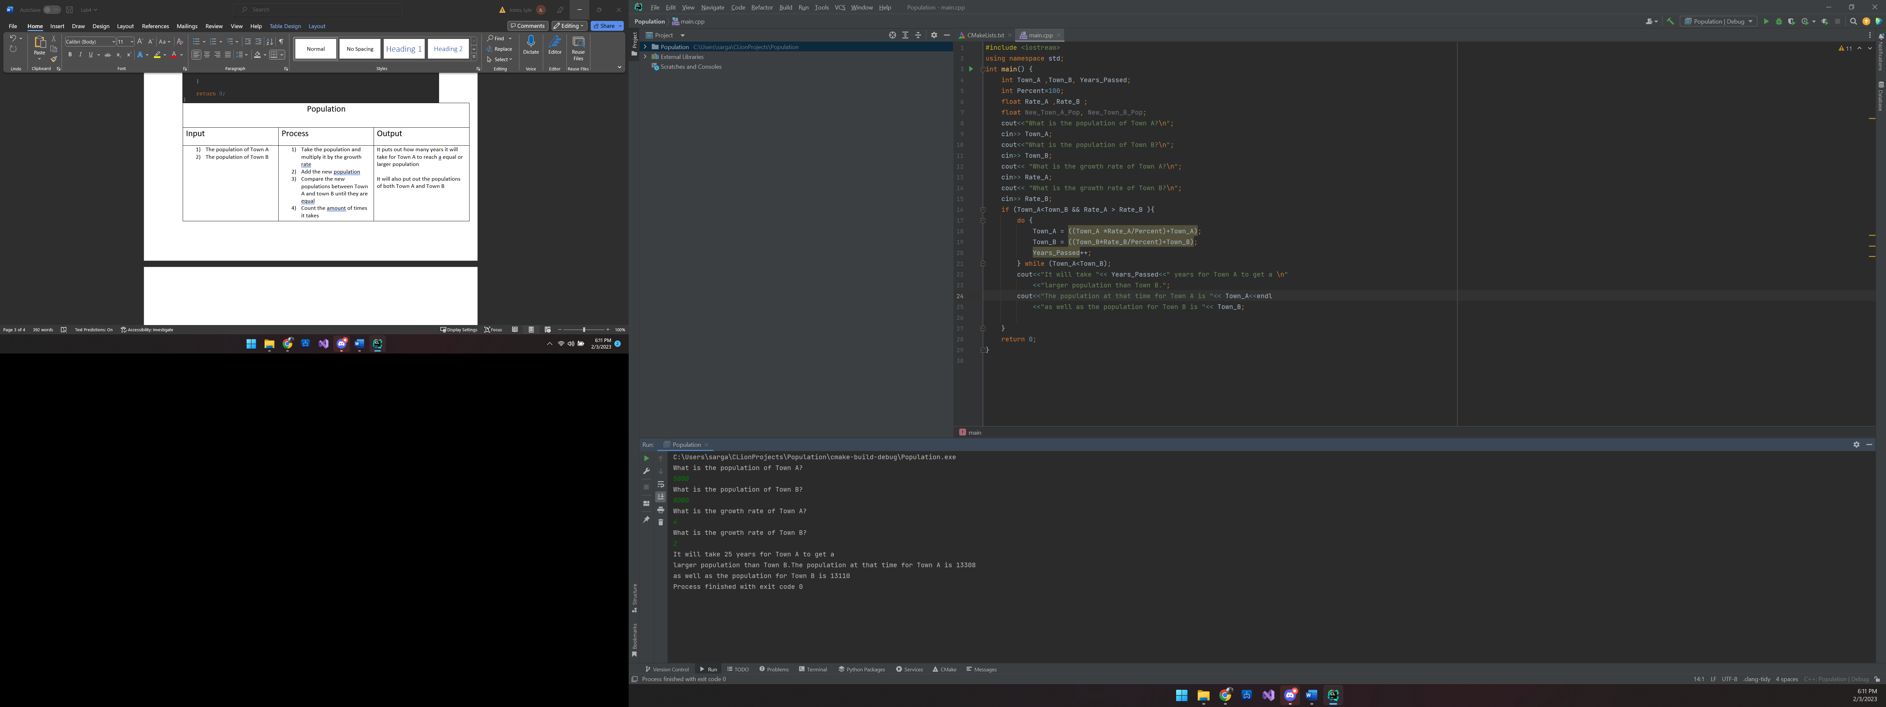

C:\Users\sarga\CLionProjects\Population\cmake-build-debug\Population.exe

What is the population of Town A?

5000

What is the population of Town B?

8000

What is the growth rate of Town A?

4

What is the growth rate of Town B?

2

It will take 25 years for Town A to get a

larger population than Town B.The population at that time for Town A is 13308

as well as the population for Town B is 13110

Process finished with exit code 0

#include <iostream>  
using namespace std;  
int main() {  
 int Town_A ,Town_B, Years_Passed;  
 int Percent=100;  
 float Rate_A ,Rate_B ;  
 float New_Town_A_Pop, New_Town_B_Pop;  
 cout<<"What is the population of Town A?\n";  
 cin>> Town_A;  
 cout<<"What is the population of Town B?\n";  
 cin>> Town_B;  
 cout<< "What is the growth rate of Town A?\n";  
 cin>> Rate_A;  
 cout<< "What is the growth rate of Town B?\n";  
 cin>> Rate_B;  
 if (Town_A<Town_B && Rate_A > Rate_B ){  
 do {  
 Town_A = ((Town_A *Rate_A/Percent)+Town_A);  
 Town_B = ((Town_B*Rate_B/Percent)+Town_B);  
 Years_Passed++;  
 } while (Town_A<Town_B);  
 cout<<"It will take "<< Years_Passed<<" years for Town A to get a \n"  
 <<"larger population than Town B.";  
 cout<<"The population at that time for Town A is "<< Town_A<<endl  
 <<"as well as the population for Town B is "<< Town_B;  
  
 }  
 return 0;  
}

|  |  |  |
| --- | --- | --- |
| Loan | | |
| Input | Process | Output |
| 1. Loan amount 2. Yearly interest rate 3. Monthly payment | 1. Take the interest rate and get the divide by 12 2. Take the monthly rate by 100 3. Take the loan and multiply by the monthly rate 4. Subtract the monthly payment from the monthly rate | If the payment isn’t high enough it will put out the payment will not make it and the loan will increase  If it is it will print out how long it will take to pay |

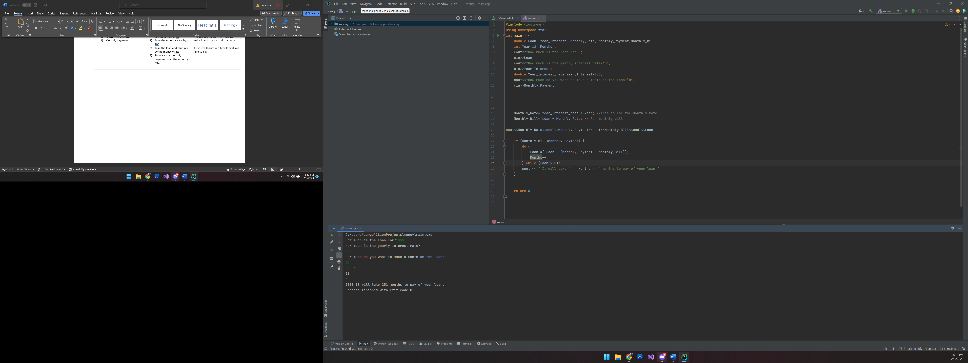

C:\Users\sarga\CLionProjects\money\main.exe

How much is the loan for?1000

How much is the yearly interest rate?

7.2

How much do you want to make a month on the loan?

10

1000 It will take 251 months to pay off your loan.

Process finished with exit code 0

#include <iostream>  
using namespace std;  
int main() {  
 double Loan, Year_Interest, Monthly_Rate, Monthly_Payment,Monthly_Bill;  
 int Year=12, Months ;  
 cout<<"How much is the loan for?";  
 cin>>Loan;  
 cout<<"How much is the yearly interest rate?\n";  
 cin>>Year_Interest;  
 double Year_Interest_rate=Year_Interest/100;  
 cout<<"How much do you want to make a month on the loan?\n";  
 cin>>Monthly_Payment;  
  
  
  
  
 Monthly_Rate= Year_Interest_rate / Year; //This is for the Monthly rate  
 Monthly_Bill= Loan * Monthly_Rate; // For monthly bill  
  
 //cout<<Monthly_Rate<<endl<<Monthly_Payment<<endl<<Monthly_Bill<<endl<<Loan;  
  
 if (Monthly_Bill<Monthly_Payment) {  
 do {  
 Loan =( Loan - (Monthly_Payment - Monthly_Bill));  
 Months++;  
 } while (Loan > 0);  
 cout << " It will take " << Months << " months to pay off your loan.";  
 } else{  
 cout<<"You will not be able to make the payments and your loan grow";  
 }  
  
 return 0;

|  |  |  |
| --- | --- | --- |
| Apartment | | |
| Input | Process | Output |
| 1. Total number of units 2. Rent if all units are occupy all the units. 3. The increase if a unit is empty. 4. Amount to maintain a unit. | 1. That the amount of maintenance cost per unit times all them 2. Take the number of units times rent if all are full 3. Take the number of units times rent if 1 unit is empty 4. Compare the prices and make the adjustments | Print out the number of units to be rented to maximize profits |

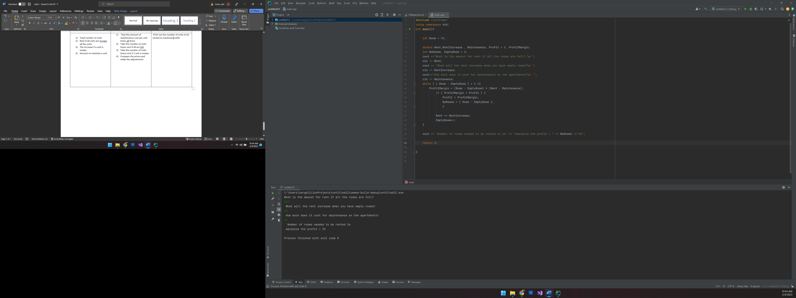

C:\Users\sarga\CLionProjects\untitled12\cmake-build-debug\untitled12.exe

What is the amount for rent if all the rooms are full?

600

What will the rent increase when you have empty rooms?

40

How much does it cost for maintenance on the apartments?

24

Number of rooms needed to be rented to

maximize the profit = 32

Process finished with exit code 0

#include <iostream>  
using namespace std;  
int main(){  
  
 int Room = 50;  
  
 double Rent,RentIncrease , Maintenance, Profit = 0, ProfitMargin;  
 int NoRooms, EmptyRoom = 0;  
 cout <<"What is the amount for rent if all the rooms are full? \n ";  
 cin >> Rent;  
 cout << "What will the rent increase when you have empty rooms?\n ";  
 cin >> RentIncrease;  
 cout<<"How much does it cost for maintenance on the apartments?\n ";  
 cin >> Maintenance;  
 while ( ( Room - EmptyRoom ) > 0 ){  
 ProfitMargin = (Room - EmptyRoom) * (Rent - Maintenance);  
 if ( ProfitMargin > Profit ) {  
 Profit = ProfitMargin;  
 NoRooms = ( Room - EmptyRoom );  
 }  
  
 Rent += RentIncrease;  
 EmptyRoom++;  
 }  
  
 cout << "Number of rooms needed to be rented to \n "<< "maximize the profit = " << NoRooms <<"\n";  
  
 return 0;  
  
}